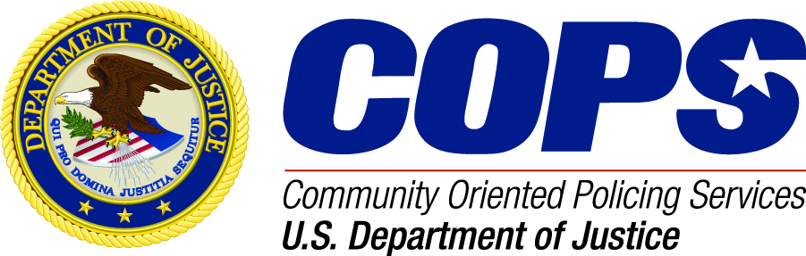

**SHARING COMMUNITY POLICING SUCCESSES**

**The COPS Office would like to hear from you!** We would like to consider featuring your success story OR successful community policing strategies and lessons learned on our website to share with other law enforcement agencies across the country. To tell us about successes related to your COPS grant, please complete the information below and attach additional sheets as necessary. Please submit by email to [COPSCPOutreach@cops.usdoj.gov](mailto:COPSCPOutreach@cops.usdoj.gov). COPS Office staff will contact you regarding your submission, or you may call our Community Policing Outreach Section at 1-800-421-6770.

**Agency Details**

|  |  |  |  |
| --- | --- | --- | --- |
| Agency Name: | | Submission Date: | |
| ORI #: | | City: | State: |
| COPS Grant Program : | Year Funded: | CHP Problem Area (If applicable): | |
| Agency Point of Contact: | Phone #: | Email: | |

**Agency submission under the following community policing component:**

[ ] Community Partnerships [ ] Problem Solving [ ] Organizational Transformation

**Description of the problem**

**Community policing strategies implemented**

**Change and/or impact as a result of these community policing efforts (including who benefited from the change/impact)**

**Lessons learned through the implementation of your program**

*Following receipt of this form, the COPS Office may use your submission, in full or in part, on the COPS website, and may make editorial changes that may be necessary prior to posting.*