Community Assistance Visit (CAV) Community Visit Report Screens in the NFIP Community Information System (CIS)

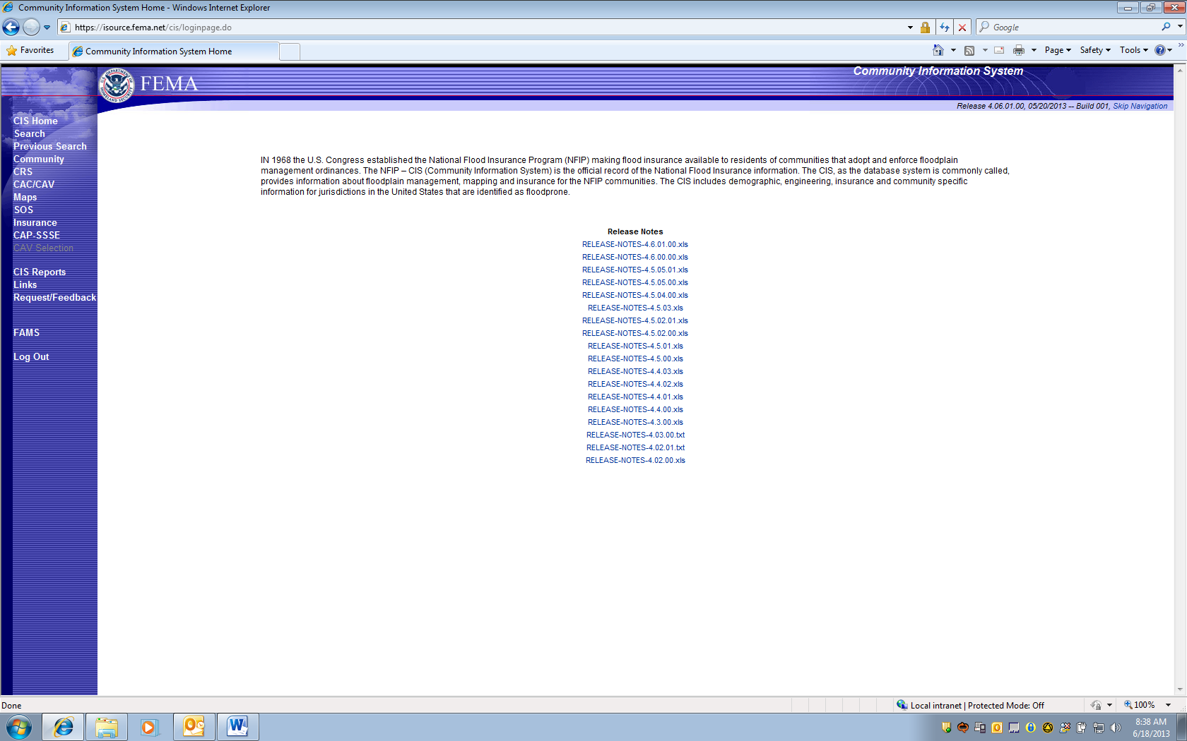
Select SEARCH on Left to Navigate to Community and State

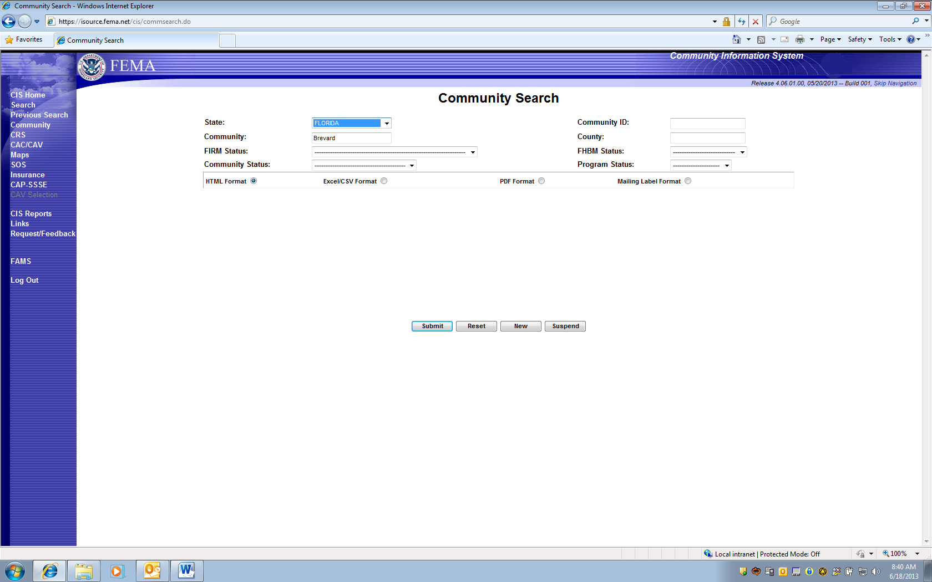
Type “Brevard”, then chose Florida from State Pick List, and Enter “Submit”

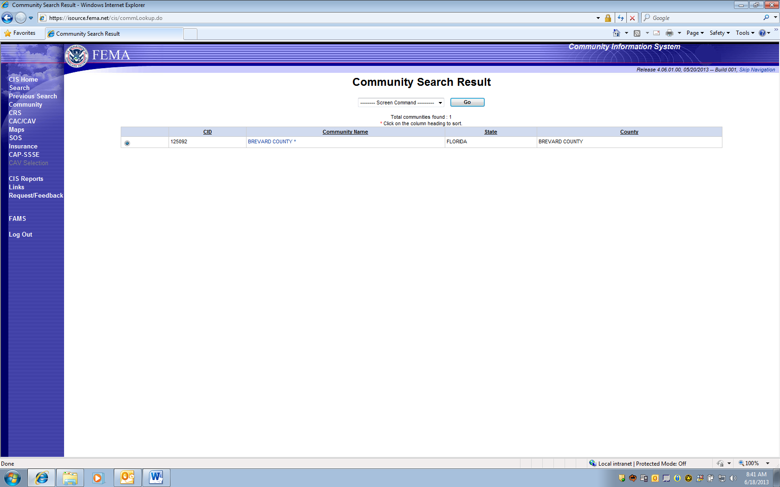

Only one NFIP Participating community called “Brevard” is returned. Double-click on community name.

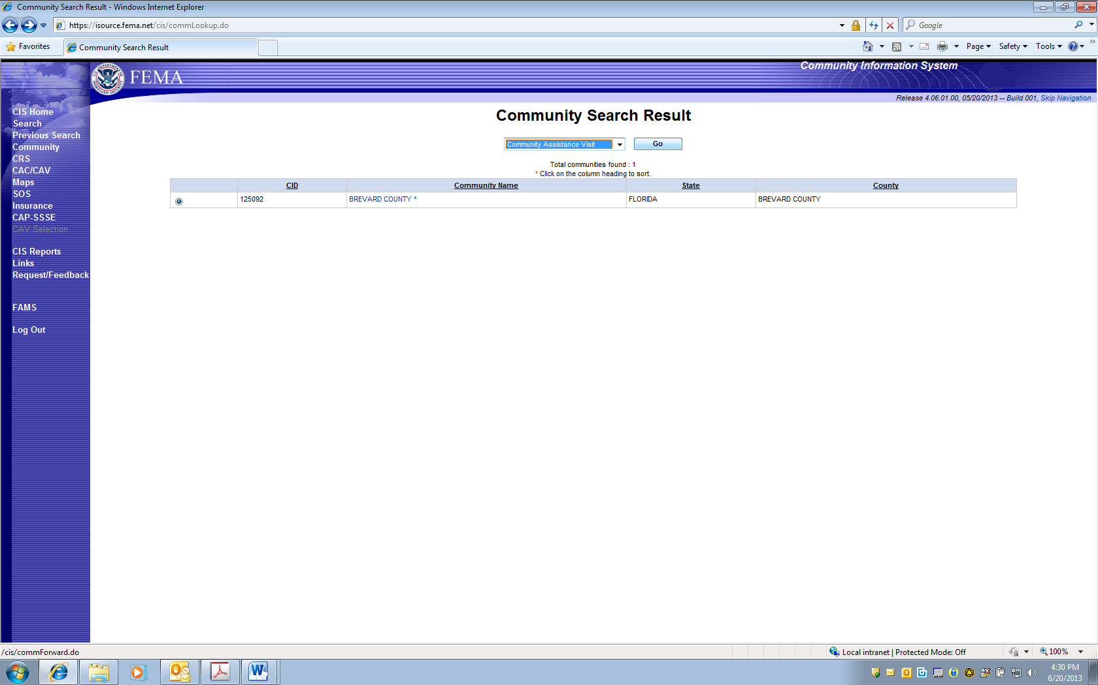

Select “Community Assistance Visit” from selection box and press “GO”

CAV is selected. 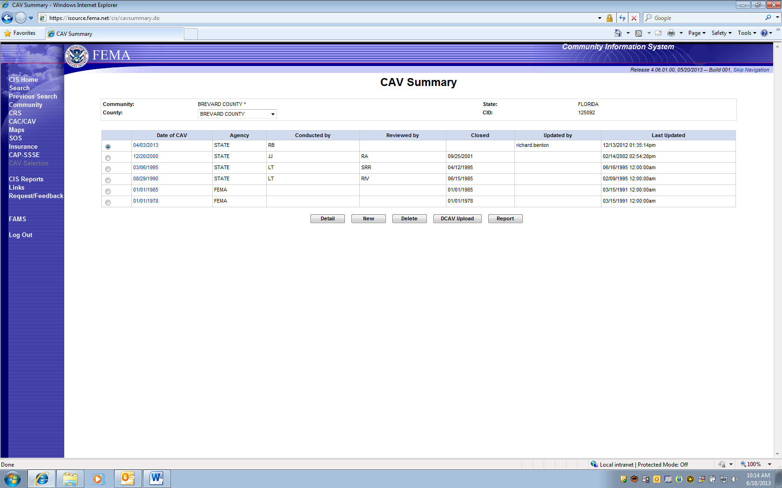

This screen reflects PRA collection Entry Information for 1660-0023, Community Assistance Visit.
Five Choices (Gray Boxes):
- DETAIL: Loads Previous CAV Information.
- NEW: Adds new CAV collection information.
- DELETE: Allows an option to delete a previous CAV entry.
- DCAV UPLOAD: Provides option for digital upload of collected data.
- REPORT: This option Prints a report for all CAV entry fields.

- DETAILS selection displays previously entered collection information on specific CAV, under 5 Screen TABS:
  - CAV Info; Findings; Narrative; Initial Follow-up; Compliance Follow-up

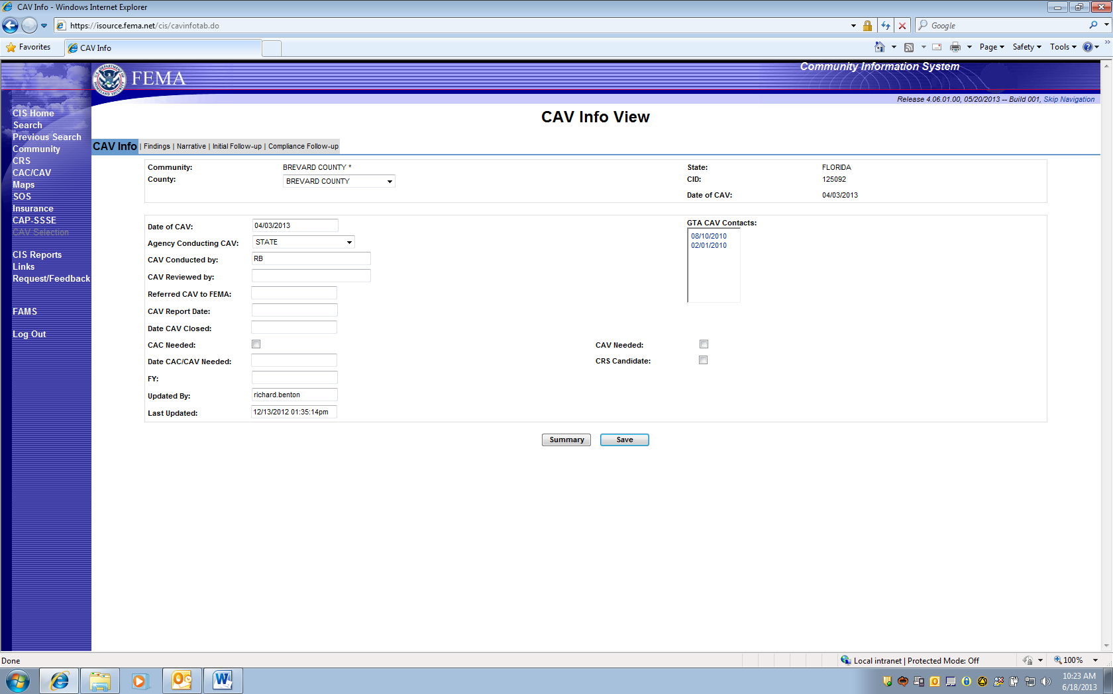
PAPERWORK BURDEN DISCLOSURE NOTICE O.M.B. No. 1660-0023 Expires “TBD – Awaiting Extension Approval”
Public reporting burden for this data collection is estimated to average 2 hours per response. The burden estimate includes the time for reviewing instructions, searching existing data sources, gathering and maintaining the data needed, and completing and submitting this form. This collection of information is required to obtain or retain benefits. You are not required to respond to this collection of information unless it displays a valid OMB control number. Send comments regarding the accuracy of the burden estimate and any suggestions for reducing the burden to: Information Collections Management, Department of Homeland Security, Federal Emergency Management Agency, 500 C Street, SW, Washington, DC 20472, Paperwork Reduction Project (1660-0023)

FEMA Form 086-0-28(E), Community Visit Report

- CAV Details:
  - FINDINGS Screen TAB
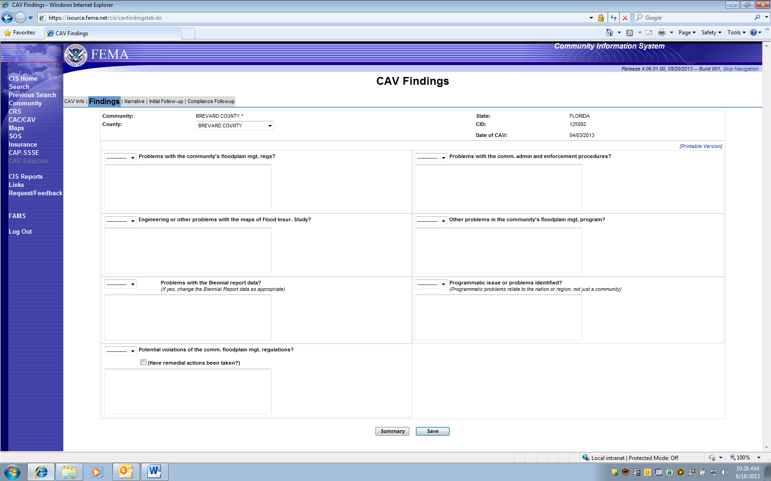

- CAV Details:
c. NARRATIVE “CAV Notes” Screen TAB

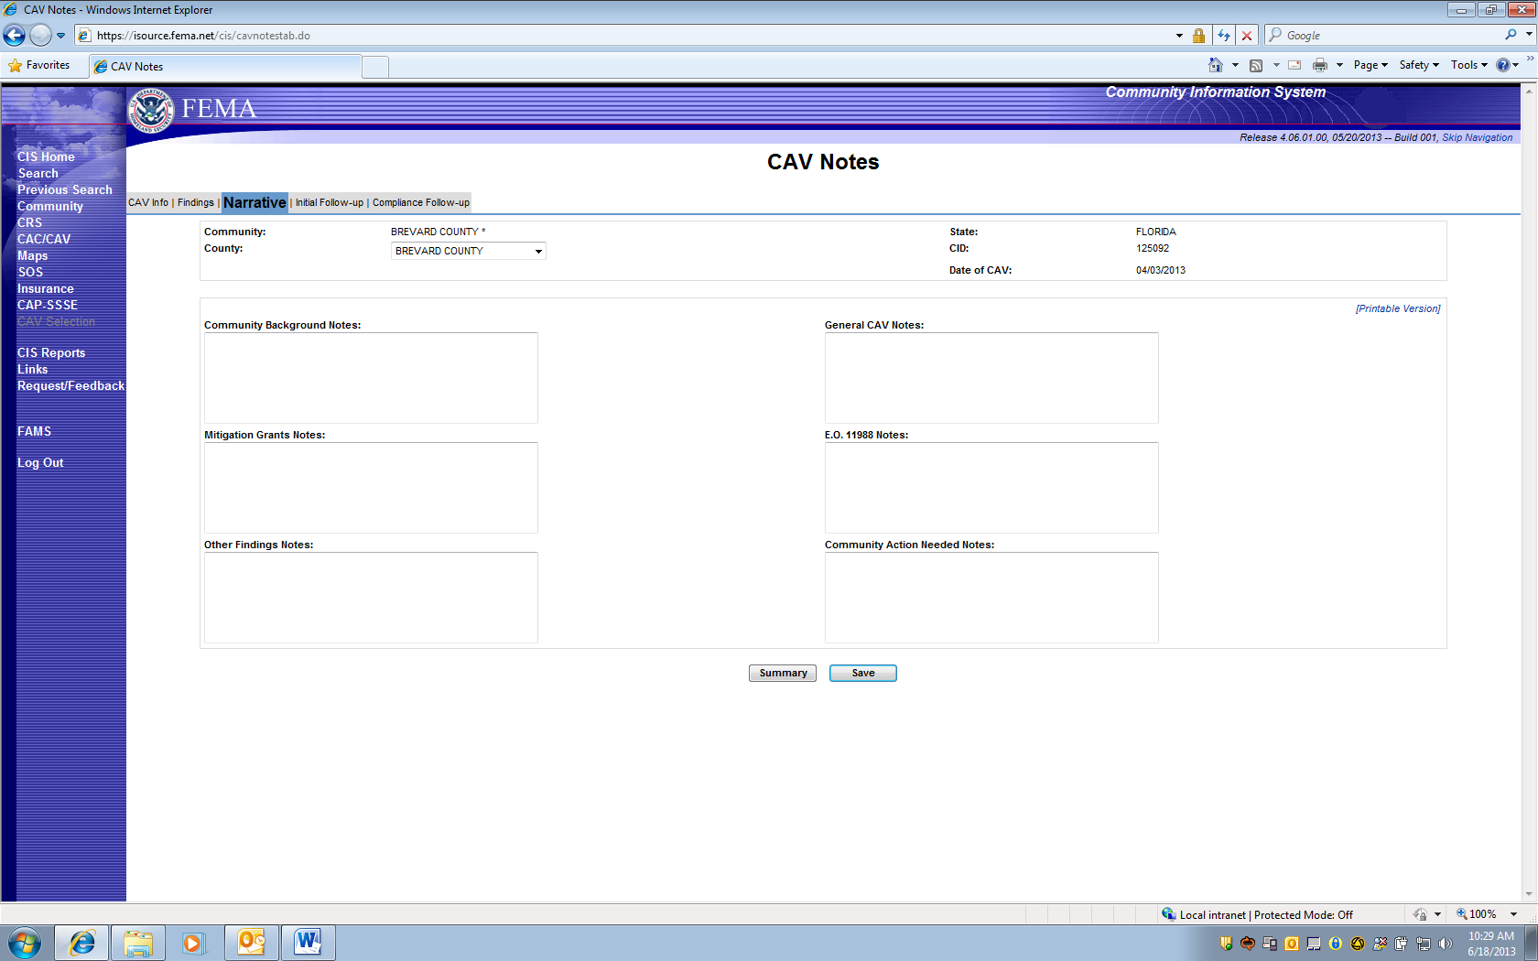

- CAV Details:
d. CAV Initial Follow-up Screen TAB

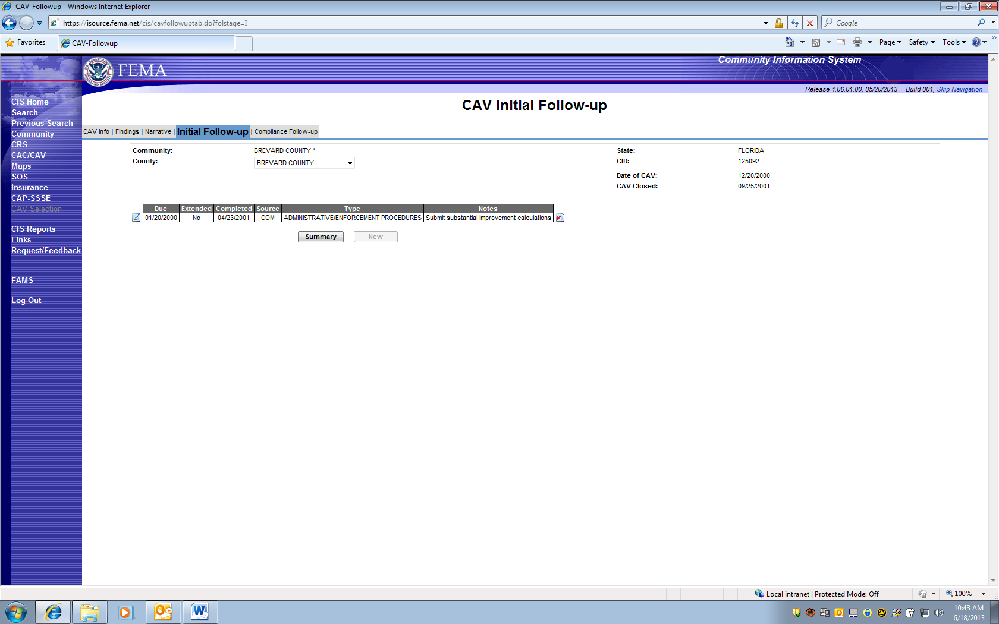

- CAV Details:

- CAV Compliance Follow-up Screen TAB
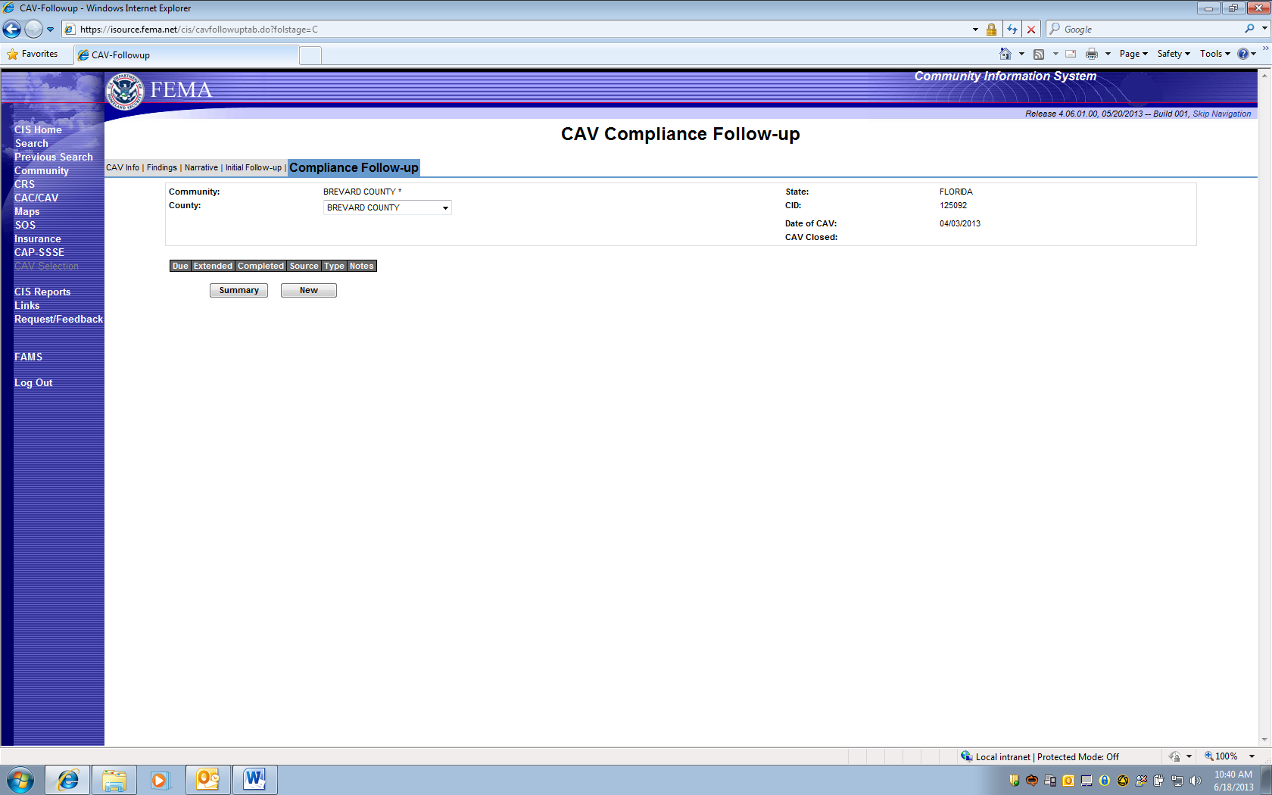

This TAB also displays optional additional tracking information dates if entered under sub TABs: Due; Extended; Completed; Source; Type; Notes.

- NEW CAV Screen TAB - 4 Data TABs to Enter:

- CAV Info
- Findings
- Narrative
- Follow-up

a. NEW CAV Info Screen:
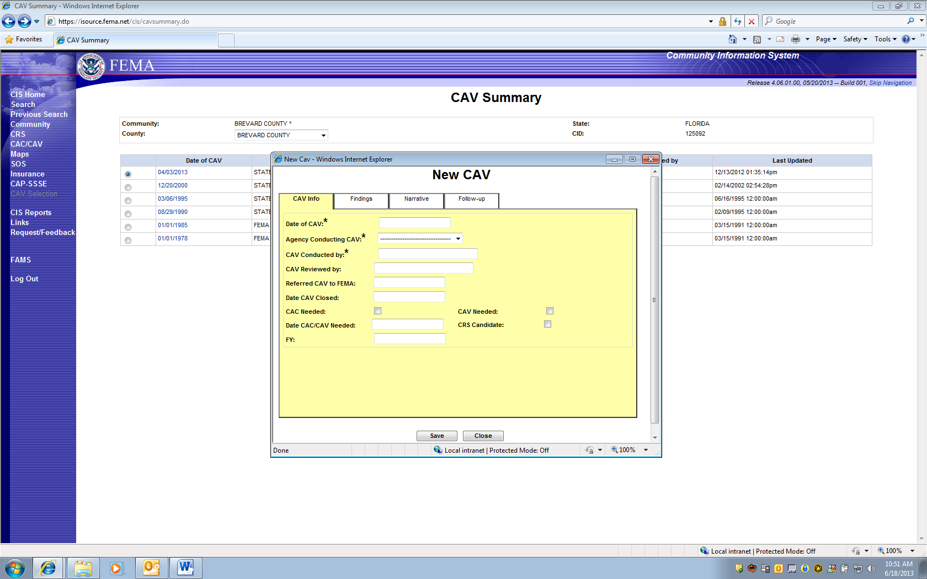
PAPERWORK BURDEN DISCLOSURE NOTICE O.M.B. No. 1660-0023 Expires “TBD – Awaiting Extension Approval”
Public reporting burden for this data collection is estimated to average 1 hour per response. The burden estimate includes the time for reviewing instructions, searching existing data sources, gathering and maintaining the data needed, and completing and submitting this form. This collection of information is required to obtain or retain benefits. You are not required to respond to this collection of information unless it displays a valid OMB control number. Send comments regarding the accuracy of the burden estimate and any suggestions for reducing the burden to: Information Collections Management, Department of Homeland Security, Federal Emergency Management Agency, 500 C Street, SW, Washington, DC 20472, Paperwork Reduction Project (1660-0023)

NOTE: The following Notice will appear on the bottom yellow portion of the screen since it is the first place a region or state may enter collection information for a “New” CAV.

PAPERWORK BURDEN DISCLOSURE NOTICE O.M.B. No. 1660-0023 Expires “TBD – Awaiting Extension Approval”
Public reporting burden for this data collection is estimated to average 1 hour per response. The burden estimate includes the time for reviewing instructions, searching existing data sources, gathering and maintaining the data needed, and completing and submitting this form. This collection of information is required to obtain or retain benefits. You are not required to respond to this collection of information unless it displays a valid OMB control number. Send comments regarding the accuracy of the burden estimate and any suggestions for reducing the burden to: Information Collections Management, Department of Homeland Security, Federal Emergency Management Agency, 500 C Street, SW, Washington, DC 20472, Paperwork Reduction Project (1660-0023)
FEMA Form 086-0-28(E), Community Visit Report

- NEW CAV Screen TAB

- Findings TAB

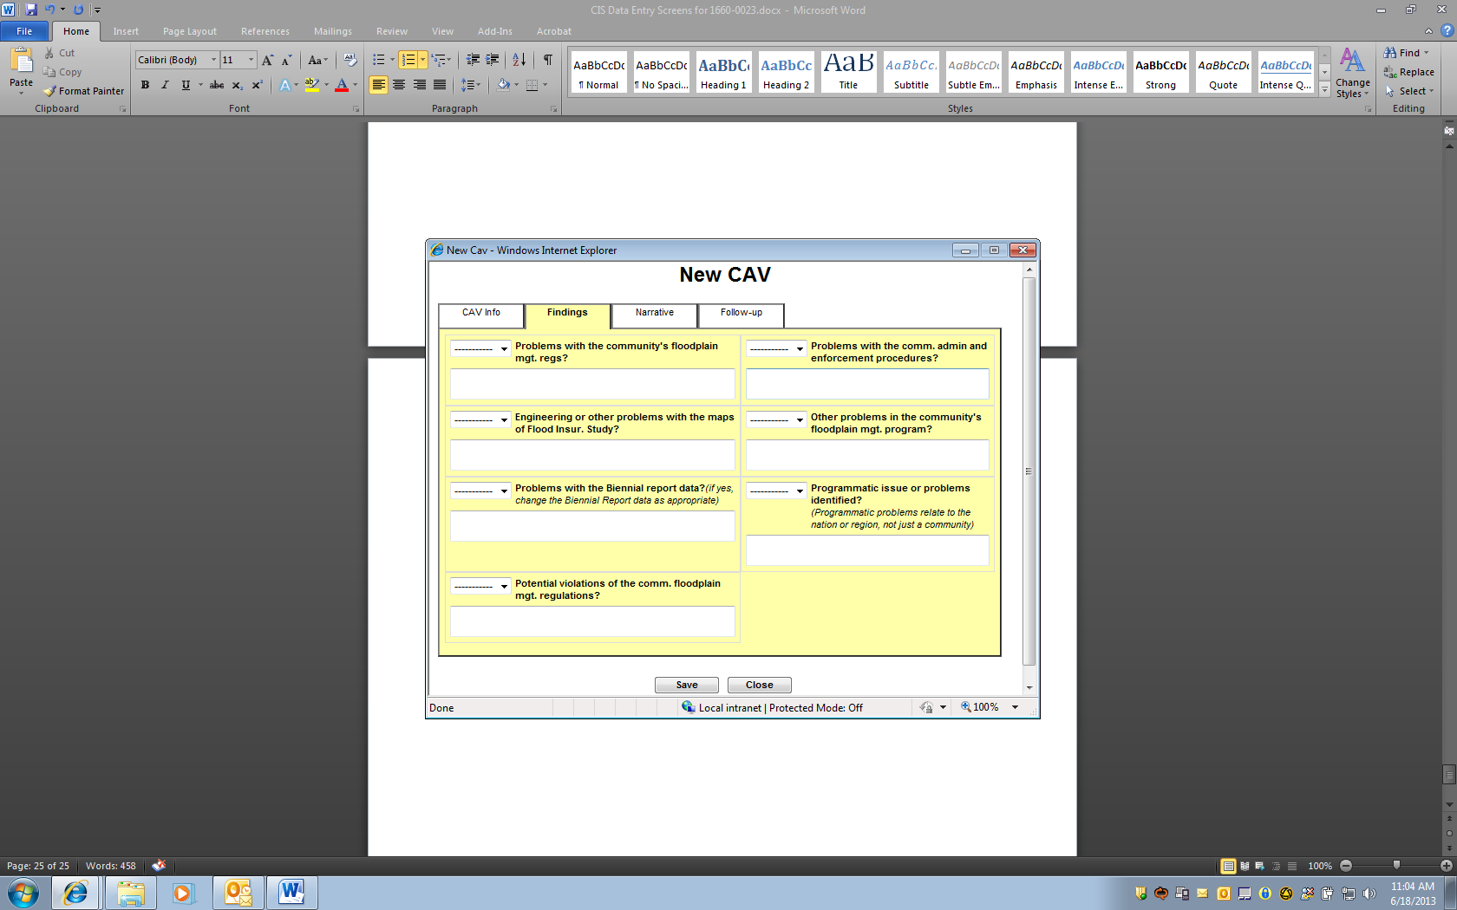

2.NEW CAV Screen TAB

- Narrative TAB

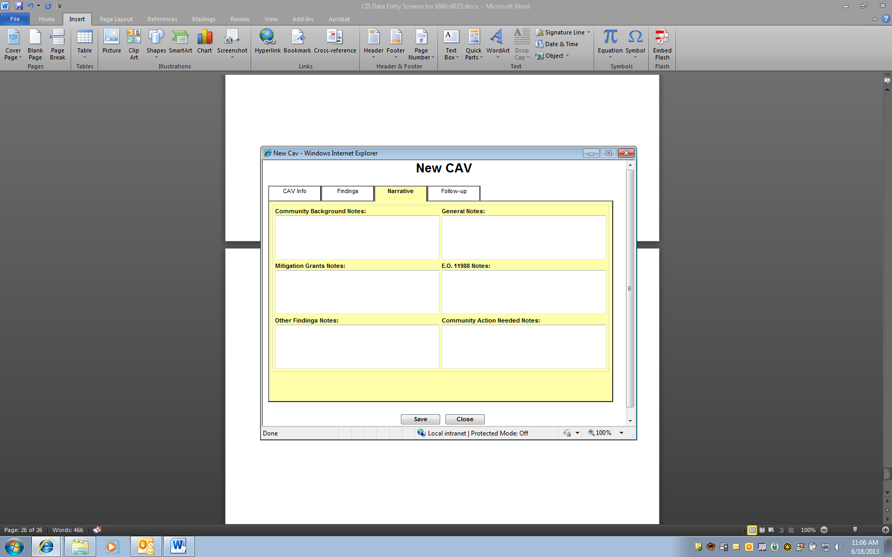

2.New CAV screen TAB

- Follow-up TAB

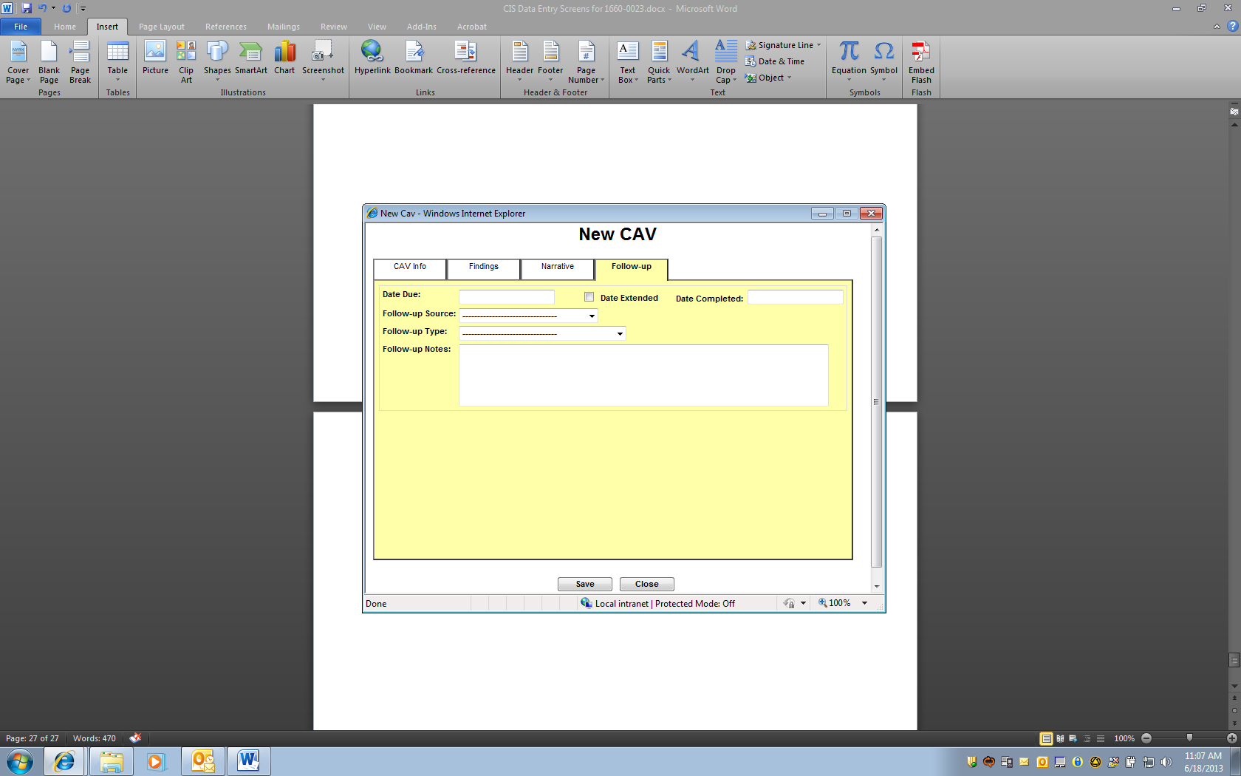

- CAV DELETE Screen TAB

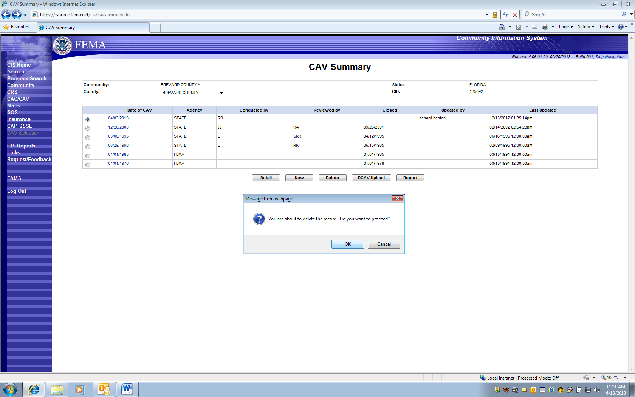

- DCAV Upload Screen TAB

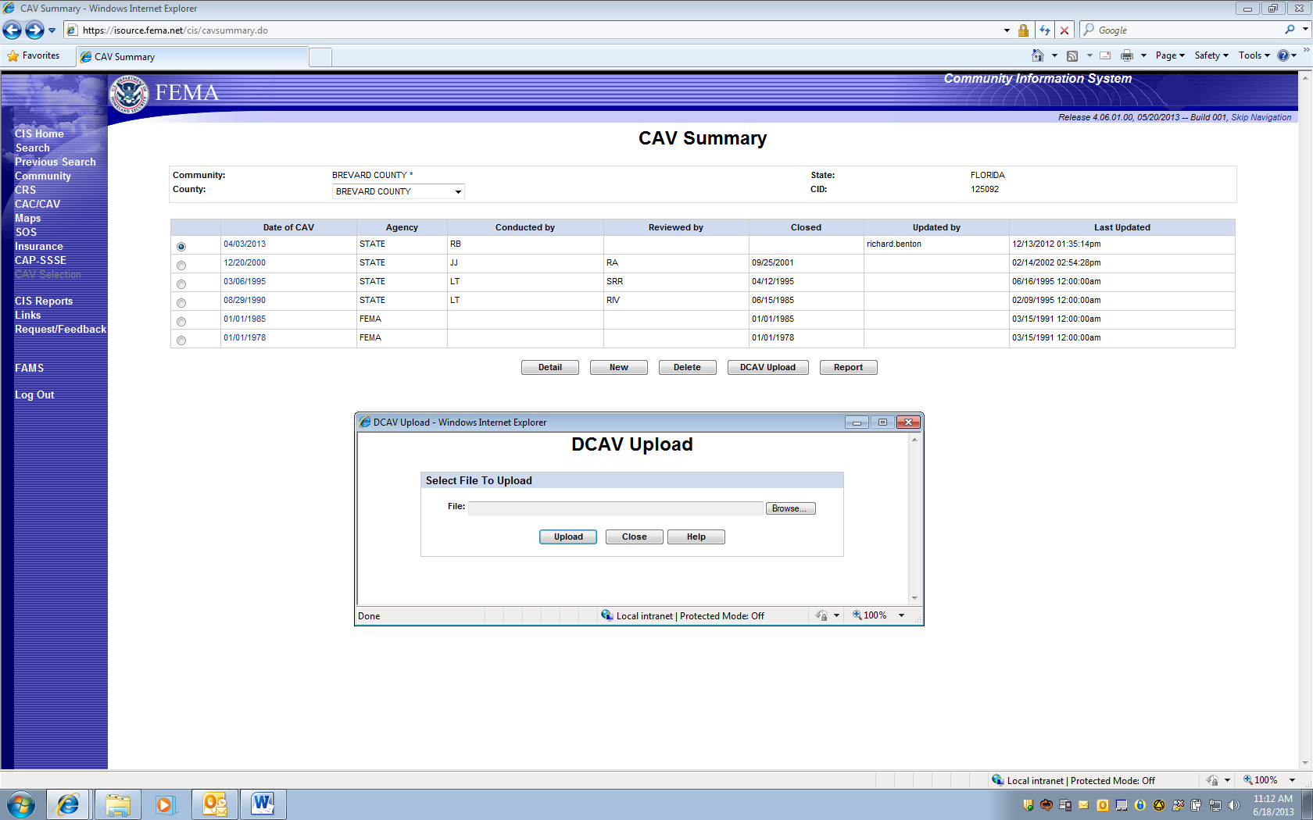

- CAV REPORT Screen TAB

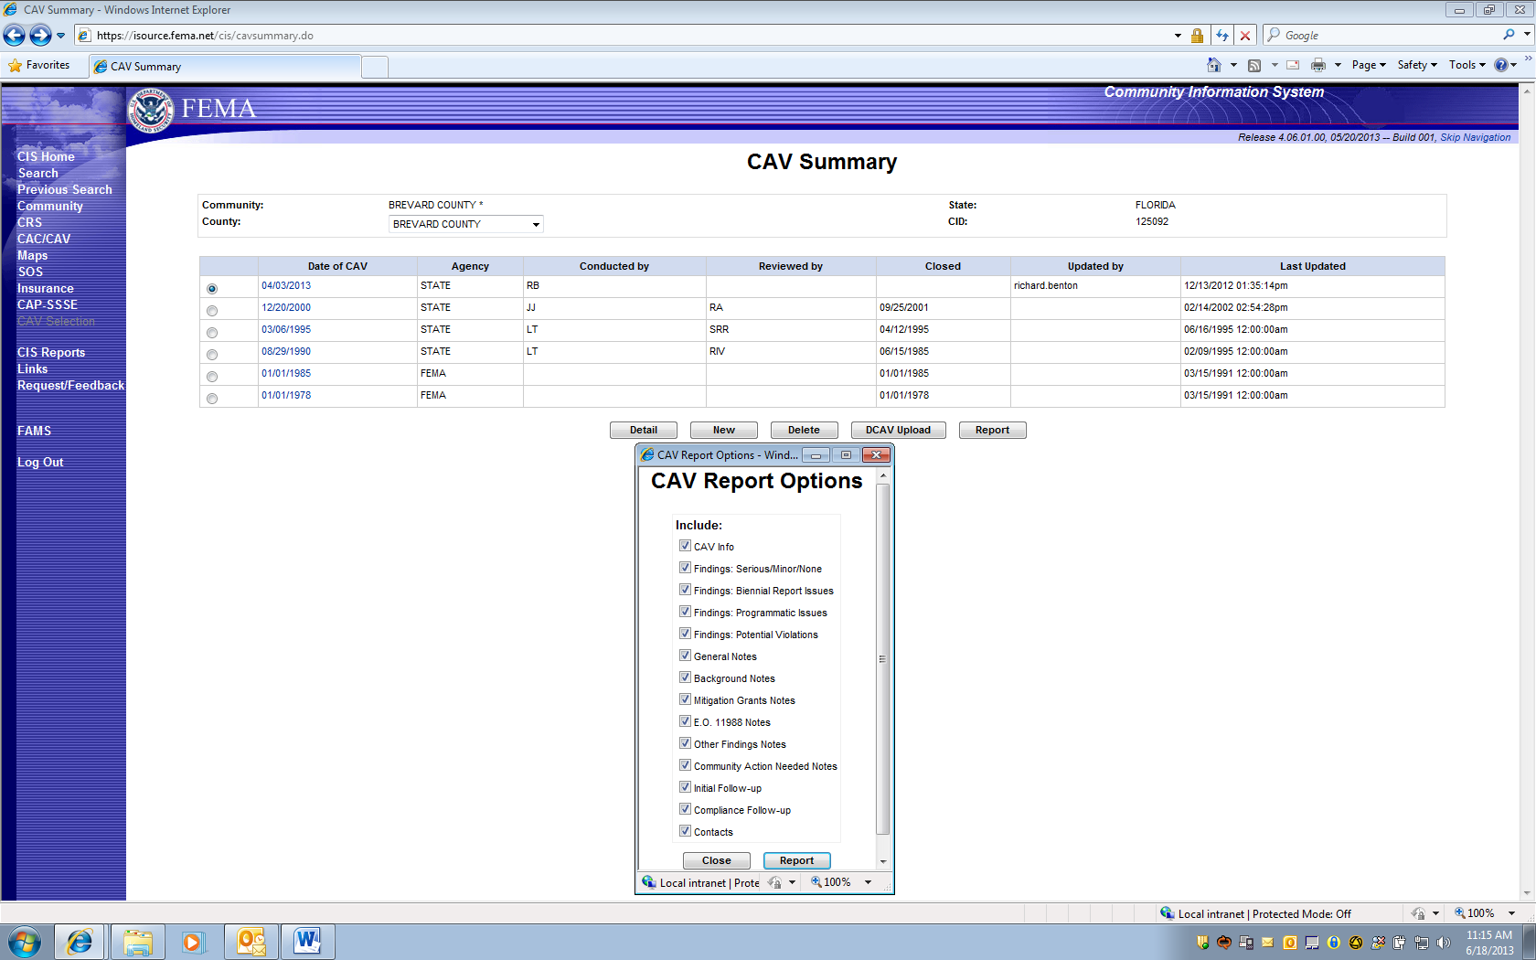
NOTE: The following Notice will appear on the “Printed” report, which displays all of the entered information.

PAPERWORK BURDEN DISCLOSURE NOTICE O.M.B. No. 1660-0023 Expires “TBD – Awaiting Extension Approval”
Public reporting burden for this data collection is estimated to average 2 hours per response. The burden estimate includes the time for reviewing instructions, searching existing data sources, gathering and maintaining the data needed, and completing and submitting this form. This collection of information is required to obtain or retain benefits. You are not required to respond to this collection of information unless it displays a valid OMB control number. Send comments regarding the accuracy of the burden estimate and any suggestions for reducing the burden to: Information Collections Management, Department of Homeland Security, Federal Emergency Management Agency, 500 C Street, SW, Washington, DC 20472, Paperwork Reduction Project (1660-0023)

FEMA Form 086-0-28(E), Community Visit Report

