**Community Assistance Visit (CAV) Community Visit Report Screens in the NFIP Community Information System (CIS)**

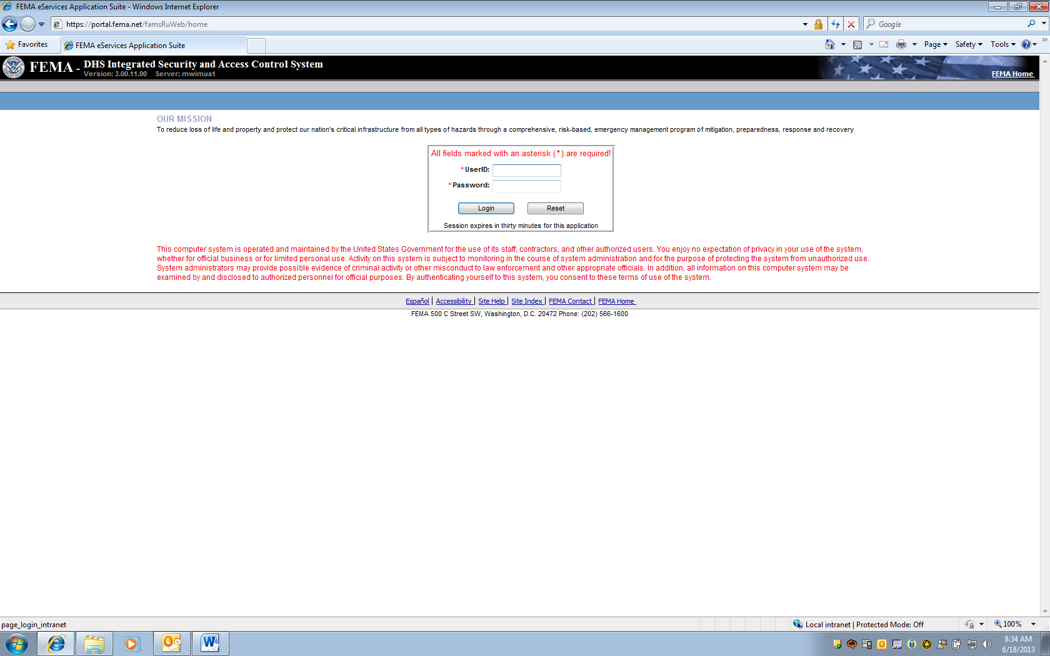

Account and Password must be requested from NFIP CIS Administrator where Read, Add, Edit Rights provided based on Need.

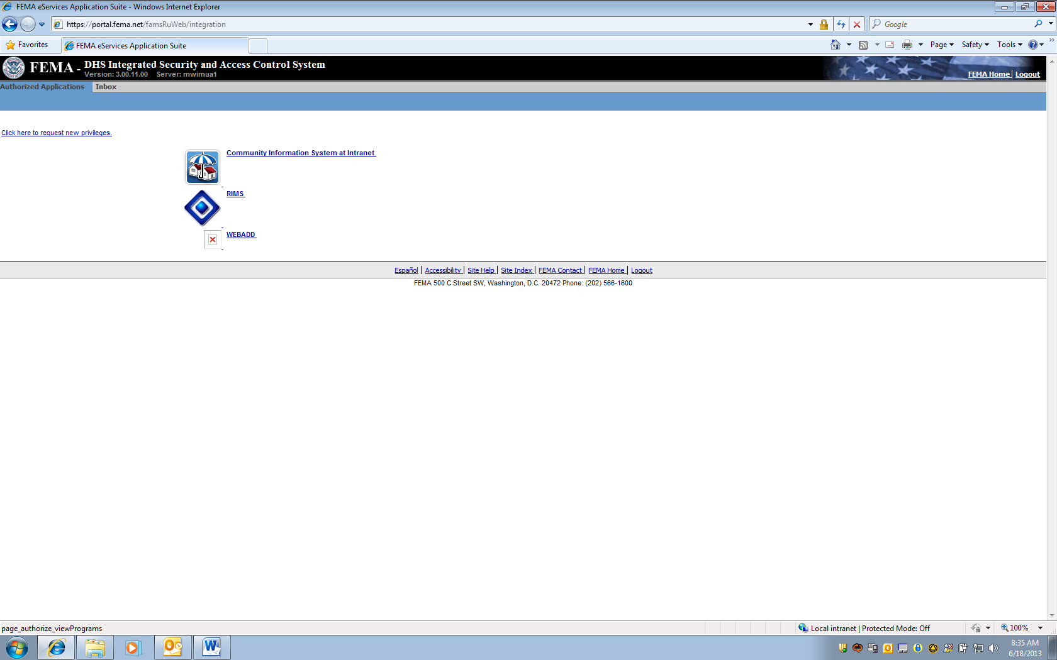

Select Community Information System

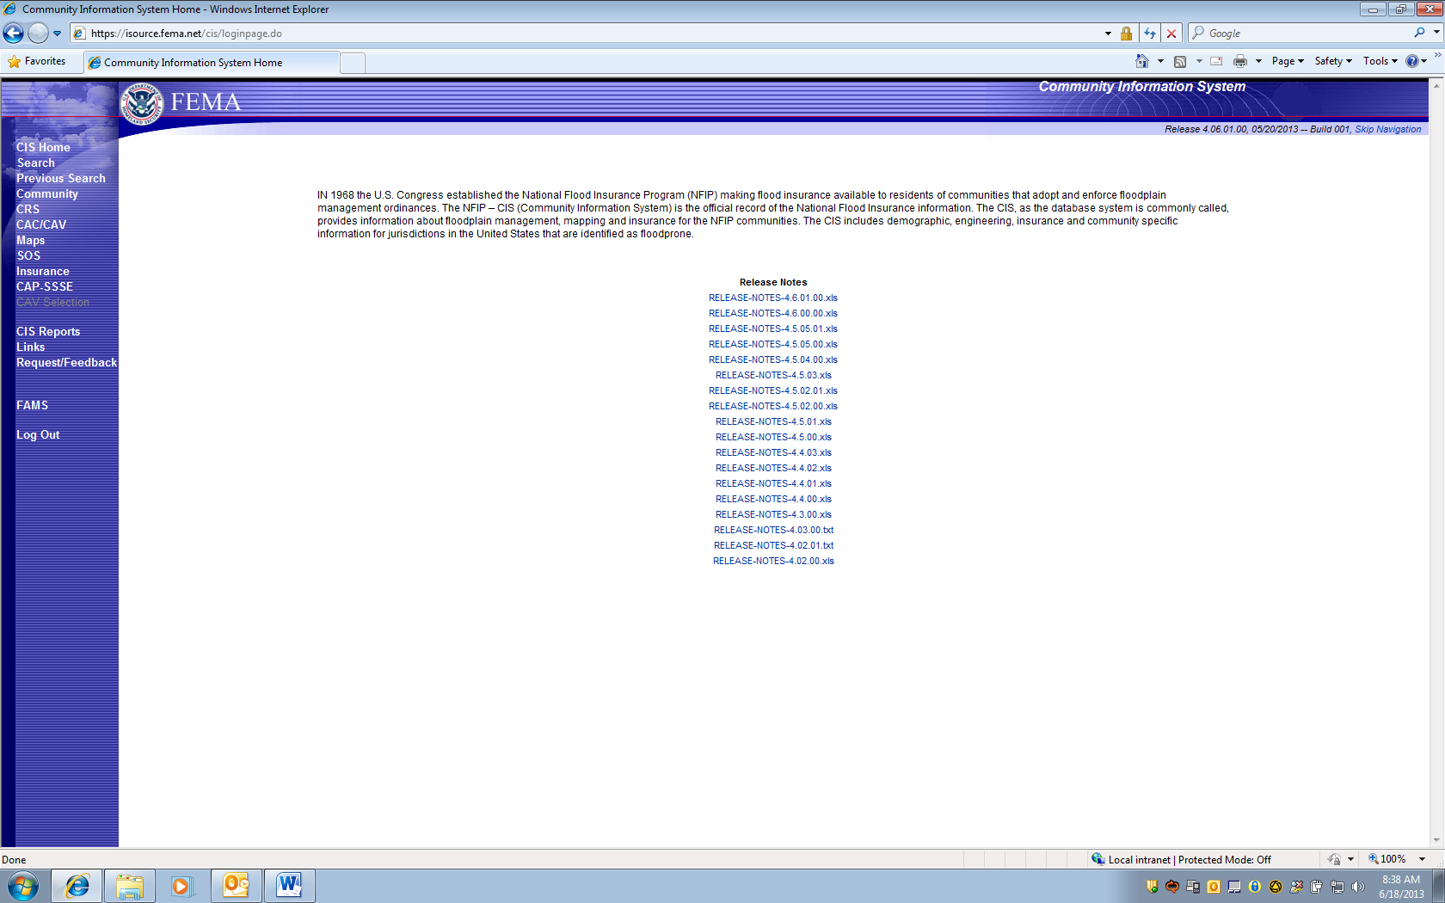

Select Search on Left to Navigate to Community and State

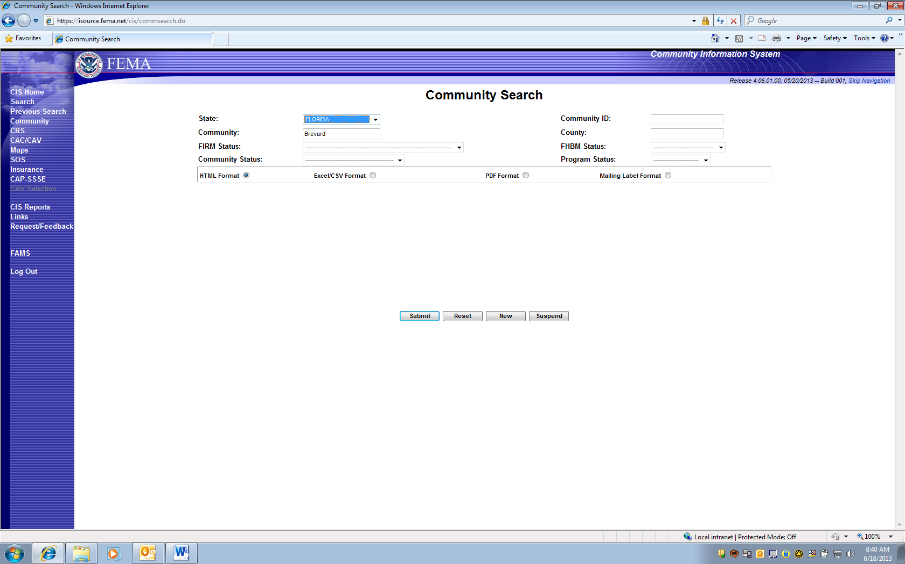

Type “Brevard”, then chose Florida from State Pick List, and Enter “Submit”

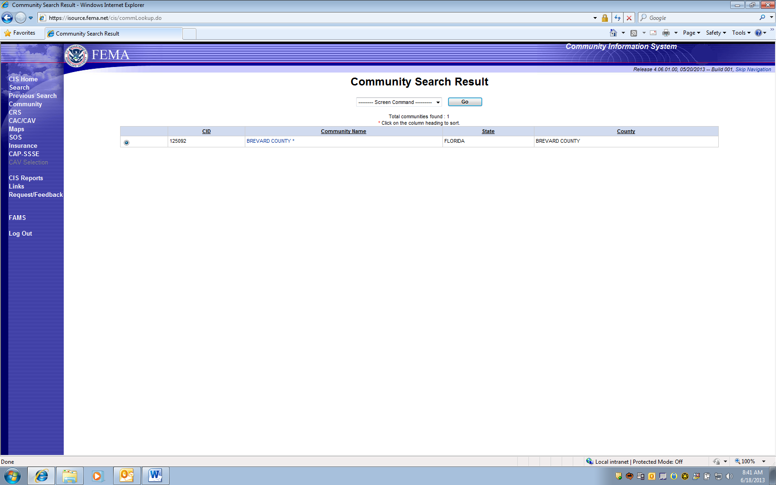

Only one NFIP Participating community called “Brevard” is returned. Double-click on community name.

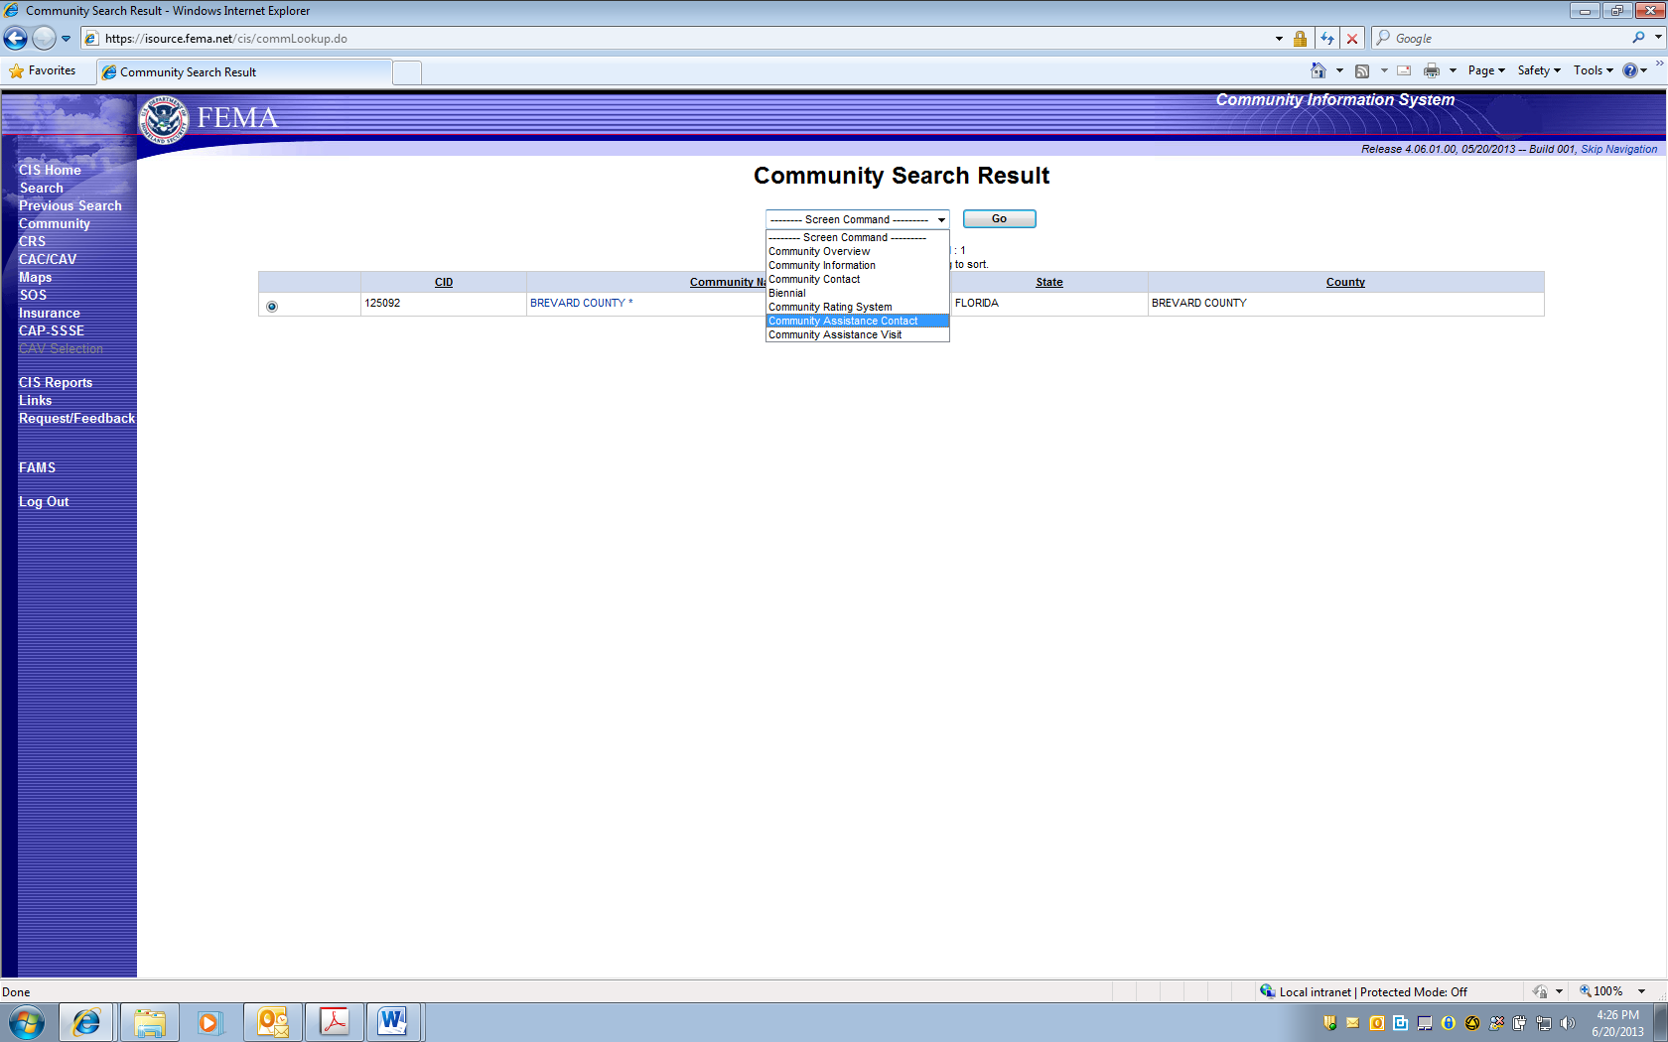

Selected Community Assistance Contact from Upper Box screen choices, and pressed “GO” button.

CAC is selected

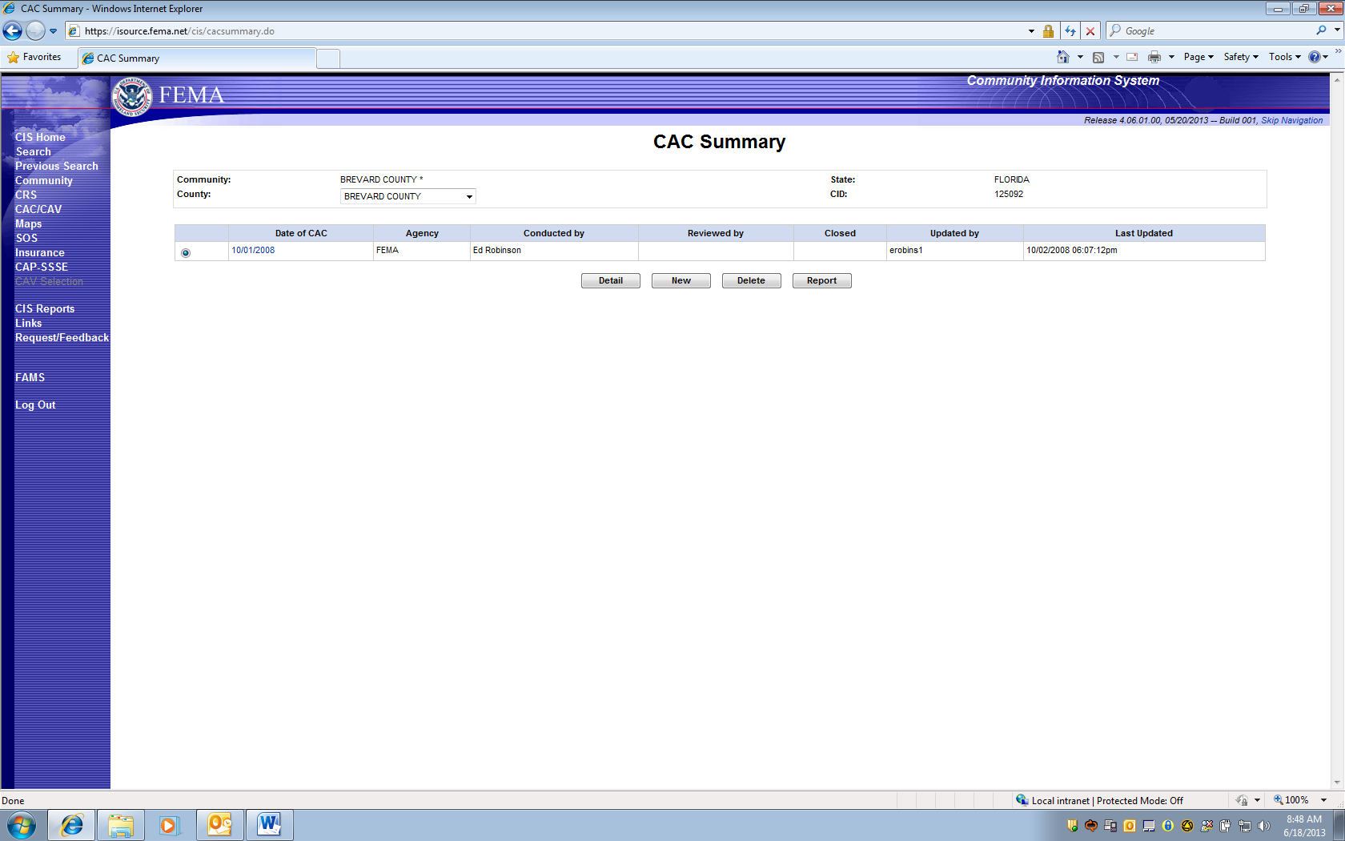

This screen reflects PRA collection Entry Information for 1660-0023, Community Assistance Contact.

Four Choices (Gray Boxes):

DETAIL: Loads Previous CAC Information

NEW: Adds new CAC collection information.

DELETE: Allows an option to delete a previous entry.

REPORT: This option Prints a report for all CAC entry fields.

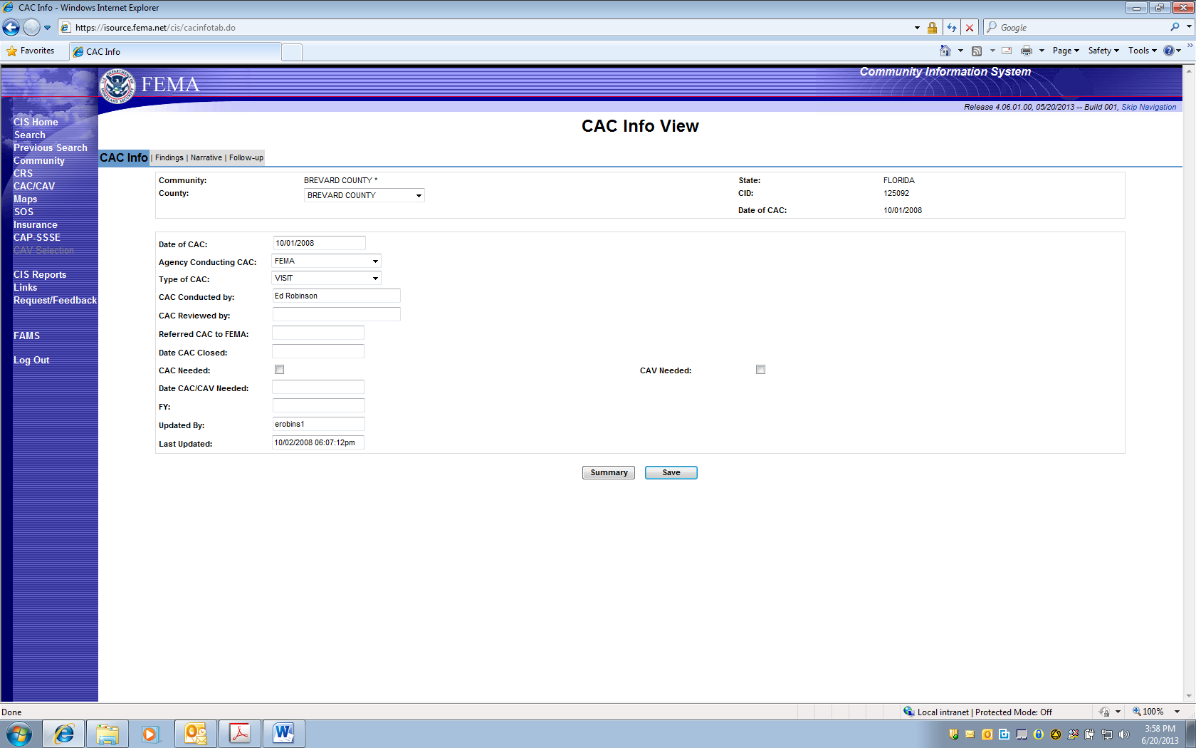

***PAPERWORK BURDEN DISCLOSURE NOTICE O.M.B. No. 1660-0023, Expires 1/31/2014***

Public reporting burden for this data collection is estimated to average 1 hour per response. The burden estimate includes the time for reviewing instructions, searching existing data sources, gathering and maintaining the data needed, and completing and submitting this form. This collection of information is required to obtain or retain benefits. You are not required to respond to this collection of information unless it displays a valid OMB control number. Send comments regarding the accuracy of the burden estimate and any suggestions for reducing the burden to: Information Collections Management, Department of Homeland Security, Federal Emergency Management Agency, 500 C Street, SW, Washington, DC 20472, Paperwork Reduction Project (1660-0023)

FEMA Form 086-0-29(E), Community Contact Report

**DETAIL:** Loads Previous entered CAC Information Collection

NOTE: The following Notice will appear on this screen since it is the first place a region or state may “edit” a previously entered collection.

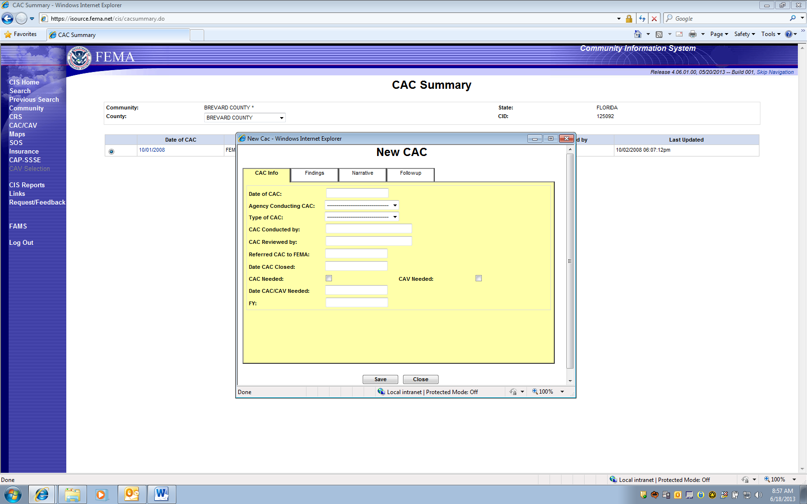

***PAPERWORK BURDEN DISCLOSURE NOTICE O.M.B. No. 1660-0023 Expires “TBD – Awaiting Extension Approval”***

Public reporting burden for this data collection is estimated to average 1 hour per response. The burden estimate includes the time for reviewing instructions, searching existing data sources, gathering and maintaining the data needed, and completing and submitting this form. This collection of information is required to obtain or retain benefits. You are not required to respond to this collection of information unless it displays a valid OMB control number. Send comments regarding the accuracy of the burden estimate and any suggestions for reducing the burden to: Information Collections Management, Department of Homeland Security, Federal Emergency Management Agency, 500 C Street, SW, Washington, DC 20472, Paperwork Reduction Project (1660-0023)

NOTE: Full PRA Notice will appear on this screen since it is the first place a region or state may “Enter” collection information.

NEW is selected to enter a new Community Assistance Contact (CAC).

Information can be added under each of four categories: CAC Info; Findings; Narrative; and Follow-up.

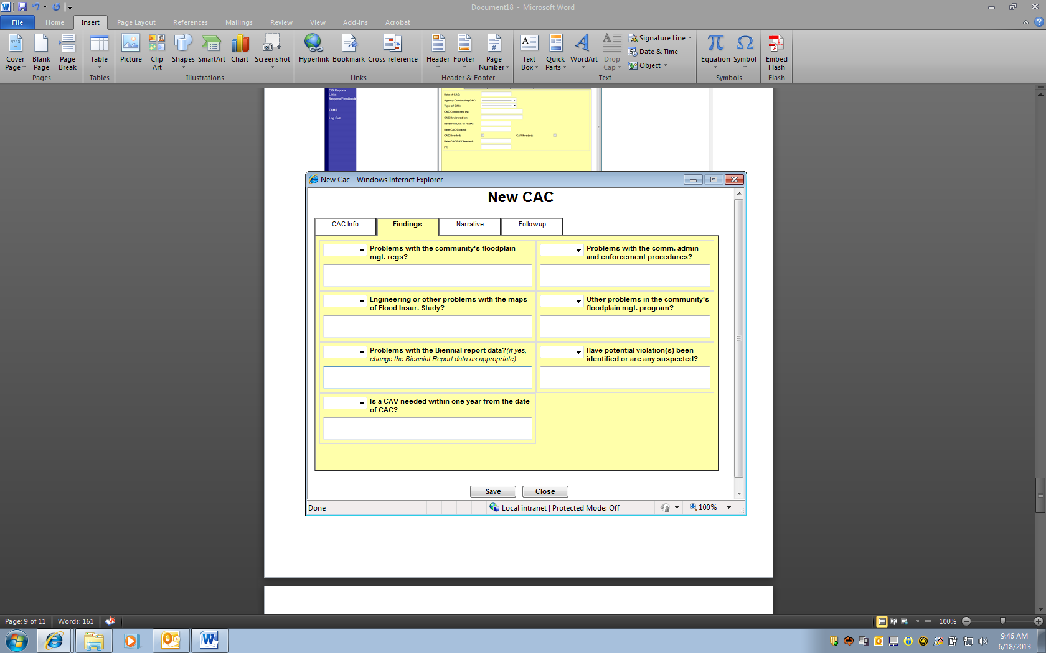

Entry Screen for CAC FINDINGS

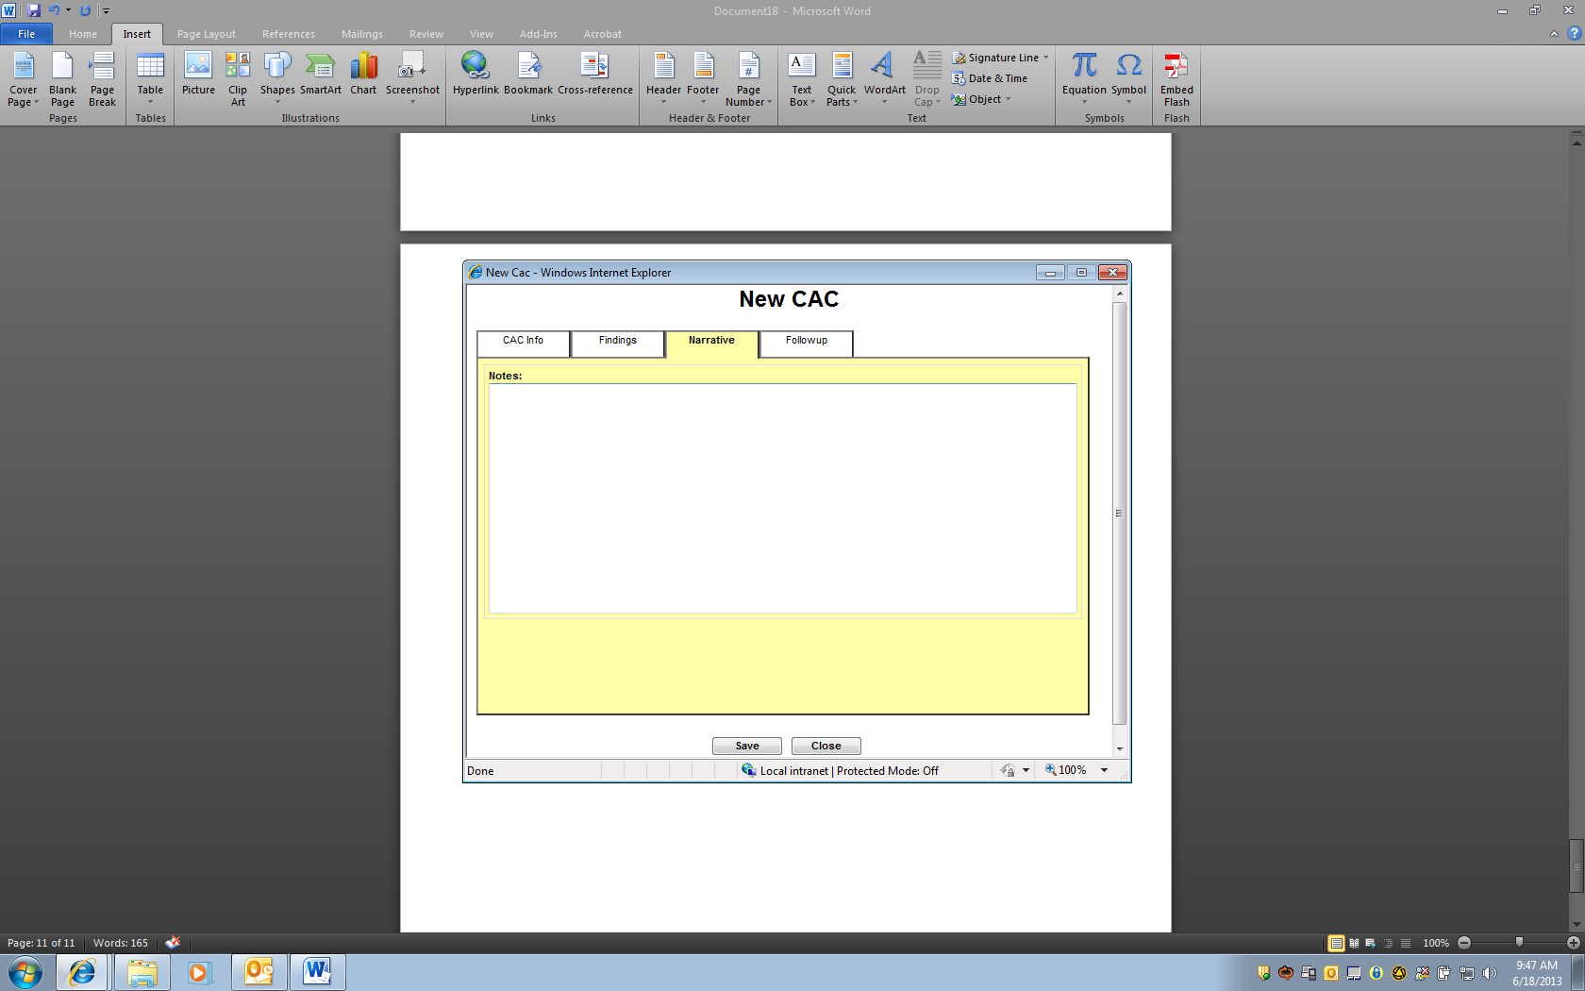

Entry Screen for CAC NARRATIVE

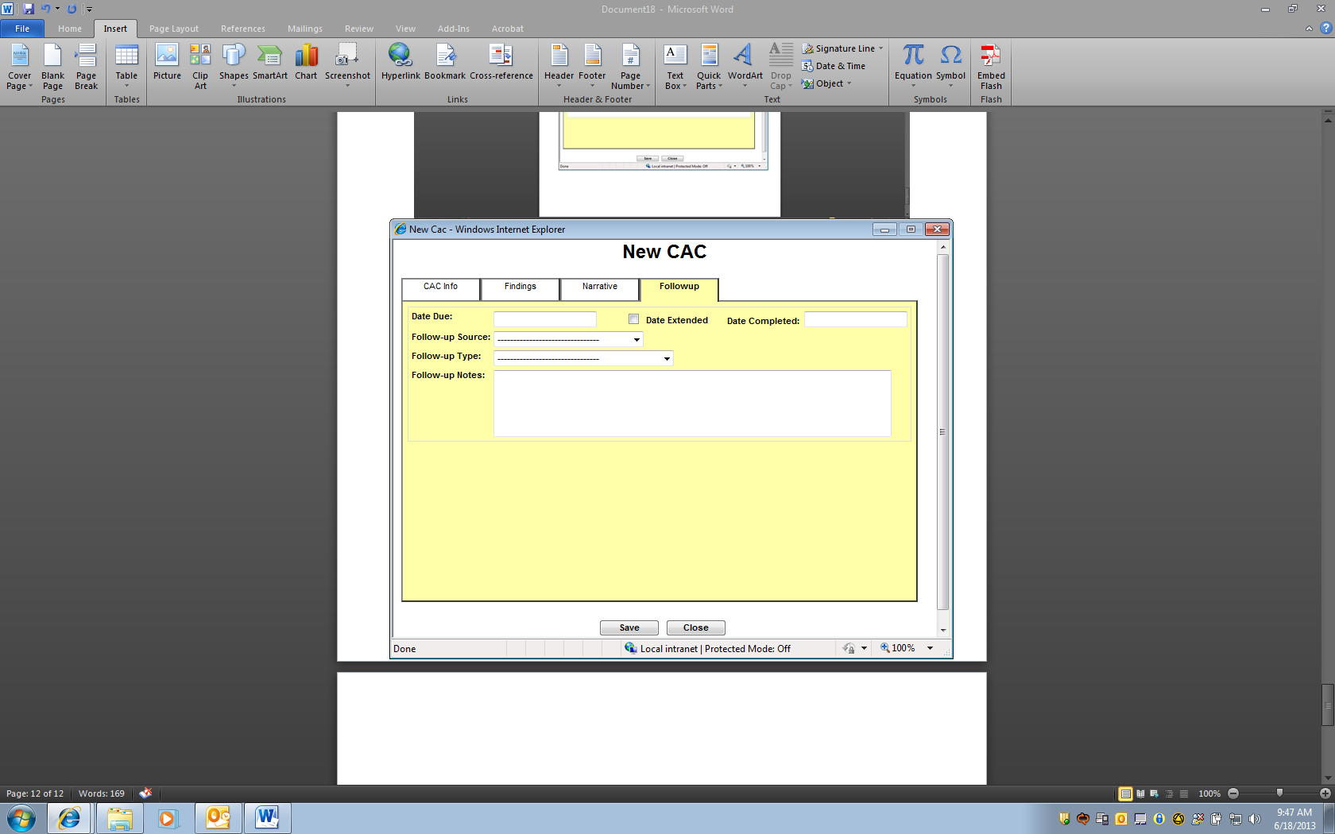

Entry Screen for CAC FOLLOW-UP.

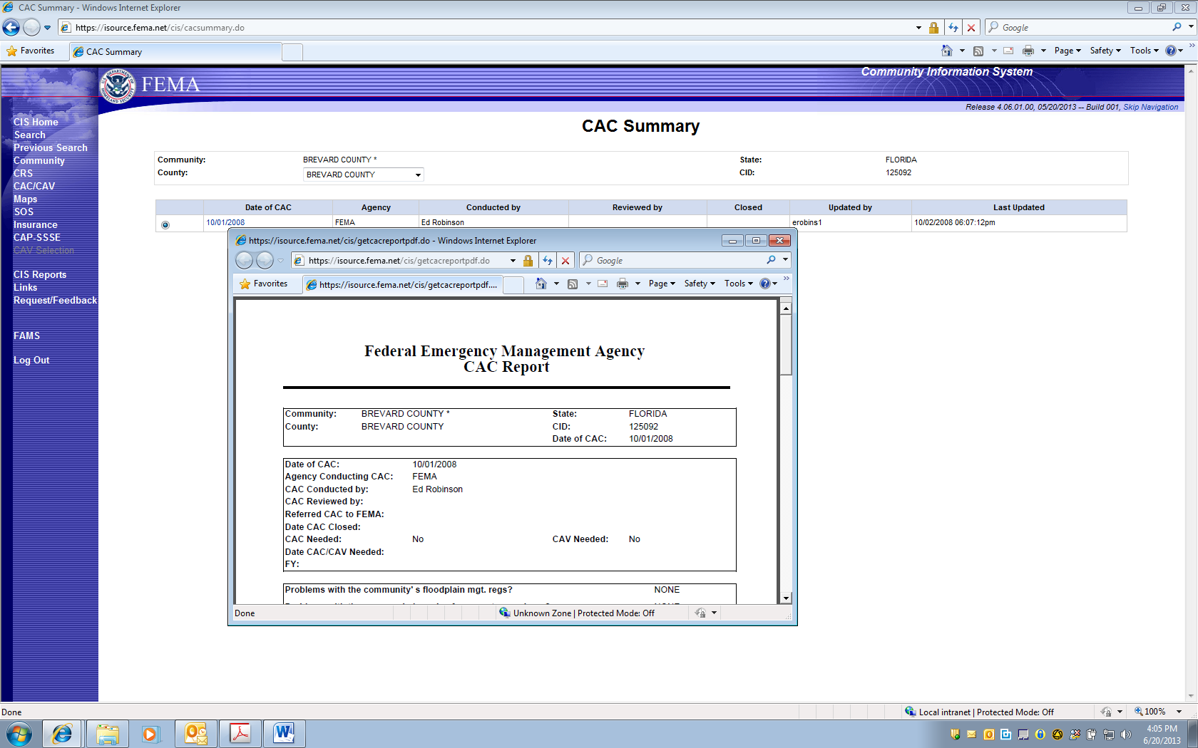

CAC Summary Screen offers Option to print full collection Information.

NOTE: The Full PRA Notice will appear on printed report pages.

***PAPERWORK BURDEN DISCLOSURE NOTICE***

Public reporting burden for this data collection is estimated to average 1 hour per response. The burden estimate includes the time for reviewing instructions, searching existing data sources, gathering and maintaining the data needed, and completing and submitting this form. This collection of information is required to obtain or retain benefits. You are not required to respond to this collection of information unless it displays a valid OMB control number. Send comments regarding the accuracy of the burden estimate and any suggestions for reducing the burden to: Information Collections Management, Department of Homeland Security, Federal Emergency Management Agency, 500 C Street, SW, Washington, DC 20472, Paperwork Reduction Project (1660-0023)

FEMA Form 086-0-29(E), Community Contact Report

***O.M.B. No. 1660-0023 Expires 1/31/2014***