SPR landing page
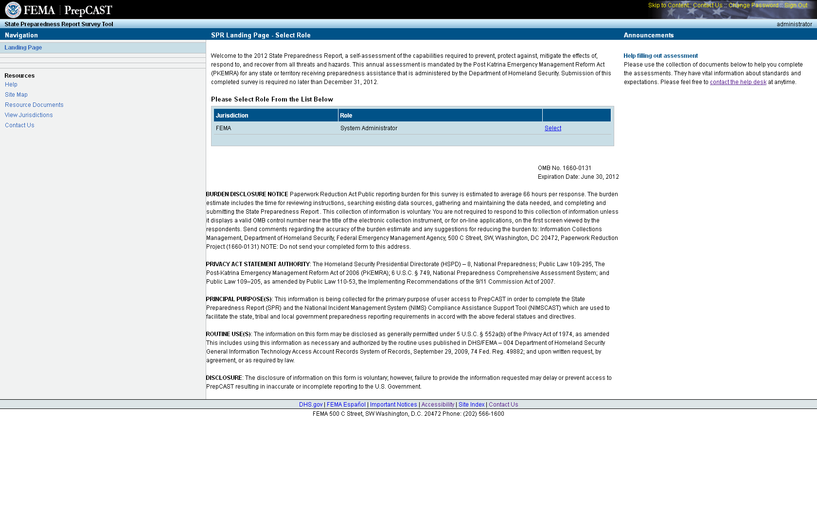
PrepCAST Landing page
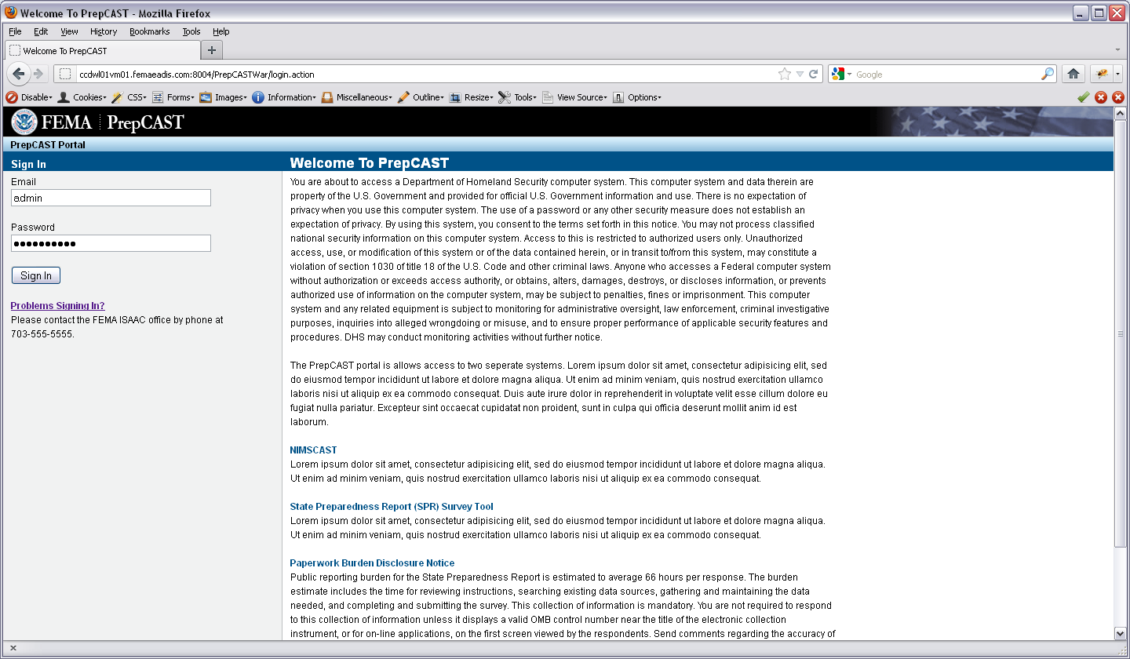

Landing page, continued
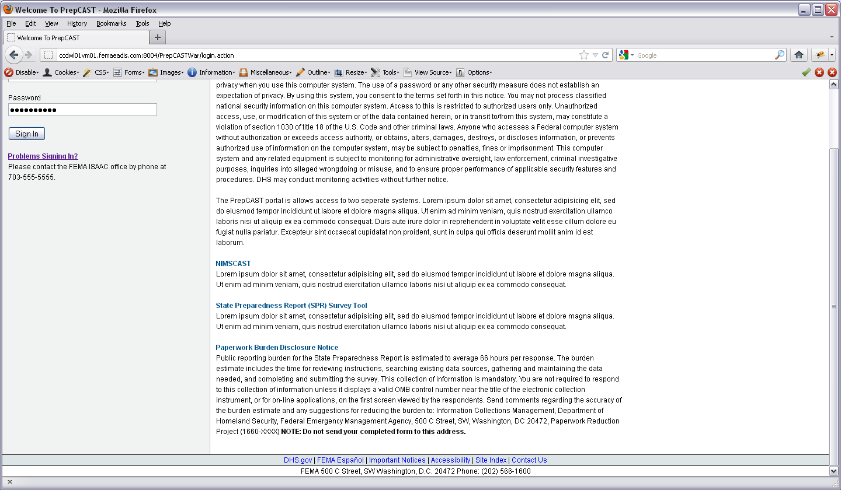

Select Hazard page
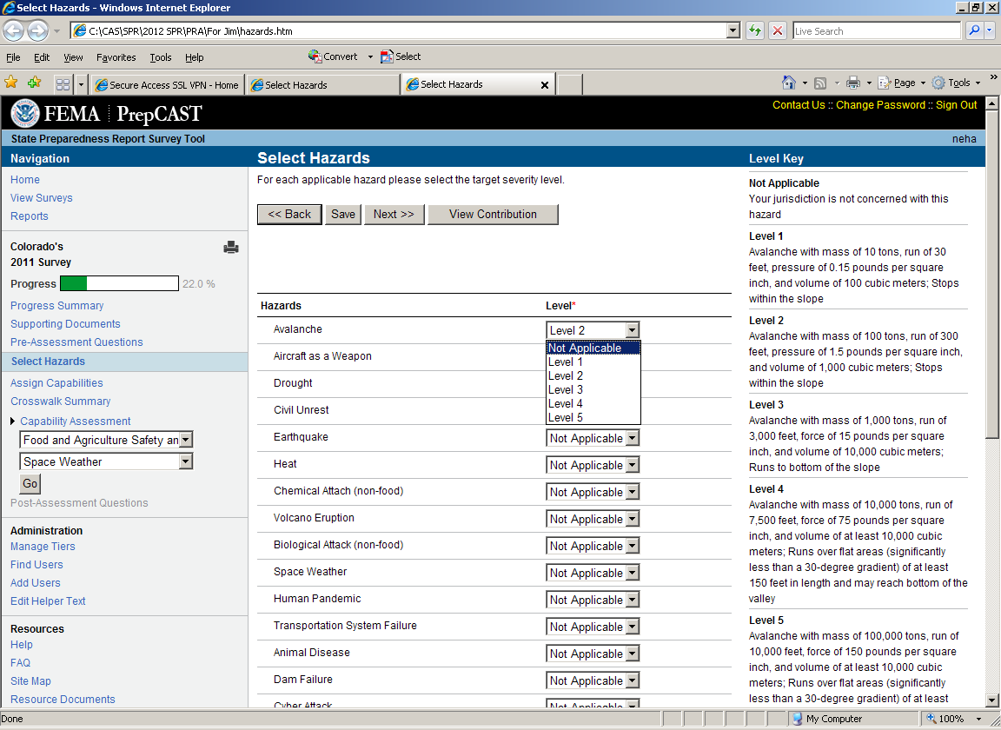

Select Hazard page, continued
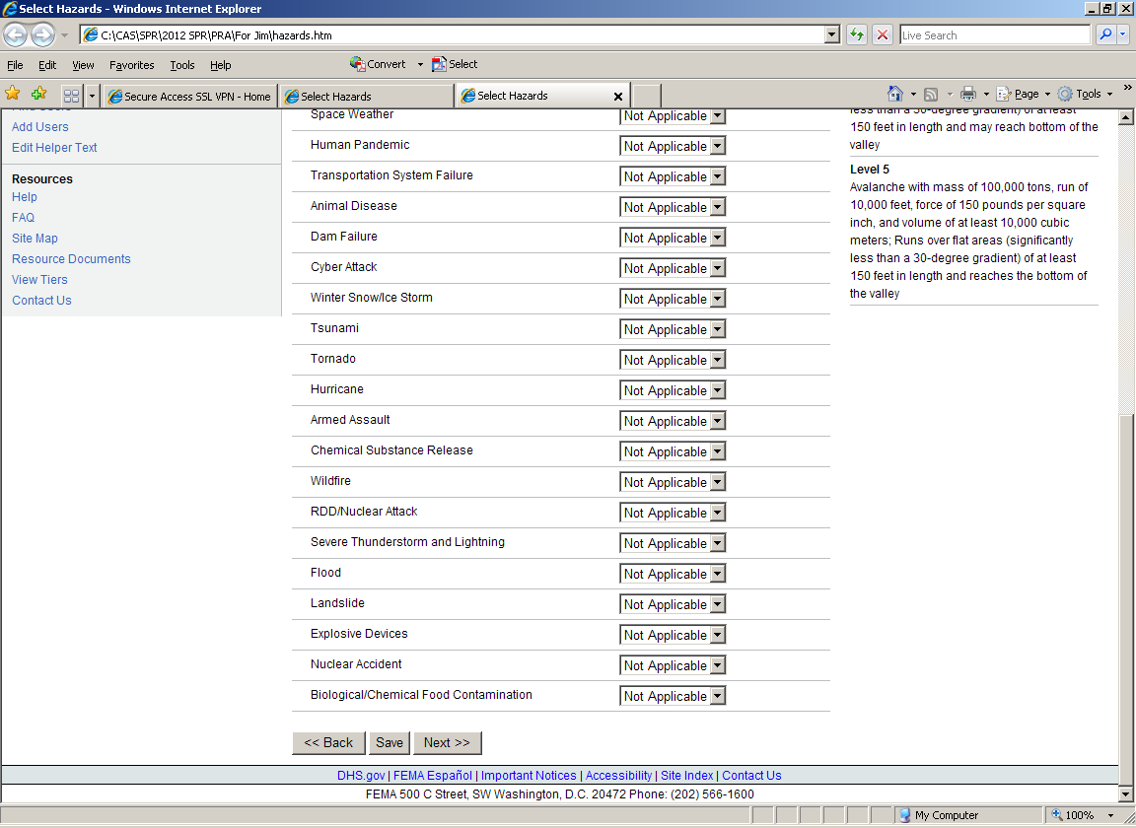

Crosswalk page
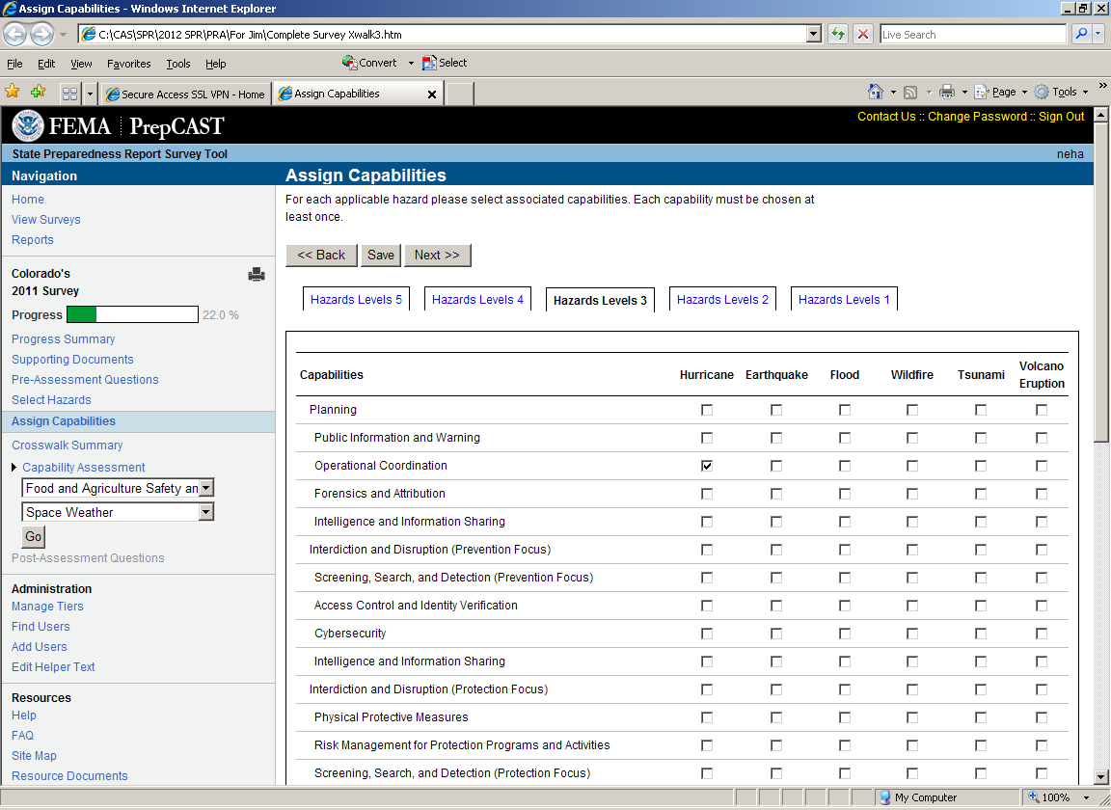

Crosswalk page, continued
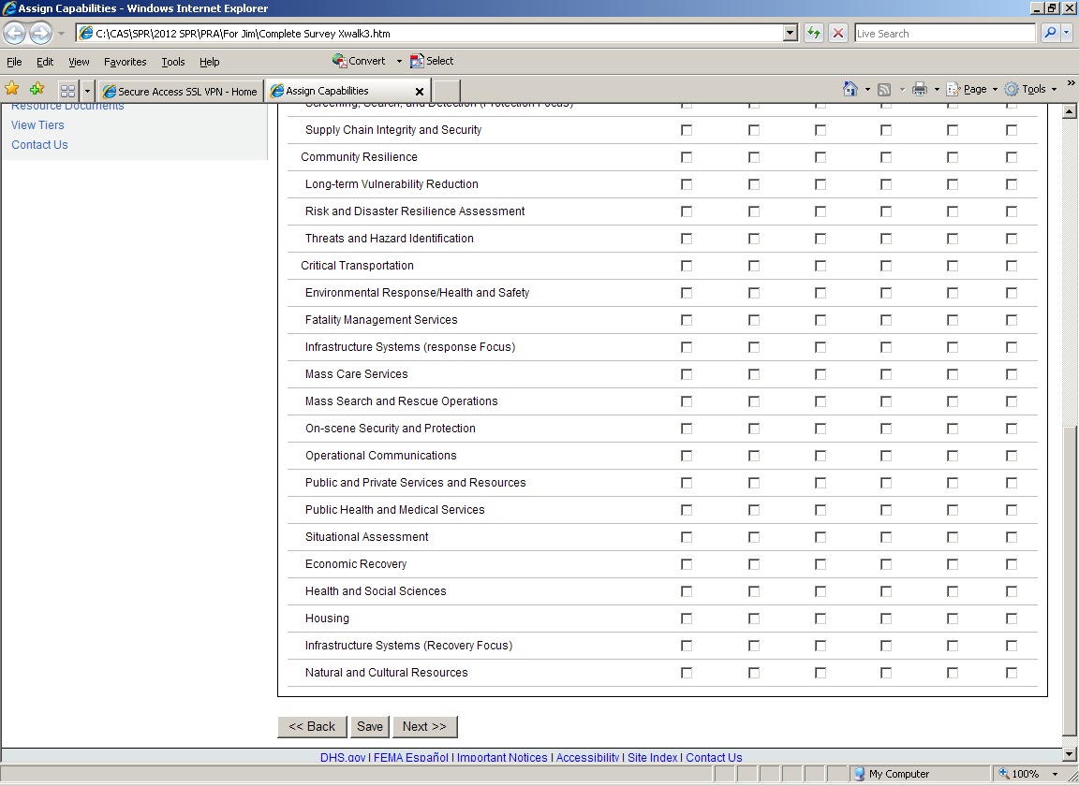

Crosswalk page, continued
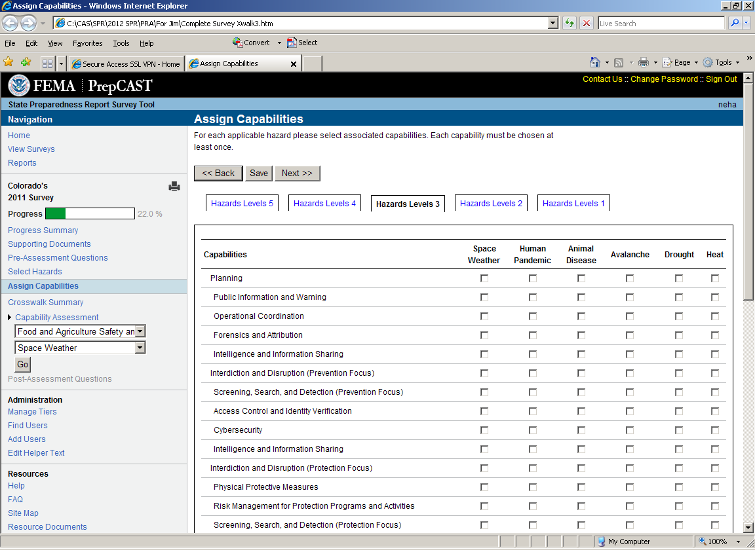

Crosswalk page, continued
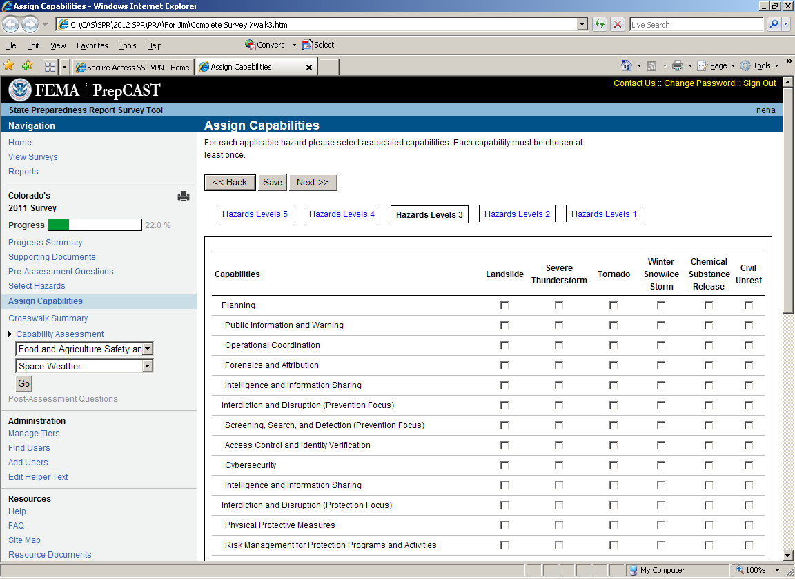

Crosswalk page, continued
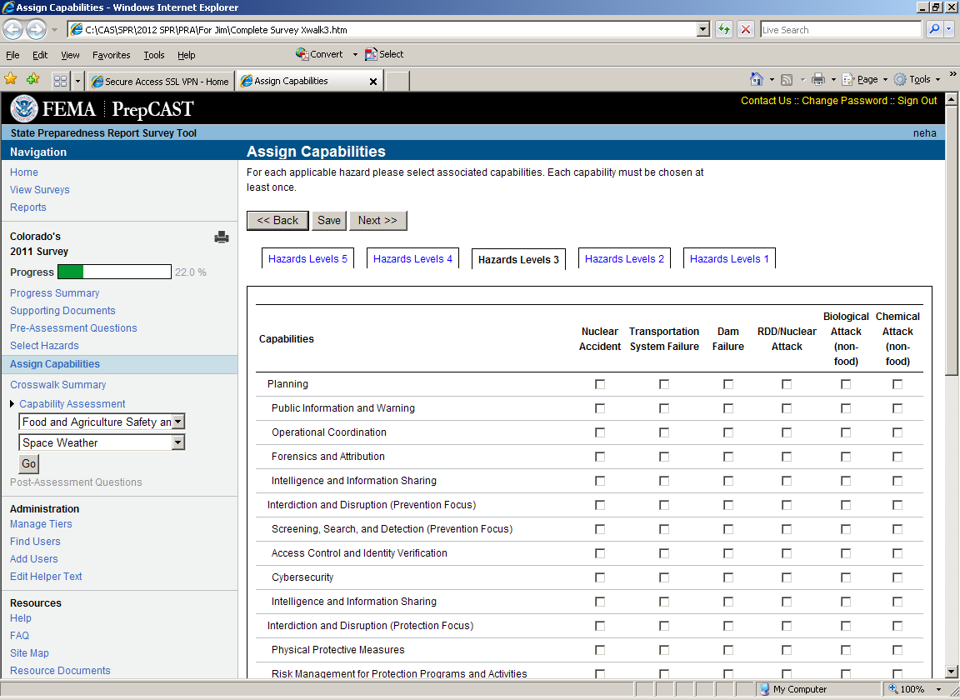

Crosswalk page, continued
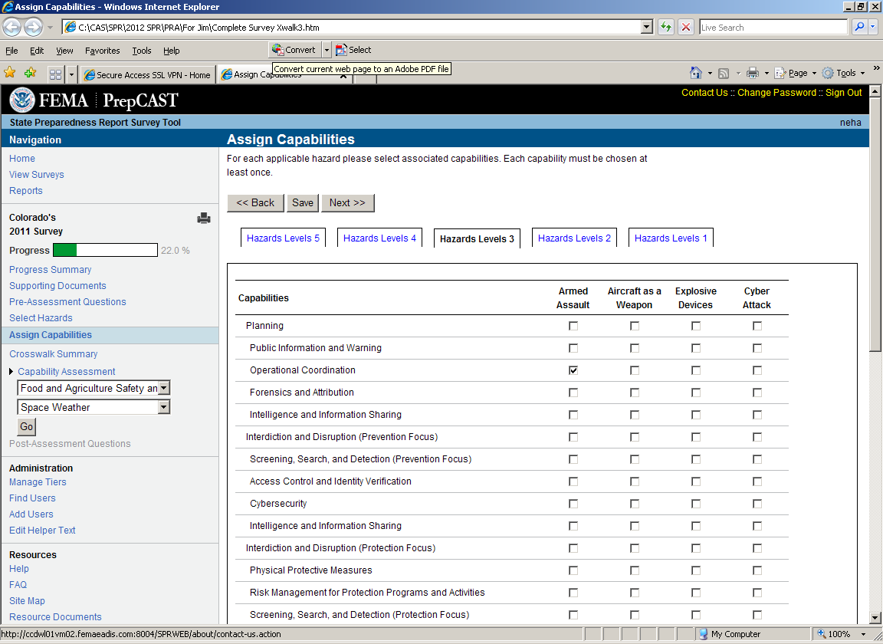

Capability Assessment page--Planning
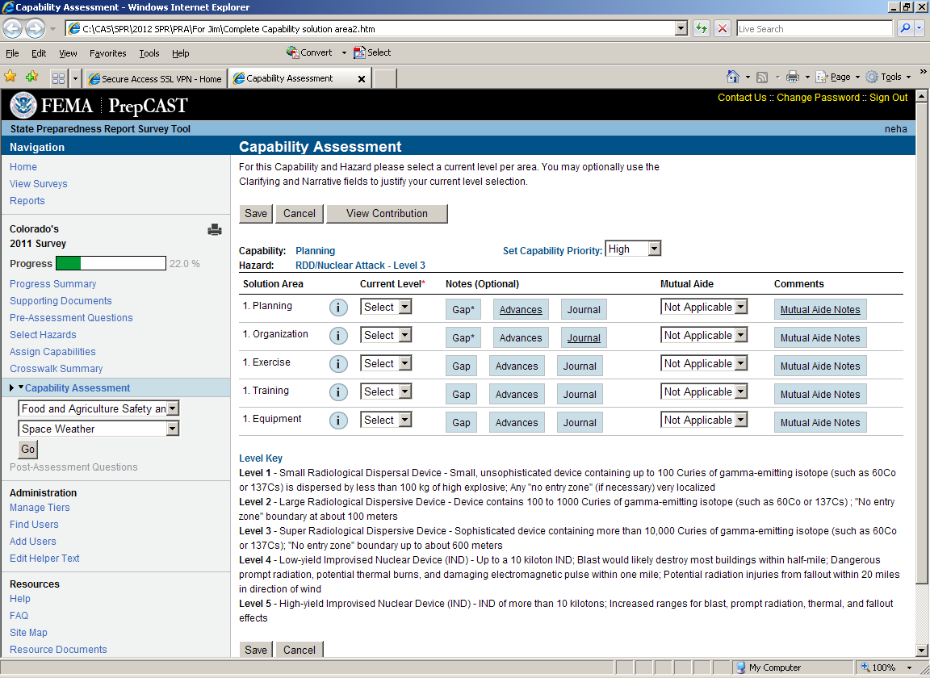

Capability Assessment page—Public Information and Warning
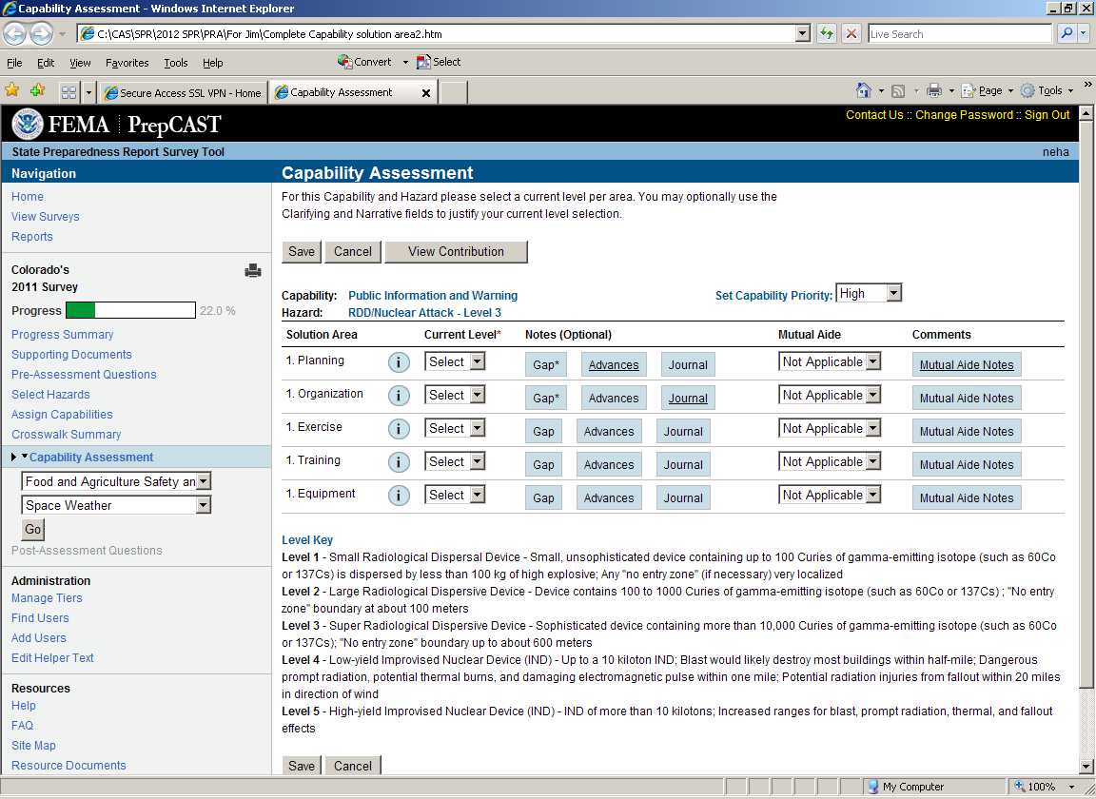

Capability Assessment page—Operational Coordination
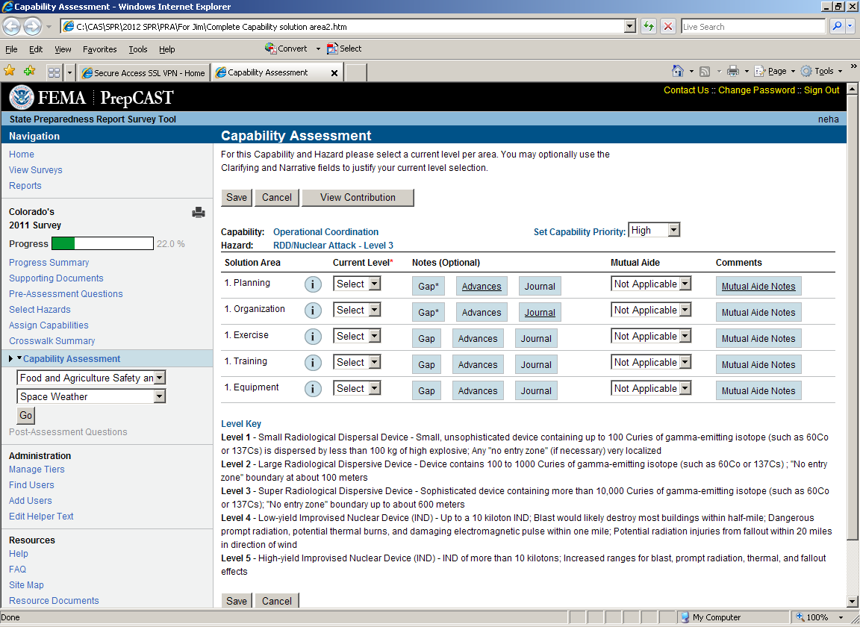

Capability Assessment page—Forensics and Attribution
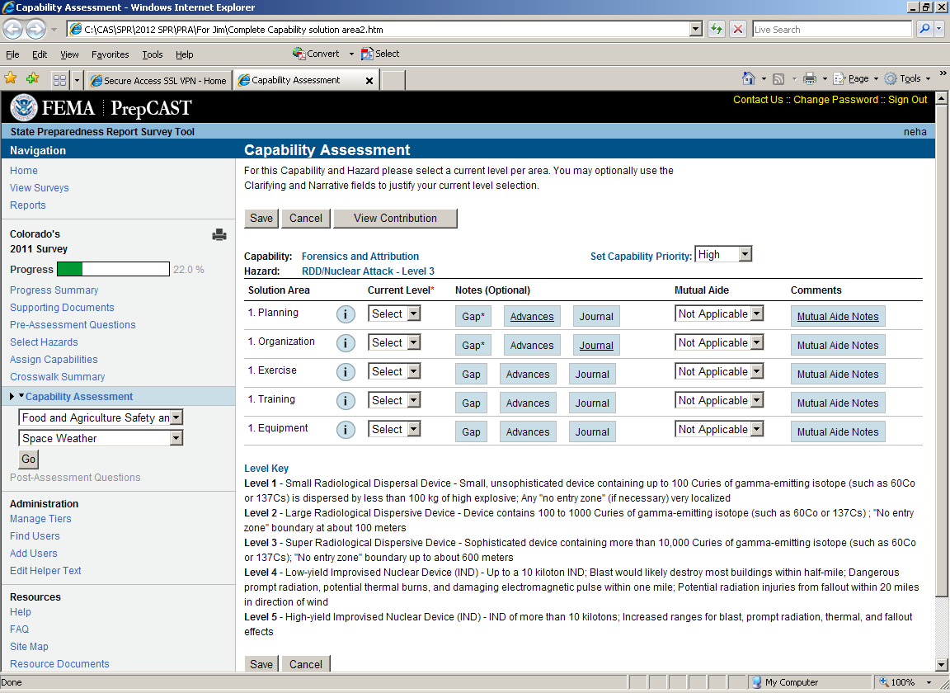

Capability Assessment page—Intelligence and Information Sharing (Prevention Focus)
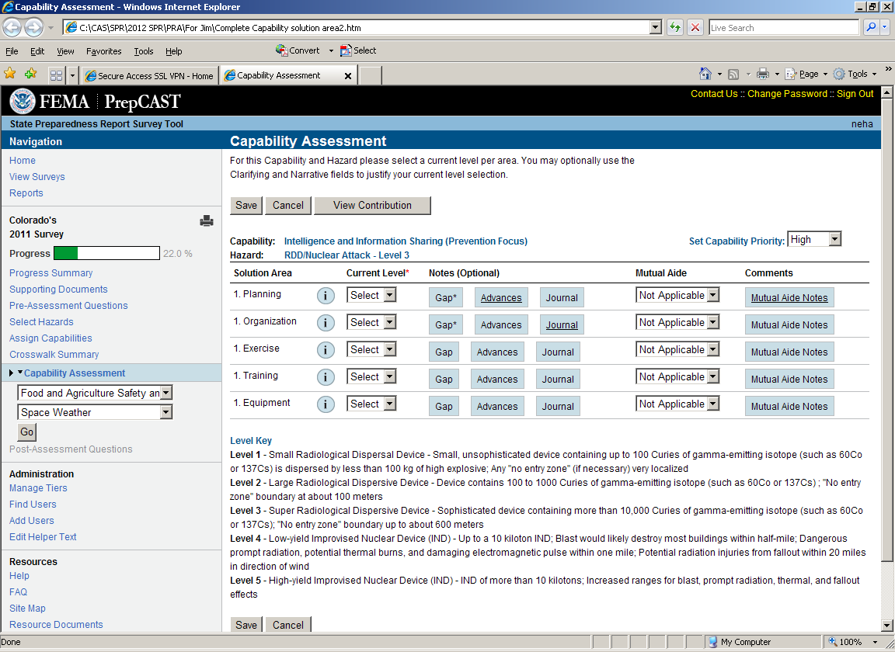

Capability Assessment page--Interdiction and Disruption (Prevention Focus)
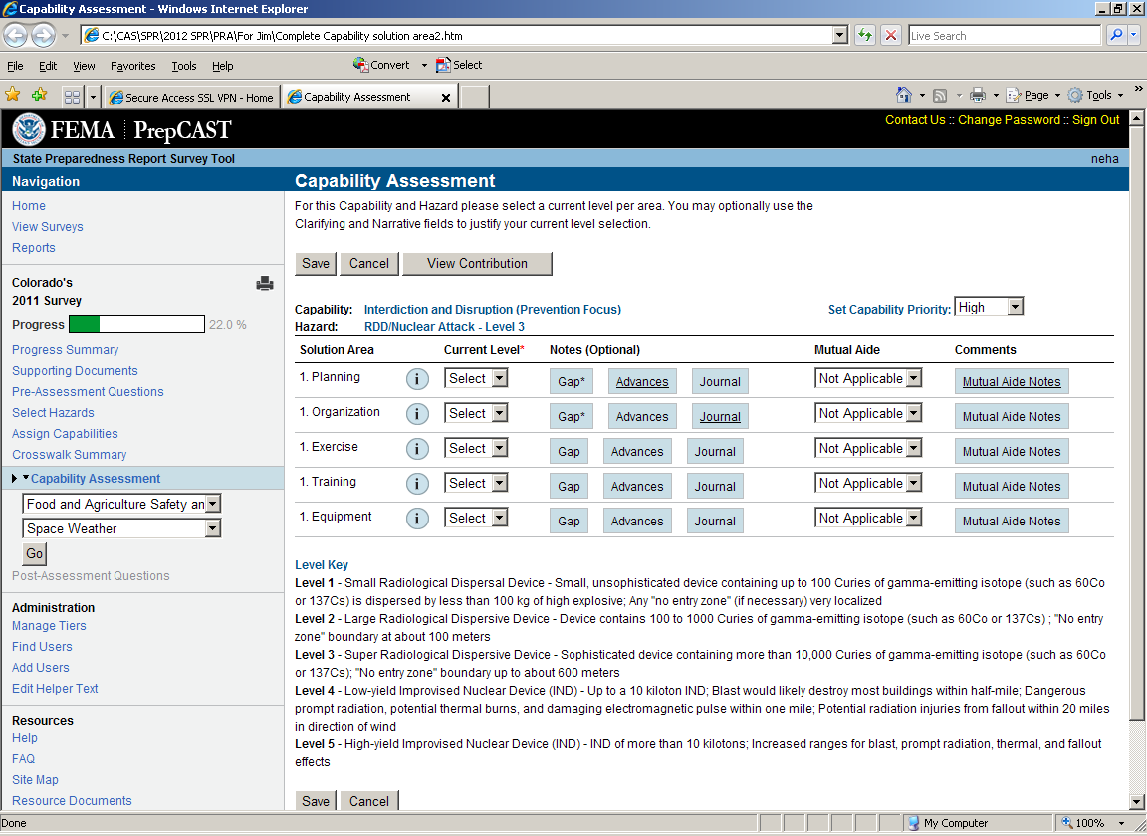

Capability Assessment page-- Screening, Search, and Detection (Prevention Focus)
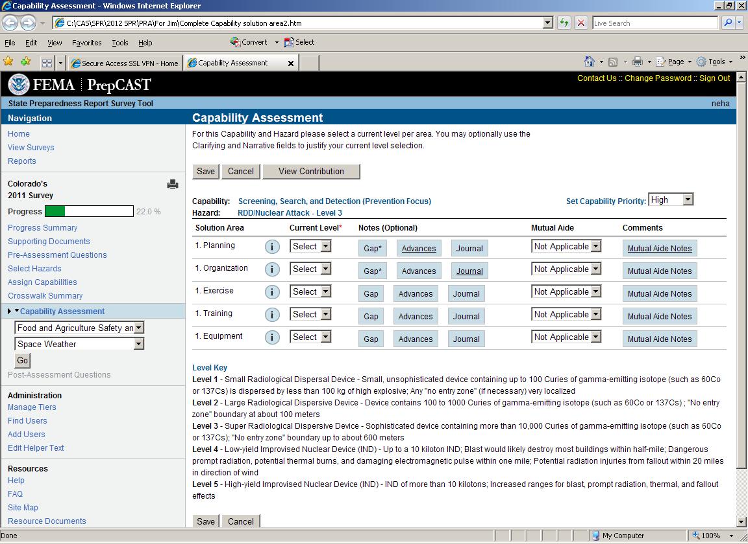

Capability Assessment page-- Access Control and Identity Verification
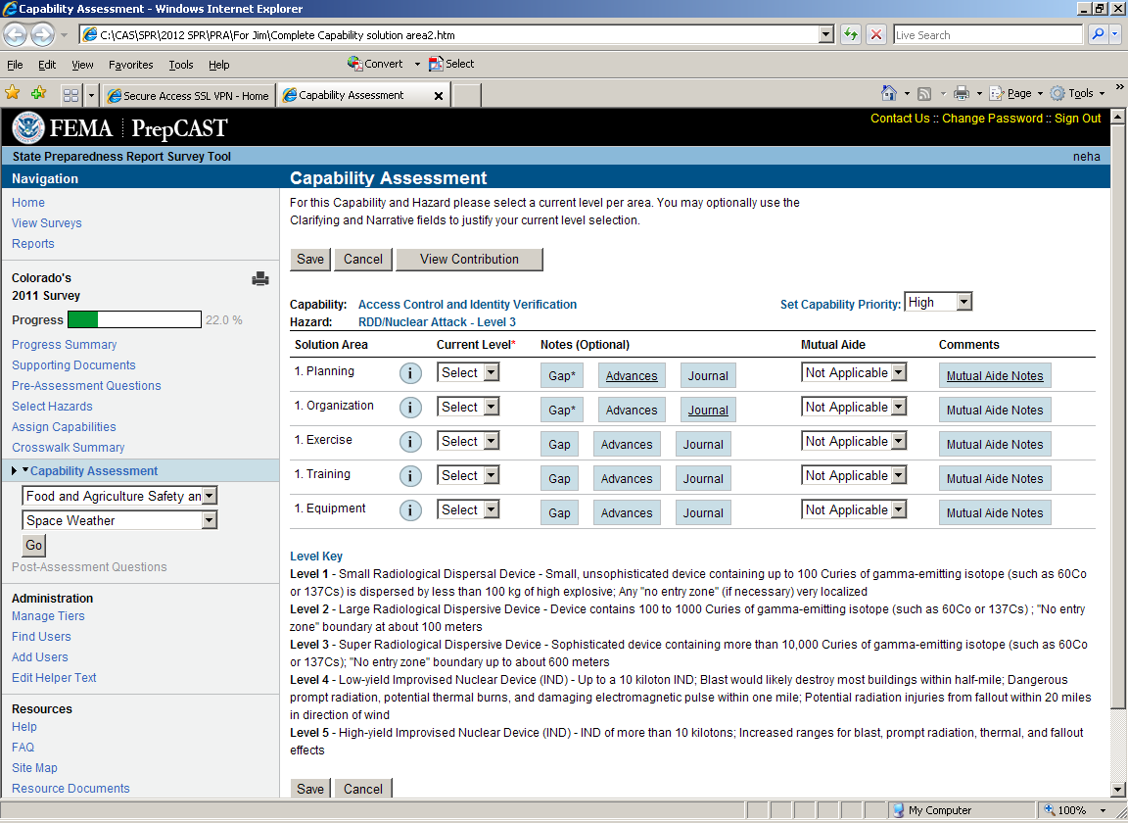

Capability Assessment page—Cybersecurity
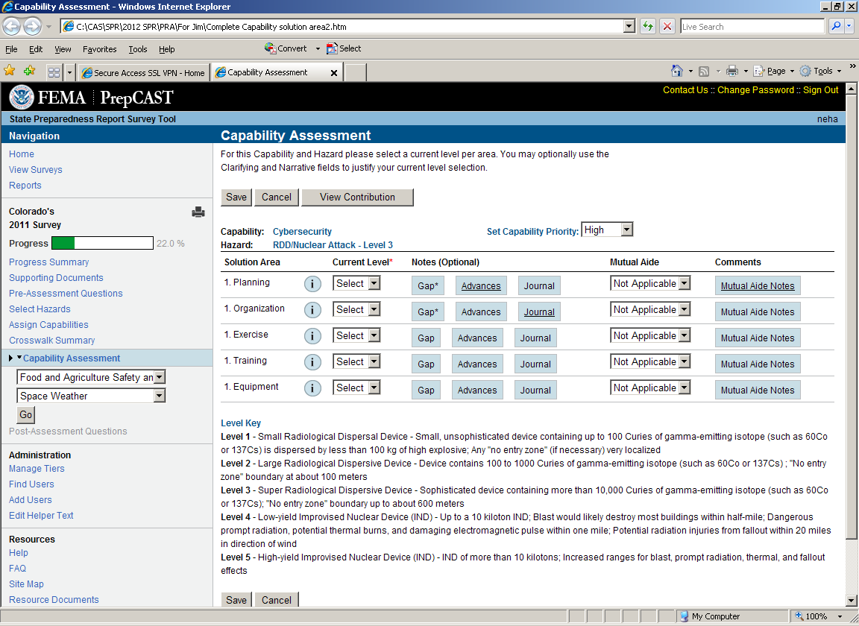

Capability Assessment page— Intelligence and Information Sharing (Protection Focus)
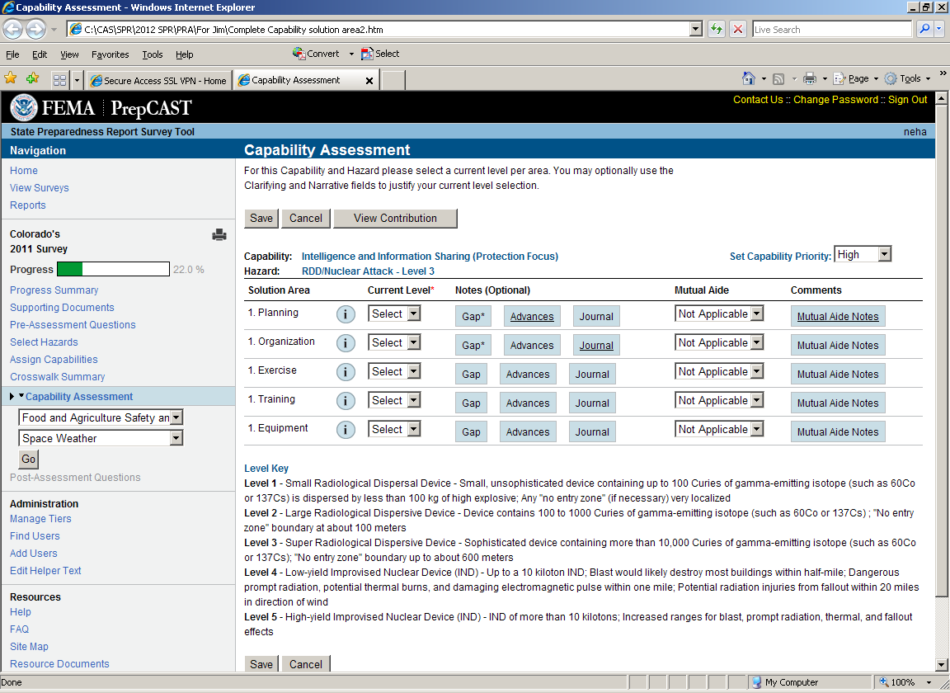

Capability Assessment page— Interdiction and Disruption (Protection Focus)
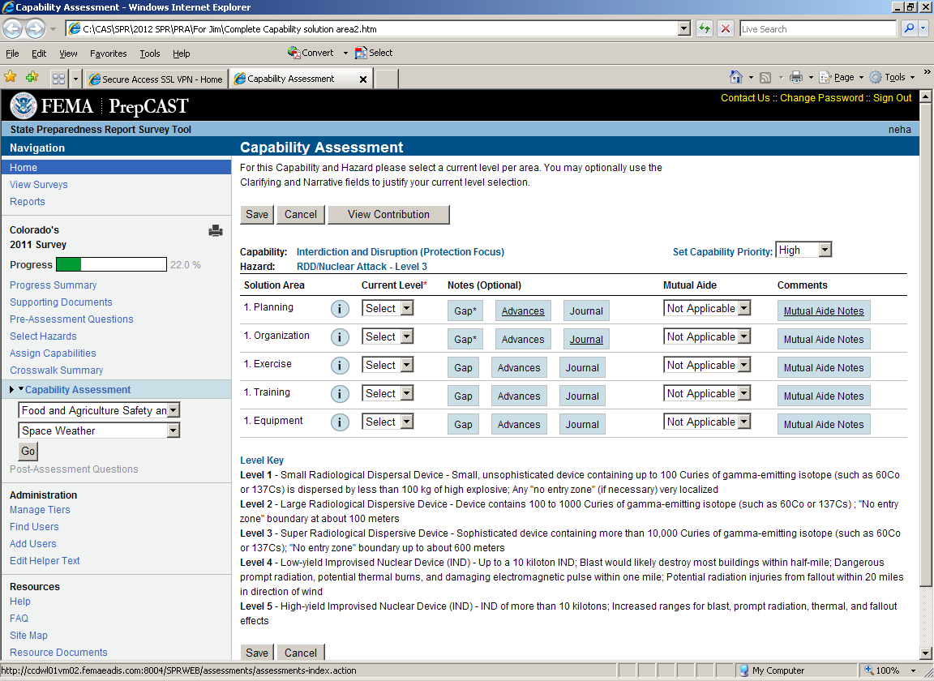

Capability Assessment page-- Physical Protective Measures
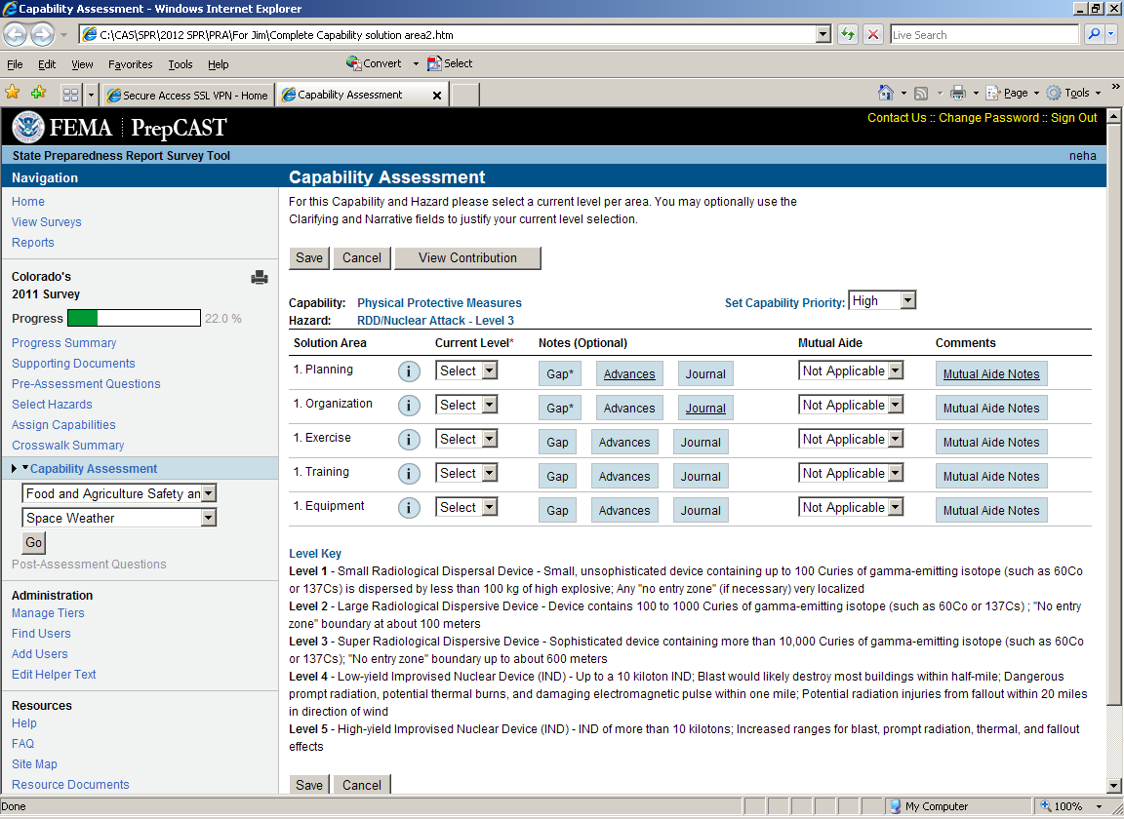

Capability Assessment page-- Risk Management for Protection Programs and Activities
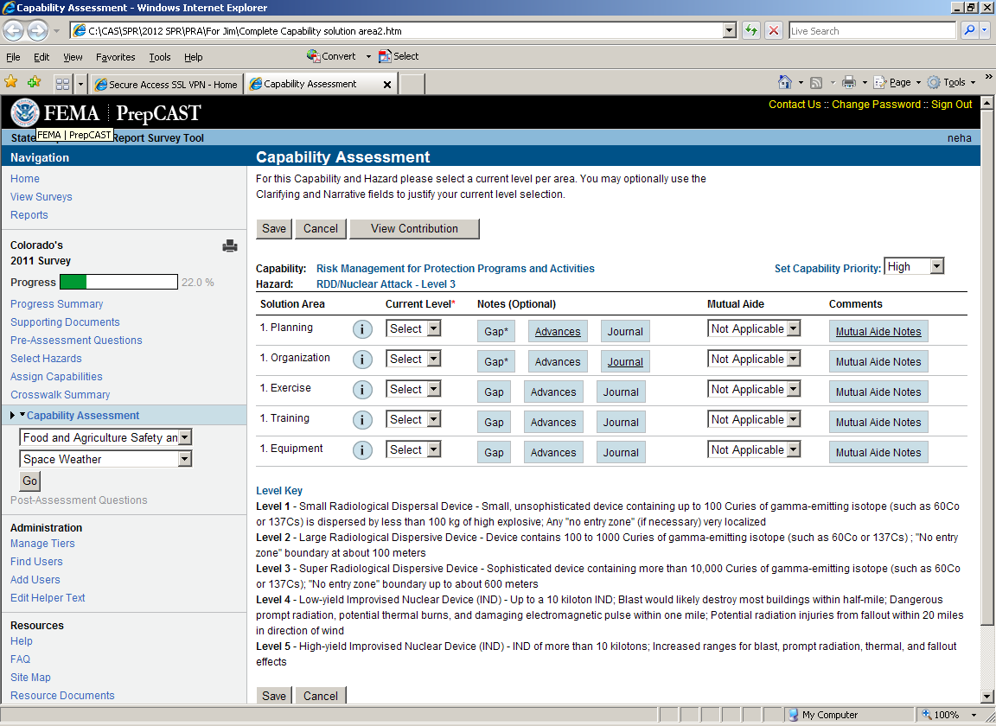

Capability Assessment Page-- Screening, Search, and Detection (Protection Focus)
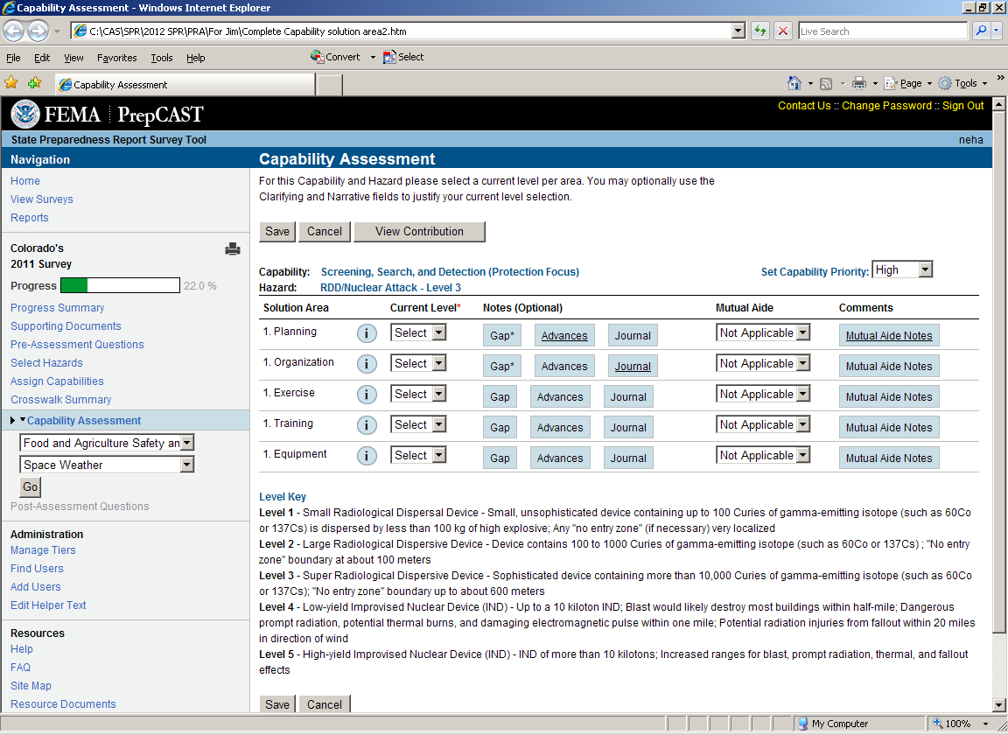

Capability Assessment page-- Supply Chain Integrity and Security
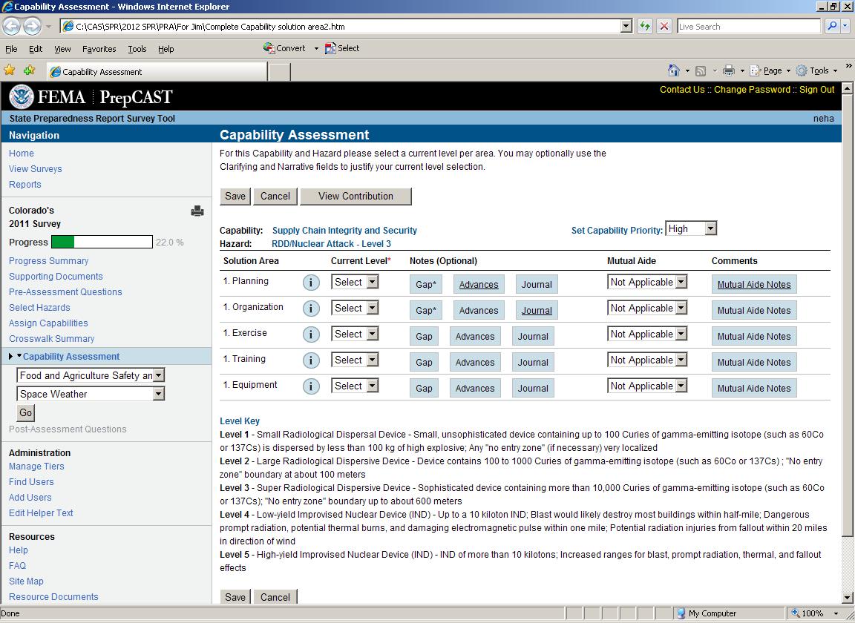

Capability Assessment page—Community Resilience
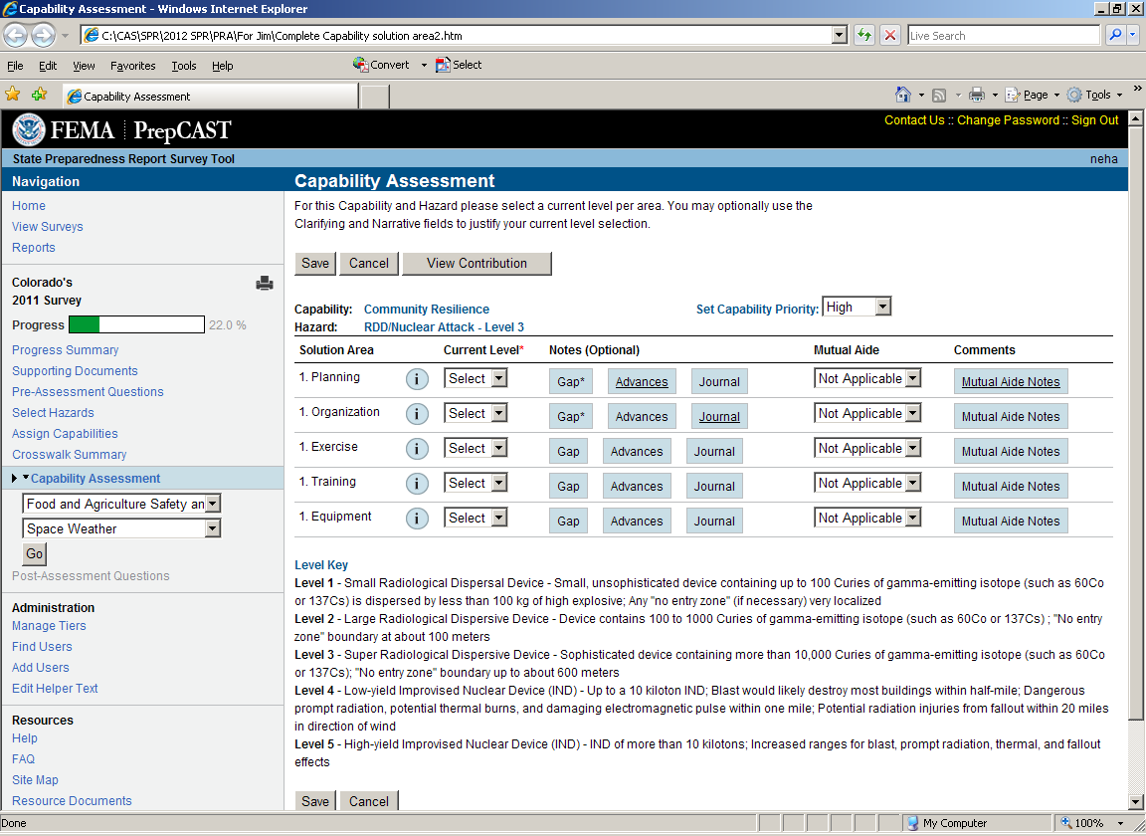

Capability Assessment page-- Long-term Vulnerability Reduction
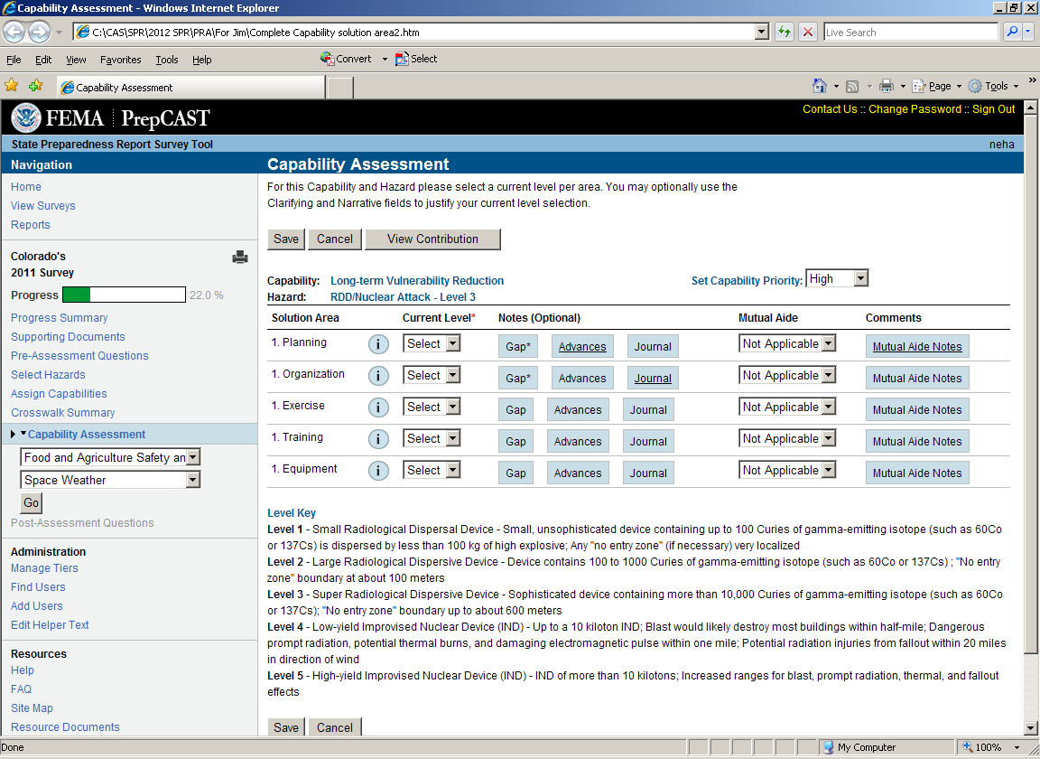

Capability Assessment page-- Risk and Disaster Resilience Assessment
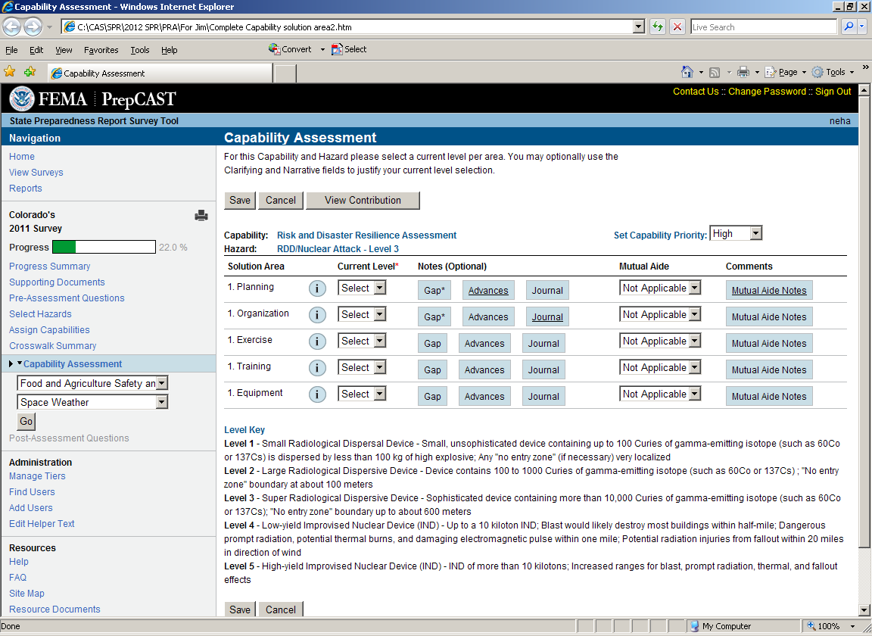

Capability Assessment page-- Threats and Hazard Identification
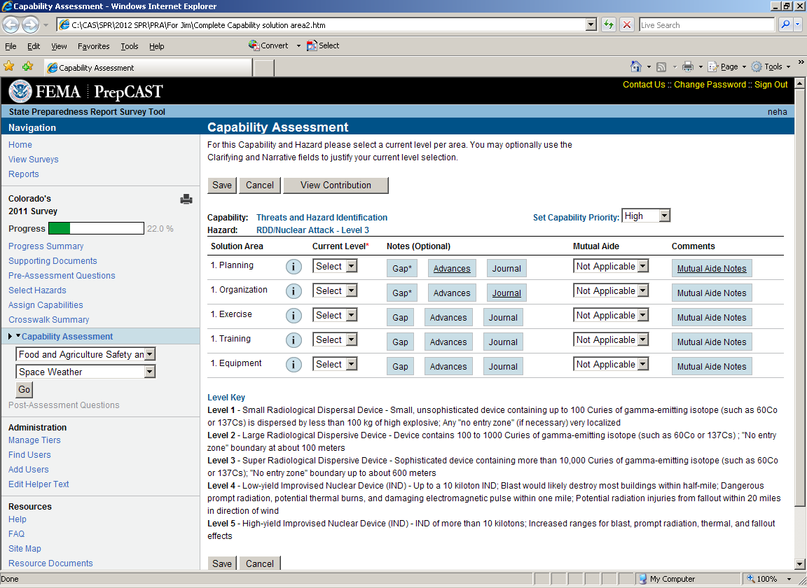

Capability Assessment page-- Critical Transportation
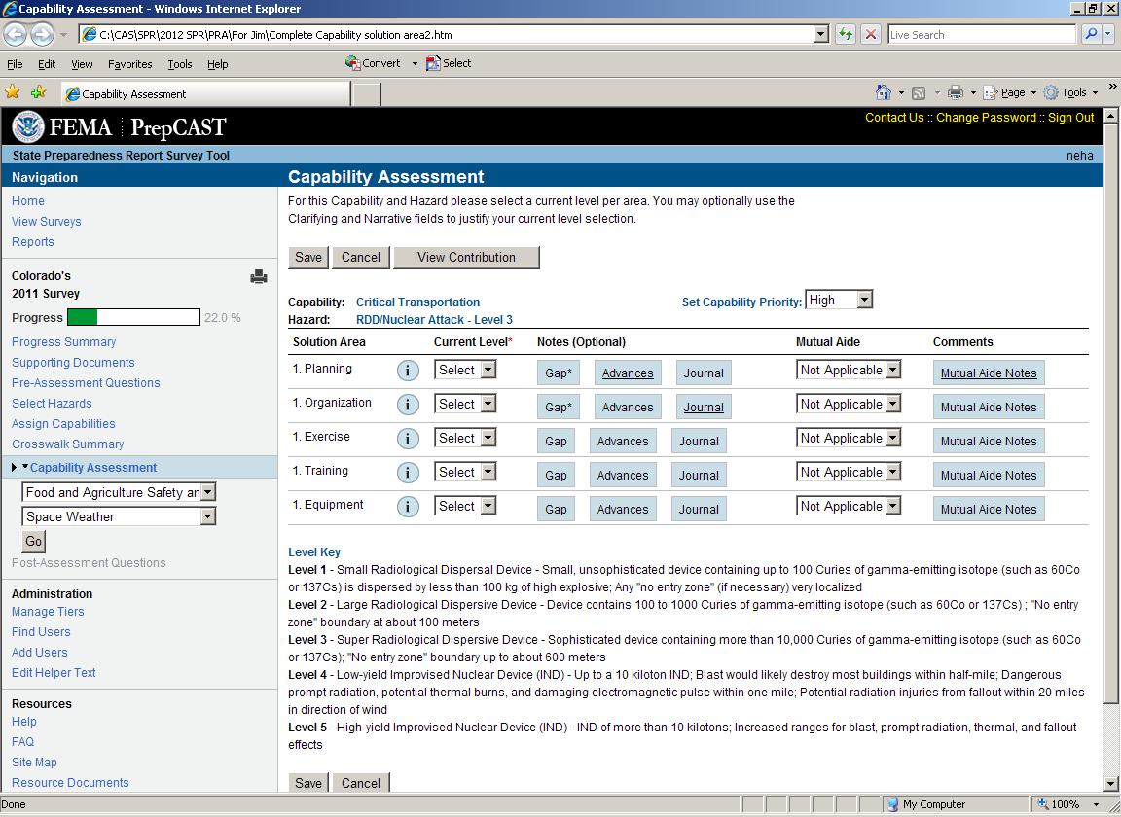

Capability Assessment page-- Environmental Response/Health and Safety
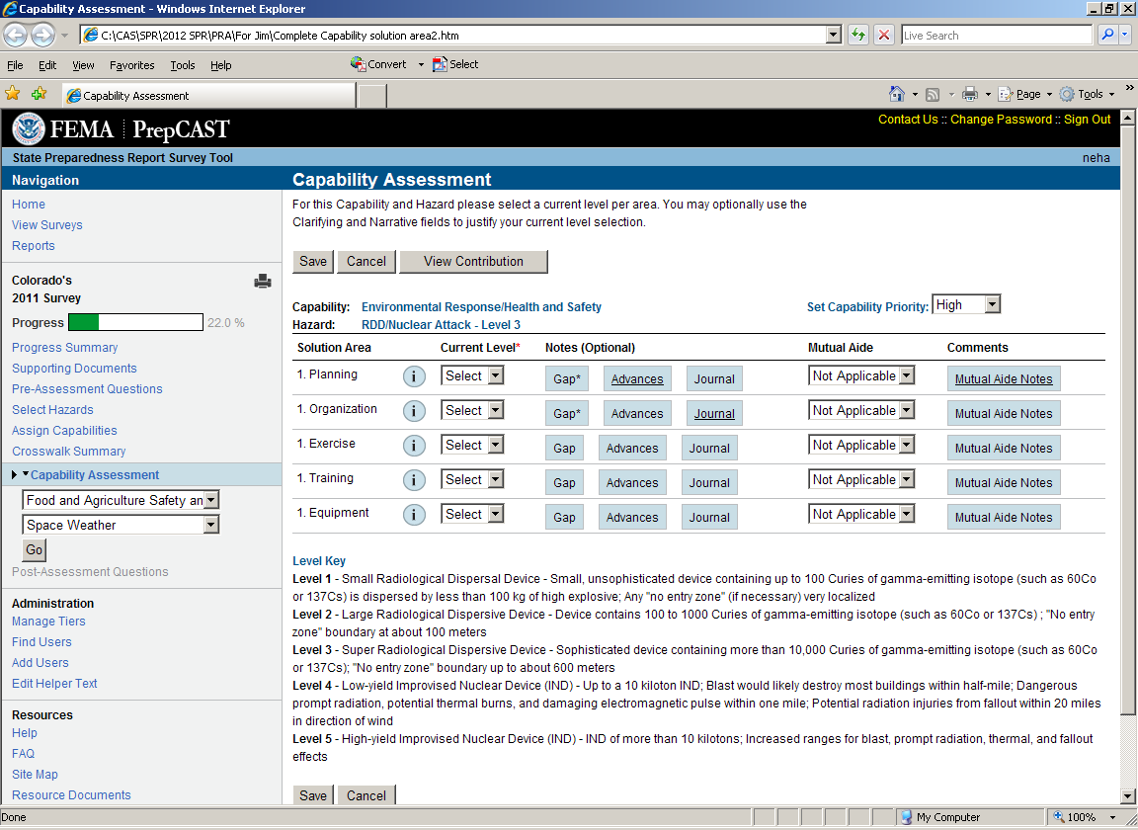

Capability Assessment page-- Fatality Management Services
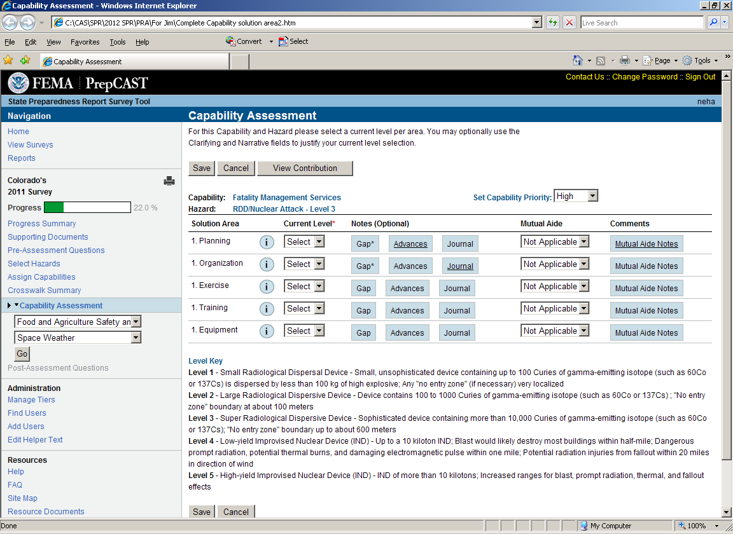

Capability Assessment page-- Infrastructure Systems (Response Focus)
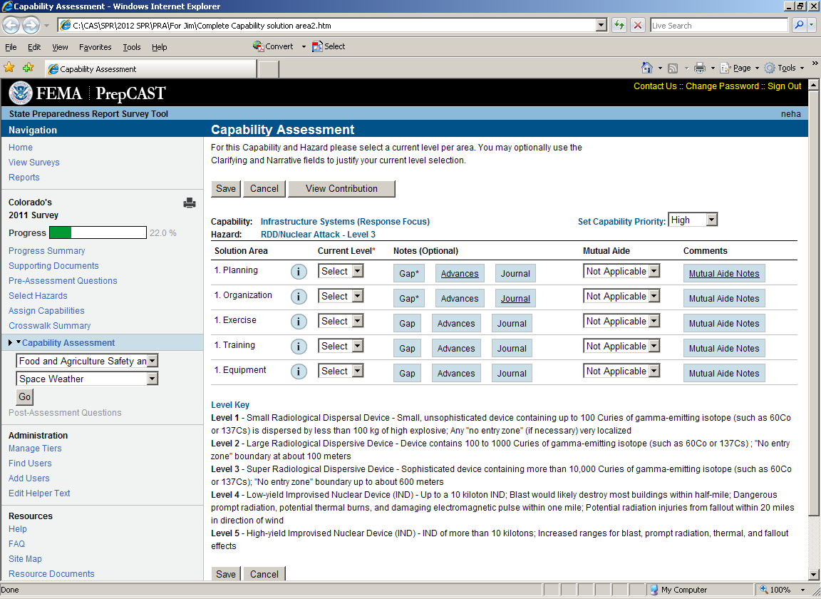

Capability Assessment page-- Mass Care Services
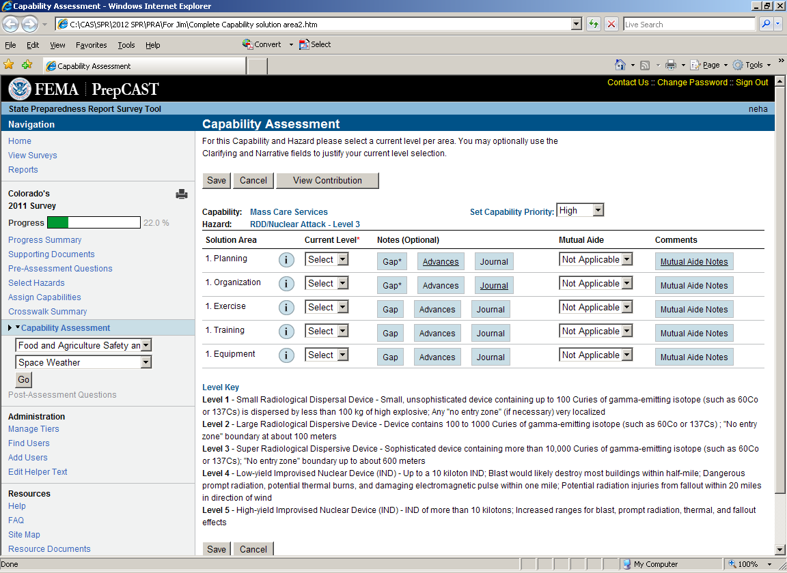

Capability Assessment page-- Mass Search and Rescue Operations
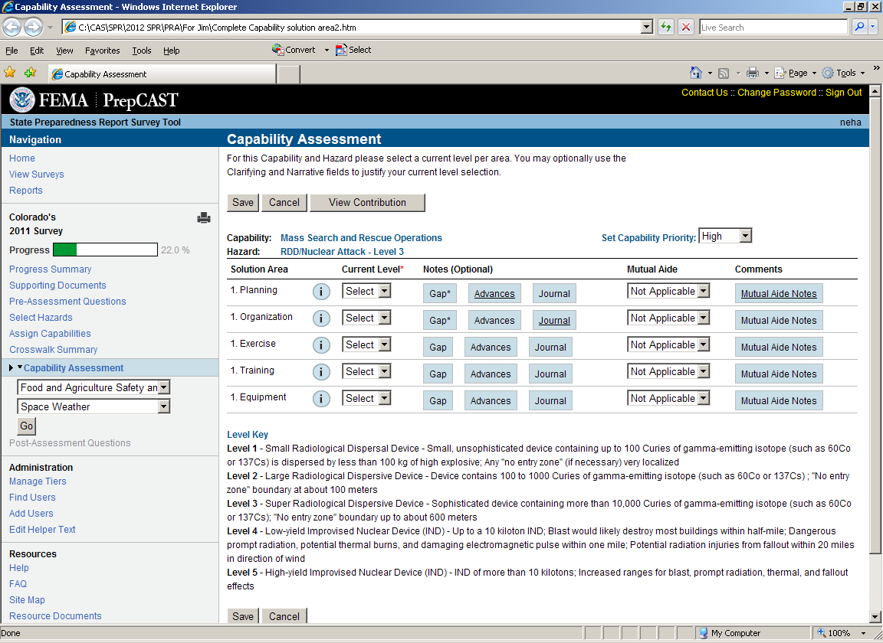

Capability Assessment page-- On-scene Security and Protection
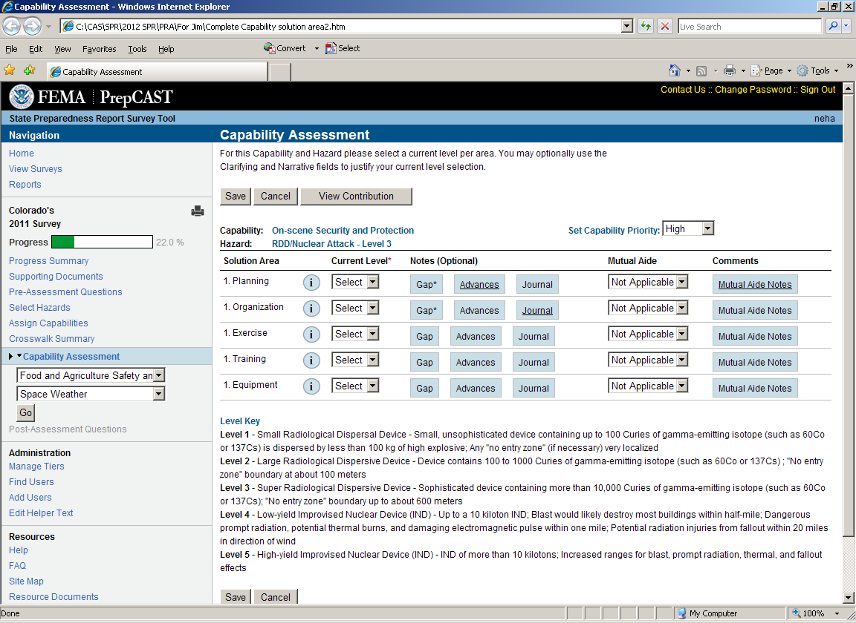

Capability Assessment page-- Operational Communications
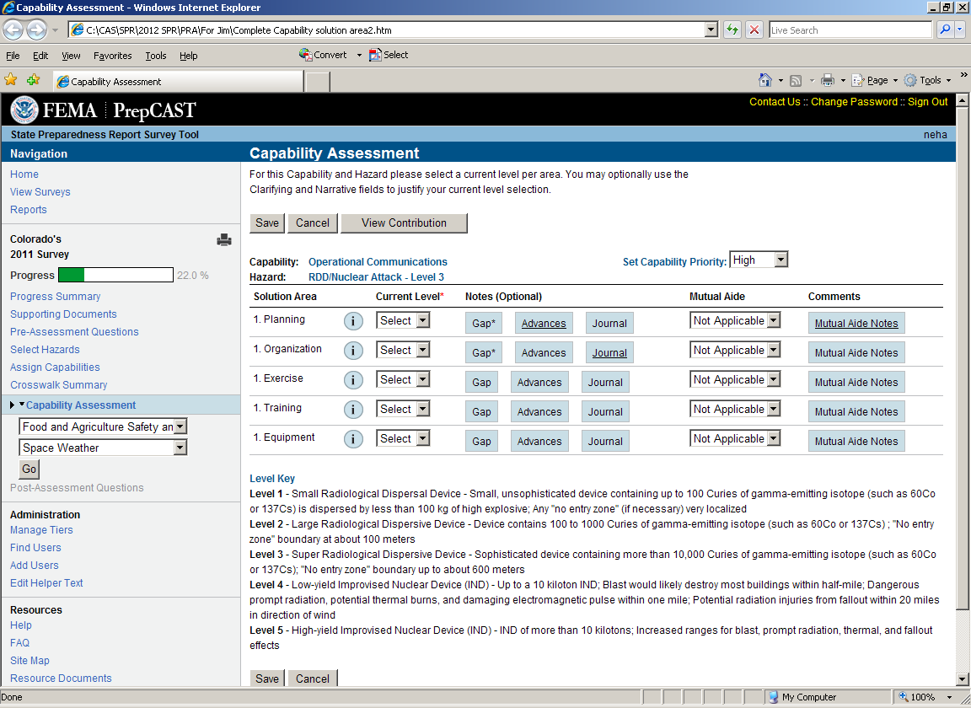

Capability Assessment page-- Public and Private Services and Resources
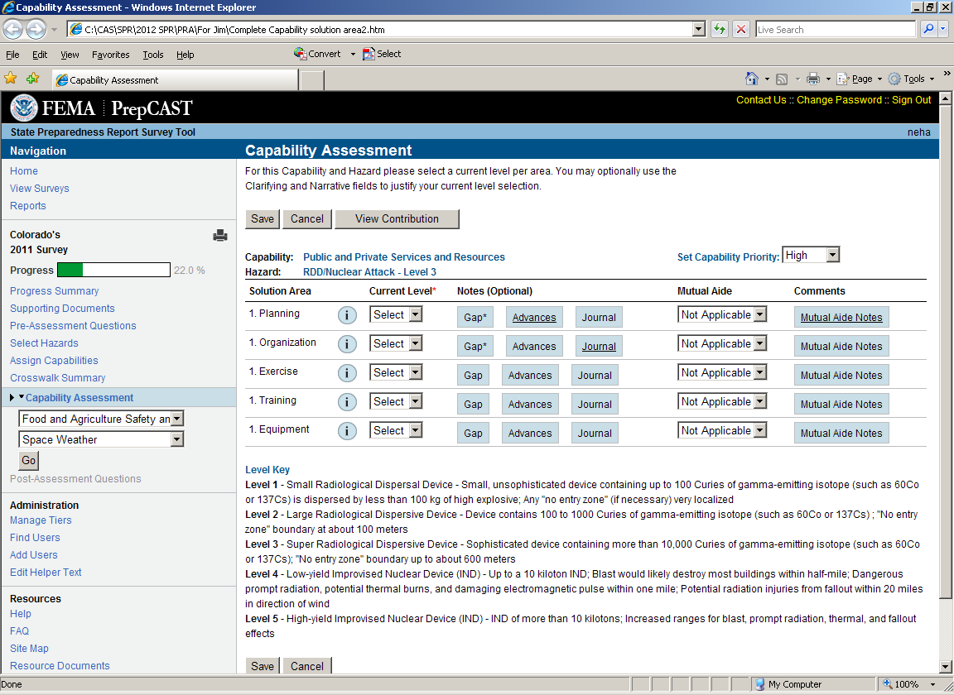

Capability Assessment page-- Public Health and Medical Services
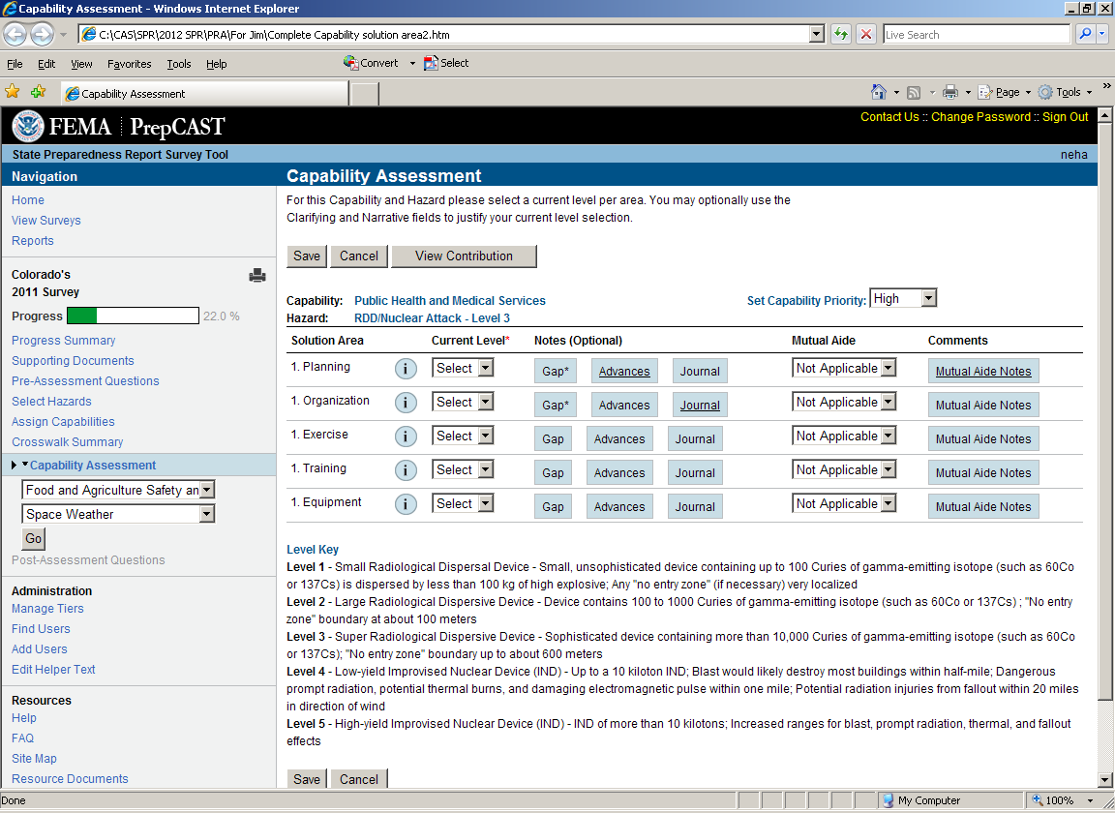

Capability Assessment page-- Situational Assessment
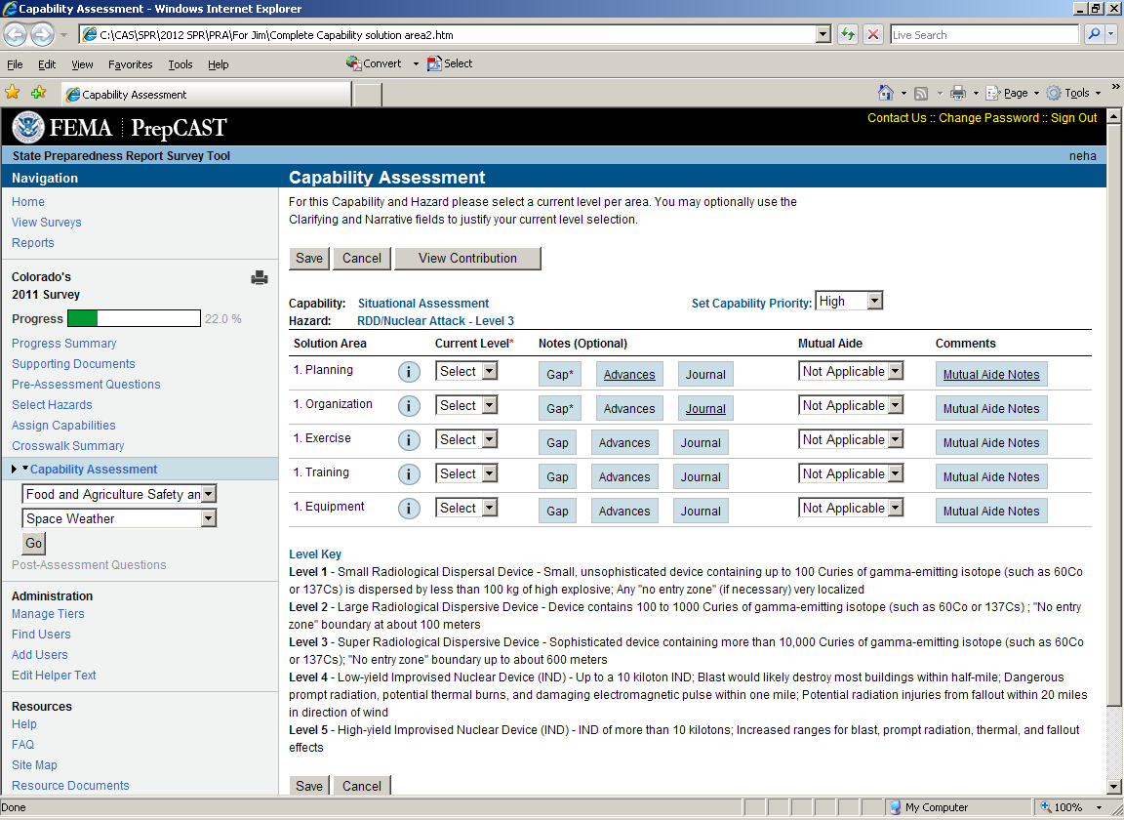

Capability Assessment page-- Economic Recovery
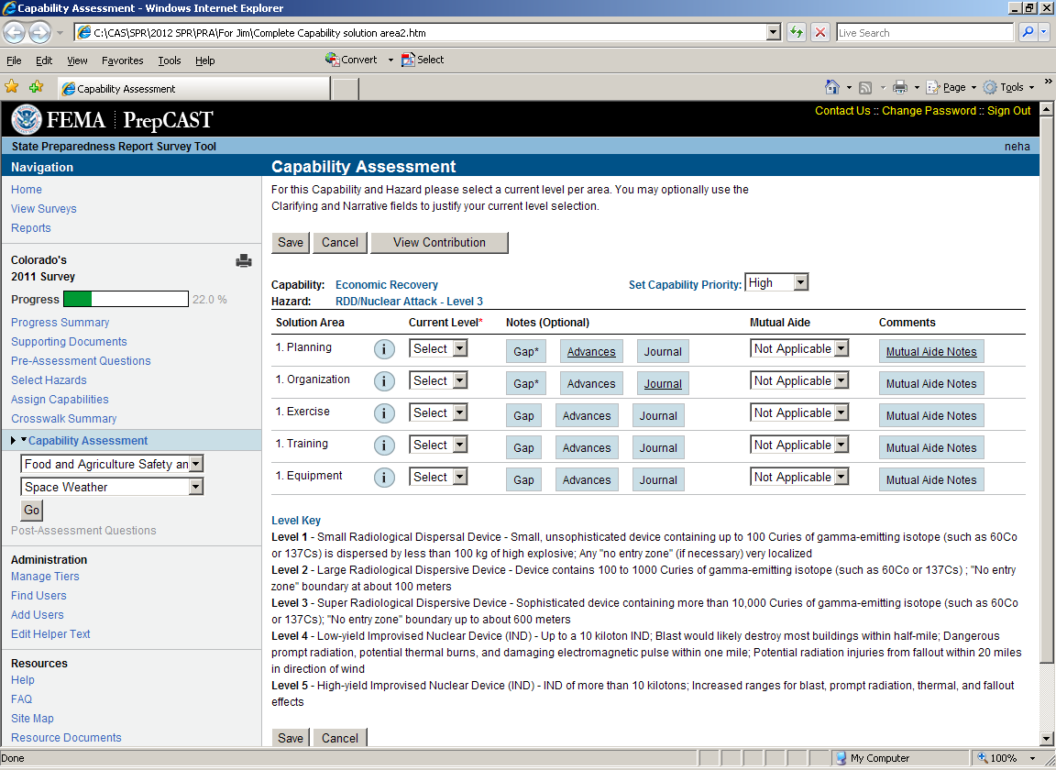

Capability Assessment page—Health and Social Services
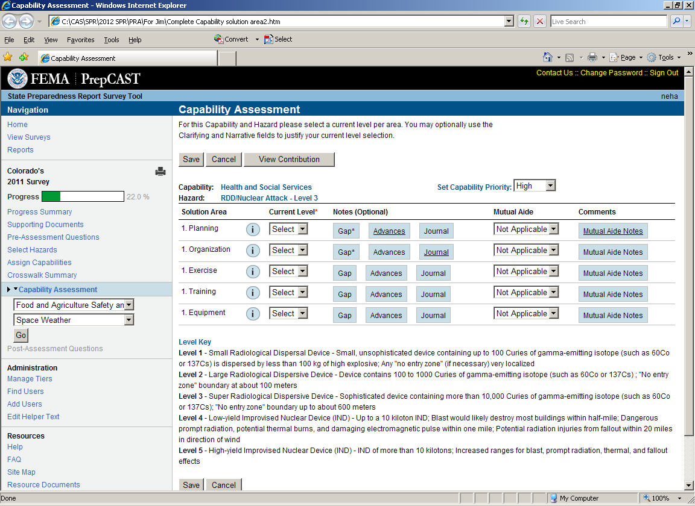

Capability Assessment page—Housing
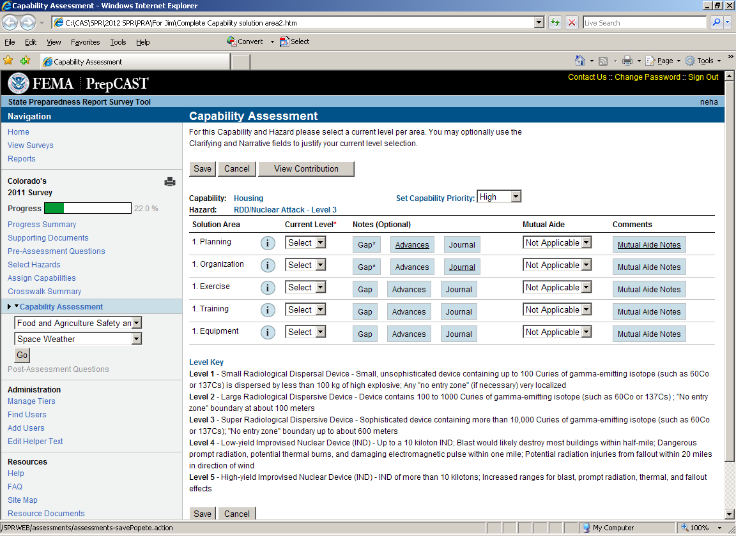

Capability Assessment page-- Infrastructure Systems (Recovery Focus)
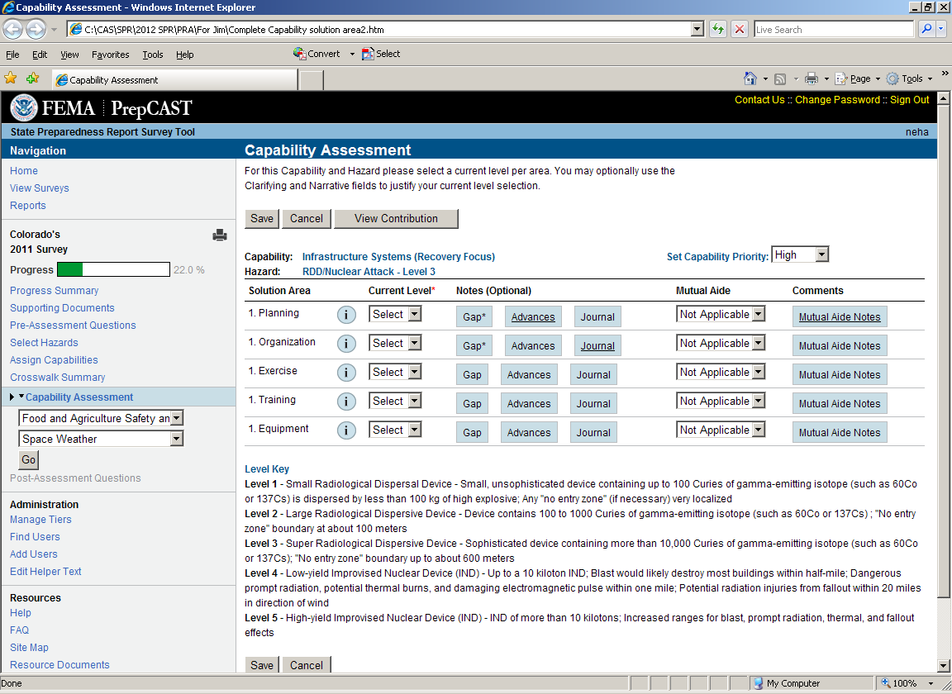

Capability Assessment page-- Natural and Cultural Resources
