Department of Transportation
Office of the Secretary
SUPPORTING STATEMENT
49 CFR Part 40
Procedures for Transportation Workplace
Drug and Alcohol Testing Programs
OMB Control # 2105-0529

Summary:

This is a request for renewal of the previously approved information collection 2105-0529. The number of annual burden hours has increased by 94,145 hours, primarily due to the increase in the number of drug and alcohol tests being performed. The increase in the number of tests was probably due to an improving economy. 855,547 more responses were estimated when compared to the previous estimates. See item #15 for more detailed explanation.

Response to Terms of Clearance: The terms of clearance stated for DOT to include an update on progress made toward consolidation of FAA's drug and alcohol testing rules (49 CFR Part 120, §§ 120.117 and 120.225) - an item that was included in DOT's regulatory look back plan.

On July 2, 2012, the FAA published a Notice of Proposed Rulemaking [77 FR 39194] proposing to allowing air carrier operators and commuter or on-demand operators that also conduct commercial air tour operations to combine the drug and alcohol testing required for each operation into one testing program. On July 15, 2013, the FAA published the final rule [78 FR 41999]. It allows air carrier operators and commuter or on-demand operators that also conduct commercial air tour operators to combine the drug and alcohol testing required for each operator into one testing program. The final rule is effective September 13, 2013.

Justification

1. Explain the circumstances that make the collection of information necessary. Attach a copy of the appropriate statue or regulation mandating or authorizing the collection of information.

Five of the Department’s Operating Administrations (OA) – Federal Motor Carrier Safety Administration (FMCSA), Federal Aviation Administration (FAA), Federal Transit Administration (FTA), Federal Railroad Administration (FRA) and the Pipeline and Hazardous Materials Safety Administration (PHMSA) and the United States Coast Guard – require drug and alcohol testing for safety-sensitive employees in their regulated industries. With few exceptions, however, all the drug and alcohol tests performed under the five OA and USCG regulations are conducted using a single source of drug and alcohol testing procedures – 49 CFR Part 40. The Office of the Secretary of Transportation (OST) is the proponent of Part 40.

The Department of Transportation (DOT) first published drug testing procedures – 49 CFR Part 40 – on November 21, 1988 [53 FR 47002] as an interim final rule and a year later on December 1, 1989 issued a final rule [54 FR 49852]. Part 40 prescribed the technical testing process that had to be adhered to by those required to implement existing OA drug testing regulations.

On October 28, 1991, the President of the United States signed Public Law 102 - 143, the Omnibus Transportation Employee Testing Act of 1991 (“the Act”) [Appendix A]. The Act compelled the Department to prescribe regulations that would require testing of safety-sensitive employees in the aviation, highway, rail, and transit industries. The Act specifically mandated, among other things, privacy in collection techniques, incorporation of Department of Health and Human Services’ (HHS) mandatory guidelines for drug testing and comparable safeguards for alcohol testing, collection of split samples of body fluid specimens, and confidentiality of test results. It required pre-employment, random, post-accident, and reasonable suspicion testing. Regulations prescribed by the Act needed to include provisions for identification of, and opportunity for treatment for, covered employees in need of assistance due to misuse of alcohol or illegal use of controlled substances.

The Act required changes to Part 40 (e.g., split specimen testing for drugs and provisions for alcohol testing) and to some of the OA regulations. The changes to Part 40, as directed by the Act, were published on February 15, 1994 [59 FR 7340].

In December 2000 [65 FR 79462], Part 40 was revised to produce a cleaner, better organized, simpler-to-follow rule that incorporated the most important guidance and interpretations and dealt creatively with numerous changes in the transportation and testing industries. It also served to introduce procedures designed to strengthen the quality and integrity of the testing program.
Since the December 2000 revision, Part 40 was amended several times.

Overall, Part 40 directs the activities of numerous persons in the drug and alcohol testing process. Among these are transportation employees and employers, as well as, service agents – urine collectors, forensic laboratory testing personnel, Medical Review Officers, Breath Alcohol Technicians, Screening Test Technicians, and Substance Abuse Professionals.

DOT Goal: The Office of Drug and Alcohol Policy and Compliance (ODAPC) regulation and associated paperwork burdens support three Department of Transportation goals – the Safety Strategic Objective; the Security Measures; and the Environmental Stewardship Strategic Objective. The regulatory requirements help promote the safety of the traveling public by working toward the elimination of drug and alcohol related transportation deaths and injuries; the security of Americans by working toward ensuring that transportation employees are not hindered by drug and alcohol abuse; and protecting the natural environment by working toward reduction of drug and alcohol use being factors in toxic spills and releases.

2. Indicate how, by whom, and for what purpose the information is to be used, and the actual use made of the information.

Part 40 requires the collection of information from a variety of transportation employers, employees and service agents. To ensure the required quality (e.g., privacy, accuracy and confidentiality) of the drug and alcohol testing services provided, OST requires documentation in the collection of urine, breath, and saliva specimens; screening and confirmation of specimen tests; the medical review of results; and the treatment recommendations for those testing positive for drug use or alcohol misuse. This information is used by employers and Department representatives to ensure that those testing positive are removed from safety-sensitive functions, that program problems are immediately identified and corrected, that quality assurance efforts are working, that security and privacy measures are upheld, and that the fairness and credibility of the Department’s testing efforts are maintained.

3. Describe whether, and to what extent the collection of information involves the use of automated, electronic, mechanical, or other forms of information technology. Also describe any consideration of using information technology to reduce burden.

The Department believes the increased use of electronic methods is both inevitable and beneficial. Since the program’s inception, Part 40 was updated to permit scanned computer images for reporting drug and alcohol test results. The Department also permits the electronic transmission of laboratory results reports to MROs and the electronic storage of certain testing data and information. Furthermore, laboratories are required to submit semi-annual statistics to the Department. They can mail, fax, or submit them electronically. Almost all the laboratories submit their reports electronically. The Department permits employers to submit year end aggregate testing data via the Internet (Previous submissions were all completed by hand and mailed to the respective OAs). In our estimation, approximately 89% of the 2011 MIS reports were submitted electronically. The following are screen shots of the various data elements the user would input into the system.

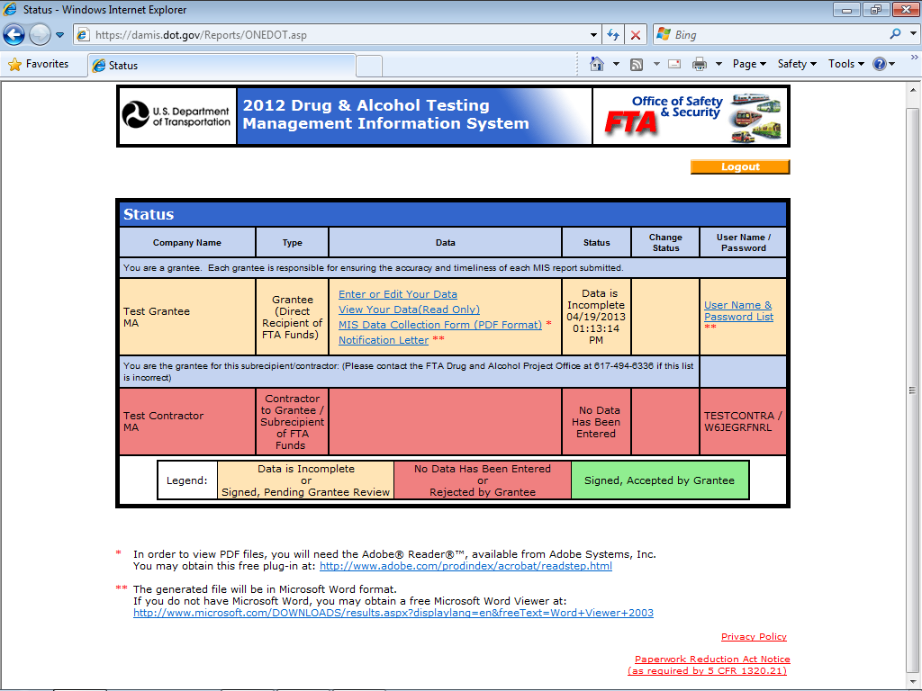

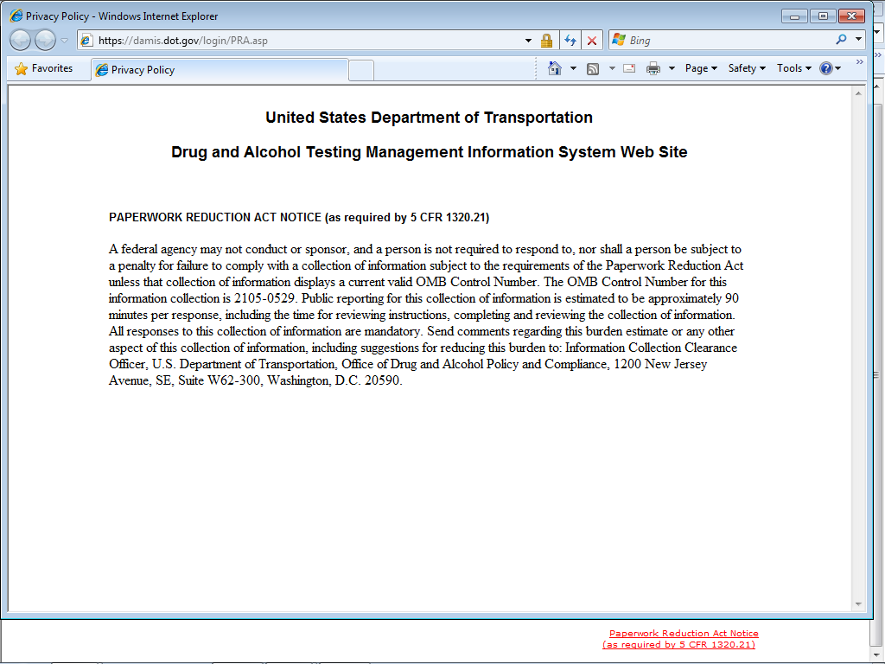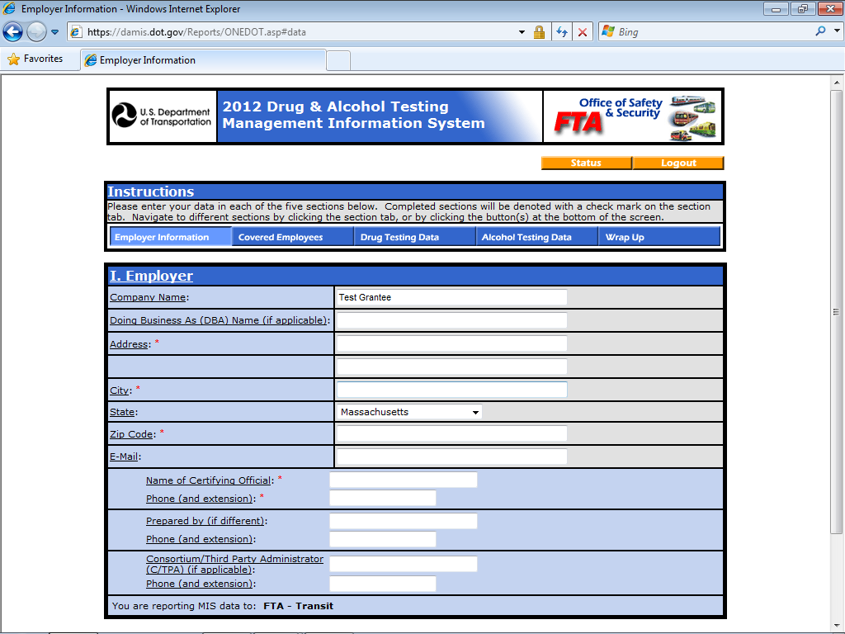

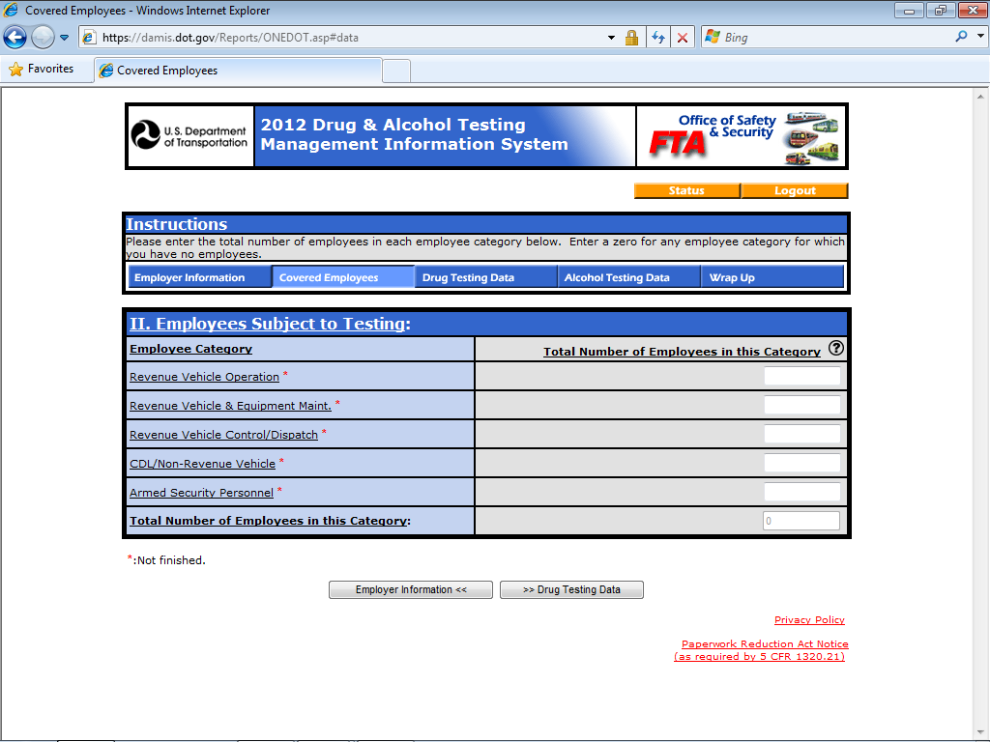

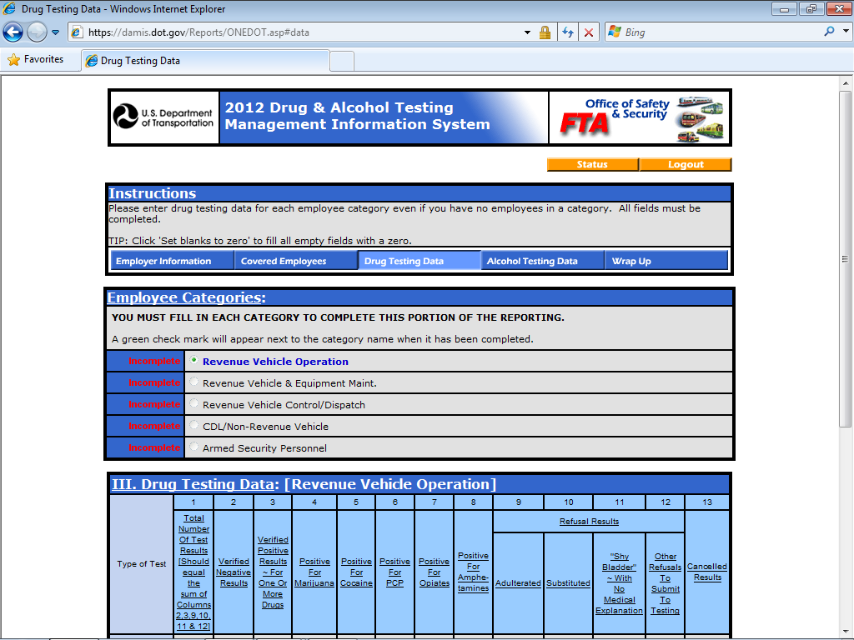
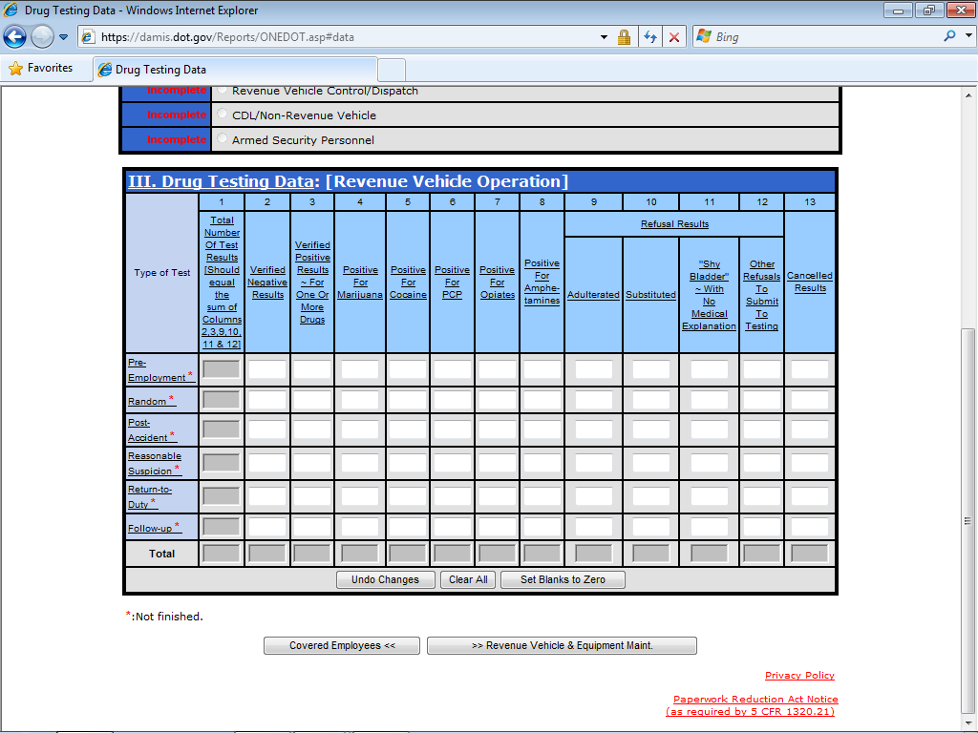
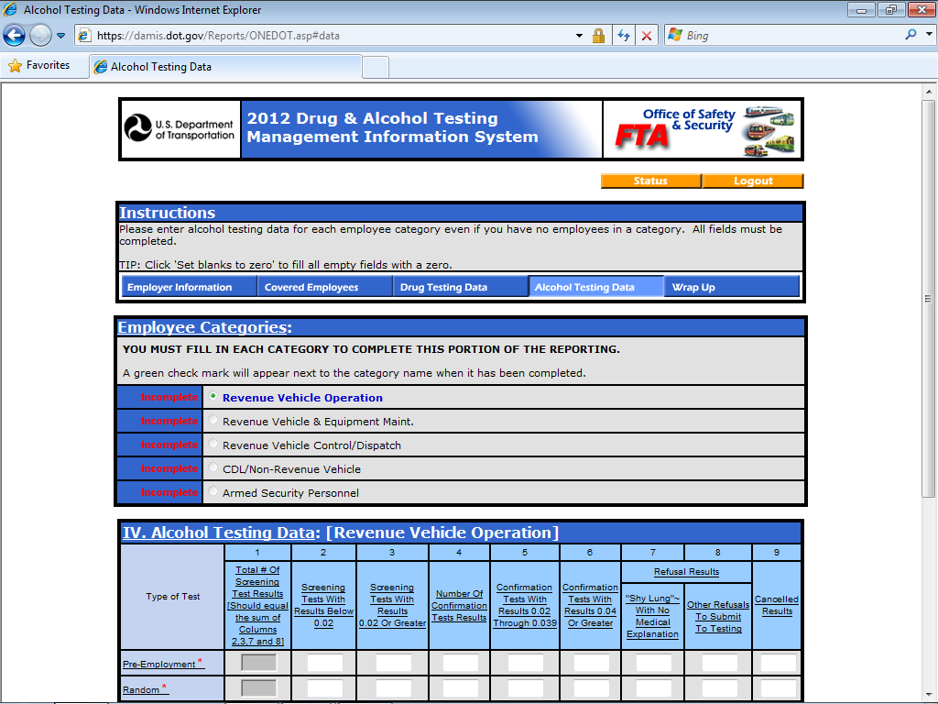
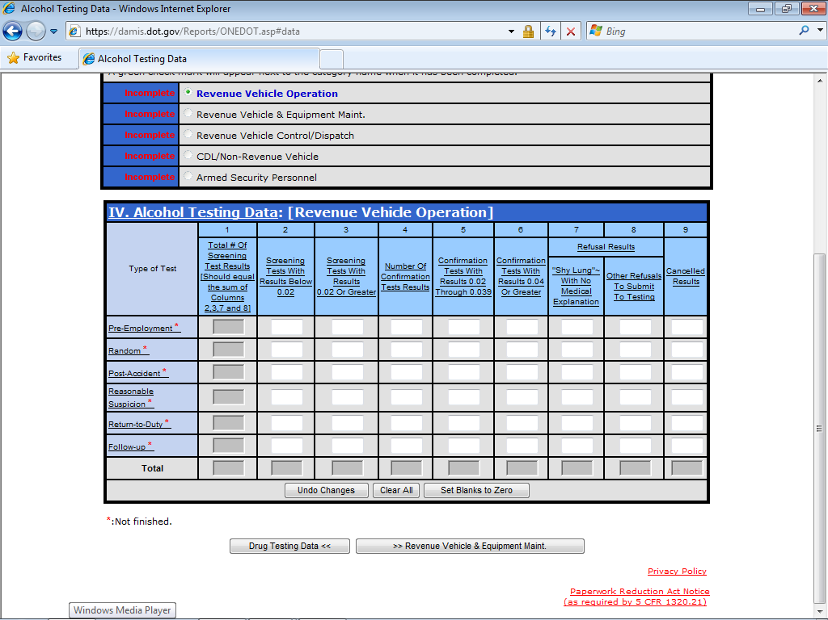

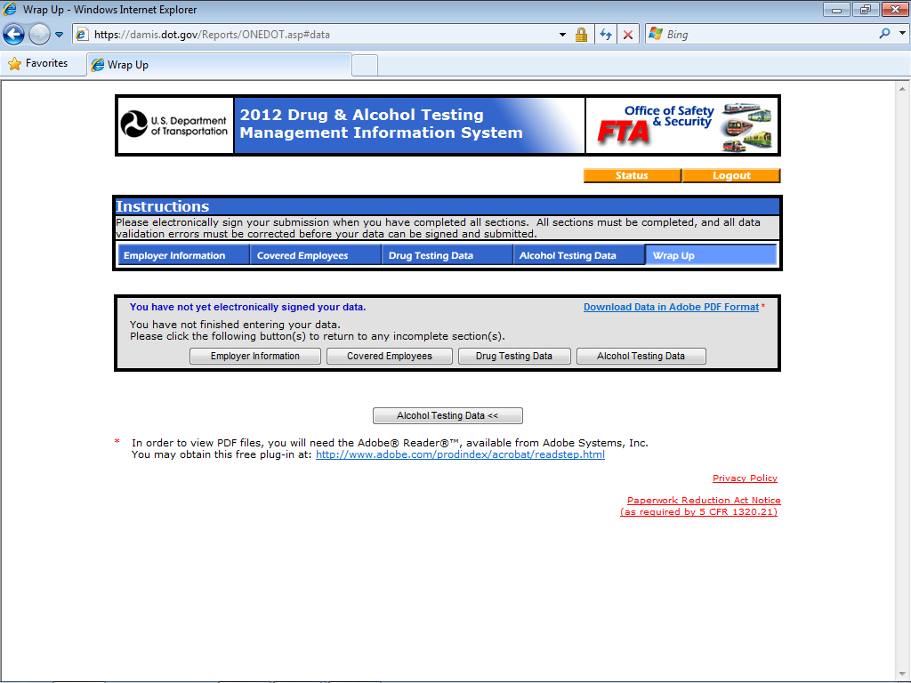

4. Describe efforts to identify duplication. Show specifically why any similar information already available cannot be used or modified for use for the purpose described in item 2 above.

This information does not readily exist elsewhere.

5. If the collection of information impacts small businesses or other small entities describe any methods used to minimize burden.

In the past, employers regulated by the Department’s drug and alcohol testing regulations and the USCG were in most instances required to submit annual aggregate drug and alcohol testing statistics. This required the employer to complete a form and then mail or fax it to the respective regulating DOT OA. The Department has developed a computer-based application which permits employers to submit year end aggregate testing data electronically via the Internet. We estimate, approximately 89% of the 2011 MIS reports were submitted electronically. Regulated employers with less than 50 employees may be required to submit MIS data when requested to do so by the regulating DOT Agency. Employers regulated by the USCG are required to submit MIS data regardless of size.

6. Describe the consequences to Federal program or policy activities if the collection is not conducted or conducted less frequently, as well as any technical or legal obstacles to reducing burdens.

Many DOT and USCG regulated employers rely on a number of persons or groups to coordinate and carry out their drug and alcohol testing responsibilities. Without this collection or by reducing the collection, program auditors and inspectors would not have information adequate to identify and address problems or compliance efforts in this safety program. In addition, custody and control is imperative in ensuring that an individual’s drug and alcohol test is an accurate reflection of the collection and testing event as well as in assigning a scientific result to a particular individual.

7. Explain any special circumstances that would cause an information collection that would be inconsistent with the guidelines in 5 CFR 1320.5(d)(2)(i) - (viii).

The information required is not in conflict with these guidelines.

8. If applicable describe efforts to:

Notify the public of information collection prior to OMB submission:

On July 12, 2013, the Office of Drug and Alcohol Policy and Compliance (ODAPC) published a 60-day notice in the Federal Register [78 FR 71974] Docket # DOT-OST-2013-0131, informing the public of ODAPC’s intention to extend an approved information collection.

On October 28, 2013, ODAPC also published the required 30-day notice in the Federal Register (78 FR 64262) again informing the public of ODAPC’s request to extend an approved information collection.

In both Federal Register notices, ODAPC solicited comments on whether the information collection is necessary for the proper performance of the functions of the Department, including whether the information will have practical utility.

We asked whether the Department’s estimate of the burden of the proposed information collection was accurate and for ways to enhance the quality, utility, and clarity of the information to be collected. The Department sought ways to minimize the burden for those who would have to provide the information, including the use of automated collection techniques or other forms of information technology.

Comments to the 60-day Federal Register notice are discussed below. Comments to the 30-day Federal Register notice are to be sent directly to the Office of Management and Budget.

Discussion of Comments to the Docket

There were three respondents to the docket with a total of seven comments to the 60-day notice. Two of the respondents are consortium/third party administrators from the trucking and pipeline industries, and one respondent represented a collection site that performs pre-employment medical exams and DOT urine collections. Below are our responses to the respondents’ comments.

Comment:
Most of the respondents expressed support for the Department’s use of the Alcohol Testing Form (ATF) to be the record of an alcohol test and the Management Information System (MIS) form to document an employer’s DOT testing data. They also supported the Department’s estimate of burden hours associated with collection and handling each of the forms.

DOT Response:
The Department agrees with the commenters’ supportive statements regarding use of the forms and the calculation of burden hours.

Comment:
Two of the respondents wondered if the DOT was contemplating an electronic ATF in the future and suggested moving away from a paper-based system.

DOT Response:
The Department has no objection to pursuing establishing the framework for an electronic ATF. We are interested in and currently working with the Department of Health and Human Services on issues related to implementing an electronic Federal Drug Testing Custody and Control Form (CCF). We believe that issues associated with the electronic CCF will be similar to issues associated with the electronic ATF. For these reasons, the Department will explore implementing an electronic ATF after an electronic CCF has been implemented.

Comment:
One respondent suggested that we modify the urine collection process to permit a portion of the DOT urine sample to also be used for other tests.

DOT Response:
Because the comment is not germane to the ATF or MIS form, the Department has no response other than to welcome the respondent to submit comments on this issue during any future rulemaking involving Part 40’s urine collections.

Comment:
One respondent, a large C/TPA providing services to the trucking industry, recommended allowing “…third-party administrators to be part of the remediation process for alcohol tests as is the case with controlled substances tests.” The C/TPA went on to say that the current three-part ATF does not provide for the capability for employers to rapidly share information leading to a hole in recordkeeping and making wrong choices regarding drivers with positive test results.

DOT Response:
The ATF is a 3-page form and the drug test CCF is a 5-page form. The difference in who ultimately gets certain pages of the form is based upon the fact that drug testing utilizes laboratories and Medical Review Officers, and alcohol testing does not. Hence, the ATF is 3 pages, not 5. As in drug testing, copies of the ATF go to the employee, the employer, and the BAT [in drug testing, the collector]. It is unclear as to what remediation process the respondent is referring. If the issue is that of permitting C/TPAs to transmit positive alcohol test results to employer, the Department has already an established position. The immediate transmission of positive alcohol test result to the employer is a safety matter. Because time is of the essence, the Breath Alcohol Technician (BAT) is required to immediately transmit the result of the confirmation test result (i.e. .020 or greater) to the Designated Employer Representative (DER) so the DER can take the appropriate action. For these reasons, C/TPAs are not permitted to act as intermediaries in transmitting this information to the DER. The Department has no reason to believe that BATs have not been transmitting or cannot immediately transmit this information to the DER.

With respect to employers making incorrect choices regarding what to do with employees who have positive alcohol test results, as a service agent, a C/TPA can advise an employer on the regulation. For example, a C/TPA can explain that an employer’s responsibility is to permanently remove an employee from safety sensitive duties when the employee has an alcohol test result of .040 or greater. They can also advise the employer about actions for results 0.02 through 0.039.

Comment:
One respondent, a C/TPA servicing the pipeline industry, did not have any concern over the Department’s estimated burden hours for either form. That same respondent went on to say that the burden hours should include an estimate for data entry into the Drug and Alcohol Management Information System (DAMIS) as the DAMIS procedures vary by Agency.

DOT Response:
DAMIS is an on-line portal to the electronic MIS form. Because of the nature of each transportation industry, each DOT Agency may require different log-in and setup procedures to ensure the accountability by those entities required to submit MIS information. These administrative procedures are external to the actual completion of the MIS form and are independent of the estimated time to actually enter the MIS data once in DAMIS.

Comment:
One respondent, a C/TPA servicing the pipeline industry, wanted to know “…what other uses the Department makes of this data in the aggregate and by agency.”

DOT Response:
As the respondent noted, the MIS data is primarily used by the DOT Agencies to determine their respective industry's random testing rate for the next calendar year. We would like to add that the DOT Agencies often use the MIS data for planning audit/inspection strategy as well.

Comment:
One respondent, a C/TPA servicing the pipeline industry, made several comments related to minimizing the burden of the collection of information on respondents. Their comments focused on the pipeline industry and were on issues leading up to the submission of the MIS data, such as: 1) The varying request dates for submitting the MIS data; 2) the standardization of data entry into DAMIS, as well as permitting to upload a data file into DAMIS; 3) standardizing the input process for contractors in the pipeline industry; and 4) permitting an audit service to log into DAMIS as the employer in order to be able to enter contractor data into DAMIS.

DOT Response:
With respect to item 1, it is a well-known fact that the due-date for submitting MIS data is set in each of the Agency’s regulations as March 15 of the following year. A DOT Agency may see the need to extend that date to accommodate the stakeholders’ request for an extension or the DOT Agency may have identified issues that have prevented their efforts to provide notice to employers in a timely manner so that employers could enter information by the March 15 due-date. In either scenario, extending the due-date would not add a paperwork burden to employers.

With respect to item 2, the one DOT Agency referenced in this comment as a potential beneficiary of “data entry standardization” is PHMSA. In particular, it appears the login process for this agency was the commenter’s primary issue and was characterized as, “complicated.” According to PHMSA, the suggestion to change this process for the sake of “standardization” may result in unintended consequences when there is a misunderstanding of the overarching intent of the login process. For PHMSA, each transportation employer – designated as either an “operator” or “contractor” – is issued a unique “user name” and “password” for purposes of data integrity and security. It is important to understand that operators are solely accountable for their contractors’ “covered employees” during the MIS reporting year. This means that contractors must provide MIS testing data under the banner of each operator for their contractor’s covered employees when they have performed covered functions, at any time and duration, on the operator’s jurisdictional pipeline facilities. With this operator-contractor association rule lodged in the programming, DAMIS designates contractor login information that is solely and directly associated with the operator who has listed them as a “covered function performing” contractor. DAMIS also captures one contractor employer entry as a “data of record” for accounting purposes and avoiding duplication of data. Eliminating these processes has the possible unintended consequence of degrading data security or forcing the agency to create a login process that is complicated, requiring additional processes such as contractor registration, to assure data integrity.

The suggestion for developing a process for downloading a DAMIS file onto a transportation employer’s computer server and then uploading it back to DAMIS while laudable is replete with potential IT security challenges. Among them are: Providing prescriptive stakeholder data entry procedures (especially those with limited computer skills); programing challenges associated with each DOT Agency; and agency budgetary considerations for developing such programming.

With respect to item 3, we mentioned earlier DAMIS is an on-line portal to the electronic MIS form. Because of the nature of the each transportation industry, each DOT Agency may require different log-in and setup procedures to ensure the accountability by those entities required to submit MIS information. These administrative procedures are external to the actual completion of the MIS form and are independent of the estimated time to actually enter the MIS data once in DAMIS.

In the DOT Agency example, PHMSA is being cited as duplicating the reporting requirements for contractor employers. Each contractor login designation is uniquely associated with the operator employer who has identified them in the DAMIS electronic reporting system. This reporting association is consistent with PHMSA regulatory mandate regarding operator monitoring and reporting requirements under Title 49 CFR Part 199, § 199.115 and § 245, which address contractor covered employees.

With respect to item 4, while we recognized the value of MIS provider service performed by C/TPAs, accommodating them for business process efficiency, with a single login, presents significant potential risk to maintaining data integrity and security. Moreover, current regulations assign accountability and responsibility on the employer for MIS reporting.

With regard to entering multiple contractor MIS data under the PHMSA regulation, operator employers, or their designated C/TPAs, always had the option of issuing the DAMIS unique user name and password to these contractors, and then allowing them to enter their data directly into DAMIS. This option is utilized effectively with DOT/FTA grantees/grantors, which allows for shared responsibility for this MIS information. In similar fashion, the pipeline safety operator employer, or their designated C/TPA, can monitor contractor employers’ submissions for data review and approval. Utilizing this process could alleviate the number of contractor MIS data has to be physically entered by operator employers or their C/TPA.

Consultations outside of agency to obtain other views:

OST has consulted with representatives from the Department’s OAs, the USCG, HHS, and service agent groups. OST regularly consults with service agents regarding their concerns with the regulations.

Consultations with representatives of the effected population:

OST regularly consults with DOT OAs, the USCG, employers, and service agents (e.g., Medical Review Officers, Substance Abuse Professionals, Urine Specimen Collectors, Screening Test Technicians, Breath Alcohol Technicians, and Consortia/Third Party Administrators), regarding their concerns with the regulations.

9. Explain any decision to provide payment or gift to respondents, other than remuneration of contracts or grantees.

There are no circumstances of any payments or gifts to respondents.

10. Describe any assurance of confidentiality provided to respondents and the basis for the assurance in statue, regulations, or agency policy.

Some of the information to be collected contains information covered under the Federal Privacy Act and conditions of the provisions of privacy contained therein. The United States Supreme Court has upheld the privacy and confidentiality elements of the Department’s testing program and chain-of-custody procedures contained in the Part 40 procedures. Some information required of Part 40 can be released to third parties only after the appropriate releases of information are signed by the employee.

11. Provide additional justification for any questions of a sensitive nature, such as sexual behavior and attitudes, religious beliefs, and other matters that are commonly considered private.

There are no issues pertaining to questions of this nature.

12. Provide estimates of the hour burden of the collection of information.

- Total Number of Respondents: 2,639,331 (see table below for an itemization)

- Total Number of Responses: 6,548,043 (see table below and worksheets in Appendix F for an explanation)

- Total Annual Hours Requested: 678,986 (see table below and worksheets in Appendix F for explanation)

- Current OMB Inventory: 584,841

- Difference: 94,145 (see item # 15 for an explanation)

- Explanation for Difference:

      - Program Change: 0
      - Adjustment: 94,145

Summary Table of Burden Estimates:
PRA Item | Number of Respondents | Number of Responses | Burden Hours | Salary Costs($)
Exemptions from Regulation Provisions Requests [40.7(a)] | 1 | 1 | 3 | $84
Employer Stand-down Waiver Requests [40.21(b)] | 5 | 5 | 40 | $1,120
Employee Testing Records from Previous Employers [40.25(a)] | 728,324 | 1,952,459 | 260,327 | $7,289,156
Employee Release of Information [40.25(f)] | 1,952,459 | 1,952,459 | 130,163 | $3,644,564
MIS Form Submission [40.26] | 15,276 | 1,681 | 2,521 | $70,588
Collector (Qualification and Refresher) Training Documentation (40.33(b) & (e)] | 5,000 | 5,000 | 333 | $9,324
Collector Error Correction Training Documentation [40.33(f)] | 10,000 | 8,960 | 597 | $16,725
Laboratory Reports to DOT Regarding Unlisted Adulterant [40.91(e)] | 1 | 1 | 1 | $28
Semi-Annual Laboratory Reports to Employers [40.111(a)] | 37 | 480,693 | 32,046 | $897,295
Semi-Annual Laboratory Reports to DOT [40.111(d)] | 37 | 74 | 5 | $138
Medical Review Officer (MRO) (Qualifications and Continuing Education) Training Documentation [40.121(c) & (d)] | 1,000 | 1,000 | 66 | $1,848
MRO Review of Negative Results Documentation [[40.127(b)(2)(ii)] | 5,000 | 278,800 | 18,586 | $520,426
MRO Failure to Contact Donor Documentation [40.131(c)(1)] | 5,000 | 31,200 | 2,080 | $58,240
MRO Effort to Contact DER Documentation [40.131(c)(2)(iii)] | 5,000 | 31,200 | 2,080 | $58,240
DER Successful Contact Employee Documentation [40.131(d)] | 24,960 | 24,960 | 1,664 | $46,592
DER Failure to Contact Employee Documentation [40.131(d)(2)(i)] | 6,240 | 6,240 | 416 | $11,648
MRO Verification of Positive Result Without Interview Documentation [40.133]. | 5,000 | 6,240 | 416 | $11,648
Adulterant/Substitution Evaluation Physician Statements [40.145(g)(2)(ii)(d)] | 0 | 0 | 0 | $0
MRO Cancellation of Adulterant / Substitution for Legitimate Reason Reports [40.145(g)(5)] | 0 | 0 | 0 | $0
Employee Admission of Adulterating / Substituting Specimen MRO Determination [40.159(c)] | 40 | 40 | 3 | $84
Split Specimen Requests by MRO [40.171(c)] | 4,690 | 4,690 | 313 | $8,764
Split Failure to Reconfirm for Drugs Reports by MRO [40.187(b)] | 32 | 32 | 2 | $56
Split Failure to Reconfirm for Adulterant / Substitution Reports by MRO [40.187(c)] | 2 | 2 | 1 | $28
Shy Bladder Physician Statements [40.193(f)] | 568 | 568 | 47 | $1,316
MRO Statements Regarding Physical Evidence of Drug Use [40.195(b) & (c)] | 0 | 0 | 0 | $0
Drug Test Correction Statements [40.205 (b)(1) & (2)] | 25,000 | 113,780 | 15,170 | $424,778
Breath Alcohol Technician (BAT) / Screening Test Technician (STT) (Qualification and Refresher) Training Documentation [40.213(b)(c)&(e)] | 2,000 | 2,000 | 133 | $3,724
BAT/STT Error Correction Training Documentation [40.213(f)] | 77 | 77 | 5 | $143
Complete DOT Alcohol Testing Forms [40.225(a)] | 10,000 | 1,531,000 | 204,133 | $5,715,733
Evidential Breath Testing Device Quality Assurance / Calibration Records [40.233(c)(4)] | 10,000 | 10,000 | 666 | $18,648
Shy Lung Physician Statements [40.265(c)(2)] | 76 | 76 | 5 | $143
Alcohol Test Correction Statements [40.271(b)(1)&(2)] | 151 | 151 | 10 | $280
Substance Abuse Professional (SAP) (Qualification and Continuing Education) Training Documentation [40.281(c)&(d)] | 3,334 | 3,334 | 222 | $6,216
Employer SAP Lists to Employees [40.287] | 10,000 | 67,000 | 4,466 | $125,048
SAP Reports to Employers [40.311(c),(d) & (e)] | 10,000 | 34,000 | 2,266 | $63,466
Correction Notices to Service Agents [40.373(a)] | 10 | 10 | 10 | $280
Notice of Proposed Exclusion (NOPE) to Service Agents [40.375(a)] | 2 | 2 | 2 | $56
Service Agent Requests to Contest Public Interest Exclusions (PIE) [40.379(b)] | 2 | 2 | 2 | $56
Service Agent Information to Argue PIE [40.379(b)(2)] | 2 | 2 | 8 | $224
Service Agent Information to Contest PIE [40.381(a) & (b)] | 2 | 2 | 8 | $224
Notices of PIE to Service Agents [40.399] | 1 | 1 | 1 | $28
Notices of PIE to Employer and Public [40.401 (b) & (d)] | 1 | 1 | 1 | $28
Service Agent PIE Notices to Employers [40.403 (a)] | 1 | 300 | 150 | $4,200
Total New | 2,639,331 | 6,548,043 | 678,986 | $19,011,691
* pro-rated over a 5 year period based upon frequency of training requirement
** pro-rated over a 5 year period based upon frequency of training requirement
The salary cost is based upon the Department of Labor’s bureau of Labor Statistics average employee compensation hourly cost in 2011.

NOTE: See Appendix F for explanation worksheets

Supplemental Program Information:

- Number of Employers Regulated by DOT’s drug and alcohol testing program

FMCSA | 700,000
FRA | 750
FAA | 6,900
FTA | 3,224
PHMSA | 2,450
USCG | 15,000
Total | 728,324
[Based on 2011 DOT Operating Administration data]

- Number of Employees Regulated by DOT’s drug and alcohol testing program

FMCSA | 8,000,000
FRA | 1 11,300
FAA | 450,000
FTA | 273,300
PHMSA | 190,000
USCG | 150,000
Total | 9,174,600
[Based on 2011 DOT Operating Administration data]

- Service Agents:

Urine Collectors | 25,000
Laboratories | 37
Medical Review Officers (MRO) | 5,000
Substance Abuse Professional (SAP) | 15,000
Breath Alcohol Technician (BAT) & Screening Test Technician (STT) | 10,000
[Based on ODAPC and HHS data]

Drug Testing:

Drug Tests Annually | 5,689,000
Laboratory Non-negative Rate | 1.83%
Laboratory Non-negatives | 104,000
MRO Verified Positive Rate | 1.18%
MRO Verified Positives | 67,000
[Based on 2011 MIS and laboratory data]

- Alcohol Testing:

Alcohol Tests Annually | 1,531,000
Alcohol Positive Rate | .35%
Alcohol Positive Tests | 5,000
[Based on 2011 MIS and Industry data]

13. Provide estimates of total annual cost burden to respondents or record keepers resulting from the collection of information.

There are no costs to the respondents.

14. Provide estimates of annualized cost to the Federal government.

There are no additional costs to the Federal Government.

15. Explain the reasons for any changes or adjustments reported in items 13 or 14 of the OMB form 83-1.

Overall the total burden hours have increased by 94,145 (adjustments). The increase in the burden hours was due to an increase in the number of tests conducted by employers, which was probably due to an improving economy.

The adjustment of 94,145 burden hours is represented by an increase in the number of drug and alcohol tests performed by employers. The adjustments are mostly represented by an increase in:

- The number of requests for information from previous employers (38,092 hours)
- The number of employee’s authorizing release of their testing information (18,985 hours)
- The number of alcohol tests performed (27,322 hours)

(See the table below for an itemization of the changes in burden hours)

PRA Item | Number of Responses | Burden Hours
Exemptions from Regulation Provisions Requests [40.7(a)] | 1 | 3
New | 1 | 3
Difference | 0 | 0
Employer Stand-down Waiver Requests [40.21(b)] | 5 | 40
New | 5 | 40
Difference | 0 | 0
Employee Testing Records from Previous Employers [40.25(a)] | 1,667,672 | 222,235
New | 1,952,459 | 260,327
Difference | -284,787 | -38,092
Employee Release of Information [40.25(f)] | 1,667,672 | 111,178
New | 1,952,459 | 130,163
Difference | -284,787 | -18,985
MIS Form Submission [40.26] | 1,588 | 2,382
New | 1,681 | 2,521
Difference | -93 | -139
Collector (Qualification and Refresher) Training Documentation (40.33(b) & (e)] | 5,000 | 333
New | 5,000 | 333
Difference | 0 | 0
Collector Error Correction Training Documentation [40.33(f)] | 6,630 | 442
New | 8,960 | 597
Difference | -2,330 | -155
Laboratory Reports to DOT Regarding Unlisted Adulterant [40.91(e)] | 1 | 1
New | 1 | 1
Difference | 0 | 0
Semi-Annual Laboratory Reports to Employers [40.111(a)] | 480,693 | 32,046
New | 348,693 | 23,246
Difference | 132,000 | 8,800
Semi-Annual Laboratory Reports to DOT [40.111(d)] | 76 | 5
New | 74 | 5
Difference | 2 | 0
Medical Review Officer (MRO) (Qualifications and Continuing Education) Training Documentation [40.121(c) & (d)] | 2,220 | 147
New | 1,000 | 66
Difference | 1,220 | 81
MRO Review of Negative Results Documentation [[40.127(b)(2)(ii)] | 250,665 | 16,711
New | 278,800 | 18,586
Difference | -28,135 | -1,875
MRO Failure to Contact Donor Documentation [40.131(c)(1)] | 34,489 | 2,299
New | 31,200 | 2,080
Difference | 3,289 | 219
MRO Effort to Contact DER Documentation [40.131(c)(2)(iii)] | 34,489 | 2,299
New | 31,200 | 2,080
Difference | 3,289 | 219
DER Successful Contact Employee Documentation [40.131(d)] | 27,591 | 1,839
New | 24,960 | 1,664
Difference | 2,631 | 175
DER Failure to Contact Employee Documentation [40.131(d)(2)(i)] | 6,897 | 459
New | 6,240 | 416
Difference | 657 | 43
MRO Verification of Positive Result Without Interview Documentation [40.133]. | 3,448 | 229
New | 6,240 | 416
Difference | -2,792 | -187
Adulterant/Substitution Evaluation Physician Statements [40.145(g)(2)(ii)(d)] | 0 | 0
New | 0 | 0
Difference | 0 | 0
MRO Cancellation of Adulterant / Substitution for Legitimate Reason Reports [40.145(g)(5)] | 0 | 0
New | 0 | 0
Difference | 0 | 0
Employee Admission of Adulterating / Substituting Specimen MRO Determination [40.159(c)] | 15 | 1
New | 40 | 3
Difference | -25 | -2
Split Specimen Requests by MRO [40.171(c)] | 2,372 | 158
New | 4,690 | 313
Difference | -2,318 | -155
Split Failure to Reconfirm for Drugs Reports by MRO [40.187(b)] | 30 | 2
New | 32 | 2
Difference | -2 | 0
Split Failure to Reconfirm for Adulterant / Substitution Reports by MRO [40.187(c)] | 4 | 1
New | 2 | 1
Difference | 2 | 0
Shy Bladder Physician Statements [40.193(f)] | 510 | 43
New | 568 | 47
Difference | -58 | -4
MRO Statements Regarding Physical Evidence of Drug Use [40.195(b) & (c)] | 0 | 0
New | 0 | 0
Difference | 0 | 0
Drug Test Correction Statements [40.205 (b)(1) & (2)] | 51,000 | 6,800
New | 113,780 | 15,170
Difference | -62,780 | -8,370
Breath Alcohol Technician (BAT) / Screening Test Technician (STT) (Qualification and Refresher) Training Documentation [40.213(b)(c)&(e)] | 2,000 | 133
New | 2,000 | 133
Difference | 0 | 0
BAT/STT Error Correction Training Documentation [40.213(f)] | 66 | 4
New | 77 | 5
Difference | -11 | -1
Complete DOT Alcohol Testing Forms [40.225(a)] | 1,326,085 | 176,811
New | 1,531,000 | 204,133
Difference | -204,915 | -27,322
Evidential Breath Testing Device Quality Assurance / Calibration Records [40.233(c)(4)] | 10,000 | 666
New | 10,000 | 666
Difference | 0 | 0
Shy Lung Physician Statements [40.265(c)(2)] | 66 | 4
New | 76 | 5
Difference | -10 | -1
Alcohol Test Correction Statements [40.271(b)(1)&(2)] | 132 | 9
New | 151 | 10
Difference | -19 | -1
Substance Abuse Professional (SAP) (Qualification and Continuing Education) Training Documentation [40.281(c)&(d)] | 3,334 | 222
New | 3,334 | 222
Difference | 0 | 0
Employer SAP Lists to Employees [40.287] | 47,430 | 3,162
New | 67,000 | 4,466
Difference | -19,570 | -1,304
SAP Reports to Employers [40.311(c),(d) & (e)] | 60,000 | 4,000
New | 34,000 | 2,266
Difference | 26,000 | 1,734
Correction Notices to Service Agents [40.373(a)] | 5 | 5
New | 10 | 10
Difference | -5 | -5
Notice of Proposed Exclusion (NOPE) to Service Agents [40.375(a)] | 2 | 2
New | 2 | 2
Difference | 0 | 0
Service Agent Requests to Contest Public Interest Exclusions (PIE) [40.379(b)] | 2 | 2
New | 2 | 2
Difference | 0 | 0
Service Agent Information to Argue PIE [40.379(b)(2)] | 2 | 8
New | 2 | 8
Difference | 0 | 0
Service Agent Information to Contest PIE [40.381(a) & (b)] | 2 | 8
New | 2 | 8
Difference | 0 | 0
Notices of PIE to Service Agents [40.399] | 1 | 1
New | 1 | 1
Difference | 0 | 0
Notices of PIE to Employer and Public [40.401 (b) & (d)] | 1 | 1
New | 1 | 1
Difference | 0 | 0
Service Agent PIE Notices to Employers [40.403 (a)] | 300 | 150
New | 300 | 150
Difference | 0 | 0
Total Old | 5,692,496 | 584,841
Total New | 6,548,403 | 678,986
Total Difference in burden hours | -855,547 | -94,145

16. For collections of information whose results will be published, outline plans for tabulation and publication.

The proposed information collection is not slated for publication.

17. If seeking approval not to display the expiration date for OMB approval of the information collection, explain.

Testing for alcohol (and drugs) as required by the Omnibus Transportation Employee Testing Act of 1991, is considered a long-term program. There are currently no plans to modify the content of the information on the alcohol form or the method of conducting alcohol tests. With this in mind, the DOT considers this form one that will be used well into the future. An expiration date could, in and of itself, create a problem in the field for the technicians (e.g. an employee might refuse to take a test because it appears that the form is outdated). Also in order to take advantage of the economy of scale, many printers of the form – including the Federal Government Printing Office – print this form in large quantities. An expiration date may unnecessarily reduce the value of these forms, and place an undue burden on employers to have more reprinted solely because of the date.

Similar to the alcohol testing form, the Management Information Form (MIS) has not been modified and there are no plans to modify the content of the form. The current form has not changed since its inception. The DOT considers this form one that will be used within the DOT Agencies and their regulated industries well into the future. The DOT Agencies would not want any employer to be out of compliance if they used an MIS form with the incorrect expiration date.

18. Explain each exception to the certification statement identified in item 19 “Certification for Paperwork Reduction Act Submissions,” of OMB form 83-l.

Not applicable.

For purposes of following the requirements of 49 CFR Part 40, “DOT, The Department, DOT Agency” is defined, at 40.3, to include the United States Coast Guard. The USCG has a memorandum of understanding [see appendix E] in which it follows 49 CFR Part 40 regulations.

