Study Introduction Email from ICF to PHAs/Owners

To: [Original Contact]

Subject: [Project] Selected for FY 2013 HUDQC Study [(Cluster/Project #)]

Dear [Original Contact],

ICF International (ICF) has been contracted by the Department of Housing and Urban Development to conduct the HUD Quality Control for Rental Assistance Subsidy Determinations Study (HUDQC Study). The study measures the amount and sources of error associated with determinations of eligibility and tenant rent in HUD programs. Information regarding the purpose and legitimacy of the study is provided in the attached letter from Dr. Kurt Usowski, HUD Deputy Assistant Secretary at the Office of Policy Development and Research.

This email serves to notify you that [Project Information] has been selected for the FY2013 HUDQC Study. ICF requires your assistance in three major data collection activities:

Activity 1: Project Specific Information (PSI) Questionnaire. In a few days, you will receive and be required to complete an online survey on your project’s administrative and local policies to help us prepare for our onsite data collection effort.

Activity 2: Field Data Collection. Sometime between December 2013 and April 2014, our field interviewer will visit your PHA/Project, collect tenant file information, and conduct in-home or off-site interviews with households selected for the study.

Activity 3: Project Staff Questionnaire (PSQ). In January 2013, you will be required to complete another online survey on your project’s certification policies and processes.

We appreciate your cooperation and hope you can help us meet the deadlines in our study schedule. If you have any questions, please contact Melanie Koehn, ICF Data Collection Manager, at toll-free (877) 392-9776 or send an email to hudqc@icfi.com.

Sincerely,
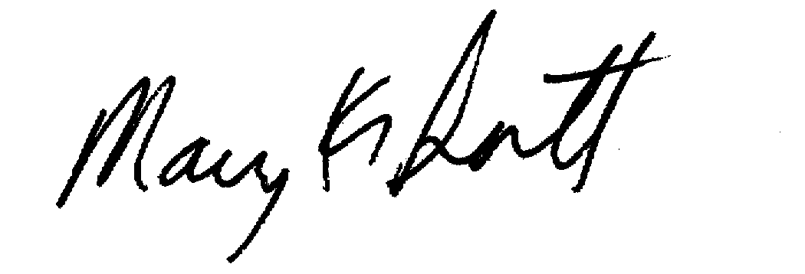

Mary K. Sistik
Project Director

