Subject Line: HUDQC Study PSQ for [Project]

[Project Contact],
The Project Staff Questionnaire (PSQ) is the second and final survey for the FY 2013 HUDQC Study. The HUDQC study, as you may recall, measures the amount and sources of error associated with determinations of eligibility and tenant rent in HUD programs nationwide.

The PSQ attempts to gather best practices for conducting certifications by surveying projects selected for the study. It should be completed in regard to the procedures and practices for administering [Project Information 2]. Please

ensure that the most appropriate person(s) at your PHA/Project completes the questionnaire.

The PSQ is due by [date]. The survey takes approximately 45 minutes to complete and data is saved as you go so you do not need to complete it in one session. To access the survey:
- Click on the following link or copy and paste this address into your browser: https://hudqc.icfiwebservices.com/

- Type or copy and paste the following information:
Survey ID: [ID number]
Username: [Username]
Password: [Password]

If you have any questions, please call Ms. Jagruti Rekhi, ICF Technical Specialist, at toll-free (877) 392-9776 or send an email to hudqc@icfi.com. If you have questions about ICF International’s authorization to collect this information, please contact Dr. Yves Djoko, HUD’s Government Technical Representative for the study, at (202) 402-5851.
We appreciate your cooperation and hope you can help us meet the timeframes in our study schedule.
Thank you,
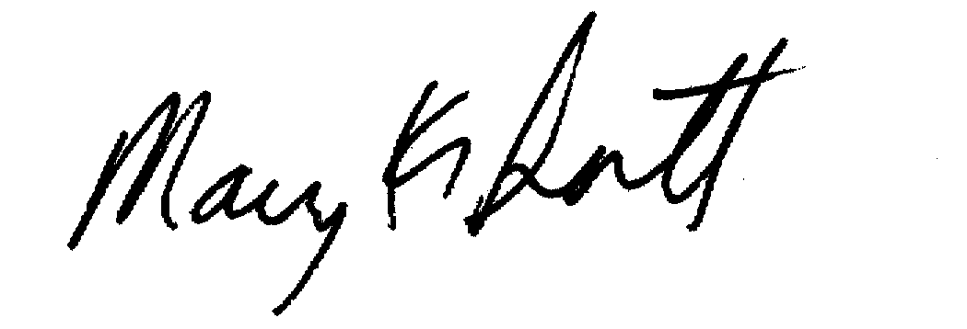

Mary K. Sistik
Project Director

C/P: [Cluster/Project #]

[Project Information 2]:
Public Housing = the Public Housing project(s) with AMP #__________
Section 8 = the project(s) with Contract #____________
HCV Program = the HCV Program in [selected area]
MR = Mod Rehab units in [selected area]

