Justification for Non-material/Nonsubstantive Change

Consumer Financial Protection Bureau

Information Collection Request

Consumer Response Intake Form

The Consumer Financial Protection Bureau (CFPB) submits this memorandum to provide justification for a proposed change to the form associated with information collection 3170-0011 Consumer Response Intake Form, approved by OMB on November 18, 2011.[1] The proposed revision will be reflected on previously-approved information collection media (i.e., telephone script, “paper” form, and web form) and does not represent a new collection instrument.

The Privacy Act statement will be revised to inform users that their complaints or inquiries may be made available to the public, without personally identifiable information, consistent with the CFPB’s general privacy policy. Moreover, in keeping with the CFPB’s commitment to reduce the unnecessary collection of Social Security numbers (SSNs), the Privacy Act statement will include a sentence indicating that disclosure of SSNs is voluntary. There will be no burden increase as a result of these changes.

The revised Privacy Act statement may be found on the final page of the attached paper intake form. The revised Privacy Act statement will appear on the web version of the form as provided below, which will be found at [www.consumerfinance.gov](http://www.consumerfinance.gov):

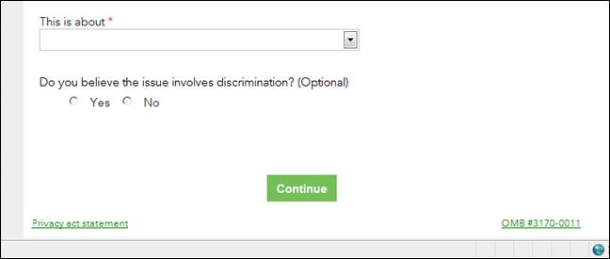

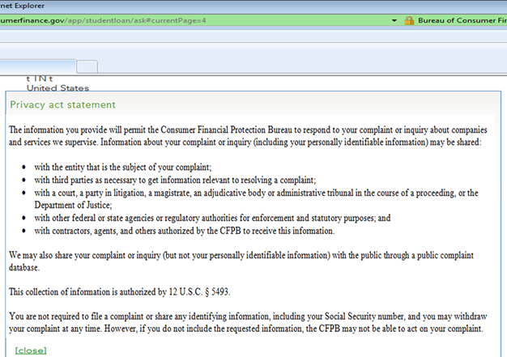

1. Originally approved as a Department of Treasury/Department Offices form, the approved information collection was transferred to Consumer Financial Protection Bureau on November 21, 2011. ICR Reference Number 201111-3170-004.