ATTACHMENT K

MAIL AND INTERNET SHORT FORM FOR TELEPHONE REFUSALS

Date

Name
Job title
Address
City, State Zip

Dear <Fname>,

One of our interviewers contacted you recently regarding an important national study of business competitiveness being sponsored by the U.S. Department of Agriculture, but was unable to complete an interview. Because your participation is important, I am writing to ask for your much needed assistance in this survey.

We have taken the liberty of providing an internet version with the hope that this might be more convenient and easier for you to answer for this business. If you prefer to answer over the Internet, type the web address below into your Internet browser and then enter your access code.
http://opinion.wsu.edu/business/ Access Code: <<RESPID>>
I hope that you will take the time to complete the questionnaire. The internet questionnaire takes less than 30 minutes to complete. If you cannot spare 30 minutes, the attached brief survey can be completed in about six minutes. It will provide some essential information but we hope you are able to complete the full web survey.

Your responses will be kept strictly confidential and your name will not be connected to your answers in any way. The identification number on the back of the survey will only be used to remove your name from the mailing list when your questionnaire is returned.

If you have any questions about this effort, or prefer to answer by telephone, please feel free to call me at 1-800-833-0867 and mention the National Survey of Business Competitiveness.

Thank you in advance for your help. We appreciate it very much.

Sincerely,

Danna Moore, PhD.
Interim Director, SESRC

OMB control number 0536-XXXX
Expires (xx/xx/xxxx)
According to the Paperwork Reduction Act of 1995, an agency may not conduct or sponsor, and a person is not required to respond to, a collection of information unless it has a valid Office of Management and Budget (OMB) control number. The valid OMB number for this information collection is 0536-XXXX. The time required to complete this information is estimated to average 2 minutes per response, including the time for reviewing instructions, searching existing data sources, gathering and maintaining the data needed, and completing and reviewing the collection of information.

YOUR RESPONSE IS VOLUNTARY. YOUR ANSWERS TO ALL QUESTIONS ARE CONFIDENTIAL. All information that is provided by participants to the National Survey of Business Competitiveness will only be used for statistical research purposes and reported in summary form. Your name and that of the business you represent will not be connected to your answers in any way. In accordance with the Confidential Information Protection provisions of Title V, Subtitle A, Public Law 107-347 and other applicable Federal laws, individual responses will be kept confidential and will not be disclosed in identifiable form to anyone outside of the research team. By law, every ERS and SESRC employee is subject to a jail term of up to 5 years, a fine of up to $250,000 or both if he/she discloses any identifiable information about research participants

1. Approximately what year did the business at this location begin operating?

_______ Year

2. Does this business have only one location or more than one location?

₁ Only one location Skip to question 5
₂ More than one location

2a. (If more than one location) Is this location the business’s headquarters or is it a branch location?

₁ Headquarters
₂ Branch location

3. What was the average number of employees on your payroll in 2012, including all full-time and part-time workers at this location?

_______ # of employees

4. Is any part of the workforce unionized or covered by a collective bargaining agreement?

₁ Yes
₂ No

5. Is the current market for your products or services…
₁ Growing
₂ Stable
₃ Declining
₄ Mixed (i.e., some are declining, others growing)
₅ Uncertain

6. In the last 3 years did this business…
Not
Yes No applicable
▼ ▼ ▼
a. Produce any new or significantly improved goods ₁ ₂ ₃
b. Provide any new or significantly improved services ₁ ₂ ₃
c. Introduce new or significantly improved methods
of manufacturing or producing goods or services ₁ ₂ ₃
d. Introduce new or significantly improved logistics, delivery, or
distribution methods for your inputs, goods, or services ₁ ₂ ₃
e. Introduce new or significantly improved support activities
for your processes ₁ ₂ ₃
f. Introduce new or significant improvements
in your marketing methods ₁ ₂ ₃

7. In the current environment, if excess cash were available, how likely is it that these funds would be used to…
Not at all Most
likely Probably definitely
▼ ▼ ▼
a. Provide additional training of employees ₁ ₂ ₃
b. Repay debt ₁ ₂ ₃
c. Provide a reserve or cushion ₁ ₂ ₃
d. Fund additional innovation projects ₁ ₂ ₃
e. Fund additional investment projects,
such as replacing old equipment or for expansion ₁ ₂ ₃

8. Did this business try to borrow money for any purpose over the past three years?
₁ Yes
₂ No
₃ Don’t know

9. That is the last question. If you have any additional comments about this survey or innovation in general, please write them in the box below.

Thank you!!
Please return your completed questionnaire to:

Business Innovation Survey
Social & Economic Sciences Research Center
Washington State University
PO Box 641801
Pullman, WA 99164-1801
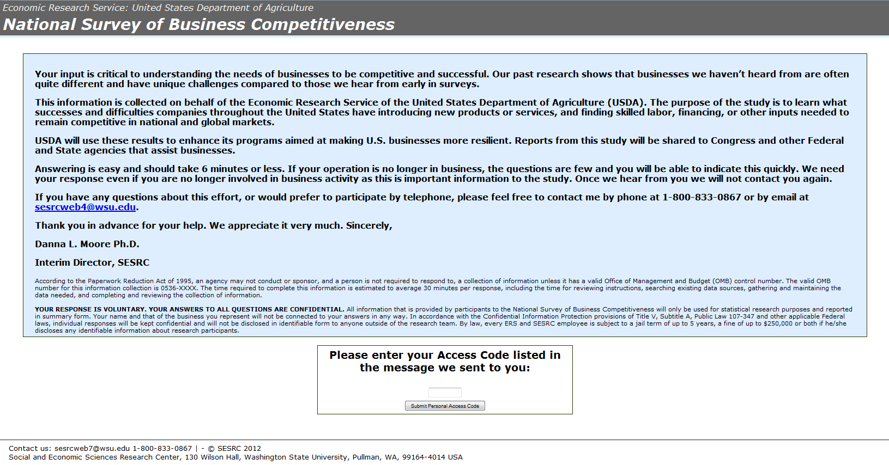

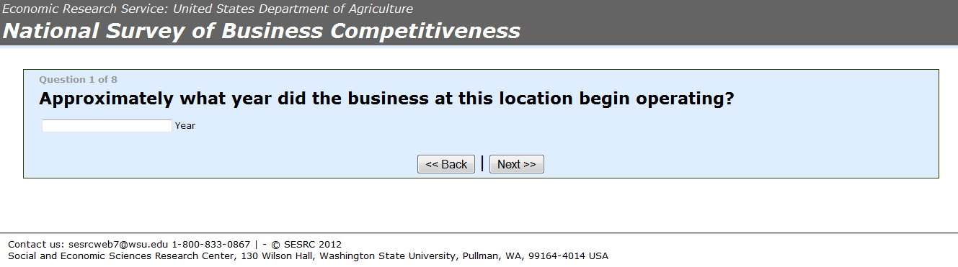

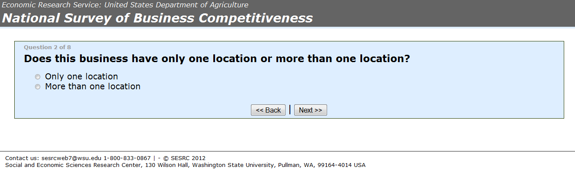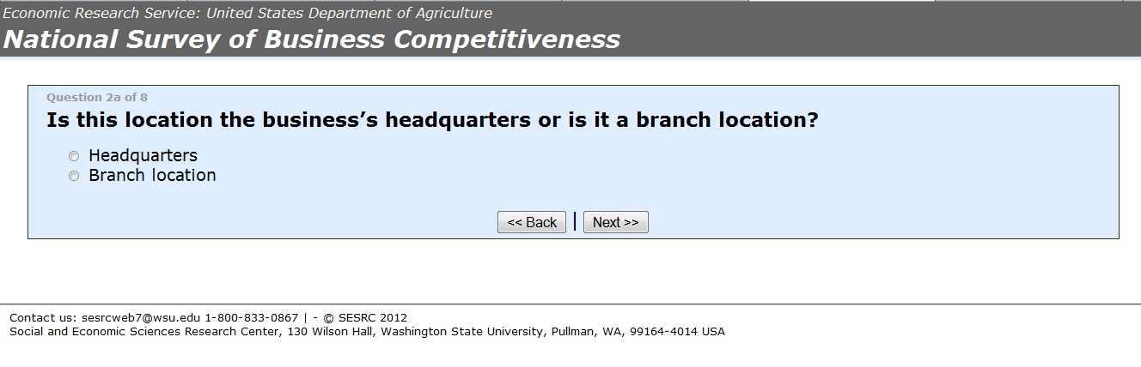
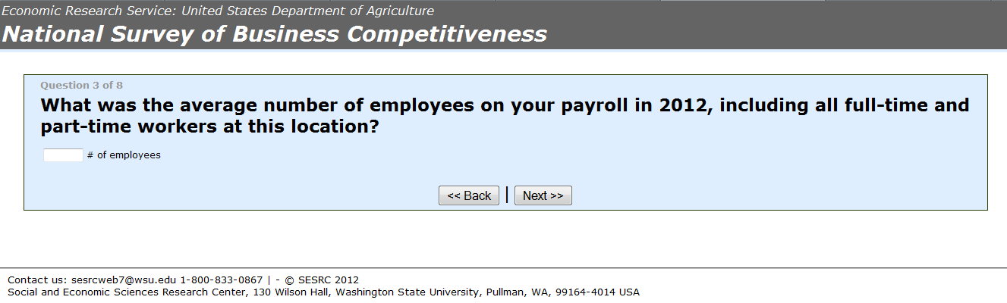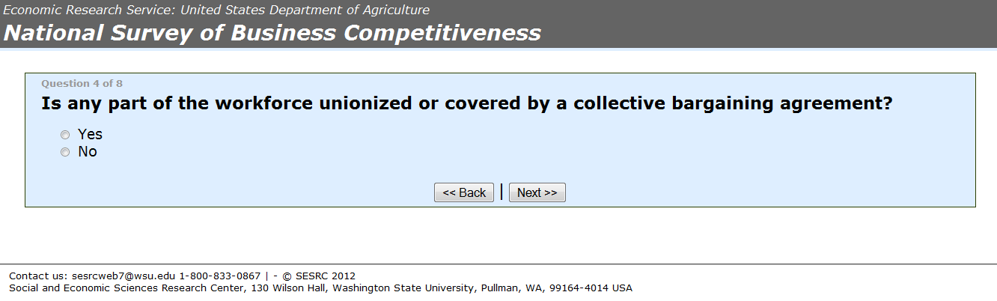
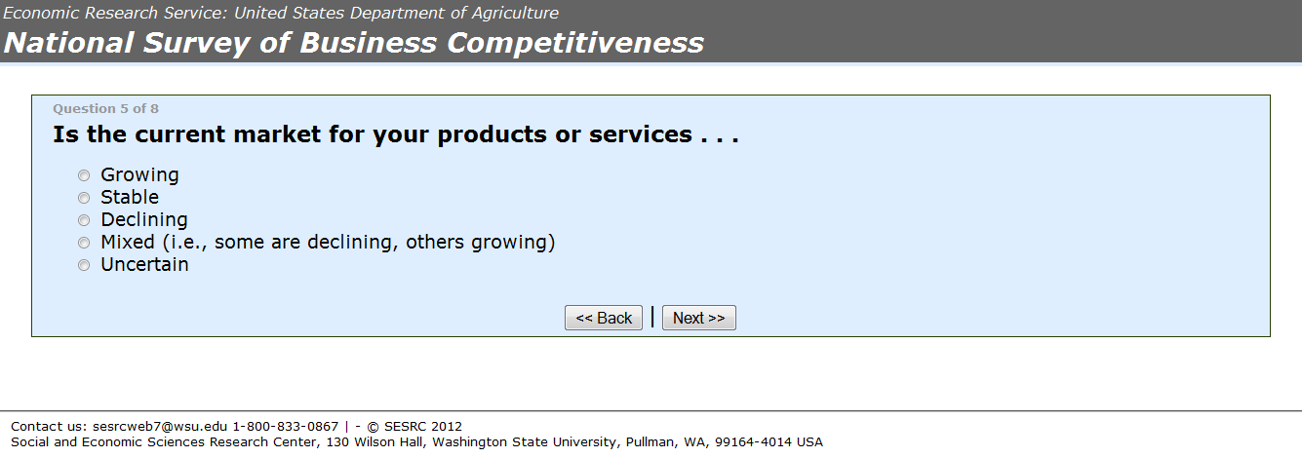
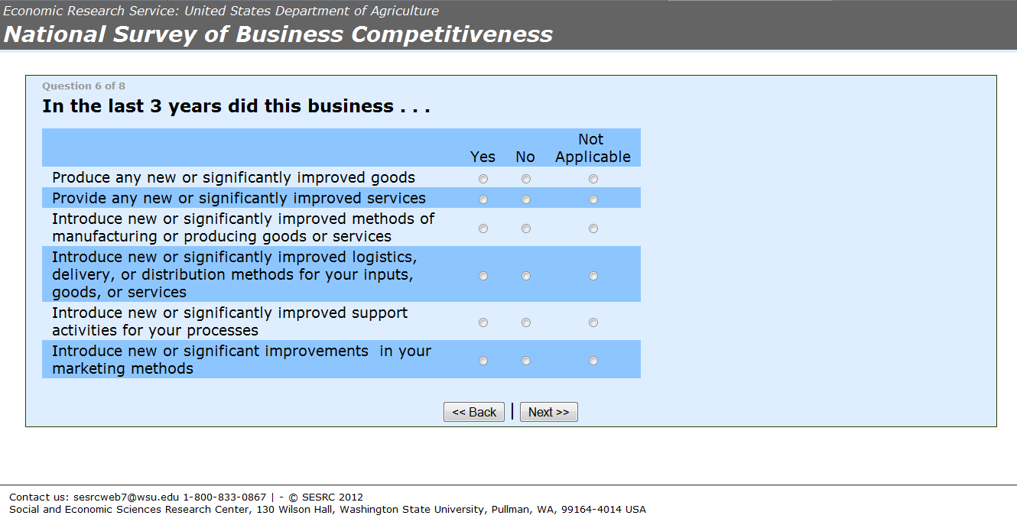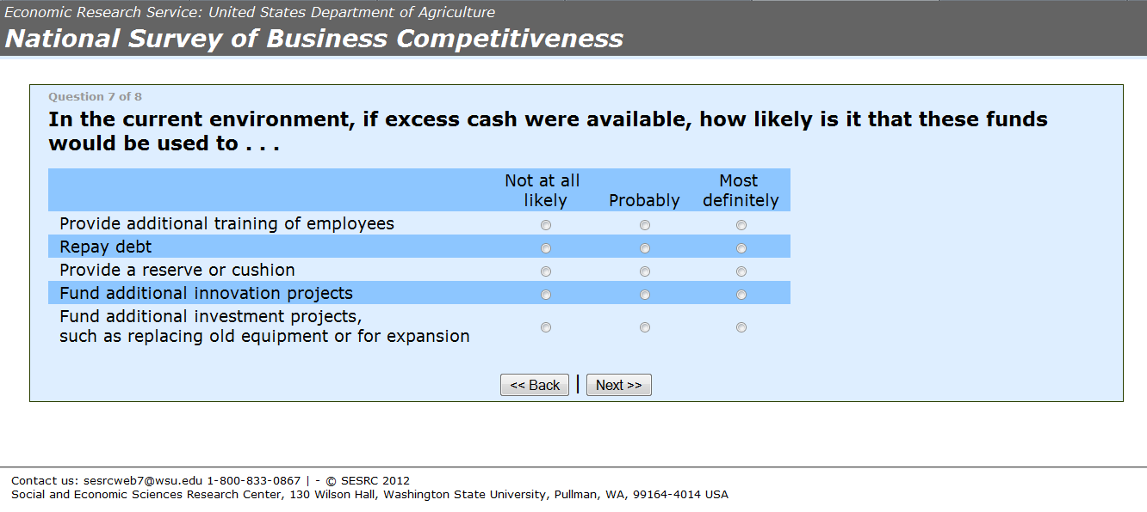
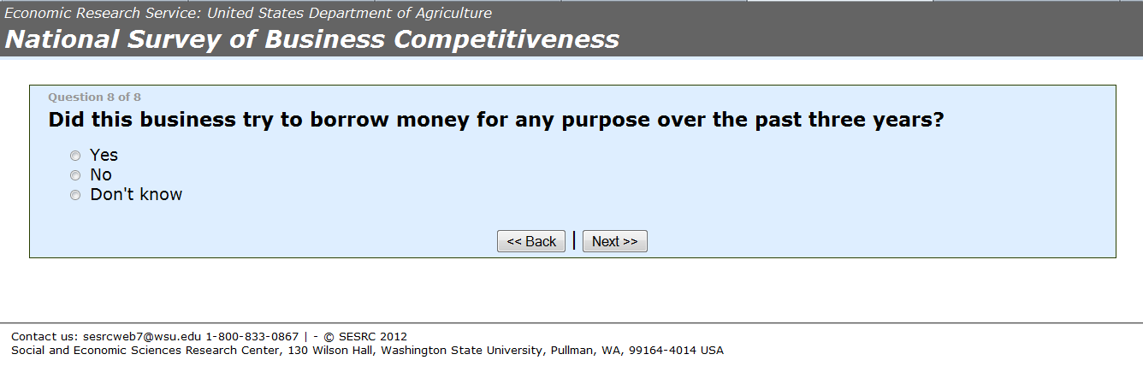

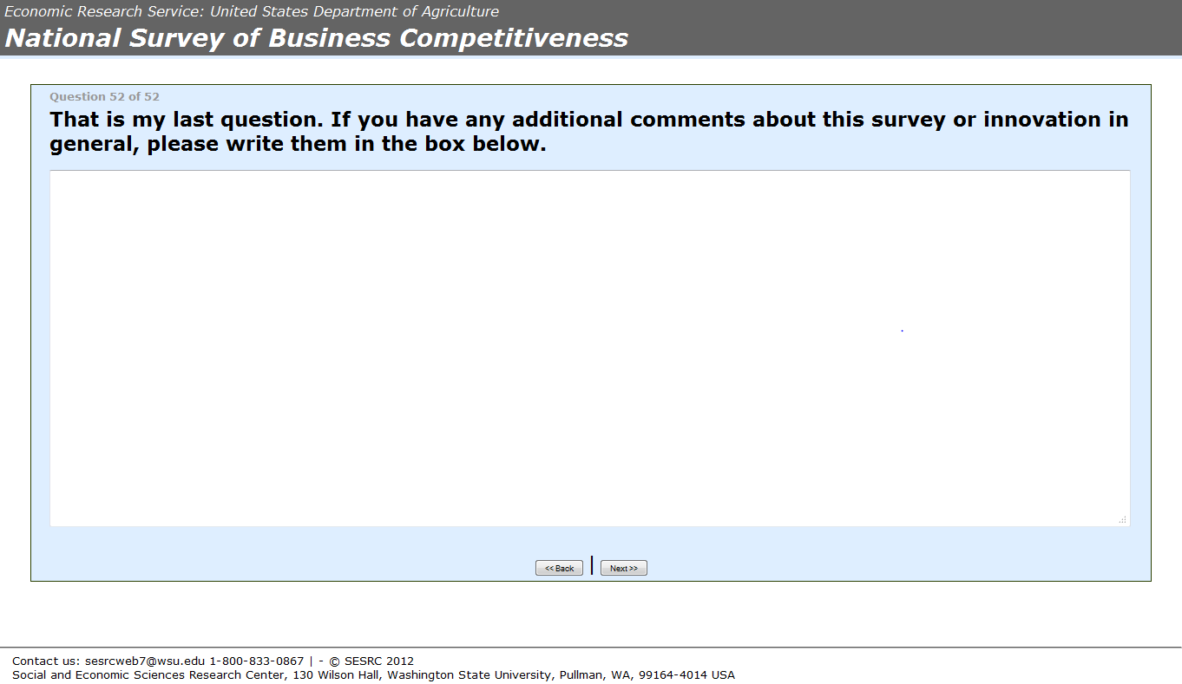

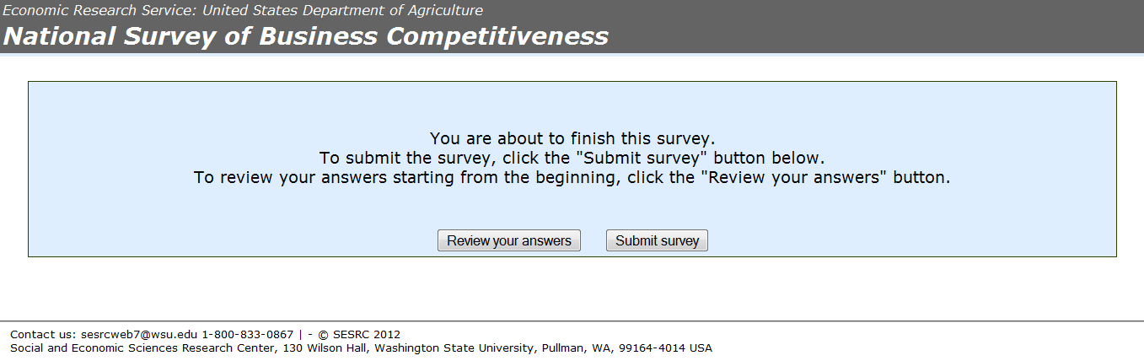
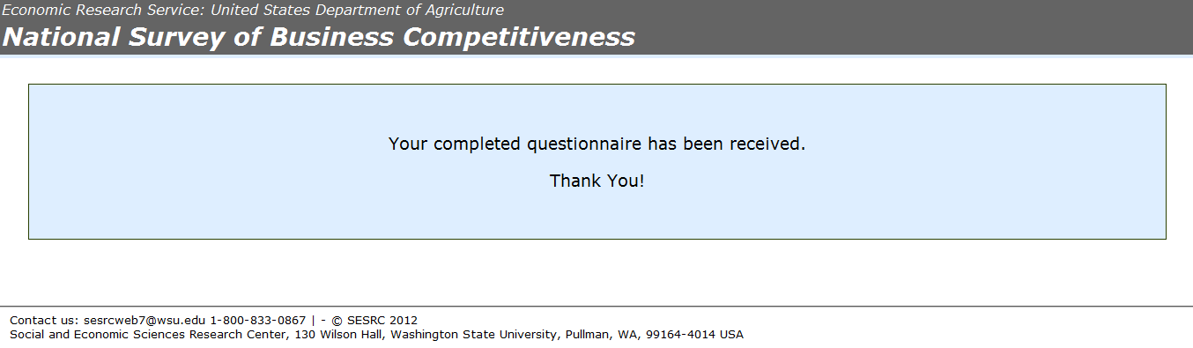

An Internet version of the brief essential information survey is also available online for your convenience. If you prefer to reply online, please go to this website: http://opinion.wsu.edu/businessbrief/ and enter your access code: <RespID> to answer the questions.

