Attachment
1. Initial emails for the Pilot Test (Half the sample will receive the email in Figure 1 and the other half will receive the email in Figure 2)
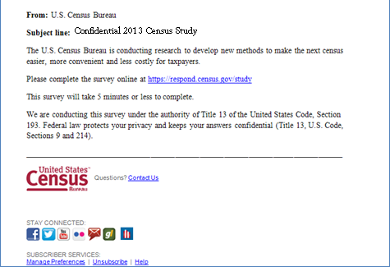
Figure 1: Initial email for half the sample, “Confidential 2013 Census Study” subject line

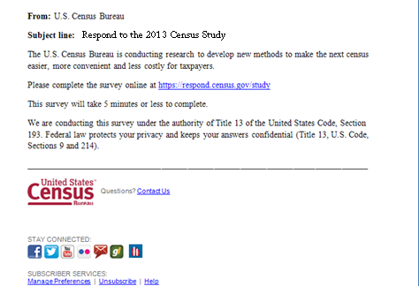
Figure 2: Initial email for half the sample, “Respond to the 2013 Census Study” subject line
2. Reminder emails for the Pilot Test
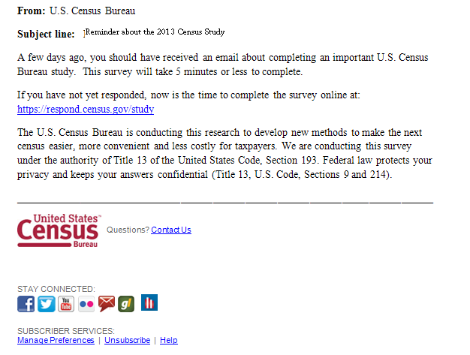
Figure 3: First reminder email –Sent to the sample which did not click the link to the survey

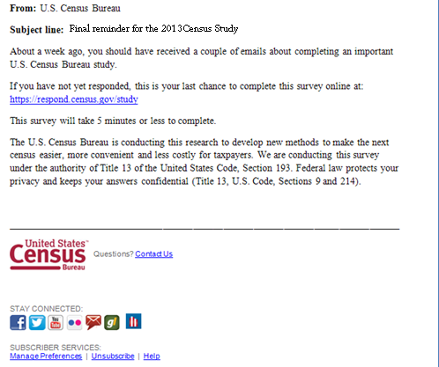
Figure 4: Final reminder for the pilot study -- Sent to the sample which did not click the link to the survey
3. Landing page
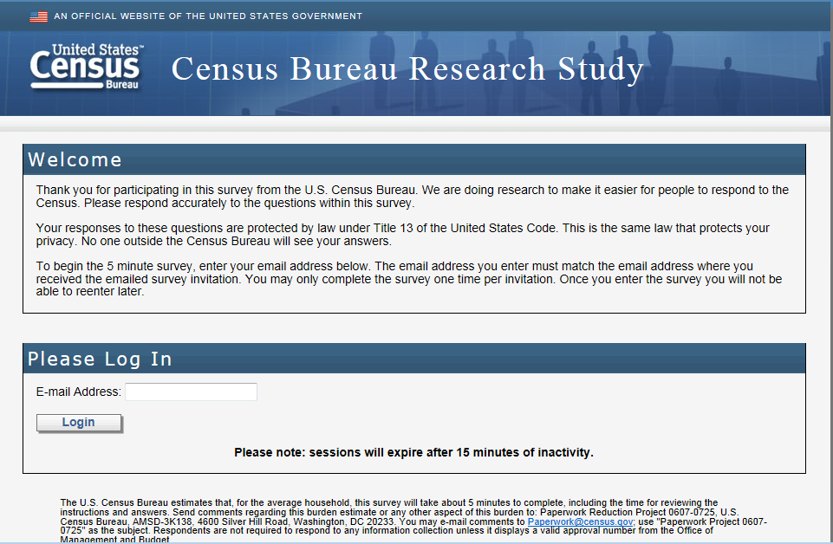
Figure 5: Landing page after clicking the link in the email (for all panels)
4. Screen shots of production address screens (horizontal design) (Half the sample will receive this design.)
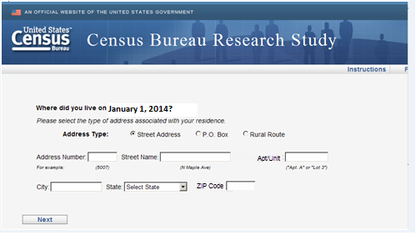
Figure 6: Main screen with the default selection of Street Address
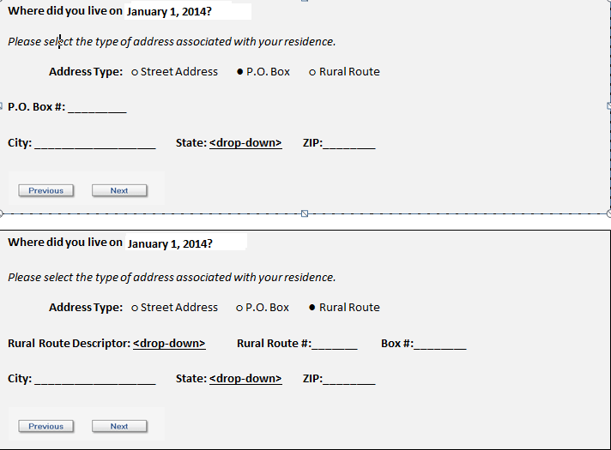
Figure 7: The screens if P.O. Box or Rural Route are selected
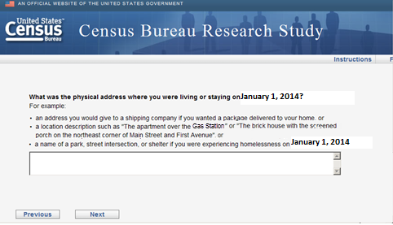
Figure 8: Write in screen if the respondent selects P.O. Box or Rural Route (The examples on the screen are a result of the usability testing conducted and are not the same examples in the 2014 Census production instrument.)
5. Screen shots of cognitive testing address screens (vertical design) (The other half of the sample will receive this design.)
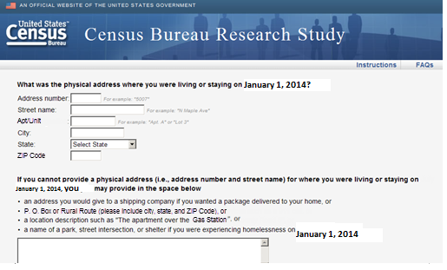
Figure 9: Design similar to the design of the 2020 Census Coverage Cognitive Testing project
6. Opinion debriefing questions (All sample) (Response choices in Question 2 will be randomized.)
- We want to get usability feedback on the address screens you just completed.
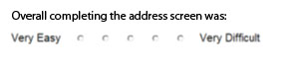
- We want to get feedback on possible email message subject lines to use in future Census Bureau studies.
Which email message subject line(s) would you be likely to click on if you saw it in your inbox? You may select more than one.
Important Census Study
Mandatory Census Study
Improve the U.S. Census Study
Help us make the U.S. Census better, answer our survey
Answer the U.S. Census– Help your community
10 minutes to improve the U.S. Census and help your community
Your Civic Duty – Answer the U.S. Census!
A message from the Director of the U.S. Census Bureau
A message from John Thompson, Director of the U.S. Census Bureau
- Do you have any additional comments on either the address screens or the possible email subject lines?
[250 max characters] with character count down

7. Additional debriefing questions (All sample) (This will be on a new page and it will be all one page.) (Response choices in Questions 1 and 2 will be randomized.)
- Every 10 years, the Census Bureau counts everyone living in the United States. We do this by collecting information from each address. For the next census in 2020, how would you prefer to be contacted by the Census Bureau?

❑ Mail a form to my home
❑ Mail a letter to my home containing the link to the online form
❑ Email a link to the online form
❑ Call me on my home phone (landline)
❑ Call me on my cell phone
❑ Text message me a link to the online form
❑ Send an interviewer to my home

- For the 2020 Census, would you rather the Census Bureau:
❑ contact you to get your information
❑complete your form for you using information you have already provided other
government agencies

- What information do you think the census typically collects every 10 years?
Select all that apply
- Names of all adults living at your address
- Names of all children living at your address
- Social security number
- Age
- Date of birth
- Race
- Ancestry
- Income
- Relationship
- Citizenship

- Do you have…
  - A cell phone?
❑Yes
❑No
  - A handheld device made primarily for e-book reading, such as a Nook or Kindle e-reader?
❑Yes
❑No
  - A tablet computer such as an iPad, Samsung Galaxy Tab, Google Nexus or Kindle Fire? ❑Yes
❑No

  - An iPod or other MP3 player?
❑Yes
❑No
  - A game console like an Xbox or PlayStation?
❑Yes
❑No
- (if yes to 4a) Some cell phones are called ‘smartphones’ because of certain features they have. Is your cell phone a smartphone or not, or are you not sure?
❑Yes
❑No
❑Not Sure

- (if yes to 5a) Which of the following best describes the type of cell phone you have? Is it an iPhone, a Blackberry, an Android phone, a Windows phone, or something else?
❑iPhone
❑Blackberry
❑Android
❑Windows
❑Something else

- Are you male or female?
❑ Male
❑ Female

- What is your age?
❑ Less than 18 years old
❑ 18-24
❑ 25-34
❑ 35-44
❑ 45-54
❑ 55-64
❑ 65 or older

- Are you of Hispanic, Latino or Spanish origin?
❑ Yes
❑ No

- What is your race? You may select one or more.
❑ White
❑Black or African American
❑American Indian or Alaska Native
❑Asian
❑Native Hawaiian or Other Pacific Islander

- What is your highest level of education?
❑ Less than High School Diploma or GED
❑ High School Diploma or GED
❑ Some College
❑ College Graduate or Professional Degree

- Which of the following best describes your current field of work?
❑ Student/Educator
❑ Government
❑ Technical/Professional
❑ Service (e.g., retail, food service, protective service, and so on)
❑ Retired or not currently working for pay
❑ Other Please specify [ 50 characters ]

- Would you like to receive a link to the research report for this study when it is complete?
❑ Yes
❑ No

Thank you for your participation in this survey. Your responses are very helpful in our research!

