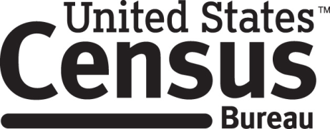

Consent Form

National Crime Victimization Survey, School Crime Supplement

Each year the Census Bureau conducts many different surveys. The Census Bureau routinely tests the questions used on these surveys in order to produce the best information possible.

______________________ [NAME] consents to take part in a study to improve the questions that will be used in the National Crime Victimization Survey, School Crime Supplement. In order to have a complete record of all comments, the interview session will be audiotaped. The Census Bureau plans to use the tapes to improve the questionnaire. Staff directly involved in the questionnaire design research project will have access to the tapes. Participation is voluntary and answers will remain strictly confidential.

This study is being conducted under the authority of Title 13 USC. The OMB control number for this study is 0607-0725. This valid approval number legally certifies this information collection.

I have agreed to participate in this Census Bureau questionnaire design study, and I give permission for my tapes to be used for the purposes stated above.

____________________________ ___________________________
Participant's Signature Researcher's Signature

____________________________ __________________________
Printed Name Printed Name

___________________________ _______________________
Date Date

