Vignettes
Depending upon time left in the interview, respondents will answer these vignettes. Give them the piece of paper with the vignette, have the participant read it aloud and then answer the questions on the next 2 pages. They only need to answer A39-A44 and D17-D21. Have them complete all 3 vignettes then review their answers if they deviate from how the sponsor would have wanted them to respond.

There is one last task I would like your help with. We would like to gather more information on how the certificates and licenses and certification questions work for different situations. Please read the following situation. Based on that situation, please answer the questions that follow to the best of your ability.
#1

Maria got a bachelor’s degree in history, but was having trouble finding a job. One of her friends told her about a certificate program in real estate that he finished in less than a year at the local community college. He felt that it really paid off for him, so Maria enrolled, got her realtor's license after completing the program, and now has her own real estate business.

Pretend you are Maria. How would you answer the questions on these next two pages?

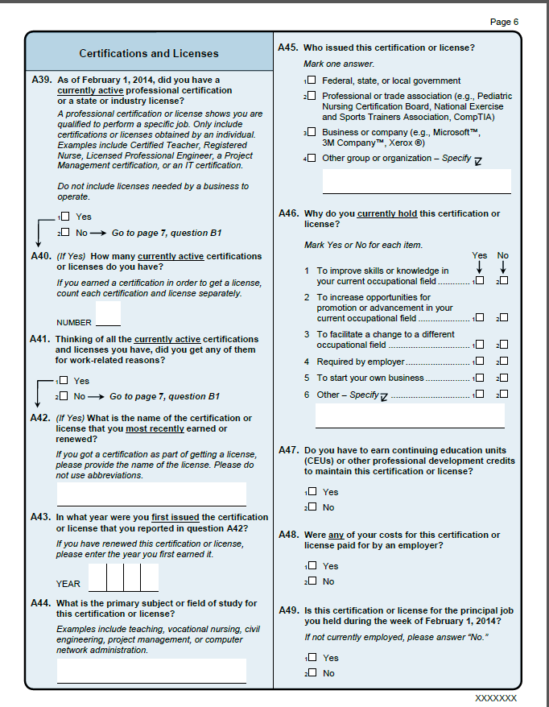

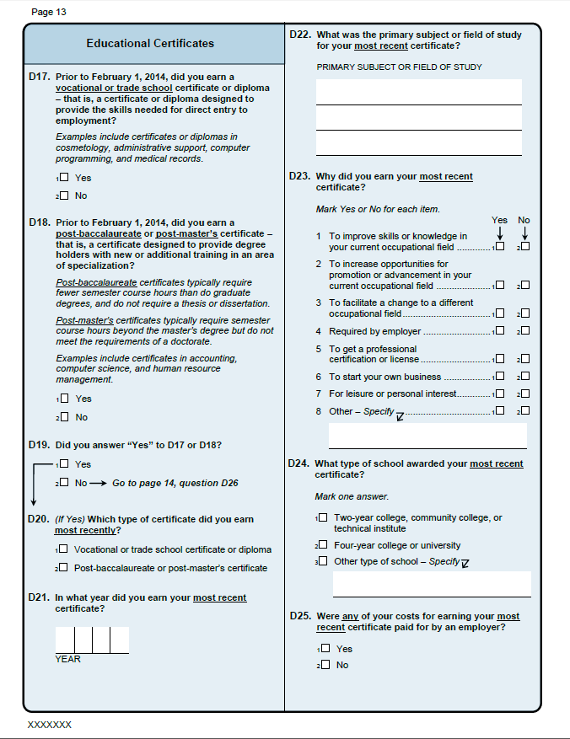

#2

John received a certificate in Computer Information Systems after attending a one-year program at a technical college. At the end of the program, John took the CompTIA A+ certification exams at a local testing site. After passing the two exams required for certification, John was certified to provide service to Dell, Intel, and Lenovo equipment.

Pretend you are John. How would you answer the questions on these next two pages?

#3
After completing a certified nursing assistant (CNA) program at the CNA Nursing School of Maryland, Ann worked as a CNA for years, moved to a different state, then decided to go back to school and get a degree to improve her career opportunities. She enrolled in a Bachelor’s of Science program at a local nursing school, which accepted many of the credits she had earned in her CNA certificate program. Once she earned her degree and passed her licensure exam, she obtained a Registered Nurse (RN) position.

Pretend you are Ann. How would you answer the questions on these next two pages?

