(Note: this is being programmed electronically in house)

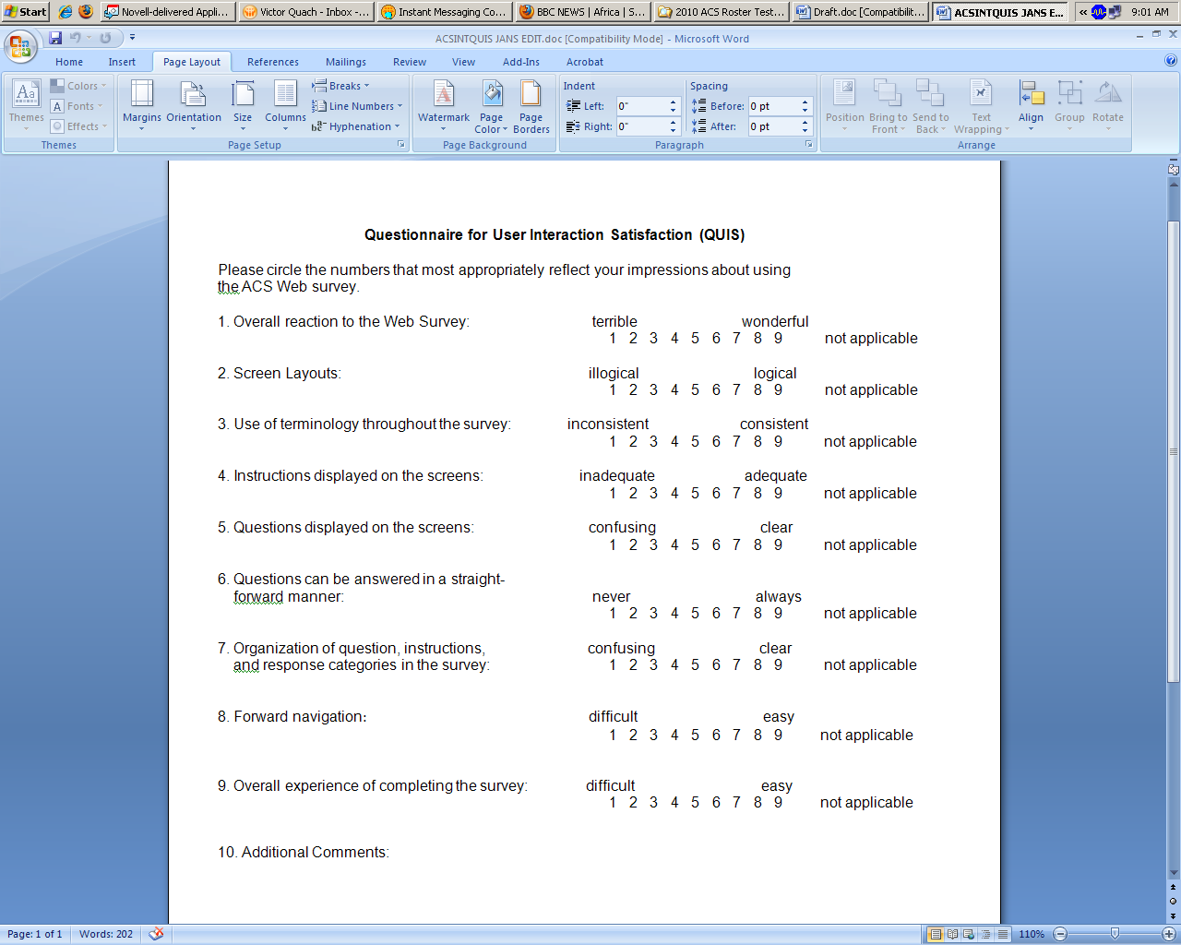

|  |  |  |  |  |  |  |  |  |  |  |  |
| --- | --- | --- | --- | --- | --- | --- | --- | --- | --- | --- | --- |
| 10. Correcting your mistakes: | difficult easy | | | | | | | | | | |
|  | 1 | 2 | 3 | 4 | 5 | 6 | 7 | 8 | 9 | not applicable |
| 11. Font on the screen: | hard to read easy to read | | | | | | | | | | |
|  | 1 | 2 | 3 | 4 | 5 | 6 | 7 | 8 | 9 | not applicable |
| 12. Arrangement of information on the screen: | illogical logical | | | | | | | | | | |
|  | 1 | 2 | 3 | 4 | 5 | 6 | 7 | 8 | 9 | not applicable |

13: Other comments