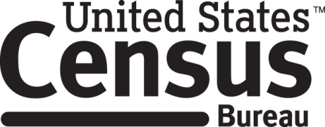

Consent Form

2020 Census Focus Groups

Every ten years the Census Bureau conducts a census of the United States population. In preparation for this task, the Census Bureau conducts smaller tests in order to improve how data is collected. This 2020 Census Research focus group is part of the effort to improve the 2020 Census.

______________________ [NAME] consents to take part in a focus group to improve the Census in 2020. In order to have a complete record of all comments, the focus group session will be audio-recorded and video-recorded. The Census Bureau plans to use the recordings to improve the next Census. Staff directly involved in the questionnaire design research project will have access to the recordings. Participation is voluntary and answers will remain strictly confidential. Focus group participants are not allowed to discuss the focus group discussion with people who did not participate in the focus group.

This study is being conducted under the authority of Title 13 USC. The OMB control number for this study is 0607-0725. This valid approval number legally certifies this information collection.

I have agreed to participate in this Census Bureau focus group, and I give permission for my tapes to be used for the purposes stated above.

____________________________ ___________________________
Participant's Signature Researcher's Signature

____________________________ __________________________
Printed Name Printed Name

___________________________ _______________________
Date Date

