**Part 4 Puerto Rico Focus Group**

**Operation and Participant Recruitment Plan**

**Revision History**

|  |  |  |  |
| --- | --- | --- | --- |
| **Date** | **Version Number &**  **Purpose** | **Author** | **Submitted by** |
| 3/23/16 | 1.0 | RSS | Katherine Kenward |
| 3/23/16 | 1.1 | RSS | Katherine Kenward |
| 3/24/16 | 2.0 | RSS | Alisu Schoua-Glusberg |
| 3/29/16 | 3.0 | RSS | Katherine Kenward |

**Part 4: Puerto Rico Focus Group**

**Operation and Participant Recruitment Plan**

Contents

Overview 3

Project Synopsis 3

Focus Group Content 3

Focus Group Locations 3

Focus Group Composition: 4

Sampling and Recruitment Criteria 5

Enrollment 7

Focus Group Team Qualifications 7

Appendix A - Information Sheet 9

Appendix B - Teasers 10

Appendix C – Flyer Template 11

Appendix D – Advertisement Template 12

Appendix E - Screener 13

## Overview

This recruitment plan addresses the methodological and operational aspects of sampling and screening participants to participate in Census Bureau-sponsored focus groups to improve the 2020 decennial census.

## Project Synopsis

A total of six focus groups will be conducted in Puerto Rico over 4 days in June 2016. Each group will consist of 8-10 participants as best practice suggests (up to 15 participants will be recruited to account for cancellations and no-shows), led by an experienced Spanish-language focus group moderator. The focus groups will take up to 2 hours and participants will be offered incentives of $75 to offset the cost of their participation, such as transportation or childcare costs. After obtaining signed consent, the focus group discussions will be both audio and video recorded. All focus group discussions, recruitment screening, and printed materials will be in Spanish.

## Focus Group Content

The objective of all six focus groups is to understand how participants report their addresses, how they describe their mailing address, their physical address, and how this may best be captured by Internet-instrument address screens for residents of Puerto Rico (PR).

Discussions will include items such as:

* Can the materials capture the location of their actual dwelling, for example, where an ambulance or delivery person would be sent rather than how mail would be addressed?
* Are they comfortable providing the information requested, including participants in various types of housing situations?

Participants will be shown various screenshots or mockups of questionnaire screens (from the 2015 National Content Test and from proposed screens for the 2017 Puerto Rico Census Test) with radio button options and fill-in choices in order to determine:

* How do participants respond to the materials? Would they fill in their complete address?
* Would they fill in only the *applicable* portions of their address and leave blank the other write-in fields?
* Can participants provide their address information on each screen as they believe it should be captured?
* What fields or buttons do they see as unnecessary or would they disregard?
* What fields or buttons do they find particularly useful or helpful?
* Do the drop-down fields help in guiding them to answer the appropriate write-in fields?

## Focus Group Locations

Several factors were taken into account in selecting the focus group locations and number of groups per location. Site selection aimed to capture a variety of address situations across the island, both in terms of types of housing and rural/urban environments. In addition, we needed to include locations that are easily accessible to potential participants (i.e., by public transportation in urban areas and by bus or car in rural areas), and that have business facilities that can accommodate focus group equipment and private participant discussions.

* Three groups will be conducted in San Juan.
* One group will be conducted in Caguas, a city in the municipality of the same name, south of San Juan within the central mountain range, with easy route access from the surrounding Caguas region as well as from the municipalities of Cayey and San Lorenzo.
* Two focus groups will be conducted in Mayagüez on Puerto Rico's western seaboard.

The San Juan focus groups will be conducted in a professional focus group facility. The three focus groups outside of San Juan will be conducted in hotel conference facilities. A staff member from the San Juan facility will assist in setting up the Caguas and Mayagüez focus groups and provide video and audio equipment from the San Juan site. Only researchers with Census Bureau-clearance will be present during the focus group discussions. Census Bureau staff will be invited to observe all the focus groups.

## Focus Group Composition:

We anticipate that conducting the focus groups in the three selected locations will allow us to include participants with a wide range of address situations. Efforts will be made to group participants by similar address types and socio-economic situations to facilitate discussion and minimize inhibitions. The goal is to create relatively homogeneous groups so that participants feel comfortable expressing their views. For each group we will strive to recruit a group with a good distribution by gender and age.

Although we will substantially over recruit (up to 15 participants to keep 8 to 10), there is always a possibility of unexpected last minutes circumstances (tropical storms or traffic accidents, for instance) that may cause fewer than 8 participants to be present for the focus group. Should such a situation arise, and after last minute attempts to identify additional participants, we will request permission from the Census Bureau to proceed with fewer than 8 participants.

***Exhibit A*** below shows our current plan for which location will draw participants with specific types of addresses. If adjustments are needed to improve recruitment efforts, we will obtain Census Bureau approval before implementing any changes.

Exhibit A. Focus Group Sites and composition

| **Types of Address Included** | **Location** |
| --- | --- |
| Private housing developments (e.g. *urbanizaciones*)  Subsidized housing (e.g. *residenciales*)  Neighborhoods/Settlements/Village (e.g. *barrios, barriadas, sector* etc.) | San Juan Focus Group Facility |
| Plots (*parcelas*) / farms / rural areas | Caguas Business Facility (Hotel) |
| Urban housing (general) - address types to be determined  Rural housing (general) - address types to be determined | Mayagüez Business Facility (Hotel) |

## Sampling and Recruitment Criteria

Including participants with unique characteristics in a focus group is particularly challenging because not only must one identify a willing participant with the desired characteristic, but that person must also be willing and able to attend a focus group on a specific date and at a specific time and place. Because of this, we tend to be conservative about recruiting for specific characteristics. Although we will strive for a mix of gender, age and education, recruiting will focus on address type and comfort with accessing the internet rather than household composition or demographic characteristics.

After each focus group is completed, additional demographic data will be collected from participants in a self-administered one-page Information Sheet, to further explain study findings (see Appendix A). This information will include English language competency, ethnicity and race, and household count, length of time at current address and the previous address.

Eligibility criteria

To be eligible, participants must:

* be 18 years old to participate and able to consent.
* read and write Spanish in order to participate fully in the focus group activities and discussion
* live in a dwelling with an address type of interest to the research objectives for the specific focus group in their area
* indicate that they are comfortable or very comfortable with accessing the Internet from a device such as a smartphone, tablet, laptop or desktop computer.

Sampling/Recruitment

We expect to recruit up to 15 individuals per focus group for a total of 90 participants. By recruiting more than we require in each focus group we can be fully confident that groups contain the 8-10 participants. If more than 10 participants arrive at a scheduled group, the moderator will choose the best mix of individuals based on their screener responses. Facility staff will give the remaining individuals the $75 incentive, thank them, and dismiss them.

Recruitment will be conducted by RSS recruitment experts using proven methods that combine broad approaches --such as newspaper advertisements, and localized approaches, including the distribution of flyers and word-of-mouth alerts from community organizations including churches, service agencies and community groups. Utilizing local contacts can facilitate reaching individuals that meet specific desired address characteristics while reducing the risk of priming that individual (see Screening/Recruitment below). In all three locations there are a number of organizations that can be tapped for support. For example, there are 109 non-profit and 501c organizations in the Caguas region[1] and 81 in the Mayagüez area.[2] There are also area churches, universities and businesses such as grocery stores where it may be possible to recruit.. Although organizations and others may assist in identifying potential participants and alert them to the study, they will not be privy to the identity of individuals who initiated contact with our recruiters nor which of them were invited to participate in a focus group.

Screening/Recruitment

Newspaper advertisements and flyers will include the study sponsor, a 'teaser' (headline) that is targeted to the specific recruitment criteria, and information about a focus group (see Appendix B-Teasers; Appendix C-Flyer; Appendix D-Advertisement). Ads will also include an invitation to call a toll free number for more information and to volunteer for the focus group. Recruiters will screen all incoming calls for possible participation. The screener (Appendix E) includes information about the study, the nature of a focus group, privacy and confidentiality assurances, and screening questions to confirm eligibility of participants.

Screening questions consist of:

* Basic demographic information such as gender, age and education.
* Potential usefulness as a participant including Spanish literacy, native language and internet comfort level
* Eligibility to receive the incentive of $75. Participants who work for the federal government are not eligible.
* Potential usefulness as an informant on specific types of address issues.
* Contact information for call backs and scheduling

Priming

Questions on the potential usefulness of an individual as an informant on specific address issues are critical to identify the best participants and to place them in the appropriate focus group. These questions, however, need to be carefully crafted to minimize priming participants to the issues being tested. The screener and recruiting materials attempt to balance these opposing needs. Recruiters will be trained on the risks of priming and how to use the screening tool in a way that minimizes that risk while collecting all the needed information.

An initial screening question asks the caller why they believe they are qualified for the study. This question has proven to be a powerful tool in the past because it allows the participant to articulate their qualifications based on the flyer or ad they saw which may not be clearly associated with the issues being tested. A teaser, for example, asking if a participant lives in a *barriada* for example, would not alert a participant to the issues of address testing.

Additional screening questions gather more information on living situation but are ambiguous enough that they do not create a significant priming risk.

* What community the participant lives in,
* Type of housing (apartment or home) and
* How mail is delivered – to the home, to a PO box or to another location

If the recruiter does not fully understand the address situation of the caller after these questions she will then ask up to three final questions that involve some risk of priming but have been drafted to minimize this risk. The first asks for the caller to answer yes or no to a variety of living situations including if they live in specific types of communities, dwellings, or farms. The list is varied enough that the caller may not associate their address situation with the specific aim of the focus group. Only if the recruiter still does not understand the address situation will she ask the participant to give her their address and to clarify if that address is for mail or emergency services. These final questions do risk priming the participant so will only be used when address clarity has not otherwise been achieved.

## Enrollment

At the time of the initial call, recruiters will collect contact information and confirm the caller is available to attend the focus group on a specific date. Recruiters and the recruitment manager will then select eligible participants and create focus groups based on their address characteristics. Demographic characteristics will also be considered in selecting from among eligible participants. Return calls will be made inviting participants to come to the scheduled focus group. Recruiters will also have the option of scheduling a caller on the initial call if they meet eligibility and usefulness requirements.

## Focus Group Team Qualifications

Alisú Schoua-Glusberg, RSS, will moderate at least three of the six focus groups. She is a Cultural/Linguistic Anthropologist (Northwestern University, Ph.D. 1985) and a Senior Survey Methodologist with 30 years of experience. She has moderated over 150 focus groups, mostly in Spanish. She has done qualitative data collection with Puerto Rican respondents in a variety of settings. She has assisted the Census Bureau with research for the Puerto Rican Community Survey. She is internationally renowned for her work and writings in translation methods and in cross-cultural cognitive interviewing techniques.

Georgina McAvinchey, RTI, will moderate at least two of the six focus groups. She is a native Spanish speaker with 15 years of experience conducting cross-cultural survey research specializing in Spanish survey translation and instrumentation. She has extensive experience moderating focus groups in Spanish, and most recently with Puerto Rican participants who provided feedback to Census Bureau mailing materials and selected Census form items. She is adept at interacting with Puerto Rico residents in interview settings, most notably through her cognitive interviewing work in Puerto Rico for the Puerto Rico Community Survey. In addition, she conducted usability testing of the 2015 NCT non-ID Puerto Rico address screens for the Census Bureau and has deep appreciation for the significance of the current research.

Jennifer Moncada, RTI, will serve as the notetaker for all six focus groups and the post-group debriefings. She is a native Spanish speaker with 10 years of experience conducting research specifically to address the public health needs within the Hispanic/Latino community. In 2015, she assisted Ms. McAvinchey with usability testing of the 2015 NCT non-ID Puerto Rico address screens and analysis of focus group data with Puerto Rican participants, both for the Census Bureau.

## Appendix A - Information Sheet

**Focus Group _______**

**Thank you for participating in today’s focus group. Please complete the following information sheet so we may better understand your household characteristics.**

1. What is the ID number assigned to you during today’s discussion? ____________

1. How well do you speak English?
   * Very Well
   * Well
   * Poor
   * Not at all
2. How well do you read English?
   * Very Well
   * Well
   * Poor
   * Not at all
3. Are you of Hispanic, Latino or Spanish origin?
   * Yes
   * No
4. What is your race and origin?

|  |
| --- |
| MARK ALL THAT APPLY |
| * White |
| * Black or African American |
| * American Indian/Alaska Native |
| * Asian |
| * Native Hawaiian or Pacific Islander |
| * Some Other Race___________________ |
| * No other Race |

1. How many people are living or staying in your household including yourself? _____
2. How long have you lived at your address? ______________Year(s)
3. What was your previous address? _____________

## Appendix B - Teasers

**Recruiting Teasers for Census Project A, Part 4 - Puerto Rico**

Teasers (headlines) are the phrases used at the top of a flyer or as the subject line in a newspaper or online ad. The teasers below may be used individually or with an ‘and’ between them to allow for broad or narrow targeting of potential participants. Not all teasers may be used.

Do you live in an apartment complex?

Do you use a PO Box to get your mail?

Do you live in a parcela?

Do you live in a barrio?

Do you live in a sub-barrio?

Do you live in a barriada?

Do you live in a sector?

Do you live in an urbanizacion?

Do you live in a residenciales?

Do you live in <name of apartment complex that is of interest>?

Do you live in <name of Barrio or sub-barrio of interest>?

Do you live in <name of parcela of interest>?

Do you live in <name of municipio of interest>?

Do you live in <name of barriada of interest>?

Do you live in <name of urbanizacion of interest>?

Do you live in <name of sector of interest>?Do you live in <a residenciales of interest>?

Do you live in a rural area?

Do you live in an urban area?

Do you live on a farm?

Can you travel to San Juan for a study?

Do you use the internet?

Do you own a smartphone or a tablet with wi-fi access?

Do you own an iPhone or android phone?

Do you own a computer?

Do you use a computer to access the internet?

Do you own a laptop?

## Appendix C – Flyer Template

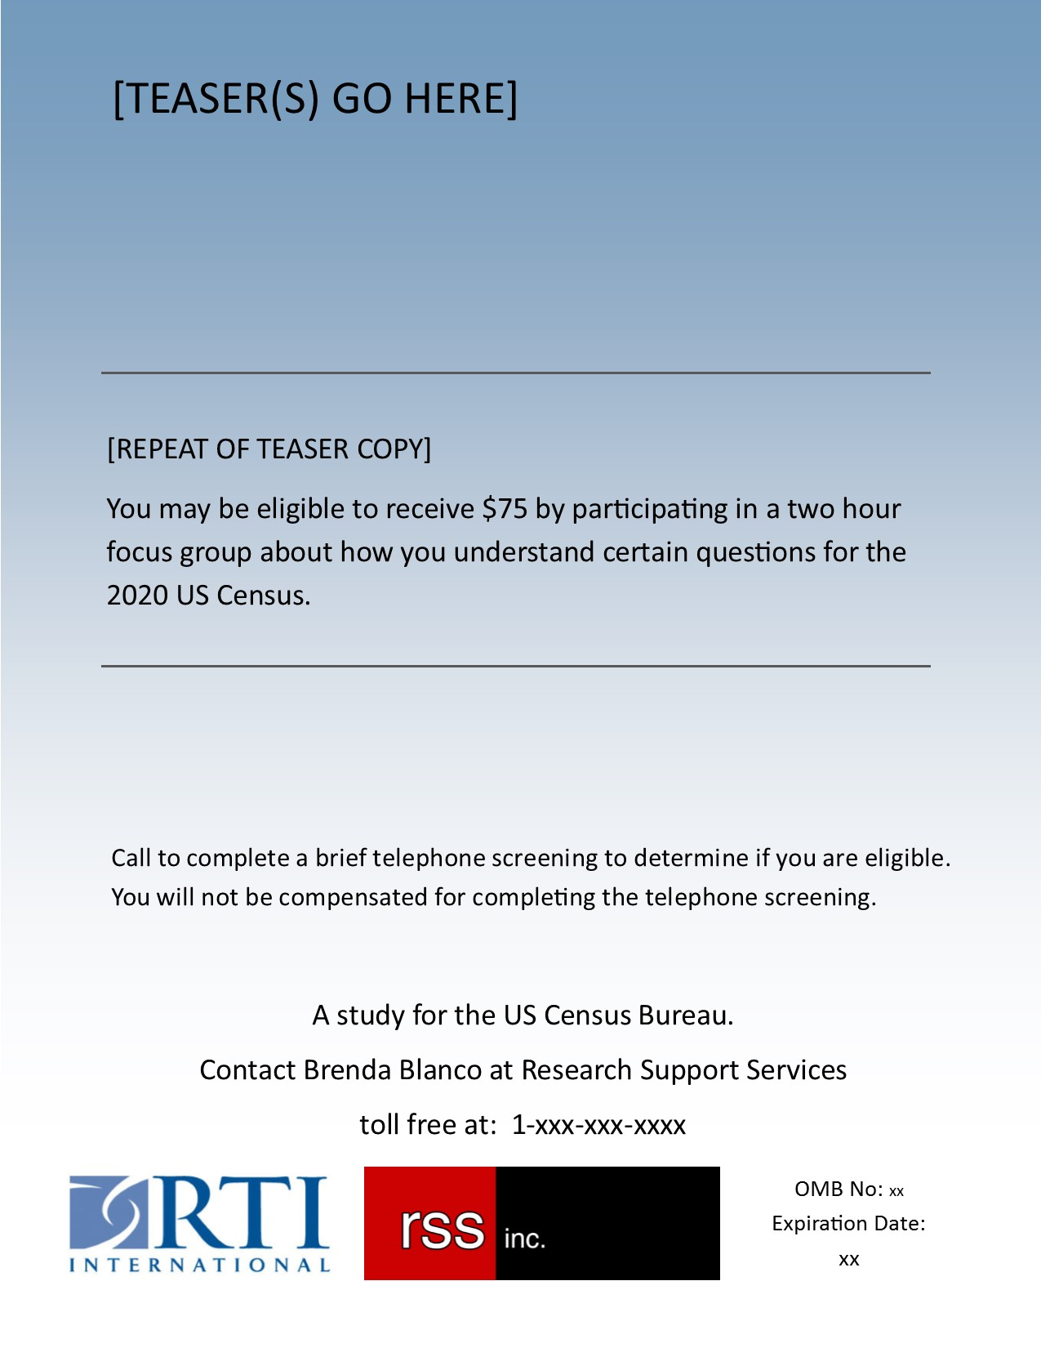

## Appendix D – Advertisement Template

[TEASER(S)]

You may be eligible to receive $75 by participating in a two hour focus group about how you understand certain questions for the 2020 US Census.

Call to complete a brief telephone screening to determine if you are eligible. You will not be compensated for completing the telephone screening.

A study for the US Census Bureau.

Contact [[NAME] at Research Support Services / RTI toll free at: 1-xxx-xxxx]. OMB No: xxxxx Expiration Date:xxxxx

## 

## Appendix E - Screener

ID Assigned:

Location:

Recruiter Initials:

Date:

Ad running in R’s area (if ad):

**0215002: Screener Part 4 Focus Groups Puerto Rico**

**Narrative FAQ:** Let me tell you a little bit about this study. The Census Bureau is conducting research to make the 2020 Census work better. We will be having a focus group about how people respond to census questions. A focus group is a group discussion between a research professional called a moderator and a small group of people, about 10, who have been selected in advance. The focus groups last about two hours. We make a video recording of the focus group so we can have the project team review it for their research.  But all information you provide is confidential and protected by law so it cannot be released to anyone outside the research team. If you do qualify and agree to participate, it is very important that you don’t cancel since only a limited number of people are invited.  If you attend the focus group you will receive $75. Do you have about 3 minutes for me to ask you the questions now to see if you qualify?

**Bulleted FAQs:**

* + **Purpose:** The Census Bureau is conducting research to make the 2020 Census work better. They would like to understand more about how people respond to the census as well as how well the census forms work and how to improve them.
  + **Incentive**: If you qualify for this study, you will receive $75 to help us complete this research.
  + **RTI/RSS:** RTI International is a nonprofit research organization (or RSS is a contract research firm). The Census Bureau contracted with us to conduct this research. We have assisted the Census Bureau with several research studies in the past.
  + **CONFIDENTIALITY:** The study is protected by US Code Title 13. Anyone working at RTI (OR RSS), including the interviewer or me, could either go to jail or pay a fine up to $250,000 if we divulge any information about you.
  + **VERIFICATION:** You can call the study’s project manager Mandy Sha at RTI, Ms Sha speaks Spanish. Her number is (312) 456-5266. I can also have project or other researchers at the Census Bureau who designed this study contact you.

***[Note Concerns or Questions]***

**START HERE**

1. What is your name? _____________________
2. Are you male or female?
   1. Male
   2. Female
   3. Other/Something Else
3. And how did you hear about this study?
   1. FRIENDS
   2. FLYER
   3. NEWSPAPER AD
   4. INTERNET AD
   5. OTHERS (SPECIFY: __________________)
4. You said that you [saw] the ad on [way heard]; Can you tell me about your situation and why you thought you might qualify for the study?
5. What town do you live in? __________
6. If you are eligible, are you available on (DATES) (TIMES) to participate in a focus group? The FG will be held in (Give city determined by where R is located)?
   1. Yes
   2. No 🡪 (IF UNABLE TO MAKE THE TIME, EXPLAIN THAT THEY DO NOT QUALIFY FOR THIS FOCUS GROUP, IF THEY KNOW SOMONE ELSE WHO MIGHT QUALIFY, THEY CAN PASS THE INFORMATION ALONG)
7. Do you work for the United States federal government?

* 1. YES 🡪 *Explain:* Unfortunately you cannot be paid for your study participation but we would still like you to participate if you qualify. Also, other household members who do not work for the federal government might qualify and could be paid.
  2. NO

1. What is your age? ___________________ YEARS OLD

CODE AGE CATEGORY:

* 1. Under 18 – not Eligible
  2. 18-34
  3. 35-44
  4. 45-54
  5. 55-64
  6. 65 and older

1. What is your highest level of education completed _______________________

Code Education category 1:

1. Less than high School Equivalent
2. Completed High school / GED
3. Some college, no degree
4. college
5. Graduate education
6. Other Education System (Specify___________) Probe as necessary for US Equivalent if Participant does not know equivalent, ask number of total years and record level name in country of origin_________________________

CODE EDUCATION CATEGORY 2:

1. Less than HS Equivalent
2. HS Equivalent OR SOME COLLEGE
3. college+
4. Is **Spanish** your native language, or is your native language some other language?

a. English

b. Spanish

c. Other (Specify :________________)

1. How well do you read **Spanish**?

a. Very well

b. Well

c. Not well - Not eligible

d. Not at all – Not eligible

**I now have a couple of questions about your current living situation**.

1. Do you live in a house, an apartment or do you live in some other type of housing?
2. House _____________________________record term used
3. Apartment _________________________record term used
4. Other _____________________________Record term used
5. How do you get your mail, that is, does it come to you at your home, at a PO Box or some other way?
   1. At home
   2. PO BOX -->
      1. Do you also get your mail delivered to you at your home or is a PO Box the only way you can receive mail?
         1. Home as well
         2. PO Box only
   3. Central location (like a store) Specify_______________
6. Recruiter, only if you cannot classify the participant to an address type ask: I’m going to read a list of the kinds of places people live, please let me know which of these apply to you

|  |  |  |
| --- | --- | --- |
| Development | * Yes | * No |
| Settlement | * Yes | * No |
| Village | * Yes | * No |
| Plot/Farm | * Yes | * No |
| Apartment/Town home Complex | * Yes | * No |
| Subsidized Housing | * Yes | * No |
| On a street | * Yes | * No |
| On a route | * Yes | * No |
| On a highway | * Yes | * No |
| Incorporated area | * Yes | * No |
| Unincorporated area | * Yes | * No |

Recruiter, only if you cannot classify the participant to an address type ask questions 15-16

1. What is your address?

___________________________________________________________________

___________________________________________________________________

___________________________________________________________________

1. Is that the information you would give to an ambulance driver to come to where you live or where mail would be sent?
   1. Mail
   2. Ambulance
   3. Both

**INTERNET USAGE/PROFICIENCY QUESTIONS**

1. In the focus groups we will asking participants about how they would answer census questions on a computer, smartphone or tablet. Do you have a **smartphone, tablet, laptop or computer** with internet access?
   1. Yes
   2. No
2. How often do you access the internet?
   1. Every day
   2. Once a week or more
   3. Less than once a week
3. How comfortable are you accessing the internet?

a. Very comfortable

b. Somewhat comfortable

c. Not very comfortable

d. Not at all comfortable

1. Finally, what is the best phone number for me to contact you at if you qualify for the study? //Is it OK to send texts to that number?

Phone: ____________________________Text yes/no

Is there another number as well? ____________________________ Text yes/no

Thank you for your information. I’m going to pass it on to my supervisor *[this evening/Monday/etc.]* who will let me know if you qualify for the study. If you do *[I will call you back to confirm the time, date and location of the FG.*

1. http://www.taxexemptworld.com/organizations/caguas-pr-puerto-rico.asp
2. http://www.taxexemptworld.com/organizations/Mayaguez-pr-puerto-rico.asp