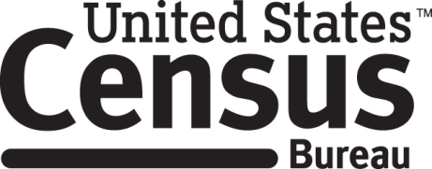

**Consent Form**

**American Housing Survey Focus Groups**

Every two years, the Census Bureau conducts a survey called the American Housing Survey. In preparation for this task, the Census Bureau conducts research in order to improve how data is collected in the survey. The 2016 American Housing Survey Focus Group is part of the effort to improve the 2017 American Housing Survey.

______________________ [NAME] consents to take part in a focus group to improve the American Housing Survey. In order to have a complete record of all comments, the interview session will be audio and video-recorded. The Census Bureau plans to use the tapes to improve the next Census. Staff directly involved in the questionnaire design research project will have access to the recordings. Participation is voluntary and answers will remain strictly confidential.

This study is being conducted under the authority of Title 13 USC. The OMB control number for this study is 0607-0725. This valid approval number legally certifies this information collection.

I have agreed to participate in this Census Bureau focus group, and I give permission for my tapes to be used for the purposes stated above.

____________________________ ___________________________

Participant's Signature Researcher's Signature

____________________________ __________________________

Printed Name Printed Name

___________________________ _______________________

Date Date