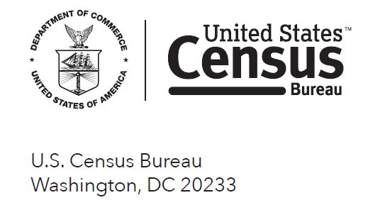

May 1, 2016

Dear Resident,

Your address has been randomly selected by the U.S. Census Bureau to participate in the **American Housing Survey**. The Census Bureau conducts this survey every other year to provide an up-to-date picture of our nation’s housing. The President, policymakers, and business owners use this information for many purposes, including to help:

* Explore housing-related topics, like commuting and emergency preparedness
* Build and improve homes
* Create tax relief programs

Your household was selected on behalf of your community. It is vital that you complete this survey to help meet critical needs in your area. You may find it helpful to locate records before starting the survey, including utility bills, property tax statements, and mortgage statements.

Respond now at **https://respond.census.gov/ahs**

**If you are unable to complete the survey online, an interviewer will come to your home to help you complete the survey.** The Census Bureau is using the Internet to collect this information to conserve natural resources, save taxpayer money, and process data more efficiently.

We have included answers to the most frequently asked questions about this survey and a checklist to help you complete the survey. If you need help with the survey or have questions, please call 1-800-923-8282.

Thank you in advance for your prompt response.

Sincerely,

{SIGNED}

John H. Thompson  
Director, U.S. Census Bureau

Enclosures

How will you get in touch with family and friends in case of emergency?

Only **33%** of U.S. households have an **emergency communication plan.**

(Source: 2013 AHS)

**WHAT IS THIS SURVEY ALL ABOUT?**

The American Housing Survey provides up-to-date information on housing quality and housing costs in the United States. As the population increases, so does the demand for housing. There is a great need for information about the types of homes in which people are living and the characteristics of these homes.

Information from the survey helps to measure the changes in our housing supply resulting from losses and new construction. It measures the structural makeup of the housing and characteristics of the occupants. The information also helps to evaluate the effects of proposals on tax reform and assistance programs.

**HOW WAS I SELECTED FOR THIS SURVEY?**

We chose your address, not you personally. The U.S. Census Bureau scientifically selected a sample of addresses throughout the United States. We need a response from every home in our sample to get a complete picture of housing quality and housing costs across the country. Your answers represent not only your home, but thousands of other homes like yours. If you move, this address will stay in the survey and we will interview the household that moves here.

**I COMPLETED THIS SURVEY TWO YEARS AGO. WHY ARE YOU ASKING ME TO DO IT AGAIN?**

It is important that someone at this address complete the survey again so that we may obtain a measure of the changes (or lack of changes) that have taken place in the number of houses available in the United States, the physical condition of the housing, and the characteristics of the occupants. Some addresses in the American Housing Survey are asked to complete the survey once every two years. Other addresses in a select group of large metropolitan areas are asked to complete the survey every few years.

**I THOUGHT THAT THE CENSUS BUREAU ONLY COUNTS PEOPLE EVERY TEN YEARS. WHAT IS THE CENSUS BUREAU DOING NOW?**

Besides the decennial census, which we conduct every ten years, we collect many different kinds of statistics through other censuses and surveys to provide current information on such topics as housing, transportation, unemployment rates, health, manufacturing, and education.

**IS THIS SURVEY AUTHORIZED BY LAW? WHAT PROTECTION DO I HAVE?**

Congress requires the U.S. Department of Housing and Urban Development (HUD) to collect this information under the Housing and Urban-Rural Recovery Act of 1983 (Title 12 of the U.S. Code). The Census Bureau conducts the survey on behalf of HUD. The Census Bureau has the authority to collect this information under Title 13 of the U.S. Code Section 8. The U.S. Census Bureau is required by U.S. Law (Title 13, U.S. Code, Section 9) to keep your answers confidential. Your participation in this survey is important; however, you may decline to answer any or all questions. Your answers may be combined with information that you give to other agencies to enhance the statistical use of these data, but all data will be kept strictly confidential. If you wish to request that your information not be combined with information from other agencies, we ask that you please call 1-800-923-8282.

**HOW LONG WILL IT TAKE?**

We expect it will take about 45 minutes for you to provide this information, but it may be somewhat shorter or longer, depending on your circumstances. The Office of Management and Budget (OMB) control number is 0607-0725 for this survey. This number confirms that we have approval from OMB to conduct this survey. Approval for this survey expires on 8/31/2016.

If you have any comments on this survey or have recommendations for reducing its length, please send them to the Director, Housing and Demographic Analysis Division, Office of Policy Development and Research, Office of Economic Affairs, Department of Housing and Urban Development, Washington, DC 20410.