FORM **AHS-30(A)**(X-X-20XX) OMB No. 0607-0725: Expiration date 08/31/2016

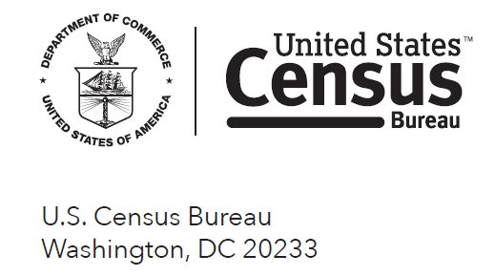

**AMERICAN HOUSING SURVEY CHECKLIST**

The American Housing Survey asks questions about your housing unit and the people living in the unit. Completing the survey will be easier if you locate certain records on paper or online before starting the survey. Here is a checklist of some of the documents you might find helpful:

|  |  |
| --- | --- |
| **Information about the Housing Unit** | |
| * Gas bill | * Mortgage statement/Form 1098 |
| * Electric bill | * Property tax statement |
| * Water bill | * Bill for mobile home fees |
| * Trash bill | * Condo, co-op, or homeowner’s association bills |
| * Other utility bills |  |
| **Information about all Household Members** | |
| * All income statements | |
| * Investment statements | |
| * Statements from other income sources | |

We expect it will take about 10 minutes for you to gather the information for this checklist, but it may be somewhat shorter or longer, depending on your circumstances. The OMB approval number for this survey is 0607–0725 and the expiration date is 8/31/2016. If you have any comments or suggestions, please send them to the Associate Director for Administration, Paperwork Reduction Project 0607–0725, Bureau of the Census, 4600 Silver Hill Road, Washington, DC 20233–0233.