Attachment M, ACS Respondent Burden Testing Protocol, Group 3, Version 2, Paper

# Introduction

Hello, my name is ______________ and I work here at Westat. Thank you for taking the time to participate in this research study.

Westat is working to develop new questions for the American Community Survey, which is sponsored by the U.S. Census Bureau. Before surveys are conducted, it’s important to try out questions with the help of people such as yourself. The survey asks questions about you and your household.

It is important that the questions make sense, are easy to answer, and that everyone understands the questions the same way. If you agree to take part in this study, I will hand you a questionnaire to answer. After you complete it, I will ask you some questions about the answers you gave. There are no right or wrong answers. Our purpose is not to compile information about you. Instead, your interview along with those of others will show us how to improve these questions for a later survey.

# Informed Consent

Before we get started, there are a few things I should mention. This is a research project, and your participation is voluntary. If you prefer not to answer any questions just say so, and you can go on to the next one. It’s also okay if you change your mind after starting and would rather not participate.

All your answers, everything you say, will be kept confidential. We will not use your name in any reports. The interview will take about 40 minutes and you will receive $40. We will also need to audio record our conversation. This helps me so I can listen to what you are saying and won’t have to take a lot of detailed notes while you are talking; it will also help when we write up a summary of this interview. Only project staff will have access to the recording and other project materials, and those materials will be stored according to Title 13 requirements for protecting the identity of individual respondents. {Finally, some of the researchers developing the questions are here today observing our interview to learn if there are things that might need to be changed.}

**HAND CONSENT FORMS TO RESPONDENT**, This form contains all of the things I just told you about your rights in this interview. Please read it over and sign both copies if you are willing to take part in the study.

**HAVE R SIGN TWO CONSENT FORMS, KEEP ONE AND GIVE ONE TO RESPONDENT.**

**TURN ON RECORDER**. The date and time is ____________. Now that the recorder is running, let me ask again, is it okay with you if we record this interview?

Protocol

In a moment, I am going to hand you the questionnaire. I’d like you to fill it out as if you received it in the mail at home. If you had received this form at home, your address would be located on the front of the questionnaire in the white area. Sometimes the questionnaire says “this house” or “here.” At those times, please continue to imagine you’re filling the survey out at home.

After you have finished answering the questions, we will talk about some of the answers you gave. Before we begin, do you have any questions about the process?

HAND QUESTIONNAIRE TO RESPONDENT: Please go ahead and start filling out the questionnaire. You can ignore any series of questions that have an “X” through them.

Please stop at the end of page 4.

**SELECTION OF PERSONS TO PROBE ON:**

**WRITE RESPONDENT’S FIRST NAME AS PERSON #1 BELOW.**

**SELECT ONLY ADULTS AGES 15 OR OLDER AS PERSONS 2-3.**

**PRIORITIZE NON-RELATIVES FROM Q2 OF HOUSEHOLD ROSTER**

**Person 1 First Name _________________________**

**Person 2 First Name _________________________**

**Person 3 First Name _________________________**

HAVE R COMPLETE ACS QUESTIONS 13-40 FOR PERSONS 1-3 AS APPROPRIATE.

Place of residence: Q15A-B, PAGE 5

Research Questions:

**How easy or difficult is it for respondents to understand and answer the revised question and why?**

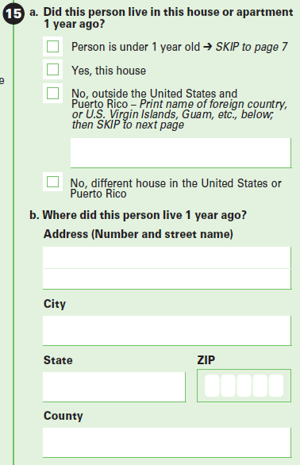

**PERSON 1** **PROBES**

Let’s start by looking at question 15b. How easy or difficult was it to remember your address from one year ago? What made it easy or difficult?

[ONLY ASK IF RESPONDENT MOVED IN PAST YEAR] How easy or difficult was it for you to remember the county where you lived one year ago?

[ONLY ASK IF RESPONDENT MOVED IN PAST YEAR] When providing an address, do you prefer to be asked city, county, state, zip – OR – city, state, zip and then county? What makes you say that?

**PERSON 2 PROBES (PAGE 7)**

[ONLY ASK IF [PERSON 2] MOVED IN PAST YEAR] How easy or difficult was this for you to answer about (PERSON 2)? What made it easy/difficult?

How confident are you in the answers you provided?

**PERSON 3 PROBES (PAGE 9)**

[ONLY ASK IF [PERSON 3] MOVED IN PAST YEAR] How easy or difficult was this for you to answer about (PERSON 3)? What made it easy/difficult?

How confident are you in the answers you provided?

Place of work: q30a-f, PAGE 6

Research Questions:

**How easy or difficult is it for respondents to understand and answer the revised question order and why?**

**Are respondents able to answer about county and city limits?**

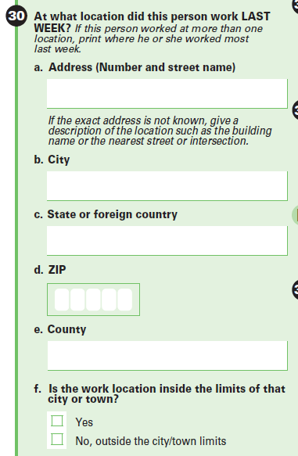

**PERSON 1 PROBES**

Now let’s look at question 30. How easy or difficult was it to answer this series of questions. What made it easy or difficult?

Question 30f asked whether the work address is inside the limits of [NAME OF CITY], and you answered [REPEAT R’s ANSWER FOR 30F]. How easy or difficult was it to answer this question?

How confident are you about your answer to this question?

IF NEEDED: Do you know what the city limits for [NAME OF CITY] are?

IF NEEDED: Question 30 asked you to provide the street, city, state, zip code, and county, and then asked if this address was within the city limits. What did you think of asking for the zip code before the county and city limits?

**PERSON 2 PROBES (PAGE 8)**

How easy or difficult was this for you to answer about (PERSON 2)’s work address? What made it easy/difficult?

How confident are you in the answers you provided?

**PERSON 3 PROBES (PAGE 10)**

How easy or difficult was this for you to answer about (PERSON 3)’s work address? What made it easy/difficult?

How confident are you in the answers you provided?

Hours worked: Q39, PAGE 6

Research Questions:

Which alternate version is easier for respondents to understand and answer and why?

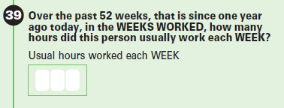

**PERSON 1 PROBES**

Now let’s look at question 39. Tell me how you came up with your answer.

How easy or difficult was it to answer this question? What made it easy or difficult?

Does the number of hours you work in a week vary from week to week or stay the same?

Did you work any other amount of time that you did not include in your answer to this question?

What time period were you thinking of when you answered this question?

How confident are you about your answer to this question?

**PERSON 2 PROBES (PAGE 8)**

How easy or difficult was this for you to answer about the number of hours (PERSON 2) worked? What made it easy/difficult?

How confident are you in the answer you provided?

**PERSON 3 PROBES (PAGE 10)**

How easy or difficult was this for you to answer about the number of hours (PERSON 3) worked? What made it easy/difficult?

How confident are you in the answer you provided?

weeks worked: Q40a-B, PAGE 6

Research Questions:

Which alternate version is easier for respondents to understand and answer and why?

Does adding an option to provide a response in months help respondents answer about the number of weeks worked?

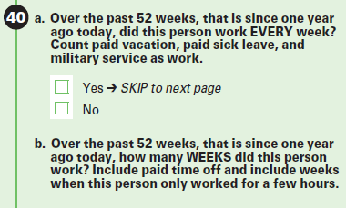

**PERSON 1 PROBES**

Let’s look now at question 40a. Tell me more about your answer to this question.

How did you decide on your answer?

Was it easy or difficult to answer this question? What made it easy or difficult?

What time period were you thinking of when you answered this question?

Were there any weeks during that time that you were receiving pay but were not at work? Did you include these times when answering this question? What made you decide that?

Were there any weeks that you did not work or receive pay that you did not include when answering this question? What made you decide that?

IF ANSWERED 40B: Now let’s look at question 40b. Tell me about your answer.

IF NECESSARY Were there any weeks during that time that you were receiving pay but were not at work? Did you include these times when answering this question? What made you decide that?

IF NECESSARY Were there any weeks that you did not work or receive pay that you did not include when answering this question? What made you decide that?

IF NECESSARY: Did you include part-time jobs? Did you include paid time off?

[IF R ANSWERED IN WEEKS] Would it be easier or more difficult to answer this question in months instead of weeks? What makes you feel that way?

How confident are you in the answer you gave? Explain.

If questions 39 and 40 were reversed so that question 40 came first, would that have been easier or more difficult for you? What makes you say that?

**PERSON 2 PROBES (PAGE 8)**

How easy or difficult was this for you to answer the number of weeks worked for (PERSON 2)? What made it easy/difficult?

How confident are you in the answer you provided?

**PERSON 3 PROBES (PAGE 10)**

How easy or difficult was this for you to answer the number of weeks worked for (PERSON 3)? What made it easy/difficult?

How confident are you in the answer you provided?

Closing and Incentive

IF OBSERVERS ARE PRESENT, CHECK TO SEE IF THEY HAVE FURTHER QUESTIONS.

Those are all the questions I have for you. Is there anything we haven't discussed that you would like to mention?

DISCUSS ANY RESPONDENT COMMENTS.

Thank you for your time.

STOP TAPE RECORDER.  
GIVE INCENTIVE AND HAVE RESPONDENT SIGN RECEIPT.