**Craigslist Interview Advertising**

**We need American Indian volunteers for a one-hour interview (receive $40)**

On behalf of the U.S. Census Bureau, Kauffman & Associates, Inc. (KAI) is looking for American Indian adults 18 years and older, who can be either enrolled or not enrolled in a tribe.

The in-person interview will take about one hour and will be held in INSERT CITY and STATE. Participants will receive a $40 prepaid credit card.

All information you give us will be treated as confidential. No information about you will be shared with others, and you will not be put on a marketing/mailing list.  
  
If you are interested in participating, please call 1-855-380-2418 or email interview@kauffmaninc.com.

**We need Alaska Native volunteers for a one-hour interview (receive $40)**

On behalf of the U.S. Census Bureau, Kauffman & Associates, Inc. (KAI) is looking for Alaska Native adults 18 years and older, who can be either enrolled or not enrolled in a tribe, village, community, or association.

The in-person interview will take about one hour and will be held in Fairbanks, Alaska. Participants will receive a $40 prepaid credit card.

All information you give us will be treated as confidential. No information about you will be shared with others, and you will not be put on a marketing/mailing list.  
  
If you are interested in participating, please call 1-855-380-2418 or email interview@kauffmaninc.com.

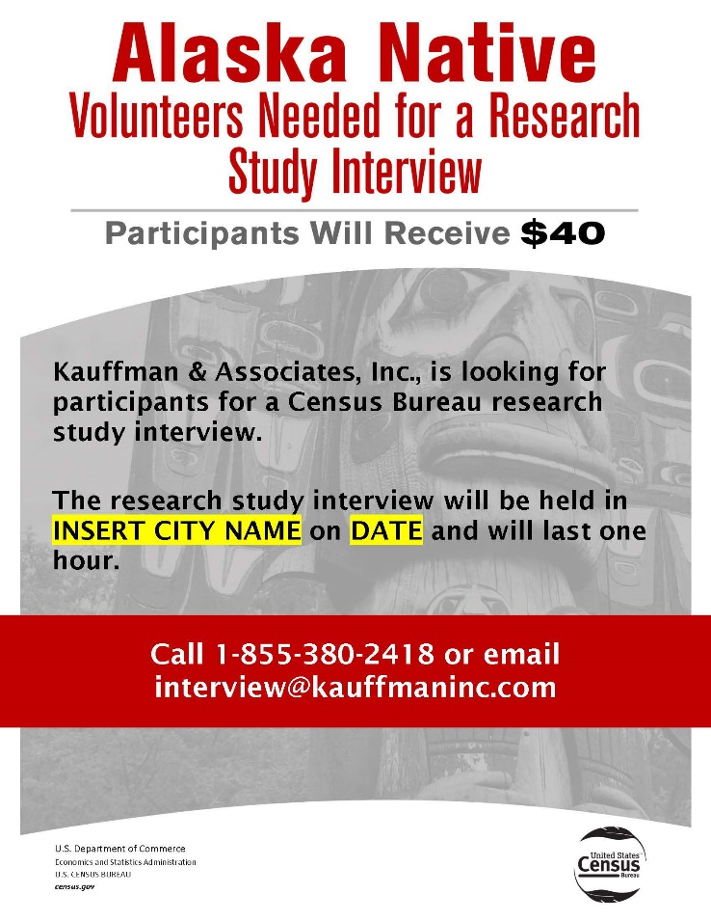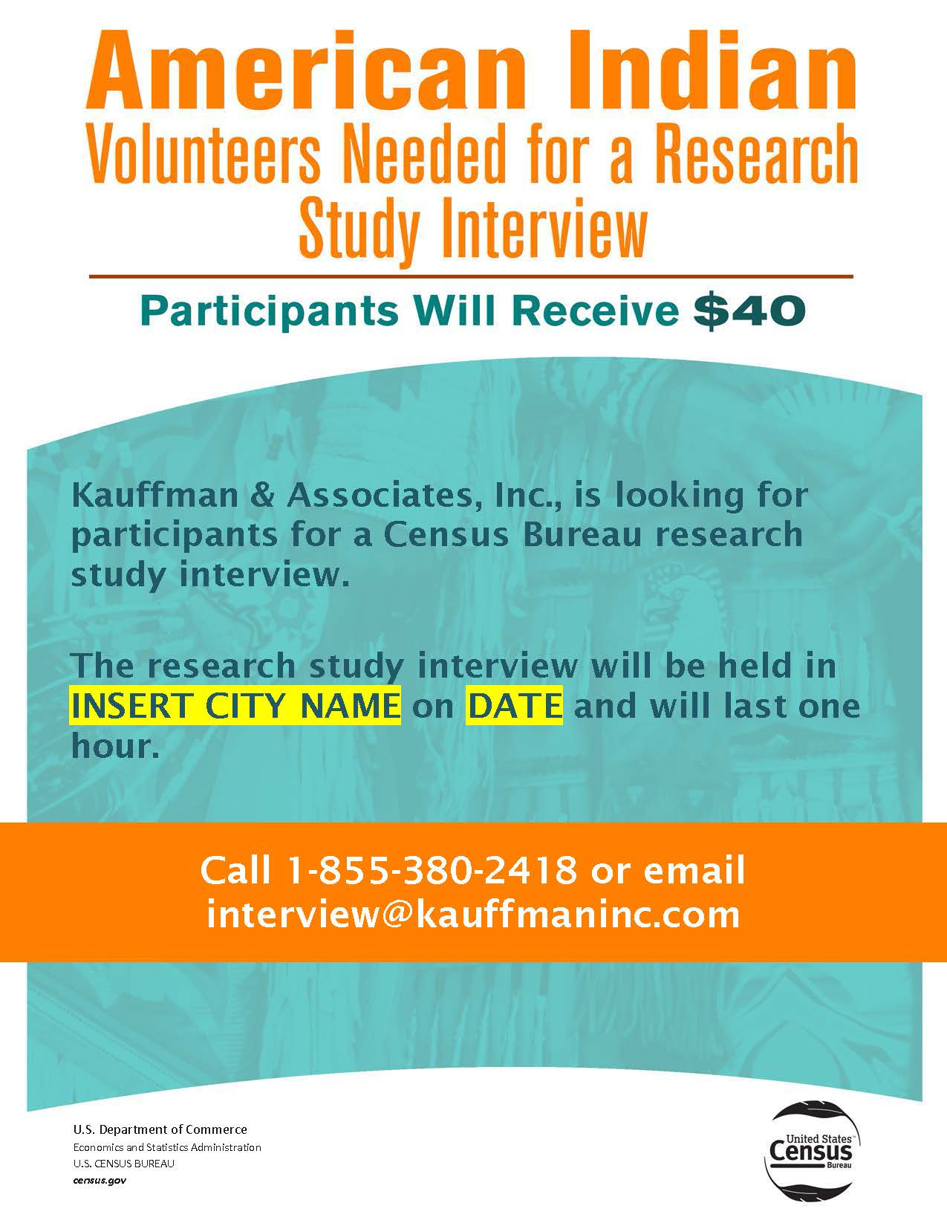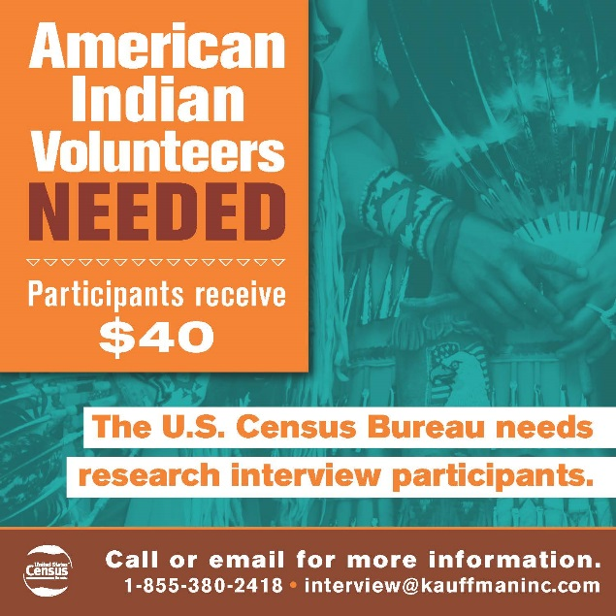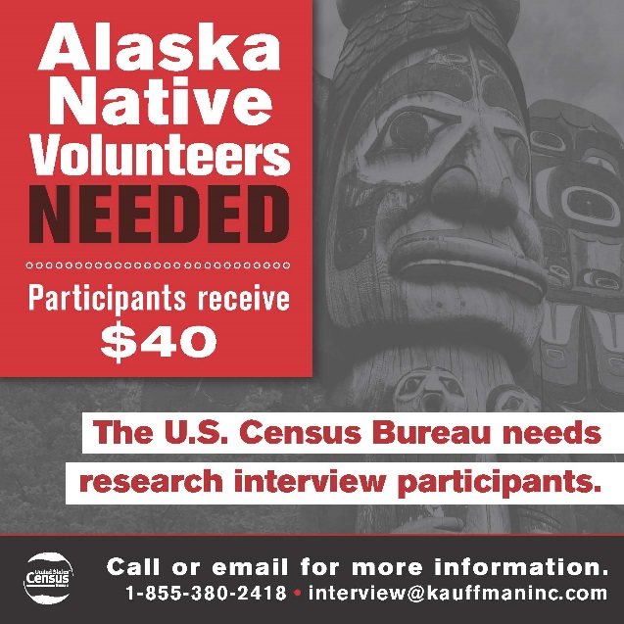

Figure 2. Proposed tribal publication print ads for potential American Indian and Alaska Native participants

Figure 1. Proposed flyers for potential American Indian and Alaska Native participants