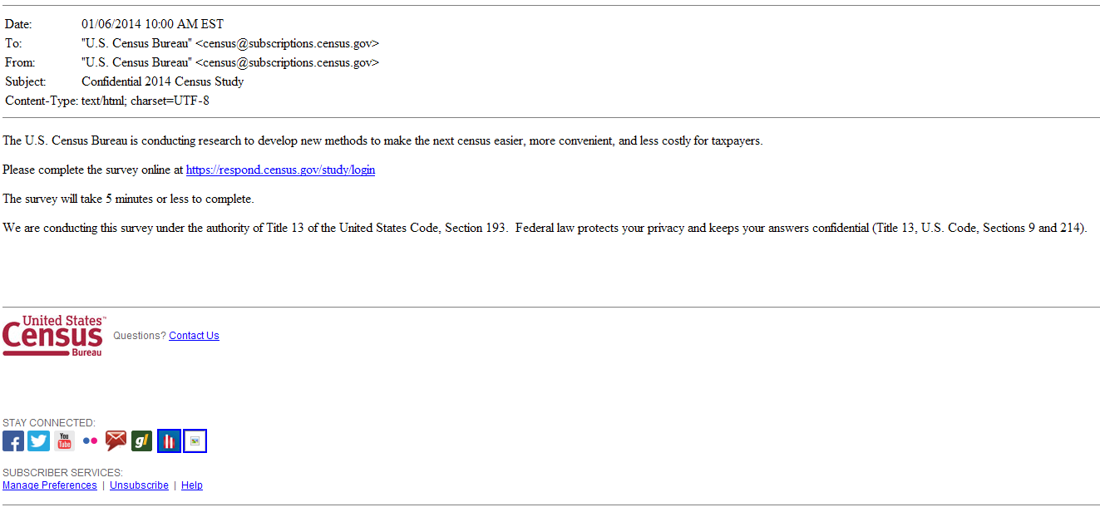
Figure 1: Initial email panel look and feel for plain format: The 3 subject lines are: (a) Confidential 2014 Census Survey; (b) 10 minute U.S. Census Survey to help your community, and (c) U.S. Census Survey to help your community

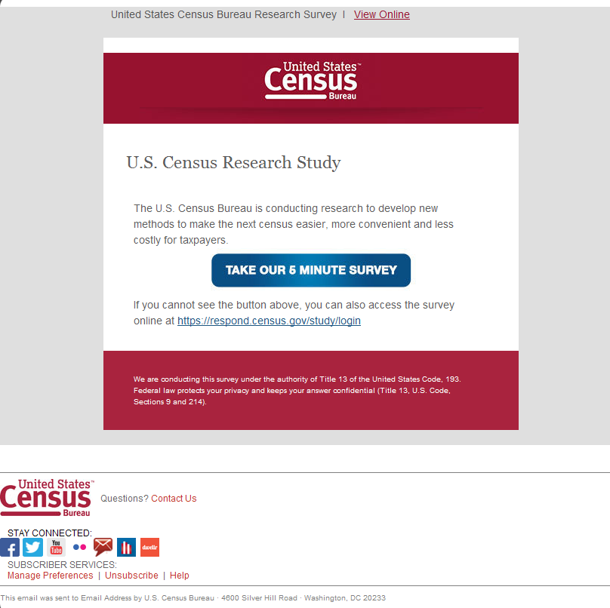
Figure 2: Initial email panel look and feel for “fancy” format: The 3 subject lines are: (a) Confidential 2014 Census Survey; (b) 10 minute U.S. Census Survey to help your community, and (c) U.S. Census Survey to help your community

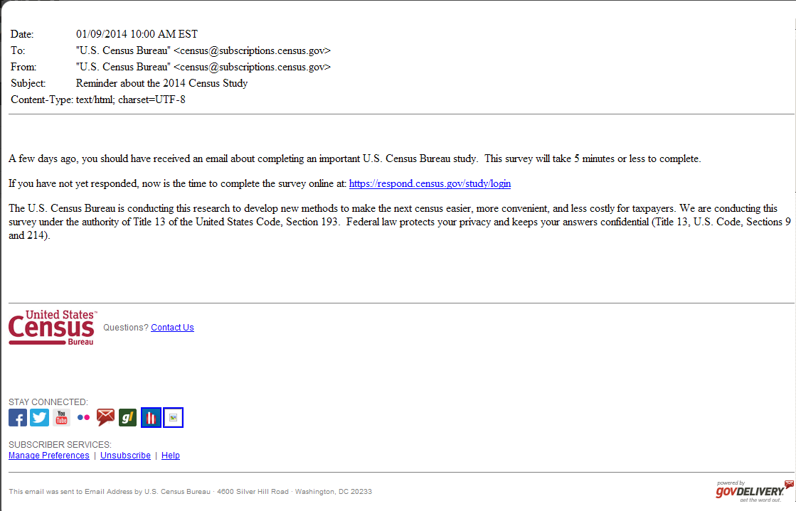
Figure 4: This is the first reminder email in the plain format (Anyone who doesn’t click on a link in the initial email receives this email.) Half of each initial email sample will receive one with “Reminder: Complete the U.S. Census Survey by May 23” in the subject line and the other half would receive one with “Reminder about the U.S. Census Survey” in the subject line. The first reminder email in the fancy format will look similar to Figure 2.
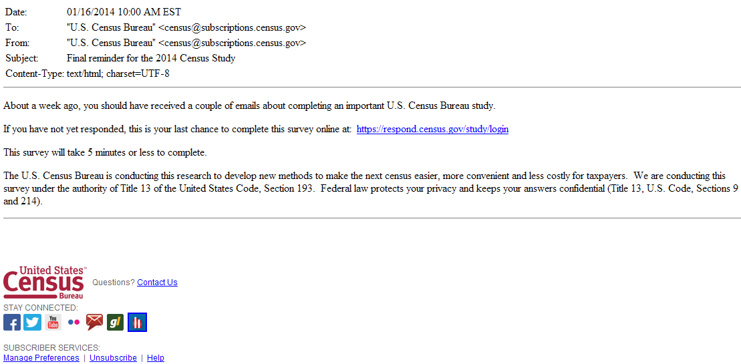
Figure 5: This is the final reminder email in the plain format (Anyone who doesn’t click on a link in the initial email or the first reminder receives this email.) Half of each initial email sample will receive one with “Due May 23: Final reminder for the U.S. Census Survey” in the subject line and the other half would receive one with “Final reminder for the U.S. Census Survey” in the subject line. The final reminder email in the fancy format will look similar to Figure 2.

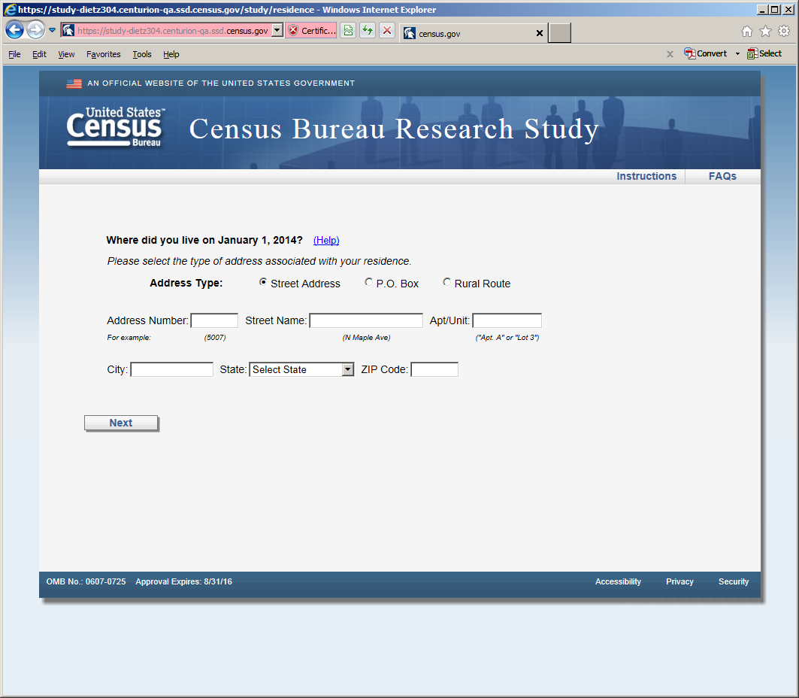
Figure 6: Horizontal Design (first screen seen in survey once entered email) The reference date changes to May 1, 2014 on all the screens.

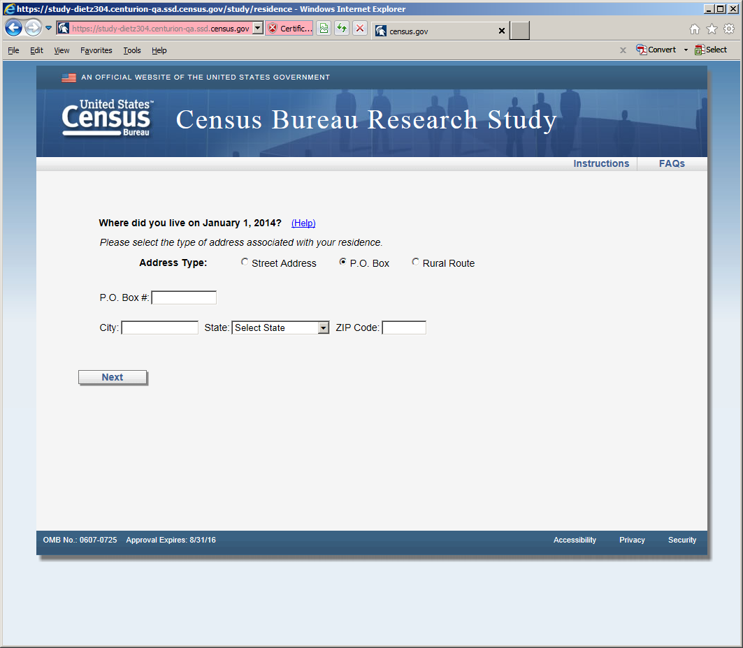
Figure 7: Horizontal Design (P.O. Box screen, shown if respondent selected P.O. Box radio button)
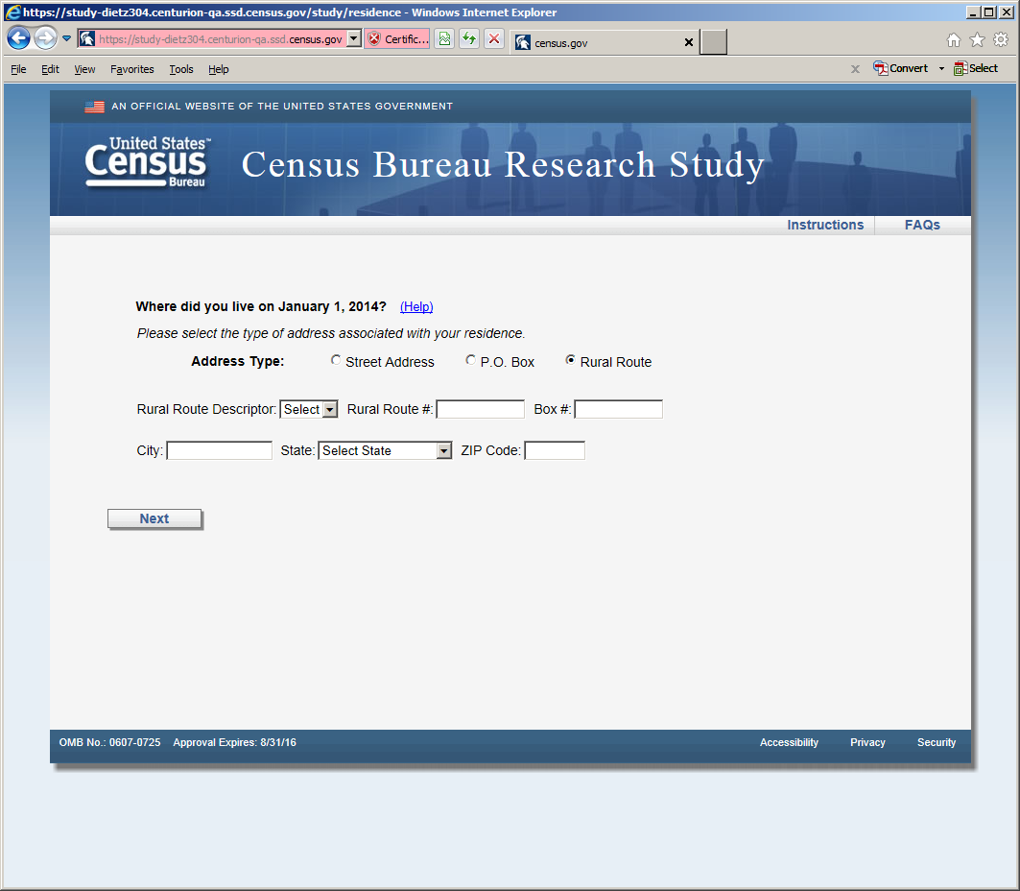
Figure 8: Horizontal design (Rural Route screen, shown if respondent selected Rural Route radio button)

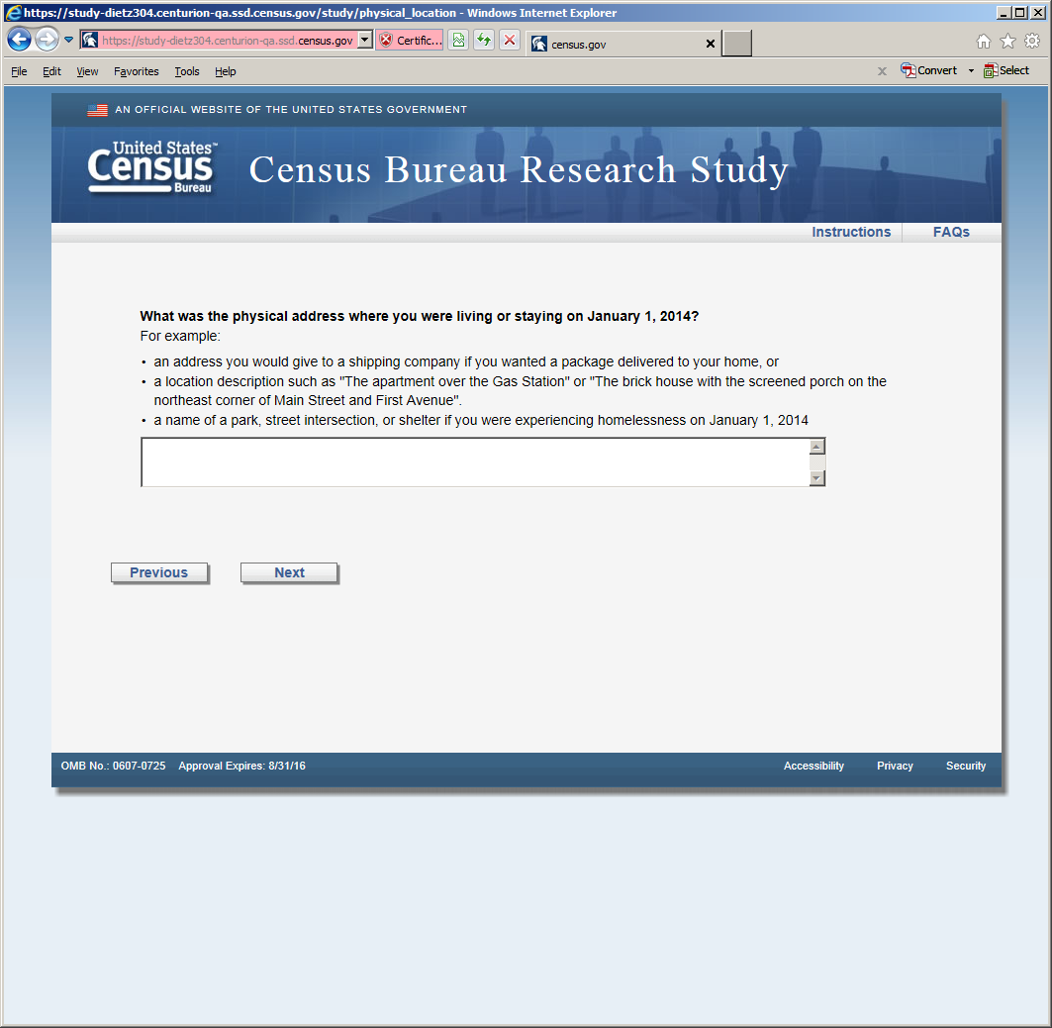
Figure 9: Horizontal Design (this screen was displayed after the P.O. or Rural Route screens)

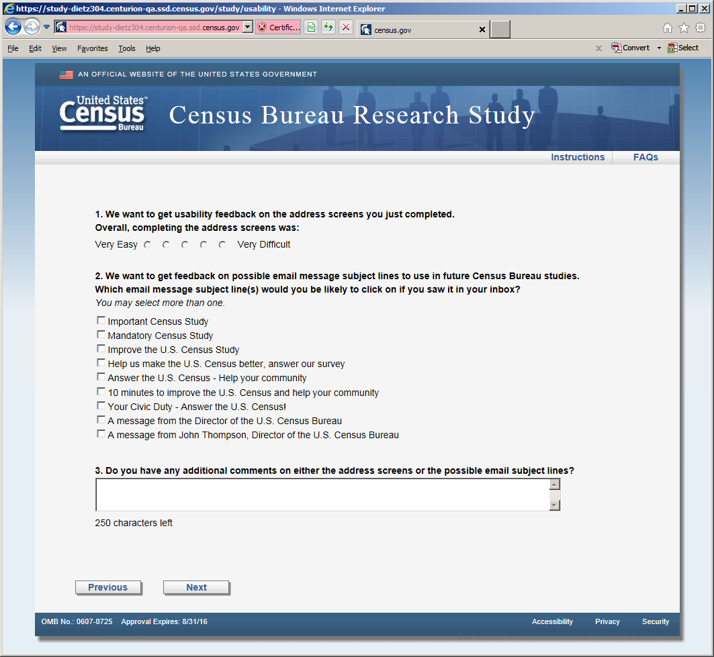
Figure 10: Usability screen, both versions received this screen after the respective address screens. There are two changes to the response categories in Question 2. The category: "A message from John Thompson, Director of the U.S. Census Bureau" becomes "Confidential 2014 Census Study" and the category “Answer the U.S. Census -- Help your community” becomes “Help improve the U.S. Census - Take a 10 minute survey”

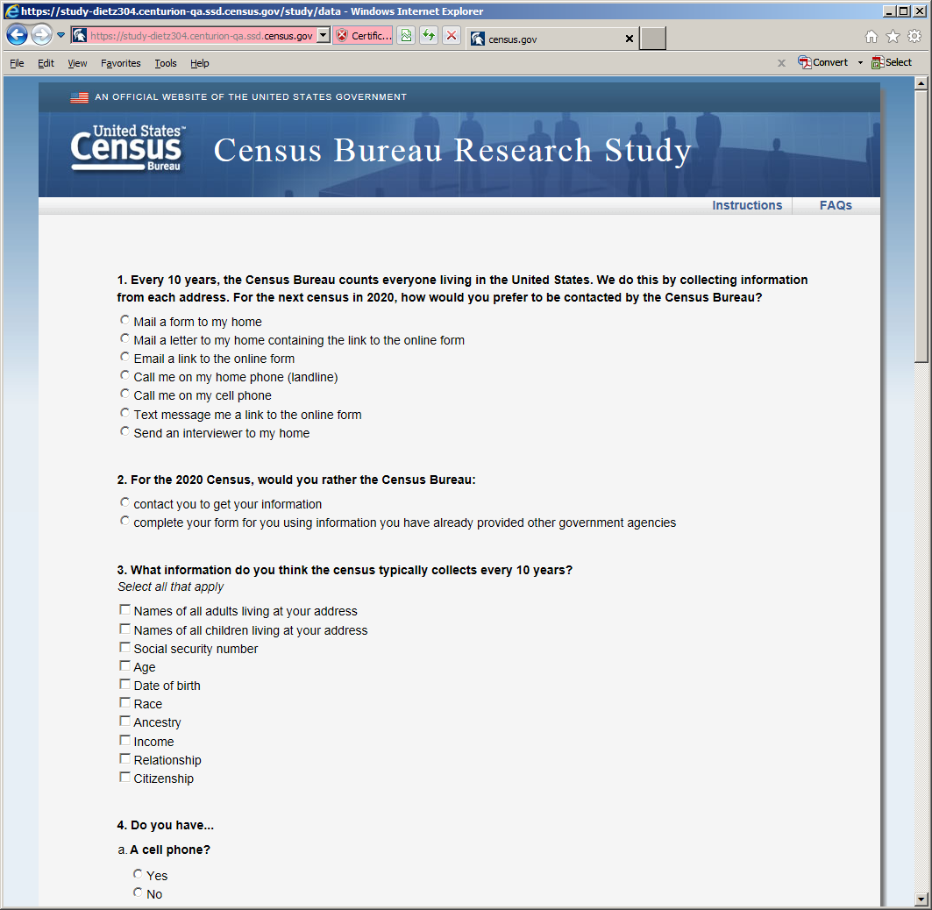
Figure 11: Opinion and demographic questions (shown in both versions after usability screen)

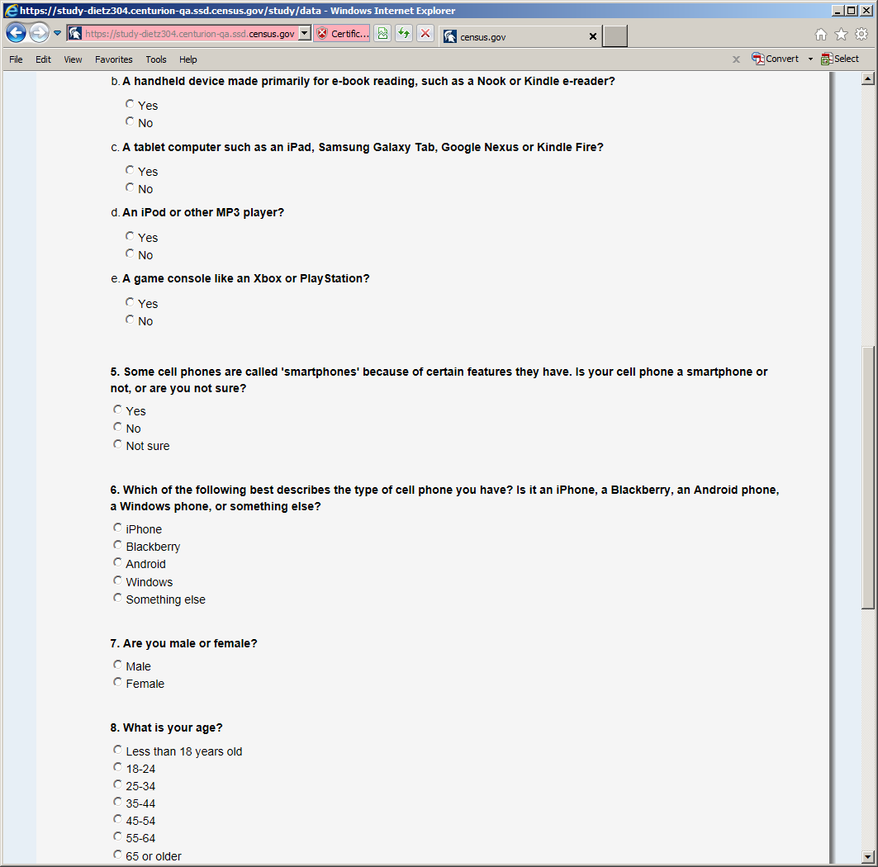
Figure 12: Opinion and demographic questions (shown in both versions after usability screen)

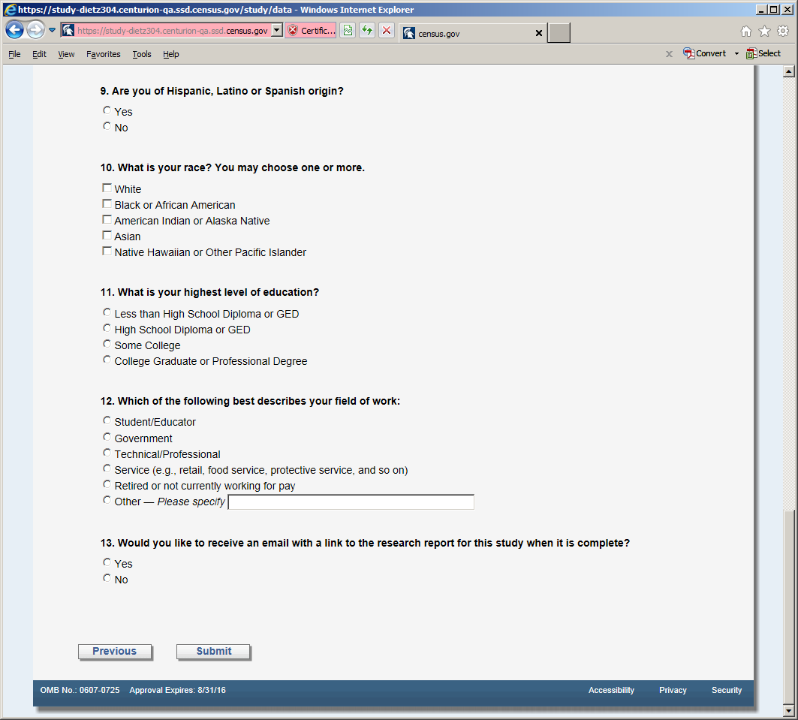
Figure 13: Opinion and demographic questions (shown in both versions after usability screen)

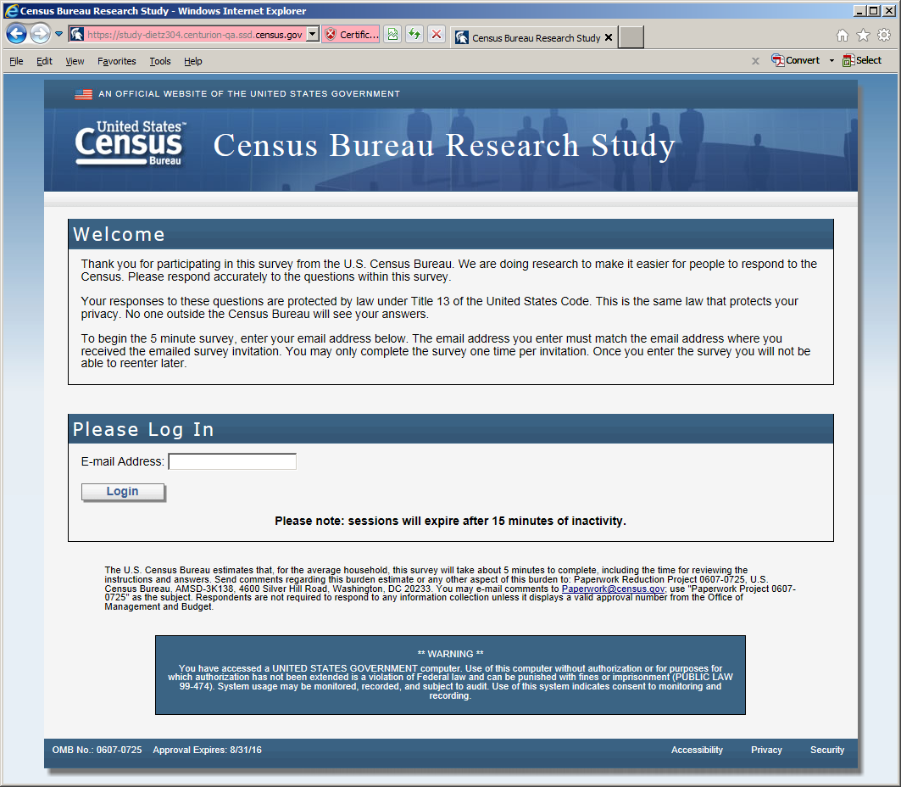
Figure 14: The entry screen

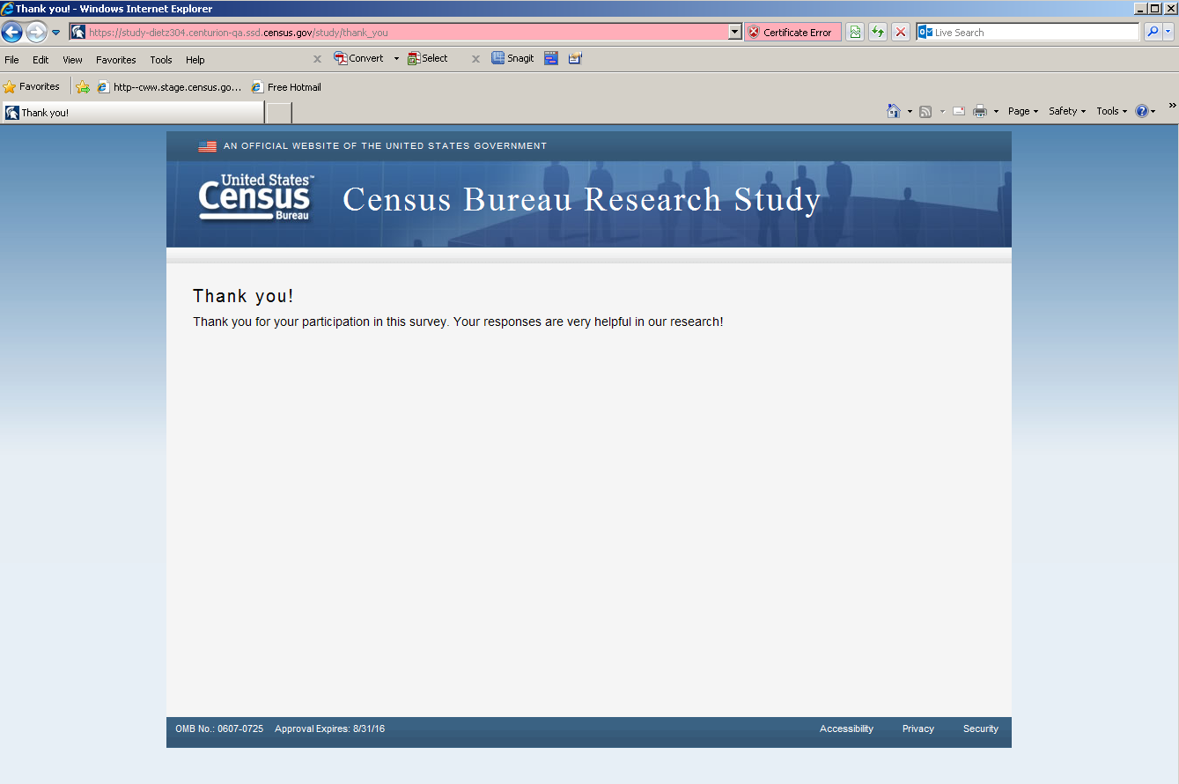
Figure 15: The final screen once the respondent submits the survey

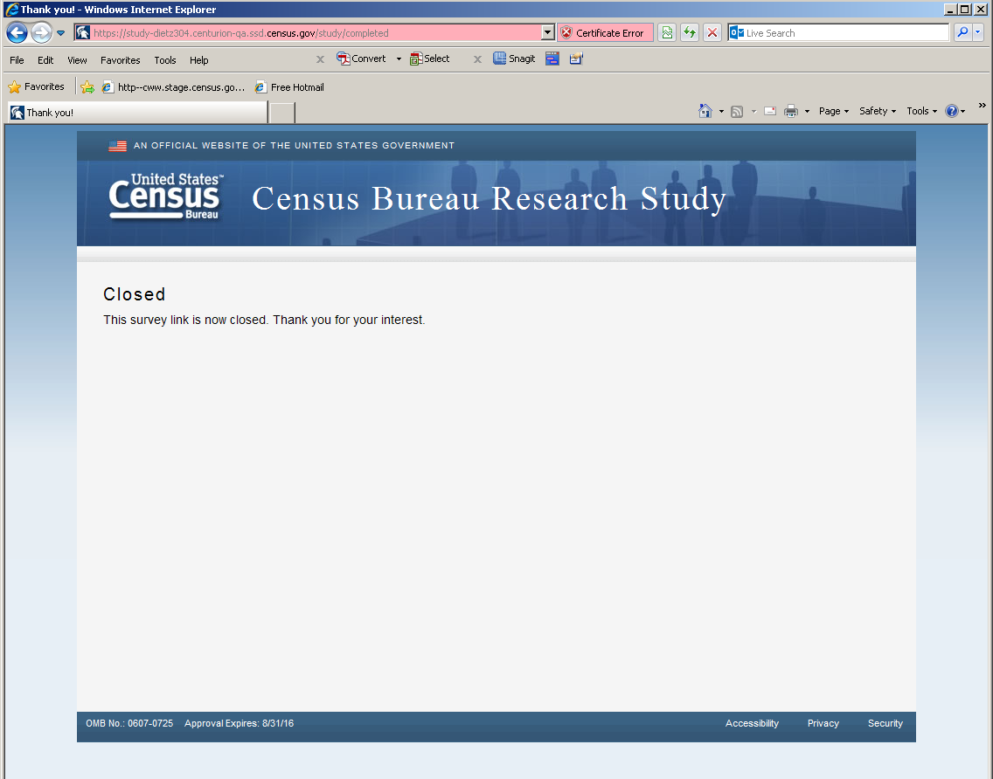
Figure 16: The screen displays if the respondent tried to re-enter the survey or complete the survey after midnight on May 23, 2014

