U.S. Department of Commerce
Geolocation Study Specification Draft
Part of the 2020 small-scale research program
Elizabeth May Nichols
3/9/2016

This survey will need to be mobile optimized following the guidelines used in the 2015 Census Test and the 2015 National Content Test. Many of the screens have been used in prior small-scale research projects with only minor changes to the questions or numbering.

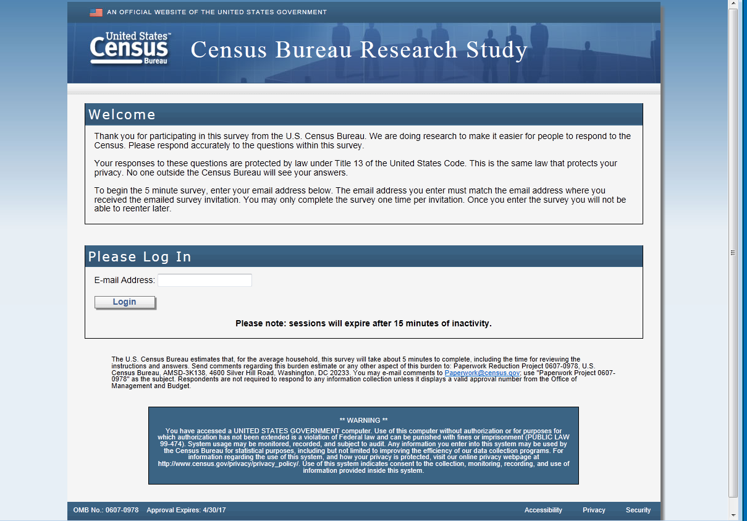

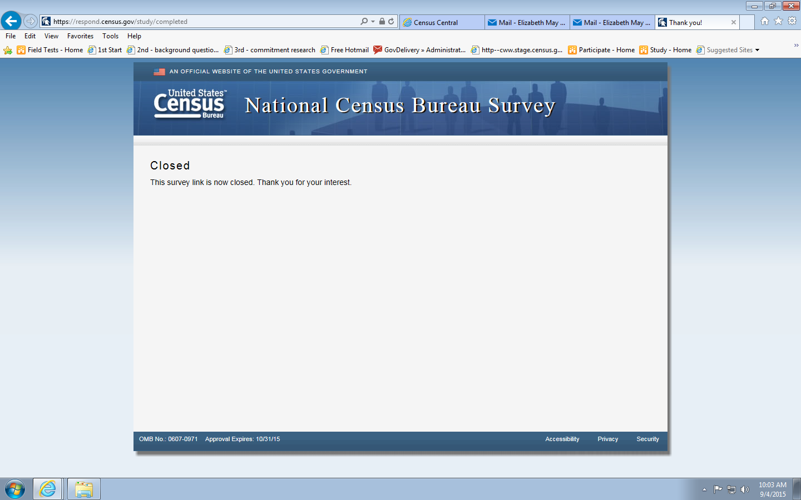
Message you get if you try to re-enter the survey.

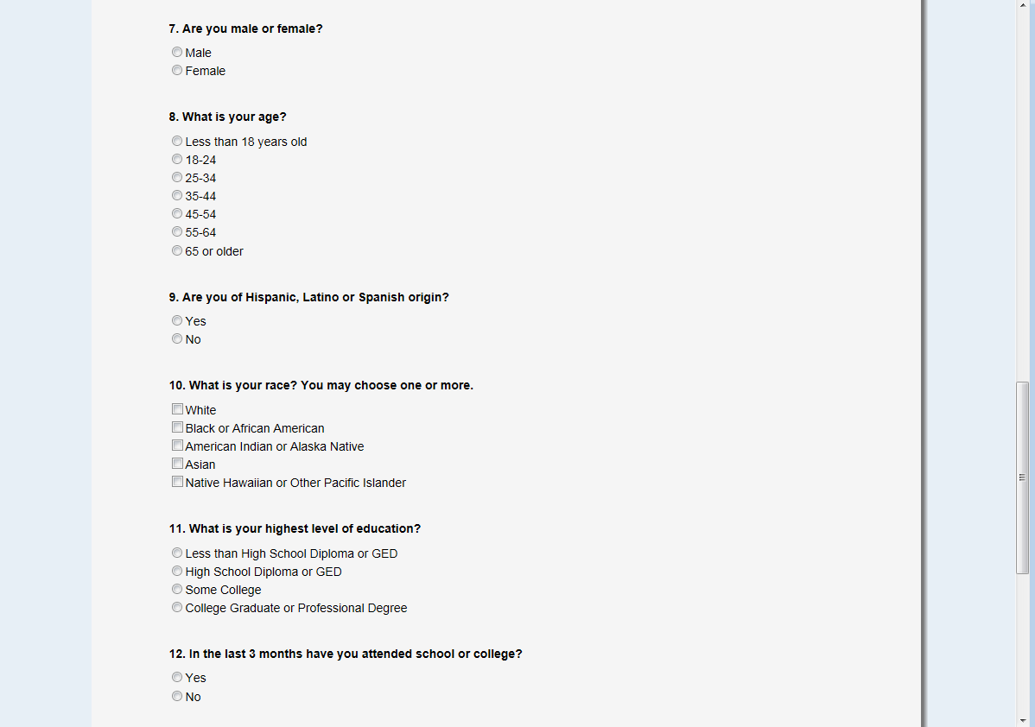
Needs to be renumbered starting at “1”

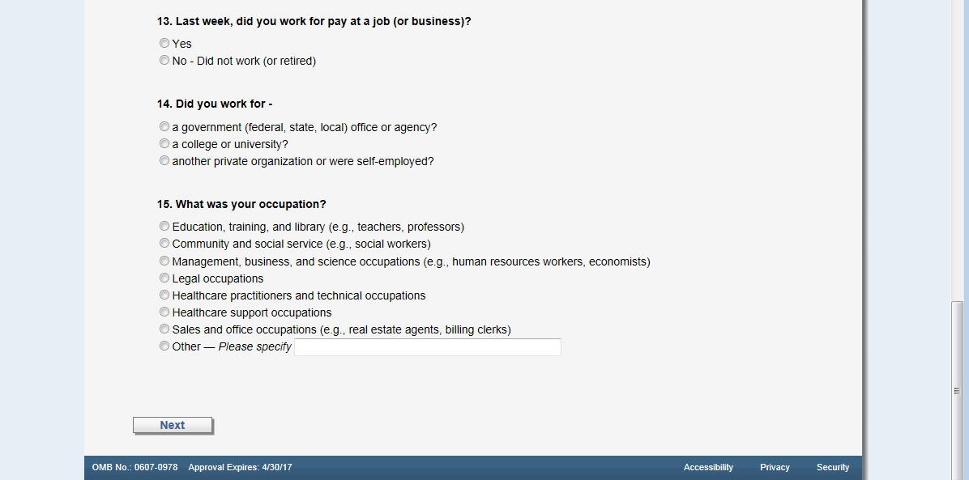
Continue renumbering
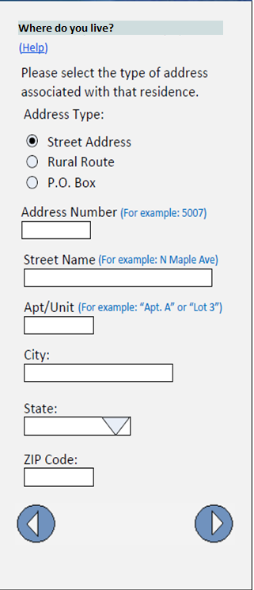
Example of mobile-optimized design
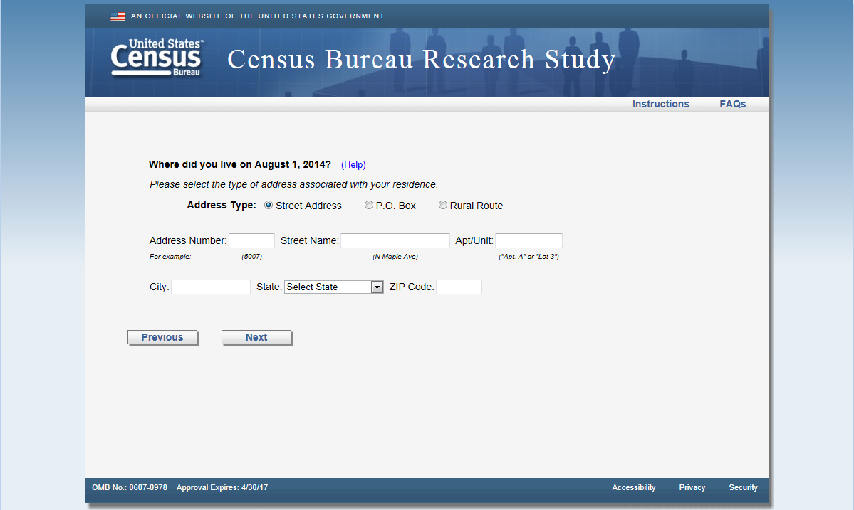
Change question to “Where do you live?”
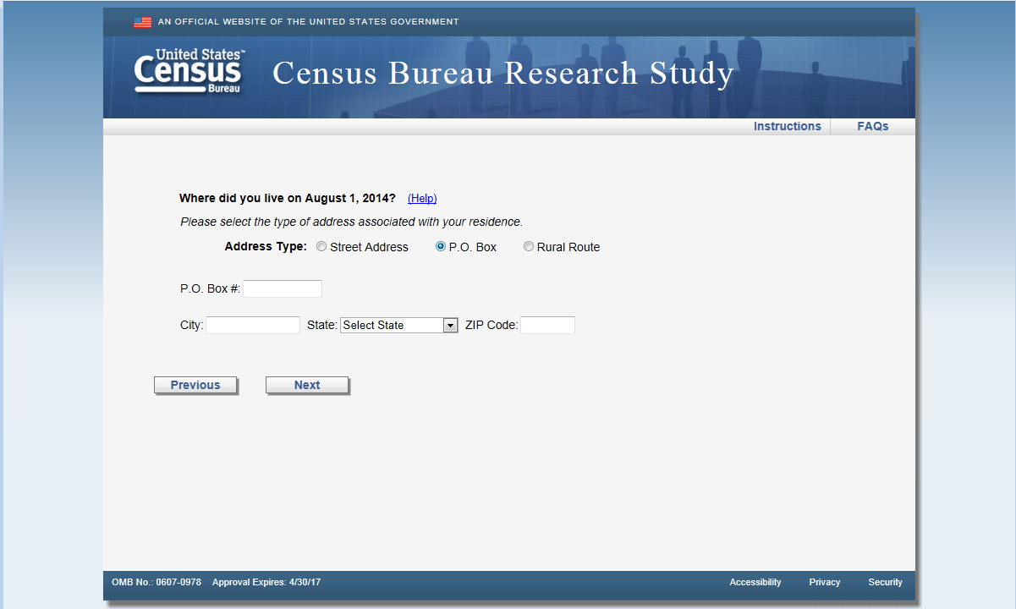
Change question to “Where do you live?”

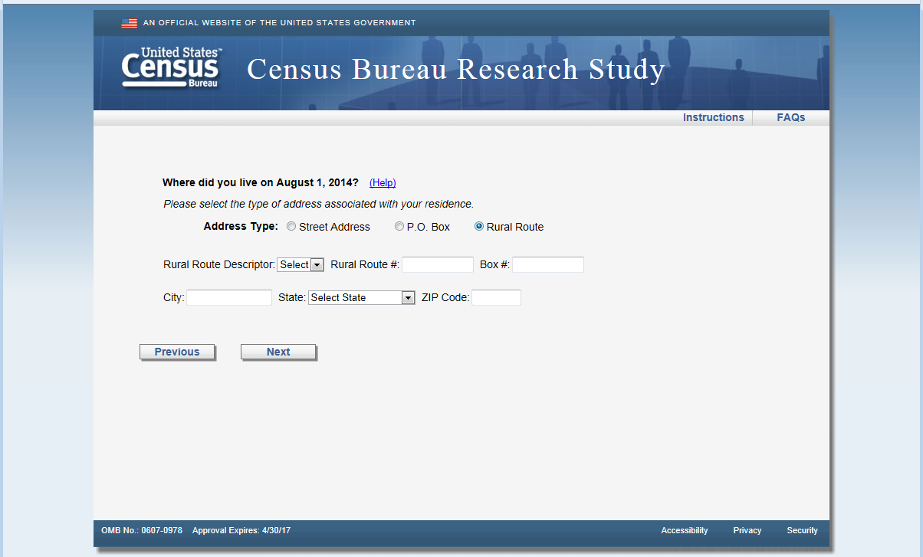
Change question to “Where do you live?”

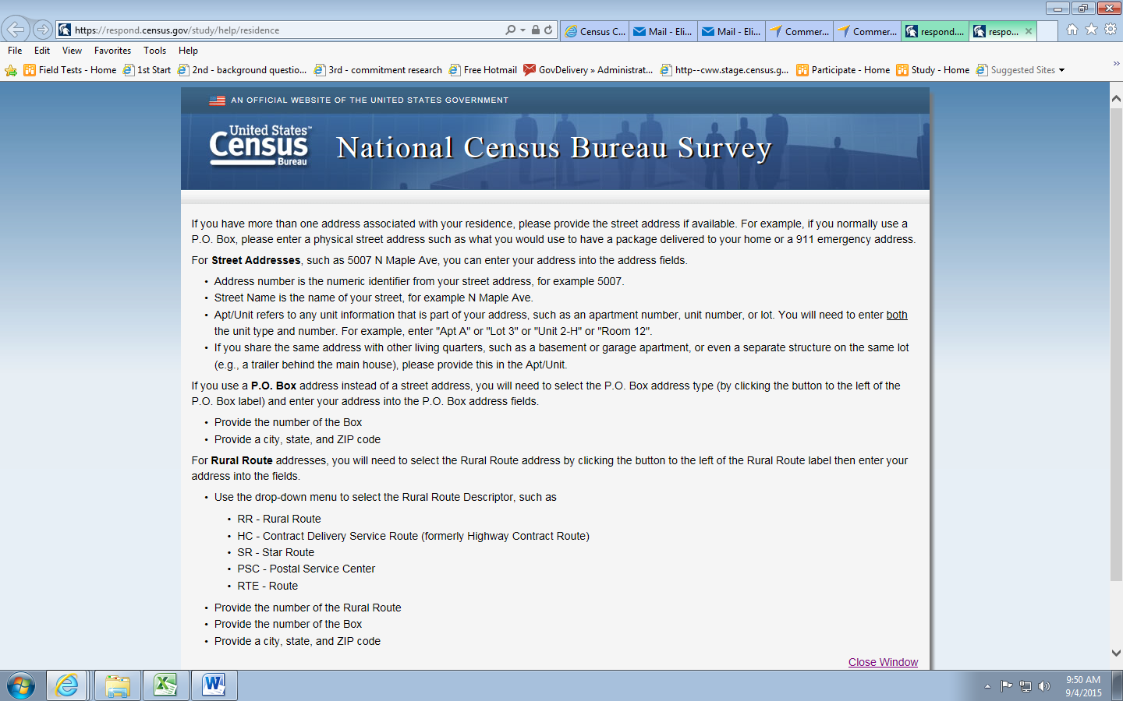
Banner is incorrect

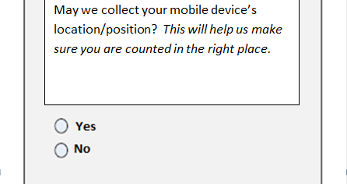
New screen: Bold the question. (If yes, then engage location service.) If not, don’t do that.

Action: If yes next button should take you to the next question which is the are you home question, otherwise skip the are you home question and go directly to the usability question.

Output user agent string regardless of answer
Output x,y coordinates if allowed.

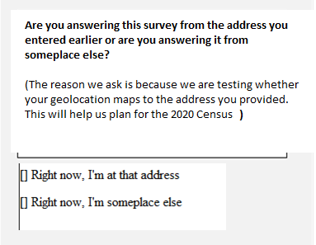
New screen: Bold the question.

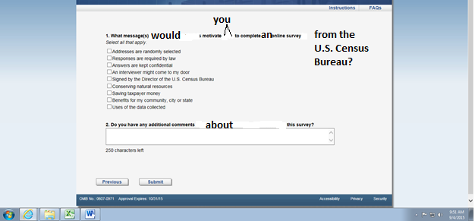
Rotation #5 is above – these are the same rotations and categories as the small-scale mailout we conducted in October 2015
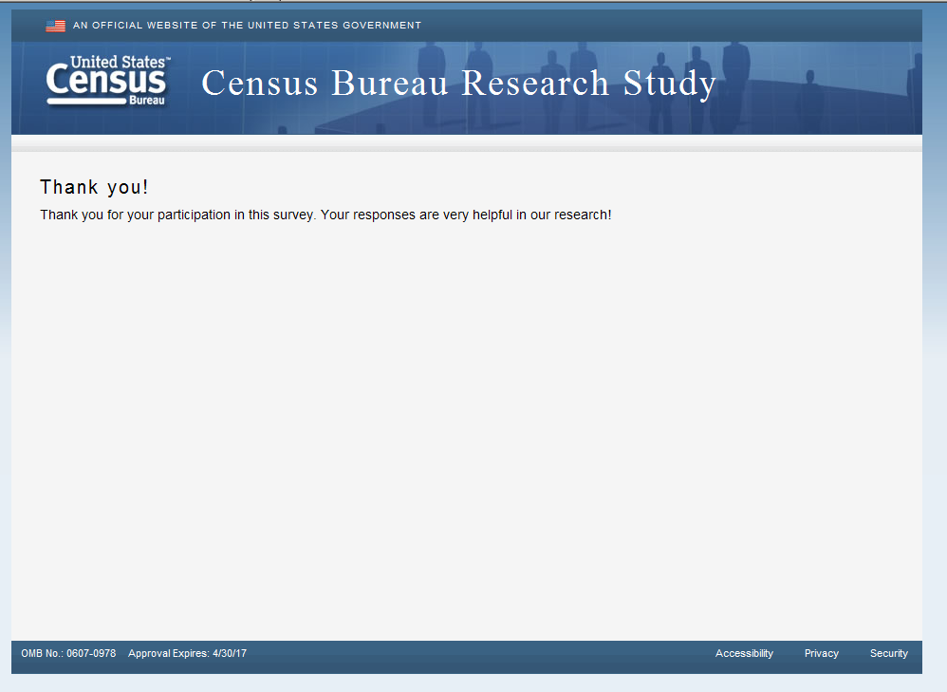

Message you get if you try to re-enter the survey.

Needs to be renumbered starting at “1”

Continue renumbering
Example of mobile-optimized design
Change question to “Where do you live?”
Change question to “Where do you live?”

Change question to “Where do you live?”

Banner is incorrect

Action: engage the locator service. If allowed, then go to next question “are you home question” Otherwise, skip and go to the usability question
Output user agent string regardless of answer
Output x,y coordinates if allowed.

New screen: Bold the question.

Rotation #5 is above – these are the same rotations and categories as the small-scale mailout we conducted in October 2015

Message you get if you try to re-enter the survey.

Example of mobile-optimized design
Change question to “Where do you live?”
Change question to “Where do you live?”

Change question to “Where do you live?”

Banner is incorrect

New screen: Bold the question. (If yes, then engage location service.) If not, don’t do that.

Action: If yes next button should take you to the next question which is the are you home question, otherwise skip the are you home question and go directly to the demographic questions.

Output user agent string regardless of answer
Output x,y coordinates if allowed.

New screen: Bold the question.

Needs to be renumbered starting at “1”

Continue renumbering

Rotation #5 is above – these are the same rotations and categories as the small-scale mailout we conducted in October 2015

Message you get if you try to re-enter the survey.

Example of mobile-optimized design
Change question to “Where do you live?”
Change question to “Where do you live?”

Change question to “Where do you live?”

Banner is incorrect

Action: engage the locator service. If allowed, then go to next question “are you home question” Otherwise, skip and go to the demographics question
Output user agent string regardless of answer
Output x,y coordinates if allowed.

New screen: Bold the question.

Needs to be renumbered starting at “1”

Continue renumbering

Rotation #5 is above – these are the same rotations and categories as the small-scale mailout we conducted in October 2015

