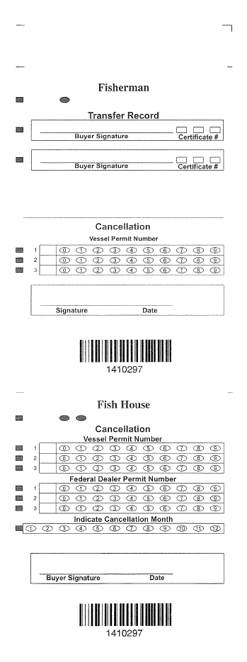**Instructions for filling out coupons**

Important Info -

Do not use red ink. Use only blue or black ballpoint pen.

Fill in transfer record only upon sale of coupon.

Prior to landing, the vessel permit number, signature, and date must be entered on the “Fisherman” part of coupons in denominations equal to the eviscerated (gutted) weight of wreckfish on board.

Submit the completed part of coupon to NMFS with the logbook forms required for each trip.

Wreckfish may be transferred only to a permitted dealer.

Separate and give the “Fishhouse” part of coupons to the dealer to whom wreckfish are transferred in amounts totaling the eviscerated weight.

A dealer must complete, sign, and date the “Fishhouse” part of coupons and submit them to NMFS with the required dealer reports.

Coupons must be made available to an authorized officer upon request.

When selling coupon to another shareholder, buyer signs transfer record and writes his shareholder certificate number

Note: an additional row (4) for Federal Dealer Permit Number will be added

Removed barcode that was here

Removed barcode that was here

Vessel id number

___________________________

Vessel id number

__________________________________

Deal must sign and date

Fill in number of month shown in date below

Write dealer permit number and fill in corresponding numbered circles

Write in the vessel id number

Operator of the permitted vessel must sign and date

Write in the vessel id number