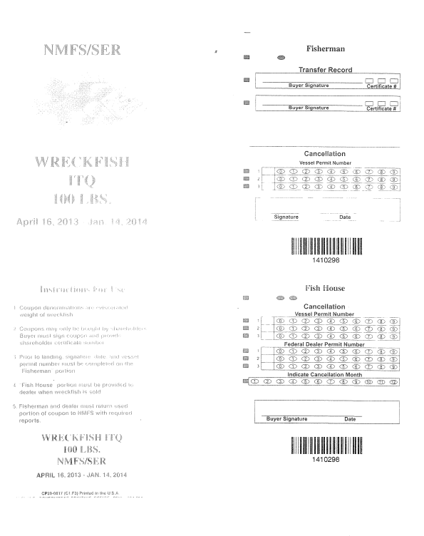
Vessel id number
_______________________________
Add additional row (4) for Federal Dealer Permit Number
April 16, 2014 – Jan. 14, 2015
April 16, 2014 – Jan. 14, 2015
Vessel id number
_____________________________

