Form Approved

OMB No. 0920-0910

Exp. Date 01/31/2015

**National Tobacco Prevention and Control Public Education Campaign:**

**Message Testing for Dual Use   
  
Screener Questionnaire**

Public reporting burden of this collection of information is estimated to average **4** minutes per response, including the time for reviewing instructions, searching existing data sources, gathering and maintaining the data needed, and completing and reviewing the collection of information. An agency may not conduct or sponsor, and a person is not required to respond to a collection of information unless it displays a currently valid OMB control number. Send comments regarding this burden estimate or any other aspect of this collection of information, including suggestions for reducing this burden to CDC/ATSDR Information Collection Review Office, 1600 Clifton Road NE, MS D-74, Atlanta, Georgia 30333; ATTN: PRA (0920-0910).On behalf of the Centers for Disease Control and Prevention (CDC), we're conducting a study about health and smoking-specific advertising that you see in the media. Your opinions are very important to us! Please be assured that the purpose of this survey is to gather feedback regarding health and smoking-specific advertising. We will not report your answers individually and will only report the results from this survey for all participants combined. Thank you for taking the time to help us!

Your participation in this survey is voluntary.

# Section: Screening Items

## Demographic Information

### DAGE1: What is your current age?

1. Under 18 years of age {TERMINATE}
2. 18-24 years of age
3. 25-34 years of age
4. 35-44 years of age
5. 45-54 years of age
6. 55-64 years of age {TERMINATE}
7. 65-74 years of age {TERMINATE}
8. 75 years of age or older {TERMINATE}
9. Refuse to answer {TERMINATE}

### DEMO5: What state do you live in?

1. Alabama
2. Alaska
3. Arizona
4. Arkansas
5. California
6. Colorado
7. Connecticut
8. Delaware
9. Florida
10. Georgia
11. Hawaii
12. Idaho
13. Illinois
14. Indiana
15. Iowa
16. Kansas
17. Kentucky
18. Louisiana
19. Maine
20. Maryland
21. Massachusetts
22. Michigan
23. Minnesota
24. Mississippi
25. Missouri
26. Montana
27. Nebraska
28. Nevada
29. New Hampshire
30. New Jersey
31. New Mexico
32. New York
33. North Carolina
34. North Dakota
35. Ohio
36. Oklahoma
37. Oregon
38. Pennsylvania
39. Rhode Island
40. South Carolina
41. South Dakota
42. Tennessee
43. Texas
44. Utah
45. Vermont
46. Virginia
47. Washington
48. West Virginia
49. Wisconsin
50. Wyoming
51. District of Columbia
52. Other please specify

*{Base = if DAGE1 = 02 & (AL (DEMO5.01) or NE (DEMO5.27))}*

### DAGE2. What is the year of your birth?

{Open-end, Mask for YYYY}

*{Terminate respondent if respondent is from AL (DEMO5.01) or NE (DEMO5.27) & is 18 or 19 years old}*

## Smoking Behavior – Core

**{PREAMBLE}**

***The next questions are about traditional tobacco cigarettes which are any roll of tobacco wrapped in paper. Below is an image of a traditional tobacco cigarette.***

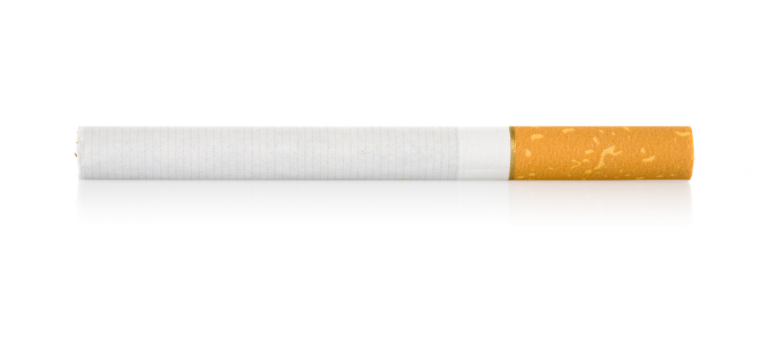

*{Base = All respondents}*

### TS1. Have you smoked at least 100 traditional tobacco cigarettes in your entire life?

1. Yes
2. No
3. Don’t know/not sure
4. Refused

*{Base = All respondents}*

### TS2. Do you now smoke traditional tobacco cigarettes every day, some days, or not at all?

1. I smoke every day
2. I smoke on some days
3. I do not smoke at all

*{Base = All respondents}*

### TS3: On how many of the past 30 days did you smoke traditional tobacco cigarettes?

Enter number: _______

## Smoking Behavior – Cigars, Cigarillos, Little Cigars

*{Base = All respondents}*

### C1a. Have you ever used cigars, cigarillos or little cigars? Select all that apply.

This is a cigarillo:

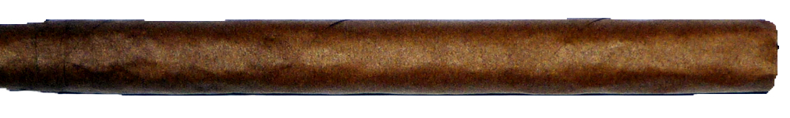

This is a little cigar:  
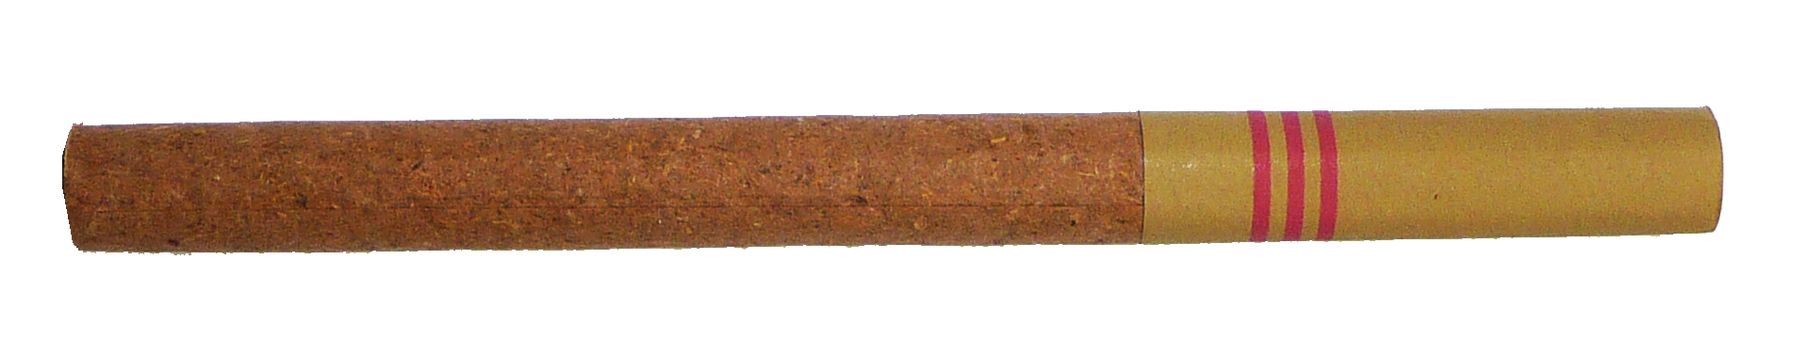

This type of cigar is a “Cigar” or “Large Cigar”:

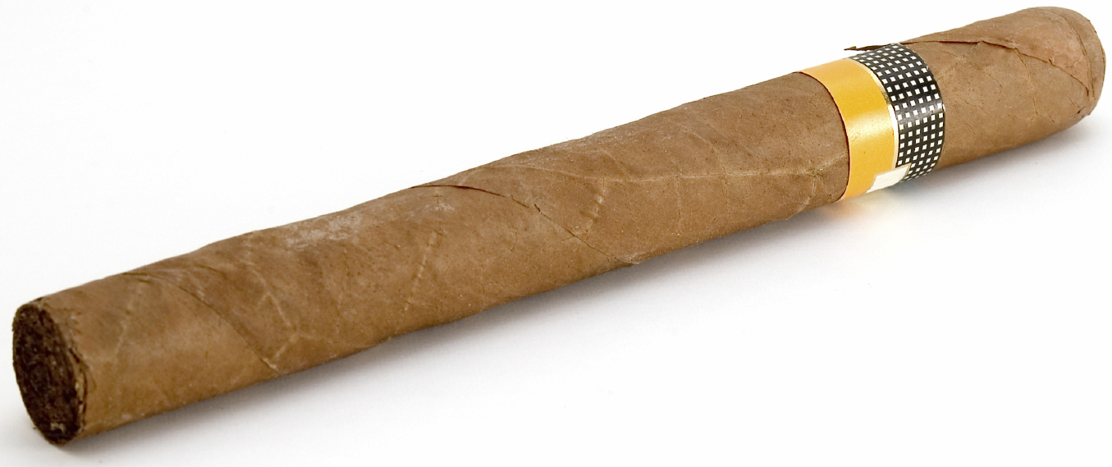

1. I have used cigars or large cigars
2. I have used cigarillos
3. I have used little cigars
4. I have never smoked cigars, cigarillos, or little cigars

*{Base = Answers 01 to C1a}*

### C2. Do you now use cigars ….

1. Every day
2. Some days
3. Not at all

*{Base = Answers 02 to C1a}*

### C3. Do you now use cigarillos ….

1. Every day
2. Some days
3. Not at all

*{Base = Answers 03 to C1a}*

### C4. Do you now use little cigars ….

1. Every day
2. Some days
3. Not at all

|  |  |
| --- | --- |
| **Categories Set #1** | **SCREENING LOGIC** |
| Current Cigarette Smokers | Answers TS1_1 to TS1 AND (TS2_1 or TS2_2 to TS2) AND Answers TS3 > 0 |
| Former Cigarette Smokers | Answers TS1_1 to TS1 AND (TS2_3 to TS_2) AND Answers TS3 = 0 |
| Current user of cigars, cigarillos or little cigars exclusively | Not (Current Cigarette Smoker or Former Cigarette Smoker) AND  (answers 01, 02, or 03 to C1a) AND (answers 01 or 02 to C2 OR C3 orC4) |
| Current cigarette smoker and currently uses cigars, cigarillos or little cigars | “Current Smoker” AND  (answers 01, 02, or 03 to C1a) AND (answers 01 or 02 to C2 OR C3 orC4) |
| Former cigarette smoker and currently uses cigars, cigarillos or little cigars | “Former Cigarette Smoker” AND  (answers 01, 02, or 03 to C1a) AND (answers 01 or 02 to C2 OR C3 orC4) |

**{Screen out all who do not satisfy Qualified Category #1}**

## Smoking Behavior – Electronic Vapor Products

*{Base = Current Cigarette Smokers and Cigarette Former Smokers}*

**{PREAMBLE}**

***The next questions are about electronic vapor products, which include e-cigarettes or electronic cigarettes. For the purposes of this study, we will use the words “electronic cigarette/e-cigarette.” An electronic vapor product can looks like a traditional tobacco cigarette, but it runs on a battery and produces vapor instead of smoke. There are several hundred brands of electronic vapor products, which come in a variety of different sizes, shapes, and flavors.***

**Smoking Behavior – Electronic Vapor Products**

### E1a. Have you ever used electronic cigarettes or e-cigarettes, such as NJOY, Blu or LOGIC, even one time?

1. Yes
2. No

*{Base = Answers Yes to E1}*

### E2. Do you now use electronic cigarettes or e-cigarettes….

1. Every day
2. Some days
3. Rarely
4. Not at all

*{Base = Answers E2.01 or E2.02}*

### E1b. Do you usually use disposable electronic cigarettes/e-cigarettes, an electronic cigarette/e-cigarette that uses cartridges, or an electronic cigarette/e-cigarette that uses tanks?

1. Disposable electronic cigarettes/e-cigarettes
2. Electronic cigarette/e-cigarette that uses cartridges
3. Electronic cigarette/e-cigarette that uses tanks

|  |  |
| --- | --- |
| **Categories Set #2** | **SCREENING LOGIC** |
| Current E-Cig Users | Answers 1 to E1 & 1 or 2 to E2 |

## Smoking Behavior – Dual-Use

*{Base = Current Smokers and Former Smokers}*

### D1a. Have you ever used chewing tobacco, snuff, or dip, such as Redman, Levi Garrett, Beechnut, Skoal, Skoal Bandits, or Copenhagen?

1. Yes
2. No

*{Base = Answers Yes to D1a}*

### D1b. Do you now use chewing tobacco, snuff, or dip ….

1. Every day
2. Some days
3. Not at all

*{Base = Current Smokers and Former Smokers}*

### D3a. Snus is a spitless smokeless tobacco product usually sold in individual or pre-packaged small pouches that are placed under the lip against the gum. Have you ever used snus, such as Camel Snus or Marlboro Snus?

1. Yes
2. No

*{Base = Answers Yes to D3a}*

### D3b. Do you now use snus ….

1. Every day
2. Some days
3. Not at all

|  |  |
| --- | --- |
| **Categories Set #3** | **SCREENING LOGIC** |
| Current Chewing Tobacco User | Answers 1 to D1A & 1 or 2 to D1b |
| Current Snus User | Answers 1 to D3a & 1 or 2 to D3b |

## Qualified Categories

|  |  |  |  |
| --- | --- | --- | --- |
| **Qualified Categories – Complete Set** | | | |
| Current Cigarette Smoker | AND CURRENTLY USES | uses e-cigarettes or chewing tobacco or snus or a combination of these three | Current Cigarette Smoker AND (Current E-Cig User AND/OR Current Chewing Tobacco User AND/OR Current Snus User) |
| Former Cigarette Smoker | AND CURRENTLY USES | uses e-cigarettes or chewing tobacco or snus or a combination of these three | Former Cigarette Smoker AND (Current E-Cig User AND/OR Current Chewing Tobacco User AND/OR Current Snus User) |
| ***Screening logic for following categories defined above as part of Categories Set #1*** | | | |
| Current user of cigars, cigarillos or little cigars exclusively | | | |
| Current cigarette smoker and currently uses cigars, cigarillos or little cigars | | | |
| Former cigarette smoker and currently uses cigars, cigarillos or little cigars | | | |

*{Fill by least-fill until quota is reached}*

**(Screen out all who do not satisfy any of the Qualified Categories}**

# {GENERAL SCREEN OUT MESSAGE}

Thank you for your participation in this study. Unfortunately, your responses indicate that you do not fit the specific criteria needed for this particular study, or that we have already reached our required quota of responses from participants similar to you. We appreciate your enthusiasm for our study and hope you will join us on future surveys!