Form Approved
OMB No. 0920-0910
Exp. Date 01/31/2015

National Tobacco Prevention and Control Public Education Campaign:
Copy testing of television ads
for current smokers
who are active military or veterans,
have anxiety or depression, or
are lesbian, gay, bisexual, or transgender
Screener Questionnaire

Public reporting burden of this collection of information is estimated to average 3 minutes per response, including the time for reviewing instructions, searching existing data sources, gathering and maintaining the data needed, and completing and reviewing the collection of information. An agency may not conduct or sponsor, and a person is not required to respond to a collection of information unless it displays a currently valid OMB control number. Send comments regarding this burden estimate or any other aspect of this collection of information, including suggestions for reducing this burden to CDC/ATSDR Information Collection Review Office, 1600 Clifton Road NE, MS D-74, Atlanta, Georgia 30333; ATTN: PRA (0920-0910).
On behalf of the Centers for Disease Control and Prevention (CDC), we're conducting a study about health and smoking-specific advertising that you see in the media. Your opinions are very important to us! Please be assured that the purpose of this survey is to gather feedback regarding health and smoking-specific advertising. We will not report your answers individually and will only report the results from this survey for all participants combined. Thank you for taking the time to help us!

Your participation in this survey is voluntary.

Section: Screening Items

Demographic Information

DAGE1: What is your current age?
- Under 18 years of age {TERMINATE}
- 18-24 years of age
- 25-34 years of age
- 35-44 years of age
- 45-54 years of age
- 55-64 years of age {TERMINATE}
- 65-74 years of age {TERMINATE}
- 75 years of age or older {TERMINATE}
- Refuse to answer {TERMINATE}

DEMO5: What state do you live in?
- Alabama
- Alaska
- Arizona
- Arkansas
- California
- Colorado
- Connecticut
- Delaware
- Florida
- Georgia
- Hawaii
- Idaho
- Illinois
- Indiana
- Iowa
- Kansas
- Kentucky
- Louisiana
- Maine
- Maryland
- Massachusetts
- Michigan
- Minnesota
- Mississippi
- Missouri
- Montana
- Nebraska
- Nevada
- New Hampshire
- New Jersey
- New Mexico
- New York
- North Carolina
- North Dakota
- Ohio
- Oklahoma
- Oregon
- Pennsylvania
- Rhode Island
- South Carolina
- South Dakota
- Tennessee
- Texas
- Utah
- Vermont
- Virginia
- Washington
- West Virginia
- Wisconsin
- Wyoming
- District of Columbia
- Other please specify

{Base = if DAGE1 = 02 & (AL (DEMO5.01) or NE (DEMO5.27))}

DAGE2. What is the year of your birth?
{Open-end, Mask for YYYY}

{Terminate respondent if respondent is from AL (DEMO5.01) or NE (DEMO5.27) & is 18 or 19 years old}

Smoking Behavior – Core
{PREAMBLE}
The next questions are about traditional tobacco cigarettes which are any roll of tobacco wrapped in paper. Below is an image of a traditional tobacco cigarette.
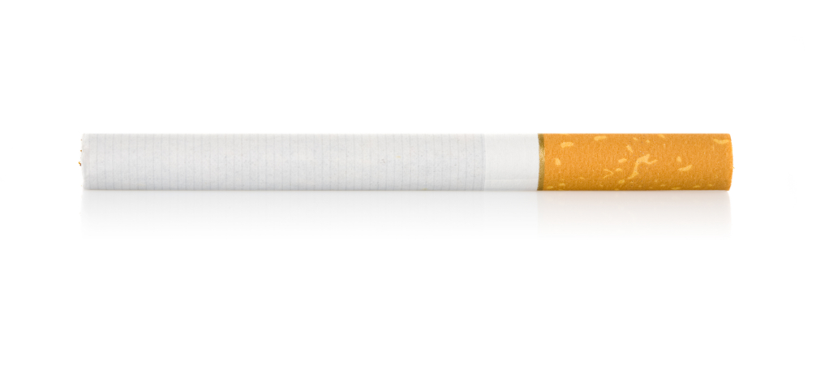
{Base = All respondents}

TS1. Have you smoked at least 100 traditional tobacco cigarettes in your entire life?
- Yes
- No
- Don’t know/not sure
- Refused
{Base = All respondents}

TS2. Do you now smoke traditional tobacco cigarettes every day, some days, or not at all?
- I smoke every day
- I smoke on some days
- I do not smoke at all

{Base = All respondents}

TS3: On how many of the past 30 days did you smoke traditional tobacco cigarettes?
Enter number: _______

Qualified Respondent Category | SCREENING LOGIC
Current Smokers | Answers TS1_1 to TS1 AND (TS2_1 or TS2_2 to TS2) AND Answers TS3 > 0

LGBT Screening Questions

DEMO1. Do you consider yourself to be:
- Male
- Female
- Don’t know/not sure
- Refused

142A. DEMO4. Do you think of yourself as…?
{IF DEMO1. GENDER EQ 1}

1. Gay
2. Straight, that is, not gay
3. Bisexual
4. Something else
7. Don’t know/not sure
9. Refused

{IF DEMO1. GENDER EQ 02 OR 03 or 04}

1. Lesbian or gay
2. Straight, that is, not lesbian or gay
3. Bisexual
4. Something else
7. Don’t know/not sure
9. Refused

{If 142A EQ 4, then}

142B. By something else, do you mean that …
1. You are not straight, but identify with another label such as queer, trisexual, omnisexual or pansexual.
2. You are transgender, transsexual or gender variant.
3. You have not figured out your sexuality or are in the process of figuring it out.
4. You do not think of yourself as having sexuality.
5. You do not use labels to identify yourself.
6. You made a mistake and did not mean to pick this answer. {GO BACK TO Q142A DEMO4}
7. You mean something else.
9. Refused

{If 142A EQ 07, then}

142C You gave “Don’t know/not sure” as an answer. Is that because….
- You don’t understand the words.
- You understand the words, but you have not figured out your sexuality or you are in the process of figuring it out.
- You mean something else
- Refused
Military/Veteran Screening Questions

{Base = All respondents}
MIL1. Have you ever served on active duty in the United States Armed Forces, either in the regular military or in a National Guard or military reserve unit? Active duty does not include training for the Reserves or National Guard, but DOES include activation, for example, for Afghanistan or Iraq.

1 Yes
2 No
8 Don’t know
9 Refused

{Base = All respondents}
{If answered Mil1.01 is selected, then ask:}

MIL2. Are you currently serving on active duty in the United States Armed Forces, either in the regular military or in a National Guard or military reserve unit? Active duty does not include training for the Reserves or National Guard, but DOES include activation, for example, for Afghanistan or Iraq.
1 Yes
2 No
8 Don’t know
9 Refused

Anxiety/Depression Screening Questions

{Base = All respondents}

ADQ1. Has a physician or other medical professional ever diagnosed you with any of the following medical conditions? (Select all that apply)
- Anxiety disorder
- Depression
- Other mental health condition (specify) ____________________________________
- None of these [Single select, anchor]

{If answered ADQ1.04 is selected, then ask:}

ADQ2. Even if a physician or other qualified medical professional has not diagnosed you with any of these medical conditions, have you ever considered yourself to have any of the following medical conditions? (Select all that apply)
- Anxiety disorder
- Depression
- Other mental health condition
- None of these [Single select, anchor]

{Terminate respondent if (ADQ1_04 AND ADQ2_04)}

Qualified Categories

Qualified Completes
Current Smoker & LGBT | “Current Smoker” AND {(answers 01, 03, 04 to DEMO4) and IF 04 to DEMO4 then {answers 01, 02, to 142B}}
Current Smoker & Active Duty | “Current Smoker” AND (answers 01 to MILQ1)
Current Smoker & Veteran | “Current Smoker” AND (answers 02 to MILQ1)
Current Smoker & Anx/Depression (Med) | “Current Smoker” AND (answers 01-03 to ADO1)
Current Smoker & Anx/Depression  (self-identified) | “Current Smoker” AND (answers 01-03 to ADO2)
{Fill by least-fill until quota is reached}
(Screen out all who do not satisfy any of the Qualified Categories}

{GENERAL SCREEN OUT MESSAGE}
Thank you for your participation in this study. Unfortunately, your responses indicate that you do not fit the specific criteria needed for this particular study, or that we have already reached our required quota of responses from participants similar to you. We appreciate your enthusiasm for our study and hope you will join us on future surveys!

