

Questions and Answers

About the Birth Defects Study To Evaluate Pregnancy exposureS exposureS

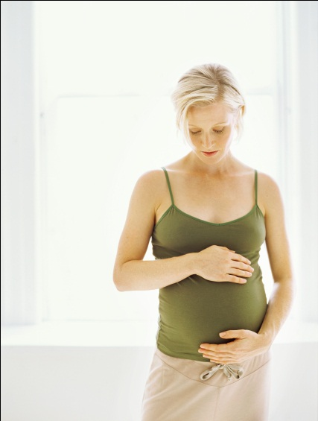One in every 33 babies in the United States is born with a birth defect. Birth defects are one of the leading causes of death in the first year of life and can affect how a child’s body looks, works, or both. While we know the causes of some birth defects, we do not know what causes most of them. Researchers across the nation are teaming up with the Centers for Disease Control and Prevention (CDC) to find answers through the Birth Defects Study to Evaluate Pregnancy exposureS (BD-STEPS).

**What is BD-STEPS?** BD-STEPS is a nationwide effort to find causes of birth defects by collecting information from women who have recently been pregnant. We study many different types of birth defects, including cleft lip, spina bifida, and heart defects.

**How does the study work?** We talk to women who had pregnancies affected by birth defects as well as women whose babies did not have birth defects. We ask about their pregnancy experience and health. Families also collect and send in saliva samples so that we can examine the role genetic (inherited) factors play in the health of a baby.

**Why do you need information about genes?** We study genetic material from saliva (spit) to see if certain forms of genes are more likely to be present when birth defects occur.

**Who funds the study?** CDC funds the Centers for Birth Defects Research and Prevention (CBDRP) to work together on the study. Participating CBDRP sites include: Arkansas, California, Georgia (CDC), Iowa, Massachusetts, North Carolina and New York.

**How did you get my name?** Birth defects are a serious

public health concern, and state laws allow each study site to collect information on pregnancies affected by a birth defect. This is how most women are identified in the study. Women whose babies do not have birth defects are chosen randomly from a group of women who gave birth in the same year.

**What will the results show?** Since the study looks at a large group of women, this means findings will apply to "the average woman" rather than any specific individual. There are many possible results. We may uncover:

* Risk factors, things that raise the risk for birth defects
* Protective factors, things that lower the chances of having a baby with birth defects
* Neutral factors, things that neither raise nor lower the risk

**What will you do with the study findings?** We publish findings in medical journals. Because birth defects are of great interest, findings are often covered in the news as well. We also will publish findings in a yearly electronic newsletter that we will make available to women who take part in the study.

**Why is this study so important?** Understanding the causes of birth defects can help us prevent them. The size and scope of this study will provide important clues to help us in our journey to ensure that every child is born with the best health possible.

**What does the study involve?**

What You Need to Know About Participating

There are three parts of the study.

1. [](http://esp.cdc.gov/sites/ncbddd/Photos/Photos/Contemporary%20lifestyles/16642CLI.jpg)An interviewer will call you in about two weeks to begin the interview or set up a convenient time for the interview. The interview lasts about 45 minutes, and it can be split into segments to fit your schedule.
2. After this, we will send you a saliva collection kit that you can complete and return to us through the mail.
3. We might also ask for your consent to review some of your medical records and for your consent to request a leftover newborn blood spot that was collected shortly after the birth of your child.

**Where is the study conducted?** You can participate in all parts of the study from your home.

**How will the study benefit my family?** Study results will not directly benefit you or your family. However, many women feel good about helping to find causes of birth defects.

**Are there any disadvantages to participating?** Some women interviewed find it emotionally difficult to discuss their pregnancies. There is no other likely disadvantage.

**What do I get for participating?** We have enclosed a $20 gift card as a token of appreciation for your time and interest. The gift card is yours to keep whether or not you take part in the study. We will send another $20 gift card with the saliva collection kit. And if you complete both parts of the study, you will get a third $20 gift card when we receive your saliva samples.

**Do I have to participate?** No. There will be no harmful effects if you refuse. Your decision will not affect health care services or other benefits you or your family may receive.

**What will I be asked in the interview?** The interview covers a wide range of topics about you and your pregnancy. Sometimes we ask you to answer in your own words. Other times, we will give you several possible responses to choose from. We will ask about the following things in your interview: your recent pregnancy and the month before you became pregnant,past pregnancies, your generalhealth,family background, lifestyle,work, and prescription and non-prescription medicines taken. We will also ask a few questions about your baby’s father. Please look at the medicine sheet in this packet to help you remember the medicines you took around the time you became pregnant and in your first trimester.

**What if I do not want to answer or can’t remember?** You may skip any questions you wish.It is okay to say that you don’t remember. We want you to answer as accurately and honestly as possible.

**How will my privacy be protected?** We will never use any names in reports or publications. We will not give any information about you to anyone who is not an approved children’s health researcher on this study. No one else may look at your data, including insurance companies or other government agencies, even if requested by a court of law. We keep records under lock and key. All computer files are password protected.

**Study contact information.** If you have any questions, please feel free to call us at our toll free number, 1-888-743-7324, or email us at <**Abt email**>. You can also visit [www.bdsteps.org](http://www.bdsteps.org) for more information about the study. You can reach your local BD-STEPS researchers with the following information:

INSERT LOCAL CONTACT INFORMATION STICKER.