**How to Collect a Saliva (Spit) Sample for Parents**

Thank you for agreeing to provide a saliva sample. To collect the sample, we have included:

* Consent forms (one copy to sign and return to us; one copy for you to keep)
* Instructions and tips for collecting a saliva sample for parents
* Frequently asked questions about saliva collection
* Collection container(s) in a clear case (includes a tube with attached funnel and separate cap)
* Plastic bag with a small square of absorbent cloth (one for each collection container)
* Postage-paid mailing envelope (one for all collection containers)

Please read the following directions BEFORE you start collecting a saliva sample.

**1** Write the date the sample was collected on the bag label.

Read and sign the enclosed consent form.

**2**Write the date the sample was collected on the bag label.

Do NOT eat, drink, smoke or chew gum for 30 minutes before giving your saliva sample.

**3**Write the date the sample was collected on the bag label.

Do NOT remove the plastic film from the funnel lid that contains the clear liquid.

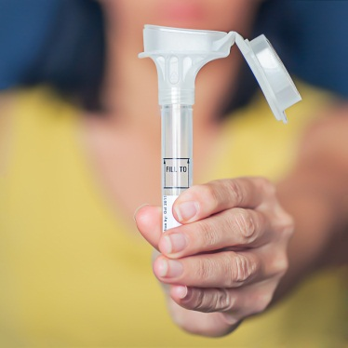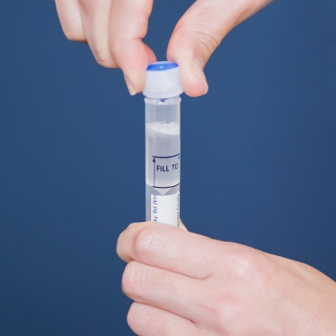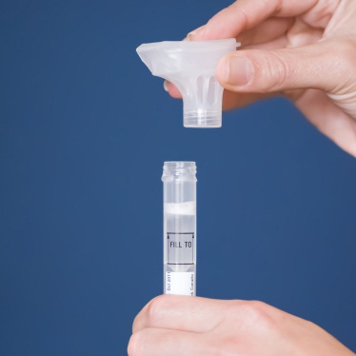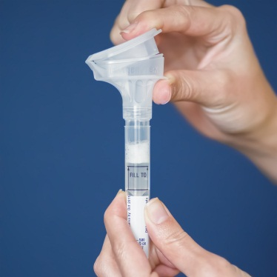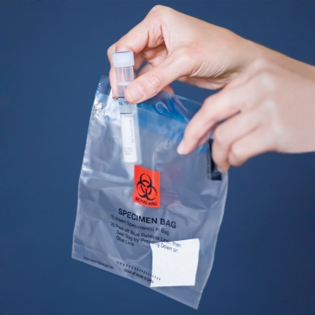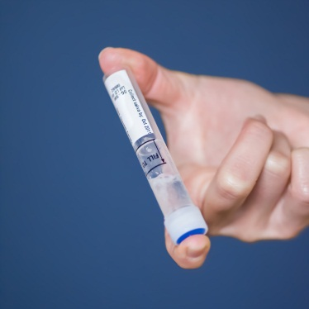

**4**Write the date the sample was collected on the bag label.

Spit into the open funnel until the amount of saliva (not bubbles) reaches the fill line. Most people take 2 to 5 minutes to fill the tube.

**7**Write the date the sample was collected on the bag label.

**6**Write the date the sample was collected on the bag label.

**5**Write the date the sample was collected on the bag label.

Close the lid tightly by pushing down hard on the funnel lid until you hear a loud click. The liquid will flow down into the tube.

**8**Write the date the sample was collected on the bag label.

Gently turn the capped tube upside down and back again for 5 seconds to mix the liquids.

Write the date the sample was collected on the bag label. Put the capped tube into the bag with the absorbent cloth and close the bag.

Hold the tube upright. Unscrew the funnel lid from the tube and discard.

**9**Write the date the sample was collected on the bag label.

Remove the small cap from the clear case. Screw the cap on tightly to the tube.

Place the signed consent form and the bag(s) with the collection container(s) into the postage-paid mailing envelope. There is only 1 mailing envelope for all collection containers from your family. Close the envelope and return it to us by U.S. mail as soon as possible.

If you have any questions or problems, please call 1-888-743-7324.

Thank you!

**10**Write the date the sample was collected on the bag label.

**Tips for Collecting Saliva from Parents**

Thank you again for participating in this important study of birth defects!

**To provide the highest quality sample, please try to follow the tips below:**

1. Wait 30 minutes after eating, drinking, smoking, or chewing gum, before beginning collection of the saliva sample. If you wait a shorter time (less than 30 minutes), you can still mail us your sample.
2. Take the small cap out of the clear case before you begin.
3. Try to provide enough saliva (NOT including foam) to reach the “Fill To” line on the tube BEFORE you close the lid of the funnel. Let the foam settle before closing the lid or it will overflow. After you close the lid, please remove the funnel and screw on the small cap right away.
4. You should NOT re-open the tube and try to add more saliva.
5. Do NOT rest the tube on a table top when it is open. It will tip over. Please place the tube upright in a glass if you need to put it down for any reason.
6. Before spitting, relax and rub your cheeks gently for 30 seconds to make saliva. If you find it hard to make saliva, place a very small amount (1/4 teaspoon) of white table sugar on your tongue.

**Warnings:**

* Do NOT ingest the liquid in the funnel. Wash with water if the liquid in the funnel comes in contact with your eyes or skin. See Material Safety Data Sheet (MSDS) for OGR-500 / OGR-250 at www.dnagenotek.com/US/pdf/PD-SVSDS-00004-PD-MSDS-00004.pdf for more information.
* The small cap is a choking hazard.