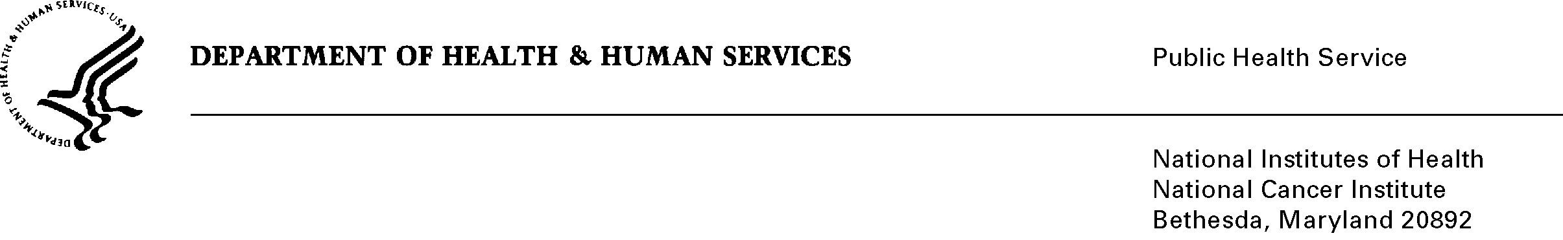

Date: December 6, 2013

TO: Office of Management and Budget (OMB)

Through: Keith Tucker, Reports Clearance Officer, HHS
Seleda Perryman, Program Clearance Officer, NIH
Vivian Horovitch-Kelley, PRA OMB Project Clearance Liaison, NCI

FROM: Jessica Faupel-Badger, PhD, MPH
Cancer Prevention Fellowship Program
National Cancer Institute (NCI)/NIH

SUBJECT: Outcomes Evaluation of the National Cancer Institute (NCI) Cancer Prevention Fellowship Program (CPFP)

This is a request for OMB to approve the new submission titled, “Outcomes Evaluation of the National Cancer Institute (NCI) Cancer Prevention Fellowship Program (CPFP)” for one year.

The purpose of this survey is to evaluate the NCI Cancer Prevention Fellowship Program in order to inform decision-making and identify opportunities to make improvements to or demonstrate the importance of the program to key stakeholders. The methods and products of this evaluation will not only serve to inform CPFP program administrators, but may serve to inform training programs beyond those at NCI as well as the evaluation community in general.

The survey will involve 160 CPFP alumni and approximately 390 individuals in two comparison groups comprised of 170 CPFP applicants and 220 former F32 fellows who received funding from NCI. Data collection will extend over several months and will be followed by an analysis of findings.

