Small Vessel Reporting System (SVRS)
Version: 1.7.5

Welcome
This web site works best with Internet Explorer. Other web browsers may not function correctly.
Scripting, cookies and TLS 1.0 must be enabled in your browser settings.

As part of the Customs and Border Protection (CBP) comprehensive effort to improve the security of our nation’s borders while enhancing legitimate travel specifically for boaters who are enrolled in the Local Boater Option (LBO) program and prospective participants, CBP has implemented the Small Vessel Reporting System (SVRS); available to all U.S. citizens, nationals and lawful permanent residents; Canadian citizens and permanent residents of Canada who are nationals of a Visa Waiver Program country. SVRS is a web-based automated on-line reporting system created for LBO participants to expeditiously report their intended arrivals from foreign. In addition, the web-based system will facilitate the enrollment of new applicants for SVRS. New applicants will be able to enroll and make an appointment for a face-to-face interview with a CBP Officer at an authorized reporting location of their choosing. Once participation in SVRS is granted by CBP, the participant will receive an email with their SVRS number and instructions for setting their initial password for SVRS. Current LBO participants must apply on-line for a password to access the float plan functions of SVRS.
Float plans consist of biographical information of all persons intending on traveling, vessel registration information and itinerary information. Once a float plan is entered and activated, SVRS will issue a float plan number. Upon return to the United States, the SVRS participant will contact an SVRS dedicated telephone line manned by a CBP Officer or an automated attendant. The CBP Officer or automated attendant will ask a series of questions reflecting those on a Customs Declaration (CBP Form 6059B) and provide the participant with their arrival number, or refer the participant to a predetermined inspection site for a CBP inspection. Persons traveling who are not SVRS members must report to their nearest CBP Office for immigration processing within 24 hours of arrival.
SVRS Eligibility:
All U.S. Citizens, nationals and lawful permanent residents; Canadian citizens and permanent residents of Canada who are nationals of a Visa Waiver Program country are eligible to participate. Both masters and passengers will be allowed to register; the master will be required to provide vessel information. The registrant’s documentation will be reviewed and verified to establish the applicant’s immigration status and identity.
Click here to see a list of registration locations. List will appear in a new window.
For more information please see the SVRS Flyer and the sample acceptance form. You may also find this enrollment form convenient for gathering the information required to complete this application.
For any other questions about SVRS Registration, please contact a CBP representative.

Main Menu
Application for SVRS Participation
Add/Update/Activate Float Plans or Vessel Registrations
Password Request (existing LBO participants)
Reschedule Your Interview Appointment

You are about to access a Department of Homeland Security computer system. This computer system and data therein are property of the U.S. Government and provided for official U.S. Government information and use. There is no expectation of privacy when you use this computer system. The use of a password or any other security measure does not establish an expectation of privacy. By using this system, you consent to the terms set forth in this notice. You may not process classified national security information on this computer system. Access to this system is restricted to authorized users only. Unauthorized access, use, or modification of this system or of data contained herein, or in transit to/from this system, may constitute a violation of section 1030 of title 18 of the U.S. Code and other criminal laws. Anyone who accesses a Federal computer system without authorization or exceeds access authority, or obtains, alters, damages, destroys, or discloses information, or prevents authorized use of information on the computer system, may be subject to penalties, fines or imprisonment. This computer system and any related equipment is subject to monitoring for administrative oversight, law enforcement, criminal investigative purposes, inquiries into alleged wrongdoing or misuse, and to ensure proper performance of applicable security features and procedures. DHS may conduct monitoring activities without further notice.
NOTICE: This system contains trade secrets and commercial and financial information relating to the confidential business of private parties. The Trade Secrets Act, (18 U.S.C. 1905), provides penalties for disclosure of such information. Customs employees who violate this act and make wrongful disclosures of confidential commercial information may be subject to a personal fine of up to $250,000, imprisonment for not more than one year, or both, and shall be removed from employment. An improper disclosure of personal information contained in this system would constitute a violation of The Privacy Act (5 U.S.C. 552a). Violators could be subject to a fine of not more than $5,000 per record and removal from employment. Information contained in this system is subject to the 3rd party rule and may not be disclosed to other government agencies without the express permission of the agency supplying the original information.
Paperwork Reduction Act Statement: An agency may not conduct or sponsor an information collection and a person is not required to respond to this information unless it displays a current valid OMB control number and an expiration date. The control number for this collection is 1651-0137. The estimated average time to complete this application is 15 minutes for the initial application and 10.6 minutes for the float plan. If you have any comments regarding the burden estimate you can write to U.S. Customs and Border Protection Office of Regulations and Rulings, 90 K Street, NE, Washington DC 20229. Expiration Date: 1-31-2014.

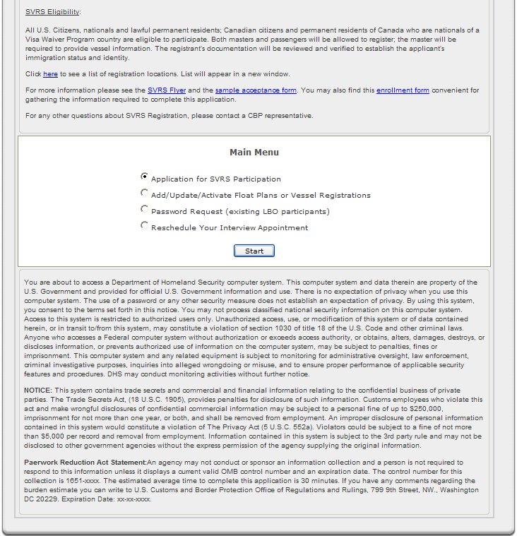

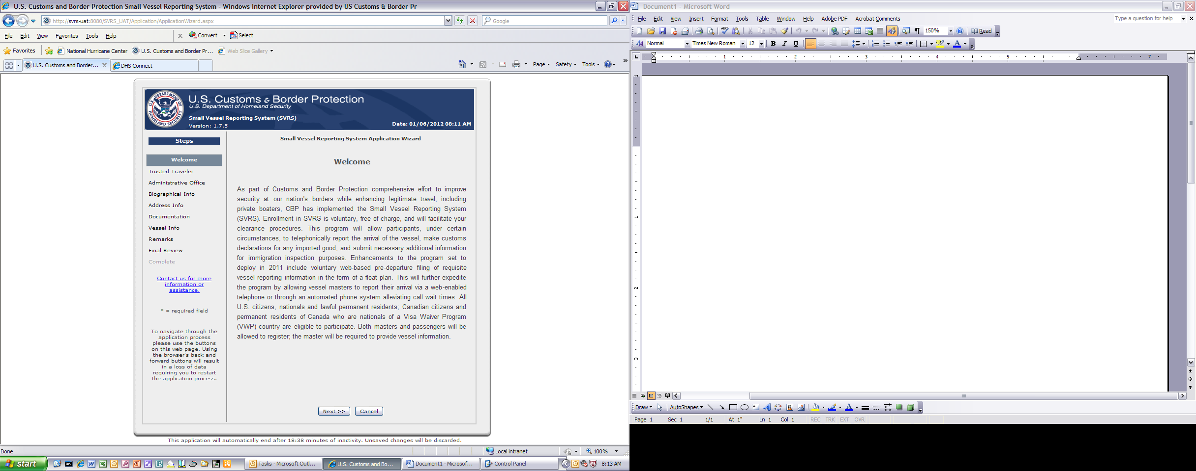

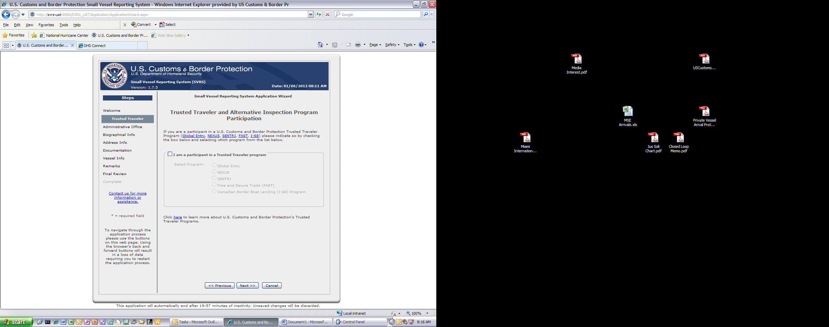

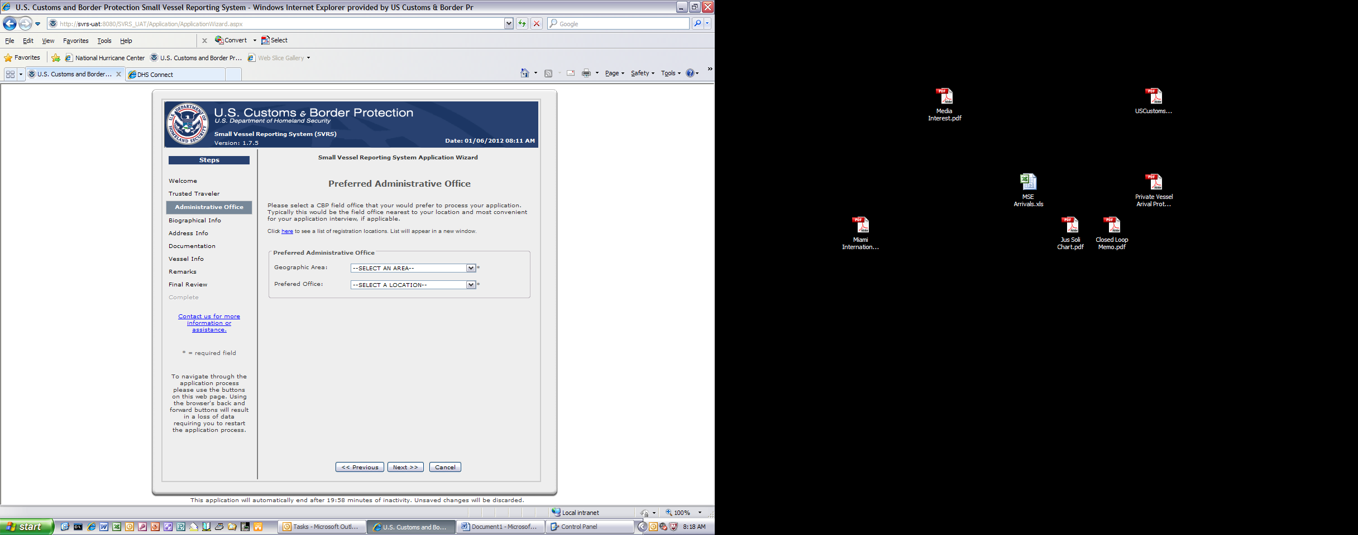

Personal Information

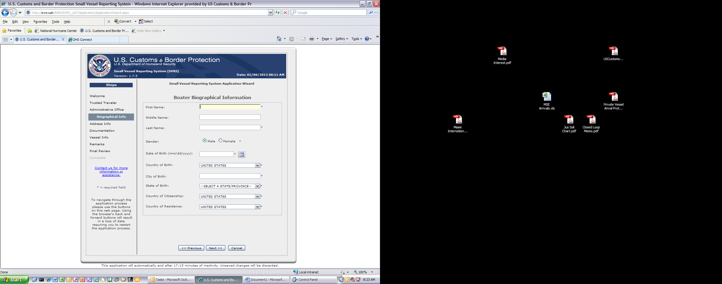

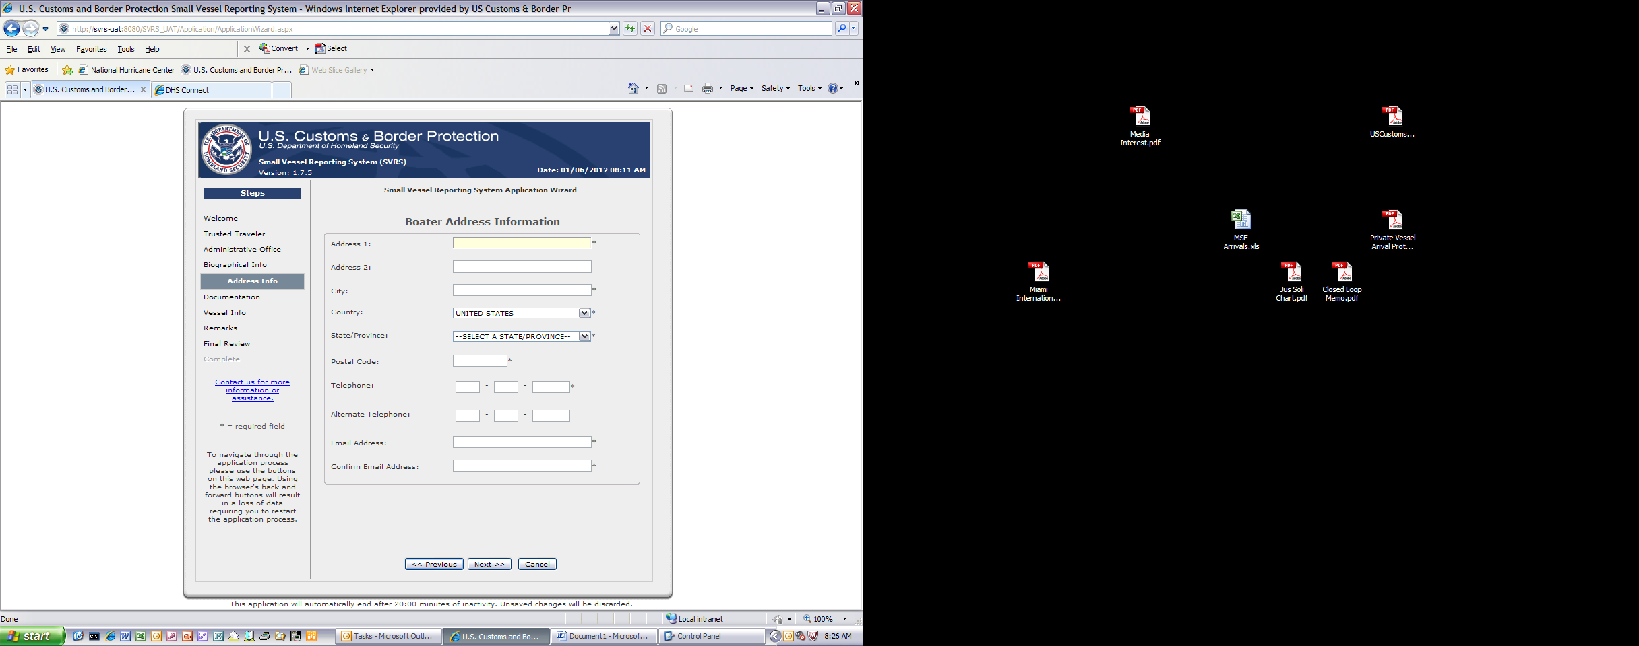

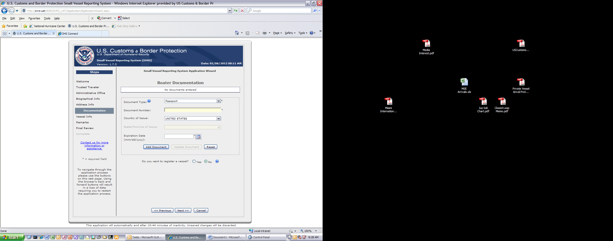

Vessel Information

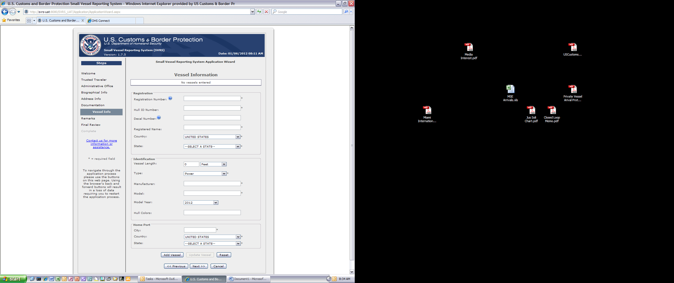

Remarks Section (Non-Mandatory Field)

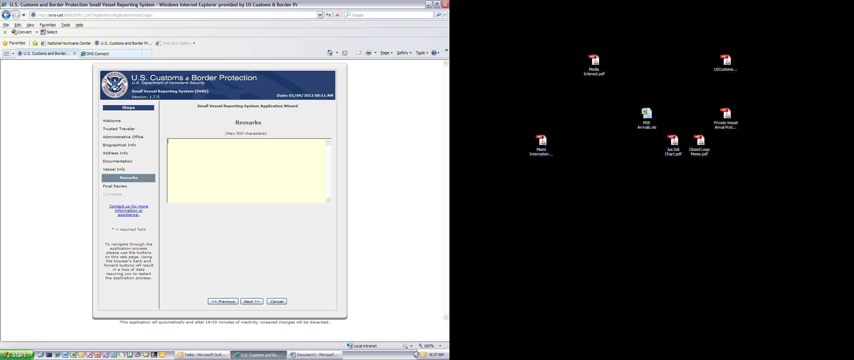

Application Receipt

