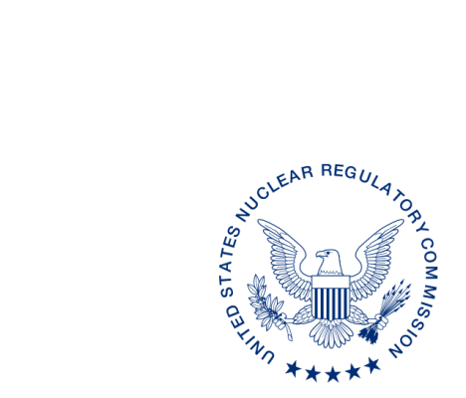
UNITED STATES
NUCLEAR REGULATORY COMMISSION
WASHINGTON, D.C. 20555-0001

DATE

ALL AGREEMENT STATES

NOTIFICATION OF CHANGE IN ADMINISTRATION OF THE INTEGRATED MATERIALS PERFORMANCE EVALUATION PROGRAM VIEWPOINT SURVEY (STC-15-XXX)

Purpose: To notify Agreement States that will participate in Integrated Materials Performance Evaluation Program (IMPEP) team reviews in fiscal year (FY) 2016 that the IMPEP Viewpoint Survey will now be administered electronically, instead of as a text document.

Background: The U.S. Nuclear Regulatory Commission’s (NRC) Office of Nuclear Material Safety and Safeguards (NMSS) conducts a satisfaction survey following completion of the Integrated Materials Performance Evaluation Program (IMPEP) review. The satisfaction survey covers IMPEP reviews of Agreement State radiation control programs and NRC materials programs. The results of the satisfaction surveys are used as part of a self-assessment performed periodically by NMSS in accordance with NMSS Procedure SA-123 Conducting Self-Assessments of the Integrated Materials Performance Evaluation Program (IMPEP). In FY 2015, NMSS requested that self-assessment surveys be completed by Agreement State or NRC Program staff and IMPEP team members, following an IMPEP review. The surveys were administered as a text document to be submitted via email to the NRC upon completion.

Discussion: Beginning in FY 2016, IMPEP participants will be requested to complete a self-assessment survey using an electronic survey tool. Based on our experience, we think it will be beneficial to administer the survey electronically, rather than as a text document to facilitate use and encourage an increase in the number of responses. Following an IMPEP review, program directors will receive a request to complete the self-assessment. Requests will also be sent to Agreement State staff who participated as a team member for another Agreement State’s IMPEP review. All requests will be made in the form of an email, which will contain a link to the survey. Upon receiving the link, please complete and submit your responses to the point of contact listed below. For your information, a copy of the survey in text format is enclosed. Feedback from the survey will not be used to judge a program, and is only for self-assessment of NRC’s performance in FY 2016.*

If you have any questions regarding this communication, please contact the individual named below.

POINT OF CONTACT: Elizabeth Doolittle EMAIL: Elizabeth.Doolittle@nrc.gov
TELEPHONE: (301) 415-6424

Pamela J. Henderson, Acting Director
Division of Material Safety, State, Tribal,
and Rulemaking Programs
Office of Nuclear Material Safety
and Safeguards

Enclosure:
IMPEP Viewpoint Survey FY 2016,
Agreement States and Regions
__________________________________

* This information request has been approved by OMB 3150-0217 expiration 1/31/2017. The estimated burden per response to comply with this voluntary collection is approximately 15 minuteshours. Send comment regarding the burden estimate to the Records and Information Services Branch (T-5F53), U.S. Nuclear Regulatory Commission, Washington, DC 20555-0001, or by e-mail to infocollects.resource@nrc.gov, and to the Desk Officer, Office of Information and Regulatory Affairs, NEOB-10202 (3150-0029), Office of Management and Budget, Washington, DC 20503. If a means used to impose an information collection does not display a currently valid OMB control number, the NRC may not conduct or sponsor, and a person is not required to respond to, the information collection.

