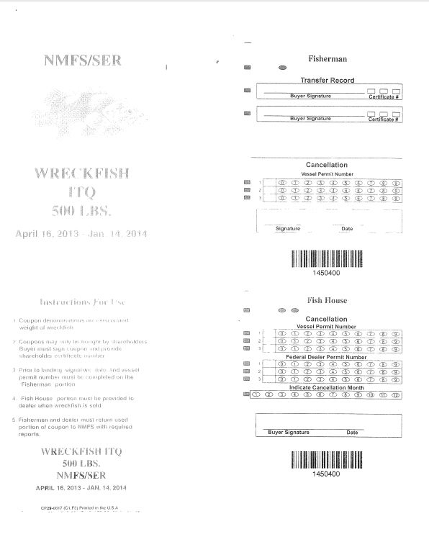

Vessel id number

____________________________

Add additional row (4) for Federal Dealer Permit Number

Vessel id number

____________________________

April 16, 2014 – Jan. 14, 2015

April 16, 2014 – Jan. 14, 2015