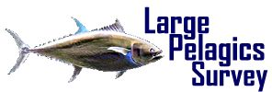



**UNITED STATES DEPARTMENT OF COMMERCE**

**National Oceanic and Atmospheric Administration**

NATIONAL MARINE FISHERIES SERVICE

OFFICE OF SCIENCE AND TECHNOLOGY

FISHERIES STATISTICS DIVISION

May 16, 2013

«RNAME»

«ADDRESS»

«CITY», «STATE» «ZIP»

Dear «First_name»,

Every year, the National Marine Fisheries Service (NMFS) sponsors the Large Pelagics Survey (LPS) which is designed to collect information about offshore recreational fishing for large pelagic species such as tunas, billfishes, sharks, dolphin, wahoo, and amberjack. The LPS consists of both a dockside component and a telephone survey. Information collected from the LPS is critical to managing and enhancing the recreational opportunities available in the fishery. Information on catch and effort of many important migratory species are reported to the International Commission for the Conservation of Atlantic Tunas (ICCAT) and are used by NMFS for domestic fisheries management.

You have been selected to participate in the LPS telephone survey. **QuanTech, Inc.**, of Arlington, Virginia is contracted to select random samples of boats from the Highly Migratory Species (HMS) permit list and contact the operators of those boats to collect information on fishing activity for large pelagic species. Your participation in this survey is greatly appreciated and is an important step toward fulfilling your *mandatory reporting requirement* as an HMS permit holder. Even *if you did not fish* during the reporting period indicated below it is still important that you participate in the survey.

You have been selected to report fishing activity of the «bname» for :

**«begin_date» through «end_date»**

Beginning on **Monday, «call_date»**

a **QuanTech** representative will attempt to contact you by telephone at

**«phone1»**

**«phone2»**

If you are not planning to renew your permit, need to schedule a time for our interviewers to speak with you, or ***if there are any errors in your telephone number(s)***, please contact **QuanTech** at **1-800-229-5220** or **lps@quantech.com**. Thank you in advance for your cooperation.

Sincerely,

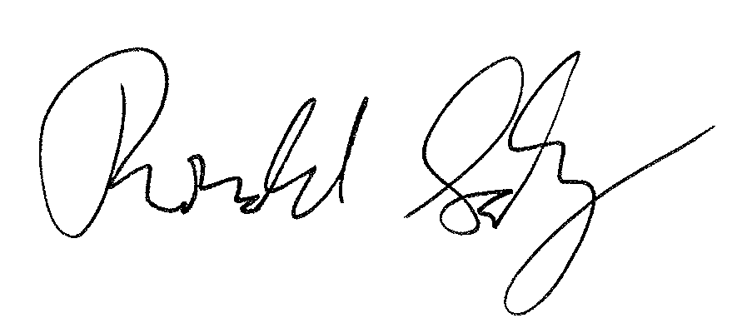

Ronald Salz, *Fishery Biologist*

NOAA Fisheries

Vessel Name: «BNAME»

Permit Category: «Permit_Cat»

Vessel Permit: «HMSPN»

Vessel Operator: «RNAME»

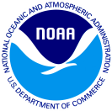Principal Port State: «PSTAT»