Survey Reminder Email #1
To: Recipient Email
From: CDC and ASCT Services, Inc.
Subject: Reminder: Cytology Workload Practices Survey
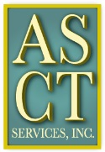
Survey Link
There is still time to complete the Cytology Workload Practices survey. Please consider doing so at your earliest convenience as the survey is only open for two more weeks. Your participation is important to the cytology profession, as you have the opportunity to contribute valuable information to agencies that develop the CLIA workload requirements.
If you haven’t forwarded the survey link to the cytotechnologists in your laboratory, please do.
Don’t miss this opportunity to WIN A PRIZE for completing the survey. Prizes consist of a variety of educational materials.
Thank you for your participation.

This survey is supported by a contract (200-2013-57614) funded by the Centers for Disease Control and Prevention/Agency for Toxic Substances and Disease Registry.

