FINAL Survey Reminder Email
To: Recipient Email
From: CDC and ASCT Services, Inc.
Subject: FINAL REMINDER: Cytology Workload Practices Survey
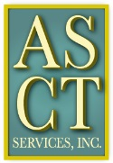
Survey Link
This is your final opportunity to complete the Cytology Workload Practices survey and possibly WIN A PRIZE! The survey closes in three days. Your feedback is valuable to the evaluation of cytology workload requirements and the development of guidelines for setting cytology workload limits.
Please forward this reminder and survey link to the cytotechnologists in your laboratory.
Thank you for your participation.

This study is supported by a contract (200-2013-57614) funded by the Centers for Disease Control and Prevention/Agency for Toxic Substances and Disease Registry.

