Survey Reminder Email #2
To: Recipient Email
From: CDC and ASCT Services, Inc.
Subject: Second Reminder: Cytology Workload Practices Survey
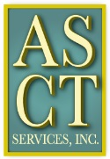
Survey Link

There is still one more week to complete the Cytology Workload Practices survey. Do not miss this unique opportunity to contribute information for the evaluation of cytology workload requirements and the development of guidelines for establishing cytology workload limits.
Your participation is also an opportunity for you to WIN A PRIZE! Prizes consist of a variety of educational materials.
Please forward this reminder and survey link to the cytotechnologists in your laboratory.
Thank you for your participation.

This study is supported by a contract (200-2013-57614) funded by the Centers for Disease Control and Prevention/Agency for Toxic Substances and Disease Registry.

