Perfluorinated Compound Biological Sampling in the Vicinity of Morgan, Lawrence, and Limestone Counties, Alabama

ATSDR Exposure Investigations (EI) Generic Information Collection Request
OMB No. 0923-0048
Expiration Date: 05/31/2016

Attachment 7: Example of Prior Exposure Investigation Final Report

Health Consultation

Exposure Investigation Report

Perfluorochemical Serum Sampling
In the vicinity of Decatur, Alabama
Morgan, Lawrence, and Limestone Counties

APRIL 1, 2013

U.S. DEPARTMENT OF HEALTH AND HUMAN SERVICES
Agency for Toxic Substances and Disease Registry
Division of Community Health Investigations Atlanta, Georgia 30333
Health Consultation: A Note of Explanation

An ATSDR health consultation is a verbal or written response from ATSDR to a specific request for information about health risks related to a specific site, a chemical release, or the presence of hazardous material. In order to prevent or mitigate exposures, a consultation may lead to specific actions, such as restricting use of or replacing water supplies; intensifying environmental sampling; restricting site access; or removing the contaminated material.

In addition, consultations may recommend additional public health actions, such as conducting health surveillance activities to evaluate exposure or trends in adverse health outcomes; conducting biological indicators of exposure studies to assess exposure; and providing health education for health care providers and community members. This concludes the health consultation process for this site, unless additional information is obtained by ATSDR which, in the Agency’s opinion, indicates a need to revise or append the conclusions previously issued.

You May Contact ATSDR TOLL FREE at
1-888-42ATSDR
or
Visit our Home Page at: http://www.atsdr.cdc.gov

HEALTH CONSULTATION

Exposure Investigation Report

Perfluorochemical Serum Sampling
In the vicinity of Decatur, Alabama
Morgan, Lawrence, and Limestone Counties

Prepared by:

Agency for Toxic Substances and Disease Registry
Division of Community Health Investigations
Science Support Branch

Table of Contents

ABBREVIATIONS and ACRONYMS 2
EXECUTIVE SUMMARY 5
PURPOSE OF EXPOSURE INVESTIGATION 10
LIMITATIONS 10
BACKGROUND 10
A. Soil sampling 12
B. Water sampling 13
C. Potentially exposed population 14
METHODS 15
RESULTS 16
A. Demographic and Survey Characteristics 16
B . Serum Perfluorochemical Concentrations: Detection, Distribution and Measures of Central 16
Tendency 16
C. Serum Perfluorochemical Concentrations by Age, Gender, Length of Residence, Vegetable 18
Consumption, Meat Consumption, Water Source, and Proximity to Biosolid Application Fields 18
DISCUSSION 20
A. Serum Perfluorochemical Concentrations and Health Effects 21
B. Serum Perfluorochemical Concentrations 22
C. Serum Perfluorochemical Concentrations: Age and Gender 24
D. Serum Perfluorochemical Concentrations and Environmental Variables 25
CONCLUSIONS 27
RECOMMENDATIONS 28
REFERENCES 29
AUTHORS 36
APPENDIX A: Figures 38
APPENDIX B: Tables 54
APPENDIX C: Exposure Investigation Protocol 57
APPENDIX D: Review of PFC Studies and Health Effects 79
APPENDIX E: Investigation Summary and Health Information Sheet 87

ABBREVIATIONS and ACRONYMS

ALP  ALT  AST  ATSDR  CDC  EI  EPA  Et-PFOSA-AcOH  FDA  GGT  Me-PFOSA-AcOH |  | Alkaline phosphatase  Alanine aminotransferase  Aspartate aminotransferase  Agency for Toxic Substances and Disease Registry  Centers for Disease Control and Prevention  Exposure Investigation  Environmental Protection Agency  2-(N-ethyl-Perfluorooctane sulfonamide) acetic acid  Food and Drug Administration  Gamma-glutamyl transferase  2-(N-methyl-Perfluorooctane sulfonamide) acetic acid  Minimal Risk Level  National Center for Environmental Health at CDC  Nanograms per milliliter (same as micrograms per liter or ppb)  National Health and Nutrition Examination Survey  Perfluoroalkyl carboxylate  Perfluoroalkyl sulfonate  Perfluorochemical  Perfluorocarboxylic acid  Perfluorodecanoic acid  Perfluorohexane sulfonic acid  Perfluorononanoic acid  Perfluorooctanoic acid
MRL

NCEH

ng/mL

NHANES

PFAC

PFAS

PFC

PFCA

PFDeA

PFHxS

PFNA

PFOA

PFOS  PFOSA  PFSA  PHA  POSF  PPAR-α  ppb  PWS  SMR  TC  TSH  ug/kg  μg/L  USDA  WM/EL |  | Perfluorooctane sulfonic acid  Perfluorooctane sulfonamide  Perfluorosulfonic acid  Provisional Health Advisory  Perfluorooctanesulfonyl fluoride  Peroxisome proliferator activated receptor-alpha  Parts per billion  Public Water System  Standardized mortality ratio  Total cholesterol  Thyroid stimulating hormone  Micrograms per kilogram (same as milligrams per kilogram or ppb)  Micrograms per liter (same as milligrams per kilogram or ppb)  United States Department of Agriculture  West Morgan / East Lawrence

EXECUTIVE SUMMARY

Background

In May 2007, a perfluorochemical (PFC) manufacturer in Decatur, Alabama, notified the EPA that it had unknowingly discharged large amounts of perfluorocarboxylic acids (PFCA) into the Decatur Utilities’ Dry Creek Wastewater Treatment Plant. PFCA is a class of PFCs that includes perfluorooctanoic acid (PFOA) and other PFCs. PFCs are a class of organofluorine compounds that are used in a variety of industrial and consumer products, including fire-fighting foams; personal care and cleaning products; and oil, stain, grease, and water repellent coatings on carpet, textiles, leather, “non-stick” cookware and paper such as wrappers used on fast food items. As a result, the general United States (U.S.) population’s exposure to PFCs is common. One PFC, perfluorooctane sulfonic acid or PFOS, is no longer manufactured in the U.S.

From 1996 to 2008 treated sewage sludge (biosolids) from Decatur Utilities was used as a soil amendment on about 5,000 acres of privately owned agricultural fields in Lawrence, Morgan and Limestone Counties, Alabama. In September 2007 EPA screened biosolids and soil for PFCs in a small number of these agricultural fields. PFCs were elevated compared to background levels. In February and March of 2009, EPA followed up with additional sample collection of the surface water, ground water, drinking water, and soils in the area around the treated fields to determine the concentrations of PFCs and PFC precursors. EPA found PFC chemicals in the Decatur Utilities’ biosolids, in soils, surface water, ground water, and drinking water.

In January 2009, EPA established a drinking water Provisional Health Advisory level (USEPA 2009) for two of the PFC compounds with the most available toxicological information, perfluorooctanoic acid (PFOA) and perfluorooctane sulfonate (PFOS). The Provisional Health Advisory level was established at 0.4 parts per billion (ppb) for PFOA and 0.2 ppb for PFOS. In February 2009 EPA tested six private drinking water wells located in close proximity to the fields tested for PFCs; two private drinking water wells had PFOA concentrations above the EPA Provisional Health Advisory levels. They were immediately provided an alternate drinking water source and then connected to the public water supply system. At EPA’s request, a group of local industries completed a comprehensive private drinking water well survey and sampling events in the areas surrounding land application sites. From August 2009 through August 2010, the local industries tested 12 private drinking water wells. One had elevated levels of PFOS above EPA’s Provisional Health Advisory value. This residence was immediately provided an alternate drinking water source and connected to the local public water supply system.

In addition, EPA sampled five local public drinking water systems. PFCs were detected in one system. PFOA and PFOS were detected in the West Morgan/East Lawrence (WM/EL) water supply but at concentrations below EPA’s Provisional Health Advisory levels. This system draws its water from the Tennessee River approximately 13 miles downstream from an industrial center where several PFC manufacturers and users are located. A study funded by one of the local industries (Hanson 2002) detected PFOA and PFOS in samples collected in 2000 from the Tennessee River. A study for analysis for PFOA in surface water and sediment from several points along the Tennessee River funded by one of the local industries found levels from not detected to 86.7 ppb in surface water and from not detected to 574 ppb in sediment (Weston 2008). A 2012 quarterly status report produced for one of the local industries in Decatur, AL identified levels of PFOA in monitoring wells bordering the industrial center along the Tennessee River and Bakers Creek to have shallow groundwater levels above 3000 ppb in some locations (Weston 2012). The agricultural fields that received the Decatur Utilities’ biosolids are not suspected to be the source of PFCs in the West Morgan/East Lawrence public water supply system.

In 2009 EPA contacted ATSDR and requested an exposure investigation.

Population Tested

A total of 155 people volunteered to have PFC concentrations measured in their blood. This investigation targeted residents who live and work in a predominantly rural community in the Decatur area who may have higher non-occupational exposure to PFCs than the average person in the United States. These included people who live on or near soils that received applications of biosolids from Decatur Utilities or were drinking water containing PFCs. Two participants did not live in the Decatur area and their results were excluded from the final analysis and reporting.

Conclusions

Because this investigation was designed to select individuals with the greatest likelihood of PFC exposure, these results cannot be generalized nor inferred to represent others living in the area or to other locations / populations. The results of this investigation are applicable only to the individuals tested. In addition, results of this EI cannot be used to predict the future occurrence of disease nor be associated with current or past health problems. Blood serum PFC concentrations do not provide information about the source (i.e., water; soil; food; personal care and cleaning products; oil, stain, grease, and water repellent coatings on carpet, textiles, and leather; ”non-stick” cookware; paper products such as the wrappers used on fast food items), timing, frequency, or magnitude of exposure.

Blood Serum PFC Concentrations

- Each participant’s blood was analyzed for eight PFCs. The results were compared to values found in the 2005-2006 National Health and Nutrition Examination Survey (NHANES).
- NHANES is a program of studies designed to assess the health and nutritional status of adults and children in the United States and examines a nationally representative sample of about 5,000 persons each year. It includes demographic, socioeconomic, dietary, and health-related questions, an examination component that consists of medical, dental, and physiological measurements and laboratory tests to include over 200 environmental chemicals.
- Five PFCs measured (PFNA, PFDeA, Me-PFOSA-AcOH, Et-PFOSA-AcOH and PFOSA) were lower than or similar to the U.S. general population as defined by the NHANES 95th percentile for PFCs.
- Geometric mean levels for three PFCs (PFOA, PFOS and PFHxS) were elevated (about two to four times) in participants compared to the U.S. general population, but were similar to or lower than levels found in other U.S. communities exposed to PFCs via drinking water or other environmental pathways.
- Of the three elevated serum PFCs, concentrations increased with age and were higher in males than females.
- Serum levels of all eight PFCs measured in this investigation were much lower than levels found in occupational studies of PFC manufacturing workers.
Finding PFCs in blood does not imply that the levels of PFCs cause an adverse health effect. The epidemiologic literature on the human health effects of PFCs is limited and the link between PFCs in blood and health effects is not conclusive. Three recent studies (C8 Science Panel 2011-2012, Grandjean 2012, Halldorsson 2012) have identified a possible link with health effects in humans with serum PFC levels similar to or below levels found in this investigation.

Blood Serum PFC Concentrations and Environmental Survey

Analysis of serum PFC levels in EI participants who regularly used the WM/EL public water system as their primary drinking water source found that they had higher serum levels of PFOA, PFOS and PFHxs when comparing the geometric mean of participants to the geometric mean found in a national survey (NHANES).

In addition, EI participants who regularly used the WM/EL public water system as their primary drinking water source had significantly higher geometric mean serum levels of PFOA and PFHxS compared to the NHANES geometric mean than participants who were otherwise similar but reported using an alternative water source that did not have a detectable level of PFCs. Serum PFOS among those who regularly used the WM/EL public water system was also found to be higher than those participants using an alternative water source compared to NHANES but was not significantly higher. Alternative water sources include bottled water, private wells and other public water systems in the region that did not have a documented detectable level of PFCs. This analysis suggests an association between the detectable levels of PFCs in the drinking water from the WM/EL public water system and elevated serum PFC levels among participants who used it as their primary drinking water source.

With the exception of the drinking water source, no association or link between serum PFC concentrations and potential PFC sources in the environment was found in this investigation. The limited sample size of this investigation was not sufficient to determine if a significant link between blood serum levels of PFCs and individual exposures to PFCs through biosolids or consumption of local cattle, fish, and vegetables existed.

Recommendations

- Continue efforts to reduce the level of PFCs present in the Tennessee River which is used as source water for the WM/EL public water supply system.

- Continue monitoring for PFCs in the WM/EL public water supply and other potentially impacted public water supplies downstream of Decatur, Alabama. The WM/EL public water system has already taken steps to improve water treatment which is expected to reduce PFC levels in finished drinking water. If PFOA and/or PFOS concentrations in the finished drinking water of the WM/EL public water system increase and remain above the EPA’s Provisional Health Advisory levels, we recommend that the public water system evaluate modifications to their treatment processes to reduce contaminant levels.

- Conduct routine periodic monitoring of other local area public water supplies for potential contamination with PFCs. Although these water supplies are considered to be at a lower risk for PFC contamination because of their location and have no detectable PFCs to date, it is good public health practice to conduct routine periodic monitoring.

- Owners of private drinking water wells located on or near biosolids application fields not previously tested should consider conducting periodic monitoring for PFCs. If levels are consistently above EPA’s Provisional Health Advisory levels, residents should use alternate drinking water sources. Some private drinking water wells in the area were sampled quarterly for a year and those that exceeded EPA’s provisional health advisory levels for PFOA/PFOS were placed on public water. All other sampled wells did not exceed the provisional health advisory levels.

- The community’s exposure to PFCs is expected to decline because of the actions taken to remove or decrease PFCs in the environment. Follow-up serum PFC testing in this community should be considered to verify that serum PFC concentrations are declining and to identify whether additional public health actions may be needed.

- Continue providing the community with any new science about health effects of PFC exposure as new information is documented.

PURPOSE OF EXPOSURE INVESTIGATION

In August 2009, the EPA Region 4 Water Protection Division contacted the ATSDR Exposure
Investigation Team and requested an exposure investigation to determine if the population using the WM/EL public water system as their primary drinking water source and the population residing near biosolids application fields in the Decatur, AL area were exposed to PFCs.

The purpose of this EI was to determine if unusual community exposures to PFCs was occurring by collecting blood serum samples from people with a high potential for PFC exposure. An EI is not a research study. Participant selection was specifically focused on those participants with the greatest potential for exposure rather than selecting participants in a systematic manner to generate or contribute to generalizable knowledge as is the case in a research study (CDC 2010a). Participants were recruited for the EI based on the following exposure factors:

- Living on or near agricultural fields that received biosolids applications as a soil amendment from Decatur Utilities, or
- Drinking water from private wells located in or near fields that received biosolids from Decatur Utilities, or
- Drinking water from the West Morgan / East Lawrence (WM/EL) public water system which has detectable PFOA and / or PFOS concentrations below U.S. Environmental Protection Agency (EPA) Provisional Heath Advisory levels.

LIMITATIONS

The results of this investigation are only applicable to the individuals tested. The results cannot be generalized to other populations because this investigation attempts to specifically target people with potential for higher exposure. In addition, results of this EI cannot be used to predict the future occurrence of disease nor be associated with current or past health problems. Serum PFC concentrations will not necessarily provide information about the source of exposure (i.e. water, soil, food etc.) but along with other exposure pathway information may help determine if there is an association or link with potential PFC sources.

BACKGROUND

In May 2007, a PFC manufacturer in Decatur, Alabama, notified the EPA that it had unknowingly discharged large amounts of perfluorocarboxylic acids (PFCA) over a period of years into the Decatur Utilities’ Dry Creek Wastewater Treatment Plant. Decatur Utilities receives wastewater from domestic and industrial sources, including fluorochemical manufacturing and use facilities. From 1996 to 2008, treated sewage sludge (biosolids) from Decatur Utilities were used as a soil amendment on about 5,000 acres of privately owned agricultural fields in Lawrence, Morgan and Limestone Counties, Alabama. EPA regulations under the Clean Water Act (CWA) allow biosolid land application for soil amendment and fertilizer. PFCs are a class of man-made chemicals that are not regulated under the CWA by EPA. Testing of biosolids for these chemicals is not required.

In September 2007, EPA tested biosolids and soil for PFCs in a small number of agricultural fields that received biosolids from Decatur Utilities. The results revealed elevated PFCs compared to background levels. In February and March 2009, EPA collected samples from the surface water, ground water, drinking water, and soils in the area around the treated fields for PFCs and PFC precursor analyses.
EPA found PFCs in the Decatur Utilities’ biosolids, in soils from the agricultural fields treated with the biosolids, and in surface water, ground water, and drinking water (EPA 2011a).

In January 2009, EPA established a drinking water Provisional Health Advisory level (EPA 2009) for two of the PFC compounds with the most available toxicological information: perfluorooctanoic acid (PFOA) and perfluorooctane sulfonate (PFOS). The Provisional Health Advisory levels are 0.4 parts per billion (ppb) for PFOA and 0.2 ppb for PFOS. Provisional Health Advisory values are developed to provide information in response to an urgent or rapidly developing situation. They reflect reasonable, health-based hazard concentrations above which action should be taken to reduce exposure to unregulated contaminants in drinking water. They are updated as additional information becomes available and can be evaluated.

In February 2009 EPA tested six private drinking water wells near agricultural fields for PFCs and identified two with PFOA above the EPA Provisional Health Advisory level. These residences were immediately provided an alternate drinking water source and connected to the local public water supply system.

At EPA’s request, Decatur Utilities and a group of local industries completed a comprehensive private drinking water well survey and sampling events in the areas surrounding the land application sites. From August 2009 through August 2010, the local industries sampled 12 private drinking water wells. One of the 12 had PFOS levels above EPA’s Provisional Health Advisory value. This residence was immediately provided an alternate drinking water source and connected to the local public water supply system.

EPA sampled five local public drinking water systems; PFCs (PFOA and PFOS) were detected in one, the WM/EL public water supply. Testing for PFCs in WM/EL public water supply began in 2006. Both PFOA and PFOS in the finished water levels were below the EPA’s Provisional Health Advisory levels. Additional treatment methods were recently implemented at this public water supply system to treat a portion of the raw water for disinfection byproducts that will also help further reduce PFCs in the finished water.

The WM/EL public water supply system draws its water from the Tennessee River several miles downstream from an industrial center where several PFC manufacturers and users are located. A study
(Hanson 2002) funded by one of the local industries detected PFOA and PFOS in samples collected in
2000 from the Tennessee River. It also noted measurable levels of PFOS present upstream of the Decatur PFC manufacturing facilities, although below the 2009 EPA Provisional Health Advisory level. The presence of PFOS in samples collected upstream of the manufacturing facilities suggests the possibility of another unidentified source of PFOS. None of the upstream samples detected PFOA. A study for analysis for PFOA in surface water and sediment from several points along the Tennessee River funded by one of the local industries found levels from not detected to 86.7 ppb in surface water and from not detected to 574 ppb in sediment (Weston 2008). A 2012 quarterly status report produced for one of the local industries in Decatur, AL identified levels of PFOA in monitoring wells bordering the industrial center along the Tennessee River and Bakers Creek to have shallow groundwater levels above 3000 ppb in some locations (Weston 2012). The agricultural fields that received the Decatur Utilities’ biosolids are not suspected to be the source of PFCs in this public water supply system.

In August 2009, the EPA Region 4 Water Protection Division contacted the ATSDR Exposure
Investigation Team and requested an exposure investigation to determine if the population using the WM/EL public water system as their primary drinking water source and the population residing near biosolids application fields in the Decatur, AL area were exposed to PFCs.

In October 2009, EPA released residential direct ingestion soil screening guidance values for PFOA and PFOS that are protective of children’s health (which are also protective of adult health). These soil screening values are 16,000 ppb [micrograms per kilogram (ug/kg)] for PFOA and 6,000 ppb for PFOS. ATSDR has not developed direct ingestion soil screening values for PFOA or PFOS.

More information on the EPA field studies in Decatur and the EPA-developed guidance values for
PFCs may be obtained from the following website: http://www.epa.gov/region4/water/PFCindex.html

PFCs are a class of organofluorine compounds where hydrogen atoms on the carbon chain have been replaced by fluorine and also contain at least one different atom or functional group. The compounds are both hydrophobic and oleophobic.

- A hydrophobic molecule is repelled by water. Hydrophobic is a chemical property of a compound which literally means something with a fear of water. Hydrophobic molecules often cluster together when dropped in water, just as oil does.

- An oleophobic molecule is repelled by oil. Oleophobic is a chemical property of a compound which literally means something with a fear of fat (or oil). Oleophobic molecules often cluster together when dropped in oil, just as water does.

PFCs and PFC precursors are used in a variety of industrial and consumer applications and products. These include fire-fighting foams; personal care and cleaning products; oil, stain, grease, and water repellent coatings on carpet, textiles, leather, ”non-stick” cookware; and paper such as the wrappers used on fast food items. As a result, the general United State (U.S.) population’s exposure to PFCs is very common. PFOS is no longer manufactured in the U.S.

A. Soil sampling

In 2007, EPA conducted limited sampling of sewage sludge and biosolids from the Decatur Utilities facility and soil from four agricultural sites that received biosolids. The results indicated relatively high levels of PFOA and PFOS compared to other industrial and non-industrial sites (U.S. EPA 2011a). The four soil sampling sites showed PFOS ranging from 276 to 1,409 ppb and PFOA ranging from 541 to 2,531 ppb. Nearby fields that did not have application of contaminated biosolids were also tested. None of the targeted PFCs were detected above the method’s lower detection limit of 100 ppb, suggesting no or very minimal background levels.

In March 2009, EPA collected 30 soil samples in or near the fields with the highest applications of biosolids. Four background samples were collected from fields that did not receive biosolids. Most background samples fell below the analytical limit of quantitation (LOQ) of 0.018 ppb and a few samples that detected PFCs fell just slightly above the LOQ. Soil test results of treated fields indicated that the majority of the Decatur soils in the land application area have concentrations of numerous PFCs above the background levels. Concentrations of PFOA ranged from below the LOQ up to 317 ppb, with most concentrations in the 100 to 200 ppb range. Concentrations of PFOS ranged from below the LOQ up to 408 ppb, with most concentrations around 100 to 200 ppb. Levels of the tencarbon carboxylic acid (C10) were as high as 986 ppb; levels of 12-carbon carboxylic acid (C12) were as high as 526 ppb.

Soil sampling and analysis techniques changed between the 2007 and 2009, making it difficult to compare results. Decatur Utilities voluntarily discontinued biosolids application in the later part of 2008. None of the soil samples collected by EPA in 2007 or 2009 exceeded EPA’s residential direct ingestion soil screening guidance values.

B. Water sampling

In November 2008, EPA tested water samples from the Moulton, Decatur and WM/EL public water systems for PFCs. There were no detectable concentrations of PFCs in the Moulton and Decatur systems. The levels of PFCs detected in the WM/EL system were below EPA’s Provisional Health Advisory levels for PFOA (0.4 ppb) and PFOS (0.2 ppb). In September 2009, EPA retested these three systems and expanded sampling to include the public water systems of the Limestone County and Swann Creek communities. No PFCs were detected in four of the five systems and the repeat samples of the WM/EL system were below EPA’s Provisional Health Advisory levels. Repeat sampling of the WM/EL system in 2011 found similar results. Because these values have remained below EPA’s Provisional Health Advisory levels, EPA does not recommend removing residents from these public water systems.

In February 2009 EPA sampled a number of private water wells (potable and non-potable), ponds, and streams located near the fields that received biosolids from Decatur Utilities.

Sampling results from twelve non-potable private water wells for PFOA ranged from below the LOQ (0.01 ppb) up to 6.41 ppb and for PFOS ranged from below the LOQ up to 0.15 ppb. These wells were used for agricultural purposes.

The surface water samples for PFOA results from 32 ponds and one stream ranged from below the LOQ up to 11.0 ppb; PFOS concentrations ranged from below the LOQ up to 0.08 ppb. EPA has not yet established PFOA or PFOS provisional health advisory values for water that is used for purposes other than human consumption.

The analytical results for two of the six private drinking water wells sampled had levels above EPA’s Provisional Health Advisory levels. Water from drinking water wells at two residences had PFOA levels of 0.6 ppb and 2.2 ppb respectively. These residents were immediately provided an alternate water source and then connected to the public water supply system. The remaining private drinking water wells sampled had PFOA and / or PFOS values below EPA’s Provisional Health Advisory levels.

From August 2009 through August 2010, at the request of EPA, Decatur Utilities and a group of local industries sampled 12 private drinking water wells. One of these 12 private drinking water wells had a PFOS level of 0.365 ppb which was above EPA’s Provisional Health Advisory value. This residence was immediately provided an alternative source of drinking water and connected to the local public water supply system. Water concentrations of PFOA and PFOS from the remaining 11 residences remained below EPA’s Provisional Health Advisory values for the duration of the sampling period.

C. Potentially exposed population

The potentially exposed population in the Decatur area includes residents who live and work in a predominantly rural community. In addition to the PFC related industries located in the general area, approximately 179 fields on approximately 35 farms received PFC contaminated biosolids from Decatur Utilities. People that live near or work in these fields are potentially exposed to PFCs by way of direct contact with contaminated soils, inhaling contaminated airborne dust, drinking contaminated water, and eating contaminated food. Possible dietary PFC sources in addition to drinking water include commercial and home grown vegetables, beef and milk from locally raised cattle that may graze on pastures that received PFC- contaminated biosolids, or may drink water containing PFCs, and fish from contaminated local rivers, ponds and lakes. Prior to this EI, there has not been human exposure monitoring for PFCs in the Decatur area population to determine if human exposure above background levels was occurring.

The USDA and FDA, in collaboration with EPA, collected and analyzed blood, tissue and milk samples from local cattle grazed on farms where Decatur Utilities biosolids were land applied. This sampling was conducted to help determine whether local foods, such as meat and dairy products, may be contaminated with PFCs. The USDA and FDA provided the following information to EPA regarding the analytic results from these tests (located on the EPA Region 4 Water Protection Division website at http://www.epa.gov/region4/water/PFCindex.html. This language is quoted from email communications sent by USDA and FDA to EPA. USDA and FDA have not provided EPA Region 4 or ATSDR with written reference materials supporting these statements):
“In May 2009, the U.S. Department of Agriculture (USDA) sampled blood and tissue from selected cows/steers from farms where Decatur Utilities biosolids were land applied in the past. Samples from seven animals associated with "high" application fields and two animals from "minimally" applied fields were collected. The final analytical results from these tests indicate the values are below USDA's minimum proficiency level (MPL) of 20 ppb for both PFOS and PFOA. Therefore, these samples are reported as not detectable for PFOS and PFOA. Based on USDA estimates for human health concerns using the MPL as an upper limit value and current Decatur area exposure patterns, this testing supports USDA's finding that there is no reason to believe there are human health concerns with consuming the meat processed from cattle grazed on lands receiving these biosolids.”

“Also in May 2009, FDA sampled and analyzed two milk samples for PFOA and PFOS. One sample was collected from a single cow and the other sample collected from a bulk milk tank from a dairy farm located in the Decatur area that received limited application of Decatur Utilities biosolids. FDA testing found no PFOA or PFOS in the milk sample from the single cow. A very low level (0.16 ppb) of PFOS was detected in the bulk tank milk sample. FDA has also tested additional samples including raw (n=10) and retail (n=49) milk samples collected throughout the U.S. for 10 perfluorinated compounds, including PFOA and PFOS, to obtain additional information on background levels for PFCs in milk. FDA testing found no PFCs in any of the additional raw or retail milk samples.”

155 participants initially enrolled in the EI but two were later found to reside outside the investigation area. One excluded participant grew up in the region and came to the EI with other local residents but only later revealed that they had not lived in the area for many years. The second excluded participant provided an address that was not initially recognized as being outside the investigation area but was later identified as such. Both participants received their individual blood test results. For the remainder of this report, all information is based on a total of 153 participants.

Nine of the 153 EI participants had been drinking water from three private water wells that exceed
EPA’s Provisional Health Advisories for PFOA and PFOS. Once sampling results from February 2009 indicated elevated PFOA and / or PFOS levels in these three drinking water wells, the residents were immediately provided an alternative source of drinking water and then connected to the public water system.

Many community members receive their drinking water from the WM/EL public water supply system.
While the concentrations of PFOA and PFOS in this water system are below EPA’s Provisional Health Advisory levels, they are present. Because of the long half-life of PFCs in the human body, sustained low level exposure may lead to increases in the blood serum concentrations of PFCs. No detectable levels of PFOA or PFOS were identified in the Decatur or Moulton public water supply.

METHODS

This exposure investigation targeted a specific population in the Decatur, Alabama area.

Property Criteria:
- Has lived on current property for at least one year
- One or more of the following: o Lives on or near property with sludge application
o Is exposed to drinking water contaminated with PFCs from private wells or low level exposure from a public water system (as defined by EPA sampling) Personal Criteria:
- Is 12 years of age and older
- Does not have a bleeding disorder or anemia
- Does not have current or past occupational (industrial) exposure to PFCs

The age criteria (12 years of age and older) was used because the reference values to be used for comparison in this investigation are only available for children 12 and older (CDC 2010b).

Approximately 519 eligible households were sent letters inviting them to participate in the EI and provided a toll-free number to call for an appointment at a central location. A total of 153 people residing in the area of interest (85 households) participated during the week of April 12-15, 2010.

At the blood collection center, each adult participant was required to provide written informed consent. Children from 12 to 17 years of age were also required to provide written assent with the written consent of their guardian. Each participant was asked to complete a short survey to gather information on risk factors for exposure to PFCs. A phlebotomist collected a 4-ml blood sample in a tube by venipuncture. ATSDR staff was available to answer participant questions.

Blood samples were analyzed for eight perfluorochemicals. Table 1B in Appendix B lists the eight PFCs measured by abbreviation, complete chemical name, and LOQ. Test results were reported as nanograms of the PFC analyte per milliliter of blood (ng/mL).

Statistical analysis was performed using SAS (Release 9.2, SAS Institute, Cary, NC) and SPSS.

For additional details on sample handling and shipment, lab processing and analysis, confidentiality protection and statistical analysis see Appendix C: Exposure Investigation Protocol for details on methods used in the exposure investigation.

RESULTS

A. Demographic and Survey Characteristics

The participant population consisted of 145 adults and 8 children. There were 63 males and 90 females. The mean age of the participants was 52 years old. The mean length of residence was 25.5 years. Table 2B, Appendix B provides the frequency distribution of demographic and environmental variables collected in this investigation.

B . Serum Perfluorochemical Concentrations: Detection, Distribution and Measures of Central

Tendency

Detection

Serum samples were analyzed for eight PFCs and PFC precursors: PFOA, PFOS, PFHxS, PFNA,
PFDeA, Me-PFOSA-AcOH, Et-PFOSA-AcOH, and PFOSA (see Table 1B, Appendix B for list of PFC chemical acronyms). PFOA, PFOS, PFHxS and PFNA were detected in 100% of the 153 serum samples. Other PFCs (PFDeA, Me-PFOSA-AcOH, and Et-PFOSA-AcOH) were not found in every sample. The percent detections for these PFCs are as shown in Table 1, below. PFOSA was not detected in any sample.

Table 1: Percent of Blood Serum Samples Containing PFC¹ or PFC Precursor
(n=153)
 | PFCs and PFC precursors
 | PFOA | PFOS | PFHxS | PFNA | PFDeA | Me- PFOSA  -AcOH | Et-  PFOSA  -AcOH | PFOSA
% Detected in EI² | 100% | 100% | 100% | 100% | 65% | 63% | 1% | 0%
% Detected in NHANES³ | 99.9% | 99.8% | 99.2% | 99.5% | 70% | 70.3% | 3.3% | 0.52%
¹PFC = Perfluorochemical. See abbreviations and acronyms section (page 3) for individual PFC definitions.
²EI = Exposure Investigation
³NHANES = 2007-2008 National Health and Nutrition Examination Survey

The percent detected of each PFC/PFC precursor in this EI is consistent with the findings of a representative sample of the U.S. population from 2007-2008 National Health and Nutrition Examination Survey (NHANES) data (Kato 2011). Detectable amounts of Et-PFOSA-AcOH and PFOSA were all below the NHANES 95th percentile and found in so few participants that it indicates this population was not significantly exposed to these PFC precursors. With the presence of a large number of values for PFDeA and Me-PFOSA-AcOH below the limit of detection, using these values for conducting additional statistical analysis for evidence of exposure compared to the U.S. population would not provide a valid analysis. The geometric mean for PFDeA (0.4 ng/mL) and Me-PFOSAAcOH (0.4 ng/mL) were below the NHANES geometric mean (PFDeA – 3.55 ng/mL, Me-PFOSAAcOH – 4.7 ng/mL). Only 1 sample for PFDeA and 4 samples for Me-PFOSA-AcOH exceeded the NHANES 95th percentile (PFDeA – 1.5 ng/mL, Me-PFOSA-AcOH – 1.8 ng/mL) indicating that participants did not have unusual exposures compared to the U.S. population. Therefore, the remainder of the report is focused on the analysis of PFOA, PFOS, PFHxS and PFNA, all of which had multiple samples that exceeded the NHANES 95th percentile.

Distribution

Figures 1 - 4 (Appendix A) display the distribution of the four PFCs selected for further analysis, PFOA, PFOS, PFHxS, and PFNA. Each distribution is highly skewed. To complete the analysis, each of the PFC measures was log₁₀ transformed. Figures 5 - 8 (Appendix A) show that the log-transformed PFC distributions are normally distributed. The Shapiro-Wilks statistic is a test of the null hypothesis that the adjusted data are normally distributed. All p-values were greater than 0.05 indicating evidence for the null hypothesis for the adjusted data, and therefore log transformation of the data is appropriate. Log-transformed PFC variables were used for calculation of geometric mean concentrations and as dependent variables in all linear regression analyses.

Measures of Central Tendency

Table 3B (Appendix B) provides comparisons of all eight PFCs measured in this investigation to the 2005-2006 NHANES data (CDC 2010b). NHANES is a population-based survey designed to collect information on the health and nutrition of the U.S. household population. This survey is periodically updated to measure chemical concentrations in the general U.S. population.

Table 3B (Appendix B) displays the measures of central tendency for each PFC measured in this investigation. PFOA had a geometric mean of 16.3 ng/mL (ppb), a range of 2.2 – 144 ng/mL. The geometric mean for PFOS was 39.8 ng/mL with a range of 5.4 – 472 ng/mL. The geometric mean for PFHxS was 6.4 with a range of 0.6 – 59.1 ng/mL. The geometric mean for PFNA was 1.7 ng/mL with a range of 0.3 – 5.5 ng/mL. This was less than twice the NHANES geometric mean for PFNA (1.09 ng/mL). The 95th percentile for PFNA (3.6 ng/mL) in this investigation was the same as NHANES 95th percentile (3.6 ng/mL) indicating that PFNA in this investigation was similar to the NHANES reference value. The remaining four PFCs and their measures of central tendency are listed in Table 3B (Appendix B) for information purposes only. They are not included in any additional analysis because they did not show any evidence to suggest the presence of unusual exposures compared to the U.S. population as noted previously. Additional analysis and discussion will focus on the three PFCs ­ PFOA, PFOS, PFHxS - that were detected in all samples and were more than twice the NHANES geometric mean.

Statistically significant correlations were detected between the log-tranformed serum concentrations of PFOA and PFOS (Pearson correlation coefficient r = 0.76, p<0.0001), between PFOA and PFHxS (r = 0.86, p<0.0001), and between PFOS and PFHxS (r =0.85, p<0.0001) (Table 4B – Appendix B).

C. Serum Perfluorochemical Concentrations by Age, Gender, Length of Residence, Vegetable

Consumption, Meat Consumption, Water Source, and Proximity to Biosolid Application Fields

Survey Variables other than Age and Gender
Linear regression models of survey variables were done using backward elimination. The first model contained all predictor variables. Subsequent models systematically removed variables that were not significant or did not improve the model. All survey variables, with the exception of age and gender, were not significantly associated with serum PFC concentrations. These variables include length of residence, consumption of locally grown vegetables, consumption of locally raised cattle meat, proximity to biosolids application fields, and soil exposure near the home. This includes drinking water source when defined as regulated (all public water sources) versus unregulated (private well, community well or spring) versus bottled water. When serum PFC concentrations were evaluated looking at individual public water systems a significant association between use of public drinking water from the WM/EL public water system was found for PFOA and PFHxS as discussed below.

Age

Linear regression analysis detected a small but significant relationship between serum PFC concentrations and age (Table 5B – Appendix B). Scatter plots of the log-transformed PFCs – PFOA, PFOS and PFHxS - and age are presented in Figures 9-11 of Appendix A. The r-squared and p-values are as follows:
- PFOA and age, the R² = 0.182 (p < 0.0001), • PFOS and age, R² = 0.313 (p < 0.0001), and
- PFHxS and age, R² = 0.262 (p < 0.0001).

These plots show a log linear association between age and PFC measurements in which age was the variable most associated with increasing PFC concentration. Generally, serum PFC concentrations increased with the increased age of the participant.

Gender

Linear regression analysis detected a small but significant relationship between serum PFC concentrations and gender. Geometric mean serum PFC concentrations were significantly higher in males than females. The r-square and p-values are as follows (Table 5B – Appendix B):
- PFOA and gender, R² = 0.039 (p = 0.014),
- PFOS and gender, R² = 0.056 (p = 0.003), and
- PFHxS and gender, R² = 0.067 (p = 0.001).

Age and Gender

Although statistically significant, gender has very low R² values for each PFC. However with multivariate linear regression using both age and gender the addition of gender improves the model (Table 5B – Appendix B) as compared to regression analysis with age alone and helps explain the source of the dependent variable’s variability.

West Morgan/East Lawrence Public Water Supply vs. other sources of primary drinking water

The initial evaluation, which included all three water systems in the public drinking water category, showed little correlation of PFCs with water source. However, further examination of the results of the 121 participants who reported using the WM/EL public water system as their primary drinking water source compared to those with a primary drinking water source that did not have a known detectable level of PFCs (Moulton and Decatur public water systems, private wells without PFCs present and bottled water) was conducted. This comparison did show a difference between the WM/EL public water system and other sources of primary drinking water. Results are shown in Table 2.

Of the 153 participants, 100 (65.4%) had a serum PFOA greater than the NHANES 95th percentile of 11.3 ng/mL. One additional participant had a serum PFOA of 11.3 ng/ml. 66 participants (43.1%) had a serum PFOS greater than the NHANES 95th percentile (47.5 ng/mL), and 55 (35.9%) had a serum PFHxS above the NHANES 95th percentile (8.3 ng/mL). One additional participant had a serum PFHxS of 8.3 ng/ml.

One participant did not provide data for all required survey variables leaving 152 participants for further analysis. Accounting for the statistically significant variables of age and sex, the odds ratio of having a serum PFOA level greater than the NHANES 95th percentile for participants using the WM/EL water system as their primary drinking water source versus participants who used a primary water source that did not have a detectable level of PFCs was 9.01. This finding was statistically significant with a 95% confidence interval of 2.63-30.85 (See Table 3).

The odds ratio of having a serum PFHxS greater than the NHANES 95th percentile for PFHxS versus the participants who used a primary water source that did not have a detectable level of PFCs was 13.08. This finding was statistically significant with a 95% confidence interval of 2.43-70.31 (See Table 3).

The odds ratio of having a serum PFOS greater than the NHANES 95th percentile for PFOS versus the participants who used a primary water source that did not have a detectable level of PFCs was 2.17. Although this suggested an association between elevated serum PFOS and use of the WM/EL water system as their primary drinking water source this finding was not statistically significant with a 95% confidence interval of 0.61-7.70 (See Table 3).

Table 2: Comparison of serum perfluorochemicals (PFCs) between primary drinking water sources: West Morgan / East
Lawrence (WM/EL) public water system (PWS) vs. primary drinking water source without detectable levels of PFCs vs.
private drinking water wells with detectable levels of PFCs (n=153)
 | Serum PFOA (ng/mL) |  |  | Serum PFOS (ng/mL) |  |  | Serum PFHxS (ng/mL)
 | WM/EL PWS with  detectable  level of  PFCs  (n=121) | Water  Source without  detectable  level of  PFCs  (n=23) | Private drinking  well with  detectable  level of  PFCs  (n=9) | WM/EL PWS with  detectable  level of  PFCs  (n=121) | Water  Source without  detectable  level of  PFCs  (n=23) | Private drinking  well with  detectable  level of  PFCs  (n=9) | WM/EL PWS with  detectable  level of  PFCs  (n=121) | Water  Source without  detectable  level of  PFCs  (n=23) | Private drinking  well with  detectable  level of  PFCs  (n=9)
Mean | 23.93 | 11.88 | 44.06 | 54.86 | 44.28 | 111.48 | 9.23 | 5.36 | 15.89
Median | 18.1 | 7.40 | 30.8 | 39.3 | 31.5 | 60.8 | 7.4 | 4.80 | 8.30
Range | 2.2-78.8 | 2.8-50.4 | 7.6-144 | 5.6-248 | 5.4-201 | 38.6-472 | 0.6-32.3 | 1.2-24.8 | 6.1-59.1
GeoMean¹ | 17.59 | 9.01 | 28.51 | 39.98 | 30.86 | 75.12 | 6.68 | 4.08 | 11.63
NHANES²  GeoMean¹ | 3.92 (3.48-4.42) |  |  | 17.1 (16.0-18.2) |  |  | 1.67 (1.42-1.98)
NHANES² 95%⁴(CI⁴) | 11.3 (8.80-14.6) |  |  | 47.5 (42.7-56.8) |  |  | 8.3 (5.80-11.9)
¹GeoMean = Geometric mean ² NHANES = 2005-06 National Health and Nutrition Examination Survey
³ 95th Percentile ⁴ CI = Confidence Interval

Levels of PFOA, PFOS and PFHxS were also higher for those participants who used private drinking wells with detectable levels of PFCs. Similar to what was found with participants using the WM/EL water system the odds of having a serum PFC greater than the NHANES 95th percentile were elevated for all three chemicals but only PFOA and PFHxS were significantly elevated. Results are summarized in Table 3.

Table 3: Summary of Odds Ratio (OR) and 95% Wald Confidence Limits (95% CL) of serum
perfluorochemicals (PFCs) for participants using West Morgan / East Lawrence (WM/EL) public water system (PWS) and private drinking water wells with detectable levels of PFCs greater than NHANES 95th percentile as compared to participants using drinking water source without detectable levels of PFCs
 | Serum PFOA |  | Serum PFOS |  | Serum PFHxS
 | OR | 95% CL | OR | 95% CL | OR | 95% CL
WM/EL PWS | 9.01 | 2.63-30.85 | 2.17 | 0.61-7.70 | 13.08 | 2.43-70.31
Private Wells | 13.24 | 1.77-99.13 | 6.42 | 0.93- 44.50 | 23.61 | 2.55-218.87

DISCUSSION

PFCs are man-made chemicals introduced after World War II for use as a lubricant and stain/water repellent and are now ubiquitous in the environment. All potential routes of exposure in the general population are not clear but have included contaminated drinking water and consumption of contaminated food such as fish caught from a water source with known PFC contamination. PFCs are present in numerous modern products including personal care and cleaning products, oil, stain, grease, and water repellent coatings on carpet, textiles, leather as well as fast food or packaged food containers such as french fry boxes, pizza boxes, hamburger wrappers, and microwave popcorn bags.

PFCs have been shown to have health effects on animals at serum concentrations that are higher than observed in human exposure studies. Human health effects associated with PFCs have not been clearly established though studies have shown a potential relationship between elevated PFC levels and a number of health end points. Animal studies of the straight-chain perfluoroalkyl sulfonate (PFAS) and perfluoroalkyl carboxylate (PFAC) have shown that these compounds are well absorbed orally, but poorly eliminated; they are not metabolized, and they undergo extensive uptake from enterohepatic circulation. Studies of PFOS and PFOA have shown that these compounds are distributed mainly to the serum, kidney, and liver, with liver concentrations being several times higher than serum concentrations; the distribution is mainly extracellular. Both compounds have a high affinity for binding to albumin, β-lipoproteins, and liver fatty acid binding protein. Studies have reported PFOS, PFOA, and other PFCs in umbilical cord blood indicating these chemicals cross the placenta. For further information of potential health effects see Appendix D: Review of PFC Studies and Health Effects.

A. Serum Perfluorochemical Concentrations and Health Effects

In animals, adverse health effects have been demonstrated with PFOA/PFOS exposure at doses that are higher than have been observed in the general human population (Kennedy 2004, Lau 2007, U.S. EPA 2005, Luebker 2005). In addition, extrapolation from animals to humans is uncertain because of pronounced differences in elimination rates, substantial variability across species and other issues (ATSDR, 2009).

The epidemiologic literature on the human health effects of PFCs is limited. Most studies have a crosssectional design, thus making causal inferences problematic.

A recent study found that PFC exposures in children at levels similar to the NHANES geometric mean were associated with lower antibody responses to childhood immunizations and an increased risk of antibody concentrations below the level needed to provide long-term protection (Grandjean 2012).

Another recent study found that the effects of low-dose developmental exposures to PFOA are consistent with experimental results suggesting obesogenic effects in female offspring at 20 years of age in a population in Denmark (Halldorsson 2012).

Reports by the C8 Science panel have noted a probable link between exposure to PFOA and several health effects to include pregnancy-induced hypertension, testicular cancer and kidney cancer, thyroid disease and ulcerative colitis. Participants had a PFOA level that was on average 37% higher than the average PFOA level in the participants in this EI. This report also noted that there was not a probable link between exposure to PFOA and birth defects, miscarriage or stillbirth, and preterm birth or low birth weight. They also did not find a link between other forms of cancer that were evaluated in the study, Type II diabetes, stroke, asthma or chronic obstructive airways disease (COPD), neurodevelopmental disorders in children (such as attention deficit disorders and learning disabilities), common infections or autoimmune disorders other than ulcerative colitis (to include rheumatoid arthritis, lupus, Type I diabetes, Crohn’s disease or multiple sclerosis). Results from this large study will continue to be shared over the next few years and should add to our knowledge about health and PFCs (C8 Science Panel 2011-2012a,b,c, Holtcamp 2012).

A brief review of additional occupational and community populations exposed to PFCs and health effects is summarized in Appendix D.

The summary provides a review of studies for PFCs and clinical laboratory measurements such as lipid concentrations, liver function tests, thyroid function, kidney function and sex hormones. In addition, studies that examined the relationship between PFCs and diseases such as diabetes, cardiovascular disease, and cancer are discussed. Most of the discussion focuses on PFOA and, when data is available, on PFOS and PFHxS.

PFC exposure and associations with chronic diseases and clinical laboratory measurements are limited and inconclusive. These limitations prohibit definitive conclusions. Although the number of studies related to PFC exposure and health effects is increasing, additional research on humans is needed to better understand the role of PFC exposure in association with diseases or clinical laboratory measurements. Currently, no clinical values are established by any U.S. Governmental agency for interpreting serum PFC levels in terms of determining public or individual health risk.

In summary, the association of PFC exposure and any disease or laboratory measurements remains inconsistent and inconclusive.

B. Serum Perfluorochemical Concentrations

PFCs have been found in the environment, in wildlife and in the blood of the general population (Calafat 2006a, 2007, Kannan 2004, Taniyasu 2003). The range of PFC concentrations varies with populations and not all PFCs are examined consistently in every study. The most commonly measured PFCs are PFOA and PFOS. The results of this investigation provide information on the distribution of eight PFCs.

PFOA, PFOS, and PFHxS were shown to be highly correlated with each other in this investigation, which is consistent with the published literature (Calafat et al., 2007b, MDH 2009). This may be due to PFOS, PFHxS and to a lesser extent PFOA being a manufactured byproduct of perfluorooctanesulfonyl fluoride (POSF), Me-PFOSA-AcOH, Et-PFOSA-AcOH and PFOSA. POSF is a synthetic perfluorinated compound with a sulfonyl fluoride functional group but was not analyzed in this EI because no national comparison data is available in NHANES. It is used to make PFOS and PFOS- based compounds.

Serum PFC concentrations for three PFCs (PFOA, PFOS, PFHxS) in this investigation are elevated compared to the U.S. general population (CDC 2010b). As observed in Table 3B, Appendix B, PFOA, PFOS and PFHxS, had geometric means that were two to four times the geometric mean of the U.S general population from NHANES data. Briefly, the geometric means for this investigation were as follows: PFOA 16.3 ng/mL (U.S. population: 3.9 ng/mL), the geometric mean for PFOS was 39.8 ng/mL (U.S. population: 17.1 ng/mL), and the geometric mean for PFHxs was 6.4 ng/mL (U.S. population: 1.67 ng/mL). Only PFOA was also above the 95 ^{th} percentile of NHANES for the U.S. population (See Table 2).

The geometric mean for the remaining five PFCs (PFNA, PFDeA, Me-PFOSA-AcOH, Et-PFOSAAcOH and PFOSA) are similar to or lower than the geometric mean for the U.S. general population (NHANES). For the remainder of this discussion PFOA, PFOS and PFHxs will be the focus of analysis because they were moderately elevated. The other five PFCs will not be discussed further.

Comparisons with other PFC published reports are useful to place these findings in context and provide a meaningful interpretation. Serum levels of PFCs, especially PFOS, appear to be higher in the U.S. compared to other countries. In Columbia, Brazil, Poland, Belgium, Malaysia, Korea and Japan, PFC levels are two- to threefold lower than the United States; in Italy and India serum levels are about eight to sixteen fold lower. (Kannan 2004). Peru is about thirty fold lower (Calafat 2006b). However, the sample sizes were small in both of these referenced studies and neither should be used to conclusively describe worldwide trends.

In a 2008 study, Red Cross Blood Donors from six different regions across the U.S. were analyzed for PFCs. Concentrations were similar to those of NHANES. Serum PFC concentrations in our investigation are elevated compared to the 600 Red Cross Blood Donor samples (PFOA geometric mean 3.4 ng/mL, PFOS geometric mean 14.5 ng/mL, and PFHxS geometric mean 1.5 ng/mL) (Olsen 2008).

The NHANES serum PFC concentrations demonstrate that PFCs are widespread in the population. These compounds are ubiquitous in the environment and it is unlikely that drinking water alone is the primary source of exposure in the general population. Although, the three serum PFC concentrations in this investigation are elevated compared to the U.S. population, this is not unexpected because NHANES represents the general U.S. population. The community in this investigation has a known history of environmental PFC contamination.

In communities where there is a documented history of environmental PFC contamination, serum PFC concentrations were similar or lower than levels found in this investigation. For instance, the serum PFC concentrations observed in this investigation are similar to a community in Minnesota exposed to
PFC contamination in the drinking water. Mean PFC contamination in six municipal wells in the Minnesota community ranged from 0.07 to 0.7 μg/L for PFOA, not detected to 1.04 μg/L for PFOS and not detected to 0.09 μg/L for PFHxS. There were efforts in this community to use water from the municipal wells that showed the least amount of contamination so the true concentration levels that the population was exposed to are not known. The serum PFC geometric means in the Minnesota community were as follows: PFOA (15.4 ng/mL), PFOS (35.9 ng/mL) and PFHxS (8.4 ng/mL) (MDH 2009).

However, other communities had higher drinking water PFC exposures and higher serum levels. In an
Ohio community exposed to PFOA-contaminated drinking water (average water level = 3.55 ng/mL,
Emmet 2006a), there was a median serum PFOA level of 354 ng/ml in the 371 participants (Emmet 2006b). This was much higher than was found in this EI (PFOA median 18.1 ng/mL). In a larger study of 69,030 people in the same area of the Ohio/West Virginia border, exposed to PFOA contaminated drinking water, (as well as food and possibly other sources), the median serum PFOA was 28.2 ng/mL (Steenland 2009a). A German study of 355 exposed subjects who drank PFC-contaminated water found a geometric mean serum PFOA of 25 ng/mL (Hölzer 2008). This community had a higher geometric mean compared to participants in the Decatur, AL EI (17.59 ng/mL).

Finally, serum PFC concentrations in this investigation are much lower compared to occupational exposures. For example, in 2000 a group of 3M employees in Decatur, Alabama voluntarily had PFC measurements taken for medical surveillance. The geometric mean for serum PFOA in this group was 1,130 ng/mL and for serum PFOS the geometric mean was 440 ng/mL (Olsen 2003). Another study reported that Dupont workers had a arithmetic mean of 428 ng/mL for serum PFOA with a median of 189 ng/mL (Sakr 2007).

A comparison of mean serum concentrations of PFOA and PFOS studies in relation to the mean serum concentration in this Decatur, AL EI is displayed in Figures 12 and 13 (Appendix A). The studies used for comparison include some where the effected population had drinking water exposure to PFCs as well as two PFC occupational studies. Worker exposure routes are generally different from participants in this EI. Occupational serum PFC concentrations are elevated compared to the general population.

In our investigation, serum PFC concentrations for PFOA, PFOS and PFHxS are moderately higher than the U.S. population but similar to or lower than U.S. communities believed to be exposed primarily through drinking water. Mean serum concentrations for five PFCs (PFNA, PFDeA, Me­ PFOSA-AcOH, Et-PFOSA-AcOH, and PFOSA) observed in this investigation were lower than or similar to the mean for the U.S. population (NHANES). PFC concentrations observed in this investigation were much lower than levels found in occupational studies of PFC manufacturing workers.

C. Serum Perfluorochemical Concentrations: Age and Gender

Age

We found that serum PFC concentrations had a small but significant association with increasing age for all three PFCs – PFOA, PFOS and PFHxS. This has been previously reported by others with PFOA contamination in drinking water (Emmett 2006a, Steenland 2009a, Minnesota 2010, Calafat 2007b). In contrast, Kannan (2004) did not find a statistical association with PFOA and age in 473 serum samples from industrialized countries. One study using pooled 2001-02 NHANES data found that most serum PFC levels in the general population are higher in children ages 3-11 years years of age compared to adults, especially for PFHxS (Kato 2009). More recent data on children under 12 years of age are not available.

PFOA is not metabolized in the body and knowledge of its tissue distribution in humans is limited.
The half-life for each PFC varies in humans and is based on small samples sizes (n = 5-26) (Olsen 2007a, Harada 2005a). Based on these small studies, half-lives are estimated at 2-4 years (PFOA), 2-5 years (PFOS), and 7 years (PFHxS). In light of the limited understanding of the half-lives of these chemicals, human pharmacokinetics, and inconsistency in published reports, the relationship of serum PFOA concentration and age is unclear.

Gender

In agreement with previous reports, we found that men had higher serum PFC concentrations than women, including couples residing at the same address. A Red Cross Donor study of 140 donors found that men had higher serum PFOA levels than women. This study was a measure of population background levels in a population with no known exposure (Olsen 2007). The Minnesota investigation also found that men had significantly higher serum PFC concentrations than women. Other investigators have reported similar results (Calafat 2007a, 2007b, Fromme 2007, Harada 2004, Midasch 2006, Yueng 2006, Hölzer 2008). However, one study did not show a gender difference. Kannan (2004) examined 473 serum PFOA samples from many industrialized countries and found no significant differences in gender even though PFOA was detected in most samples.

The reason for a gender difference in PFC concentrations is unclear. Perhaps this observation may represent gender differences in occupation, diet, lifestyle, loss during menstruation and lactation and/or use of PFC containing products. Additional research is ongoing in a number of laboratories to try to verify and better understand this observation.

D. Serum Perfluorochemical Concentrations and Environmental Variables

In this investigation, length of residence, soil exposure, proximity to fields which received biosolids applications from Decatur Utilities, locally raised cattle meat consumption, and local vegetable consumption did not show an association with serum PFC concentrations. In addition a review of drinking water sources when looking at regulated water sources (all public water systems) as compared to unregulated water sources (private well water) did not show a clear association with serum PFC concentrations.

However, analysis of serum PFC levels in EI participants who regularly used the WM/EL public water system as their primary drinking water source found that they had higher geometric mean serum levels of PFOA, PFOS and PFHxs when compared to the geometric mean found in a national survey
(NHANES). In addition serum PFC levels in EI participants who regularly used the WM/EL public water system as their primary drinking water source had significantly higher serum levels of PFOA and PFHxS compared to NHANES than participants who were otherwise similar but reported using an alternative water source that did not have a detectable level of PFCs. Serum PFOS among those who regularly used the WM/EL public water system was also found to be higher than those participants using an alternative water source compared to NHANES but was not significantly higher. Alternative water sources include bottled water, private wells and other public water systems in the region that did not have a documented detectable level of PFCs. This analysis suggests an association between the detectable levels of PFCs in the drinking water from the WM/EL public water system and elevated serum PFC levels among participants who used it as their primary drinking water source.

EI participants who used private drinking water wells that were found to have elevated levels of PFCs as their primary drinking water source were also found to have elevated serum PFC levels that were significantly higher than the general U.S. population as shown in Table 2.

In a population primarily exposed to PFCs from their drinking water supply, Emmet (2006a) found a PFOA median serum/drinking water ratio of 105. Applying that same ratio to the participants in this EI who used the WM/EL public water system as their primary drinking water source (median serum PFOA of 18.1 ng/mL) results in the following estimate of PFOA level in the drinking water: 18.1/105 = 0.172 ng/ml (172 ng/L). The level of PFOA in finished water from the WM/EL public water system in 2010 was found to be 0.070 ng/ml (70 ng/L). However there have been ongoing efforts by the WM/El public water system to reduce PFOA in finished water over the past several years. Past samples of finished water from 2006 (the first year that PFOA was evaluated) have been as high as 0.155 ng/ml (155 ng/L). This value is much closer to the expected value of 172 ng/L estimated by the ratio proposed by Emmet and provides further indication that the presence of PFOA in WM/EL public water system drinking water was a contributor to elevated serum PFOA levels in the EI participants using this water source as their primary drinking water.

Limited published data is available on factors associated with serum concentrations of PFCs.
Although this investigation did not find a statistical association with environmental variables and PFC serum concentrations other than drinking water source, others have reported positive correlations. In a German population, increased serum PFOA concentrations were associated with eating locally grown vegetables, drinking large quantities of PFC contaminated public water and residing in an area with environmental contamination compared to a reference population (Hölzer 2008). A later publication on the same population suggested an association between serum PFCs and fish consumption from PFC contaminated water sources (Hölzer 2011). Emmett (2006a) reported a correlation between consuming locally grown vegetables and wild game and serum PFC levels in an area with contaminated drinking water. A study (Yoo et al., 2011) compared PFC concentrations in vegetation growing in fields treated with and without biosolids in the Decatur, AL area. Results showed measurable concentrations of PFC in the treated fields. There are additional studies looking at vegetative uptake of PFCs that are ongoing.

Trudel (2008) used environmental and product-related data, to include contaminated foods and drinking water, in Europe and North America to model estimates of chronic exposure to PFOA and PFOS. They conclude that ingestion of contaminated dietary sources, like drinking water, is the greatest source of exposure in the general population. For those living near an identified source of contamination, drinking water has been identified as associated with exposure (Emmett 2006a, Holzer 2008, Steenland 2009a). A study in Ohio found that activated carbon filtration in the drinking water system reduced serum PFOA concentrations in the population (Bartell 2010). In addition to implementing an activated carbon filtration system, Emmet (2006a) found that substitution with bottled water resulted in lower levels of serum PFOA concentrations in a population exposed to PFOA contaminated public water.

Participants who are outliers in this EI may provide additional insight into potential sources of exposure from drinking water. For example, the highest serum PFOS concentration was 248 ng/mL (NHANES 95th percentile: 47.5 ng/mL) and for PFHxS was 59 ng/mL (NHANES 95th percentile: 8.3 ng/mL) and both were detected in one individual. This person was over 80 years of age and had been drinking private well water the majority of their life (they changed to public water the week that blood was collected for this investigation). The water sampled from this well had PFOS levels above EPA’s
Provisional Health Advisory. Another participant who had the highest serum PFOA concentration (144 ng/mL - NHANES 95th percentile: 11.3 ng/mL) was middle aged (age 40 – 50 years). This person had been using the same private well water as their primary source of drinking water. Their drinking water well had PFOA levels above EPA’s Provisional Health Advisory, so the residence was connected to the public water system and the person no longer uses the well as a drinking water source.

In contrast, two participants from a residence connected to the WM/EL public water system reported using bottled water almost exclusively for their drinking water source (they did use WM/EL public water for cooking) and neither had any elevation in PFCs above the NHANES 95th percentile. They lived next door to two other participants who were connected to and used the WM/EL public water system as their primary drinking water source. The latter two participants had serum PFOA, PFOS and PFHxS values above the NHANES 95th percentile. An elderly male EI participant (the group that tended to have the highest levels of serum PFC’s) used a private well with no PFC contamination as his primary drinking water source had serum PFOA, PFOS and PFHxS results below the NHANES
95th percentile.

Serum PFOA, PFOS and PFHxS levels were higher in participants who used the WM/EL public water system as their primary drinking water source compared to those who used an alternative primary drinking water source with non-detectable levels of these chemicals. The WM/EL group had twice the amount of serum PFOA present on average than the alternative group and the geometric mean was well above the NHANES 95th percentile. The alternative water supply group had an average PFOA slightly above the NHANES 95th percentile but within its upper 95th confidence interval. The primary limitation of this comparison was the relatively small number of participants, particularly in the alternative drinking water source group (n=23). Although the geometric mean for the alternative group was significantly less than the WM/EL group some members of the alternative group did have levels of PFCs that were elevated well above the NHANES 95th percentile suggesting other factors could have a role in the presence of elevated serum PFCs in this population.

Steps have already been taken to improve finished water produced by the WM/EL public water system which has had a history of detectable levels of PFCs (2006 PFOA level – 155 ng/L, 2010 PFOA level – 70 ng/L). These levels have remained below the current EPA Provisional Health Advisory level. The water intake for the WM/EL public water system is located downstream from the local PFC producing industries. Other tested public water systems in Morgan, Limestone and Lawrence counties have not demonstrated evidence of detectable levels of PFCs. Water intake for these public water systems is less likely to be impacted by local PFC producing industries because the water intake is located upstream from these industries or uses surface water reservoirs.

CONCLUSIONS

Because this investigation was designed to select individuals with the greatest likelihood of PFC exposure, results cannot be generalized nor inferred to represent others living in the area or other locations. The results of this investigation are applicable only to the individuals tested. In addition, results of this EI cannot be used to predict the future occurrence of health effects or associations with current or past health problems. Blood serum PFC concentrations do not provide information about the source of exposure (i.e., water; soil; food; personal care and cleaning products; oil, stain, grease, and water repellent coatings on carpet, textiles, and leather; ”non-stick” cookware; paper products such as the wrappers used on fast food items).

Blood Serum PFC Concentrations

- Eight PFCs were measured in the blood of each participant.
  - Five PFCs measured (PFNA, PFDeA, Me-PFOSA-AcOH, Et-PFOSA-AcOH and PFOSA) were lower than or similar to the U.S. general population as defined by the 2005-06 NHANES 95th percentile for PFCs.
  - Geometric mean levels for three PFCs (PFOA, PFOS and PFHxS) were elevated (about two to four times) in participants compared to the U.S. general population, but were similar to or lower than levels found in other U.S. communities exposed to PFCs via drinking water or other environmental pathways.
  - Of the three elevated serum PFCs, concentrations increased with age and were higher in males than females.
  - Serum levels of all eight PFCs measured in this investigation were much lower than levels found in occupational studies of PFC manufacturing workers.
- Finding PFCs in blood does not imply that the levels of PFCs cause an adverse health effect. The epidemiologic literature on the human health effects of PFCs is limited and the link between PFCs in blood and health effects is not conclusive. See the discussion section for more information on recent human studies.

Blood Serum PFC Concentrations and Environmental Survey

With the exception of drinking water source, this EI found no association or link between serum PFC concentrations and potential PFC sources in the environment. The limited sample size may not have been sufficient to determine a significant association between blood serum PFCs and exposures through biosolids or consumption of local cattle, fish, and vegetables, all of which have been found to be significant in other studies.

Although a link to fish and blood serum concentrations of PFCs was not found in this EI PFCs, including both PFOA and PFOS, were detected in fish tissue samples taken from catfish and largemouth bass in the Tennessee River near Decatur. The PFOA analytical results averaged 0.74 ppb and the PFOS analytical results averaged 806.06 ppb. Based on the PFOS results, the Alabama Department of Public Health issued a 'no consumption' fish advisory in August 2012 for all species of fish in the Baker's Creek embayment of Wheeler Reservoir. Future testing will determine if this advisory needs to be expanded. The entire advisory can be found at www.adph.org.

Serum PFC levels in EI participants who regularly used the WM/EL public water system as their primary drinking water source had significantly higher levels of PFOA and PFHxS compared to a national survey (NHANES) than participants who were otherwise similar but reported using an alternative primary water source with no detectable PFCs. Levels of PFOS were also higher, but not significantly higher. Alternative water sources include bottled water, private wells and other public water systems in the region that did not have a documented detectable level of PFCs. Results suggest an association between PFCs in the WM/EL public water system and elevated serum PFC levels among participants who used it as their primary drinking water source.

While serum PFC levels are not as high among participants using an alternative primary water source with no detectable PFCs, they did have serum PFC levels that were at the high end of the range of PFCs found in the general population with NHANES. This group of participants could be exposed part of the time to drinking water from the WM/EL public water system. However, it is possible that other exposure pathways are contributing to the level of serum PFCs that are present in addition to drinking water with detectable levels of PFCs and that they were not identified by this EI.

RECOMMENDATIONS

- Continue efforts to reduce the level of PFCs present in the Tennessee River which is used as source water for the WM/EL public water supply system.

- Continue monitoring for PFCs in the WM/EL public water supply and other potentially impacted public water supplies downstream of Decatur, Alabama. The WM/EL public water system has already taken steps to improve water treatment which is expected to reduce PFC levels in finished drinking water. If PFOA and/or PFOS concentrations in the finished drinking water of the WM/EL public water system increase and remain above the EPA’s Provisional Health Advisory levels, we recommend that the public water system evaluate modifications to their treatment processes to reduce contaminant levels.

- Conduct routine periodic monitoring of other local area public water supplies for potential contamination with PFCs. Although these water supplies are considered to be at a lower risk for PFC contamination because of their location and have no detectable PFCs to date, it is good public health practice to conduct routine periodic monitoring.

- Owners of private drinking water wells located on or near biosolids application fields not previously tested should consider conducting periodic monitoring for PFCs. If levels are consistently above EPA’s Provisional Health Advisory levels, residents should use alternate drinking water sources. Some private drinking water wells in the area were sampled quarterly for a year and those that exceeded EPA’s provisional health advisory levels for PFOA/PFOS were placed on public water. All other sampled wells did not exceed the provisional health advisory levels.

- The community’s exposure to PFCs is expected to decline because of the actions taken to remove or decrease PFCs in the environment. Follow-up serum PFC testing in this community should be considered to verify that serum PFC concentrations are declining and to identify whether additional public health actions may be needed.

- Continue providing the community with any new science about health effects of PFC exposure as new information is documented.

REFERENCES

Agency for Toxic Substance and Disease Registry (ATSDR). Toxicological Profile for Perfluoroalkyls (Draft for Public Comment) October 30, 2009. Agency for Toxic Substances and Disease Registry. Atlanta, GA: U.S. Department of Health and Human Services, Public Health Services.

Alexander BH, Olsen GW, Burris JW, Mandel JH, Mandel JS. 2003. Mortality of employees of a perfluorooctanesulphonyl fluoride manufacturing facility. Occup Environ Med 60:722-729.

Bartell SM, Calafat AM, Lyu C, Kato K, Ryan PB, Steenland K. 2010. Rate of decline in serum PFOA concentrations after granular activated carbon filtration at two public water systems in Ohio and West Virginia. Environ. Health Perspect. 118(2):222-8.

Bloom MS, Kannan K, Spliethoff HM, Tao L, Aldous KM, Vena JE 2010. Exploratory assessment of perfluorinated compounds and human thyroid function. Physiol Behav. 99(2): 240–245.

Butenhoff J, Costa G, Elcombe C, Farrar, D, Hansen K, Hiroyuki I, Jung, R, Kennedy G, Lieder P, Olsen G, and Thomford P. 2002. Toxicity of ammonium perfluorooctanoate in male cynomolgus monkeys after oral dosing for 6 months. Toxicol Sci 69(1):244-257.

C8 Science Panel. Probable Link Evaluation of Pregnancy Induced Hypertension and Preeclampsia (5 Dec 2011). Available: http://www.c8sciencepanel.org/pdfs/Probable_Link_C8_PIH_5Dec2011.pdf [accessed January 2012].

C8 Science Panel. Probable Link Evaluation of Cancer (15 Apr 2012a). Available: http://www.c8sciencepanel.org/pdfs/Probable_Link_C8_Cancer_16April2012.pdf [accessed August 2012].

C8 Science Panel. Probable Link Evaluation of Autoimmune Disorders (30July2012b). Available: http://www.c8sciencepanel.org/pdfs/Probable_Link_C8_Autoimmune_Disease_30Jul2012.pdf [accessed August 2012].

C8 Science Panel. Probable Link Evaluation of Thyroid disease (30July2012c). Available: http://www.c8sciencepanel.org/pdfs/Probable_Link_C8_Thyroid_30Jul2012.pdf [accessed August 2012].

Calafat AM, Kuklenyiz Z, Caudill SP, Reidy JA, Needham LL. 2006a. Perfluorochemicals in pooled serum samples from United States residents in 2001 and 2002. Environ Sci Technol 40:2128-2134.

Calafat AM, Needham LL, Kuklenyik Z, Reidy JA, Tully JS, Aguilar-Villalobos M, et al. 2006b.
Perfluorinated chemicals in selected residents of the American continent. Chemosphere;63:490-496.

Calafat AM, Wong LY, Zsuzsanna K, Reidy JA, Needham LL. 2007. Polyfluoroalkyl chemicals in the U.S. population: Data from the National Health and Nutrition
Examination Survey (NHANES) 2003-2004 and Comparisons with NHANES 1999-2000. Environ Health Perspect. 115(11):1596-1602.

Calafat AM, Kuklenyik Z, Reidy JA, Caudill SP, Tully JS, Needham LL. 2007a. Serum concentrations of 11 polyfluoroalkyl compounds in the U.S. population: Data from the National Health and Nutrition Examination Survey (NHANES) 1999–2000. Environ Sci Technol; 41:2237-2242.

Calafat AM, Wong LY, Kuklenyik Z, Reidy JA, Needham LL. 2007b. Polyfluoroalkyl chemicals in the U.S. population: data from the National Health and Nutrition Examination Survey (NHANES) 2003–2004 and comparisons with NHANES 1999–2000. Environ Health Perspect. 115(11):1596-1602.

Centers for Disease Control and Prevention (CDC). Distinguishing Public Health Research and Public Health Nonresearch, July 2010(a). Centers for Disease Control and Prevention (CDC). Atlanta, GA: U.S. Department of Health and Human Services, Public Health Services. Available at: http://aopsmas-iis.cdc.gov/policy/Doc/policy557.pdf [accessed October 2012]

Centers for Disease Control and Prevention (CDC). Fourth National Report on Human Exposure to Environmental Chemicals, Updated Tables, July 2010(b). Centers for Disease Control and Prevention (CDC). Atlanta, GA: U.S. Department of Health and Human Services, Public Health Services.
Available at: http://www.cdc.gov/exposurereport/pdf/Update_Tables.pdf [accessed May 2011].

Costa G, Sartori S, Consonni D. 2009. Thirty years of medical surveillance in perfluooctanoic acid production workers. J Occup Environ Med 51: 364–372.

Ellington, J. J.; Washington, J. W.; Evans, J. J.; Jenkins, T. M.; Hafner, S. C.; Neill, M. P. Analysis of fluorotelomer alcohols in soils: Optimization of extraction and chromatography. J. Chromatogr. A 2009, 1216 (28), 5347–5354

Emmett EA, Shofer FS, Zhang H, Freeman D, Desai C, Shaw LM. 2006a. Community exposure to perfluorooctanoate: relationships between serum concentrations and exposure sources. J Occup Environ Med 48: 759–770.

Emmett EA, Zhang H, Shofer FS, Freeman D, Rodway NV, Desai C, et al. 2006b. Community exposure to perfluorooctanoate: Relationships between serum levels and certain health parameters. J Occup Environ Med 48:771-779.

Eriksen KT, Sørensen M, McLaughlin JK, Lipworth L, Tjønneland A, Overvad K, et al.
2009. Perfluorooctanoate and perfluorooctanesulfonate plasma levels and risk of cancer in the general Danish population. J Natl Cancer Inst 101: 605–609.

Frisbee SJ, Shankar A, Knox SS. Steenland K, Savitz DA, Fletcher T, Ducatman AM. 2010.
Perfluorooctanoic acid, perfluorooctanesulfonate, and serum lipids in children and adolescents: Results from the C8 Health Project. Arch Pediatr Adolesc Med 164(9):860-9.

Fromme H, Midasch O, Twardella D, Angerer J, Boehmer S, Liebl B. 2007. Occurrence of perfluorinated substances in an adult German population in southern Bavaria. Int Arch Occup Environ Health 80: 313–319.

Gallo V, Leonardi G, Genser B, Lopez-Espinosa MJ, Frisbee SJ, Karlsson L, Ducatman AM, Fletcher
T. 2012. Serum Perfluorooctanoate (PFOA) and Perfluorooctane Sulfonate (PFOS) Concentrations and Liver Function Biomarkers in a Population with Elevated PFOA Exposure. Environ Health Perspect http://dx.doi.org/10.1289/ehp.1104436 [Epub ahead of print. Accessed February 2012]

Gilliland FD and Mandel JS. 1993. Mortality among employees of a perfluorooctanoic acid production plant. J Occup Med 35(9):950-954.

Grandjean P, Andersen EW, Budtz-Jørgensen E, Nielsen F, Mølbak K, Weihe P, Heilmann C. 2012.
Serum Vaccine Antibody Concentrations in Children Exposed to Perfluorinated Compounds. JAMA 307(4):391-397

Grice MM, Alexander BH, Hoffbeck R, Kampa DM. 2007. Self reported medical conditions in perfluoroooctanesulfonyl fluoride manufacturing workers. J Occup Environ Med 49:722-729.

Halldorsson TI, Rytter D, Haug LS, Bech BH, Danielsen I, Becher G, Henriksen TB, Olsen SF 2012. Prenatal Exposure to Perfluorooctanoate and Risk of Overweight at 20 Years of Age: A Prospective Cohort Study. Environ Health Perspect 120: 668-673.

Hansen KJ, Johnson HO, Eldridge JS, Butenhoff JL, Dick LA. 2002. Quantitative characterization of trace levels of PFOS and PFOA in the Tennessee River. Environ Sci Technol 36: 1681-1685

Harada K, Saito N, Inoue K, Yoshinaga T, Watanabe T, Sasaki S, et al. 2004. The influence of time, sex and geographic factors on levels of perfluorooctane sulfonate and perfluo-rooctanoate in human serum over the last 25 years. J Occup Health 46: 141–147

Harada K, Inoue K, Morikawa A, et al. 2005. Renal clearance of perfluorooctane sulfonate and perfluorooctanoate in humans and their species-specific excretion. Environ Res 99:253-261.

Holtcamp W. 2012. Pregnancy-Induced Hypertension “Probably Linked” to PFOA Contamination. Environmental Health Perspectives. 120 (2): A59

Hölzer J, Midasch O, Rauchfuss K, Kraft M, Reupert R, Angerer J, et al. 2008. Biomonitoring of perfluorinated compounds in children and adults exposed to perfluorooctanoate-contaminated drinking water. Environ Health Perspect 116: 651–657.

Hölzer J, Göen T, Just P, Reupert R, Rauchfuss K, Kraft M, et al. 2011. Perfluorinated Compounds in Fish and Blood of Anglers at Lake Möhne, Sauerland Area, Germany. Environ. Sci. Technol 45 (19):8046–8052.

Kannan K, Corsolini S, Falandysz J, Fillmann G, Kumar KS, Loganathan BG et al. 2004.
Perfluorooctanesulfonate and related fluorochemicals in human blood from several countries. Envrion. Sci Technol 38:4489-4495.

Kato K, Calafat AM, Wong LY, Wanigatunga AA, Caudill SP,Needham LL. 2009. Polyfluoroalkyl compounds in pooled sera from children participating in the National Health and Nutrition Examination Survey 2001-2002. Envrion. Sci Technol 43(7), 2641-2647.

Kato K, Wong LY, Jia LT, Kuklenyik Z, Calafat AM. Trends in exposure to polyfluoroalkyl chemicals in the U.S. Population: 1999-2008. 2011. Environ Sci Technol. 2011 Oct 1;45(19):8037-45.

Kennedy GL. 1987. Increase in mouse liver weight following feeding of ammonium perfluorooctanoate and related fluorochemicals. Toxicol Lett 39(2-3):295-300.

Kennedy GL, Buttenhoff JL, Olsen GW, O’Connor JC, Seacat AM, Perkins RG et al. 2004. The toxicology of perfluorooctanoate. Crit Rev Toxicol 34:351-384.

Kinney LA, Chromey NC, Kennedy GL. 1989. Acute inhalation toxicity of ammonium perfluorononanoate. Food Chem Toxicol 21(1):46-68.

Klaunig JE, Babich MA, Baetcke KP, et al. 2003. PPARα agonist-induced rodent tumors: Modes of action and human relevance. Crit Rev Toxicol 33(6):655-780.

Kudo N, Kawashima Y. 2003. Toxicity and toxicokinetics of perfluorooctanoic acid in humans and animals. J Toxicol Sci 28(2):49-57.

Lau C, Anitole K, Hodes C, Lai D, Pfahles-Hutchens A, Seed J. 2007. Perfluoroalkyl acids: a review of monitoring and toxicological findings. Toxicol Sci 99: 366–394.

Lin CY, Lin LY, Chiang CK, Wang WJ, Su YN, Hung KY, et al. 2010. Investigation of the associations between low-dose serum perfluorinated chemicals and liver enzymes in U.S. adults. Am J Gastroenterol 105(6): 1354–1363.

Lindstrom, Andrew; Strynar, Mark; Delinsky, Amy; Nakayama, Shoji; McMillan, Larry; Libelo, E Laurence.; Neill, Michael; Thomas, Lee. 2011. Application of WWTP Biosolids and Resulting Perfluorinated Compound Contamination of Surface and Well Water in Decatur, Alabama, USA. Environ. Sci. Technol 45 (19): 8015–8021.

Leonard RC, Kreckman KH, Sakr CJ, Symons JM. 2008. Retrospective cohort mortality study of workers in a polymer production plant including a reference population of regional workers. Ann Epidemiol 18:15-22.

Luebker DJ, York RG, Hansen KJ, Moore JA, Butenhoff JL. 2005. Neonatal mortality from in utero exposure to perfluorooctanesulfonate (PFOS) in Sprague-Dawly rats: Dose-response, biochemical and pharmacokinetic parameters. Toxicology. 215:149-169.

Lundin JI, Alexander BH, Olsen GW, Church TR. 2009. Ammonium perfluorooctanoate production and occupational mortality. Epidemiology 20(6): 921–928.

MacNeil J, Steenland K, Shankar A, Ducatman A. 2009. A cross-sectional analysis of type II diabetes in a community with exposure to perfluorooctanoic acid (PFOA). Environ Res 109(8): 997–1003.

Melzer D, Rice N, Depledge MH, Henley WE, Galloway TS 2010. Association between serum perfluoroctanoic acid (PFOA) and thyroid disease in the NHANES study. Environ Health Perspect 118: 686–692.

Midasch O, Schettgen T, Angerer J 2006. Pilot study on the perfluorooctanesulfonate and perfluorooctanoate exposure of the German general population Int J Hyg Environ Health 209: 489– 496.

Minnesota Department of Health (MDH). East Metro Perfluorochemical Biomonitoring Pilot Project.
July 21, 2009. Minnesota Department of Health (MDH). [accessed September 2011]. Available: http://www.health.state.mn.us/divs/hpcd/tracking/biomonitoring/projects/pfcfinalrpt2009.pdf

Nelson J, Hatch E, Webster T. 2010. Exposure to polyfluoroalkyl chemicals and cholesterol, body weight, and insulin resistance in the general U.S. population. Environ Health Perspect 118: 197–202.

Olsen GW, Gilliland FD, Burlew MM, et al. 1998. An epidemiologic investigation of reproductive hormones in men with occupational exposure to perfluorooctanoic acid. J Occup Environ Med 40(7):614-622.

Olsen GW, Burris JM, Burlew MM, Mandel JH 2003. Epidemiologic assessment of worker serum perfluorooctanesulfonate (PFOS) and perfluorooctanoate (PFOA) concentrations and medical surveillance examinations. J Occup Environ Med 45: 260–270.

Olsen GW, Burlew MM, Marshall JC, Burris JM, Mandel JH. 2004. Analysis of episodes of care in a perfluorooctanesulfonyl fluoride production facicility. J Occup Environ Med. 46:837-846.

Olsen GW, Zobel LR. 2007. Assessment of lipid, hepatic, and thyroid parameters with serum perfluorooctanoate (PFOA) concentrations in fluorochemical production workers. Int Arch Occup Environ Health 81:231-246

Olsen GW, Mair DC, Reagen WK. 2007. Preliminary evidence of a decline in perfluorooctanesulfonate (PFOS) and perfluorooctanoate (PFOA) concentrations in American Red Cross blood donors. Chemosphere 68:105-11.

Olsen GW, Burris JM, Ehresman DJ, Froehlich JW, Seacat AM, Butenhoff JL, et al. 2007a. Half-life of serum elimination ofperfluorooctanesulfonate, perfluorohexanesulfonate, and perfluorooctanoate in retired fluorochemical production workers. Environ Health Perspect. 115(9):1298-1305.

Olsen GW, Mair DC, Church TR, et al. 2008. Decline in perfluorooctanesulfonate and other polyfluoroalkyl chemicals in American Red Cross adult blood donor, 2000-2006. 42 (13):4989-4995.

Sakr CJ, Kreckmann KH, Green JW, Gillies PJ, Reynolds JL, Leonard JC. 2007a. Cross-sectional study of lipids and liver enzymes related to a serum biomarker of exposure (ammonium perfluoroooctanoate or APFO) as part of a general health survey in a cohort of occupationally exposed workers. J Occup Environ Med 49:1086-1096.

Sakr CJ, Leonard RC, Kreckmann KH, Slade Md, Cullen MR. 2007b. Longitudinal study of serum lipids and liver enzymes in workers with occupational exposure to ammonium perfluorooctanoate. J Occup Environ Med 49:872-879.

Steenland K, Jin C, MacNeil J, Lally C, Ducatman A, Vieira V, et al. 2009a. Predictors of PFOA levels in a community surrounding a chemical plant. Environ Health Perspect 117: 1083–1088.

Steenland K, Tinker S, Frisbee S, Ducatman A, Vaccarino A. 2009b. Association of perfluorooctanic acid (PFOA) and perfluoroctanesulfonate (PFOS) with serum lipids among adults living near a chemical plant. Am J Epidemiol 170: 1268–1278

Steenland K, Fletcher T, and Savitz, D. 2010. Epidemiologic evidence on the health effects of perfluorooctanoic acid (PFOA). Environmental Health Perspectives. 118 (8):1100-1108.

Taniyasu S, Kannan K, Horil Y, Hanari N, Yamashita N. 2003. A survey of perfluorooctane sulfonate and related perfluorinated organic compunds in water, fish, birds, and humans from Japan. Environ Sci Technol 37:2634-2639.

Trudel D, Horowitz L, Wormuth M, et al. 2008. Estimating consumer exposure to PFOS and PFOA. Risk Anal 28(2):251-269.

U.S. EPA (Environmental Protection Agency). 2005. Draft Risk Assessment of the Potential for Human Health Effects Associated with Exposure to Perflourooctanoic Acids and Salts. Available: http://www.epa.gov/opptintr/pfoa/pubs/pfoarisk.pdf [accessed September 2010].

U.S. EPA (Environmental Protection Agency). 2009. Provisional Health Advisories for Perfluorooctanoic Acid (PFOA) and Perfluorooctane Sulfonate (PFOS) Available: http://www.epa.gov/region4/water/documents/d_pha_phoa_pfos_final_010809.pdf [accessed July 2011]

U.S. EPA (Environmental Protection Agency). 2011a Perflourochemical Contamination of Biosolids Near Decatur, Alabama. Available: http://www.epa.gov/region4/water/PFCindex.html [accessed November 2011]

U.S. EPA (Environmental Protection Agency). 2011b Release of Perflourochemicals (PFCs) from the Dalton Utilities Loopers Bend Wastewater Treatment Plant (Dalton Utilities) in Dalton, Georgia. Available: http://www.epa.gov/region4/water/PFCdaltonindex.html [accessed July 2011]

Washington, J. W.; Henderson, W. M.; Ellington, J. J.; Jenkins, T. M.; Evans, J. J. Analysis of perfluorinated carboxylic acids in soils II: Optimization of chromatography and extraction. J. Chromatogr. A 2008, 1181 (1-2), 21–32.

Washington, J. W.; Yoo, H.; Ellington, J. J.; Jenkins, T. M.; Libelo, E. L. Concentrations, distribution and persistence of perfluoroalkylates in sludge-applied soils near Decatur, Alabama, USA. Environ. Sci. Technol. 2010, 44 (22), 8390–8396.

Weston Solutions, Inc. Perfluorooctanoic Acid (PFOA) Site Related Environmental Assessment Program, 3M Decatur, Alabama Site, Quarterly Status Report, Raw Data Volumes for July 25, 2007 to August 2008, Volume 1. Prepared for 3M Company by Weston Solutions, Inc.
http://www.regulations.gov/#!documentDetail;D=EPA-HQ-OPPT-2004-0112-0124 [accessed January 2013]

Weston Solutions, Inc. Perfluorooctanoic Acid (PFOA) Site Related Environmental Assessment Program, 3M Decatur, Alabama Site - Quarterly Status Report, April 1, 2012 to June 30, 2012.
Prepared for 3M Company by Weston Solutions, Inc. http://www.regulations.gov/#!documentDetail;D=EPA-HQ-OPPT-2004-0112-0147 [accessed January 2013].

Yeung LWY, So MK, Jiang GB, Taniyasu S, Yamashita N, Song MY, et al. 2006.
Perfluorooctanesulfonate and related fluorochemicals in human blood samples from China. Environ Sci Technol 40: 715–720.

Yoo, Hoon, John W. Washington, Thomas M. Jenkins, and J. Jackson Ellington, 2011. Quantitative
Determination of Perfluorochemicals and Fluorotelomer Alcohols in Plants from Biosolid-Amended Fields using LC/MS/MS and GC/MS, Environ. Sci. Technol., Publication Date (Web): January 19, 2011.

Yoo, H.; Washington, J. W.; Ellington, J. J.; Jenkins, T. M.; Neill, M. P. Concentrations, distribution and persistence of fluorotelomer alcohols in sludge-applied soils near Decatur, Alabama, USA. Environ. Sci. Technol. 2010, 44 (22), 8397–8402.

AUTHORS

Prepared by:

Bruce C. Tierney, M.D.
Captain, U.S. Public Health Service
Medical Officer, Exposure Investigation Team
Science Support Branch
Division of Community Health Investigations
Agency for Toxic Substances and Disease Registry

Statistical analysis by:

Michael Lewin, M.S.
Senior Statistician
Division of Toxicology and Human Health Studies
Agency for Toxic Substances and Disease Registry

Field and logistical assistance by:

Jane Zhu, B.S.
Environmental Health Scientist
Division of Community Health Investigations (proposed) Agency for Toxic Substances and Disease Registry

Ed Poolos
Alabama Department of Environmental Management Decatur, Alabama

Connie Roberts
Environmental Protection Agency, Region 4 Atlanta, Georgia

Reviewed by:

Susan Metcalf, M.D., M.P.H.
Team Leader, Exposure Investigation Team
Science Support Branch
Division of Community Health Investigations
Agency for Toxic Substances and Disease Registry

Susan Moore, M.S.
Branch Chief
Science Support Branch
Division of Community Health Investigations
Agency for Toxic Substances and Disease Registry

Lynn Wilder, Ph.D., CIH
Associate Director of Science
Division of Community Health Investigations
Agency for Toxic Substances and Disease Registry

Tina Forrester, Ph.D.
Acting Division Director
Division of Community Health Investigations
Agency for Toxic Substances and Disease Registry

Clement Welsh, Ph.D.
Acting Deputy Director
Division of Toxicology and Human Health Studies
Agency for Toxic Substances and Disease Registry

Ken Orloff, Ph.D., DABT
Toxocologist, Exposure Investigation Team
Science Support Branch
Division of Community Health Investigations
Agency for Toxic Substances and Disease Registry

Acknowledgments:

Ketna Mistry, M.D. - ATSDR, Division of Community Health Investigations, Exposure Investigation Team for contributions to protocol development and implementation.

Diane Jackson, B.S., P.E. - ATSDR, Division of Community Health Investigations for data entry.

Antonia Calafat, Ph.D. and staff - Centers for Disease Control and Prevention, National Center for Environmental Health for PFC laboratory analysis.

U.S. Environmental Protection Agency (EPA), Region 4; Office of Research and Development; and EPA, Office of Pollution Prevention and Toxics for providing background information of the area and review of the report.

APPENDIX A: Figures

Figure 1: Serum Perfluorooctanoic Acid (PFOA) distribution

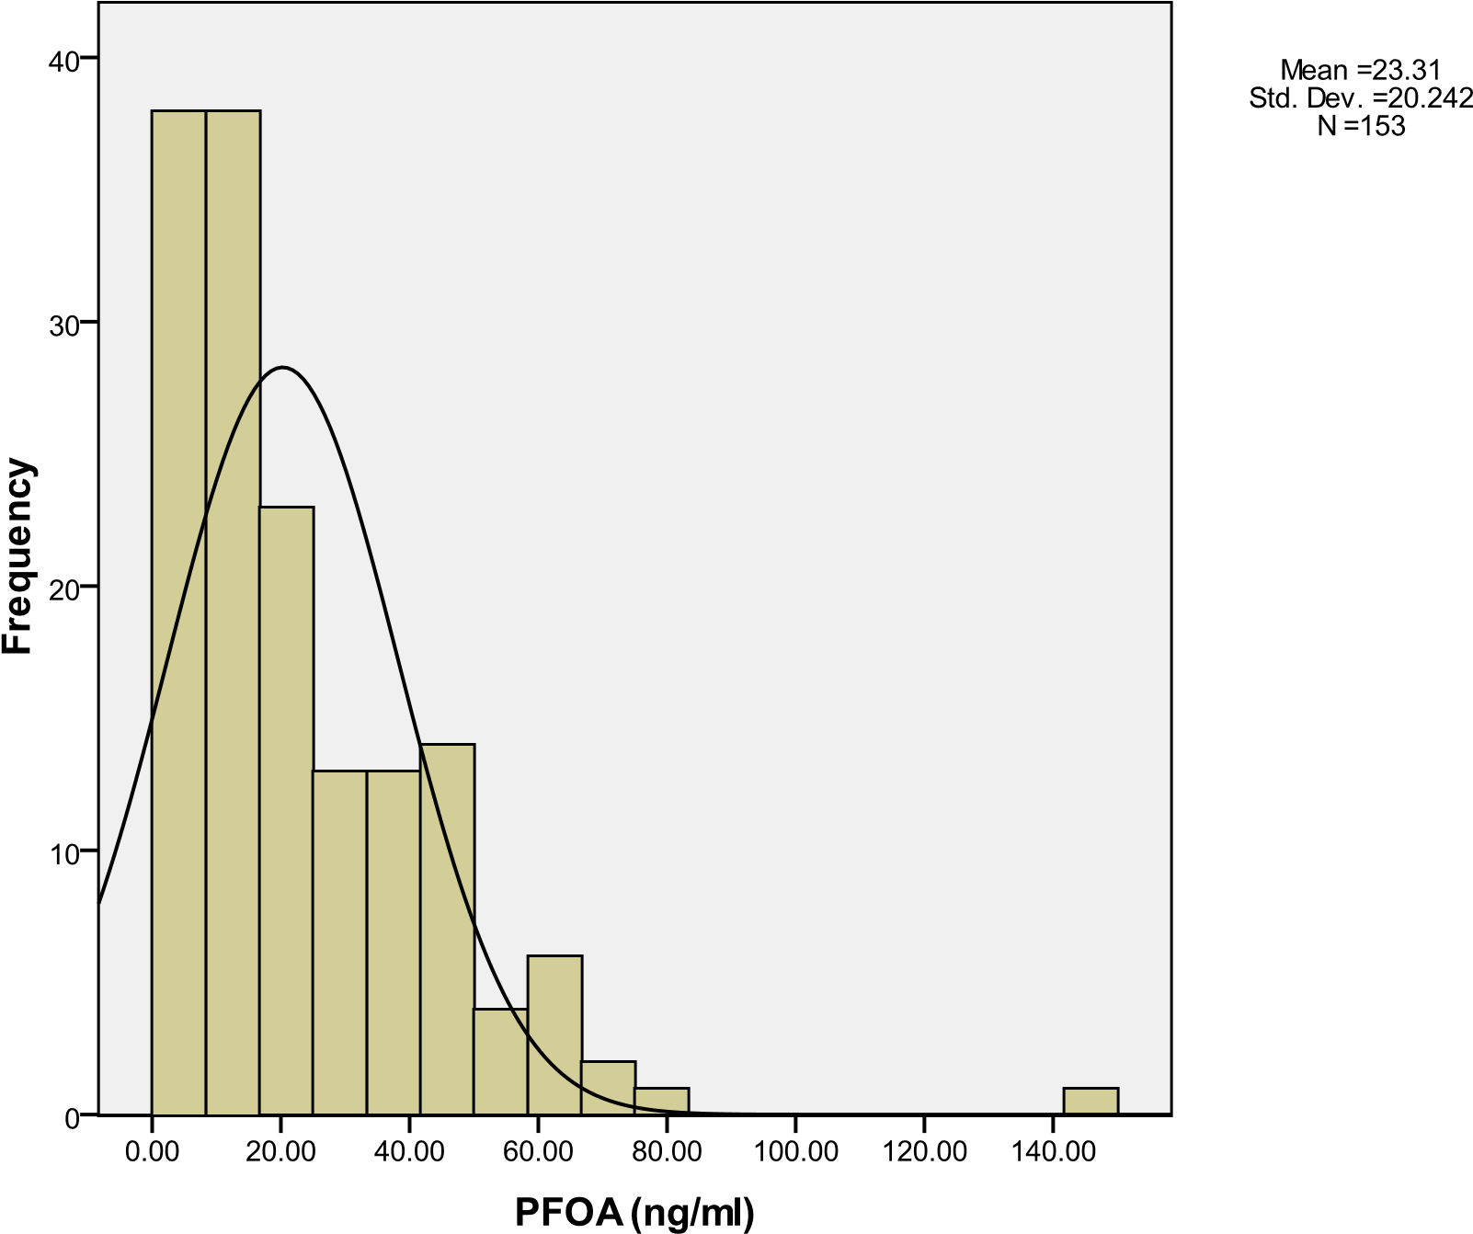

Figure 2: Serum Perfluorooctane Sulfonic Acid (PFOS) distribution

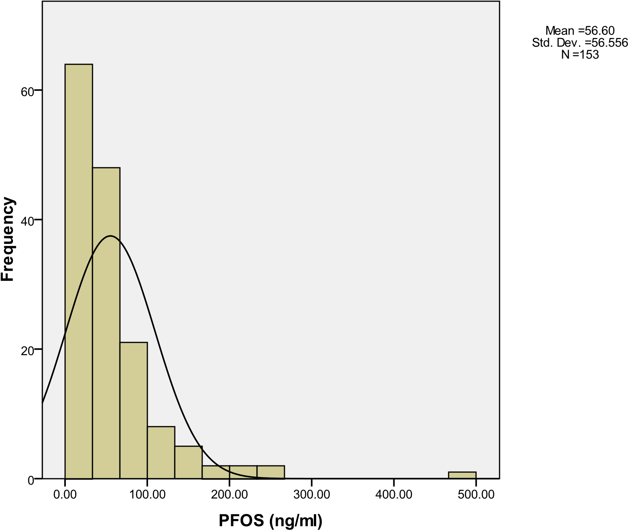

Figure 3: Serum Perfluorohexane Sulfonic Acid (PFHxS) Distribution

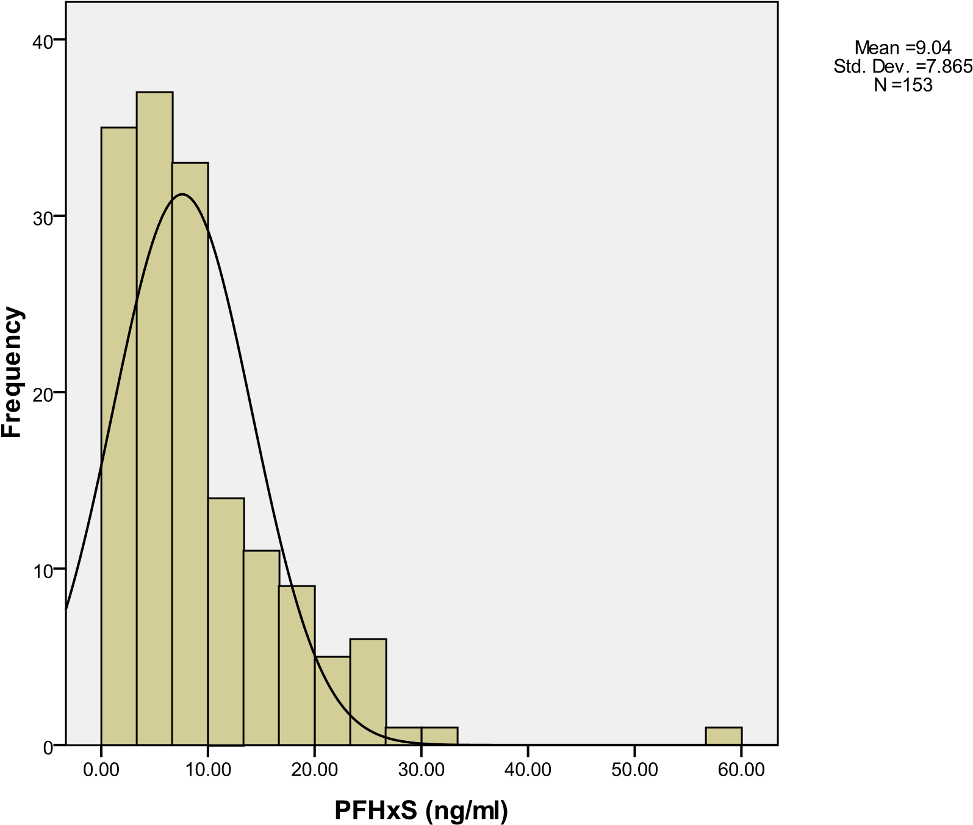

Figure 4: Serum Perfluorononanoic Acid (PFNA) Distribution

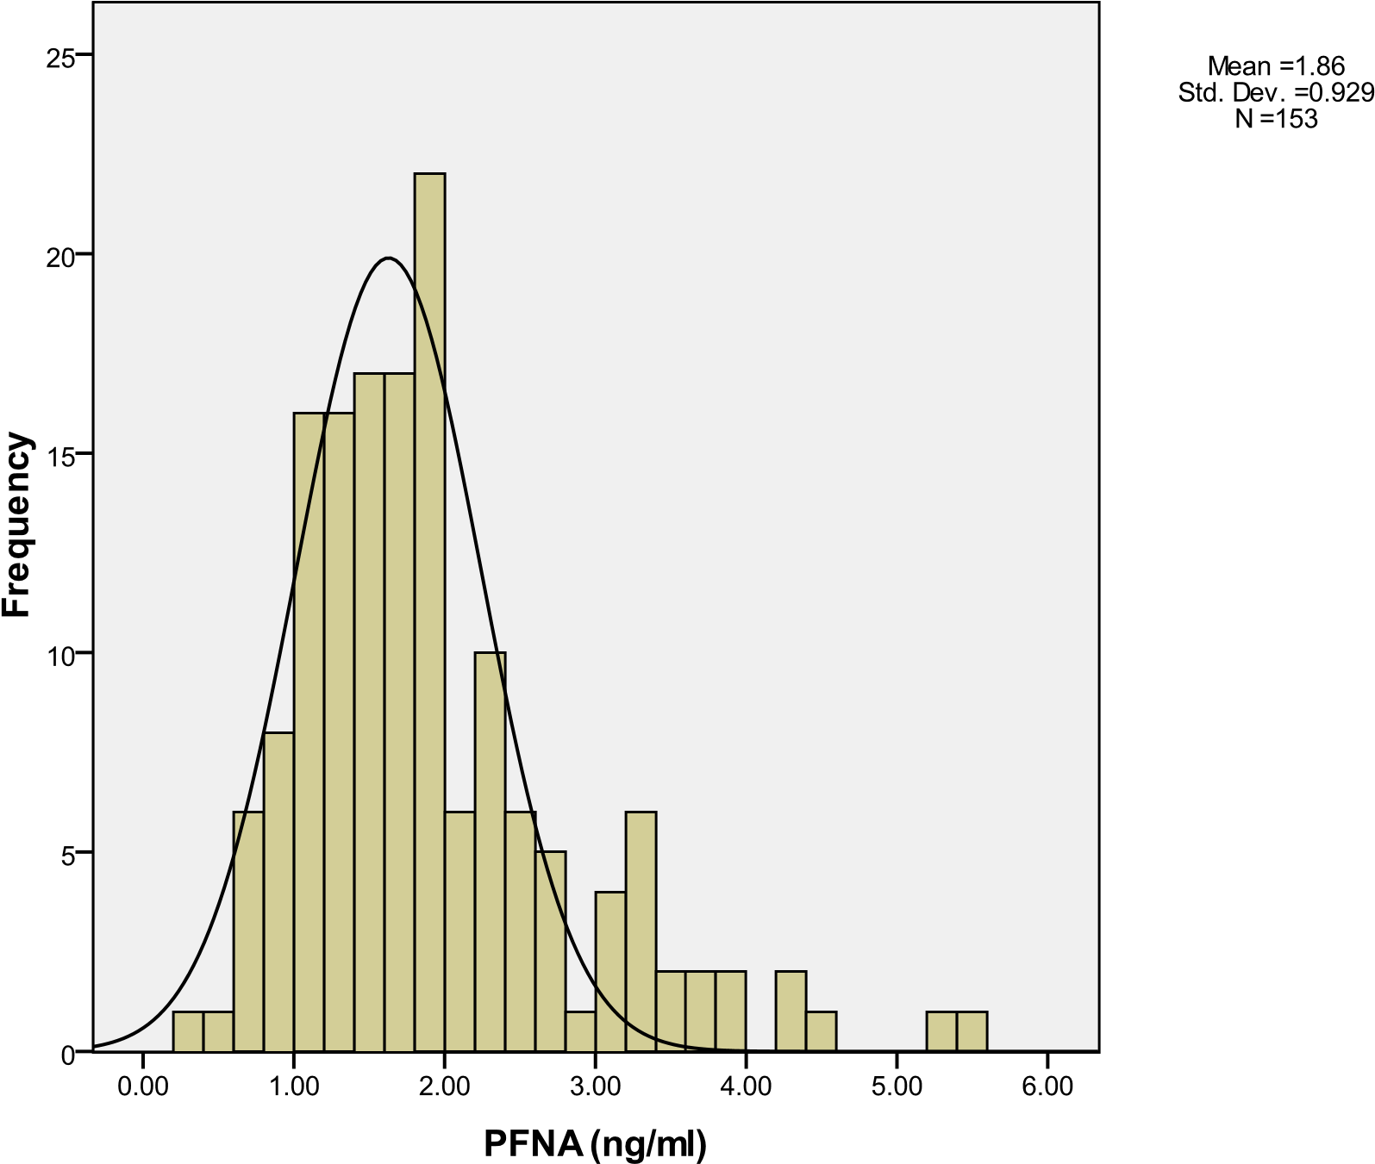

Figure 5: Log 10 Serum Perfluorooctanoic Acid (PFOA)

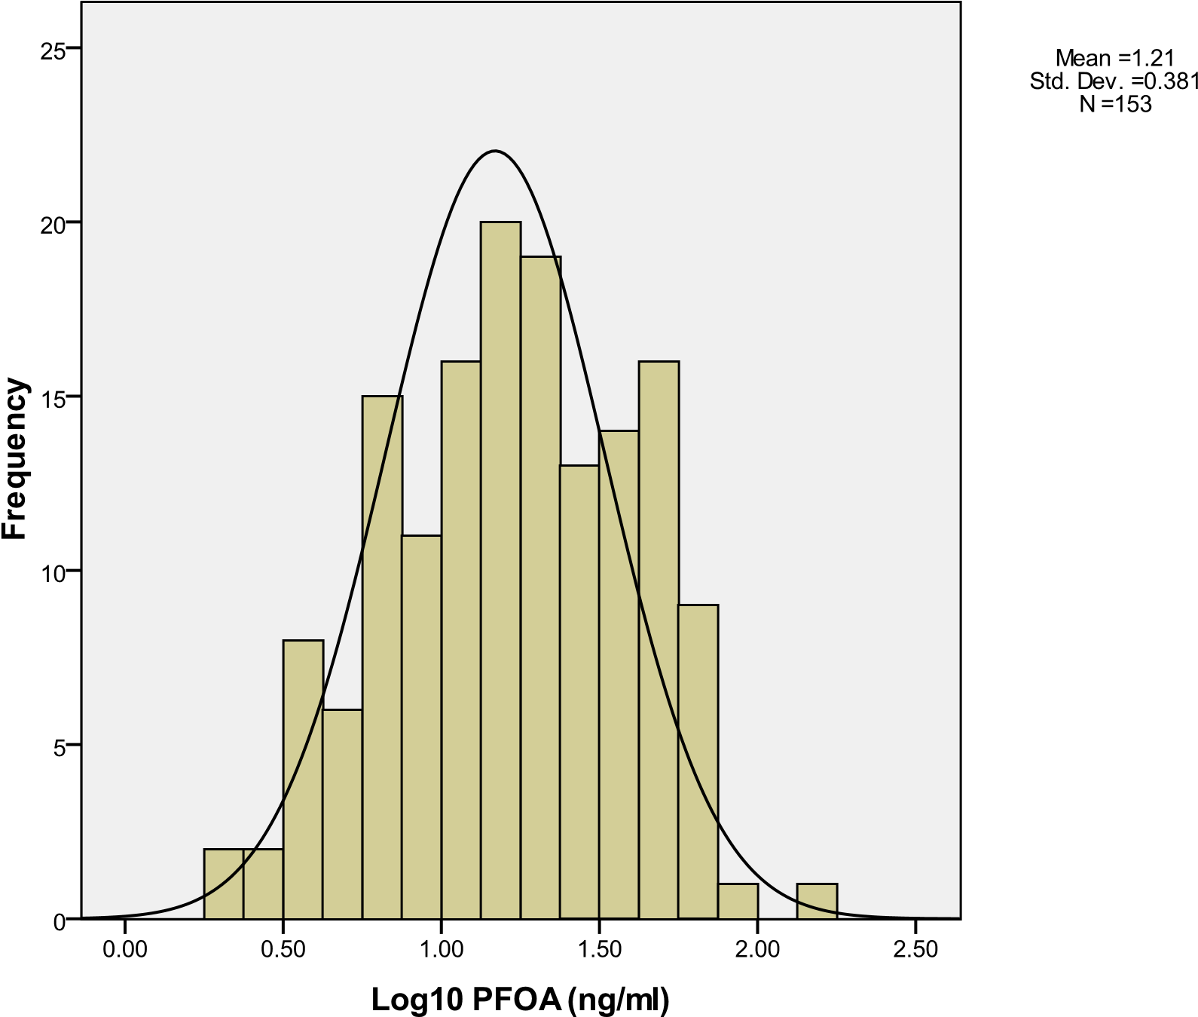

Figure 6: Log 10 Serum Perfluorooctane Sulfonic Acid (PFOS)

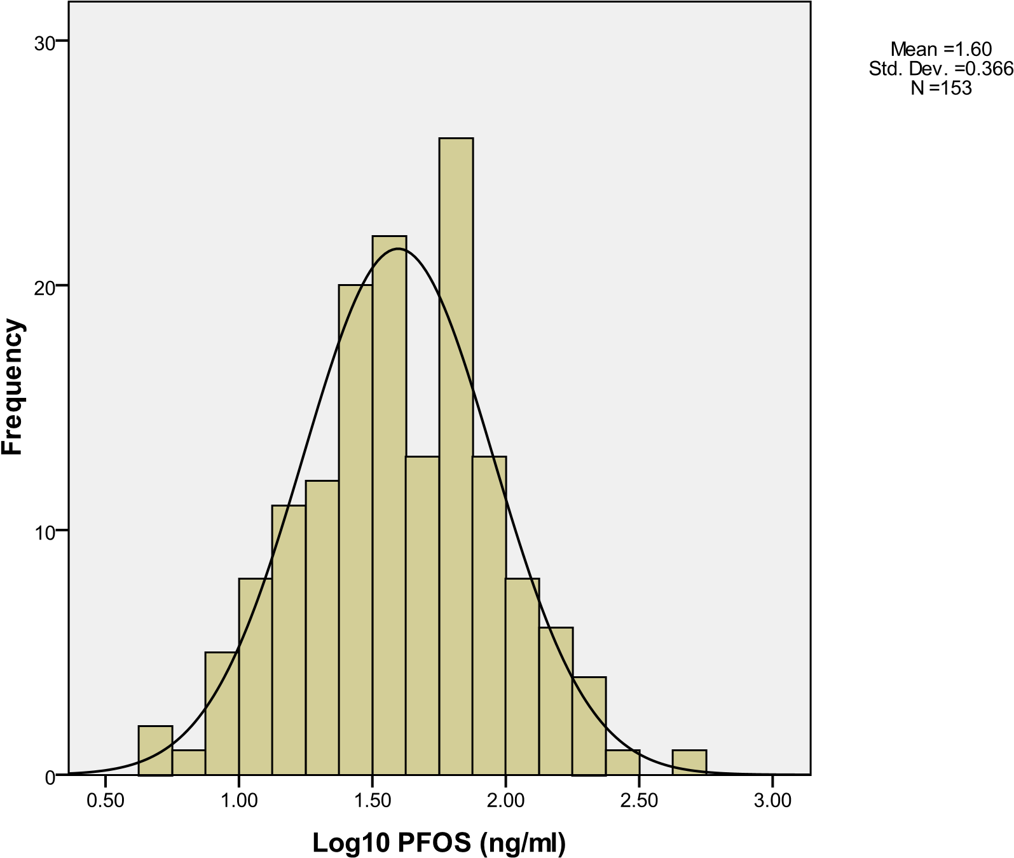

Figure 7: Log 10 Serum Perfluorohexane Sulfonic Acid (PFHxS)

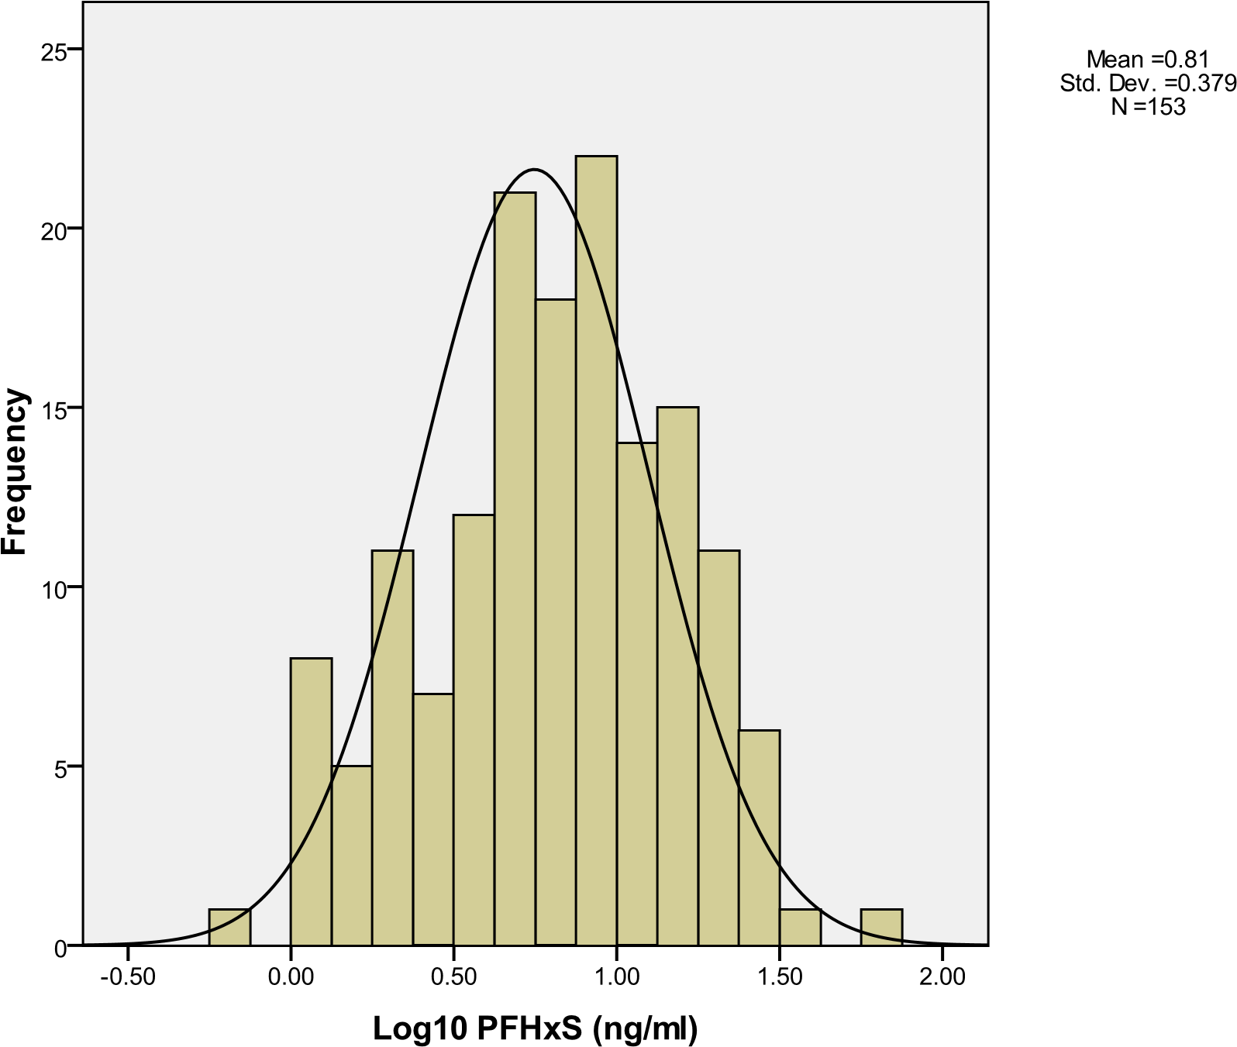

Figure 8: Log 10 Serum Perfluorononanoic Acid (PFNA)

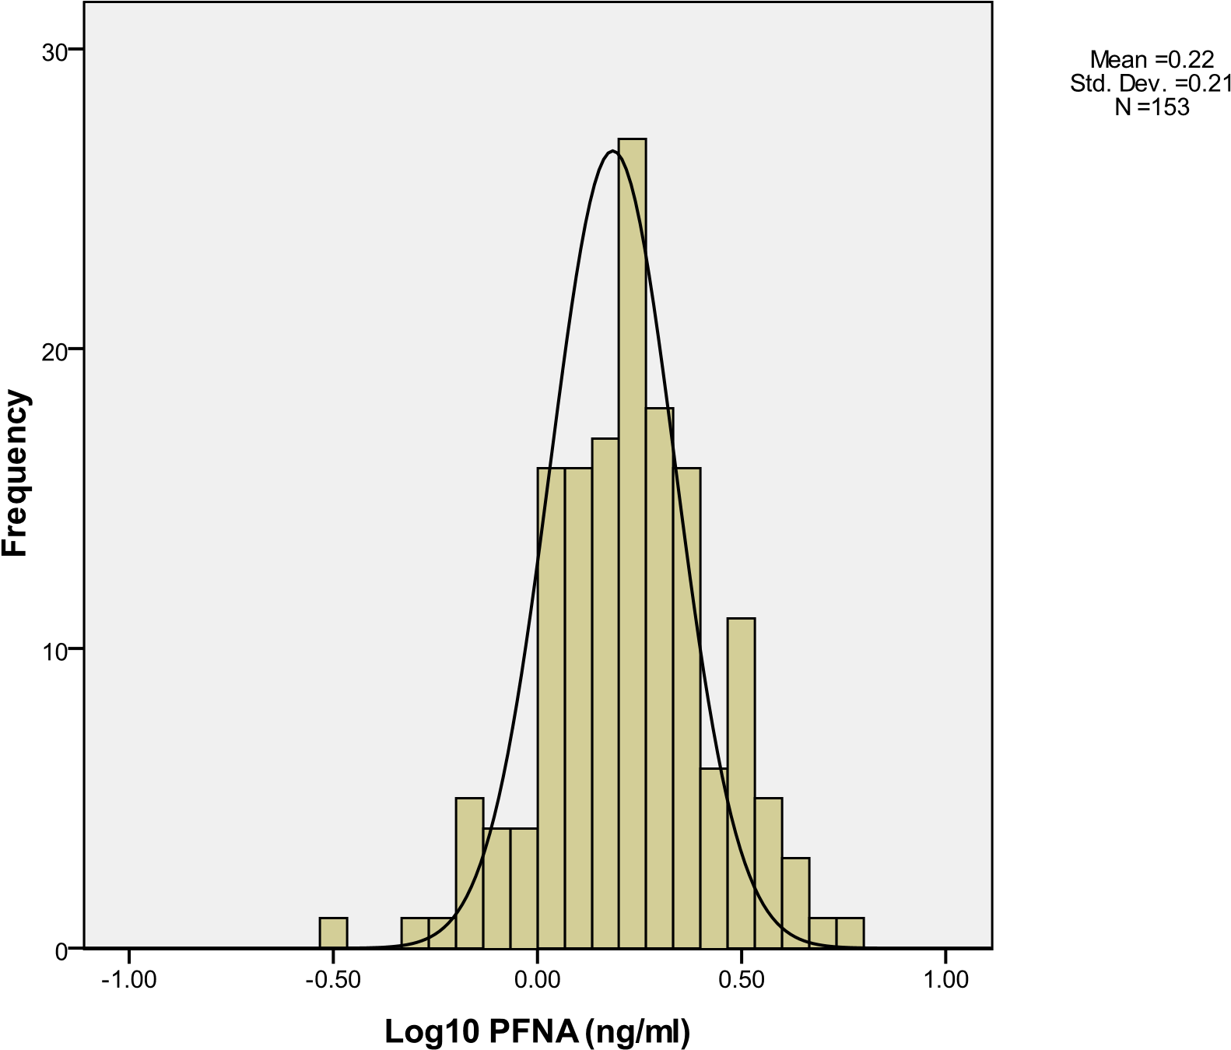

Figure 9: Linear Regression and 95% Confidence Limits of Log 10 Serum
Perfluorooctanoic Acid (PFOA) vs. Age

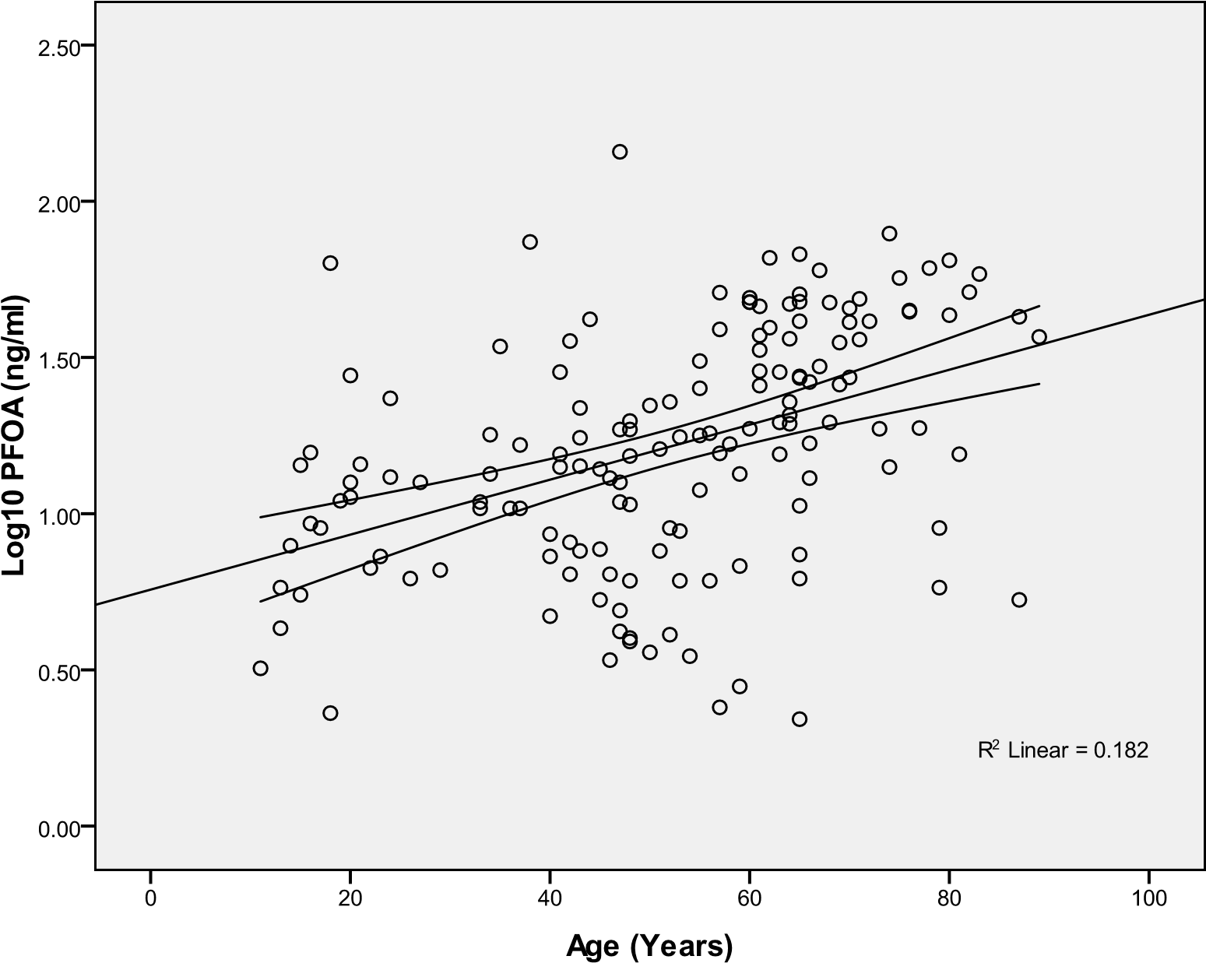

Figure 10: Linear Regression and 95% Confidence Limits of Log 10 of Serum
Perfluorooctane Sulfonic Acid (PFOS) vs. Age

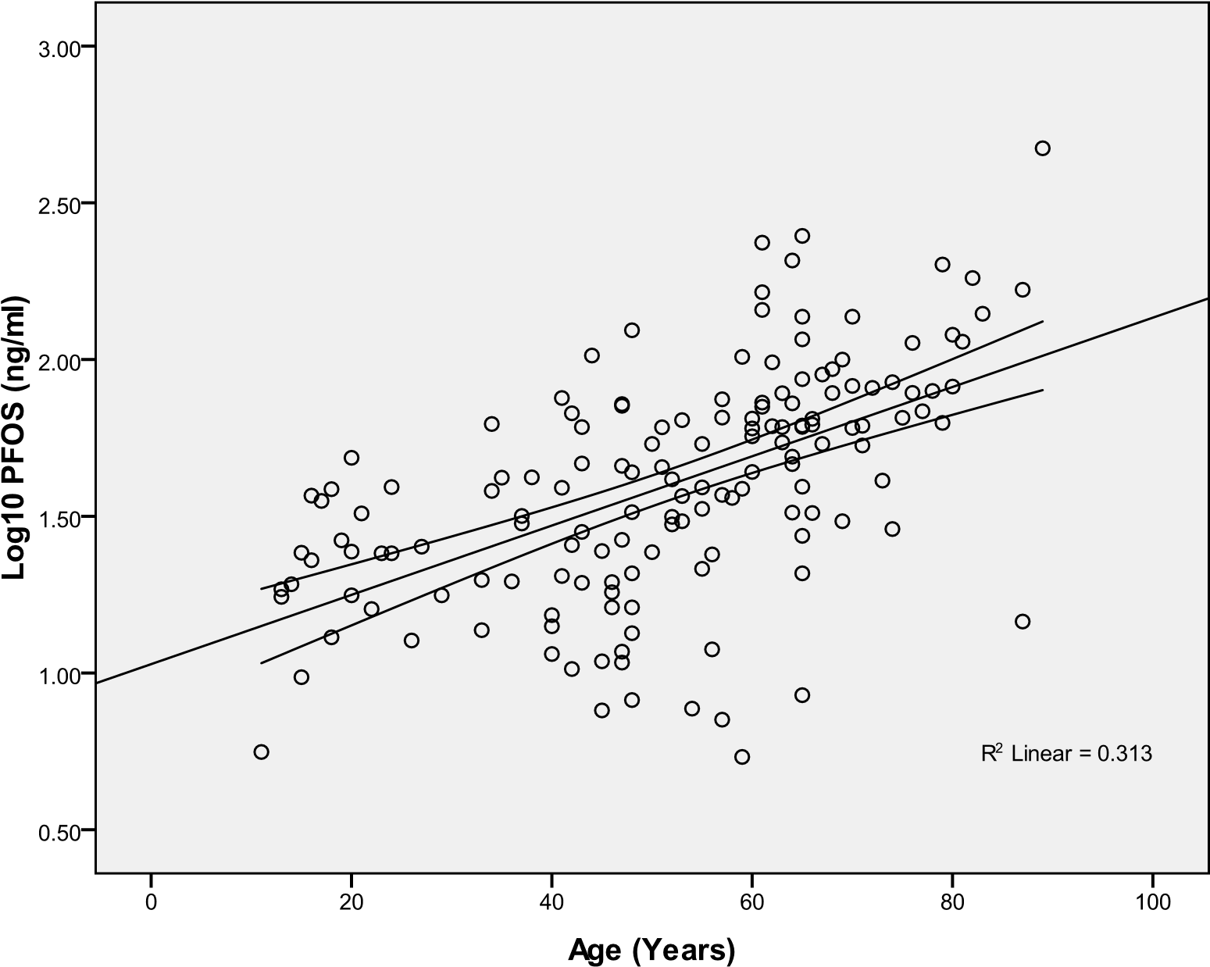

Figure 11: Linear Regression and 95% Confidence Limits of Log 10 of Serum
Perfluorohexane Sulfonic Acid (PFHxS) Serum vs. Age

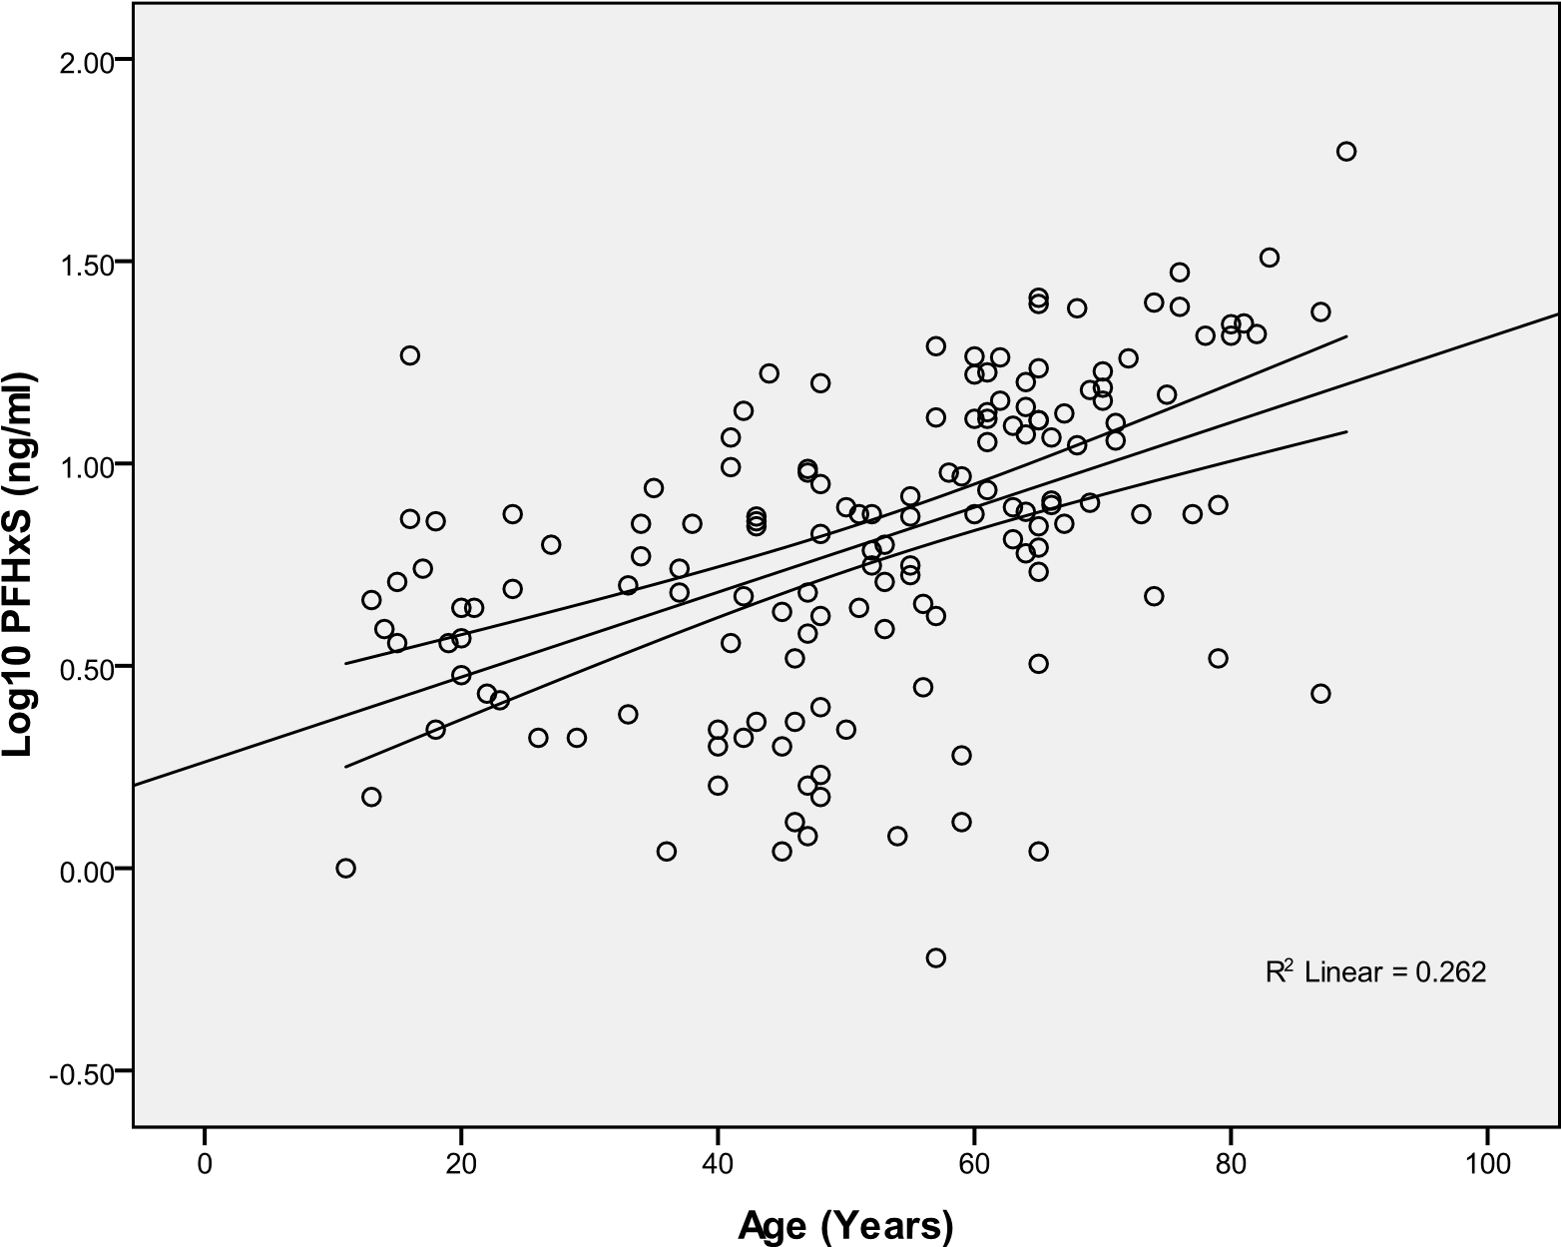

Figure 12 : Study Comparison of
Perfluorooctanoic Acid (PFOA) Mean Serum
Concentrations (ng/mL)
3M Workers
Dupont Workers
Little Hocking, OH
Ohio River Valley
Minnesota Pilot Study
Decatur, AL PFC Testing
Red Cross Blood Donors
U.S. Population
0 200 400 600 800 1000 1200
PFOA Mean Serum Concentration (ng/mL)
References: 3M Workers - Olsen 2003; Dupont - Sakr 2007; Little Hocking, OH - Emmet 2006a,b; Ohio River Valley - Steenland
2009; Minnesota Pilot Study - MDH 2009; Red Cross Blood Donors - Olsen 2008; U.S. Population - CDC/NHANES 2010

Figure 13: Study Comparison of Mean
Perfluorooctane Sulfonic Acid (PFOS) Serum
Concentrations (ng/mL)

0

100

200

300

400

500

US Population
Red Cross Blood Donors
Decatur, AL PFC Testing
Minnesota Pilot Study
3
M Workers
PFOS Mean Serum Concentration (ng/mL)
References: 3M Workers - Olsen 2003; Minnesota Pilot Study - MDH 2009; Red Cross Blood Donors - Olsen 2008; U.S. Population - CDC/NHANES 2010

APPENDIX B: Tables

Table 1B: List of Perfluorochemicals (PFCs) measured listed by abbreviation, chemical name and limit of quantitation (LOQ).
Abbreviation | Chemical Name | LOQ  (ng/mL)
PFOA | Perfluorooctanoic acid | 0.1
PFOS | Perfluorooctane sulfonic acid | 0.2
PFHxS | Perfluorohexane sulfonic acid | 0.1
PFNA | Perfluorononanoic acid | 0.1
PFDeA | Perfluorodecanoic acid | 0.2
Me-PFOSA-AcOH | 2-(N-methyl-Perfluorooctane sulfonamido) acetic acid | 0.2
Et-PFOSA-AcOH | 2-(N-ethyl-Perfluorooctane sulfonamido) acetic acid | 0.2
PFOSA | Perfluorooctane sulfonamide | 0.1

Table 2B: Description of survey data collected for participants.
(n=153)
Survey Variable | Count | Percent
Age
0-29 years | 23 | 15.0
30-59 years | 67 | 43.8
60+ years | 62 | 40.5
Not reported | 1 | 0.7
Length of residence
6 months-1 year | 4 | 2.6
2-5 years | 20 | 13.1
6-10 years | 23 | 15.0
11-20 years | 24 | 15.7
21-30 years | 22 | 14.4
31-40 years | 20 | 13.1
>40 years | 39 | 25.5
Unknown | 1 | 0.7
Frequency of working on soil on home property
Never | 16 | 10.5
Daily | 30 | 19.6
Weekly | 68 | 44.4
Monthly | 18 | 11.8
Yearly | 13 | 8.5
Seasonal | 5 | 3.3
Unknown | 3 | 2.0

Table 2B (cont.): Description of survey data collected for participants (n=153)
Wear gloves while working in soil on home property
Never Do This | 47 | 30.7
Seldom Do This | 41 | 26.8
Sometimes Do This | 41 | 26.8
Always Do This | 5 | 3.3
Unknown | 19 | 12.4
Frequency of consuming locally grown fruits & vegetables
Never | 11 | 7.2
Daily | 58 | 37.9
Weekly | 55 | 35.9
Monthly | 21 | 13.7
Other | 2 | 1.3
Unknown | 6 | 3.9
Frequency of consuming domestically raised cattle
Never | 78 | 51.0
Daily | 3 | 2.0
Weekly | 25 | 16.3
Monthly | 11 | 7.2
Yearly | 5 | 3.3
Don’t Know | 29 | 19.0
Unknown | 2 | 1.3
Consume fish caught from local rivers, ponds, and lakes
Never | 67 | 43.8
1-3 meals/month | 37 | 24.2
4-6 meals/month | 15 | 9.8
7-9 meals/month | 9 | 5.9
10 or more meals/month | 2 | 1.3
Unknown frequency/month | 23 | 15.0
Major source of current drinking water
Regulated (public water source) | 128 | 83.7
Unregulated (private well, community well, spring) | 14 | 9.1
Bottled | 11 | 7.2

Table 3B: Blood serum geometric mean and range for eight perfluorochemicals measured compared to NHANES geometric mean (ng/mL) and 95th percentile
PFC | EI#  Geometric Mean | EI Range | NHANES  Geometric Mean  (CI##)  (2005-06)** | NHANES  95th  Percentile | Limit of  Detection
PFOA | 16.3 | 2.2 - 144 | 3.92 (3.48 – 4.42) | 11.3 | 0.1
PFOS | 39.8 | 5.4 - 472 | 17.1 (16.0 – 18.2) | 47.5 | 0.2
PFHxS | 6.4 | 0.6 - 59.1 | 1.67 (1.42 – 1.98) | 8.3 | 0.1
PFNA | 1.7 | 0.3 - 5.5 | 1.09 (0.91 – 1.29) | 3.6 | 0.1
Et-PFOSA-Acoh | * | 0.2 - 0.2 | * | 0.3 | 0.2
Me- PFOSA-Acoh | 0.4 | 0.2 - 4.8 | 0.47 (0.43 - 0.52) | 1.8 | 0.2
PFDeA | 0.4 | 0.2 - 2.5 | 0.36 (0.30 - 0.42) | 1.5 | 0.2
PFOSA | * | 0.1 - 0.1 | * | 0.3 | 0.1
*Not calculated: proportion of results below limit of detection was too high to provide a valid result. **NHANES, the National Health and Nutrition Examination Survey, is a population-based survey designed to collect information on the health and nutrition of the U.S. household population.
#
EI refers to this “exposure investigation” conducted in the Decatur, Alabama area Note: The limit of detection for this investigation was the same as NHANES.
##CI = 95% Confidence Interval

Table 4B : Pearson correlation coefficients (Log₁₀) between PFOA, PFOS, PFHxS and
PFNA (n=153)
 | PFOA | PFOS | PFHxS | PFNA
PFOA | 1
PFOS | 0.76 | 1
PFHxS | 0.85 | 0.81 | 1
PFNA | 0.58 | 0.66 | 0.58 | 1
p<0.0001 for all correlations

Table 5B: Linear regression results of log-transformed Perfluorochemical (PFC) concentrations and survey variables*
Variable |  | log PFOA |  |  | log PFOS |  |  | log PFHxS
 |  | R2 | β | P value | R2 | β | P value | R2 | β | P value
Age |  | 0.182 | 0.009 | <0.0001 | 0.313 | 0.011 | <0.0001 | 0.262 | 0.010 | <0.0001
Sex |  | 0.039 | -0.153 | 0.014 | 0.056 | -0.175 | 0.003 | 0.067 | -0.199 | 0.001
Age & Sex** | Age | 0.214 | 0.009 | <0.0001 | 0.358 | 0.011 | <0.0001 | 0.318 | 0.010 | <0.0001
 | Sex |  | -0.137 | 0.016 |  | -0.158 | 0.001 |  | -0.183 | 0.001
* Multiple linear regression was initially done with all survey variables for each PFC. Only age and sex were found to be significant. Both age and sex were significant for each PFC.
** Males=0, Females=1

APPENDIX C: Exposure Investigation Protocol

Exposure Investigation Protocol

Perfluoroalkyl Serum Sampling
Near Decatur, Alabama
Morgan, Lawrence and Limestone Counties

November 6, 2009

Prepared by

Agency for Toxic Substances and Disease Registry
Atlanta, Georgia

Exposure Investigation

An exposure investigation (EI) is not a study. It is a biased attempt to determine if exposure is occurring among a potentially highly exposed group of individuals. This investigation has received an IRB exemption because it is not considered research. Its primary intent is public health practice.

Background

Introduction

In 2007, a Perfluoroalkyl (PFC) manufacturer in Decatur, Alabama notified the Environmental Protection Agency (EPA) that it had unknowingly discharged PFCs into the Decatur Utilities wastewater treatment plant. Sewage sludge from the Decatur wastewater treatment plant was applied to agricultural fields. This action led EPA to initiate an investigation to determine if the biosolids from the treatment plant were contaminated and if land application had resulted in a potential discharge of PFCs to the environment.

The Decatur Utilities plant receives wastewater from domestic and industrial sources, including fluorochemical manufacturing and use facilities in the area. Municipal sewage sludge from this facility was land applied to approximately 5000 acres of privately owned agricultural fields for approximately 12 years. To date, EPA has identified four direct sources of PFCs to the Decatur Utilities Plant: the 3M Company, Daikin America, Inc., Toray Fluorofibers America, Inc., and the Morgan County Landfill leachate.

PFCs are used in a variety of industrial and consumer applications and products, including fire-fighting foams; personal care and cleaning products; and oil, stain, grease, and water repellent coatings on carpet, textiles, leather, and paper (ATSDR 2009). Perfluorooctyl sulfonate (PFOS) is no longer manufactured in the United States.

PFCs are not currently regulated by EPA and the testing of biosolids for these chemicals is typically not required. EPA has not established an action level for PFOA or PFOS in soil or sewage sludge. ATSDR has not established a minimal risk level (MRL) for PFCs due to the paucity of human data in the scientific literature.

EPA recently developed drinking water provisional health advisory levels for two of the PFCs, perfluorooctanoic acid (PFOA), and PFOS. The provisional health advisory level for PFOA is 0.4 parts per billion (ppb) [micrograms per liter (ug/L)] and the provisional advisory level for PFOS is 0.2 ppb.

Soil sampling

In 2007, EPA conducted limited sampling of soil and sludge samples from two biosolid agricultural application sites and from the Decatur Utilities facility. In 2008, the results indicated relatively high levels of PFOA and PFOS compared to other industrial and non-industrial sites. The two soil sampling sites showed PFOS ranging from 589 to1296 ppb [micrograms per kilogram (ug/kg)] and PFOA ranging from 55 to 2531 ppb in the nine soil samples. The Decatur Utilities ceased land application of biosolids after learning of these PFC levels in its biosolids.

In March 2009, EPA collected 30 soil samples in or near the fields with the highest applications of biosolids. The results indicate that the majority of the Decatur soils in the land application area have concentrations of numerous PFCs above the background levels. Concentrations of PFOA range from non-detect up to 312 ppb with most concentrations in the 100 to 200 ppb range. Concentrations of PFOS range from non-detect up to 325 ppb with most concentrations around 100 to 200 ppb.
Concentrations of ten carbon PFCs (C10) are as high as 986 ppb and concentrations of 12 carbon PFCs (C12) are as high as 526 ppb.

Water sampling

In November 2008, water samples were collected for PFCs analysis. There were non-quantifiable levels of PFCs in two of the three public water systems (Moulton and Decatur). Levels of PFCs detected in the East Lawrence/West Morgan system were at levels below EPA’s provisional health advisory levels of 0.4 ppb for PFOA and 0.2 ppb for PFOS in drinking water. Based on its current understanding, EPA believes these levels are not of concern and residents may rely upon public water systems.

In February 2009, 51 water samples were collected from ground water wells, ponds, and a stream in or near the fields that received the highest applications of biosolids. The final report indicated the following results:

- Two of six private drinking water wells sampled had PFOA levels above EPA’s provisional health advisory level and none had levels above the PFOS provisional health advisory levels. These two wells had PFOA levels of 2.2 ppb and 0.6 ppb respectively. Both of these residences with elevated PFOA levels were quickly provided with bottled water and connected to the public water supply system by Decatur Utilities and a group of local industries in the area.

- The final ground water sampling results from the 13 other water wells for PFOA ranged from no detectable levels to 6.41 ppb and for PFOS ranged from no detectable levels to 0.15 ppb. These wells serve as a water supply for livestock, gardens, and lawns.

- The final surface water sampling results from 32 ponds and one stream for PFOA ranged from no detectable levels to 11.0 ppb and for PFOS ranged from no detectable levels to 0.08 ppb.

All soil and water sampling data collected can be obtained from the following website: http://www.epa.gov/region4/water/PFCindex.html.

Perfluoroalkyls and health effects

PFCs have been found in the environment, in wildlife and in the blood of the general population (Calafat 2006a, 2007, Kannan 2004, Taniyasu 2003).

In one population with environmental exposure to PFOA contaminated drinking water, no definite association between PFC exposure and adverse health effects was observed (Emmett 2006b). Some human studies report associations with lower birth weight (Apelberg 2007, Fei 2007), higher cholesterol (Sakr 2007a, 2007b), and changes in liver function (Olsen 2007), however the effects are relatively small.

In occupational studies, no definite association has been established between PFOA/PFOS and adverse health effects (Leonard 2007, Grice 2007, Olsen 2004a, Alexander 2003, Gilliland and Mandel 1993).

In animals, adverse health effects have been demonstrated with PFOA/PFOS exposure (Kennedy 2004, Lau 2004) but at doses that are orders of magnitude higher than has been observed in the general human population (Butenhoff 2004, Luebker 2005). In addition, extrapolation from animals to humans is highly uncertain because of pronounced differences in elimination rates, substantial variability across species and other issues (ATSDR, 2009).

Exposed population

The exposed population in the Decatur area includes residents who live and work in a predominantly rural community. There are approximately 179 fields on approximately 35 farms that received contaminated biosolids. People that work in these fields are exposed to contamination by way of direct contact, air and dust inhalation, and in some cases, drinking water and food consumption (home grown vegetables, beef from locally raised cows that may consume PFC contaminated water, and fish from ponds contaminated with PFCs).

Two families have been drinking water from private water wells that exceeds EPA’s Provisional
Health Advisory. Many community members receive their drinking water from the East
Lawrence/West Morgan public water supply system. While the concentrations of PFOA and PFOS are below EPA’s PHAs, this system has detectable current levels of PFOA in the 0.025 ppb range and PFOS also at the 0.025 ppb range.

In a German population, increased PFOA concentrations were associated with eating locally grown vegetables, drinking large quantities of public water and residing in an exposed versus non-exposed area (Holzer 2007). Emmett (2006a) reported a correlation between consumption of locally grown vegetables and wild game and human blood levels in an area contaminated with PFC.

Project Overview

A. Purpose

The purpose of this Exposure Investigation (EI) is to determine if unusual exposure to PFCs is occurring by collecting serum samples from people with a high potential of exposure. An exposure investigation is not a study. It is a biased attempt to determine if exposure is occurring among a potentially highly exposed group of individuals. If unusual exposure is documented in an EI, then additional public health activities may be initiated. Participants will be recruited based on two exposure factors:

- Living on or near soil with elevated levels of PFCs or
- Drinking water contaminated with elevated PFCs from private wells or from chronic exposure to low level PFCs from the East Lawrence/West Morgan public water supply system

ATSDR will utilize EPA soil and water sampling data to focus recruitment efforts of residents with soil and water exposures. ATSDR will protect the privacy of all individual information provided by EPA. Participants will be asked about local vegetable and meat consumption to address other exposure pathways. ATSDR will test up to 200 volunteers.

The results of the EI will help individual participants better understand the magnitude of their sitespecific environmental exposures to PFCs. In addition, the results of the EI will assist EPA in deciding the appropriate course of action at this site. Because these contaminants are not currently regulated by EPA, the course of follow-up (or remedial) action is not clearly defined by existing regulations. A detection of unusually high exposures in this investigation would support and provide further impetus for further site investigation. Unusually high exposures would also clearly signal the need for communication to residents on ways to reduce their exposure, and minimize risk to their health.

If the EI indicates that exposures are no higher that what is considered to be normal or usual exposures to PFCs, community residents could be reassured that their risk of exposure is no greater than that of the general population. This information would also be useful to EPA’s decision-making process and would provide information about the merit of conducting further site characterization and remedial action, if needed.

The results of this investigation will be applicable only to the individuals tested and cannot be generalized to other populations. In addition, results of this exposure investigation cannot be used to predict the future occurrence of disease nor be associated with current health problems.

B. Investigators and collaborators

The ATSDR will be the lead agency for this investigation. The EPA and Alabama Department of Environmental Management (ADEM) will be collaborators in this investigation.

ATSDR will:

- Contact and recruit eligible participants
- Provide and pay for all collection supplies and equipment
- Make arrangements and pay for the use of blood collection centers
- Make a arrangements and pay for phlebotomists at the blood collection centers
- Arrange and fund laboratory analyses of the biological samples
- Coordinate blood sampling and sample shipment
- Provide participants with an interpretation of their individual results
- Write a report that summarizes the findings of the investigation

EPA/ADEM will:

- Assist ATSDR in recruiting participants
- Provide assistance with logistical organization
- Provide field assistance, if needed

Methods

A. Eligibility criteria

This exposure investigation targets a specific population in the Decatur area. A maximum of 200 residents will be offered blood testing. Participants must meet all eligibility requirements to participate in this investigation. A full-time resident who meets the all the following criteria is eligible to participate in this investigation:

- Is 12 years of age and older
- Lives on or near property with elevated levels of PFCs in soil and/or is exposed to drinking water contaminated with PFCs from private wells or low level exposure from a public water system (as defined by EPA sampling)
- Has lived on current property for at least one year
- Does not have a bleeding disorder or is anemic
- Does not have current or past occupational (industrial) exposure to PFCs
Participants who have soil or sludge exposure will be recruited first because data regarding soil exposure in humans to PFCs is not available. After all available soil exposure participants have agreed to participate in the investigation, participants with drinking water exposure will be recruited next until a maximum of 200 participants has been reached. Residents with known private well exposure to PFCs will be given priority to participate in the investigation compared to residents drinking from a public water supply with PFC concentrations below the PHA. The age criteria (12 years of age and older) is used because the reference values to be used for comparison in this investigation are only available for children 12 and older (Calafat et al. 2007).

B. Recruiting participants

On December 1, 2009, staff from ATSDR/EPA and other government agencies will hold a public meeting with the residents to inform them of the investigation and participation criteria. Community members will be informed that families that live on or near property with elevated levels of PFCs or have current or past exposure to PFC from drinking water will be sent a letter. The letter will provide information about the investigation and a
1-800 number for participants to call and make an appointment for a blood draw.

During the week of April 12-15, 2010, ATSDR will meet with eligible participants at the designated blood collection center. ATSDR staff will further explain the investigation, answer questions, and obtain written informed consent/assent prior to blood collection.

C. Sample collection, informed consent, and survey
Participants in the investigation will be instructed to make an appointment at a blood collection center to have a blood sample drawn. At the blood collection center, each adult participant will be required to sign an informed consent form. Children ages 12 to 17 will also be required to sign an assent form with the consent of their guardian. Copies of these forms are attached. (Attachment A).

Each participant will be asked to complete a short survey (Attachment B). Each participant will be asked a few questions to gather information on risk factors for exposure to PFCs through food pathways, contact with contaminated soil, or local well water use. The total time it will take participants to read through consent/assent forms, respond to a brief survey, and provide a blood specimen is estimated to be approximately 15 minutes.

A nurse/technician will collect a 5-ml blood sample in a tube by venipuncture. Blood samples will be collected 4 days/week, Monday through Thursday, for one week. For one night, Tuesday, the blood collection location will be open from 6-8 pm, to accommodate people who are not available during the day.

D. Sample handling and shipping

Each tube will be labeled with a preprinted bar-coded label associated with the participant. A collection log will also be maintained. Then each sample tube will be placed upright in a rack. This will allow the blood to clot for a minimum of 30 minutes, preferably as much as 2 hours to create maximum serum yield.

After the contents in the tube have clotted, each will be placed inside storage boxes provided by the laboratory. Each box will be placed inside a plastic Saf-T-Pak™ biohazard bags along with an absorbent pad and sealed. This plastic bag will be placed inside a larger Tyvek ® bag and sealed. The bagged specimen boxes will be placed inside a Styrofoam shipping container. Dry ice will be added to the shipper. The blood samples will be shipped overnight on dry ice to the National Center for Environmental Health (NCEH) Laboratory in Atlanta, Georgia. ATSDR staff will maintain and manage proper chain of custody for all blood samples.

E. Lab processing and analysis

Blood samples will be analyzed for twelve perfluoroalkyls. Test results will be reported as nanograms of the PFC analyte per liter of blood (ng/mL). All laboratory analysis will be conducted with established procedures for quality assurance and control. Details of the laboratory processing, analysis methods, quality assurance and quality control measures are available at http://www.cdc.gov/nchs/data/nhanes/nhanes_05_06/pfc_d_met.pdf .

Table 1 provides the list of the 12 PFCs to be measured in this investigation. Table 2 provides the limits of detection for each PFC to be measured in this investigation.

Table 1: List of PFCs to measured in this investigation - abbreviation and associated chemical name.

Abbreviation | Chemical Name
PFOSA | Perfluorooctane sulfonamide
Me-PFOSA-AcOH | 2-(N-methyl-Perfluorooctane sulfonamido) acetic acid
Et-PFOSA-AcOH | 2-(N-ethyl-Perfluorooctane sulfonamido) acetic acid
PFBuS | Perfluorobutane sulfonic acid
PFHxS | Perfluorohexane sulfonic acid
PFOS | Perfluorooctane sulfonic acid
PFHpA | Perfluoroheptanoic acid
PFOA | Perfluorooctanoic acid
PFNA | Perfluorononanoic acid
PFDeA | Perfluorodecanoic acid
PFUA | Perfluoroundecanoic acid
PFDoA | Perfluorododecanoic acid

Table 2: Limit of Detection (LOD) for each PFC to be measured in serum.

Analyte | LOD (ng/mL)
PFOSA | 0.1
Me-PFOSA-AcOH | 0.1
Et-PFOSA-AcOH | 0.1
PFBuS | 0.1
PFHxS | 0.1
PFOS | 0.2
PFHpA | 0.4
PFOA | 0.1
PFNA | 0.1
PFDeA | 0.2
PFUA | 0.2
PFDoA | 0.2

F. Confidentiality

Confidentiality will be protected to the fullest extent possible by law. Any reports produced from this information will give only group information and not identify specific individuals. Confidential information will be kept in locked cabinets at ATSDR or on a password-protected computer. Only if a participant consents, the test results may be released only to other federal, state and local public health and environmental agencies. These agencies must also protect this confidential information.

G. Data management, analysis and interpretation

Serum PFC results will be electronically transmitted from NCEH to ATSDR in spreadsheet format. No personal identifiers will be included in the spreadsheet. Data quality assurance and quality control will be performed by the NCEH laboratory.

National values for twelve PFC analytes are available from the National Health and Nutrition Examination Survey NHANES 2003-2004 (Calafat et al. 2007) and are considered to be national measures of exposure for the general US population. The 95th percentile for each PFC serum concentration will be used as a comparison value.

H. Reporting of results

Individual test results with a written explanation of their meaning will be provided to the participants six months after blood is collected. ATSDR will author the letters. Following dissemination of individual results, an ATSDR physician will be available to discuss individual questions by phone. Recommendations for follow-up actions will be made, if warranted.

Individual test results will not be made available to the public, and confidentiality will be protected according to Federal and State laws. At the conclusion of the investigation, ATSDR will prepare a report summarizing the findings of the investigation, but will not reveal personal identifiers.

I. Limitations of exposure investigation

PFC serum concentrations cannot be used to predict the future occurrence of disease nor be attributed to current health problems. Serum PFC concentrations will not necessarily provide information about the source of exposure (i.e. water, soil, food etc.). The results of this investigation will be applicable only to the individuals tested and can not be generalized to other populations.

J. Risks and benefits to participants

Risks

A risk to participants of this investigation is the possibility of bruising from collecting a blood sample.

Benefits

The potential benefit to the participant is that they will learn the amount of PFCs that are present in their serum. They will also be provided an interpretation of this result by a health care professional who can advise on preventative actions to reduce current or future exposure to PFCs.

As more studies are conducted, a better of understanding of PFC serum concentrations and associated health effects may be demonstrated in the future. If PFC associated health effects are demonstrated in the future, the PFC measurements in this investigation may inform and guide future health care issues in the participant.

References

Alexander BH, Olsen GW, Burris JW, Mandel JH, Mandel JS 2003. Mortality of employees of a perfluorooctanesulphonyl fluoride manufacturing facility. Occup Environ Med 60:722-729.

Agency for Toxic Substance and Disease Registry (ATSDR). Toxicological Profile for Perfluoroalkyls (Draft for Public Comment) October 30, 2009. Agency for Toxic Substances and Disease Registry. Atlanta, GA: U.S. Department of Health and Human Services, Public Health Services.

Apelberg BJ, Witter FR, Herbstman JB, Calafat Am, Haiden RU, Needham LL et al. 2007. Cord serum concentrations of perfluorooctane sulfonate (PFOS) and perfluorooctanoate (PFOA) in relation to weight and size at birth. Envirn Health Perspect 115:1670-1676.

Butenhoff JL, Kennedy GL, Frame SR, O’Connor JC, York RG 2004. The reproductive toxicology of ammonium perfluorooctanoate (APFO) in the rat. Toxicology. 196:95-116.

Calafat AM, Wong LY, Zsuzsanna K, Reidy JA, Needham LL. 2007. Polyfluoroalkyl chemicals in the U.S. population: Data from the National Health and Nutrition Examination Survey (NHANES) 2003-2004 and Comparisons with NHANES 1999­ 2000. Environmental Health Perspectives. 115 (11): 1596-1602.

Calafat AM, Kuklenyiz Z, Caudill SP, Reidy JA, Needham LL. 2006a.
Perfluorochemicals in pooled serum samples from United States residents in 2001 and 2002. Environ Sci Technol 40:2128-2134.

Emmett EA, Zhang H, Shofer FS, Freeman D, Rodway NV, Desai C, et al. 2006b. Community exposure to perfluorooctanoate: Relationships between serum levels and certain health parameters. J Occup Environ Med 48:771-779.

Fei C, McLaughlin JK, Tarone RE, Olsen J. 2007. Perfluorinated chemicals and fetal growth: a study within the Danish National Birth Cohort, Environmental Health Perspectives. 115:1677-1682.

Gilland FD and Mandel JS. 1993. Mortality among employees of a perfluorooctanoic acid production plant. J Occup Med 35(9):950-954.

Grice MM, Alexander BH, Hoffbeck R, Kampa DM. 2007. Self reported medical conditions in perfluoroooctanesulfonyl fluoride manufacturing workers. J Occup Environ Med 49:722-729.

Holzer J, Midasch O, Rauchfuss K, Kraft M, Reupert R, Angerer J, et al. 2008. Biomonitoring of perfluorinated compounds in children and adults exposed to perfluorooctanoate-contaminated drinking water. Environ Health Perspect. 116:651-657.

Kannan K, Corsolini S, Falandysz J, Fillmann G, Kumar KS, Loganathan BG et al. 2004.
Perfluorooctanesulfonate and related fluorochemicals in human blood from several countries. Envrion. Sci Technol 38:4489-4495.

Kennedy GL, Buttenhoff JL, Olsen GW, O’Connor JC, Seacat AM, Perkins RG et al 2004. The toxicology of perfluorooctanoate. Crit Rev Toxicol 34:351-384.

Lau C. Buttenhoff JL, Rogers JM. 2004. The developmental toxicity of perfluoroalkyl acids and their derivatives. Toxicol Appl Pharmacol 198:231-241.

Leonard RC, Kreckman KH, Sakr CJ, Symons JM. 2007. Retrospective cohort mortality study of workers in a polymer production plant including a reference population of regional workers. Ann Epidemiol 18:15-20.

Luebker DJ, York RG, Hansen KJ, Moore JA, Butenhoff JL. 2005. Neonatal mortality from in utero exposure to perfluorooctanesulfonate (PFOS) in Sprague-Dawly rats: Dose-response, biochemical and pharmacokinetic parameters. Toxicology. 215:149-169.

Olsen GW, Burlew MM, Marshall JC, Burris JM, Mandel JH. 2004a. Analysis of episodes of care in a perfluorooctanesulfonyl fluoride production facicility. J Occup Environ Med. 46:837-846.

Olsen GW, Mair DC, Reagen WK. 2007. Preliminary evidence of a decline in perfluorooctanesulfonate (PFOS) and perfluorooctanoate (PFOA) concentrations in American Red Cross blood donors. Chemosphere 68:105-11.

Sakr CJ, Kreckmann KH, Green JW, Gillies PJ, Reynolds JL, Leonard JC. 2007a. Cross-sectional study of lipids and liver enzymes related to a serum biomarker of exposure as part of a general health survey in a cohort of occupationally exposed workers. J Occup Environ Med 49:1086-1096.

Sakr CJ, Leonard RC, Kreckmann KH, Slade Md, Cullen MR. 2007b. Longitudinal study of serum lipids and liver enzymes in workers with occupational exposure to ammonium perfluorooctanoate. J Occup Environ Med 49:872-879.

Taniyasu S, Kannan K, Horil Y, Hanari N, Yamashita N. 2003. A survey of perfluorooctane sulfonate and related perfluorinated organic compunds in water, fish, birds, and humans from Japan. Environ Sci Technol 37:2634-2639.

.

Attachment A: Consent Forms

Place ID # sticker

HERE

For office use only

U.S. Department of Health and Human Services Agency for Toxic Substances and Disease Registry

PFC Exposure Investigation

Adult Consent Form

Who are we and why is this blood test being offered to me?

We are from the Agency for Toxic Substances and Disease Registry (ATSDR), a federal public health agency based in Atlanta. We are inviting you to have a blood test for a family of chemicals called Perfluoroalkyls (PFC). We are offering this test to find out how much of these chemicals is getting into your body.

The Environmental Protection Agency has found these chemicals in soil fields treated with sewage sludge from the local wastewater treatment plant. People that work or live near these fields may come into contact with these chemicals. Some private drinking water wells have been contaminated with this chemical. Recent tests in one public water system have found these PFC chemicals at levels below current guidelines. PFCs can be found in consumer products like non-stick cookware, paper coatings, stain-resistant carpets, nail polishes and fire-fighting foam. The effect on human health from PFC chemicals in not known; more research is needed.

What is involved in this blood testing?

In this test, a 5 ml sample of blood (about 1 teaspoon) will be collected from a vein in your arm. The blood sample will be tested for 12 different types of PFC chemicals. If you are anemic (low blood) or have a bleeding disorder then we will not be able to sample your blood.

Your blood sample will be sent to a lab for testing. We will mail you the test results 6 months after testing, but some delays might occur. In some cases, we may ask you to repeat the test for chemicals in your blood. You may share these results with your doctor - it is your choice.

What are the benefits from being involved in this testing effort?

By being part of this testing effort, you will find out how much of the PFC chemicals is present in your blood. If the tests show high levels of PFC, you will get tips on how to avoid current and future exposure to PFC chemicals. We will give you written information about PFC chemicals.

Scientists do not know how PFC levels in the blood can affect a person’s health; more research is needed. We will not be able to tell you if the PFC levels in your blood will make you sick now or later in life. We will not be able to tell you from where or how the PFC chemicals entered your body. No medical diagnosis, treatment, or additional testing will be offered from this testing effort.

This testing is free for you.

What are the risks of being tested?

There may be some bruising in the bend in your elbow where the blood sample is collected.

What about my privacy?

We will protect your privacy as much as the law allows. We will give you an identification (ID) number. This number, not your name, will go on the blood sample. We will not use your name in any report we write. We will keep a record of your name, address, and ID number so that we can send you the test result. We keep all records with your name on them in a locked file cabinet or in a passwordprotected computer file.

Who do I contact if I have questions?

If you have any questions about this testing, you can ask us now. If you have questions later, you can call Dr. Ketna Mistry of ATSDR toll-free at 1-866-448-0242.

Voluntary Consent

I agree to be tested. I have been given a chance to ask questions and feel that all questions have been answered. I know that being in this testing is my choice. I know that after choosing to be in this testing, I may leave it at any time.

SIGNATURE

I have read this form or it has been read to me. I have had a chance to ask questions about this testing and my questions have been answered. I agree to be a part of this testing.

________________________________________________
Participant - Printed Name

________________________________________________ ______________
Participant - Signature Date

May we share these test results with other Federal and State health and environmental agencies? YES or NO (Circle One)

Address: ____________________________________________

____________________________________________

____________________________________________

Phone - Home #: __________________ Phone - Cell #: ______________

U.S. Department of Health and Human Services Agency for Toxic Substances and Disease Registry
Place ID # sticker

HERE

For office use only

PFC Exposure Investigation

Assent Form for Children
(12-17 Years)

Who are we and why are we doing this blood testing?

We are from the Agency for Toxic Substances and Disease Registry (ATSDR), a federal public health agency, based in Atlanta. We are inviting you to have your blood tested for a family of chemicals called Perfluoroalkyls (PFC). You will find out how much of the PFC chemicals is in your blood.

These chemicals have been found in soil fields treated with sewage sludge from the local wastewater treatment plant. People that work or live near these fields may come into contact with these chemicals. These chemicals have also been found in some private wells and low amounts in one water system. Scientists don’t know how these chemicals can affect a person’s health.

What is involved in this blood testing?

In this test, a 5 ml sample of blood (about 1 teaspoon) will be taken from a vein in your arm. If you are anemic (low blood) or have a bleeding disorder then we will not be able to take your blood.

What are the benefits from being involved in this testing effort?

By being part of this testing effort, you will find out how much PFC chemicals is in your blood. We will give you written information about PFC chemicals.

We will not be able to tell you if the PFC levels in your blood will make you sick now or later in life. We will not be able to tell you from where or how the PFC chemicals got into your body.

This testing is free for you.

What are the risks of being tested?

There may be some bruising in the bend in your elbow where the blood sample is collected.

Assent
Your parents/guardian said it is all right for you to have this test. You don’t have to get tested if you don’t want to.

What if I have questions?

If you have questions, you can ask us now. You can talk with your parents if you want. If you have questions later, ask your parent. They can call us for answers.

SIGNATURE

I have talked with someone about this test. I asked questions, if I wanted to. I agree to be part of this testing.

__________________________________________ ______________________ Signature of Minor Date

__________________________________________
Printed Name of Minor

____________________________________________________ Signature of Parent/Guardian

________________________________________________
Printed Name or Parent/Guardian

May we share these test results with other Federal and State health and environmental agencies? YES or NO (Circle One)

Address: ____________________________________________

____________________________________________

____________________________________________

Phone - Home #: _________________ Phone - Cell #: __________________

Attachment B: Survey

Place ID # sticker

HERE

For office use only

Agency for Toxic Substances and Disease Registry

PFC Survey

Name:_________________________________________________________

Age: _________(years) Gender: Male or Female

- Do you work in the soil around your home or in the fields (e.g. gardening, digging, farming, building, repairing)? Yes No Don’t Know

If "No" or “Don’t Know”, skip to question # 4.

- How frequently do you work in the soil?

Daily | Weekly | Monthly | Yearly

- How often do you use gloves and protective clothing when you work in the soil (e.g. working, playing outdoors, gardening, yard work)? Circle One

Never | Seldom | Sometimes | Always

- Do you eat locally grown fruits and vegetables? Yes No Don’t Know

If “No” or “ Don’t Know”, skip to question # 7.

- When you eat those fruits and vegetables, how often do you eat them?

Daily | Weekly | Monthly

- What fruits and vegetables do you eat and where do you get them?

Type of Fruit/Vegetable Place Bought
__________________________ ___________________________ ___________________________ ___________________________
___________________________ ___________________________

- Do you currently eat locally raised cattle meat? Yes No Don’t Know

If “No” or “Don’t Know”, go to # 11.

- How often do you eat locally raised cattle? Circle One

Daily | Weekly | Monthly | Yearly

- Where do you buy or get your local cattle meat? Please list below.
___________________________ ___________________________
___________________________ ___________________________
___________________________ ___________________________

- Do you eat the fish caught from local ponds, lakes or rivers?
Yes No Don’t Know

If “No or “Don’t Know”, skip to question # 13.

- Please name the kind of fish you eat and where you catch it. Please list below.

Type of Fish Place Caught
___________________________ ___________________________
___________________________ ___________________________
___________________________ ___________________________

- In the last 30 days, how many fish meals have you eaten from the fish caught in any of the water bodies listed above?

1-3 | 4-6 | 7-9 | More than 10

- What is the main source of drinking water in your home? Circle One.

Public - City or county  Name of water supplier:  _____________________ |  | Private Well | Spring | Pond
Cistern | Community Well |  | Bottled | Don’t Know

- If you have a private well, has it been tested for PFCs? Yes No Don’t Know

If “No” or “Don’t Know”, skip to question # 16.

- If yes, do you know the date it was tested, who did the testing, and the results of the PFC testing?

Date | Company/Government | PFC Results

- How many years have you lived at your current address? ______________

- If you live on land that had PFCs applied to it, do you work (tilling, plowing,
digging, farming) the land? (Circle One)

Yes No Don’t Know Not Applicable

- Please list your job title and where you have worked for the past 20 years?

Company Name | Job Title | Year Started | Year Ended

*** THANK YOU ***

APPENDIX D: Review of PFC Studies and Health Effects

Brief Review of PFC Studies and Health Effects

Clinical Laboratory Measurements: Lipids, Liver Function, Thyroid Function, Kidney Function and Sex Hormones

Lipids

In animal studies, PFOA has been associated with decreasing serum lipids (Lau 2007).
Animal studies suggest that PFOA/PFOS are peroxisome proliferator activated receptor-alpha (PPAR­ α) agonists that subsequently activate peroxisome proliferation (Lau 2007, Kennedy 2004, Kudo 2003). Peroxisome proliferator-activated receptors are nuclear receptor proteins that regulate gene expression for metabolism of carbohydrates and lipids. However, PPAR-α is expressed at only 10% in humans compared to rats, therefore humans are thought to be less responsive to PPAR-α agonists (Klaunig 2003). It is not clear if this animal-based evidence can be extrapolated to humans. Also, the elimination rate for PFOA/ PFOS in humans (2-5 years) is much longer than in rats (days) (ATSDR, 2009). Thus, associations between lipids and PFCs are etiologically plausible if a non-PPAR-α mechanistic pathway is initiated in humans.

Human studies have reported different associations between PFOA and lipid levels compared to animals. Several reports have evaluated lipid profiles in workers and communities exposed to PFOA/PFOS, and the results are not consistent. For the remainder of the discussion, only total cholesterol will be discussed because it remains consistently examined in studies. Most studies do not address the dose-response curve and the strength of association varies considerably among studies.

Four occupational studies observed a statistically significant association between cholesterol and serum PFOA values (Costa 2009, Olsen 2003, Sakr 2007a, 2007b). Sakr (2007a, 2007b) studied a large cohort of DuPont workers (n = 454 for a longitudinal study and 1,025 for a cross-sectional study) and reported that PFOA was positively associated with total cholesterol (TC). However, in the Sakr (2007a) study, the subjects studied represented only 16% of all employees who ever worked in the
PFOA area. A small study of Italian workers (n = 53), reported a positive association between TC and
PFOA (Costa 2009). Findings from worker studies with the 3M Company at three locations (Cottage
Grove, Minnesota; Decatur, Alabama; Antwerp, Belgium) are not consistent. In a 3M study (Olsen and Zobel 2007), investigators did not find evidence of an association between serum PFOA and TC among 506 employees who did not take cholesterol-lowering medications. However, in a previous study of the same workers at two 3M locations, investigators found a positive association between serum PFOS and PFOA and TC in a cross-sectional analysis (n = 421) and PFOA in a longitudinal analysis (n = 174) (Olsen 2003). In the 2003 study, investigators did not adjust for use of cholesterollowering medications.

Two community studies have been conducted on PFCs with clinical laboratory measurements (Emmett 2006a, Steenland 2009b). Emmett (2006a) studied serum PFOA concentrations in 371 residents living near a Dupont plant. Subjects were exposed to PFOA in their drinking water. This investigation did not find an association between serum PFOA and TC and also did not exclude individuals on cholesterol-lowering medications. Steenland (2009b) reported on 46,294 people living in six water districts near a Dupont plant where the water system contained PFOA. Mean serum PFOA and PFOS levels were 80 ng/mL and 22 ng/mL, respectively. Investigators found a positive association between serum PFOA and PFOS levels and TC. The most important predictors for increased total cholesterol were age, gender and body mass index, not serum PFOA/PFOS levels. In addition, approximately
71% of subjects had a body mass index of greater than 24 kg/m² . Both studies were cross-sectional by design and therefore causality cannot be inferred.

Finally, investigators studied the relationship between serum PFC concentrations and lipid outcomes in a publicly available data set that represents the U.S. general population (NHANES) for participants 12–80 years of age (N=2094) (Nelson 2010). They detected an association between serum PFOA, PFOS and PFNA levels and total cholesterol. A negative association with serum PFHxS and total cholesterol was detected. They did not find consistent associations between PFCs and BMI or insulin resistance. This study does not demonstrate a causal association between PFC exposure and serum cholesterol levels because of its cross-sectional design.

In summary, some limited evidence of cholesterol increases associated with higher PFOA levels has been reported. The strength of association for PFOA and TC varied by study and therefore interpretation remains difficult. Also, most of these studies have been cross-sectional in nature and causality cannot be determined. The mechanism of action for this observation in humans is not understood.

Liver Function

Reports on the effects of liver function in animals are limited. At elevated exposures, increased weight in the rat liver has been reported (Kennedy 1987, Kinney 1989, Lau 2007). Serum liver enzymes in rats were unremarkable except for alkaline phosphatase which was elevated in rats with medium to high exposure (Kennedy 1987). Using predominately a cross-sectional design, a number of human studies have examined this endpoint.

Some occupational studies did not report any association between serum PFOA levels and liver enzymes (Grice 2007, Olsen 2003, Olsen 2004). Olsen and Zobel (2007) in assessment of 506 employees at three fluorochemical production plants (Cottage Grove, Minnesota; Decatur, Alabama; Antwerp, Belgium) found no statistically significant associations between PFOA and hepatic enzymes for the three facilities, although some modest positive associations were observed between PFOA and hepatic enzymes, alanine aminotransferase (ALT) and gamma-glutamyl transferase ( GGT), at one of the three facilities. The relationship between PFOA and bilirubin was consistently negative. Sakr (2007) examined the relationship between PFOA and liver enzymes in a longitudinal study of 454 workers and a cross-sectional analysis of 1,025 PFOA exposed workers (Sakr 2007). In the longitudinal study, PFOA was negatively associated with total bilirubin and positively with serum aspartate aminotransferase (AST) activity, but not ALT or GGT. Limitations of this analysis include lack of information about lipid-lowering medications and alcohol intake, and exposure and outcome were not always measured simultaneously. In the same group of workers, investigators conducted a cross-sectional study of 1,025 active workers (76% males) at the same plant with PFOA exposure (Sakr et al. 2007b). The serum PFOA levels ranged from 5 to 9,550 ng/mL. There was a modest but statistically significant positive association between PFOA and GGT activity. No associations were found for bilirubin, ALT and AST activities. Finally, Costa (2009) reported on 30 years of medical surveillance for 56 workers in a PFOA plant. A cross sectional analysis did not detect any associations between PFOA and liver enzymes. However, in the longitudinal analysis ALT, GGT and alkaline phosphatase (ALP) were associated with increasing serum PFOA concentrations, with p values ≤ 0.05.

In the one community investigation by Emmett (2006b) with 371 residents (PFOA median serum level
=354 ng/mL), no correlation was found with liver enzymes and PFOA concentrations. Within the general population, Lin (2010) examined the relationship between four serum PFC concentrations and
liver enzymes in a publicly available data set that represents the U.S. general population for participants 12–80 years of age (N=2216). In this cross-sectional analysis, ALT and GGT were positively associated with serum PFOA concentrations in subjects who were obese and had insulin resistance and/or metabolic syndrome. Also, the effect of exposure was small, ranging from 1 to 3 ng/ml. A more recent study by Gallo (2012) showed a positive association in adults between PFOA and PFOS concentrations and serum ALT level, a marker of hepatocellular damage. There was less consistent evidence of an association of PFOA and GGT or bilirubin. The relationship with bilirubin appears to rise at low levels of PFOA and to fall again at higher levels.

These studies provide limited and inconsistent evidence of the association between PFOA and liver enzymes. The changes liver enzymes appear to be small. The magnitude of the effect appears to be inconsistent. The clinical or public health relevance is not clear because causality cannot be inferred from the limited data.

Thyroid Function

Animal data demonstrate that rats and monkeys have reduced thyroxine (T4) and triiodothyronine (T3) levels when exposed to very high concentrations of PFCs (Butenhoff 2002, Lau 2007). Consequently, a number of studies have examined this endpoint, usually with a cross-sectional design. Generally, the occupational studies do not demonstrate evidence of a reduction in thyroid hormone at high exposure levels. Olsen (2003) did not find an association between PFOA and thyroid hormones in a longitudinal analysis of 174 3M workers with three consecutive examinations. Similar results were reported in another cross-sectional study of PFOA workers (Sakr 2007). Researchers in this study reported that serum TSH, T4, and T3 uptake was within normal limits.

Another recent study (Olsen and Zobel 2007), with 506 workers in three locations with a median serum PFOA level of 1,100 ng/mL, also did not find an association between thyroid measurements, thyroid stimulating hormone (TSH) and T4, and serum PFOA levels. A negative association was observed for free T4 and a positive association for T3; however, all assays were within normal limits.

In a community that was exposed to PFOA in the drinking water (Emmett 2006b), investigators found no significant association between TSH and serum PFOA levels with median PFOA levels of 197 ng/mL. A small study, (N=31) in New York State found no association between thyroid hormone and serum PFOA levels (PFOA geometric mean = 1.33 ng/mL) (Bloom 2010).

Finally, investigators studied the relationship between serum PFC concentrations and self-reported thyroid disease in a publicly available data set that represents the U.S. general population (N=3974) (Melzer 2010). They detected a statistical association between higher serum PFOA and PFOS levels and self-reported thyroid disease. The study had only self-reported diagnosis, no thyroid hormone data, no exposure data at the time of diagnosis, and no information about the type of thyroid disease. Because of these significant study limitations, interpretation is very difficult. This study does not demonstrate a causal association between PFC exposure and thyroid disease because of its crosssectional design and significant study limitations.

In general, there is very weak and inconclusive evidence between an association with thyroid function and PFC exposure.

Kidney Function

In animals, PFOA has been demonstrated to concentrate in the kidney (Lau 2007, Kennedy 2004). To date, kidney toxicity has not been reported in animals.

In an Italian worker study (Costa 2009), no significant associations in kidney function parameters, blood urea nitrogen or creatinine, have been reported in association with serum PFC concentrations. Similarly, Emmett (2006b) also did not find a significant association between clinical laboratory measurements for kidney function and serum PFC concentrations in a community study. Shankar (2011) found that serum levels of PFCs, including PFOA and PFOS, were positively associated with chronic kidney disease.

As a whole, there is only a very sparse data set addressing kidney function and serum PFC concentrations and no association has been found to date.

Sex Hormones

In animals, increases in estradiol and decreases in testosterone were observed in rodents with PFOA exposure (Lau 2007). Only three human studies have assessed sex hormones in relation to serum PFC concentrations. In two occupational studies (Olsen 1998, Costa 2009) no significant associations were found between PFC exposure and sex hormones. In contrast, in one occupational study a significant association was found in men with serum estradiol and testerone and PFOA in linear regression models. No significant findings for hormones were found in women (n=243). The investigators did not propose an explanation for this finding.

In short, the role of sex hormones and associations with PFC exposure remains unclear and data is insufficient to draw conclusions.
PFC Exposure and Health Effects: Diabetes, Cardiovascular Disease and Cancer

Diabetes

Animal data do not indicate PFCs are associated with diabetes as a disease endpoint, however, some epidemiological studies of humans have addressed it. The studies are limited to two principal occupational studies. In a study of Dupont workers exposed to PFCs, with a sample size of 6,027 individuals, an increase in the standardized mortality ratio (SMR) was not observed in exposed workers when compared to U.S. or West Virginia expected rates (Leonard 2008). However, an increased SMR for diabetes was observed in these workers when compared to non-exposed Dupont workers (SMR 1.97; 95% CI, 1.23-2.98; 22 deaths).

In another 3M worker study, diabetes-related deaths were significantly elevated among workers with moderate exposure, with an (RR= 3.7; 95% CI (1.4–10.1); 18 vs. 5 deaths). This category of workers was classified as probably or definitely exposed workers vs. nonexposed workers. No deaths from diabetes occurred in workers with high exposure (Lundin 2009).

Diabetes in relation to a community that was exposed to PFOA via drinking water was examined by
MacNeil (2009). Median serum PFOA levels were 28 ng/mL and self-reported diabetes prevalence was
7.8% in sample size of 54,468 adults. Overall, no relationship between diabetes prevalence and serum PFOA measurements was found. Also, no increasing trend was detected with fasting serum glucose and increasing serum PFOA concentrations.

Thus, the role of diabetes in relationship to PFC exposure remains very limited and inconsistent, and no firm conclusions can be drawn.

Cardiovascular Diseases

Cardiovascular endpoints have been studied given that some studies report lipid abnormalities associated with PFC exposure, although these remain inconsistent as well. The data are sparse and consist mostly of mortality studies in workers. Workers at the Dupont plant exposed to PFOA (Leonard 2008, Sakr 2007) have been studied for decades (1948-2002) and did not show a significant association with ischemic heart disease and PFOA exposure. Melzer (2010) found no association between PFOA levels and self-reported history of heart disease in a sample of background serum PFOA levels in the U.S. population. This data is limited by the lack of validation from self-report and the cross-sectional nature of the analysis.

Overall, the data for heart disease and PFC exposure remain sparse and are too limited to draw conclusions.

Cancer

The International Agency for Research on Cancer has not evaluated PFCs for carcinogenicity. In 2005, EPA in its draft risk assessment described PFOA as having “suggestive evidence of carcinogenicity, but not sufficient to assess human carcinogenic potential” based on no adequate human studies and uncertain human relevance from rat studies (US EPA 2005).

Cancer mortality studies among workers are limited in number and demonstrate inconsistencies. In a 3M mortality study, a statistically significant association was reported for prostate cancer mortality and employment duration in a plant that manufactures PFOA. But this association was not observed in a follow-up study which included more specific exposure measures (Gilliland and Mandel, 1993; Alexander, 2003). The biologic mechanism for an association between PFOA and prostate cancer is not clear. No histologic evidence of prostate neoplasia was detected in rats dosed with PFOA (Kennedy 2004).

Leonard (2008) reported a statistically nonsignificant elevation in mortality risk for kidney cancer among workers at a Dupont facility. But this study did not find evidence of increased deaths due to neoplasms in the following areas: liver and biliary passages, pancreas, kidney and urinary tract, bronchus, trachea or lungs, and prostate.

In a non-occupational group, a Danish study of 55,053 people with much lower serum PFOA/PFOS concentrations than occupational exposures did not observe any significant excesses of cancer (Eriksen 2009). Median serum PFOA concentrations were 6-7 ng/ml with a range of 1-76 ng/mL in this population and median serum PFOS concentrations were 29 -35 ng/mL with a range of 1 -130.5 ng/mL.

Overall, the data for PFC exposure and cancer remain sparse and inconclusive.

REFERENCES

Agency for Toxic Substance and Disease Registry (ATSDR). Toxicological Profile for Perfluoroalkyls
(Draft for Public Comment) October 30, 2009. Agency for Toxic Substances and Disease Registry. Atlanta, GA: U.S. Department of Health and Human Services, Public Health Services.

Alexander BH, Olsen GW, Burris JW, Mandel JH, Mandel JS. 2003. Mortality of employees of a perfluorooctanesulphonyl fluoride manufacturing facility. Occup Environ Med 60:722-729.

Bloom MS, Kannan K, Spliethoff HM, Tao L, Aldous KM, Vena JE 2010. Exploratory assessment of perfluorinated compounds and human thyroid function. Physiol Behav. 99(2): 240–245.

Butenhoff J, Costa G, Elcombe C, Farrar, D, Hansen K, Hiroyuki I, Jung, R, Kennedy G, Lieder P, Olsen G, and Thomford P. 2002. Toxicity of ammonium perfluorooctanoate in male cynomolgus monkeys after oral dosing for 6 months. Toxicol Sci 69(1):244-257.

Costa G, Sartori S, Consonni D. 2009. Thirty years of medical surveillance in perfluooctanoic acid production workers. J Occup Environ Med 51: 364–372.

Emmett EA, Shofer FS, Zhang H, Freeman D, Desai C, Shaw LM. 2006a. Community exposure to perfluorooctanoate: relationships between serum concentrations and exposure sources. J Occup Environ Med 48: 759–770.

Emmett EA, Zhang H, Shofer FS, Freeman D, Rodway NV, Desai C, et al. 2006b. Community exposure to perfluorooctanoate: Relationships between serum levels and certain health parameters. J Occup Environ Med 48:771-779.

Eriksen KT, Sørensen M, McLaughlin JK, Lipworth L, Tjønneland A, Overvad K, et al. 2009. Perfluorooctanoate and perfluorooctanesulfonate plasma levels and risk of cancer in the general Danish population. J Natl Cancer Inst 101: 605–609.

Gilliland FD and Mandel JS. 1993. Mortality among employees of a perfluorooctanoic acid production plant. J Occup Med 35(9):950-954.

Grice MM, Alexander BH, Hoffbeck R, Kampa DM. 2007. Self reported medical conditions in perfluoroooctanesulfonyl fluoride manufacturing workers. J Occup Environ Med 49:722-729.

Kennedy GL. 1987. Increase in mouse liver weight following feeding of ammonium perfluorooctanoate and related fluorochemicals. Toxicol Lett 39(2-3):295-300.

Kennedy GL, Buttenhoff JL, Olsen GW, O’Connor JC, Seacat AM, Perkins RG et al. 2004. The toxicology of perfluorooctanoate. Crit Rev Toxicol 34:351-384.

Kinney LA, Chromey NC, Kennedy GL. 1989. Acute inhalation toxicity of ammonium perfluorononanoate. Food Chem Toxicol 21(1):46-68.

Klaunig JE, Babich MA, Baetcke KP, et al. 2003. PPARα agonist-induced rodent tumors: Modes of action and human relevance. Crit Rev Toxicol 33(6):655-780.

Kudo N, Kawashima Y. 2003. Toxicity and toxicokinetics of perfluorooctanoic acid in humans and animals. J Toxicol Sci 28(2):49-57.

Lau C, Anitole K, Hodes C, Lai D, Pfahles-Hutchens A, Seed J. 2007. Perfluoroalkyl acids: a review of monitoring and toxicological findings. Toxicol Sci 99: 366–394.

Leonard RC, Kreckman KH, Sakr CJ, Symons JM. 2008. Retrospective cohort mortality study of workers in a polymer production plant including a reference population of regional workers. Ann Epidemiol 18:15-22.

Lin CY, Lin LY, Chiang CK, Wang WJ, Su YN, Hung KY, et al. 2010. Investigation of the associations between low-dose serum perfluorinated chemicals and liver enzymes in US adults. Am J Gastroenterol 105(6): 1354–1363.

Lundin JI, Alexander BH, Olsen GW, Church TR. 2009. Ammonium perfluorooctanoate production and occupational mortality. Epidemiology 20(6): 921–928.

MacNeil J, Steenland K, Shankar A, Ducatman A. 2009. A cross-sectional analysis of type II diabetes in a community with exposure to perfluorooctanoic acid (PFOA). Environ Res 109(8): 997–1003.

Melzer D, Rice N, Depledge MH, Henley WE, Galloway TS 2010. Association between serum perfluoroctanoic acid (PFOA) and thyroid disease in the NHANES study. Environ Health Perspect 118: 686–692.

Nelson J, Hatch E, Webster T. 2010. Exposure to polyfluoroalkyl chemicals and cholesterol, body weight, and insulin resistance in the general U.S. population. Environ Health Perspect 118: 197–202.

Olsen GW, Gilliland FD, Burlew MM, et al. 1998. An epidemiologic investigation of reproductive hormones in men with occupational exposure to perfluorooctanoic acid. J Occup Environ Med 40(7):614-622.

Olsen GW, Burris JM, Burlew MM, Mandel JH 2003. Epidemiologic assessment of worker serum perfluorooctanesulfonate (PFOS) and perfluorooctanoate (PFOA) concentrations and medical surveillance examinations. J Occup Environ Med 45: 260–270.

Olsen GW, Burlew MM, Marshall JC, Burris JM, Mandel JH. 2004. Analysis of episodes of care in a perfluorooctanesulfonyl fluoride production facicility. J Occup Environ Med. 46:837-846.

Olsen GW, Zobel LR. 2007. Assessment of lipid, hepatic, and thyroid parameters with serum perfluorooctanoate (PFOA) concentrations in fluorochemical production workers. Int Arch Occup Environ Health 81:231-246

Sakr CJ, Kreckmann KH, Green JW, Gillies PJ, Reynolds JL, Leonard JC. 2007a. Cross-sectional study of lipids and liver enzymes related to a serum biomarker of exposure (ammonium perfluoroooctanoate or APFO) as part of a general health survey in a cohort of occupationally exposed workers. J Occup Environ Med 49:1086-1096.

Sakr CJ, Leonard RC, Kreckmann KH, Slade Md, Cullen MR. 2007b. Longitudinal study of serum lipids and liver enzymes in workers with occupational exposure to ammonium perfluorooctanoate. J Occup Environ Med 49:872-879.

Shankar A, Xiao J, Ducatman A. 2011. Perfluoroalkyl Chemicals and Chronic Kidney Disease in US Adults. Am. J. Epidemiol. 174: 893-900.

Steenland K, Jin C, MacNeil J, Lally C, Ducatman A, Vieira V, et al. 2009. Predictors of PFOA levels in a community surrounding a chemical plant. Environ Health Perspect 117: 1083–1088.

Steenland K, Tinker S, Frisbee S, Ducatman A, Vaccarino A. 2009. Association of perfluorooctanic acid (PFOA) and perfluoroctanesulfonate (PFOS) with serum lipids among adults living near a chemical plant. Am J Epidemiol 170: 1268–1278

US EPA (Environmental Protection Agency). 2005. Draft Risk Assessment of the Potential for Human Health Effects Associated with Exposure to Perflourooctanoic Acids and Salts. Available:
http://www.epa.gov/opptintr/pfoa/pubs/pfoarisk.pdf [accessed September 2010].

APPENDIX E: Investigation Summary and Health Information Sheet

Blood PFC Testing and Health Information Summary
Morgan, Lawrence and Limestone Counties, Alabama

What are Perfluorochemicals (PFCs)?

Perfluorochemicals (PFCs) are a class of man-made chemicals. In most cases, PFCs are not regulated by the U.S. Environmental Protection Agency (EPA). PFCs have been used for many years to make products that resist heat, stains, grease and water. Because of their widespread use, most people in the United States have some PFCs in their body. Once the PFCs are in a person’s body, it takes about two to four years before those PFC levels go down by half, even if no more is taken in.

Some products that may have used PFCs when they were made or that might contain PFCs include:

- Furniture and carpets treated for stain resistance
- Treated clothing that is stain resistant or waterproof
- Foams used to fight fires
- Fast food or packaged food containers, such as french fry boxes, pizza boxes, hamburger wrappers, and microwave popcorn bags
- Makeup and personal care products, such as dental floss, pressed powders, nail polish and shaving cream with
ingredients that have ‘perfluoro’ in the name
- Floor care products
- Cleaning products

Why did ATSDR become involved in the investigation of PFCs in this region?

In May 2007, a PFC manufacturer in Decatur, Alabama, notified the EPA that it had unknowingly discharged large amounts of perfluorocarboxylic acids (PFCA), a class of compounds that include perfluorooctanoic acid (PFOA) and other PFCs, into the Decatur Utilities’ Dry Creek Wastewater Treatment Plant. From 1996 to 2008, treated sewage sludge (biosolids) from Decatur Utilities were used as a soil amendment on about 5000 acres of privately owned agricultural fields in Lawrence, Morgan and Limestone Counties, Alabama.

Decatur Utilities Dry Creek Waste Water Treatment Plant (Decatur Utilities) in Decatur, Alabama receives wastewater from domestic and industrial sources, including PFC manufacturing and use facilities in the area. To date, the U.S. Environmental Protection Agency (EPA), the Alabama Department of Environmental Management (ADEM), and Decatur Utilities have identified several direct sources of PFCs to Decatur Utilities.

As with all waste water treatment plants, solids and many chemicals are removed from the water. The solids are called “biosolids.” They are rich in nutrients and can be used as fertilizer. Biosolid content is tested regularly and must meet regulatory requirements. However, PFCs in water and biosolids are generally not regulated by EPA, so testing of biosolids for these chemicals is typically not required. EPA has not established an action level for PFOA or perfluorooctane sulfonate (PFOS) in soil, sewage sludge, biosolids, groundwater, surface water, or air.

In September 2007, EPA tested the farm fields for PFCs. EPA collected biosolids and soil from a small number of the farm fields that received biosolids from Decatur Utilities. The results showed raised levels of PFCs compared with background levels. In February and March of 2009, EPA followed up with more sample collection of surface water, groundwater, drinking water, and soils in areas near the treated fields. EPA found PFCs in the soils from the farm fields on which the biosolids were spread, and in surface water, groundwater, and drinking water.

In January 2009, EPA set up a drinking water Provisional Health Advisory level for PFOA and PFOS—two of the PFC compounds about which we have the most toxicological data. EPA set the Provisional Health Advisory level at 0.4 parts per billion (ppb) for PFOA and 0.2 ppb for PFOS. In February 2009, EPA tested for PFCs in six private drinking

Agency for Toxic Substances and Disease Registry
Division of Community Health Investigations

water wells near the farm fields. Two private drinking water wells had PFOA concentrations above the EPA Provisional Health Advisory levels. EPA supplied other drinking water to residents who used those wells and then arranged for the residences’ connection to the public water supply system. After EPA’s February–March 2009 sampling and at EPA’s request, a local industries group did a complete private drinking water well survey and did sampling in the areas near the farm lands where the biosolids were spread. From August 2009 through August 2010, the local-industries group sampled 12 private drinking water wells. One of the 12 wells had levels of PFOS above EPA’s Provisional Health Advisory values. Residents who used this well were supplied other drinking water, and their home was linked to the local public water supply system.

In addition, EPA sampled five local public drinking water systems. No PFCs were detected in four of the five public water supply systems. PFOA and PFOS were detected in the West Morgan/East Lawrence public water supply but at concentrations below EPA’s Provisional Health Advisory levels. The West Morgan/East Lawrence public water supply system draws its water from the Tennessee River approximately 13 miles downstream from an industrial center where several PFC manufacturers and users are located. A study funded by one of the local industries detected PFOA and PFOS in samples collected in 2000 from the Tennessee River. The agricultural fields that received the Decatur Utilities’ biosolids are not suspected to be the source of PFCs in the West Morgan/East Lawrence public water supply system.

In October 2009 EPA released residential soil screening guidance values for PFOA and PFOS that are protective of children’s health (which are also protective of adult health). These soil screening values are 16,000 ppb [micrograms / kilogram] for PFOA and 6,000 ppb for PFOS. All soil and water sampling data collected can be obtained from the following website: http://www.epa.gov/region4/water/PFCindex.html

In 2009 EPA contacted ATSDR to request that an exposure investigation be conducted.

Why was blood testing done for PFCs?

It was not known how much PFCs might be in a person’s body from contact with contaminated soil, water or other exposure pathways. The Agency for Toxic Substances and Disease Registry (ATSDR), a federal public health agency, tested people’s blood for PFCs to find out how much of this chemical may be entering a person’s body.

Who was eligible for testing?

People who were 12 and older and who
- Lived on or near fields that received biosolids from Decatur Utilities; and
- Had private drinking water wells located near these biosolids application sites; or • Drank water from the West Morgan / East Lawrence public water system.

A total of 155 persons—63 males and 92 females—volunteered for blood testing. Of these, 147 were adults and 8 were children.

Why was the PFC blood testing not offered to children under age 12?

At this time, PFC comparison values for the U.S. population are limited to children 12 years of age and older. If children under 12 were tested, we would not be able to tell them how their PFC level compared with the levels seen in the general U.S. population.

How many PFCs were tested in the blood of participants?
Eight PFCs were tested in the blood of participants. These PFCs are listed below:
Abbreviation
Complete Chemical Name
•

PFOA
Perfluorooctanoic acid
•

PFOS
Perfluorooctane sulfonate
•

PFHxS
Perfluorohexane sulfonate
•

PFOSA
Perfluorooctane sulfonamide
•

PFNA
Perfluorononanoate
•

PFDeA
Perfluorodecanoate
•

Et-PFOSA-AcOH
ethyl-perfluorooctane sulfonamido) acetate
2-(N-
•

methyl-perfluorooctane sulfonamido) acetate
2-(N-
Me-PFOSA-AcOH
Scientists know the most about PFOA and PFOS. Less is known about the other PFCs. This information sheet is
mostly about PFOA and PFOS.
What were the PFC blood test results?
•

Five PFCs in the blood were at levels similar to or lower than the average levels in a person in the United
States.
•

Three PFCs (PFOA, PFOS and PFHx) in the blood were two to four times higher than average levels in the
United States. These levels were similar to or lower than levels found in other U.S. communities with PFCs in
their drinking water.
•

This investigation found that drinking well or public water with detectable levels of PFCs may contribute to an
increase in blood PFC levels. The investigation did not show that living on or near a biosolids application
field, eating local cattle, fish or vegetables or gardening are associated with blood PFC levels in participants.
However the investigation could not exclude these possible sources of exposure.
•

Older people and men tended to have higher blood PFC levels than others tested.
How do results of this testing compare to other studies?
The chart below shows the average blood levels of PFOA found in the U.S. population, in this investigation (PFC
testing in the Decatur, Alabama area), other community studies, and in PFC manufacturing workers. The results are
listed as nanograms per milliliter (ng/mL)
–
the same as parts per billion (ppb).
Concentration is the measure of how
much of a given substance, such as a chemical, is mixed with another substance (blood, for example). Just as one
percent means one part out of a hundred, one ppb means one part out of a billion.
s
s

y
y
g
s
n

1000

1200

0

200
400

600

800

PFOA Studies: Comparison of Average Blood

Levels

M Worker
3
Dupont Worker
Little Hocking, OH
Ohio River Valle
Minnesota Pilot Stud
Decatur, AL PFC Testin
Red Cross Blood Donor
U.S. Populatio
PFOA Mean Serum Concentration (ng/mL)

What do these results mean for your health?
As a result of this investigation the community has learned that there has been an exposure to PFCs. The participants
have received their individual test results. At this time we do
not have enough information to say what level of PFC’s
in the blood might result in a health problem. This investigation will not
tell a person if the PFC levels in their blood
will make them sick now or later in life, or if their current health problems are related to the PFC levels found in their
body.
However, there are recent studies that show a possible link to health effects from PFCs although more research
needs to be done by scientists who work in this field.
Animal Studies
Animal studies have found that PFCs may affect animals’ health. Animals exposed
to PFCs at much higher levels than
the levels found in this investigation can result in changes in the function of the liver, thyroid, pancreas and hormone
levels. Animals may be more sensitive to the effects of PFCs than humans.
Human Studies
In humans, research has not clearly shown that PFCs are related to specific illnesses. Recent studies have found
possible links to some PFC-related health problems. Science experts who work in this field need to do more research.
Worker Studies
Much of the research on humans has been done with people who were exposed to PFCs on the job. Workers involved
in the manufacture or use of PFCs as part of their job duties usually have higher blood PFC levels than the general
population.

Studies on PFC workers have looked for effects on cholesterol levels, male hormones, heart disease, liver changes and other effects. So far, these studies have not consistently shown that PFC exposure is linked to health problems.

General Population Studies

Currently, a large study of 70,000 people is being done in the Ohio River Valley. The drinking water was contaminated and people were exposed to PFOA. So far, testing in this large group of people has found that the average PFOA levels in blood were higher when compared to the national average and about twice as high as what was found in the Decatur area, but lower than levels found in workers involved in the manufacture or use of PFCs as part of their job duties. This study will look to see if PFOA exposure is linked with heart disease, immune system function, liver function, hormone disorders, cancer, diabetes, and birth outcomes. In the most recent updates from December 2011, April 2012, July 2012 and October 2012, the C8 Scientific Panel (C8 is a shorthand name for PFOA), a panel that was formed to look at whether there is a probable link between C8 exposure and any human disease, released C8 Probable Link Reports which focused on several different health outcomes.

These reports noted a probable link between exposure to PFOA (C8) and pregnancy-induced hypertension, thyroid disease, ulcerative colitis, testicular cancer, kidney cancer and high cholesterol. The reports found no link between PFOA and other forms of cancer reviewed in the study. These reports also noted that there is not a probable link between exposure to PFOA (C8) and birth defects, miscarriage or stillbirth, and preterm birth or low birth weight. They also did not find a link between Type II diabetes, stroke, asthma or chronic obstructive airways disease (COPD), neurodevelopmental disorders in children (such as attention deficit disorders and learning disabilities), common infections or autoimmune disorders other than ulcerative colitis (to include rheumatoid arthritis, lupus, Type I diabetes,
Crohn’s disease or multiple sclerosis), Parkinson’s disease, osteoarthritis, liver disease, chronic kidney disease, hypertension or coronary artery disease. Results from this large study will continue to be shared over the next few years and should add to our knowledge about health effects associated with PFCs.

For more information see: http://www.c8sciencepanel.org

Do PFCs cause cancer?

The C8 study noted above has recently reported a probable link to testicular and kidney cancer. Additional studies are needed to better evaluate this link. Studies of workers involved in the manufacture or use of PFCs as part of their job duties who were exposed to PFCs have looked at whether PFCs are linked with prostate, bladder, and liver cancer. None of these existing studies have found a link between exposures to PFCs and cancer. However, additional health studies are underway.

Should other members of my family get tested for PFCs?

ATSDR does not advise that everyone get their PFC levels tested. The test may be very costly and cannot predict health effects or be linked to current health problems. There is also no way to remove PFCs from the body other than the body’s normal elimination processes.

What are the next steps?

- Continue efforts to reduce the level of PFCs present in the Tennessee River which is used as source water for the WM/EL public water supply system.

- Continue monitoring for PFCs in the WM/EL public water supply and other potentially impacted public water supplies downstream of Decatur, Alabama. The WM/EL public water system has already taken steps to improve water treatment which is expected to reduce PFC levels in finished drinking water. If PFOA and/or PFOS concentrations in the finished drinking water of the WM/EL public water system increase and remain above the EPA’s Provisional Health Advisory levels, we recommend that the public water system evaluate modifications to their treatment processes to reduce contaminant levels.

- Conduct routine periodic monitoring of other local area public water supplies for potential contamination with PFCs. Although these water supplies are considered to be at a lower risk for PFC contamination because of their location and have no detectable PFCs to date, it is good public health practice to conduct routine periodic monitoring.

- Owners of private drinking water wells located on or near biosolids application fields not previously tested should consider conducting periodic monitoring for PFCs. If levels are consistently above EPA’s Provisional Health Advisory levels, residents should use alternate drinking water sources. Some private drinking water wells in the area were sampled quarterly for a year and those that exceeded EPA’s provisional health advisory levels for PFOA/PFOS were placed on public water. All other sampled wells did not exceed the public health advisory levels.

- The community’s exposure to PFCs is expected to decline because of the actions taken to remove or decrease PFCs in the environment. Follow-up serum PFC testing in this community should be considered to verify that serum PFC concentrations are declining and to identify whether additional public health actions may be needed.

- Continue providing the community with any new science about health effects of PFC exposure as new information is documented.
What can people do to avoid PFC exposure?

Consumer Products
PFCs are found in the blood of people and animals all over the world. How people get PFCs into their bodies from products with PFCs in them is not clear. It is also not clear whether a person can avoid getting PFCs into their body by limiting the use of products that were made using PFCs. Because there is so little information about how people are exposed to PFCs from products, ATSDR is not able to recommend ways to reduce a person’s exposure to PFCs from using products that contain PFCs.

Water
Private well
People with private wells that contain PFCs above the current guidelines have been provided an alternate drinking water source. If you have questions about your private well, contact the U.S. Environmental Protection Agency, Region 4, Lee Thomas at 404-562-9786.

Public water PFCs were not detected in the Decatur and Moulton public drinking water systems. PFCs levels were below EPA’s current Provisional Health Advisory level in the West Morgan/East Lawrence public drinking water system. These levels have remained below EPA’s Provisional Health Advisory levels.

However, if you are worried about PFC chemicals in your drinking water, a study by the Minnesota Department of Health and other studies in recent scientific journals found that some water filtration devices (point of use devices that are put in at a single tap, faucet, or outlet) may remove some of these compounds from water. You should contact the company that makes the water filtration device to find out how well the device works in removing PFC chemicals. Also ask about how often you should change the filters.

Fish Consumption
PFCs, including both PFOA and PFOS, were detected in fish tissue samples taken from catfish and large-mouth bass in
the Tennessee River near Decatur. The PFOA analytical results averaged 0.74 ppb and the PFOS analytical results
averaged 806.06 ppb. Based on the PFOS results, the Alabama Department of Public Health has issued a
'no
consumption'
fish advisory for all species of fish in the Baker's Creek embayment of Wheeler Reservoir. Future
testing will determine if this advisory needs to be expanded. The entire advisory can be found at
f
http://adph.org/news/assets/120831.pd
ATSDR recommends that people follow this fish consumption advisory to
.
reduce potential exposure to PFCs.
More Information
Because this investigation was designed to select individuals with the greatest likelihood of PFC exposure, these
results cannot be generalized nor inferred to represent others living in the area or to other locations /
populations.
Questions about PFC blood testing:
ATSDR: 1-888-529-1906 (toll-free) or 404-639-3311
ATSDR website:

http://www.atsdr.cdc.gov/
PFC environmental information from EPA:
EPA website:
http://www.epa.gov/region4/water/PFCindex.html

EPA, Region 4
–
Atlanta:
Lee Thomas: 404-562-9786 or Thomas.lee@epa.gov
Note: Some of the material in this information sheet was adapted from the East Metro Perfluorochemical Biomonitoring Pilot P roject,
Minnesota Department of Health, July 21, 2009.

