As part of the National Children’s Study, we ask that you collect a sample of your child’s urine using a collection cup.
- Instruct the child to sit on the toilet. Alternatively, boys may stand if they would like.
- Open the collection container. Place the lid face down on the paper towel.

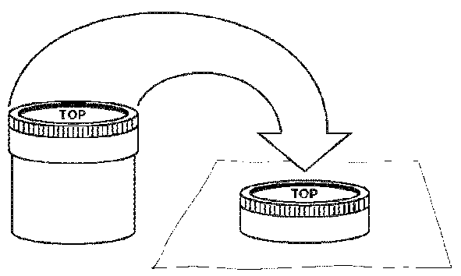
- For children who sit on the toilet: have the child spread their legs wide enough so you are able to hold the cup under them as they urinate without anything coming in contact with the inside of cup.
For boys who choose to stand over toilet: make sure the urine stream is directed into the cup without anything other than urine coming in contact with the inside of the cup.

- Instruct the child to urinate when they are ready.
- When the child begins to urinate, catch the urine in the urine collection container.
- After the child has finished urinating, put the lid back on the collection cup and wipe the outside of the cup with the paper towel provided.
- Return the collection cup to the data collector.
If you have any questions during the collection, please direct them to the data collector.

Thank you for providing this sample!

For Office Use Only:

Click here to insert Respondent ID.

Click here to insert child Participant ID.

Click here to insert ROC contact information.

