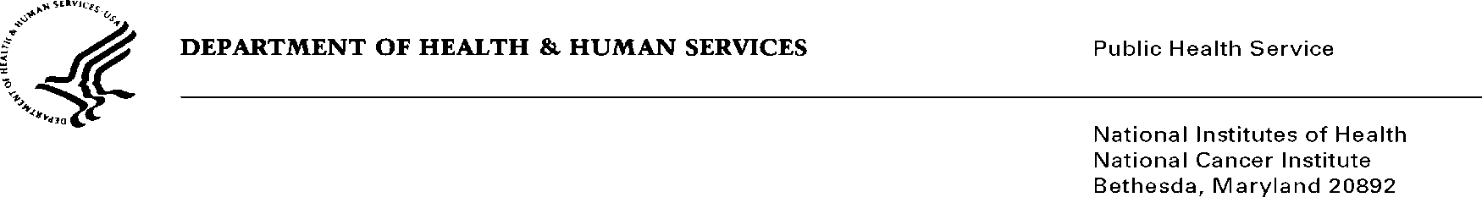

Date: December 31, 2013

TO: Office of Management and Budget (OMB)

Through: Keith Tucker, Reports Clearance Officer, HHS
Seleda Perryman, Report Clearance Officer, NIH
Vivian Horovitch-Kelley, PRA OMB Clearance Liaison, NCI

FROM: Irene Prabhu Das, Ph.D.
Outcomes Research Branch, Division of Cancer Control & Population Sciences
National Cancer Institute (NCI)/NIH

SUBJECT: New Submission of “Multidisciplinary Treatment Planning (MTP) within the
NCI Community Cancer Centers Program”

The survey project for OMB review, “Multidisciplinary Treatment Planning within the NCI Community Cancer Centers Program” is targeted toward hospitals currently participating in the NCI Community Cancer Centers Program (NCCCP).

The program is under some time constraint because the NCCCP as a program will end their sub-contractual relationship with the NCI on June 30, 2014. Data collection for this survey has been planned for eight weeks, with an additional twelve weeks to complete the planned analyses. In addition, we had planned to share preliminary results of the analyses with the NCCCP hospitals.

A timely review of the low-burden, simple survey by OMB is requested. Consideration of this request is greatly appreciated.

Should you have any additional questions, do not hesitate to contact me at 240-276-6799.

Sincerely,

Irene Prabhu

