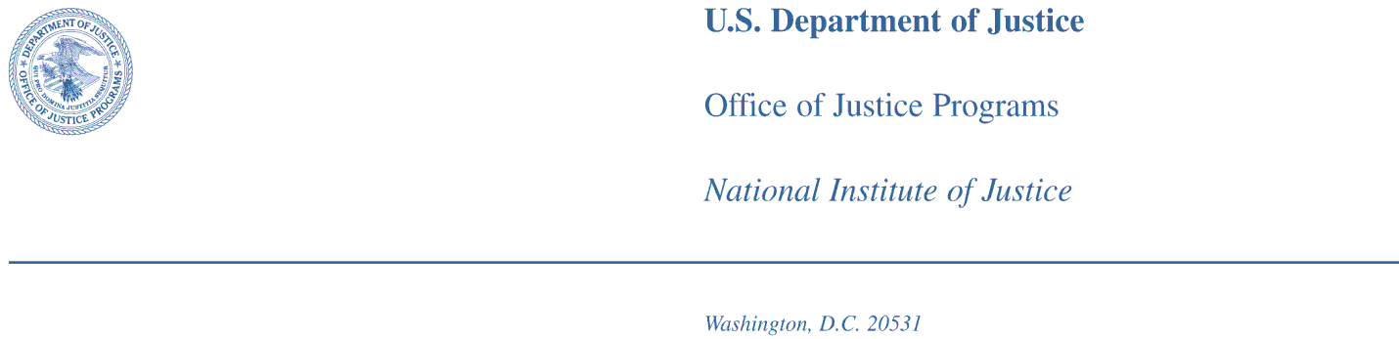

Dear Chief/Sheriff:

The National Institute of Justice (NIJ) respectfully requests your voluntary participation in the 2013 NIJ Geospatial Capabilities Survey it is conducting among the nation’s largest law enforcement agencies. The purpose of the survey is to determine the geospatial tools, techniques, and practices used by law enforcement agencies and the potential for expanded use of such capabilities. The results of the survey will help NIJ determine how best it can meet the needs and enhance the effectiveness of geospatial capabilities among crime analysts in law enforcement agencies through future technology development grants.
The responses on the completed questionnaire your agency submits will be made available by Originating Agency Identifier (ORI) on a publicly available database on the National Archive of Criminal Justice Data (NACJD) website through the Interuniversity Consortium for Political and Social Research (ICPSR) program at the University of Michigan (http://www.icpsr.umich.edu/icpsrweb/NACJD/).. We are seeking the best available information to use in improving our technological services to you and other law enforcement agencies.

You can download the electronic version of the survey questionnaire now by accessing the 2013 NIJ Geospatial Capabilities Survey webpage at the following link:
http://www.rand.org/nij-gcs
Access to Microsoft Excel 2007 or more recent for Windows computers (PC) or Microsoft Excel 2011 for Apple computers (Mac) is required to use the electronic version of the survey. If you do not have access to these versions, please contact the survey coordinator at Geospatial_Survey@rand.org.

Once the webpage displays, please enter the following login name and password to log in to the site. You will be asked to supply the official name of your law enforcement agency to download the Excel Workbook that contains the survey questionnaire.

Login name: NIJLEsurvey
Password: LZag2H9qc

We very much would like you to use the electronic form of the survey and return the completed survey by e-mail. However, if you prefer to complete a paper version, you will be mailed a hardcopy form with a business reply envelope in about two weeks.

The due date of the survey questionnaire is TBD date. Please return your completed survey by e-mail as an Excel file attachment to Geospatial_Survey@rand.org or mail the completed paper version in the business reply envelope by the due date.

The 2013 NIJ Geospatial Capabilities Survey is being conducted on behalf of NIJ by the National Law Enforcement and Corrections Technology Center (NLECTC) for Information and Geospatial Technologies, which is operated by The RAND Corporation. All future correspondence regarding this survey will come from The RAND Corporation. Please direct all questions or concerns to the following contact at The RAND Corporation:

Dr. Carolyn Wong
E-mail: Geospatial_Survey@rand.org
Telephone: 800 number TBD

Should you wish to decline our invitation to participate in the survey, please log in to the website above using the login name and password shown above to decline this invitation. Agencies who decline the invitation will not be mailed a hardcopy of the survey questionnaire. If your agency declines this invitation, but later decides to participate, you may do so by using the same log in information above and download the electronic version of the questionnaire. Your agency may also request a hardcopy of the questionnaire by sending an e-mail to Geospatial_Survey@rand.org. Completed questionnaires will be accepted through the TBD due date.

Thank you for your participation. We at NIJ look forward to using the survey results to better understand the needs and requirements of the nation’s law enforcement agencies.

Yours truly,

Chris Tillery
Office Director
Office of Science and Technology
National Institute of Justice

