Table of Contents

Federal Register Notice: *Submission of Data by State Educational Agencies;*

*Submission Dates for State Revenue and Expenditure Reports for Fiscal Year*

*(FY) 2011, Revisions to those Reports, and Revisions to prior Fiscal Year Reports* ii

Initial Cover Letter to Respondents vi

Submission letter vii

Crosswalk Letter viii

Closeout Letter ix

NPEFS FY11 Instruction Manual x

4000-01-U

DEPARTMENT OF EDUCATION

**Submission of Data by State Educational Agencies; Submission Dates for State Revenue and Expenditure Reports for Fiscal Year (FY) 2012, Revisions to Those Reports, and Revisions to Prior Fiscal Year Reports**

**AGENCY:** National Center for Education Statistics, Institute of Education Sciences, Department of Education.

**ACTION:** Notice.

**SUMMARY:** The Secretary announces dates for the submission by state educational agencies (SEAs) of expenditure and revenue data and average daily attendance statistics on ED Form 2447 (the National Public Education Financial Survey (NPEFS)) for FY 2012. The Secretary sets these dates to ensure that data are available to serve as the basis for timely distribution of Federal funds. The U.S. Census Bureau is the data collection agent for the National Center for Education Statistics (NCES). The data will be published by NCES and will be used by the Secretary in the calculation of allocations for FY 2014 appropriated funds.

**DATES:** SEAs can begin submitting data on Wednesday, January 30, 2013. The deadline for the final submission of all data, including any revisions to previously submitted data for FY 2011 and FY 2012, is Thursday, August 15, 2013. Any resubmissions of FY 2011 or FY 2012 data by SEAs in response to requests for clarification, reconciliation or other inquiries by NCES or the Census Bureau must be completed by Tuesday, September 3, 2013. All outstanding data issues must be reconciled or resolved by the SEAs, NCES, and the Census Bureau prior to September 3, 2013.

*Addresses and Submission Information:* SEAs may mail ED Form 2447 to: U.S. Census Bureau, ATTENTION: Governments Division, Washington, DC 20233-6800.

SEAs may submit data via the World Wide Web (“Web”) using the interactive survey form at: <http://surveys.nces.ed.gov/ccdnpefs>**.** The Web form includes a digital confirmation page where a pin number may be entered. A successful entry of the pin number serves as a signature by the authorizing official. A certification form also may be printed from the Web site, and signed by the authorizing official and mailed to the Governments Division of the Census Bureau, at the address listed in the previous paragraph. This signed form must be mailed within five business days of Web form data submission.

Alternatively, SEAs may hand-deliver submissions by August 15, 2013 at 4:00 p.m. (Eastern Time) to: Governments Division, U.S. Census Bureau, 4600 Silver Hill Road, Suitland, MD, 20746.

**FOR FURTHER INFORMATION CONTACT:** Mr. Stephen Q. Cornman, National Center for Education Statistics, Institute of Education Sciences, U.S. Department of Education. Telephone: (202)502-7338 or by email: [stephen.cornman@ed.gov](mailto:stephen.cornman@ed.gov); or Mr. Jumaane Young, NPEFS Project Manager, or an NPEFS team member (Census Bureau). Telephone: 1-800-437-4196 or (301) 763-1571 or email: [Govs.npefs.list@census.gov](mailto:Govs.npefs.list@census.gov). If you use a telecommunications device for the deaf (TDD) or a text telephone (TTY), call the Federal Relay Service (FRS), toll free, at 1-800-877-8339.

Individuals with disabilities may obtain this document in an accessible format (e.g., braille, large print, audiotape, or CD-ROM) on request to: Mr. Stephen Q. Cornman, National Center for Education Statistics, Institute of Education Sciences, U.S. Department of Education. Telephone: (202) 502-7338 or email: [stephen.cornman@ed.gov](mailto:stephen.cornman@ed.gov).

**SUPPLEMENTARY INFORMATION:** Under the authority of section 153(a)(1)(I) of the Education Sciences Reform Act of 2002, 20 U.S.C. 9543, which authorizes NCES to gather data on the financing of education, NCES collects data annually from SEAs through ED Form 2447. The report from SEAs includes attendance, revenue, and expenditure data from which NCES determines a State’s “average per-pupil expenditure” (SPPE) for elementary and secondary education, as defined in section 9101(2) of the Elementary and Secondary Education Act of 1965, as amended (ESEA) (20 U.S.C. 7801(2)).

In addition to using the SPPE data as general information on the financing of elementary and secondary education, the Secretary uses these data directly in calculating allocations for certain formula grant programs, including, but not limited to, Title I, Part A of the ESEA, Impact Aid, and Indian Education programs. Other programs, such as the Education for Homeless Children and Youth program under Title VII of the McKinney-Vento Homeless Assistance Act and the Teacher Quality State Grants program (Title II, Part A of the ESEA), make use of SPPE data indirectly because their formulas are based, in whole or in part, on State Title I, Part A allocations.

In January 2013, the Census Bureau, acting as the data collection agent for NCES, will email to SEAs ED Form 2447 with instructions and request that SEAs commence submitting FY 2012 data to the Census Bureau on Wednesday, January 30, 2013. SEAs are urged to submit accurate and complete data by Friday, March 15, 2013, to facilitate timely processing. Submissions by SEAs to the Census Bureau will be analyzed for accuracy and returned to each SEA for verification. All data, including any revisions to FY 2011 and FY 2012 data, must be submitted to the Census Bureau by an SEA not later than Thursday, August 15, 2013. Any resubmissions of FY 2011 or FY 2012 data by SEAs in response to requests for clarification, reconciliation or other inquiries by NCES or the Census Bureau must be completed by Tuesday, September 3, 2013. Between August 15, 2013 and September 3, 2013, States may also, on their own initiative, resubmit data to resolve data issues not addressed in their final submission of NPEFS data by August 15, 2013. All outstanding data issues must be reconciled or resolved by the SEAs, NCES, and the Census Bureau prior to September 3, 2013.

In order to facilitate timely submission of data, the Census Bureau will send reminder notices to SEAs in June and July of 2013.

Having accurate and consistent information on time is critical to an efficient and fair allocation process and to the NCES statistical process. To ensure timely distribution of Federal education funds based on the best, most accurate data available, NCES establishes, for program funding allocation purposes, Thursday, August 15, 2013, as the final date by which the NPEFS Web form or ED Form 2447 must be submitted. Any resubmissions of FY 2011 or FY 2012 data by SEAs in response to requests for clarification or reconciliation, or other inquiries, by NCES or the Census Bureau must be completed through the NPEFS Web form or ED Form 2447 by Tuesday, September 3, 2013. If an SEA submits revised data after the final deadline that result in a lower SPPE figure, its allocations may be adjusted downward or the Department may direct the SEA to return funds. SEAs should be aware that all of these data are subject to audit and that, if any inaccuracies are discovered in the audit process, the Department may seek recovery of overpayments for the applicable programs.

**Note**: The following are important dates in the data collection process for FY 2012:

|  |  |
| --- | --- |
| January 30, 2013 | SEAs can begin to submit accurate and complete data for FY 2011 and FY 2012. |
| March 15, 2013 | SEAs are urged to submit accurate and complete data for FY 2011 and FY 2012. |
| August 15, 2013 | Mandatory final submission date for FY 2011 and FY 2012 data to be used for program funding allocation purposes. |
| September 3, 2013 | Response by SEA’s to requests for clarification, reconciliation or other inquiries by NCES or the Census Bureau. All data issues to be resolved. |

If an SEA’s submission is received by the Census Bureau after August 15, 2013, the SEA must show one of the following as proof that the submission was mailed on or before that date:

1. A legibly dated U.S. Postal Service postmark.

2. A legible mail receipt with the date of mailing stamped by the U.S. Postal Service.

3. A dated shipping label, invoice, or receipt from a commercial carrier.

4. Any other proof of mailing acceptable to the Secretary.

If the SEA mails ED Form 2447 through the U.S. Postal Service, the Secretary does not accept either of the following as proof of mailing:

1. A private metered postmark.

2. A mail receipt that is not dated by the U.S. Postal Service.

**Note:** The U.S. Postal Service does not uniformly provide a dated postmark. Before relying on this method, an SEA should check with its local post office.

*Electronic Access to This Document*: The official version of this document is the document published in the **Federal Register**. Free Internet access to the official edition of the **Federal Register** and the Code of Federal Regulations is available via the Federal Digital System at: www.gpo.gov/fdsys. At this site you can view this document, as well as all other documents of this Department published in the **Federal Register**,in text or Adobe Portable Document Format (PDF). To use PDF you must have Adobe Acrobat Reader, which is available free at this site.

You may also access documents of the Department published in the **Federal Register** by using the article search feature at: www.federalregister.gov. Specifically, through the advanced search feature at this site, you can limit your search to documents published by the Department.

**Authority**: 20 U.S.C. 9543.

Dated:

**John Q. Easton**,

*Director, Institute of Education Sciences*.

Initial cover letter to respondents



Date

State Contact

State Address

Dear _________:

The National Center for Education Statistics (NCES) requests your state’s continued participation in the Fiscal Year 2010 National Public Education Financial Survey (NPEFS). The U.S. Census Bureau will once again act as the collection agency on behalf of NCES. Your participation in this voluntary survey is important as the data are used to allocate federal funds for education. In addition, the data are widely published as the official data on revenues and expenditures for public education in your state.

We have several methods for you to use to report your survey data. Most of our respondents use the Internet reporting option and we encourage you to utilize this time and cost saving alternative. As a part of the Internet application, we also offer the crosswalk software. All crosswalk users may upload their table files on line. Each Crosswalk state that logs into the application will be immediately directed to the Crosswalk section of the application to begin the processing of your state’s files.

You may access the NPEFS questionnaire at http://suveys.nces.ed.gov/ccdNPEFS/. We have enclosed your new username and password, along with general instructions for accessing the Internet application. Note that detailed instructions for using the Internet application can also be found in Appendix A of the on-line instruction manual. You may contact our office at the numbers given below if you would like a hard copy of the NPEFS questionnaire and instruction manual. Crosswalk users will also find specific Crosswalk information and detailed instructions in a manual, also on-line.

Survey replies and data plans should be submitted directly to the Census Bureau by March 15, 2011. To request an extension, please contact the NPEFS staff at the U.S. Census Bureau, at 1(800) 437-4196 or (301) 763-1571. Please note that data submissions received after August 15, 2012 cannot be accepted for purposes of federal program allocations. Any resubmissions of FY 2010 or FY 2011 data by SEAs in response to requests for clarification, reconciliation or other inquiries by NCES or the Census Bureau must be completed by Tuesday, September 4, 2012. All outstanding data issues must be reconciled and/or resolved by the SEAs, NCES, and the Census Bureau prior to September 4, 2012. The Census Bureau address for Federal Express mailing, survey contact names, telephone numbers, and e-mail addresses are all located in the survey contact section of the instruction manual.

Sincerely yours,

Stephen Q. Cornman

Project Director











**NATIONAL CENTER FOR EDUCATION STATISTICS**

**February 2011**

**The National Public Education Financial Survey Instruction**

**FY 2011 Instruction Booklet**

**U.S. Department of Education**

**Institute of Education Sciences**

#### U.S. Department of Education

Arne Duncan

Secretary

#### Institute of Education Sciences

John Q. Easton

Director

#### National Center for Education Statistics

Jack Buckley

Commissioner

#### Elementary/Secondary and Libraries Studies Division

Jeffrey Owings

Associate Commissioner

**Elementary/Secondary Cooperative System and Institutional Studies Program**

Marie Stetser

Program Director

The National Center for Education Statistics (NCES) is the primary federal entity for collecting, analyzing, and reporting data related to education in the United States and other nations. It fulfills a congressional mandate to collect, collate, analyze, and report full and complete statistics on the condition of education in the United States; conduct and publish reports and specialized analyses of the meaning and significance of such statistics; assist state and local education agencies in improving their statistical systems; and review and report on education activities in foreign countries.

January 2012

Contact:

Stephen Q. Cornman

NCES

(202) 502-7338

[stephen.cornman@ed.gov](mailto:frank.johnson@ed.gov)

NPEFS Staff

U.S. Census Bureau

(301) 763-1571

1 (800) 437-4196

[Govs.NPEFS.List@census.gov](mailto:Govs.NPEFS.List@census.gov)

**TABLE OF CONTENTS**

OVERVIEW 1

HOW FISCAL DATA ARE USED 1

Federal Grants 1

Other Uses of NPEFS Data 2

Publications 2

U.S. CENSUS BUREAU 3

Figure 1: Responsibilities of NCES and Census 3

Data Collection 4

Fiscal Crosswalk Project 4

Fiscal Data Plan 4

STEPS IN DATA COLLECTION CYCLE 5

NPEFS Schedule FY 2010 6

Figure 2. NPEFS Schedule 6

Survey Contacts 6

HOW TO SUBMIT FISCAL DATA 8

Instructions for Electronic Data Submissions 8

Submitting Crosswalk Data 8

Instructions for Mail Submissions 8

Instructions for Prior Year Data Submissions 9

Record Keeping Requirements 9

DATA PREPARATION, COLLECTION, REVIEW, AND SUBMISSION 10

Fiscal Respondent Preparation Prior to Data Collection 10

PREPARING AND SUBMITTING COMPARABLE DATA 11

The Importance of Submitting Comparable Data 11

Ensuring Comparability of Submitted Data During Data Collection 12

Figure 3. Criteria for Distinguishing Supplies from Equipment 16

Completing the National Public Education Financial Survey 19

Data Review Prior to Submitting the NPEFS Survey 22

NCES Response 23

OTHER CONSIDERATIONS 24

Federal Program Classifications 24

Initiatives and Programs 24

Universal Service Fund Schools and Libraries Program 24

Charter Schools 26

NCES Support for Fiscal Respondents 27

PUBLIC ELEMENTARY AND SECONDARY EDUCATION REVENUES FROM ALL SOURCES 27

Discussion of Revenues 27

I. REVENUE FROM LOCAL SOURCES (1000) 29

Definition 29

Details for Revenue from Local Sources 30

II. REVENUE FROM INTERMEDIATE SOURCES (2000) 33

Definition 33

Details for Revenue from Intermediate Sources 33

III. REVENUE FROM STATE SOURCES (3000) 34

Definition 34

Details for Revenue from State Sources 34

IV. REVENUE FROM FEDERAL SOURCES (4000) 35

Definition 35

Details for Revenue from Federal Sources 35

V. OTHER SOURCES OF REVENUE (5000) 36

PUBLIC ELEMENTARY AND SECONDARY EDUCATION EXPENDITURES 37

Distinguishing Between Current and Total Expenditures 37

Programs Included in Current and Total Expenditures 38

Expenditure Categories Included in NPEFS Survey 40

I. INSTRUCTION (1000) 44

II. SUPPORT SERVICES (2000) 47

Support Services—Students (2100) 49

Support Services – Instruction (2200) 50

Support Services – General Administration (2300) 51

Activities 52

Support Services – School Administration (2400) 53

Support Services – Operation and Maintenance (2600) 54

Support Services – Student Transportation (2700) 55

Support Services – Other (2500, 2900) 56

Central Support Services (2500) 57

Other Support Services (2900) 58

III. OPERATION OF NON-INSTRUCTIONAL SERVICES (3000) 59

Food Services Operations (3100) 59

Enterprise Operations (3200) 60

IV. DIRECT PROGRAM SUPPORT 62

Introduction 62

Expenditure Details for Direct Program Support 63

V. CURRENT EXPENDITURES 64

VI. FACILITIES ACQUISITION AND CONSTRUCTION SERVICES (4000) 64

Introduction 65

Expenditure Details for Facilities Acquisition and Construction Services 65

VII. OTHER USES (5000) 67

Introduction 67

Expenditure Details for Other Uses 67

VIII. COMMUNITY SERVICES (3300) 68

Introduction 68

Expenditure Details for Community Services 68

IX. DIRECT COST PROGRAMS 69

Introduction 69

Expenditure Details for Direct Cost Programs 70

X. PROPERTY (700) 71

XI. TOTAL EXPENDITURES 71

XII. EXCLUSIONS FROM CURRENT EXPENDITURES FOR PURPOSES OF DETERMINING SPPE 72

Items excluded 73

Transferability under NCLB 74

Consolidating funds under ESEA 76

XIII. NET CURRENT EXPENDITURES 77

XIV. AVERAGE DAILY ATTENDANCE (ADA) 77

Average Daily Attendance 78

Current Expenditures and Average Daily Attendance 78

ADA – State Law 78

ADA – NCES Definition 79

XV. CALCULATION OF SPPE 81

American Recovery and Reinvestment Act of 2009 (ARRA) 82

ARRA and the Crosswalk 87

Prior Year Data Corrections 88

**TABLE OF FIGURES AND APPENDICES**

**TABLE OF FIGURES**

Figure 1: Responsibilities of NCES and Census…………………………………….……3

Figure 2. NPEF Schedule FY 2010 Data Collection…………….……………….….……6

Figure 3. Criteria for Distinguishing Supplies from Equipment…………………….…..16

Figure 4: Programs Included in Total Expenditures…………………………….……….39

Figure 5: Examples of Calculation of Average Daily Attendance (ADA) ……….……..80

Figure 6: Calculation of State Per Pupil Expenditures (SPPE)…………………….…….81

**APPENDICES**

Appendix A: Internet Data Collection for the NPEFS Survey…………….…….………86

Appendix B: National Center for Education Statistics Internet Site……………..….….102

Appendix C: Governmental Accounting Reference Materials………………………….105

##### THE NATIONAL PUBLIC EDUCATION FINANCIAL SURVEY

# OVERVIEW

The **National Public Education Financial Survey (NPEFS)** is a key component of the U.S. Department of Education's Common Core of Data (CCD), the annual collection of basic information about the nation’s public elementary and secondary schools. The CCD consists of six surveys: The School Universe Survey, Local Education Agency Universe Survey, Local Education Agency Finance Survey (F-33), State Non-fiscal Survey, Teacher Compensation Survey, and the National Public Education Financial Survey (NPEFS).

NPEFS collects school finance data derived from administrative and fiscal records from the 50 state education agencies (SEAs), the District of Columbia, and five outlying areas under U.S. jurisdiction: American Samoa, Northern Marianas, Guam, Puerto Rico, and the Virgin Islands.

# HOW FISCAL DATA ARE USED

## Federal Grants

Data from the NPEFS survey are used to calculate a State Per Pupil Expenditure (SPPE) that is used in the formula for allocating a number of federal program funds to states and school districts, including:

1. Title I (College and Career Ready Students) of the Elementary and Secondary Education Act (ESEA) of 1965 as amended by the No Child Left Behind Act of 2001;

2. Impact Aid; and

3. Indian Education.

Other programs make use of SPPE data indirectly because their allocation formulas are based, in whole or in part, on State Title I allocations. These include:

1. Educational Technology State Grants (Title II, Part D);
2. Education for Homeless Children and Youth Program under Title VI of the Stewart B. McKinney Homeless Assistance Act;
3. Teacher Quality State Grants Program (Title II, Part A); and
4. Safe and Drug-Free Schools and Communities Programs.

The data are used to determine grant allocations. State fiscal submissions and records may be audited by the Office of the Inspector General of the U.S. Department of Education, as well as authorized representatives of the Comptroller General of the United States. The Single Audit Act of 1984 requires that non-federal auditors and the U.S. General Accounting Office may conduct audits.

Please see the section in this manual entitled, “NCES Response,” for a discussion of overpayments of allocations and the recovery of funds.

## Other Uses of NPEFS Data

NPEFS data are used by state and local officials, researchers and journalists to generate and compare state rankings in various categories of revenues and expenditures. They can also use the information in the Local Education Agency survey for information on school district finances by state. Researchers and private education trade groups also make use of the data supplied by NPEFS for papers, briefings, and background for presentations to private and public entities.

## Publications

NCES publishes fiscal data reported by states in many different types of publications, ranging from the First Look series (tabular displays of fiscal data) to the annual Digest of Education Statistics. The most recent NPEFS First Look Publication TAB is Revenues and Expenditures for Public Elementary and Secondary Education: School Year 2007-08 (Fiscal Year 2008).

Other NCES publications include the 2009 Digest of Education Statistics and State Profiles of Public Elementary and Secondary Education. All NCES publications are available on-line at http://nces.ed.gov/ and hard copies of most NCES publications can be obtained for free by calling ED PUBS toll free at 1 (877) 433-7827.

# U.S. CENSUS BUREAU

The Census Bureau is the collection agent for NPEFS. All survey data are collected by the Census Bureau and analyzed and edited before being sent to NCES. The relationship between the two agencies and responsibilities for the various aspects of collecting and publishing the data are illustrated below.

# Figure 1: Responsibilities of NCES and Census

|  |  |  |
| --- | --- | --- |
| **NCES** |  | **CENSUS** |
| * Sets all parameters and controls for NPEFS data collection; * Coordinates and publishes Federal Accounting Handbook; * Finalizes all scheduling; * Resolves all subject-matter and data issues; * Sets up all training sessions, workshops, and conferences; * Prepares data for Title I office; * Publishes and disseminates final data for all CCD surveys. |  | * Collects data and maintains all databases; * Edits and analyzes data; * Sets-up and maintains all survey instruments including Internet site; * Maintains all aspects of crosswalk applications; * Participates in respondent training and conferences;      * Maintains and runs imputation program; * Provides final data set of NPEFS data to NCES; * Coordinates and publishes   CCD Fiscal newsletter. |

## Data Collection

The Census Bureau collects NPEFS data several ways:

1. Internet application
2. Hard copy (mailed or hand–delivered)
3. Other electronic file
4. The Crosswalk application output (described below)

## Fiscal Crosswalk Project

As part of the NPEFS survey, NCES funds the “Crosswalk Project.” This project creates a computer program that crosswalks data from a state’s format to the NPEFS survey administered by the Census Bureau. Participation in the Crosswalk Project is voluntary.

Through this project, an extensive study is made of the participating state’s accounting and reporting systems. A program for translating the data from the state’s system to the NPEFS survey is then developed with assistance and review by the state’s data coordinator. Detailed fiscal data from the state is then entered into the program, which combines or disaggregates the data as necessary to meet NPEFS requirements.

This process has identified difficulties the states are likely to encounter in attempting to report fiscal data in accordance with NCES standards. The Crosswalk Project has enabled NCES to tailor training to individual states and to develop a protocol for state fiscal coordinators to use in responding to the survey.

Since FY 2007, the Crosswalk software has been incorporated into the NPEFS Web application. The Crosswalk is now web-based (as opposed to downloadable) software that allows respondents to process their state account code data online within the NPEFS application. For detailed information on the new Crosswalk application or to become a new Crosswalk user, please contact Census staff.

## Fiscal Data Plan

The fiscal data plan is a brief survey that is completed online by each state. These questions help the Census Bureau and NCES to properly analyze each state’s data submission. The fiscal data plan:

1. Requests information about each state’s chart of accounts;
2. Catalogs each states response to questions raised about subject-matter areas, e.g., grants, change in reporting due to GASB statements; and
3. Gathers information about new initiatives that affect elementary-secondary fiscal reporting, e.g., school choice and charter schools.

# STEPS IN DATA COLLECTION CYCLE

The data collection cycle begins with the issuance of the Federal Register Notice. This notice can be found on the Internet at: <http://www.ed.gov/news/fedregister/index.html>.

* The Federal Register Notice outlines the authority for collecting this survey’s data and also lists the survey deadlines, submission methods, and contact information for NPEFS survey staff.
* Census staff sends out a letter to all fiscal respondents. The letter includes the survey opening and closing dates and asks whether there are any states that wish to have their data “translated” using the crosswalk application.
* Census mails out the survey package to all states and territories concurrent with the availability of the Internet site.
* States can access the NPEFS website on January 31, 2012.
* The first deadline for NPEFS submission is **March 15th** or as soon as possible thereafter.
* The last day for original submissions of NPEFS data is August 15, 2012. This is also the last day to report revisions to the prior year’s fiscal data.
* Any resubmissions of FY 2010 or FY 2011 data by SEAs in response to requests for clarification, reconciliation or other inquiries by NCES or the Census Bureau must be completed by Tuesday, September 4, 2012. All outstanding data issues must be reconciled and/or resolved by the SEAs, NCES, and the Census Bureau prior to September 4, 2012.
* All reported data are reviewed and respondents queried about data anomalies.
* A reported data file for the prior year containing all the state and territory is forwarded to NCES for their review.
* The imputation program is run on all state’s data that do not report on standard, or have missing or combined new data.
* The states review and concur with the imputed data for their state via e-mail.
* NCES gives final review and concurrence on the entire data set.
* The data is forwarded to the Title I office of the Department of Education.

* Key data items are published by NCES in the “First Look” report and the complete data file is released on the NCES website.
* This process is repeated with the current year data sets.

## NPEFS Schedule FY 2011

The schedule for the NPEFS data collection cycle for Fiscal Year 2011 is in Figure 2.

# Figure 2. NPEFS Schedule

|  |  |
| --- | --- |
| NPEFS Schedule **FY 2011 Data Collection** | |
| November 2011 | Request for new crosswalk states |
| February 15-17, 2012 | Management Information Systems Conference |
| January 31, 2012 | NPEFS Officially Opens  - Mail out survey letters  - Survey and Fiscal Data Plan available on-line |
| March 15, 2012 | NPEFS Submission Initial Due Date |
| March – September 2012 | Editing and analysis of NPEFS Data |
| April 2012 | Non-response follow-up #1 |
| June 2012 | Non-response follow-up #2 |
| July 2012 | Summer Data Conference and Forum  - CCD Awards |
| Late July 2012 | Non-response follow-up #3  - Chief State School Officer non-response letter |
| August 15, 2012 | - Last Day to submit FY 2011 NPEFS Data  - Last Day to submit FY 2010 “One Year Later”  revised NPEFS Data |
| September 4, 2012 | Response by SEA’s to response to requests for clarification, reconciliation or other inquiries by NCES or the Census Bureau. All data issues to be resolved. |
| November2012 | Imputed data on NPEFS website for review |
| December 2012 | NCES final review and concurrence |
| January 2013 | Final data to Department of Education Office of Elementary and Secondary Education (OESE) |

## 

## Survey Contacts

NCES

If you wish to address questions to the NCES Project Director, you may contact him at the listing below:

Stephen Cornman

National Center for Education Statistics

CCD School Finance Surveys

1990 K Street, N.W.

Suite 9104

Washington, D.C. 20006-5651

Telephone: (202) 502-7338

Fax: (202) 502-7490

Email: Stephen.cornman@ed.gov

Census

Respondents should contact the NPEFS team at the Census Bureau with questions regarding proper procedures for completing the survey form (Telephone: 1(800) 437-4196, (301) 763-1571, FAX: (877) 574-6549 and e-mail [govs.npefs.list@census.gov](mailto:govs.npefs.list@census.gov)). The NPEFS staff consists of the following and may be reached at the phone number and fax number above:

Jumaane. N. Young: NPEFS Project Manager

Jumaane.N.Young@census.gov

Mary M. Church: Crosswalk Coordinator/Edit Programs/Survey Analyst

[Mary.M.Church@census.gov](mailto:Mary.M.Church@census.gov)

Janean M. Darden: Crosswalk/Survey Analyst

[Janean.Darden@census.gov](mailto:Janean.Darden@census.gov)

Shannon Doyle: Crosswalk/Survey Analyst

Shannon.Doyle@census.gov

Kenneth Herrell: Survey Analyst

Kenneth. Herrell@census.gov

State CCD Coordinators

Every state education agency has a CCD coordinator who acts as a liaison between NCES and the state education agency (SEA) who facilitates NCES data requests. To obtain the name of the CCD coordinator for your state, contact your state department of education or visit the CCD web site list of coordinators at: <http://nces.ed.gov/ccd/ccMembersFis.asp>.

# HOW TO SUBMIT FISCAL DATA

The NPEFS data (used for federal program allocations) must be submitted by 4 p.m. Eastern Standard Time on the Wednesday, August 15, 2012. The data may be submitted over the web or by mail.

NPEFS survey data is collected in several formats. You may mail a hard copy of the survey to the address listed below, or you may send in your survey data using one of the electronic formats made available through the Internet site. You may also submit NPEFS data by CD.

## Instructions for Electronic Data Submissions

The URL for the Internet site is: <http://surveys.nces.ed.gov/ccdnpefs>.

Complete instructions for electronic data submissions are in Appendix A.

## Submitting Crosswalk Data

Instructions for the electronic processing and submission of NPEFS crosswalk data can be found online in the **Crosswalk User’s Guide**. This guide is available to all states that are participating in the crosswalk program for FY 2011.

## Instructions for Mail Submissions

Regular mail submissions of the survey form must be postmarked by midnight August 15, 2012. Survey forms sent by express mail must be postmarked by midnight **August 15, 2012**. An SEA must show one of the following as proof of mailing:

1. A legible U.S. Postal Service dated postmark.
2. A legible mail receipt with the date of mailing stamped by the U.S. Postal Service.
3. A dated shipping label, invoice, or receipt from a commercial carrier.
4. Any other proof of mailing acceptable to the Secretary of the U.S. Department of Education.

If the survey form is mailed through the U.S. Postal Service, the Secretary does **not** accept either of the following as proof of mailing:

1. A private metered postmark.
2. A mail receipt that is not dated by the U.S. Postal Service.

Address: Mail the survey form to:

U.S. Census Bureau

Ms. Rosa Lindsey

ATTN: Governments Division

Washington, DC 20233-6800.

The address for FEDEX or U.P.S. or hand delivery is:

U. S. Census Bureau

Government Division

4600 Silver Hill Road

Suitland, Maryland 20746–6800

## Instructions for Prior Year Data Submissions

For federal allocation purposes, NCES will only accept changes to fiscal data from SEAs for up to one year after the August 15th deadline. The revised data will go through the same edit process and will be published as final data about 18 months after the August 15th closeout. NCES will accept all changes to data for publication purposes. Changes or revisions must be received within one year of the closing date. Revisions that result in a decrease in SPPE will be forwarded to the Title I office. **Please read “What’s New for FY 2011?” to learn more about prior year data submissions.**

## Record Keeping Requirements

Retain Documentation of Survey Preparation

Each state education agency must retain copies of completed fiscal survey forms and all documentation on the preparation of SPPE data for at least five years (as required by the U.S. Department of Education's regulations at 34 CFR 80.42). This documentation includes all finance and program records, supporting documents (such as worksheets and spreadsheets), statistical records, SEA publications, internal guidelines and control document, and any other records that are pertinent to program regulations or grant agreements.

For example, the FY 2011 survey (for the 2010-2011 school year) should be retained in state education agency archives until January 1, 2016.

Documentation Requirements

Documentation on the preparation of the fiscal survey should include the following information:

1. Name and title of the person who calculated the totals on the fiscal survey and his or her title;
2. The Department of Education reports used to obtain the aggregate numbers;

1. A list of the LEAs and other agencies (e.g., schools for the deaf) included or excluded from the calculations;
2. The item detail (spreadsheets) that resulted in each subtotal and total; and
3. Documentation for the average daily attendance calculation.

Working Files - Internal Guidelines

NCES strongly recommends that each SEA maintain spreadsheets, databases, or other working files of fiscal data each year. State education agencies should also develop guidelines and controls for the preparation of the fiscal survey. Establishing internal guidelines and controls is important because they provide continuity when staff assignments change and different individuals work on the survey.

***Designation of Authorized State Official***

The written memo designating the “authorized state official” who certified the accuracy of the fiscal submission also must be retained. Federal auditors from the Office of the Inspector General and nonfederal auditors frequently review fiscal survey submissions three to five years after they are submitted to NCES.

# DATA PREPARATION, COLLECTION, REVIEW, AND SUBMISSION

## Fiscal Respondent Preparation Prior to Data Collection

* **Obtain a copy of the Accounting Handbook.** NCES requires all SEA staff that respond to the fiscal survey to adhere to the definitions and classifications in the NCES accounting handbook, [Financial Accounting for Local and State School Systems, 2009 Edition](http://nces.ed.gov/pubsearch/pubsinfo.asp?pubid=2009325) (the “2009 Handbook”). States may order a free copy of the handbook from ED PUBS by calling 1(877) 433-7827. The publication number for the 2009 Handbook is 2009-325. The handbook is also available on line at: [http://nces.ed.gov/pubsearch/pubsinfo.asp?](http://nces.ed.gov/pubsearch/pubsinfo.asp?pubid=2009325) . The NCES web site also has a tool for finding account codes by number or alphabetically by the account code descriptor at <http://nces.ed.gov/pubs2009/fin%5Facct/codefinder.asp>.

Although many states use accounting handbooks that differ from the 2009 Handbook, all states should complete the fiscal survey in accordance with the NCES handbook. In order to do this, some SEAs may have to disaggregate data reported by their LEAs and recombine the data to fit the categories specified in the 2009 Handbook. NCES questions survey responses that do not appear to conform to the generally accepted accounting principles and the 2009 Handbook specifications.

**GAAFR.** NCES also encourages fiscal survey respondents to become familiar with the Government Finance Officers Association (GFOA) publication, “Governmental Accounting, Auditing, and Financial Reporting, 2005 (GAAFR).” This document has gained widespread acceptance as an authoritative statement on the application of generally accepted accounting principles (GAAP) for state and local government.

Appendix C provides information on obtaining these publications by mail or on-line.

* **Obtain copies of your state’s chart of accounts** and a copy of any instructions given to LEAs on reporting revenue and expenditure data to the SEA. Compare the state reporting requirements with those in the 2009 Handbook and determine where they are different.
* **Obtain copies of fiscal surveys submitted previously by your state.** Try to obtain information about the steps taken to complete the survey in the past and about state guidelines or control documents that can assist you. Obtain information about special-purpose districts whose finances should be included in the survey and about expenditures by other agencies for, or on behalf of, LEAs that may not be included in LEA fiscal reports to the SEA.

# PREPARING AND SUBMITTING COMPARABLE DATA

## The Importance of Submitting Comparable Data

Data submitted by each state and territory in the NPEFS survey must be comparable between the states. The reasons comparable fiscal data are essential include:

* Federal education program offices require comparable fiscal data for determining funding allocations to state and local education agencies. The multiple uses of fiscal data and the wide audience for publications that use the data require that SEA staff use the utmost care in responding to the fiscal survey.
* Statistics from the financial survey are widely compared and analyzed to identify issues and trends in public elementary-secondary school finance and to assess the relative condition of school finance in each state.
* State policy analysts and school finance researchers compare states on the basis of the reported data.
* State-by-state comparisons appear in NCES publications and other U.S. Department of Education publications.

## Ensuring Comparability of Submitted Data During Data Collection

Survey respondents can take the following steps to ensure that the fiscal data they submit to NCES are comparable to data submitted by other states.

**Step One: Use the correct fiscal year.**

Standard Fiscal Year

This year, we are collecting data for Fiscal Year 2011. For the purpose of this report, the fiscal year is the 12-month period beginning **July 1** and ending **June 30**. Some states and LEAs use other fiscal years.

Non-standard Fiscal Year

If your state is among those that use a different fiscal year, it is essential to point this out to the Census Bureau staff in a cover letter, e-mail, or “comments” section of the Internet form when submitting the survey.

For example, if a state’s 2011 fiscal year ends between July 1, 2010, and June 30, 2011 (e.g., December 31, 2010), the state need only inform Census in a cover letter of the fiscal year being reported (with exact dates). However, if the 2011 fiscal year ends after June 30, 2011 (e.g., August 31, 2011), the state should report revenues and expenditures as of the end of its fiscal year (in this example, August 31, 2011) and inform Census in a cover letter that it has done so. Fiscal data from states whose fiscal year end after June 30 of the reported fiscal year will be footnoted in NCES publications.

Step Two: Separate reporting for traditional and non-traditional prekindergarten-through grade-12 public education programs.

Co-curricular pre-K-12 education programs

The NPEFS survey collects data on both public elementary-secondary education programs and other programs funded by local school districts; however, only public elementary-secondary education program expenditures should be reported under the instruction, support services, and non-instructional services sections of the survey. Examples of public elementary-secondary education programs are:

* Pre-kindergarten (programs from birth to kindergarten)
* Head Start (if funded by school districts)
* Special and vocational education
* Summer school (even when students pay tuition to attend)
* Food Services
* Co-curricular activities
* ROTC
* Safety and driver education

Other programs

Programs outside of public elementary-secondary education should be reported under community services and direct cost programs as appropriate. Only revenues and expenditures of local education agencies (school districts) and those state government expenditures that go toward the operation of state schools should be reported on NPEFS. State direct support for and on behalf of school districts should be considered LEA expenditures for NPEFS reporting purposes. Expenditures for operating the state education agency should not be included in NPEFS. Examples of other programs are:

* School construction
* Day care
* Head Start (if privately funded)
* Adult education
* Continuing education
* Community/junior college
* Community service programs
* School district support for private education

Some states use public funds for programs that benefit both public and private school students (e.g., transporting private school students on public school buses). Expenditures for private school students should be reported on the survey in Part IV. Direct Program Support for Private School Students or in Part IX. Direct Cost Programs. Instructions for reporting the above nontraditional programs are more fully explained in later sections of this manual.

Step Three: Differentiate between Current Expenditures and Total Expenditures.

Exclude capital outlay and debt service

Current expenditures exclude capital outlay and debt service. The GAAFR defines capital outlays as expenditures resulting in the acquisition of or addition to the government's general fixed assets. Fixed assets are defined as “long-lived tangible assets obtained or controlled as a result of past transactions, events or circumstances” – including buildings, equipment, other improvements, and land.

Private sector accounting for fixed assets

In the private sector, fixed assets are often referred to as property, plant and equipment. The 2009 Handbook specifically excludes initial, additional, or replacement purchases of machinery and equipment (tools, trucks, cars, school buses, furniture, and furnishings) from current expenditures. This treatment of current expenditures may differ from state accounting practices and may make it necessary to make adjustments to current expenditures when responding to the fiscal survey.

Total expenditures include capital outlay and expenditures for programs that are outside of public elementary and secondary education. This category includes expenditures for the “other programs” as listed above.

Step Four: Distinguish between Supplies and Equipment.

Distinguishing between supplies and equipment is crucial to accurately reporting expenditures on the National Public Education Financial Survey. The 2009 Handbook specifies that purchases of supplies are considered current expenditures while equipment purchases are property expenditures. Property expenditures are included in total expenditures but not in current expenditures. Although state practices vary greatly on this subject, it is essential to adhere to the guidelines contained in the 2009 Handbook and this Instruction Booklet when responding to the fiscal survey. The decision tree is below in Figure 3, and on page E-5 (page 210 on the pdf file) of the 2009 Handbook.

The distinction between supplies and equipment is very important. The reasons are as follows:

* Different accounting procedures are required for supplies and equipment.
* Insurance requirements may also differ for supplies and equipment.
* Some types of funds can only be used to purchase certain items; for example, some funds cannot be used to purchase equipment, and others may not be used to purchase supplies.

This distinction also affects comparisons of state per pupil expenditures and federal funding allocations to LEAs, which usually are based on current expenditures rather than total expenditures. Recall that supplies (600) fall within current expenditures while equipment is considered property (700), and property is excluded from current expenditures.

Criteria

NCES has developed a “decision tree” diagram (Figure 3, page 16) with five criteria for distinguishing between equipment and supplies (also in the 2009 Handbook, p. E-5 (page 210 on the pdf file)). An item is measured against each of the criteria, starting at the top of the decision tree. At the first “no,” the item is designated a supply. Only if the item meets all five criteria is it considered equipment.

The **decision tree** has a bias toward classification of items as supplies rather than equipment because of the long-term responsibilities that are assumed for an item identified as equipment. Unlike supplies, equipment must be inventoried each year of its useful life. Other accounting requirements for equipment include general fixed assets, subsidiary accession ledgers, tagging, and reconciliation of book balance to inventory.

Classifying items

By way of example, let us classify two items, a new personal computer and a flash drive. The computer is likely to meet the first criterion – “lasts more than one year.” But let us suppose that the computer begins to malfunction before a year is over. In most cases the computer would be repaired not replaced. Thus, the computer meets the second criterion – “repair rather than replace.” The process continues for the remaining criteria: Is it an independent unit? Is the cost of tagging and inventory a small percent of item cost? Did the cost exceed minimum dollar value for equipment established by state or other government unit? Finally, after there is a “yes” answer to all five criteria, the computer would be designated as equipment.

Now let us consider a flash drive. Although a flash drive might last for more than a year, when used up, it would be replaced not repaired. Thus, the response would be “no” to the second criterion, and the item would be declared a supply. Although it is not necessary to continue down the list, many of the criteria support the classification of diskettes as supplies rather than equipment. Flash drives are not independent units. Nor would the cost of keeping inventory on them represent a small percentage of the item cost. All of these criteria strengthen the classification of flash drives as supplies.

Final Determination for classification

While the criteria are helpful, survey respondents must exercise judgment in making a final determination about how to classify an item. This is particularly true for items where the distinction is unclear. It is important to remember that there are more stringent accounting requirements for any item designated as equipment and that such equipment must remain in the accounting system throughout its useful life.

# Figure 3. Criteria for Distinguishing Supplies from Equipment



Step Five: Report revenue and expenditure items only once.

Double Counting by Dependent School Districts

“Double counting” of revenues and expenditures can occur when fiscal reports are submitted by overlapping political jurisdictions or when one LEA pays tuition to another to educate students who reside in the LEA that pays tuition.

Overlapping political jurisdictions sometimes report the same revenues or expenditures, particularly in the case of “fiscally dependent” school districts. These are districts that do not have the authority to raise revenues by levying taxes but that instead receive funds from another government entity such as a city or county. When an SEA allocates funds to a fiscally dependent school district, the funds are paid to a city or county government rather than directly to the dependent school district. The city or county government then transfers the revenue to the LEA.

As a result, both the school district and the city or county may report these funds as state revenue for education. Double counting may also occur if both the fiscally dependent school district and the city or county from which it receives funds report education expenditures (because the LEA is spending funds provided by the city or county).

Double Counting Tuition Payments by LEAs

Cases in which one LEA pays tuition to another for educating students may result from the particular organization of some school systems (e.g., several K-9 LEAs send their students to a regional high school that is part of a separate school district). This can also occur when students from one LEA attend school in another LEA in order to participate in a particular program or curricular offering not available in their home school district (e.g., an appropriate special education program for handicapped children). In some school districts (often termed non-operating LEAs), there are no school buildings within an LEA's boundaries and students residing in the LEA must attend school in another LEA.

Excluding tuition amounts from current expenditures

States must ensure that expenditures made by one LEA to another LEA in the same state are not included in current expenditure totals. Therefore, it is essential that tuition expenditures from LEAs within the state be accurately reported. This must be done to ensure that both the “sending LEA” and the “receiving LEA” are not reporting expenditures for the same child.

Including student counts in Average Daily Attendance

Federal regulations require that when one LEA pays tuition to another for students to be educated by the receiving LEA, the school district that pays tuition counts the students in ADA. The LEA making the tuition expenditure (sending LEA) should count the tuition expenditures and include the students in average daily attendance.

The LEA providing the education (receiving LEA) should claim any tuition received as revenue and may not claim the average daily attendance of any child for whom it receives tuition.

Step Six: Include expenditures made by SEAs for, or on behalf of, local school districts.

Retirement benefits

States often pay all or part of the retirement benefits for teachers and other LEA employees. They do so by transferring funds from the state treasury to the state employees' retirement fund.

Because school districts are bypassed in these transactions, LEAs do not report the funds to the SEA as either state revenues or as school district expenditures for employee retirement benefits. Yet these payments often represent a large percentage of an SEA's total revenues and expenditures, and substantial under-reporting can occur if the funds are not included in the survey.

Other on behalf payments

Textbooks, computers, student transportation, state textbook and computer purchases, student transportation programs, and school building construction programs are other examples of state revenues and expenditures that may not be reported by LEAs to the SEA. These revenues should be included in state revenues. State direct support expenditures for construction should be reported under Facilities Acquisition and Construction Services. State direct support for instruction, support services, and food services should be reported as expenditures in Part IV. Direct Program Support. It may be necessary for fiscal survey respondents to contact other agencies within their state government to determine if they are distributing revenues and making expenditures on behalf of LEAs in a particular state.

Step Seven: Include revenues and expenditures for special school districts.

Special service school districts

Special service school districts do not always report their revenues and expenditures to their SEAs (although they may report numbers of pupils served as well as numbers of staff and staff characteristics). Thus, survey respondents must take care to identify special LEAs within their states and to include education revenues and expenditures from those LEAs in the fiscal survey.

State education agency staff may need to contact other state agencies to alert them to the need to provide fiscal data for these special schools and school districts. Revenues and expenditures for these schools and school districts must be reported on the fiscal survey even if they are not classified in your state as “regular school districts” or “local education agencies.” However, it is also necessary to remove non-education costs such as medical and room and board costs, particularly in residential facilities.

Examples of special service school districts

* Schools for handicapped
* Juvenile custodial institutions
* Other special education state-established entities
* Schools for the deaf, blind, and mentally retarded
* Charter schools

|  |
| --- |
| **NOTE:** It is important to remember that the SPPE is used only for determining federal program allocations – not for making state-by-state comparisons – because significant amounts have been subtracted by NCES from the SPPE figure. |

**Step Eight: Use the correct method for reporting your state’s Average Daily Attendance (ADA).**

ADA - state law

The Elementary and Secondary Education Act of 1965 requires that state education agencies calculate ADA in accordance with state law if such laws exist. Thus, if state law or regulation defines ADA, then the SEA must use that definition to calculate ADA for the NPEFS survey. The state has no discretion to use another method for calculating ADA.

Survey respondents should become familiar with any state laws regarding average daily attendance as well as instructions or rulings regarding ADA by the Attorneys General of their states.

ADA - NCES definition

However, if there is no state law or regulation regarding ADA, a state may use the definition provided by NCES. That definition requires an SEA to collect attendance figures from each school or school district in the state on a daily basis and to divide that amount by the actual number of days the school or district is in session. The resulting figures are then added for the entire state.

Regardless of which method is used, states should report an ADA figure that includes every school district, local education agency, and special school for which expenditures are reported.

A more detailed discussion of ADA is in the Expenditures section of this manual.

## Completing the National Public Education Financial Survey

The Department of Education requests that each state submit responses for the fiscal data plan and the NPEFS survey. There are several steps that will assist respondents in completing the fiscal survey and ensure that the data are complete and accurate. These steps are particularly important for those who are providing CCD fiscal data to NCES for the first time. Although the Census Bureau has provided several means for reporting your survey data, these instructions may be applied to all submissions.

**1. Rounding**

Round all numbers to the nearest whole dollar before entering them on the survey. Any value of 0.5 and above should be rounded up, any value below rounded down. Examine one significant digit after the decimal point. For example, 1.50 would be treated as 2, while 1.49 would be treated as 1.

**2. Missing and Not Applicable Data**

Within the NPEFS Web application, all cells are initially set to zero. When a revenue or expenditure has a reported value of zero, respondents should select the appropriate flag to identify the data item(s) as missing or not applicable.

1. **Not Applicable** – No revenue was received or expenditure made, which makes the item not applicable; or
2. **Missing** – Revenue was received or an expenditure occurred, but the value of that transaction is missing.

In both cases, the reported value should be “0.” Differentiate between “missing” and “not applicable” data by selecting “missing” (M) or “not applicable” (N) from the flag field drop-down box.

For missing data, please indicate in the comment box (on the web collection site) when the data will become available, or if data for this item are included in another reported item, or any other information that explains why the data are missing.

We expect every state to report expenditures of over $1,000 for each of the following items:

A. Revenues

1. Local Revenues

* + 1. At least one of four tax revenue items
    2. Individual Tuition
    3. Tuition from other LEAs within state
    4. Earnings on Investments
    5. Food Service
    6. Student activities

2. State Revenue

3. Federal Revenues

1. Direct – to LEAs
2. Indirect – through State Governments
3. Other Federal Revenues

B. Expenditures

1. Current (every item)

1. Instruction
2. Support Services
3. Food Services

2. Other Expenditures

a) Facilities acquisition and construction services expenditures

i) Non-Property (construction)

ii) Existing Buildings and Land (subtotal)

iii) Equipment (for new and renovated schools)

b) Other Uses - Debt Service

i) Interest and redemption of principal

3. Community services expenditures

a) Non-Property

b) Property

4. Exclusions for Title I

1. Title I Expenditures
2. Title I Carryover Expenditures

5. Average Daily Attendance

**3. Negative Data**

Negative numbers are not acceptable responses to the items in this collection. This survey requests data on revenues and expenditures made by public elementary and secondary education agencies in the state. Although negative expenditures are sometimes used in fund accounting, they are not appropriate for reporting expenditures made for specific functions and objects.

**4. Authorization of NPEFS Submission by Authorizing Official**

In the designated boxes on the cover sheet or using the options provided by the NPEFS web form, provide the name of the responding state and the name and telephone number (including area code and extension) of the person preparing the report. Also, provide the name, title, and signature of the “authorized state official” that must certify the accuracy of the fiscal submission.

NCES requests that this be a fiscal official at the highest level in the SEA (e.g., Assistant Commissioner for Finance, Assistant Commissioner for Research). For the purpose of certifying the accuracy of the NPEFS report, the individual designated as the “authorized state official” MUST have been approved, in writing, by the Chief State School Officer (CSSO).

See Appendix A. for information on the web options for authorization by the designated state official.

## Data Review Prior to Submitting the NPEFS Survey

1. **Check all subtotals and totals prior to submitting NPEFS data to NCES.**

The most common errors made in completing the survey are mistakes in adding up the subtotals to determine the correct totals. The Internet form has calculated totals for each subtotal and total field. A message will appear in a dialogue box if an addition error is made. These errors are designated in the web editing system as “must fix”. You will not be able to send your NPEFS data until you have made corrections to all addition errors. See Appendix A. for more information about calculated totals in the Internet application.

1. **Make certain to compare the fiscal data for the current year with fiscal data from the previous year.**

Large differences may indicate errors such as “double counting” (e.g., placing an item under “Support Services” when it has already been included in “Instruction”) or failure to include an expenditure object (e.g. salaries) in a total. Dramatic changes in revenues or expenditures may mean that some LEAs have been erroneously included or excluded, or that a change to a states chart of accounts has meant reclassifying some revenue or expenditure items. Dramatic changes in average daily attendance may indicate double counting of students, or missing schools or districts from the attendance calculation.

1. **Review the section in this instruction booklet entitled “Record Keeping Requirements.”**

Identify the records, notes, and other materials that must be retained in the event of an audit or to assist a future staff member in understanding how the submitted numbers were compiled.

1. **Make certain that the survey is signed or an electronic confirmation is supplied by the “authorized state official.”**

This person has been designated to certify the accuracy of the submission.

|  |
| --- |
| **NOTE:** Initial survey data are due on March 15 of each year or as soon thereafter as possible. If an SEA cannot submit fiscal data by this deadline, the SEA should inform Census in writing of the delay and note the date by which the SEA will be able to submit the fiscal data. |

## NCES Response

The Census Bureau, under NCES directives, enters the data from each state's fiscal survey data into an electronic database and performs edit procedures to check for internal and longitudinal consistency. Examples of these edits are:

1. Add-Check Errors (summed values are incorrectly reported)

2. Total Revenues less than Current Expenditures

3. Instruction subtotal less than 50% of Total Current Expenditures

4. Employee Benefits greater than Salaries in any function

5. Current Expenditures for function are reported, without Property Expenditures

6. Facilities Acquisition and Construction Services (FACS) – Non-Property amount less than 50 % of Total FACS Expenditure

7. Current Expenditures increase more than 12% or decrease more than 10%

8. Exclusions subtotal increase more than 12% or decrease by more than 10%

9. Average Daily Attendance increases by more than 5% or decrease by more than 2%.

Response to Questionable Data

Questionable entries are referred to the SEA for verification or correction before publication. All state submissions are acknowledged with letters that include a summary of questions raised during the editing procedures. NCES strongly recommends that states respond in writing to resolve any questions addressed in these letters. All data collected by the Census Bureau is transmitted to NCES for their review and concurrence.

Notification of Chief State School Officers (CSSOs)

NCES may write to Chief State School Officers to remind them of the March 15 or August 15 response dates. However, states bear the full responsibility for ensuring that fiscal data are submitted to NCES on or about March 15 and that the data have been certified as accurate by the “designated state official.” States also bear the full responsibility for responding to questions raised in letters sent to the NPEFS/CCD state coordinator and for revising fiscal data submissions by 4:00 p.m. no later than the **Wednesday, August 15, 2012.**

Recovery of Overpayments

SEAs should be aware that all fiscal data are subject to an audit and that the U.S. Department of Education may seek to recover overpayments based on inaccurate SPPE data for the applicable programs.

# OTHER CONSIDERATIONS

## Federal Program Classifications

Congress routinely makes changes in the funding levels, purposes, and even titles of federal education programs. More than half of the programs listed in the 1980 NCES accounting handbook were combined into block grants or discontinued by 1990. In order to build flexibility into the National Public Education Financial Survey and allow for the possibility of annual changes in federal education aid programs, no list of programs has been included in either the 2009 Handbook or the Instruction Booklet.

Catalog of federal programs

Fiscal survey respondents are urged to become familiar with the Catalog of Federal Domestic Assistance (CFDA), an annual publication of the General Services Administration. The CFDA lists, describes, and provides uniform code numbers for all federal aid programs including those funded by the U.S. Department of Education. The Catalog is published every June and the catalog update is published every December. It lists over 1,000 assistance programs administered by more than 50 federal agencies classified by types of assistance. The U.S. General Services Administration distributes a limited number of the catalogs at no charge to federal, state, and local government offices. The URL for the website is <http://www.cfda.gov> and staff can be contacted toll-free at 1-866-606-8220.

A computerized system is available to answer specific queries regarding domestic assistance programs listed in the catalog. For information on the use of the Federal Assistance Programs Retrieval System (FAPRS), call the Federal Domestic Assistance

Catalog Staff at the telephone number above.

## Initiatives and Programs

State and federal initiatives and programs require that special instructions be included in the manual to advise respondents on the appropriate classification of their revenues and expenditures. Below are descriptions of two programs: the Universal Service Fund and Charter Schools.

## Universal Service Fund Schools and Libraries Program

On May 7, 1997, the Federal Communications Commission (FCC) adopted a Universal Service Order implementing the Telecommunications Act of 1996. The order was designed to ensure that all eligible schools and libraries have affordable access to modern telecommunications and information services. Up to $2.25 billion annually is available to provide eligible schools and libraries with discounts for approved goods and services. This discount is often referred to as the “E-rate” and administered by the Universal Service Fund. The Federal Communications Commission (FCC), established the fund to provide for affordable access to specified telecommunications services for all communities, regardless of location or economic strata.

Universal Service Administrative Company

The not-for-profit Universal Service Administrative Company (USAC) is responsible for administering the Fund under the direction of the FCC. The Schools and Libraries Division of the USAC administers the schools and libraries (SL) program. This program is popularly referred to as the E-rate program.

Discounts for schools and libraries

Eligible schools and libraries are a part of this program and may receive discounts, ranging from 20 percent to 90 percent, on authorized telecommunication goods and services. The level of discount is dependent on economic need and location (urban or rural) and is based upon the percentage of students eligible for participation in the National School Lunch or other federally approved alternative mechanisms contained in the Improving America’s Schools Act. Libraries use the discount percentage of the school district in which they are located.

Discounts can be applied to commercially available telecommunications services, Internet access, and internal connections. Eligible services range from basic local and long distance phone services, and Internet access services, to acquisition and installation of equipment to provide internal connections. You may find additional information on this program at <http://www.universalservice.org/>.

NPEFS Reporting Instructions for Universal Service Discounts and Revenues

If public school districts in your state are participating in the Universal Service SL program, you should account for the revenues or expenditures on the NPEFS survey as follows:

* Any Universal Service Fund SL discounts received during the same fiscal year should not be reported as revenue.
* Any retroactive revenues for previous fiscal years that are received in the current fiscal year via the SL program should be reported “other local revenues” Revenue code 1990.
* Any school district expenditures made as a part of the SL program should be reported in NPEFS under Support Services-Instruction (function 2230), Support Service-Other Support Services (function 2580), or Facilities Acquisition and Construction Services (for improvements to the property, e.g., wiring, function 4000) and in the appropriate object class (purchased services (object 530), supplies (object 650), or property (objects734 or 735), for each function.

## Charter Schools

A public school charter is generally formed by a contract between an organization and a state or local education agency. The charter or contract authorizes that organization to manage a school’s operations outside of many of the rules and regulations governing public schools in the surrounding district.

NPEFS reporting instructions for charter school revenues and expenditures

Public revenues and expenditures and average daily attendance for charter schools should be reported on the NPEFS form unless these data have already been included in data from LEAs in your state. Funding for charter schools in some states flows directly to charter schools. In other states, funding flows through LEAs. In any case, double counting of data must be avoided.

Report charter school revenues with regular public school revenues

If not otherwise included, public charter school revenues should be reported along with revenues for regular public schools under the appropriate source. Don’t forget to include student fees for textbooks, student activities, etc., in the local revenue items. If you are not getting this information from the charter schools in your state, then you should provide a best estimate.

Break out expenditures into functions/objects

If possible, the expenditures should be broken out into the functions and objects requested on the NPEFS form. However, if this is not possible, report the expenditures as a total figure under “Expenditures Part IV, Direct Program Support, e. Other Direct Program Support for Public School Students.” Add a note identifying the reported amount as charter schools expenditures.

Reporting “Exclusions” data

Expenditures from Title I must be reported with other Title I expenditures in the section titled “Exclusions from Current Expenditures for SPPE” near the end of the form.

Include average daily attendance for charter schools

The average daily attendance calculation should include students attending charter schools. These students should be treated the same as other public school students in the formula to calculate average daily attendance.

## NCES Support for Fiscal Respondents

Processing Assistance

NCES and the Census Bureau offer training and other types of assistance to states responding to the fiscal survey. NCES and Bureau personnel are available to guide the state coordinators through the survey process by providing answers to processing and subject-matter questions throughout the survey processing cycle. States are encouraged to contact either agency with questions about definitions and classifications in the survey.

In addition, the Bureau takes steps to ensure that all states respond before all final deadlines and that the appropriate submission procedures are followed.

Conferences and Workshops

The NCES Elementary and Secondary Education Data Conference held each summer provides training, at NCES expense, for selected SEA personnel who complete the fiscal survey. NCES also holds workshops and trainings at the Management Information Systems conference every spring. Details are available approximately three months before each conference at <http://ies.ed.gov/whatsnew/conferences/>.

CCD Internet Site

The CCD web site (http://nces.ed.gov/CCD) also has links to the published data, this instruction booklet, and data and file documentation for the most recent NPEFS survey. Published data files can be accessed through the ‘Data Resources’ drop-down menu. CCD publications, handbooks, and other resources can be found on this site as well.

# PUBLIC ELEMENTARY AND SECONDARY EDUCATION REVENUES FROM ALL SOURCES

## Discussion of Revenues

The 2009 Handbook defines revenues as additions to assets that do not increase any liability, do not represent the recovery of expenditure, and do not represent the cancellation of certain liabilities without a corresponding increase in other liabilities or a decrease in assets. The GAAFR adds that revenues are “increases in net current assets of a governmental fund type from other than expenditure refunds and residual equity transfers. General long-term debt proceeds and operating transfers in are classified as other financing sources' rather than as revenues.”

**Modified accrual accounting.** The GAAFR states, “Governmental fund revenues should be recognized when they become measurable and available.” The implication of recognizing revenue when it becomes measurable and available is apparent when one considers local property tax revenue. Generally, property tax revenue is recorded even if received as much as 90 days after the end of the fiscal year if the property tax has been billed and property owners are expected to pay promptly. Notice that property tax abatements (reductions) have already been determined and that the school district knows the amount of revenue it expects to collect. In addition, the revenue becomes available when billed.

**Cash basis accounting.** Contrast the approach described above with that of school districts whose accounting systems are on a cash basis. Such school districts would only recognize property tax revenue when received. At the beginning of a property tax collection cycle, these districts may appear to be operating without local property tax funds.

**Revenue from “other sources.”** The 2009 Handbook notes that revenue from “other sources” including receipts from bond sales and inter-fund transfers are not considered revenues to LEAs. Typically, bonds are sold to finance long-term construction and property acquisition – not to finance current operations. Inter-fund transfers are not considered revenue because the same revenue would be counted twice: first, when collected and recorded in one fund, and again when transferred to another fund.

The four major sources of revenue: local, intermediate, state, and federal. The revenue code number from the 2009 Handbook is provided in parentheses. Each of these sources is described below.

I. REVENUE FROM LOCAL SOURCES (1000)

## Definition

Revenue from local sources refers to money produced within the boundaries of an LEA that is available for the use of the LEA. These revenues include money collected by another government unit for use by an LEA – for example, revenue raised by a municipal government to fund a dependent school district. School districts that do not have the authority to raise funds directly and that, instead, receive revenues from another unit of government are dependent school districts. Those that have the authority to raise funds directly through local taxes are independent school districts. Revenue from local sources includes shared revenue – funds raised by another unit of government and shared in proportion to the amount collected within the LEA.

|  |  |  |
| --- | --- | --- |
| **SECTION 1** | | |
|  | | |
| **PUBLIC ELEMENTARY AND SECONDARY EDUCATION REVENUES FROM ALL SOURCES** | | |
|  |  |  |
|  |  |  |
| **REVENUE FROM LOCAL SOURCES (1000)** | **Current Amount** | **Flag** |
| a. Property Tax (1110) |  |  |
| b. Non-property Tax (1120-1190) |  |  |
| c. Other Local Government Units-Property Tax (1210) |  |  |
| d. Other Local Government Units-Non-Property Tax (1220-1290) |  |  |
| e. Tuition from Individuals (1310) |  |  |
| f. Tuition from other LEAs within the State (1321) |  |  |
| g. Transportation Fees from Individuals (1410) |  |  |
| h. Transportation Fees from other LEAs within the State (1421) |  |  |
| i. Earnings on Investments (1500-1540; not 1532) |  |  |
| j. Food Services (excluding federal reimbursements) (1600-1650) |  |  |
| k. District Activities (1700-1790) |  |  |
| l. Other Revenue From Local Sources (1320-1350, 1420-1440, 1800, 1900-1990; not 1321, 1421,1940) |  |  |
| m. Textbook Revenues (1940) |  |  |
| n. Summer School Revenues (1312) |  |  |
| **LOCAL SOURCES OF REVENUE SUBTOTAL (1000) [Sum a-e, g, i-n.]** |  |  |

## 

## Details for Revenue from Local Sources

1. **Property Tax (1110).** These are “ad valorem” taxes levied by an LEA on the assessed value of real property (e.g., dwellings and commercial property) and personal property (e.g., automobiles, boats) located within the LEA. However, penalties and interest are reported under non-property tax (1140) below. DO NOT report property taxes that go to dependent school districts here; report them in c. Other Local Government Units – Property Tax. State education agencies should instruct LEAs filing comprehensive annual financial reports (CAFRs) to include property taxes billed within the school year and collected within 60 days of the close of the school year.

**b.** **Non-property Tax (1120-1190).** These taxes include sales and use taxes (1120) imposed upon the sale and consumption of goods and services; income taxes (1130) levied on individuals, corporations, and unincorporated businesses; penalties and interest (1140) on late and delinquent taxes; and “other taxes,” such as, revenue raised through licenses and permits. DO NOT include non-property taxes that go to dependent school districts here; report them in 1220-1290.

**c.**  **Other Local Government Units – Property Tax (1210).** This category is used to report property taxes raised by a unit of government for use by a dependent school district. DO NOT include penalties and interest here.

**d.**  **Other Local Government Units—Non-property Tax (1220-1290).** This category is used to report non-property taxes raised by a governmental unit for use by a dependent school district. These taxes include sales and use taxes (1220); income taxes (1230) on individuals, corporations, and unincorporated businesses; penalties and interest (1240) on late or delinquent taxes; revenue in lieu of taxes (1280); and “other taxes” (1290).

**e.**  **Tuition from Individuals (1310).** Tuition paid by an individual to attend school in an LEA other than the one in which he or she resides.

**f. Tuition from Other LEAs Within the State (1321).** Tuition from one LEA to another within the same state for educating students (e.g., an LEA receives tuition from another LEA to provide a special program for a student that is not available in the LEA where the student resides). (NOTE: Tuition from LEAs outside the state should be reported in Other Local Revenues.)

**g.**  **Transportation Fees from Individuals (1410).** Fees paid by students to be transported to school. Such students usually reside outside the zone of free public school busing established by a school district. Fees paid by students for transportation on school field trips should also be included.

**h.**  **Transportation Fees from Other LEAs Within the State (1421).** Transportation fees received from another LEA within a state for transporting students.

**NOTE:**  Transportation fees from other LEAs outside the state (1430) and from "other sources" (1440) are included in Other Revenues from Local Sources on page 2 of the survey or Part I of the web application.

i. **Earnings on Investments (1500-1540 exclude 1532).** Include interest (1510) and dividends (1520) on investments; gains or losses from the sale of stocks or bonds (1530) (gains from the sale of U.S. treasury bills represent interest income and should be recorded under 1510); and earnings from investments in real property (1540), including rentals and use charges. Unrealized gains or losses on investments (1532) should not be included in the data reported on NPEFS survey.

**j.**  **Food Services (excluding**  **federal reimbursements) (1600-1650).** Include revenue from the daily sales of school lunch, breakfast, and milk programs to students and staff. These programs are considered reimbursable by the U.S. Department of Agriculture. These programs include the National School Lunch Program (1611), the School Breakfast Program (1612), and the Special Milk Program (1613).

This category also includes revenues from students and adults for the sale of non-reimbursable breakfasts, lunches, and milk – including all sales to adults, the second Type-A lunch to students, and a la carte sales. Include receipts from students, adults, and organizations for the sale of food products and services considered special functions, such as athletic banquets, potluck dinners, and PTA-sponsored functions.

**NOTE:**  Federal reimbursements for food service programs should appear under restricted Grants-in-Aid from the Federal Government Through the State (4500)

1. **District Activities (1700-1790).** Revenue from co-curricular and extra-curricular activities controlled and administered by school districts. These include:

* Admissions fees (1710)
* Fees from school-sponsored activities such as concerts or football games; book sales by students (1720)
* Fees from student sponsored bookstores;
* Dues and fees (1730)
* Fees for student membership in school clubs and organizations; fees (1740)
* Fees for goods and services such as towels, lockers, and equipment; and “other student activity income” (1790).
* Student transportation fees are reported in the appropriate account under Transportation Fees (1410).

Only revenues that are under the control of LEAs should be reported here. Those revenues that belong to the students do not need to be reported, as long as the expenditures from those funds are not reported on NPEFS.

1. **Other Revenue from Local Sources (1320-1350, 1420-1440, 1800, 1900-1990 – except 1321, 1421 and 1940).** This category includes revenue from local sources not included in earlier accounts. These revenues include:

* Tuition from other government sources besides school districts (1322),
* Tuition from other LEAs outside the state (1330),
* Tuition from other sources (1340),
* Transportation fees from other government sources besides school districts (1422),
* Transportation fees from other LEAs outside the state (1430),
* Transportation fees from other sources (1440),
* Revenues from community services activities (1800), operated by an LEA as a community service (e.g., swimming pool, child care program),
* Revenues from the rental (1910) of real or personal property owned by the school (however, the rental of property held for income purposes (1540) should be reported under Earnings on Investment);
* Contributions and donations (1920) from private philanthropic foundations, organizations or individuals;
* Gains or losses on the sale of fixed assets of proprietary funds (1930) (gains or losses on the sale of nonproprietary funds (5300) should be reported outside of local revenues as Other Sources of Revenue);
* Revenue from services provided to other LEAs (1950),
* Revenue from services provided to other local governmental units (1960),
* Operating revenues received from goods and services provided (1970),
* Refund of prior year’s expenditures (1980),
* Miscellaneous local sources not reported elsewhere (1990).

1. **Textbook Revenues (1940).** Revenue from the sale (1941) and rental (1942) of textbooks.
2. **Summer School Revenues.** Include amounts from the following categories for Tuition, fees, and charges paid by students to attend summer school programs.

Include tuition, fees, and charges (1312).

|  |
| --- |
| **NOTE:** Transportation fees from individuals to attend summer school should be reported in Transportation Fees from Individuals (1410). Summer school revenue received from other school districts should appear in Tuition from Other LEA’s within the State (1321). |

##### ALSO

|  |
| --- |
| **NOTE:** DO NOT include Tuition from Other LEAs Within the State (1321) or Transportation Fees from Other LEAs Within the State (1421) in the Local Revenues Subtotal. |

II. REVENUE FROM INTERMEDIATE SOURCES (2000)

## Definition

Intermediate state education agencies (ISAs) are government agencies that are neither local nor state entities but that operate at an intermediate level between local and state education agencies and that possess independent fund-raising capability. ISAs provide four types of revenue to LEAs: unrestricted grants-in-aid, restricted grants-in-aid, revenue in lieu of taxes, and revenue for or on behalf of LEAs.

Survey respondents should be careful to avoid double counting revenues contributed by ISAs for, or on behalf of, local education agencies. For example, consider a situation in which an ISA receives funds from the state and distributes this money to several local education agencies. Double counting could occur if these funds are reported as revenue by the ISA and as well as by the LEAs that ultimately receive the funds.

|  |
| --- |
| **SECTION 1** |

|  |  |  |  |  |  |  |  |  |
| --- | --- | --- | --- | --- | --- | --- | --- | --- |
|  | | | | **Current Amount** | | | **Flag** | |
| **II. REVENUE FROM INTERMEDIATE SOURCES (2000)** | | |  | | |  | |
|  | | |  | | |  | |
|  |  | | |

## Details for Revenue from Intermediate Sources

**Unrestricted Grants-in-Aid (2100).** Include grants from an intermediate unit to a local education agency that can be used, without restriction, for any legal purpose desired by the LEA.

**Restricted Grants-in-Aid (2200).** Include grants from an intermediate unit to a local education agency that must be used for a “categorical” or specific purpose.

**Revenue in Lieu of Taxes (2800).** Include commitments or payments made out of general revenues by an intermediate unit to an LEA in lieu of taxes. The unit would have had to pay its property or other tax base been subject to taxation on the same basis as privately owned property or other tax base. This revenue includes payments received in lieu of taxes on privately owned property that is not subject to taxation on the same basis as other private property because of an action taken by the intermediate unit.

**Revenue for, or on Behalf of, the LEA (2900).**  Include commitments or payments made by an intermediate unit for the benefit of an LEA including contributions of equipment and supplies. Such revenue includes payments made for, or on behalf of, an LEA by an intermediate unit to a pension fund for LEA employees.

III. REVENUE FROM STATE SOURCES (3000)

## Definition

Funds from state government agencies provided to local education agencies in the form of grants or other types of allocations. States provide four types of revenue to local education agencies: unrestricted grants-in-aid, restricted grants-in-aid, revenue in lieu of taxes, and revenue for, or on behalf of, LEAs.

|  |
| --- |
| **SECTION 1** |

|  |  |  |  |  |  |  |  |  |
| --- | --- | --- | --- | --- | --- | --- | --- | --- |
|  | | | | **Current Amount** | | | **Flag** | |
| **III. REVENUE FROM STATE SOURCES (3000)** | | |  | | |  | |
|  |  | | |

## Details for Revenue from State Sources

**Unrestricted Grants-in-Aid (3100).** State grants to a local education agency that can be used, without restriction, for any legal purpose desired by the LEA.

**Restricted Grants-in-Aid (3200).** State grants to an LEA that must be used for a “categorical” or specific purpose.

**Revenue in Lieu of Taxes (3800).** Commitments or payments made out of general revenues by a state to an LEA in lieu of taxes. The state would have had to pay had its property or other tax base been subject to taxation on the same basis as privately owned property. This revenue includes payments in lieu of taxes for privately owned property that is not subject to taxation on the same basis as other privately owned property because of action(s) taken by a state.

**Revenue for, or on Behalf of, the LEA (3900).**  Include state commitments or payments for the benefit of an LEA and contributions of equipment and supplies. Such revenue includes payments made for, or on behalf, of an LEA by a state to a pension fund for LEA employees.

IV. REVENUE FROM FEDERAL SOURCES (4000)

## Definition

Funds provided from federal government agencies directly, or through a state agency, to a local education agency. This category includes unrestricted and restricted Grants-in-Aid Direct from the Federal Government, unrestricted and restricted Grants-in-Aid Through the State, Grants-in-Aid from the Federal Government Through Other Intermediate Agencies, and Other Revenue from Federal Sources, which includes payments in lieu of taxes and contributions to LEAs.

|  |
| --- |
| **SECTION 1** |

|  |  |  |  |  |  |
| --- | --- | --- | --- | --- | --- |
|  | | **Current Amount** | | **Flag** | |
| **IV. REVENUE FROM FEDERAL SOURCES (4000)** |  | |  | |
| a. Grants-in-Aid Direct from the Federal Government (4100,4300) |  | |  | |
| b. Grants-in-Aid from the Federal Government through the State (4200,4500) |  | |  | |
| c. Grants-in-Aid from the Federal Government through other Intermediate Agencies (4700) |  | |  | |
| d. Other Revenue from Federal Sources (4800,4900) |  | |  | |
| **FEDERAL SOURCE OF REVENUE SUBTOTAL (4000) [Sum a-d]** |  | |  | |

## Details for Revenue from Federal Sources

**a.**  **Grants-in-Aid Direct from the Federal Government – Unrestricted and Restricted (4100, 4300).** Federal grants provided directly to a local education agency that can be used, without restriction, for any legal purpose desired by the LEA (4100). Federal grants provided directly to an LEA that must be used for a “categorical” or specific purpose (4300).

**b.**  **Grants-in-Aid from the Federal Government Through the State – Unrestricted and Restricted (4200, 4500).** Federal grants provided to a local education agency through the state that can be used, without restriction, for any legal purpose desired by the LEA (4200). Federal grants provided to a local education agency through the state that must be used for a “categorical” or specific purpose (4500).Include Medicaid reimbursements here. **Revenue received through the Title I program and most revenue from the American Recovery and Reinvestment Act of 2009 (ARRA) should be reported here.**

**c.**  **Grants-In-Aid from the Federal Government Through Other Intermediate Agencies (4700).** Federal revenue provided to a local education agency through an intermediate unit.

* + 1. **Other Revenue from Federal Sources (4800, 4900).** Federal commitments or payments made out of general revenues to an LEA in lieu of taxes it would have had to pay had federal property or other tax base been subject to taxation by the LEA on the same basis as privately owned property or other tax base (4800). This revenue includes payments in lieu of taxes for privately owned property that is not subject to taxation on the same basis as other privately owned property because of action by the Federal Government. This category also includes other federal commitments or payments for the benefit of an LEA and contributions of equipment or supplies. Such revenue includes federal contributions of fixed assets and donations of food to an LEA ( commodities) (4900).

V. OTHER SOURCES OF REVENUE (5000)

|  |
| --- |
| **SECTION 1** |

|  |  |  |  |  |  |
| --- | --- | --- | --- | --- | --- |
|  | | **Current Amount** | | **Flag** | |
| **V. OTHER SOURCES OF REVENUE (5000) (6000)** |  | |  | |

**Bond Sales (5100).** Include revenue from the sale of bonds including bond principal (5110) and premium (5120). Accrued interest (5130) from the sale of bonds should be included only when state law permits.

**Inter-fund Transfers (5200).** Amounts available from another fund that will not be repaid.

**Sale or Compensation for Loss of Fixed Assets (5300).** Proceeds from the sale of fixed assets. Report gains from the sale of fixed assets of proprietary funds under Other Revenue from Local Sources – Gains or Losses on Sale of Fixed Assets (1930) (proprietary funds are funds generated by Enterprise Operations).

**Loan Proceeds (5400).** Proceeds from loans greater than 12 months.

**Capital Lease Proceeds (5500).**  Proceeds from capital leases.

**Other Long-Term Debt Proceeds (5600).** Proceeds from other long-term debt instruments.

**Capital Contributions (6100).** Capital assets acquired as a result of a donation or bequest of an individual, estate, other government, a corporation or an affiliate organization.

**Amortization of Premium on Issuance of Bonds (6200).**

**Special Items (6300).** Transactions or events within the control of the school district administration that are either unusual in nature or infrequent in occurrence, for example: the sale or lease of mineral rights, the sale of infrastructure assets, or significant forgiveness of debt by a financial institution.

**Extraordinary Items (6400).** Transactions or events within the control of the school district administration that are either unusual in nature or infrequent in occurrence, for example: insurance proceeds to cover significant costs related to a natural disaster.

|  |
| --- |
| **NOTE:** Do not include Revenue from Other Sources (5000) when calculating Total Revenue. |

# 

# PUBLIC ELEMENTARY AND SECONDARY EDUCATION EXPENDITURES

## Distinguishing Between Current and Total Expenditures

Current expenditures for Public Elementary and Secondary Education include salaries, employee benefits, purchased services, supplies, and tuition expenditures to districts out-of-state or to private schools. It excludes expenditures for capital outlays (school construction, property, equipment, and other assets), debt services, and for programs that are outside of free public education. Current Expenditures for Public Elementary and Secondary Education is the most commonly reported statistic on public school expenditures, and is often referred to as simply “current expenditures.”

Total Expenditures includes current expenditures plus expenditures for property, school construction, community services, and direct cost programs (e.g., adult education, community colleges, and support for private schools). Most NCES publications, including the Digest of Education Statistics report a larger total expenditure than is calculated on the NPEFS form. This larger total expenditure includes Direct Support for Private Schools and Interest Payments on Long-term Debt, in addition to the total expenditures from the NPEFS survey. NPEFS data providers should use the total as defined on the NPEFS survey in reporting data to NCES.

## Programs Included in Current and Total Expenditures

Current Expenditures includes all spending for regular elementary and secondary education programs (pre-kindergarten through grade 12), special education, vocational education, co-curricular activities and athletics, enterprise operations, ROTC, driver education, and summer school (even when students pay tuition to attend). This includes programs: 100, 200, 300, 400, and 900. Programs EXCLUDED from Current Expenditures, but covered by Total Expenditures, include Direct Cost Programs (such as, support for nonpublic school students, adult/continuing education, and community/junior centers, colleges) and community services programs (such as, school-sponsored day care swimming pools, and programs for the elderly). To assist respondents in maintaining this distinction, programs included in Current Expenditures appear in Parts 1- 4 of the survey and those that are added to produce Total Expenditures are in parts 6 - 10.

Figure 4 shows the categories that comprise total and current expenditures.

***Special note on*** ***property expenditures***

Although a property item (700) appears in each expenditure category (e.g., Instruction, School Administration Support Services), property is not a component of Current Expenditures. Instead property expenditures are totaled in a separate section of the fiscal survey, X. Property [700] for inclusion in Total Expenditures. For the survey's purposes, property is synonymous with machinery and equipment. Criteria to assist in making the distinction between supplies and equipment are in this manual. See the section in this instruction booklet, “Distinguishing Between Supplies and Equipment.”

***Special Note on*** ***Enterprise Operations***

Although SEAs often exclude Enterprise Operations from Current Expenditures, enterprise activities are considered a component of Current Expenditures in the Financial Survey and for purposes of calculating federal program allocations to state and local education agencies. This is because activities such as school food services and student athletics may be operated as businesses supported primarily by fees and charges. If so, these activities are categorized as Enterprise Operations. Food service expenditures should be reported under Food Services only, even if the food service is run as an enterprise.

Enterprise Operations may receive subsidies from local or state education agencies to make up for deficits not covered by fees. These expenditures made to Enterprise Operations are included in Current Expenditures; however, revenues from fees or other charges are subtracted out in calculating Net Current Expenditures used in SPPE. For more information, see the “Public Elementary and Secondary Education Expenditures” section of this manual.

**Figure 4. Program Included in Total Expenditures**

## Expenditure Categories Included in NPEFS Survey



The National Public Education Financial Survey uses the following three primary categories of expenditures:

#### 1. Functions. These identify the major types of services and activities provided by local school systems:

Instruction (1000)

Support Services (2000)

Operation of Non-instructional Services (3000)

Facilities Acquisition and Construction Services (4000)

Other Uses (Debt Service) (5000)

The 2009 Handbook designates a 4-digit number to each of these functions. The survey form, both the hard copy and electronic versions, references these function codes. In addition, the survey includes two major expenditure categories that do not have function numbers: Direct Program Support and Direct Cost Programs.

###### Direct Program Support

Includes state expenditures for textbooks, student transportation, public school employee benefits, and programs for private school students and other state expenditures for and on behalf of school districts.

**Direct Cost Programs**

Includes LEA expenditures for programs that are not part of the regular elementary and secondary education curricula (pre-kindergarten through grade 12), such as nonpublic school programs, adult education, and community/junior college programs.

#### 2. Sub-functions. Within the Support Services (2000) function, there are eight sub-functions. They include:

Student Support Services (2100)

Instruction Support Services (2200)

General Administration Support Services (2300)

School Administration Support Services (2400)

Operations and Maintenance (2600)

Student Transportation Support Services (2700)

Other Support Services (2500, 2900)

#### 3. Objects. The Financial Survey breaks down spending for the major functions and sub-functions by specific types of expenditures called objects. Object codes (in parentheses) are from the 2009 accounting handbook. Objects include:

Salaries (100)

Employee benefits (200)

Purchased services (300-500)

Supplies (600)

Property (700)

Other (800)

(Instruction expenditures include two additional objects – tuition paid by an LEA to another LEA within a state and tuition paid by an LEA to an LEA in another state or to a private school.)

Let us take a close look at the object categories.

**Salaries**

Salaries (100) include both payroll salaries and “supplemental amounts for additional duties” such as coaching, supervising extracurricular activities, bus supervision, and summer school teaching. Salaries are reported under the function or sub-function to which the staff are assigned. For example, salaries for teachers fall under Instruction (1000) while salaries for school bus drivers would be reported under Student Transportation (2700).

In cases where staff serves in more than one capacity,their salaries should be distributed, when feasible, among the appropriate functions or sub-functions on an FTE basis. For example, if a department chair spends three periods per day on administrative duties and two periods teaching math, three-fifths of the chair's salaries should be reported under School Administration Support Services (2400) and two-fifths under Instruction (1000). (The department chair's employee benefits would be pro rated between the two categories in the same proportion (See Employee Benefits, below).

Teachers and Student Support Services staff are more likely to be assigned to supervise athletic and extracurricular activities than Operations and Maintenance or Student Transportation staff. Similarly, teachers and administrative staff are more likely to receive paid sabbatical leave than Operations and Maintenance or Student Transportation staff.

Salaries Paid to Teachers in the new ‘Special Exhibit Items’ section are the base salaries paid to certified teachers and certified substitute teachers.

##### Employee benefits

Employee benefits (200) are expenditures for staff that are made in addition to gross salary and “not paid directly to employees.” They include amounts paid by, or on behalf of, an LEA for fringe benefits such as group insurance (including health benefits for current and retired employees), social security contributions, retirement contributions, tuition reimbursements, unemployment compensation, worker's compensation, and other benefits such as unused sick leave.

**Purchased services**

The purchased services (300-500) object covers many types of services including (1) purchased professional and technical services, (2) purchased property services, and (3) other purchased services (e.g., student transportation services, certain types of insurance [not employee benefits], communications and advertising, printing and binding, tuition, food services management, and travel).

**Supplies**

The 2009 Handbook defines supplies (600) as “items that are consumed, worn out, or deteriorated through use; or items that lose their identity through fabrication or incorporation into different or more complex units or substances.”

**Property**

For purposes of the survey, property (700) is synonymous with machinery and equipment. See guidelines on distinguishing between supplies and property in Figure 3.

**Other Expenditures**

Other expenditures (810, 890) include dues and fees paid by LEAs on behalf of instructional staff for membership in professional or other organizations. Miscellaneous expenditures for goods and services not classified above are also reported here.

**Direct Program Support**

Direct Program Support is not a function itself but a category that cuts across all functions. These are expenditures made by state education agencies for, or on behalf of local education agencies. States provide Direct Program Support primarily for textbooks, transportation, employee benefits, and support for private school students. However, states may also provide other types of Direct Program Support.

If any Direct Program Support expenditure can be identified with a particular function or sub-function, or broken down among several functions or sub-functions, the expenditures should be reported accordingly. However, if the expenditure cannot be identified with a particular function or sub-function, or, prorated among them, survey respondents should report the entire expenditure under the separate Direct Program Support section of the survey.

This is particularly important in the case of employee benefits. In some states, SEAs make contributions to a pension fund or other benefit program for LEA employees. If such contributions can be broken down by function or sub-function, they are reported under employee benefits (200) in the appropriate category.

However, if these expenditures cannot be broken down, which is often the case, the entire sum should be reported under Direct Program Support. State contributions for employee benefits often go directly from the state treasury to a particular fund without passing through the local education agency. Therefore, it is important for survey respondents to check with state agencies to determine whether the state has made such contributions.

|  |  |  |
| --- | --- | --- |
| **SECTION 2** | | |
|  |  |  |
| **PUBLIC ELEMENTARY AND SECONDARY EDUCATION EXPENDITURES** | | |
|
|  |  |  |
| **1. INSTRUCTION (1000)** | **Current Amount** | **Flag** |
| 1. Salaries (100) |  |  |
| 2. Employee Benefits (200) |  |  |
| 3. Purchased Services (300-500; exclude 560) |  |  |
| 4. Tuition (562,563,565,569) |  |  |
| 5. Tuition to other LEAs within the State (561, 564, 566, 567) |  |  |
| 6. Supplies (600) |  |  |
| 7. Property (700) |  |  |
| 8. Other (810, 890) |  |  |
| **INSTRUCTION SUBTOTAL (1000) [Sum 1,2,3,4, 6, & 8 only]** |  |  |

I. INSTRUCTION (1000)

Instruction encompasses all “activities dealing directly with the interaction between teachers and students. Teaching may be provided for students in a school classroom, in another location such as a home or hospital, and in other learning situations such as those involving co-curricular activities. [It] may also be provided through some other approved medium such as television, radio, telephone, and correspondence” (2009 Handbook). For example, salaries for teachers should be reported under Instruction (1000) while salaries for school bus drivers should be reported under Student Transportation (2700).

***Staff***

Instructional staff includes regular and part-time teachers, teachers' aides, homebound teachers, hospital-based teachers, substitute teachers (including permanent substitute teachers, teachers on sabbatical leave, and classroom assistants of any type who assist in the instructional process, including clerks and graders. Report supplemental amounts for additional duties such as coaching or supervising extracurricular activities, bus supervision, and summer school teaching.

***Supervisory staff excluded.*** DO NOT include salaries, benefits, or other expenditures for principals or principals' offices, head teachers serving as principals, full-time department chairpersons, supervisors of instruction, teaching school nurses, or librarians. However, expenditures for department chairpersons who teach part-time may be included if their departmental and teaching expenditures cannot be prorated using full-time equivalent (FTE) ratios. (Information needed to prorate expenditures is not always available to an SEA.) DO NOT include salaries or other expenditures for non-teaching staff that perform duties to which teachers may be assigned but that do not include instruction such as detention or lunch supervision.

***Activities***

Include the purchased professional services of teachers or others who provide instruction to students (including expenditures for computer-assisted instruction.)

***Tuition Expenditures.*** Include amounts for tuition expenditures, when the tuition is paid by an individual to attend elementary and secondary school (grades pre-K through 12) in an LEA other than the one in which he or she resides. Include tuition to other LEAs outside the State, tuition to private schools (in-state and out-of-state), and other tuition such as state schools for the blind.

***Tuition to Other LEAs and Charter Schools Within the State*.** Include amounts for Tuition to Other LEAs within the State. This category consists ONLY of tuition paid from one LEA to another within the same state for educating students (e.g. an LEA pays tuition to another LEA to provide a student a special program that is not available in the LEA where the student resides). Types of expenses covered by these payments would include classroom teaching and audiovisual supplies, textbooks, workbooks, other books (including reference books), and periodicals that are prescribed and available for general use.

***Student Body Activities***

There is no separate section in the survey for reporting District Activities expenditure, instead, these expenditures are included in Instruction. Salaries for staff such as athletic coaches should appear in instructional salaries (100). Staff benefits, if provided, should be reported in employee benefits (200). When applicable, expenditures should also be reported under purchased services (300-500), supplies (600), property (700), and other (800).

District Activities refer to school-sponsored programs such as co-curricular activities and athletic programs that supplement regular instruction. Co-curricular activities are carried out under the guidance and supervision of LEA staff and are designed to enhance student motivation, enjoyment, and skill improvement.

These activities include band, chorus, choir, speech, and debate. They also include student-managed activities such as “Class of 200X,” chess clubs, senior proms, and Future Farmers of America. School-sponsored athletics usually involve interscholastic competition, which frequently generates gate receipts or fees.

|  |
| --- |
| **NOTE:** If such activities are profit-making ventures that receive most of their support from receipts rather than local government, these activities should be reported under Enterprise Operations. See Part IIIB, Non-Instruction. |

**Special Exhibit Items: Salaries Paid to Teachers by Program and Textbooks**

Salary expenditures in this section are the base salaries paid to certified teachers and certified substitute teachers.

|  |
| --- |
| **SECTION 2** |

|  |  |  |
| --- | --- | --- |
| **INSTRUCTION, continued (1000)** |  |  |
|  |  |  |
| **Special Exhibit Items** | **Current Amount** | **Flag** |
| 1. Salaries (100) paid to teachers by program |  |  |
| A. Salaries paid to teachers in regular education programs (Objects 111 and 113; Program #100) |  |  |
| B. Salaries paid to special education teachers (Object 111 and 113; Program #200) |  |  |
| C. Salaries paid to vocational education teachers (Object 111 and 113; Program #300) |  |  |
| D. Salaries paid to teachers in other programs providing instruction to grades pre-kindergarten through grade 12 and ungraded students (Objects 111 and 113; Programs #400 and #900) |  |  |
| 2. Textbook expenditures for classroom instruction (Function 1000, Object 640) |  |  |

Report base salaries paid to certified teachers (Object 111) and certified substitute teachers (Object 113). Do not include salaries paid to instructional aides or assistants or any uncertified teachers in the Special Exhibit Items. Report teacher salaries paid for regular programs (Program 100) on line 1; special education programs (Program 200) on line 2; vocational programs (Program 300) on line 3; and other programs (Program 400) on line 4. These amounts should also be included with the instruction salaries and total Instruction amounts reported in instruction expenditures on the previous page.

Program 100, Regular Elementary-Secondary Education Programs, is for activities that provide students in pre-kindergarten through grade 12 with learning experiences to prepare them for further education or training and for responsibilities as citizens, family members, and workers. Regular programs should be distinguished from special education programs that focus on adapting curriculum or instruction to accommodate a specific disability; from vocational-technical programs that focus on career skills; and from alternative education programs that focus on the educational needs of students at risk of failing or dropping out of school because of academic, behavioral, or situational factors.

Program 200,Special Programs, includes activities for elementary and secondary students (pre-kindergarten through grade 12) receiving services outside the realm of “regular programs.” These services are related to mental retardation, orthopedic impairment, emotional disturbance, developmental delay, specific learning disabilities, multiple disabilities, hearing impairment, other health impairments, visual impairments including blindness, autism, deaf-blindness, traumatic brain injury, and speech or language impairments. Special Programs is also inclusive of students receiving services related to gifted and talented programs.

Program 300,Vocational and Technical Programs, are activities delivered through traditional comprehensive and vocational-technical high schools or recognized charter schools that prepare students to meet challenging academic standards as well as industry skill standards while preparing students for broad-based careers and further education beyond high school.

Program 400, Other Instructional Programs—Elementary-Secondary, includes activities that provide students in pre-kindergarten through K–12 with learning experiences not included in the Program codes 100–300 or 500–900. Examples of such programs include: Bilingual-English for Speakers of Other Languages (ESOL) and Alternative (and At Risk) Education Programs.

Special Exhibit Item B. Textbooks. Report expenditures for textbooks, periodicals and other print medium used for classroom instruction (Function 1000, Object 640). Do not include expenditures relating to on-line texts or tools.

II. SUPPORT SERVICES (2000)

Support services provide administrative, technical (e.g., guidance and health), and logistical support to facilitate and enhance instruction. These services are adjuncts that help to fulfill the objectives of instruction and enterprise programs rather than entities in themselves. The 2009 Handbook identifies the following nine Support Services sub-functions:

S**tudent Support Services (2100):** attendance and social work, guidance, health, psychological services, speech pathology, audiology, and other student support services;

**Instruction Support Services (2200):** instructional improvement, education media (library and audiovisual), and other instructional staff support services;

**General Administration Support Services (2300):** board of education, executive administration;

**School Administration Support Services (2400):** office of the principal, full-time department chairpersons, graduation expenses;

**Central Support Services (2500):** fiscal services (such as payroll); purchasing, short-term debt, warehousing and distribution; printing, publishing, and duplicating; and other business support services; planning, research, development, and evaluation; information; personnel; data processing; and other central support services (note: 2500 is grouped with 2900, below, in the “Other Support Services” category);

**Operation and Maintenance Services (2600):** supervision of operations and maintenance, operating buildings (heating, lighting, ventilating, repair, and replacement), care and upkeep of grounds and equipment, vehicle operations and maintenance (other than student transportation), security, and other operations and maintenance services;

**Student Transportation Support Services (2700):** supervision, vehicle operation, monitoring, vehicle servicing and maintenance, and other student transportation services;

**Other (2500, 2900):** all other support services not classified elsewhere in the 2000 series.

|  |
| --- |
| **NOTE:** Central Support Services and Other – are combined under a single heading, “Other Support Services” in the survey. |

Support Services—Students (2100)

|  |  |  |
| --- | --- | --- |
| **SECTION 3A** |  |  |
|  |  |  |
| **II. SUPPORT SERVICES (2000)** |  |  |
|  |  |  |
| **SUPPORT SERVICES, STUDENTS (2100)** | **Current Amount** | **Flag** |
| 1. Salaries (100) |  |  |
| 2. Employee Benefits (200) |  |  |
| 3. Purchased Services (300-500) |  |  |
| 4. Supplies (600) |  |  |
| 5. Property (700) |  |  |
| 6. Other (810, 890) |  |  |
| **SUPPORT SERVICES STUDENTS EXPENDITURES SUBTOTAL (2100) [Sum 1,2,3,4, & 6 only]** |  |  |

**Introduction**

Student Support Services are activities designed to assess and improve the well-being of students and to supplement the teaching process. These activities support and assist students by providing services in attendance, social work, counseling, guidance, health, hearing, and speech.

***Staff***

This category includes staff in areas such as health, attendance, and social work; guidance; psychology; speech pathology; audiology; physical therapy; and occupational therapy.

***Activities***

Include activities designed to improve student attendance, mental, and physical health. Registration activities for adult education are to be reported in this function. Also include student record services and supervision of student support staff services here.

Include attendance supplies, medical supplies, films, tapes, paper supplies, books, and periodicals in support of the activities in this function.

Support Services – Instruction (2200)

|  |  |  |
| --- | --- | --- |
| **SECTION 3A** |  |  |
|  |  |  |
| **II. SUPPORT SERVICES (2000)** |  |  |
|  |  |  |
| **SUPPORT SERVICES, INSTRUCTION (2200)** | **Current Amount** | **Flag** |
| 1. Salaries (100) |  |  |
| 2. Employee Benefits (200) |  |  |
| 3. Purchased Services (300-500) |  |  |
| 4. Supplies (600) |  |  |
| 5. Property (700) |  |  |
| 6. Other (810, 890) |  |  |
| **SUPPORT SERVICES INSTRUCTION EXPENDITURES SUBTOTAL (2200) [Sum 1,2,3,4, & 6 only]** |  |  |

**Introduction**

Instruction Support Services are activities associated with assisting the instructional staff with both the content and process of providing learning experiences for students .

Include activities that support the instructional program and its administration such as curriculum improvement services, and library and media support. Report fees, salaries, travel expenses, employee benefits, and payment for sabbatical leave when applicable.

###### Staff

Staff in this category includes supervisors of instruction, curriculum coordinators and in-service training staff; school library, audiovisual, and educational television staff; and staff engaged in the development of computer-assisted instruction.

***Activities***

This category includes the following three service areas:

**Improvement of instruction**: Development of instruction and curriculum , instructional staff training, supervision, and other services whose goal is to improve instructional services. Such activities include purchased services of curriculum developers and individuals who make presentations at workshops, demonstrations, and school visits. Also included are expenditures for courses taken for college credit by LEA staff and other staff training programs.

**Educational media services**: School libraries, audiovisual services, educational television, supervision of educational media services, and other educational media services. Internet hook-up services should also be included here. Fees for on-line computer information retrieval services for students such as computer bulletin boards and databases are also recorded here.

Include expenditures for supplies, library books, and periodicals (but NOT textbooks, which are reported under expenditures for instruction), films, slides, tapes, videotapes, television programs, reference books, and other books and periodicals used by staff for purposes other than classroom instruction.

|  |
| --- |
| **NOTE:** Library books may be reported in the supplies object for this function. However, library books used to stock a newly built library should be reported as Facilities Acquisition and Construction Services - Equipment. |

Support Services – General Administration (2300)

|  |  |  |
| --- | --- | --- |
| **SECTION 3A** |  |  |
|  |  |  |
| **II. SUPPORT SERVICES (2000)** |  |  |
|  |  |  |
| **SUPPORT SERVICES, GENERAL ADMINISTRATION (2300)** | **Current Amount** | **Flag** |
| 1. Salaries (100) |  |  |
| 2. Employee Benefits (200) |  |  |
| 3. Purchased Services (300-500) |  |  |
| 4. Supplies (600) |  |  |
| 5. Property (700) |  |  |
| 6. Other (810, 890) |  |  |
| **SUPPORT SERVICES GENERAL ADMINISTRATION EXPENDITURES SUBTOTAL (2300) [Sum 1,2,3,4, & 6 only]** |  |  |

**Introduction**

General Administration includes activities concerned with establishing and administering policy for operating the LEA .

General Administration Support Services cover two key categories

Board of education services include supervision of board of education services, board secretary/clerk services, board treasurer services, election services, tax assessment and collection services, staff relations and negotiations services, and other board of education services.

Executive administration services include the office of the superintendent, community relation services, state and federal relations services, and other executive administration services.

***Staff***

Include special area administration personnel such as Title I (ESEA) program staff. Include school board personnel including the supervisor. Include staff that work on tax assessment and treasury board services. Salaries and benefits for school board members and their staff should be included here. Expenditures relating to the principal’s office should be reported as school administration.

|  |
| --- |
| **NOTE:** **DO NOT include the chief business official or the official’s staff and activities.** Report expenditures for such staff in Support Services Business (2500). Central Support Staff in planning, research, development and evaluation and data processing should not be reported here, but in Central Support Services (2900). |

## Activities

Include expenditures for legal services, elections, staff relations and negotiations, grant procurement, community relations, and tax assessment and collection services. Report fees, salaries, travel expenses, employee benefits, and payment for sabbatical leave when applicable.

Other examples include paper supplies for school board election materials and printing of school district budget information.

Support Services – School Administration (2400)

|  |  |  |
| --- | --- | --- |
| **SECTION 3A** |  |  |
|  |  |  |
| **II. SUPPORT SERVICES (2000)** |  |  |
|  |  |  |
| **SUPPORT SERVICES, SCHOOL ADMINISTRATION (2400)** | **Current Amount** | **Flag** |
| 1. Salaries (100) |  |  |
| 2. Employee Benefits (200) |  |  |
| 3. Purchased Services (300-500) |  |  |
| 4. Supplies (600) |  |  |
| 5. Property (700) |  |  |
| 6. Other (810, 890) |  |  |
| **SUPPORT SERVICES SCHOOL ADMINISTRATION EXPENDITURES SUBTOTAL (2400) [Sum 1,2,3,4, & 6 only]** |  |  |

**Introduction**

School Administration Support Services are activities concerned with overall administrative responsibility for a school.

###### Staff

Staff includes school principals, vice principals, administrative assistants, other principal's office staff, head teachers serving as principals, and full-time department chairpersons and their staffs.

###### Activities

School Administration Support Services focus primarily on the activities of the office of the principal, which are concerned with directing and managing the operation of a particular school. This category includes activities performed by the principal, assistant principal, and other assistants while they supervise the operations of the school, evaluate staff, assign duties, supervise and maintain school records, and coordinate school instructional activities with the policies and objectives of the LEA.

Also included are the activities of full-time department chairpersons, the work of clerical staff in support of teaching and administration, and expenses for graduation activities.

Support Services – Operation and Maintenance (2600)

|  |  |  |
| --- | --- | --- |
| **SECTION 3B** |  |  |
|  |  |  |
| **II. SUPPORT SERVICES (2000)** |  |  |
|  |  |  |
| **SUPPORT SERVICES, OPERATIONS AND MAINTENANCE (2600)** | **Current Amount** | **Flag** |
| 1. Salaries (100) |  |  |
| 2. Employee Benefits (200) |  |  |
| 3. Purchased Services (300-500) |  |  |
| 4. Supplies (600) |  |  |
| 5. Property (700) |  |  |
| 6. Other (810, 890) |  |  |
| **SUPPORT SERVICES OPERATIONS AND MAINTENANCE EXPENDITURES SUBTOTAL (2600) [Sum 1,2,3,4, & 6 only]** |  |  |

Introduction

Operation and Maintenance of plant services are activities concerned with keeping the physical plant open, comfortable, and safe for use, and keeping the grounds, buildings, and equipment in effective working condition and state of repair. These include the activities of maintaining safety in buildings, on the grounds, and in the vicinity of schools.

###### Staff

Staff include the operation and maintenance supervisor; custodians, and other operations staff for services such as heating, lighting, ventilation, and repair and replacement of facilities and equipment. Include personnel responsible for the care and upkeep of grounds and equipment; security staff; and vehicle operations and maintenance staff.

###### Activities

Expenditures for Operation and Maintenance Support Services include the costs associated with all services addressed above as well as building rental and property insurance costs. Include the care and upkeep of equipment and vehicles for LEA staff also.

|  |
| --- |
| **NOTE:** DO NOT include expenditures for staff, maintenance and operation of student transportation vehicles. Driver education staff and equipment should be reported in Instruction (1000). |

Include purchased services expenditures to companies that provide maintenance, security, vehicle maintenance and equipment repair (EXCEPT for student transportation), and grounds upkeep.

Include expenditures for energy such as electricity and natural gas purchased from a public or private utility, bottled gas, gasoline, and oil and coal for heating. Energy expenditures should be included here rather than in Instruction (1000). Energy expenditures for student transportation should be reported in Student Transportation (2700). Include general supplies such as paper towels and cleaning supplies.

Include expenditures for initial, additional, and replacement equipment such as machinery (e.g., lathes, drill presses, snow removal equipment, lawn mowers), vehicles, furniture and fixtures, and other equipment.

Support Services – Student Transportation (2700)

|  |  |  |
| --- | --- | --- |
| **SECTION 3B** |  |  |
|  |  |  |
| **II. SUPPORT SERVICES (2000)** |  |  |
|  |  |  |
| **SUPPORT SERVICES, STUDENT TRANSPORTATION (2700)** | **Current Amount** | **Flag** |
| 1. Salaries (100) |  |  |
| 2. Employee Benefits (200) |  |  |
| 3. Purchased Services (300-500) |  |  |
| 4. Supplies (600) |  |  |
| 5. Property (700) |  |  |
| 6. Other (810, 890) |  |  |
| **SUPPORT SERVICES STUDENT TRANSPORTATION EXPENDITURES SUBTOTAL (2700) [Sum 1,2,3,4, & 6 only]** |  |  |

**Introduction**

Student Transportation Support Services are activities concerned with conveying students to and from school, as provided by state and federal law. This includes trips between home and school and trips to events, museums, parks and other locations as part of the instructional program or in support of extra-curricular and co-curricular activities.

###### Staff

Staff includes student transportation supervisors and personnel responsible for vehicle operation and maintenance and student monitoring.

###### Activities

Student Transportation Support Services include the following categories:

* Supervision of student transportation services;
* Vehicle operation services;
* Student monitoring;
* Vehicle servicing and maintenance;
* Other student transportation services.

Include the purchased services of student busing companies and handicapped transportation services. Also report subsidized student transportation (e.g., families receiving a subsidies to offset the cost of transporting their children to and from school using public or private transportation).

Include expenditures for parts and materials required for routine vehicle maintenance, energy supplies such as gasoline, and general supplies.

Include expenditures for initial, additional, and replacement vehicles for transporting students including school buses, vans, automobiles, machinery, furniture and fixtures, and other equipment.

Support Services – Other (2500, 2900)

|  |  |  |
| --- | --- | --- |
| **SECTION 3B** |  |  |
|  |  |  |
| **II. SUPPORT SERVICES (2000)** |  |  |
|  |  |  |
| **SUPPORT SERVICES, OTHER (2500, 2900)** | **Current Amount** | **Flag** |
| 1. Salaries (100) |  |  |
| 2. Employee Benefits (200) |  |  |
| 3. Purchased Services (300-500) |  |  |
| 4. Supplies (600) |  |  |
| 5. Property (700) |  |  |
| 6. Other (810, 890) |  |  |
| **SUPPORT SERVICES OTHER EXPENDITURES SUBTOTAL (2500, 2900) [Sum 1,2,3,4, & 6 only]** |  |  |

**Introduction**

The survey form combines the following expenditure categories in the column entitled “Other Support Services.”

Central Support Services (2500)

Central Support Servicesare activities concerned with paying, transporting, exchanging, and maintaining goods and services for the LEA. Included are the fiscal and internal services necessary for operating the LEA . Central Support Services also include planning, research, development, evaluation, information, staff, and data processing services.

###### Staff

Staff includes the chief business officer, the supervisor of fiscal services, their staffs, and all staff involved in budgeting, payroll operations, financial accounting, internal auditing, purchasing, personnel (human resources), warehousing, and printing and duplication, planning, research, development, evaluation, and data processing.

###### Activities

Central Support Services include activities concerned with the fiscal operation of the LEA such as supervising fiscal services (the assistant superintendent, director, or school business official who directs and manages fiscal activities), budgeting services, receiving and disbursing funds, payroll and personnel services, financial accounting, internal auditing, property accounting, and other fiscal services. Other Central Support Services include:

* Planning services include activities concerned with selecting or identifying the overall, long-range goals and priorities of the school system or a particular program. Planning also involves formulating various courses of action needed to achieve these goals by identifying needs and the relative costs and benefits for each alternative.
* Research services include activities concerned with the systematic study and investigation of the various aspects of education, undertaken to establish facts and principles.
* Development services include activities that are part of the ongoing effort to improve education programs including the application of research findings in the school and classroom setting.
* Evaluation services include activities concerned with appraising specified data in view of the particular situation and the established goals.
* Information services such as supervision of information services, internal information, public information, management information services, and other information services;
* Staff services such as supervision of staff services, recruitment and placement, staff accounting, in-service training for non instructional staff, health services, and other staff services; and
* Data processing services including supervision of data processing services, systems analysis, programming, and operations, and other data processing services.

Other Support Services (2900)

Other support services not described above.

**Instructions for Calculating Support Services Subtotal**

The support services subtotals are calculated on the Internet form. Survey respondents using the paper form or other electronic formats should take great care in calculating the “Total” column at the end of the Support Services (2000 series) section of the survey. Add all of the functions to get a total-by-function. Add all of the objects to get a total-by-object. These two subtotals should match. Be careful not to include property expenditures in the function subtotals or the support services subtotal.

III. OPERATION OF NON-INSTRUCTIONAL SERVICES (3000)

Non-instructional services include Food Services for students and staff and Enterprise Operations. Although Community Services (e.g., child care programs) are within the 3000 function, they are recorded separately on the survey because Community Services are not part of the regular elementary and secondary education curriculum (pre-kindergarten through grade 12) and thus, are EXCLUDED from Current Expenditures.

Food Services Operations (3100)

|  |  |  |
| --- | --- | --- |
| **SECTION 4** | | |
|  |  |  |
| **III. OPERATION OF NON-INSTRUCTIONAL SERVICES (3000)** |  |  |
|  |  |  |
| **FOOD SERVICES OPERATIONS (3100)** | **Current Amount** | **Flag** |
| 1. Salaries (100) |  |  |
| 2. Employee Benefits (200) |  |  |
| 3. Purchased Services (300-500) |  |  |
| 4. Supplies (600) |  |  |
| 5. Property (700) |  |  |
| 6. Other (810, 890) |  |  |
| **FOOD SERVICES EXPENDITURES SUBTOTAL (3100) [Sum 1,2,3,4, & 6 only]** |  |  |

**Introduction**

Food Services operations are activities that provide food to students and staff in a school or LEA.

***Staff***

Personnel include staff involved in purchasing, planning, preparing, and serving meals to students and teachers and other staff in a school or school district. These include supervisors, nutritionists, cooks, servers, and other cafeteria workers providing meal services.

***Activities***

These services include preparing and serving regular and incidental meals or snacks in connection with school activities as well as delivery of food to schools. Gross food services expenditures should be reported even if the services receive substantial funding from federal nutrition programs. The value of **food commodities** received from USDA or other agencies and consumed by students or staff should be included also.

Include the services of firms that provide meals for students and staff. Also include purchased cleaning and disposal services. **Expenditures for supplies include the cost of food used in school food services programs** as well as items such as silverware, plastic utensils, trays, napkins, plates, and paper or other types of disposable cups. The value of food commodities received from USDA or other agencies and consumed by students or staff should be included also.

Include expenditures for machinery and equipment such as ovens, dishwashers, and refrigerators.

|  |
| --- |
| **NOTE:** If food services are run as enterprise operations in your state, note this practice in the area provided on the forms. Expenditures are still recorded in 3100, not Enterprise Operations (3200). |

Enterprise Operations (3200)

|  |  |  |
| --- | --- | --- |
| **SECTION 4** | | |
|  |  |  |
| **III. OPERATION OF NON-INSTRUCTIONAL SERVICES (3000)** |  |  |
|  |  |  |
| **ENTERPRISE OPERATIONS (3200)** | **Current Amount** | **Flag** |
| 1. Salaries (100) |  |  |
| 2. Employee Benefits (200) |  |  |
| 3. Purchased Services (300-500) |  |  |
| 4. Supplies (600) |  |  |
| 5. Property (700) |  |  |
| 6. Other (810, 890) |  |  |
| **ENTERPRISE OPERATIONS EXPENDITURES SUBTOTAL (3100) [Sum 1,2,3,4, & 6 only]** |  |  |

**Introduction**

Enterprise Operations are financed and operated in a manner similar to private businesses. They receive most, if not all, of their financing from receipts for the goods or services they provide, and they may be operated as profit-making ventures. Food service expenditures should be reported under Food Services only, even if the food service is run as an enterprise. Community service and adult education programs should be reported in those categories and not in enterprise operations, even if the program is run as an enterprise.

###### Identifying enterprise operations

The criterion for inclusion in this category is not the type of activity, per se, but that the operation be run as a business, not as a regular government entity funded primarily with public revenues. However, Enterprise Operations sometimes receive supplemental local government funding to cover deficits, and this funding should be reported. Survey respondents should identify the types of enterprises being reported in the space below the Enterprise Operations column on the survey.

###### Enterprise operations and government sponsored programs

To understand the distinction between enterprise operations and government-sponsored education programs, consider the case of school athletic programs. If an athletic program is primarily financed by the LEA, it is considered a Student Body Activity – even if the program receives some funds from gate receipts, concessions, and other sources. However, if the program is financed primarily by the profits generated by the athletic events and related activities, expenditures would be reported under Enterprise Operations.

***Staff***

Staff includes personnel who are employed by the enterprise at a school or school district.

***Activities***

Examples include a local education agency providing computer services to neighboring LEAs on a fee basis and school bookstores financed through receipts from sales.

Expenditures reported in this category should be for activities that are part of the traditional pre-kindergarten-through-grade 12 public education program.

Other activities, such as day care or adult education classes, should be reported under community services or direct cost programs, even if they are operated as an enterprise.

IV. DIRECT PROGRAM SUPPORT

|  |  |  |
| --- | --- | --- |
| **SECTION 5** | | |
|  |  |  |
| **IV. DIRECT PROGRAM SUPPORT** | **Current Amount** | **Flag** |
| a1. Textbooks for Public School Children |  |  |
| a2. Textbooks; Property (700) only |  |  |
| b1. Transportation for Public School Children |  |  |
| b2. Transportation; Property (700) only |  |  |
| c1. Employees Benefits for Public School Employees |  |  |
| c2. Employees Benefits; Property(700) only |  |  |
| d.  Direct Program Support for Private School Students |  |  |
| e1.  Other Direct Program Support for Public School Students (Please specify program names.) |  |  |
| e2.  Other Direct Program Support for Public School Students. Property (700) only |  |  |
| **DIRECT SUPPORT EXPENDITURES SUBTOTAL** |  |  |
| **[Sum a1, b1, c1, and e1]** |
|  |  |  |

## Introduction

As noted earlier, Direct Program Support is not a function itself but cuts across all functions as it refers to expenditures made by state education agencies for, or on behalf of, local education agencies. State financial contributions to LEA employee retirement funds are an example of Direct Program Support. States that pay the employer's contribution to retirement funds often do so by transferring money directly from the state treasury to the state retirement fund for public employees. Because local school districts never actually receive these funds, LEAs do not include them in year-end financial audit reports to the SEA. State practices vary greatly in this area, and survey respondents must check with other state agencies to identify any expenditures for, or on behalf of, local education agencies.

|  |
| --- |
| **NOTE:** NCES would prefer that SEAs report direct program support expenditures in the appropriate function and object rather than here. This section in the survey is only provided as a means for those states that cannot correctly report these expenditures. |

###### Direct Support Employee Benefits

For example, employee retirement expenditures should be reported under each sub-function (Instruction, School Administration, etc.) as an employee benefit object expenditure (200). However, if the state makes a lump-sum transfer payment for the employer's contribution to retirement funds for all school districts in the state, it may not be possible to determine what the expenditure was for the Instruction (1000), employee benefit object (200), compared to the expenditure for the School Administration (2400), employee benefit object (200). In such a case, the state would complete the items for direct program support, because it cannot report in the correct expenditure sub-functions and objects.

###### Other Direct Support

Since this survey was first developed, there has been growth in contract schools. Some SEAs and LEAs do not collect detailed information on the expenditures for contract schools, but these expenditures should be included on the survey. If data for these schools is not available in sufficient detail to be included under the specific functions and objects of this survey, then we ask that the expenditures be reported under “Direct Program Support: e. Other Direct Program Support for Public Schools” and that it is labeled as “charter school expenditures” on the dotted line.

## Expenditure Details for Direct Program Support

The survey form lists five categories of Direct Program Support expenditures:

1. Textbooks for Public School Children
2. Transportation for Public School Children
3. Employee Benefits for Public School Employees
4. Direct Program Support for Private School Students
5. Other Direct Program Support for Public School Students

Two figures are requested for each category:

1. The sum of salaries, employee benefits, purchased services, supplies, and other.
2. Property, including furniture, fixtures, and equipment.

Property is a separate item because property is not a component of Current Expenditures.

If your state has Direct Program Support expenditures for activities other than the first four categories, record them under Other Direct Program Support for Public School Students.

DO NOT include Support for Private School Students or property (700) in the Direct Program Support subtotal.

DO NOT include Support for Private School Students or property (700) in the Direct Program Support subtotal.

V. CURRENT EXPENDITURES

|  |  |  |
| --- | --- | --- |
| **SECTION 5** | | |
|  |  |  |
|  | **Current Amount** | **Flag** |

|  |  |  |
| --- | --- | --- |
| **V. CURRENT EXPENDITURES**  **[Sum Subtotals for Instruction(1000), Support Services (2000), Non-Instruction (3000 - exclude 3300: Community Services), and Direct Program Support (exclude Direct Program Support for Private School Students). Exclude Property (700).]** |  |  |

Add expenditures for:

* Instruction (1000),
* Support Services (2000),
* Non instructional Services (3000) (except for Community Services [3300]),
* Direct Program Support (except for Support for Private School Students).

2009 Handbook. Care should be taken not to include any property (700) expenditures. As noted earlier, the Handbook specifically excludes property from the definition of “Current Expenditures.”

VI. FACILITIES ACQUISITION AND CONSTRUCTION SERVICES (4000)

|  |  |  |
| --- | --- | --- |
| **SECTION 6** | | |
|  |  |  |
| **VI. FACILITIES ACQUISITION & CONSTRUCTION SERVICES (4000)** | **Current Amount** | **Flag** |
| 1. Non-Property Expenditures (Construction)(4100-4900) |  |  |
| 2. Property Expenditures Land and Improvements (710), and Land and Existing Buildings (720) and Infrastructure (740) |  |  |
| 3. Equipment (730) |  |  |

## 

## Introduction

Facilities Acquisition and Construction Services (FACS) includes building construction, remodeling and additions, acquisition of land and existing buildings, and equipment and other materials for new, renovated, or expanded schools. This category also encompasses architectural and engineering services including the development of blueprints.

## Expenditure Details for Facilities Acquisition and Construction Services

1. **Non-property Expenditures – For New Building Construction and Alterations to existing buildings (4100-4900).**

This item is for all construction costs associated with building schools and other structures required by local school districts. Include:

* + All construction costs for new buildings
  + Expenditures for renovations, additions, or improvements to existing buildings if already acquired by the LEA
  + Expenditures on the materials used in construction
  + Expenditures for improvements to land and sites (after they are acquired by the LEA)
  + Construction costs for temporary buildings and classrooms
  + Payments to contractors for construction and planning services
  + Expenditures for designing, blueprints, and other costs necessary for the construction of facilities.

**Report expenditures for wiring for Local Area Networks (LANs) and Internet here.**

Expenditures for acquiring existing (already built) structures and for purchasing land should be reported under Land and Existing Buildings. Financing costs associated with facilities acquisition and construction should be reported under Other Uses, Debt Services.

|  |
| --- |
| **NOTE:** DO NOT include property expenditures in Non Property (4100-4900). Property expenditures should be reported under Property expenditures (710, 720, and 740) and Equipment (730). |

1. **Land (710), Existing Buildings (720), and Infrastructure (740).**

Report expenditures for the purchase of land, as well as expenditures for acquiring existing (already built) structures. Expenditures for improvements to land and infrastructure (streets, curbs, drains, etc.) should only be included here if they are special assessments against the LEA. Also include the purchase of air rights, mineral rights, etc., if applicable. Construction expenditures should be reported under Non Property expenditures; however, the purchase of existing structures should be reported here.

|  |
| --- |
| **NOTE:** DO NOT include expenditures for improving sites and adjacent ways after acquisition by an LEA, such expenditures are reported under construction (450) or technical services (340) – FACS, Non Property. This category (710) is used only when purchases are made with governmental funds. |

1. **Equipment (730)**

Report expenditures for initial, additional, and replacement equipment including machinery, vehicles, and furniture and fixtures. **Expenditures for the initial purchase of property items such as books for a newly constructed library or equipment for a newly constructed laboratory should be included here** as well. Expenditures for the same items but for already existing structures should be reported as supplies (books) or property (lab equipment) under Instruction (1000) or Support Services (2000).

VII. OTHER USES (5000)

|  |
| --- |
| **SECTION 6** |

|  |  |  |
| --- | --- | --- |
| **VII. OTHER USES (5000)** |  |  |
| **[Include debt service payments (principal and interest)]** |  |  |
|  |  |  |
| **Debt Service (5100)** | **Current Amount** | **Flag** |
| 1. Interest (832) |  |  |
| 2. Redemption of Principal (831) |  |  |
| **OTHER USES SUBTOTAL (5000)** |  |  |

## Introduction

A number of outlays of governmental funds are not properly classified as expenditures but still require budgetary controls. These include debt service (5100) payments – both principal and interest. Normally, only long-term debt service – obligations exceeding one year – are reported here. The survey form includes separate lines for reporting interest and principal. (**Note:** Interest on current loans, repayable within one year of receiving the obligation, are labeled as Business Support Services – Receiving and Disbursing Funds Services [2510] and should be reported under Other Support Services - Other [2500-800].)

## Expenditure Details for Other Uses

Debt Service (5100). Include only long-term debt service (obligations exceeding one year).

1. Interest (832). Interest on long-term debt.

2. Principal (831). Redemption of principal on long-term debt.

VIII. COMMUNITY SERVICES (3300)

|  |
| --- |
| **SECTION 6** |

|  |  |  |
| --- | --- | --- |
|  | **Current Amount** | **Flag** |
| **VIII. COMMUNITY SERVICES (3300)** |  |  |
| 1. Non-Property (objects 100-600, 800) |  |  |
| 2. Property (700) |  |  |

## Introduction

Community Services are activities that provide services to students, staff, or community participants. Examples include community swimming pools, recreation or transportation programs for the elderly, and child care centers.

## Expenditure Details for Community Services

Report the following two figures:

1. The sum of the following object categories: salaries (100), employee benefits (200), purchased services (300-500), supplies (600), and other expenditures (800).
2. Property (700). Includes expenditures for machinery, equipment, furniture, fixtures, and vehicles.

If community services are operated as business (that is, as enterprise activities), this fact should be reported in a footnote on the survey and those enterprise expenditures should be reported here, as community services.

IX. DIRECT COST PROGRAMS

|  |
| --- |
| **SECTION 6** |

|  |  |  |
| --- | --- | --- |
| **IX. DIRECT COST PROGRAMS** | **Current Amount** | **Flag** |
| a. Non-Public School Programs (program #500) |  |  |
| b. Adult Education (program #600) |  |  |
| c. Community College (program #700) |  |  |
| d. Other (Please specify program names.) |  |  |
| d1. Direct Cost Programs; Property (700) |  |  |
| **DIRECT COST PROGRAMS SUBTOTAL [Exclude Property (700)]** |  |  |

## Introduction

Direct Cost Programs encompass expenditures by LEAs for education activities that are not considered part of the regular elementary and secondary education curricula (pre-kindergarten-grade 12). There are separate lines for three categories of Direct

Cost Programs:

1. Nonpublic School Programs,
2. Adult Education, and
3. Community Colleges.

In addition, the names of Other Direct Cost Programs can be specified by selecting the link “Please specify program names.” A separate property (700) category is included. This section of the survey is for reporting expenditures for programs that are funded by school districts but are not part of the public education program. Expenditures reported here are for programs 500, 600, and 700 as defined in the 2009 Handbook.

No function codes are provided because all functions within these programs should be reported. Only report current expenditures (objects 100 through 600, and 800) for these programs in items 1a through 1d. Report only property expenditures (object 700) in item 2.

## Expenditure Details for Direct Cost Programs

**1a.**  **Non Public School Programs (Program No. 500).** Report expenditures for services for students attending schools established by agencies other than states, subdivisions of states, or the federal government. These schools usually receive their primary financial support from nonpublic sources. Report expenditures for services paid for by local government (LEA) funds, not state funds.

**1b.**  **Adult/Continuing Education Programs (Program No. 600).** Activities that develop knowledge and skills to meet the immediate and long-range educational objectives of adults who, having completed or interrupted formal schooling, have accepted adult roles and responsibilities. Adult basic education programs are included as well as career education.

The activities may foster the development of fundamental learning skills, prepare students for postsecondary careers or education programs, upgrade occupational competence, prepare students for a new or different career, develop skills and appreciation for special interests, or enrich the aesthetic qualities of life.

**1c.**  **Community/Junior College Education Programs (Program No. 700).** Report expenditures for programs for students attending institutions of higher education that offer (in most cases) the first two years of college instruction. If an LEA is responsible for providing this program, all program costs should be reported here. If the LEA is not responsible for providing this program, the survey respondent should enter a zero.

**1d.**  **Other Direct Cost Programs.** The survey provides several lines for expenditures for additional Direct Cost Programs.

**2.**  **Property (700).** Add equipment expenditures (property) from a, b, c, d above.

**Subtotal – Direct Cost Programs.** Add expenditures for Nonpublic School Programs, Adult Education, Community Colleges, and Other Direct Cost Programs. DO NOT include Property (Object 700) in the subtotal.

X. PROPERTY (700)

|  |
| --- |
| **SECTION 6** |

|  |  |  |
| --- | --- | --- |
|  | **Current Amount** | **Flag** |
| **X. PROPERTY (700)** |  |  |

Add equipment (property) expenditures for Instruction (I), Support Services (II), Operation of Non Instructional Services (III), Direct Program Support (IV), Facilities Acquisition (VI), Community Services (VIII), and Direct Cost Programs (IX).

XI. TOTAL EXPENDITURES

|  |
| --- |
| **SECTION 6** |

|  |  |  |
| --- | --- | --- |
|  | **Current Amount** | **Flag** |
| **XI. TOTAL EXPENDITURES FOR EDUCATION**  **[Sum Current Expenditures (V), F.A.C.S. Non-property Expenditures (VI), Community Services (VIII), Direct Cost Programs (IX), and Property (X). Exclude Other Uses (VII).]** |  |  |
|

Add Current Expenditures (V) (including expenditures for Instruction, Support Services, Operation of Non Instructional Services, and Direct Program Support), Non-property Expenditures from Facilities Acquisition (VI), Community Services (VIII), Direct-Cost Programs (IX), and Property (X). This total should include all expenditures for public elementary and secondary education in your state. To avoid double-counting, DO NOT INCLUDE Other Uses (5000) (VII).

XII. EXCLUSIONS FROM CURRENT EXPENDITURES FOR PURPOSES OF DETERMINING SPPE

|  |  |  |
| --- | --- | --- |
| **SECTION 7** | | |
|  |  |  |
| **XII. EXCLUSIONS FROM CURRENT EXPENDITURES FOR STATE PER PUPIL EXPENDITURES (SPPE)** | **Current Amount** | **Flag** |
|  |  |
| a. Tuition paid by individuals (1310) |  |  |
| b. Transportation fees paid by individuals (1410) |  |  |
| c. Title I expenditures |  |  |
| [As defined in the No Child Left Behind Act of 2001. DO NOT simply restate revenues received. This item is to contain expenditures.] |
| d. Title I carryover expenditures |  |  |
| e. Title V, Part A expenditures |  |  |
| [As defined in the No Child Left Behind Act of 2001. DO NOT simply restate revenues received. This item is to contain expenditures.] |
| f. Title V, Part A carryover expenditures |  |  |
| [Include carryover expenditures from Title V, Part A (as defined in the No Child Left Behind Act of 2001).] |
| g. Food Service revenues (1600-1650) |  |  |
| h. District Activities revenues (1700-1790) |  |  |
| i. Textbook revenues (1940) |  |  |
| j. Summer School Revenues |  |  |
| **TOTAL EXCLUSIONS [Sum a-j]** |  |  |
|  |  |  |

Parts XII through XV are devoted to the calculation of the State Per Pupil Expenditure (SPPE). The SPPE is a key component in the formula for allocating Title I and other federal funds to state and school districts. The Title I amount to be allocated for (federal) FY 2010) is over $14 billion. An additional $10 billion was allocated through the Title I program from the America Recovery and Reinvestment Act of 2009 (ARRA). Most ARRA funds were not available to states until the very end of FY 2009 (as the fiscal year is defined in most school districts), and are expected to have been spent in FY 2010. Expenditures from the Title I funds from ARRA should also be reported in Part XII of the survey. The Title I amount and the details of the SPPE calculation are carefully scrutinized by the U.S. Department of Education and the U.S. Congress. This careful scrutiny includes routine audits by the U.S. Department of Education’s Inspector General.

Part of the original Title I law states that the SPPE used for allocation purposes consists of current expenditures minus the exclusions listed on part XII of the NPEFS form. These exclusions include fees and charges to individuals, and the expenditures made from specific federal grants.

## Items excluded

For purposes of calculating SPPE, expenditures (including carryover, see below) from certain federal grants as well as fees and other revenue from individuals must be subtracted from Current Expenditures. Section XII of the Financial Survey provides a list of revenues and expenditures to be subtracted. All of the revenues from individuals have already been reported in the Local Revenues section of the survey and are automatically included in this category’s subtotals. These numbers will be visible in the Internet form and the crosswalk form. Federal law requires NCES to use net expenditures (expenditures minus exclusions) when calculating a per pupil expenditure for allocating federal grants to states.

The EXCLUSION list also includes expenditures and carryover funds for Title I and Part A of Title V (ESEA as amended by the No Child Left Behind Act of 2001). The Title I program is now titled “College- and Career-Ready Students.” Expenditures from Title I funds received from the ARRA stimulus program must be included in the Title I expenditures reported in Part XII of the NPEFS survey. Title V, Part A consists expenditures from funds received through the Innovative Program Strategies program. The Title V, Part A program ended during fiscal year 2008, and funds from this program must have been spent by September 30, 2009. The FY 2010 NPEFS collection will be the last year that data on Title V, Part A funds will be collected.

Federal law permits states to retain Title I and Part A of Title V revenues for up to 27 months in order to allow districts to spend the money at a later date. Funds which were spent in a fiscal year other than the fiscal year in which they were received are called “carryover funds”. NCES excludes expenditures and carryover funds for ALL Title I programs when calculating per pupil expenditures for allocation purposes. Although the survey does not provide a separate place for reporting Title I and Part A of Title V spending in the expenditure sections, these funds must be included in the appropriate expenditure categories (in parts I, II and III of the survey).

## Transferability under NCLB

One of the provisions of the No Child Left Behind Act (NCLB) allows states to transfer federal grants in some programs to certain other programs (see ESEA sections 6121 through 6123). Federal Title I grants may NOT be transferred to other programs, but Part A of Title V grants may be transferred to other programs, and funds from certain federal programs may be transferred into Title I or Part A of Title V programs.

Additional guidance on transferability can be found on the U.S. Department of Education site at: <http://www.ed.gov/programs/transferability/legislation.html>.

The U.S. Department of Education Web site on Public Law PL 107-110, the No Child Left Behind Act of 2001 is located at: <http://www.ed.gov/legislation/ESEA02/>.

When reporting Title I and Title V expenditures and carryover exclusions, only report expenditures and carryover exclusions from their initial allocations under those titles (including Title I grants from ARRA) and do not include any expenditure of funds that were transferred to those titles under the transferability provisions.

## 

###### Carryover Requirements and Title I

The U.S. Department of Education's Title I, Part A: Policy Guidance Booklet establishes policies governing the use of Title I carryover funds based on the Title I law and other applicable federal laws and regulations. The Policy Booklet notes that Title I funds are initially available for a 15-month period, beginning on the July 1 preceding the federal fiscal year for which the funds are appropriated and continuing until the end of that fiscal year (September 30). If an LEA does not obligate all of its Title I allocation by the end of the federal fiscal year for which Congress appropriated the funds, the LEA has the authority to obligate the remaining funds during a carryover period of an additional 12 months, subject to certain limitations. Thus, Title I allocations are available to LEAs for a maximum of 27 months.

The intent of the form is to collect financial information on Title I for a specific fiscal year, including (1) expenditures against Title I funds that were appropriated for the fiscal year or the school year in operation during the fiscal year being reported and (2) expenditures for the school year being reported that were made against funds that were appropriated for the prior fiscal year but remained available for obligation under the carryover provision in the Title I statute.

For this report, obligations as defined in section 76.707 of the Education Department General Administrative Regulations should be reported. For example, for the fiscal year 2010 NCES report, you should report all Title I obligations during school year 2009-2010 that were made against the 2008-09 grant awards and against carryover funds from the 2008-09 grant awards.

###### Carryover limitations

No more than 15 percent of the Title I, Part A (subpart 2) funds allocated to an LEA for a given fiscal year may be carried over for an additional year. (This limitation applies only to LEAs that receive $50,000 or more.) In addition, there are no percentage limits on carryover of school improvement funds (section 1003) and capital expenses funds (section 1002); Title I funds for state agency programs for migratory children (section 1002 (c)), and neglected and delinquent children (section 1002(d)); and Title I state administration funds (section 1603(c)).

###### Carryover limitations - nonstandard fiscal year

Ev\en if a state uses a fiscal year that is different from that of the federal government, the Title I carryover limitations are based on the 15-month period ending September 30. Although a state may establish a Title I project period that coincides with a different fiscal year (e.g., July 1 through June 30), LEAs are entitled to the Title I funds for the full 15-month period. The state may not apply the limitations on LEA carryover amounts until after September 30. SEAs should establish controls to ensure that LEAs do not use prior year funds that exceed the carryover limitations, and SEAs and LEAs should continue to account for Title I funds by grant year.

###### Waiver of carryover limitations

Under section 1127(b) of Title I, a state may grant an LEA a waiver, once every three years, of the percentage limitations on carryover funds if the SEA determines that the waiver is “reasonable and necessary” if a supplemental Title I appropriation becomes available.

## 

## Consolidating funds under ESEA

Under the Elementary and Secondary Education Act of 1965 (ESEA), a state education agency (SEA) may consolidate state administrative funds under covered programs. Similarly, a local education agency (LEA) may consolidate local administrative funds under covered elementary and secondary programs, and combine in a school-wide program school funds from virtually any federal education program administered by the Secretary. Title I and Title V of the ESEA are covered programs. As a result, if an SEA or LEA consolidates those funds under any of these authorities, current expenditures of the Title I and Title V funds will lose their specific program identify.

###### Separating consolidated funds for NPEFS reporting

In reporting Title I and Title V, Part A funds an SEA must account separately for the expenditures of the Federal Title I and Title V, Part A funds, even if those funds are consolidated.

In order to separate state and local expenditures of consolidated Title I or Title V funds, the SEA should calculate the percentage of funds that Title I and Title V contributed to a consolidated expense category, such as school-wide programs, and apply those same percentages to the total expenditures in that category to estimate the expenditures of Title I and Title V funds.

For example, if Title I contributed 20% of the funds in an LEA school-wide program and Title V, Part A contributed 5%, the SEA would attribute 20% of the funds expended in the school-wide program to Title I and 5% to Title V, Part A. Other reasonable methods may also be used to attribute Title I and Title V consolidated fund expenditures to the appropriate categories. If you use a method for separating consolidated Title I and Title V expenditures, please note this on your NPEFS submission.

XIII. NET CURRENT EXPENDITURES

|  |
| --- |
| **SECTION 7** |

|  |  |  |
| --- | --- | --- |
|  | **Current Amount** | **Flag** |
| **XIII. NET CURRENT EXPENDITURES as defined by Hawkins-Stafford Education Amendments of 1988 (P.L. 100-297).** |  |  |
| **[Subtract Total Exclusions from Current Expenditures]** |

Subtract total Exclusions (XII) from Current Expenditures (V). This is a computed field.

XIV. AVERAGE DAILY ATTENDANCE (ADA)

|  |
| --- |
| **SECTION 7** |

|  |  |  |
| --- | --- | --- |
|  | **Current Amount** | **Flag** |
| **XIV. AVERAGE DAILY ATTENDANCE (ADA)** |  |  |
|  |  |  |
| A. ADA as defined by State Law |  |  |
| B. ADA as defined by NCES |  |  |

## Average Daily Attendance

To obtain state per-pupil expenditures (SPPE) for use in determining federal program allocations, NCES divides each state's net current expenditure by the state's Average Daily Attendance (ADA). States may use one of two NCES-approved methods for reporting average daily attendance.

**The first method is to follow state laws** and regulations governing ADA. In state law, ADA must be reported in accordance with that definition.

**The second method** is to use the NCES definition of ADA. Method B may ONLY be used in the absence of state legislation or regulations defining ADA. Only one ADA figure should be reported. DO NOT compute ADA using both Method A and Method B. Whichever method is used, every state must report ADA – aggregated to the state total – for every school district, local education agency, or special school for which expenditures are reported.

Average daily attendance refers to “resident attendance,” defined in 20 U.S.C. 8801(I) as the average daily attendance of students residing within the boundaries of a local education agency. Students who reside in one state and attend school in another state should only be counted by the state in which the student resides. In this type of situation, the state in which the student attends school should be careful to exclude the out-of-state students from their ADA count.

## Current Expenditures and Average Daily Attendance

States must reconcile the total count of students in attendance with the number of students in attendance in programs covered by Net Current Expenditures. This means that a state must be able to identify the number of students in attendance for each of the programs included in Current Expenditures – and the expenditures for each program – in order to count the students in ADA.

## ADA – State Law

When state laws or regulations define average daily attendance or provide methods for calculating ADA, those definitions and methods must be used to report ADA in the Financial Survey. Survey respondents should become familiar with the laws and regulations regarding ADA in their states – as well as with instructions or rulings on ADA by the attorneys general of their states.

Federal law requires states to report ADA exactly as mandated by their laws and regulations even if state requirements differ from those of NCES regarding summer school attendance, partial-day attendance, excused absences, and other issues.

## ADA – NCES Definition

States that have no laws or regulations governing the determination of average daily attendance are requested to use the NCES definition of ADA: The aggregate number of days of attendance at a given school during a given reporting period divided by the number of days in session during this period.

This definition requires every school or school district in a state to collect attendance every day it is in session and to record the number of days it is in session. The aggregate number of days of student attendance for each school or school district is divided by the number of days each school or school district is in session. To calculate the state total, add the figures for every school or school district in the state.

As with states that use their own laws or regulations governing ADA, **states that use the NCES definition must reconcile the total count of students in attendance with the number of students in attendance in programs covered by Net Current Expenditures.**  This means that a state must be able to identify the number of students in attendance for each of the programs covered by Current Expenditures – and the expenditures for each program – in order to count the students in ADA.

**States should aggregate attendance figures at either the school or the school district level, but not both.** Combining attendance figures for schools and school districts would result in double counting because school district attendance figures include attendance figures for individual schools.

***Measure to nearest half day***

|  |
| --- |
| **NOTE:** Summer school is considered part of the free public education program even if students pay a fee to attend. Therefore, summer school students should be included in the Average Daily Attendance figure. |

**Figure 5. Example of Calculation of Average Daily Attendance (ADA)**

|  |
| --- |
| Collecting ADA on a daily basis from every school or school district in the state for  both the regular school year and summer school, and totaling, the following numbers  are obtained:  1. Total student days in attendance for regular school year: 685,288,968  2. Total student days in attendance for summer school year: 20,598,508  3. Average number of days schools are in session in regular school year: 182  [Note: although the state-mandated minimum is 180 days, the actual average should be used].  [Note: the number of days of summer school will not be used in the calculation].  Calculation of State ADA:  (685,288,968 + 20,598,508)  ___________________________________ =  (182)  (705,887,476)  ___________________________________ = 3,878,502.6  (182)    = 3,878,503 |

Student attendance should be measured to the nearest half day.

XV. CALCULATION OF SPPE

|  |
| --- |
| **SECTION 7** |

|  |  |  |
| --- | --- | --- |
|  | **Current Amount** | **Flag** |
| **XV. STATE PER PUPIL EXPENDITURES** |  |  |

SPPE is calculated by dividing net current expenditures by average daily attendance. The use of SPPE data for the allocation of grants to states is stated in section 101(2) of the Elementary and Secondary Education Act of 1965, as amended (ESEA) (20 U.S.C. 7801(2)). <http://www2.ed.gov/policy/elsec/leg/esea02/pg1.html#sec101> . Definitions for the data items used in calculating SPPE are defined in 20 U.S.C. 7801.

|  |
| --- |
| **Figure 6.**    Calculating SPPE  **Step 1**  Current Expenditures - Exclusions = Net Current Expenditures  **Step 2**  Net Current Expenditures  _________________________ = SPPE  Average Daily Attendance |

# American Recovery and Reinvestment Act of 2009 (ARRA)

The Recovery and Reinvestment Act of 2009 (ARRA, PL 111-5) provided states with additional federal funds to support public education. These funds were allocated through existing programs such as Title I, Impact Aid and IDEA, and also directly through the State Fiscal Stabilization Fund. For example, the U.S. Department of Education distributed $15.5 billion through the regular Title I program in FY 2009, and an additional $10 billion in ARRA funds were also distributed through the Title I program.

Only expenditures from ARRA funds should be reported in part XVI of NPEFS, however expenditures from ARRA funds should also be included in the expenditures reported in parts I through XIII.

**Lead Question and New Data Items:**

**Do you have any ARRA expenditure data to report? Yes     No**

|  |  |  |
| --- | --- | --- |
|  | **Current Amount** | **Flag** |
| **XVI. ARRA DATA ITEMS** |  |  |
| 1. **Current expenditures for public elementary-secondary education instruction (function 1000, objects 100-600, 810 and 890)** |  |  |
| 1. **Total current expenditures for public elementary-secondary education (functions 1000, 2000, 3100, 3200, objects 100-600, 810, and 890)** |  |  |
| 1. **Current expenditures for community services, adult education and other programs outside of public elementary-secondary education (programs 500, 600, 800)** |  |  |
| 1. **Property expenditures (functions 1000-3200, object 700)** |  |  |
| 1. **School construction expenditures (function 4000, all objects)** |  |  |
| 1. **Expenditures for the Title I and Title V, Part A reported under Exclusions from Current Expenditures for State Per Pupil Expenditures programs that were included in the data items above** |  |  |
| 1. **Direct Program Support** |  |  |

ARRA expenditures collected on NPEFS include:

**Item A. Instruction Expenditures (from ARRA funds)**

Item A is defined as total current expenditures for instruction from ARRA funds. Instruction expenditures here are defined the same as the subtotal for instruction expenditures that is reported in Section 2, Part I (of the web survey form) at the beginning of the expenditure items, except that only expenditures from ARRA funds should be reported in the ARRA section. Instruction expenditures from ARRA funds should be included in the instruction expenditures reported in Section 2. These expenditures should include most, if not all, expenditures from the Title I portion of the ARRA funds.

Function: Instruction (1000)

Objects: Salaries (100), Employee Benefits (200), Purchased Services (300-500), Supplies (600), Other (810, 890)

**Item B. Total Current Expenditures for public elementary-secondary education (from ARRA funds)**

Total current expenditures from ARRA funds should include expenditures for instruction, support services and noninstruction, functions 1000 through 3200, that were made from ARRA funds. Instruction expenditures from ARRA (item A) should also be included here. This item is defined the same as the Total Current Expenditures total that appears after the Direct Support items in Section 5, except that only expenditures from ARRA funds should be reported in the Part XVI, ARRA section. Current expenditures for programs that are outside of public elementary-secondary education should be reported in item C. Total Current Expenditures from ARRA Funds should also be included in the amounts reported in Sections 2 through 4 (Parts I, II, and III).

Function: Instruction (1000), Support Services (2000), Food Services (3100), and Enterprise Operations (3200)

Objects: Salaries (100), Employee Benefits (200), Purchased Services (300-500), Supplies (600), Other (810, 890)

**Item C. Total Current Expenditures for Community Services, Adult Education and Other programs outside of public elementary-secondary education (from ARRA funds)**

Programs: Non-Public School Programs (500), Adult/Continuing Education Programs (600), Community Services Programs (800)

Item C is Total Current Expenditures for Community Services, Adult Education and other programs outside of public elementary-secondary education. This is the same as the sum of the **Community Services Non-Property** item and **Direct Cost Programs Subtotal**, except that only expenditures from ARRA funds should be reported in the ARRA section. We don’t expect to see a lot of ARRA money reported here, but it is possible that some expenditure occurred. Expenditures reported here should also be included in the amounts reported under Community Services and/or Direct Cost Programs in Section 6.

**Current Expenditures for Community Services, Adult Education and Other programs outside of public elementary-secondary education include:**

**Non-Public School Programs (500).** Activities for students attending a school established by an agency other than the state, a subdivision of the state, or the federal government, which usually is supported primarily by other than public funds. The services consist of such activities as those involved in providing instructional services, attendance and social work services, health services, and transportation services for non-public school students.

**Adult/Continuing Education Programs (600).** Activities that develop knowledge and skills to meet immediate and long-range educational objectives of adults who, having completed or interrupted formal schooling, have accepted adult roles and responsibilities. Programs include activities to foster the development of fundamental tools of learning; prepare students for a postsecondary career; prepare students for postsecondary education programs; upgrade occupational competence; prepare students for a new or different career; develop skills and appreciation for special interests; or enrich the aesthetic qualities of life. Adult basic education programs are included in this category.

**Community Services Programs (800).** Activities that are not directly related to the provision of educational services in a school district. These include such services as community recreation programs, civic activities, public libraries, programs of custody and care of children, and community welfare activities provided by the district for the community as a whole or for some segment of the community.

**Item D. Property Expenditures (from ARRA fundfs)**

Item D is Property expenditures from ARRA funds, and includes the sum of all property expenditures for Instruction (1000), Support Services (2000), Food Services (3100) and Enterprise Operations (3200), except that only expenditures from ARRA funds should be reported in the ARRA section. Property expenditures from ARRA funds should also be reported with the other property expenditures in Sections 2 through 4.

Report property expenditures made by the state for and on behalf of districts here.

Function: Instruction (1000), Support Services (2000), Food Services (3100), and Enterprise Operations (3200)

Objects: Property (700)

**Item E. School Construction Expenditures (from ARRA funds)**

Item E is School Construction Expenditures from ARRA funds, and should be the sum of all expenditures reported under Facilities Acquisition and Construction Services, except that only expenditures from ARRA funds should be reported in the ARRA section.

Function: Facilities Acquisition and Construction (4000)

Objects: Salaries (100), Employee Benefits (200), Purchased Services (300-500), Supplies (600), Property (700), Other (810, 890)

**Item F. Expenditures from the Title I funds received under ARRA..**

Item F is for reporting expenditures from the Title I program received under ARRA. These expenditures should also be included in the amounts reported in ARRA Items A (Instruction expenditures) and B (Total Current Expenditures). These expenditures should also be included in the amounts reported and in the current expenditures items in Parts I and II (functions 1000-2000) and in the Title I Expenditures in the Part XII Exclusions Section. The Title I and Title V, Part A Expenditures reported in the Part XII Exclusions Section should be all expenditures from the Title I and Title V, Part A program funds, including ARRA funds that were allocated through the Title I program. In the ARRA section (Part XVI, at the end of the survey), only expenditures from the ARRA funds received through the Title I program should be reported in item F.

Function: mostly Instruction (1000), but may include some Support Services (2000)

**Item G. Direct Program Support (from ARRA funds)**

Item G is for reporting expenditures from ARRA funds that were made by state governments for and on behalf of school districts. These direct support expenditures are defined the same as those reported in Section 5, Part IV, except that only expenditures from ARRA funds should be reported in the Part XVI ARRA section. Report Direct Support expenditures from ARRA here only if they are not included in the other ARRA expenditures (items A through F).

These expenditures should also be included in the amounts reported for Direct Program Support in Section 5, Part IV of the survey. Direct Support in Property Expenditures (from ARRA funds) should be reported in Item D. Property Expenditures from ARRA funds. Direct Support for Private School Students (from ARRA funds) should be reported under Item C. Current Expenditures for Community Services, Adult Education and Other Programs Outside of Public Elementary-Secondary Education (from ARRA funds)

**Direct Program Support expenditures include:**

* Textbooks for Public School Children
* Transportation for Public School Children
* Employees Benefits for Public School Employees
* Other Direct Program Support for Public School Students

**Note: The sum of items B, C, D, E, and G should equal all of the ARRA funds spent on public education in fiscal year 2010.**

**Include ARRA Data with Your State’s NPEFS Revenues and Expenditures**

ARRA data items should be reported within your state’s NPEFS data as well as separately at the end of Section 7. Report ARRA revenues in Grants-in-Aid from the Federal Government through the State, report ARRA expenditures in the appropriate expenditure categories and report the ARRA data as an Exhibit Item in Section 7 of the NPEFS main Web application.

# ARRA and the Crosswalk

The Crosswalk application is not designed to collect ARRA data items. Respondents **must** utilize the NPEFS web application to provide ARRA data. Crosswalk respondents with ARRA data to report should hand-key these data items after they transfer their completed Crosswalk submission to the NPEFS section of the Web application. For more information concerning ARRA data and the Crosswalk application, refer to the **Crosswalk User’s Guide**.

**Instructions**

1. Transfer the crosswalk data to the NPEFS main electronic form via the **Transfer to NPEFS** link on the **Main Crosswalk** page.
2. Select the **Key Data** link from the **Main NPEFS** menu.
3. Go to Section 7. Respond to the ARRA lead question: “Do you have any ARRA expenditure data to report?” If you answer “Yes,” please key your state’s ARRA data into the form.
4. You must click the **Save** button on each page after entering data (data are not automatically saved).
5. ARRA errors (if applicable) are displayed at the top of the data entry screen. You can address errors immediately or return at a later time. ARRA errors should be explained or corrected.
6. View and explain or correct your ARRA errors. [Errors can be viewed in Section 7, the Final Data Check page (entered to by clicking the **Final Data Check** button at the bottom of Section 7) or by clicking the **Evaluate Errors** link from the **Main NPEFS** page. All NPEFS data errors are displayed in their respective sections. If an error message is shown in the ARRA section as a “MUST FIX” error in a red box, you must fix the error or you cannot submit in your data.
7. Follow the general instructions for correcting or validating all data items listed in the **Final Data Check**.

# Prior Year Data Corrections

Respondents now have the ability to revise last fiscal year’s data within the NPEFS application. “One Year Later” revisions are now available by selecting “Revise Data” from the Prior Year menu. The Prior Year menu is located near the bottom of the main menu. **Revisions to prior year’s data are due by Wednesday, August 15, 2012.**

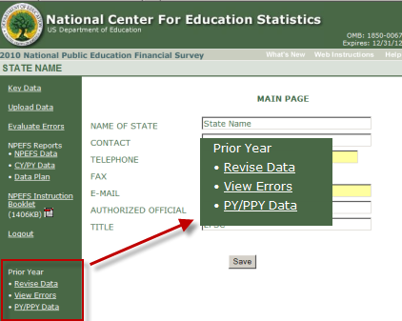

1. To access prior year’s data, select “**Revise Data**” under the “**Prior Year”** heading.
2. A window will pop up to confirm that respondents intend to access prior year data.
3. After revising a prior year data item, select “save” at the bottom of the screen. Once a data item has been revised and saved, it will be highlighted.

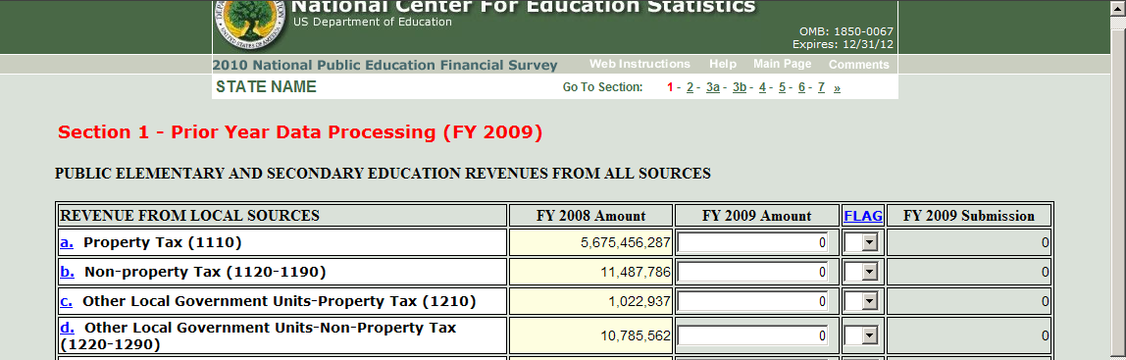

1. To access prior year’s Data Error Listing report, select “**View Errors**.”

If changes are made to prior year data, the menu option says “**Evaluate Errors**” instead of “**View Errors**.”

1. To view prior year’s data in comparison to the previous year, select “**PY/PPY Data**.”
2. If you save any changes to your prior year data or flags:

* Data fields or flags with changes will be highlighted.
* You must resolve any newly introduced “Must Fix” or “Critical” edit issues.
* Your current year data submission will be **unlocked** if it is currently locked.
* You **must** lock your revised prior year data before you will be able to lock your current year submission.

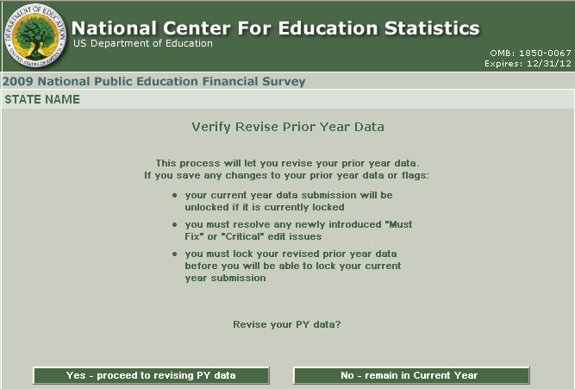

**Appendix A**

**INTERNET DATA COLLECTION FOR THE NPEFS SURVEY**

URL: <http://surveys.nces.ed.gov/ccdnpefs>

**NPEFS Internet Data Collection Instrument**

With the development of the Internet application by the U.S. Census Bureau and NCES for the NPEFS data collection, we have decreased the paperwork burden of the state respondents and our data analysts. The application provides respondents with additional tools to review their data and helps decrease keying errors.

We continuously make upgrades to the web application and we announce and list the changes through our “What’s New” document. A link is located on the NPEFS welcome page.

**The application integrates all parts of NPEFS data collection:**

* Help screens
* Instruction manuals in PDF format
* Enhanced form printing capability
* Fiscal data plan
* *Crosswalk System* integrated in Web application
* Transfer of aggregated Crosswalk System data files to and from the NPEFS Web application
* Imputation review (acceptance and denial options)
* Digital confirmation by designated authorized official with instant receipt verification
* Prior year data screens for viewing and / or correcting data
* Resource Link (various resources regarding NPEFS data collection)
* FAQ’s general to NPEFS and specific to the Crosswalk System
* Awards criteria for early submission of clean data
* NPEFS and crosswalk reports availability after survey submission
* Enhanced edits of NPEFS data before survey submission

The design of the Web form was geared toward assisting respondents and analysts.

The survey application includes displays of prior year data and built-in data validity checks. We have the instruction booklet on-line to help respondents with the survey. For Crosswalk users, we have a User’s Guide to the Crosswalk Application. Within the application, we have instructions for filling out the Web form and fiscal data plan that can be found by clicking the “Resources” button. With the NPEFS web form, our respondents, analysts, and sponsor are able to view and print the survey data, and we can easily date stamp and track the states’ survey submissions and re-submissions.

**Instructions for Using the NPEFS Web Application**

**NPEFS Home Page**

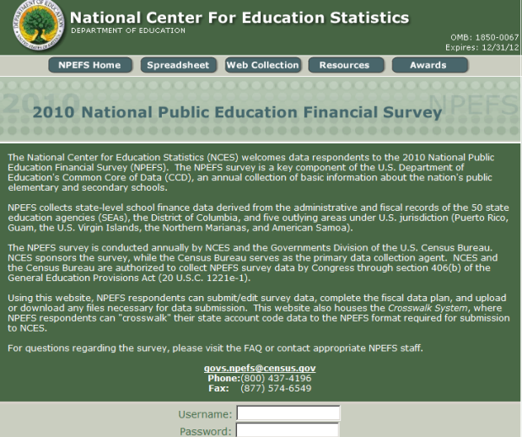

1. Access the NPEFS Website by going to the URL <http://surveys.nces.ed.gov/ccdnpefs/>.
2. On the **Home Page**, enter your **username and password.**  Passwords are issued for CCD fiscal coordinators and authorized designated officials (ADOs). Passwords are re-issued when the states inform us that there are new coordinators and/or ADOs.

**General instructions**

|  |
| --- |
|  |

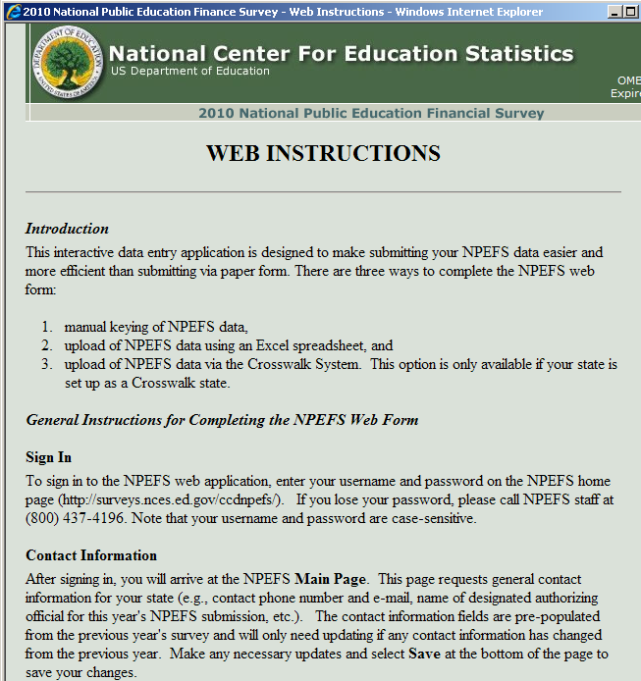

**Main Page**

|  |
| --- |
| Contact page |

**Non-Crosswalk States**

1. Choose the desired option from the links on the NPEFS Main Page. You can choose

to open a section of the survey, or you may choose the upload feature. You can also check your data (view of CY/PY) once you have completed the survey. You can choose the fiscal data plan option or view and print your data.

Note: CY = Current Year and PY = Prior Year

**Crosswalk states main Page**

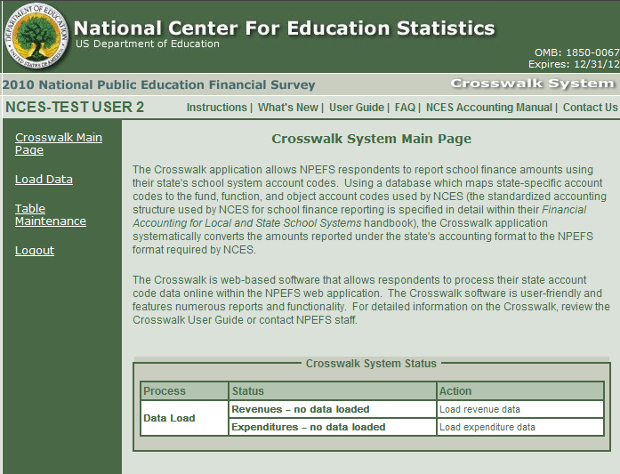

____________________________________________________________

**Crosswalk States**

1. The Crosswalk System Main Page provides the reader a quick synopsis of the purpose of the Crosswalk system. It describes how the system converts the amounts reported under the state's accounting format to the NPEFS format required by NCES.
2. The Crosswalk System Main Page is equipped with a Status system to keep respondents abreast of the Crosswalk process and the steps that are complete and incomplete as they go through the load, translation, submission process. The status table consists of three columns that track the major steps of taking the data from the state’s format to the federal format: Process; Status; and Action.

**Crosswalk states main Page after data load and translation**

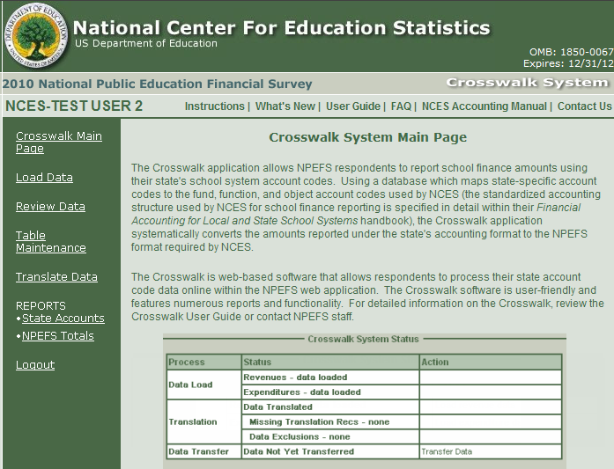

____________________________________________________________

* ***Process*** lists the process and status of the functions: Data load, Translation, and Data Transfer.
* ***Status*** describes the “status” of the revenue and/or expenditure state data load; and the match, allocation, and exclusion errors that result from the load. Lastly, the status column also describes whether or not the data was transferred successfully.
* ***Action*** describes the action required by the Crosswalk respondent when the load, translation, and transfer are successful or unsuccessful

The *Crosswalk System* is efficient and streamlined. The system’s process for making data adjustments, translating state records to federal format, and the transferring of data to the NPEFS portion of the Web application for editing and submission is easily accomplished whether going through these steps once or several times.

Each state should continue its roll in performing routine maintenance to their translation table and allocation tables (as warranted) for adding, deleting or modifying records to accommodate yearly changes in a states chart of accounts. Further discussion on table maintenance is discussed fully in the Crosswalk User Guide that is available in the Web application.

**Fiscal Data Plan**

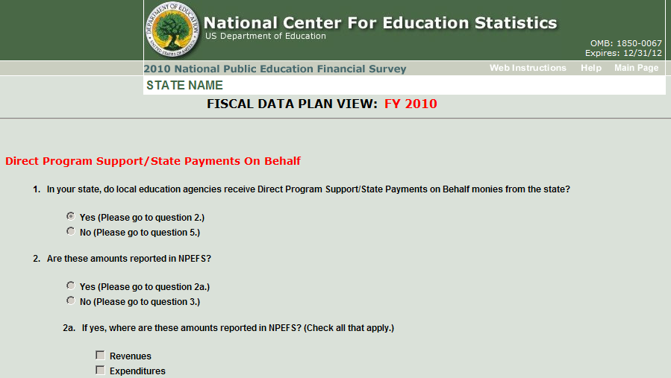

|  |
| --- |
|  |

Please remember to fill out the **Fiscal Data Plan**. The data plan contains a list of questions that help the Census Bureau and NCES properly analyze each state’s data submission. The data plan requests information about state’s chart of accounts and catalogues each state’s response to questions raised about subject matter areas (i.e., grants, school choice, charter schools, GASB statements, etc.).

**SPREADSHEET INSTRUCTION PAGE**

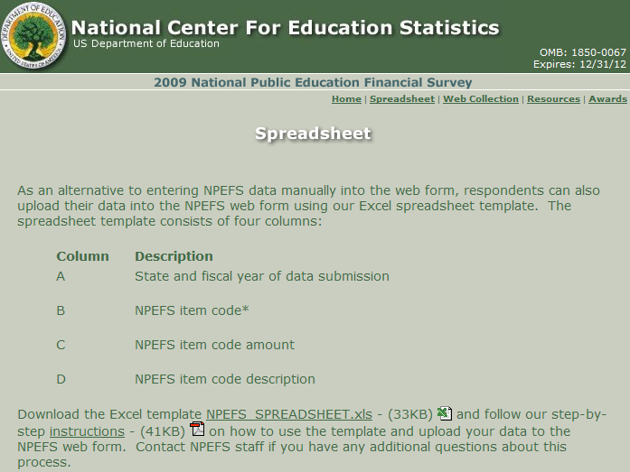

|  |
| --- |
|  |

**Instructions for Uploading NPEFS Data**

1. This feature allows respondents to transfer their NPEFS data from their PC to our server where it is automatically uploaded.
2. Download the spreadsheet template (NPEFS_SPREADSHEET.xls) from the Spreadsheet page. The link to this page is found either on the Home page or the Web Collections page.
3. Access the Adobe document and follow the detailed instructions for transferring and uploading your state’s data.

**Template for Upload**

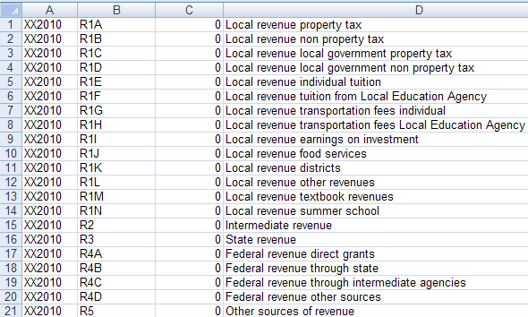

|  |
| --- |
|  |

**About the Spreadsheet Template**

1. Populate the template and name the file according to the instructions.
2. Upload the NPEFS data by using the Spreadsheet template and save it as a .csv file to a directory of your choosing.

**Note:** The template has been revised as of FY 2010. The NPEFS no longer includes “subtotal” or “total” item codes for summary amounts (i.e., total revenue, total expenditure, etc.). The web application will calculate these amounts for you. Any attempt to upload NPEFS data using previous versions of the spreadsheet template will not be successful.

**Upload the NPEFS Data**

**Respondents can upload their NPEFS submissions through this feature.**

**Data upload page**

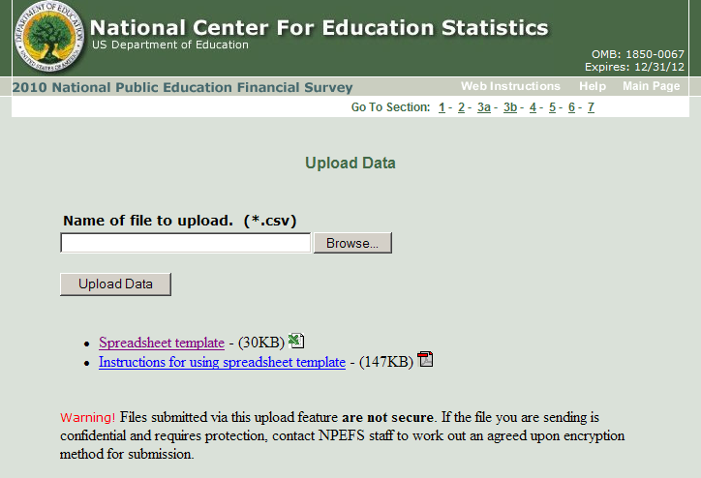

________________________________________________________________________

**Keying in the Data**

**Data Entry form**

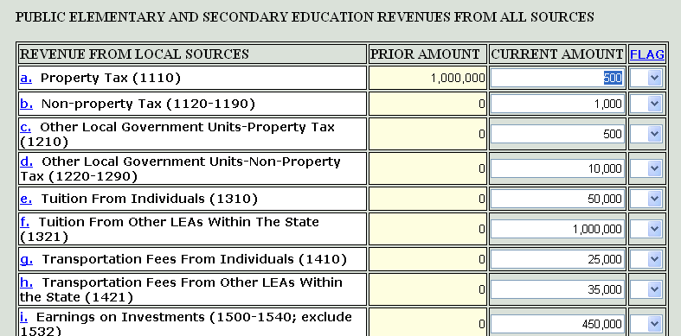

|  |
| --- |
|  |

1. Data may be keyed or uploaded. The column highlighted in yellow displays reported data for the prior year. That column is write-protected (read-only). If you wish to re-submit prior year data, please contact Census Bureau staff. Enter current year data in the column labeled “CURRENT AMOUNT.”
2. Notice the blue, lower case letters on the data entry pages, listed in alphabetical order. These are links to the Quick Reference (QR) pages. Click on the letter, and a corresponding definition of the data item will appear in the QR screens. You can also access these screens by clicking on the “Help” link at the top of the Main Menu.
3. Report all missing or not-applicable data as a “0.” The flag fields have a drop-down box so that you can annotate missing (M) or not-applicable (N) data. Flags must be used for all appropriate data whether or not the data are keyed or uploaded.

**Flag options**

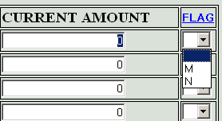

______________________________________________________________

**Interactive Edits**

The interactive edit feature checks the data according to the parameters in our edit specifications, and we would like you to correct or verify data before you to transmit your submission or use the digital confirmation feature.

**ADD-CHECK DIALOGUE BOX**

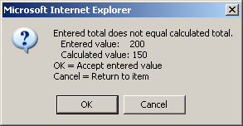

|  |
| --- |
|  |

1. If data are keyed, there may be add-check errors. If the calculated subtotal or total does not equal the reported amount, you will get an error-message pop-up.
2. Note the “Comments” option on each data entry page. Within each section of the Web form there is a feature for adding comments. You should use the comments box to explain any data anomalies.

**Comments box**

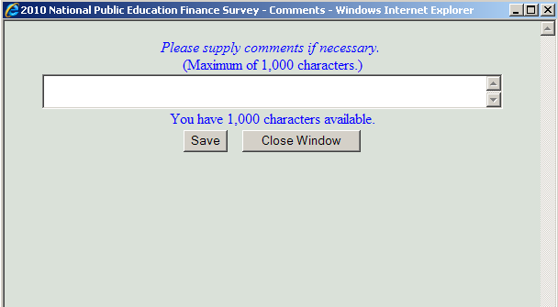

|  |
| --- |
|  |

**DIRECT PROGRAM SUPPORT PROGRAM NAME**

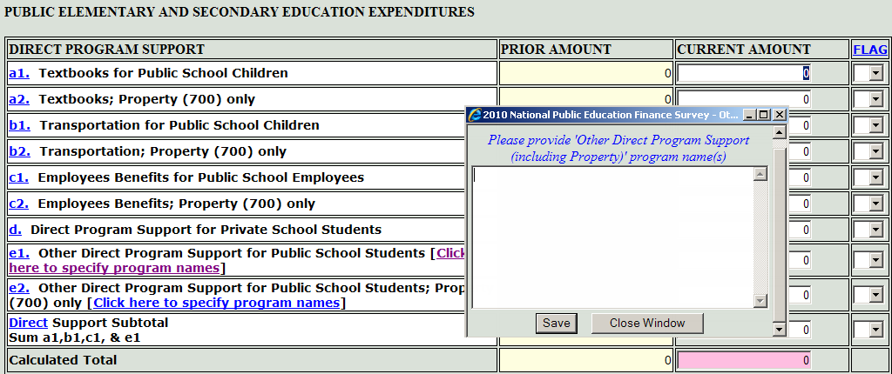

|  |
| --- |
|  |

1. If you report data for Direct Program Support, Other Direct Program Support for public school students, or Direct Cost Programs-Other, you must select the “Program Name” link and type in the names for all programs you report.

**EDIT PAGE/DATA ERROR LISTING**

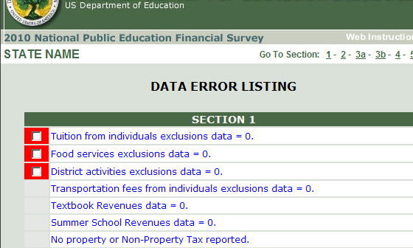

**EDIT PAGE/DATA ERROR LISTING**

1. After reviewing the data in the last section (7), choose “Save” and “Final Data Check” to begin the edit process. On the “Data Error Listing” page, there will be critical and non-critical edits listed by section. These are data that have failed our edits.
2. We want you to “clear” all of the error messages. The critical errors have a red box to the left of the edit message. You should check that box if you wish to verify any errors you do not correct.
3. If you do not correct an error, please verify the amount by providing an explanation in the comment box; then put a check in that error’s red box.
4. You cannot submit your data unless you have cleared all of your state’s critical edits. Resolve any issues with the non-critical errors.

DATA ERROR MESSAGE

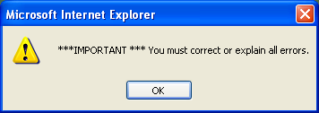

1. If you have add-check errors, or any other errors you can correct, go back to the form and fix them. Run the edit program again to make sure they are cleared; or, to ensure that your editing of the NPEFS form has not created more errors.
2. Once you have finished verifying or correcting all of the critical and non-critical errors, follow the instructions at the bottom of the page.

**Digital Confirmation**

Use the digital confirmation feature.

* + Use the 15-digit password to affirm the authorized state official’s review, concurrence, and approval of the survey data.
  + Hit the submit button.
  + The approval is recorded in the Census Bureau’s survey database.
  + This page may also be printed out and signed and mailed to the Census Bureau.

**NOTE:** Only an original signature is accepted in lieu of the digital confirmation.

**Digital Confirmation Page**

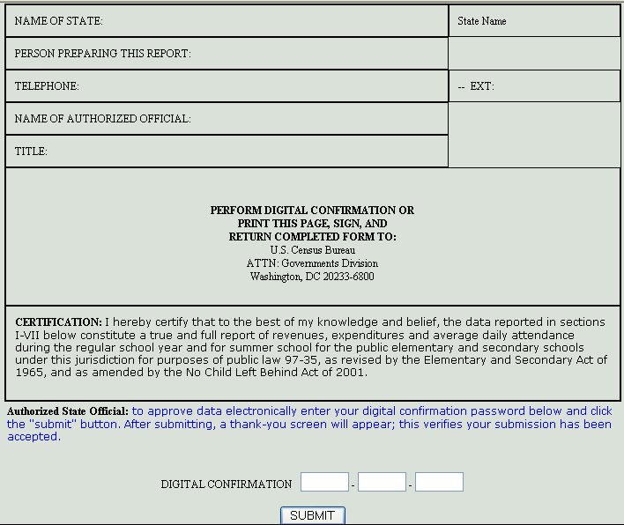

For further information about the NPEFS Internet Survey, please contact **NPEFS Staff, (800) 437-4196**.

**Appendix B**

NATIONAL CENTER FOR EDUCATION STATISTICS

INTERNET SITE

URL: <http://nces.ed.gov/>

The National Center for Education Statistics is the primary federal entity responsible for collecting, analyzing, and reporting education data, as mandated by the United States Congress. NCES maintains a Web site that highlights its major programs and surveys.

**NCES Home Page**

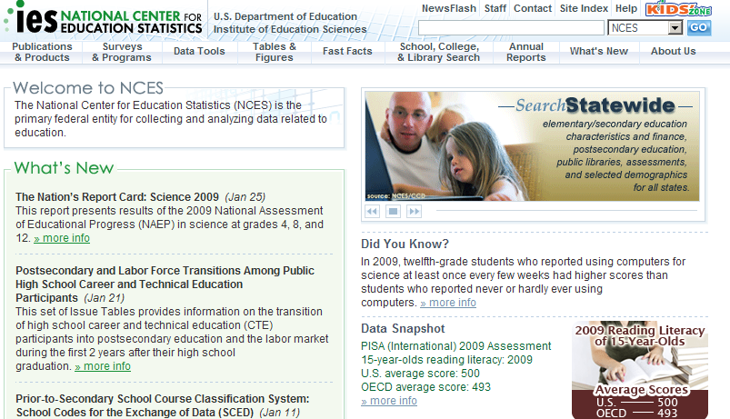

The CCD data collection is the definitive source for State and national data on public education revenues and expenditures. CCD fiscal data (NPEFS) is used in the formula for calculating Title I federal allocations to states.

**CCD Home Page**

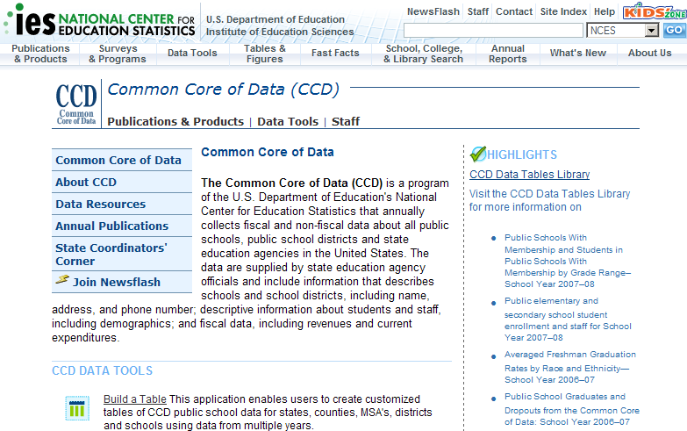

From this page you can access CCD search tools, Data Resources, the Coordinator’s Corner, and Publications. Also, you can access all of the CCD data collected in the last ten years or more.

Data Resources: All of the data collected, CCD reports, and information on CCD coordinators can be found from this site.

Publications: You can access complete list of CCD publications by survey.

Coordinators Corner: List of all CCD data coordinators and contact information, list of state education agency Web sites, information of CCD awards, and other coordinator resources (such as handbooks, survey instructions, and joining the CCD list serv).

**The Digest of Education Statistics**

The Digest of Education Statistics is an annual publication of NCES that covers broad categories of the American education system from pre-K through graduate school. The Digest of Education Statistics Web site URL is: http://nces.ed.gov/programs/digest/ Download the Digest tables as excel, Lotus or text files.

**Digest Home Page**

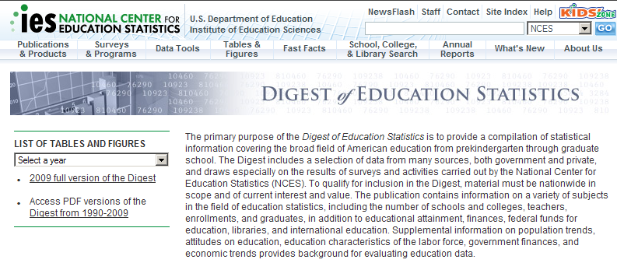

For further information about the NCES/CCD Web site, contact **Stephen Cornman, NCES, (202) 502-7338.**

**Appendix C**

**GOVERNMENTAL ACCOUNTING REFERENCE MATERIALS**

|  |
| --- |
|  |
|  |

Financial Accounting for Local and State School Systems, 2009

Single copies of the handbook (2003 or 2009) can be obtained for free from ED PUBS 1(877) 433-7827. Multiple copies may be ordered from the U.S. Government Printing Office, Washington, DC 20402 ($11 per copy) (Stock # 065-000-000414-3). You may use VISA and MasterCard. Call GPO at (202) 512-1803.

Financial Accounting for Local and State School Systems, 2009 Edition

This handbook is on the NCES Web site at:

http://nces.ed.gov/pubsearch/pubsinfo.asp?pubid=2009325

Governmental Accounting and Financial Reporting (GAAFR)

The publication may be ordered from GFOA, 203 N. LaSalle St., Ste 2700, Chicago, Illinois, 60601-1210, Tel: (312-977-9700). For more information, visit

[http://www.gasb.org](http://www.gasb.org/) .

Catalog of Federal Domestic Assistance (CFDA)

The catalog is available on magnetized tape, high-speed diskettes, and CD-ROM. Private individuals may purchase a hard copy of the catalog or an electronic media copy by writing: Federal Domestic Assistance Catalog Staff (MVS), General Services Administration, 300 7th Street, SW, Suite 101, Washington, DC 20407. You may order by telephone: (202) 708-5126. You may also access the catalog at the CFDA Web site: [http://www.cfda.gov](http://www.cfda.gov/).

**Appendix D**

**COURSES, TRAINING ACTIVITIES, AND INFORMATION SOURCES**

|  |
| --- |
|  |

***Government Finance Officers Association (GFOA)***

Several professional accounting organizations offer classes in governmental accounting that may be helpful to those who are new to the school finance area. The Government Finance Officers Association (GFOA) presents classes several times each year at various locations throughout the country. GFOA also publishes Governmental Accounting, Auditing, and Financial Reporting, 1988 (GAAFR), which has gained widespread acceptance as an authoritative statement on the application of generally accepted accounting principles (GAAP) to state and local government. To order a copy of the GAAFR or to obtain information about accounting courses, call or write the association at 203 N. LaSalle St, Ste 2700, Chicago, Illinois 60601-1210, Tel:  (312) 977-9700.For more information, please visit: <http://www.gfoa.org>.

***Association of School Business Officers (ASBO)***

Courses in government accounting are also offered by the Association of School Business Officials (ASBO), 11401 North Shore Drive, Reston, Virginia 22091, Tel: (703) 478-0405. For more information, please visit: <http://network.asbointl.org>.

***Governmental Accounting Standards Board (GASB)***

GASB is an independent professional organization whose purpose is to establish standards for accounting and financial reporting for state and local governments. A number of professional accounting organizations supported the creation of GASB in 1984, including the Financial Accounting Foundation, the American Institute of Certified Public Accountants, and the Government Finance Officers Association. GASB establishes standards by issuing pronouncements after appropriate due process. Final GASB pronouncements apply to all state and local government entities. Information on GASB publications may be obtained from the Governmental Accounting Standards Board, 401 Merritt No. 7, P.O. Box 5116, Norwalk, Connecticut 06856-5116, Tel: (203) 847-0700. For more information, please visit: <http://www.gasb.org>.

***NCES Training***

NCES offers training for state fiscal staff at the annual Elementary and Secondary Education Data Conference (held in July). At the conference, NCES staff and invited speakers present a series of workshops, training sessions, and other activities designed to assist SEA staff in responding to the fiscal survey and other CCD surveys.

Conference sessions also provide information about important issues and trends in education finance and other topics, future NCES data collection efforts, and issues regarding the use of CCD data. In recent years, NCES has provided funds for three to four persons from each state to attend the Data Conference. For more information, please visit: <http://ies.ed.gov/whatsnew/conferences>.

***Forum Guide to Core Finance Data Elements***

The Forum Guide to Core Finance Data Elements is a good source for information on using the NPEFS and district level F-33 data files. It contains a crosswalk between the data items of the 2 surveys, and as well as definitions and uses of key financial performance indicators and measures. This guide is available on the internet at: <http://nces.ed.gov/pubsearch/pubsinfo.asp?pubid=2007801> .