SUPPORTING STATEMENT FOR
INFORMATION COLLECTION REQUEST NUMBER 2421.04

“HAZARDOUS WASTE MANAGEMENT SYSTEM: CONDITIONAL EXCLUSION FOR CARBON DIOXIDE (CO₂) STREAMS IN GEOLOGICAL SEQUESTRATION ACTIVITIES – final RULE”

August 27, 2013

TABLE OF CONTENTS

1. IDENTIFICATION OF THE INFORMATION COLLECTION 1
1(a) Title and Number of the Information Collection 1
1(b) Short Characterization or Abstract 1
2. NEED FOR AND USE OF THE COLLECTION 2
2(a) Need and Authority for the Collection 2
2(b) Practical Utility and Users of the Data 2
3. NONDUPLICATION, CONSULTATIONS, AND OTHER COLLECTION CRITERIA 3
3(a) Nonduplication 3
3(b) Public Notice 3
3(c) Consultations 3
3(d) Effects of Less Frequent Collection 3
3(e) General Guidelines 4
3(f) Confidentiality 4
3(g) Sensitive Questions 4
4. THE RESPONDENTS AND THE INFORMATION REQUESTED 4
4(a) Respondents and NAICS Codes 4
4(b) Information Requested 5
5. THE INFORMATION COLLECTED, AGENCY ACTIVITIES, COLLECTION METHODOLOGY, AND INFORMATION MANAGEMENT 7
5(a) Agency Activities 7
5(b) Collection Methodology and Management 7
5(c) Small Entity Flexibility 7
5(d) Collection Schedule 7
6. ESTIMATING THE ANNUAL HOUR AND COST OF THE COLLECTION 8
6(a) Estimating Respondent Hours 8
6(b) Estimating Respondent Costs 8
6(c) Estimating Agency Hours and Costs 10
6(d) Estimating the Respondent Universe 10
6(e) Bottom Line Burden Hours and Cost Tables 18
6(f) Reasons for Change in Burden 18
6(g) Burden Statement 18

1. IDENTIFICATION OF THE INFORMATION COLLECTION

1(a) Title and Number of the Information Collection

This ICR is titled, “Hazardous Waste Management System: Conditional Exclusion for Carbon Dioxide (CO₂) Streams in Geological Sequestration Activities – Final Rule.” ICR Number 2421.04, OMB Number 2050-0207.

1(b) Short Characterization or Abstract

Under the authority of the Resource Conservation and Recovery Act (RCRA), the U.S. Environmental Protection Agency (EPA) is finalizing a conditional exclusion from the definition of hazardous waste for carbon dioxide (CO₂) streams that are captured, stored, transported, and injected into a well subject to the requirements for Class VI Underground Injection Control (UIC) wells, including the requirements in 40 CFR Parts 144 and 146 of the Underground Injection Control Program of the Safe Drinking Water Act. The exclusion will only apply to the CO₂ stream itself (as defined in 40 CFR 146.81(d)), and not to hazardous wastes that are mixed with, or are otherwise co-injected with, CO₂ streams. The exclusion will be codified at 40 CFR 261.4(h).

The conditional exclusion requires that generators and owner/operators of a Class VI UIC well who claim that a CO₂ stream is exempt under section 261.4(h), have an authorized representative sign a certification statement worded as specified under (i) or (ii). The signed certification statement must be kept on site for no less than three years, and posted prominently on the corporate website (if such website exists) as a public notification with the title of “Carbon Doxide Stream Certification.” The signed certification statement, which must be made available within 72 hours of a written request from EPA or a state director (if authorized), must be renewed every year that the generator and Class VI UIC well owner/operator claim the exclusion.
The EPA is taking this action to encourage the use of carbon capture and sequestration (CCS) technologies in order to help reduce the levels of greenhouse gases emitted to the atmosphere. In 2010, EPA finalized amendments to the UIC program to establish a new type of well (Class VI) to cover the underground injection of CO₂ for the purposes of geological sequestration (December 10, 2010 FR 77230).¹, These UIC amendments address the unique nature of geological sequestration projects to ensure that the injection of large volumes of CO₂ in geological formations for the purposes of long term storage would not endanger underground sources of drinking water. The UIC amendments prohibit the injection of RCRA hazardous waste into Class VI wells.

Public comments on the proposed UIC amendments raised questions and concerns about the status of CO₂ as a RCRA hazardous waste. The final RCRA conditional exclusion clarifies that captured CO₂ would not be RCRA hazardous provided that the generator and Class VI UIC well owner/operator claim the exclusion and comply with its conditions. In this respect, the RCRA conditional exclusion is necessary for clarifying the status of the captured CO₂ stream under RCRA and encouraging the capture and sequestration of CO₂ in Class VI wells in accordance with the final UIC amendments.

The Agency believes that the risk posed to human health and the environment from the management of CO₂ streams is not substantial when these streams are managed for purposes of geological sequestration under the final RCRA conditional exclusion, including compliance with regulations governing the storage, transport and injection into UIC Class VI permitted wells. The EPA believes that the full set of hazardous waste regulations is in many ways inappropriate for these CO₂ streams and the conditional exclusion would substantially reduce the uncertainty associated with managing the streams under the hazardous waste regulations.

This ICR examines the information collections under the final RCRA conditional exclusion at 40 CFR 261.4(h). Sections 1 through 5 of this document describe the collections (e.g., from the standpoint of need and use/utility of the information collected). The sections also describe respondent and Agency activities. In Section 6, we estimate the total annual hour and cost burden to respondents and the Agency under the information collections.

2. NEED FOR AND USE OF THE COLLECTION

2(a) Need and Authority for the Collection

The conditional exclusion is being finalized under the authority of sections 2002, 3001, 3002, 3003, 3004, and 3007 of RCRA, as amended. EPA believes that the final rule is an important part of its efforts to establish a regulatory framework that supports the future development and deployment of carbon capture and sequestration (CCS) technology, to help control levels of greenhouse gases (GHGs) in the atmosphere.

The certification statements required by the conditional exclusion are necessary to hold claimants accountable for knowing and following the conditions of the exclusion. They also are necessary to demonstrate to regulators that claimants are aware of the conditions applicable to them (e.g., during an onsite inspection). In addition, the certification statements help to convey the seriousness of the conditions to claimants and likely would encourage employees to make their upper management aware of the conditions and involve them in ensuring that their company remains in compliance.

2(b) Practical Utility and Users of the Data

The certification statements required by the conditional exclusion would be used by regulators to hold generators and Class VI well owner/operators accountable for knowing the conditions applicable to them (e.g., during an onsite inspection). The certification statements and Web posting requirements would also be used by generators and owner/operators to demonstrate that they are aware of, and complying with, the conditions.

EPA believes the certifications are a practical way to assure compliance because they hold a single person at each facility accountable for compliance (i.e., the authorized representative). Because of this, the representative has a personal incentive to make sure that the facility complies with the conditions. The rule requires that the certification be posted to the company websites (if such exists), and updated annually to ensure that the facilities are reminded regularly of the applicable conditions, and that the person chosen to be the authorized representative is a current employee.

3. NONDUPLICATION, CONSULTATIONS, AND OTHER COLLECTION CRITERIA

3(a) Nonduplication

The information collected under this ICR is not available from any source other than respondents. No other Federal agency or department currently collects or will collect this information.

3(b) Public Notice

In compliance with the Paperwork Reduction Act of 1995, EPA opened a 60-day public comment period at the time that the Proposed Rule was published in the Federal Register. To assist the public in commenting on the proposal, EPA raised a number of issues in the preamble to the Proposed Rule and asked for public comment. EPA responses to public comments on the proposed rulemaking are available from the RCRA docket (Docket ID No. EPA-HQ-RCRA-2010-0695).

The proposed rule was published at 76 FR 48073 on August 8, 2011, and a correction was published at 76 FR 55846 on September 9, 2011.

3(c) Consultations

EPA consulted and collected information from interested parties over the course of several months to support the Final Rule. EPA solicited and received comments on the Proposed Rule and has addressed these comments. EPA also met and communicated with interested stakeholders and those potentially affected by the rule.

3(d) Effects of Less Frequent Collection

The certification statements must be prepared and posted to the company website (if such exists) when the generator and Class VI well owner/operator claim the exclusion, and renewed every year that the exclusion is claimed. EPA believes this frequency is essential to ensure that the facilities are reminded regularly of the conditions applicable to them. If EPA does not require an annual renewal, it is possible that a facility could overlook the conditions, particularly as a result of employee turnover. In addition, the requirement for an annual renewal helps to ensure that the authorized representative is currently employed by that organization.

In addition, the signed certification must be made available within 72 hours of a written request from EPA or an authorized state official. The certification is submitted only when requested (e.g., one-time basis) and therefore is not submitted according to any specified frequency.

3(e) General Guidelines

This ICR adheres to the guidelines established in the Paperwork Reduction Act of 1995, OMB’s implementing regulations, EPA’s ICR Handbook, and other applicable OMB guidance.

Information collections performed under this clearance will follow all of OMB’s General Guidelines regarding data collection, as relevant.

3(f) Confidentiality

Section 3007(b) of RCRA and 40 CFR Part 2, Subpart B, which defines EPA’s general policy on public disclosure of information, contain provisions for confidentiality. However, the Agency does not anticipate that businesses will assert a claim of confidentiality covering all or part of the Final Rule. If such a claim is asserted, EPA must and will treat the information in accordance with the regulations cited above. EPA also will assure that this information collection complies with the Privacy Act of 1974 and OMB Circular 108.

3(g) Sensitive Questions

No questions of a sensitive nature are included in the information collection requirements associated with this Final Rule.

4. THE RESPONDENTS AND THE INFORMATION REQUESTED

4(a) Respondents and NAICS Codes

Table 1 presents the North American Industrial Classification System (NAICS) codes that may be affected by information collections in this ICR.

Table 1. North American Industrial Classification System (NAICS) Codes
NAICS Codes | Description
211111 | Crude Petroleum and Natural Gas Extraction
22 | Utilities
31-331 | Manufacturing
48-49 | Transportation
56 | Administrative and Support and Waste Management and Remediation Services
92 | Public Administration

4(b) Information Requested

This section describes information collection requirements applicable to entities that would be affected by the Final Rule.

(1) Private Sector Organizations

EPA is finalizing a conditional exclusion from the definition of hazardous waste for carbon dioxide (CO₂) streams that are captured, stored, transported, and injected into a well subject to the requirements for Class VI Underground Injection Control (UIC) wells, including the requirements in 40 CFR Parts 144 and 146 of the Underground Injection Control Program of the Safe Drinking Water Act. The exclusion would only apply to the CO₂ stream itself (as defined in 40 CFR 146.81(d)), and would not apply to hazardous wastes that are mixed with, or are otherwise co-injected with CO₂ streams. The exclusion is codified at 40 CFR 261.4(h).

The conditional exclusion requires that any generator (person or persons, by site, who capture the carbon dioxide for eventual injection into a Class VI Underground Injection Control well) and any owner/operator of a Class VI UIC well who claim that a CO₂ stream is exempt under section 261.4(h) to have an authorized representative sign a certification statement worded as specified. The signed certification statement must be posted to the company website (if such is available) and kept on site for no less than three years. The signed certification, which must be made available within 72 hours of a written request from EPA, must be renewed every year by anyone claiming the exclusion.
(i) Data Item

A signed certification statement from the generator and Class VI UIC well owner/operator that is worded as follows:

- For any generator of a carbon dioxide stream who claims that a carbon dioxide stream is excluded under this section:

I certify under penalty of law that the carbon dioxide stream that I am claiming to be excluded under 40 C.F.R. §261.4(h) has not been mixed with hazardous wastes, and I have transported the carbon dioxide stream in compliance with (or have contracted with a pipeline operator or transporter to transport the carbon dioxide stream in compliance with) Department of Transportation requirements, including the pipeline safety laws (49 U.S.C. § 60101 et seq.) and regulations (49 C.F.R. Parts 190-199) of the U.S. Department of Transportation, and the pipeline safety regulations adopted and administered by a state authority pursuant to a certification under 49 U.S.C. § 60105, as applicable, for injection into a well subject to the requirements for the Class VI Underground Injection Control Program of the Safe Drinking Water Act.

- For any Class VI Underground Injection Control well owner or operator who claims that a carbon dioxide stream is excluded under this section:

I certify under penalty of law that the carbon dioxide stream that I am claiming to be excluded under 40 C.F.R. §261.4(h) has not been mixed with, or otherwise co-injected with, hazardous waste at the Underground Injection Control (UIC) Class VI permitted facility, and that injection of the carbon dioxide stream is in compliance with the applicable requirements for UIC Class VI wells, including the applicable requirements in 40 CFR parts 144 and 146.

(ii) Respondent Activities

- Generators and Class VI UIC well owner/operators claiming the exclusion must perform the following:
- Prepare the certification statement and have it signed by the authorized representative;
- Keep the signed certification statement onsite for no less than three years;
- Post the certification statement to the company website (if such is available);
- Renew and report the certification every year the exclusion is claimed; and
- Make the certification available to EPA or state, if requested.

(2) State Governments

Authorized states may provide a written request to generators or Class VI UIC well owner/operators asking for a copy of the signed certification.

(i) Data Item

- Written request for a signed certification.

(ii) Respondent Activities

- Authorized states may perform the following:
- Prepare and transmit a written request to generators or Class VI UIC well owner/operators requesting a copy of their signed certification; and
- Receive, review and file the signed certifications.

5. THE INFORMATION COLLECTED, AGENCY ACTIVITIES, COLLECTION METHODOLOGY, AND INFORMATION MANAGEMENT

5(a) Agency Activities

EPA may perform the following:

- Prepare and transmit a written request to generators or Class VI UIC well owner/operators requesting a copy of their signed certification; and

- Receive, review and file the signed certifications.

5(b) Collection Methodology and Management

EPA will review and file the certification statements received from generators and Class VI UIC well owner/operators.

5(c) Small Entity Flexibility

The conditional exclusion is optional and will only be claimed if generators and Class VI UIC well owner/operators find that the exclusion is in their best interest. EPA believes that the conditional exclusion will reduce the burden for generators and owner/operators, regardless of size, because they would no longer be required to comply with the existing RCRA hazardous waste regulations for the exempted CO₂ stream.

5(d) Collection Schedule

Following is the rule’s collection schedule:

- Generators and Class VI UIC well owner/operators that claim the exclusion must sign a certification statement attesting to their compliance with the conditions and keep it onsite for three years.
- Generators and Class VI UIC well owner/operators claiming the exclusion must post the signed certification statement to the company website (if such is available)..
- The signed certification must be renewed and reposted each year that the exclusion is claimed.
- The signed certification must be made available within 72 hours of a written request from EPA or authorized state officials

6. ESTIMATING THE ANNUAL HOUR AND COST OF THE COLLECTION

6(a) Estimating Respondent Hours

Exhibit 1 estimates annual burden hours for private sector organizations under the final rule. Exhibit 2 estimates annual burden hours for state governments under the final rule. Exhibit 3 presents the total annual burden to the private sector and state governments under the rule. Exhibit 4 estimates the annual burden hour impacts (i.e., savings) to these respondents under the existing RCRA requirements.

6(b) Estimating Respondent Costs

Exhibit 1 estimates annual costs to private sector organizations under the final rule. Exhibit 2 estimates annual costs to state governments under the final rule. Exhibit 3 presents the total annual cost to the private sector and state governments under the rule. Exhibit 4 estimates the annual cost impacts (i.e., savings) to these respondents under the existing RCRA requirements. Specific cost assumptions are discussed below.

(i) Estimating Labor Costs

Private Sector Organizations

EPA estimates an average loaded hourly labor rate for private sector organizations of $101.13 for legal staff, $77.67 for management, $110.99 for technical staff, and $25.06 for clerical staff. To derive these rates, EPA obtained mean (unloaded) average hourly labor rates from the “Occupational Employment Statistics, May 2009 National Occupational Employment and Wage Estimates, United States” of the U.S. Bureau of Labor Statistics (BLS) and from surveys of oil and gas professionals performed by the American Association of Petroleum Geologists (AAPG) and the Society of Petroleum Engineers (SPE). Table 2 identifies the occupations whose labor rates were used in this ICR for each labor category as well as the source of the rates. Note that the technical labor rate is an average of petroleum geologists and petroleum engineers.

EPA updated the non loaded labor rates to 2010 levels using the BLS Employment Cost Index. Finally, we applied an average loading factor of 1.6 to reflect overhead.

Table 2. Occupation Labor Category and Wage Rate Source --
Private Sector Organizations
Labor Category | Occupation |  | Source
Legal | Lawyers |  | Bureau of Labor Statistics
Managerial | Managers, All Others |  | Bureau of Labor Statistics
Technical |  | Petroleum Geologists | AAPG Salary Survey
 |  | Petroleum Engineers, Reservoirs | SPE Salary Survey
Clerical | Office and Administrative Support, All Others |  | Bureau of Labor Statistics

State Governments

EPA estimates an average loaded respondent hourly labor rate for state governments of $64.86 for legal staff, $61.50 for management, $38.53 for technical staff, and $26.74 for clerical staff. To derive these rates, we obtained mean (unloaded) average hourly labor rates from the “May 2009 National Industry-Specific Occupational Employment and Wage Estimates, NAICS 999200 – State Government” of the Bureau of Labor Statistics (BLS). Table 3 identifies the occupations whose labor rates were used in this ICR for each labor category as well as the source of the rates.

EPA updated the wage rates to June 2010 levels using the BLS Employment Cost Index. Finally, we applied an average loading factor of 1.6 to reflect overhead.

Table 3. Occupation Labor Category and Wage Rate Source –
State Governments
Labor Category | Occupation | Source
Legal | Lawyers | Bureau of Labor Statistics
Managerial | Managers, All Others | Bureau of Labor Statistics
Technical | Compliance Officers | Bureau of Labor Statistics
Clerical | Office and Administrative Support, All Others | Bureau of Labor Statistics

(ii) Estimating Capital and Operations and Maintenance (O&M) Costs

Operation and maintenance (O&M) costs are those costs associated with a paperwork requirement incurred continually over the life of the ICR. They are defined by the Paperwork Reduction Act of 1995 as the recurring dollar amount of costs associated with O&M or purchasing services. This ICR includes postage costs for generators and Class VI UIC well owner/operators to mail the certification to EPA or the state (i.e., $0.44/letter). There are no capital costs associated with the information collections.

6(c) Estimating Agency Hours and Costs

EPA estimates an average loaded hourly labor rate of $76.38 for legal staff, $71.42 for management, $52.37 for technical staff, and $21.02 for clerical staff. To derive these rates, EPA obtained unloaded federal government hourly rates from the 2010 GS pay schedule available from the Office of Personnel Management. The labor rates are based on the following GS levels and steps: legal labor rates were based on GS Level 15, Step 1, managerial labor rates were based on GS Level 14, Step 4, technical labor rates were based on GS Level 12, Step 5, and clerical labor rates were based on GS Level 5, Step 1. We then multiplied the unloaded rates by the standard government loading factor of 1.6 to reflect overhead (loading factor recommended in EPA’s ICR Handbook).

6(d) Estimating the Respondent Universe

In this section, we estimate the impacted universe and the annual burden to respondents under the rule’s paperwork requirements. We then estimate the burden impact (i.e., savings) to respondents for no longer complying with the existing RCRA paperwork standards for excluded CO₂ streams. Exhibits 1 through 4 calculate respondent burden.

PAPERWORK REQUIREMENTS

(1) Private Sector Organizations

Table 4 presents that annual number of generators and Class VI UIC well owner/operators that are estimated to claim the exclusion and prepare the certification statement during the three-year period of this ICR. These estimates reflect the number of generators and Class VI UIC well owner/operators that are expected to begin capture and sequestration activities from 2012 through 2014 as estimated for the final rule economic assessment.

As shown in the table, EPA estimates that 2 generators and 1 Class VI UIC well owner/operator would prepare the certification statement at 40 CFR 261.4(h) on average annually during the three-year period of this ICR. In total, this equates to 3 respondents on average annually.

For purposes of this ICR, EPA expects that legal, managerial, and technical personnel at each generator site and UIC well facility would read the regulations before claiming the exclusion. We have applied our best professional judgment to estimate that it would take 45 minutes per respondent to read the regulations at section 261.4(h) for purposes of discussing the requirement to prepare the certification statement.

In addition, EPA believes these personnel would review relevant documentation and discuss the exclusion’s paperwork requirements. A clerical person would type up the certification statement and a manager would sign and keep it onsite. Again, we have used best professional judgment to estimate that these activities would take 4 hours per respondent.

Table 4. Annual Number of Generators and Class VI UIC Well Owner/Operators
Claiming the Exclusion During Three-Year Period of ICRª
Facility Type | Years |  |  | Total | Three-Year Average^{b}
 | 1 | 2 | 3
Claiming Exclusion/Preparing Certification
Generators | 3 | 1 | 0 | 4 | 1.33 (2)
Class VI UIC Well Owner/Operators | 1 | 0 | 0 | 1 | 0.33 (1)
Sub-Total | 4 | 1 | 0 | 5 | 1.67 (3)
Renewing Certification Annually
Generators | 0 | 3 | 4 | 7 | 2.33 (3)
Class VI UIC Well Owner/Operators | 0 | 1 | 1 | 2 | 0.67 (1)
Sub-Total | 0 | 4 | 5 | 9 | 3.00 (4)
Grand Total | 4 | 5 | 5 | 14 | 4.67 (7)
ª For the Final Rule ICR we assume that no more than 10 percent CO2 is hazardous waste.
The annual number for affected facilities is based on the revised high-end number of generators (19) and Class VI well owner/operators (9) that are projected would begin practice over the three-year ICR duration period, as derived from the June 2, 2011 Assessment Exhibits 5 and 10.

^{b} Table contains rounding. Three-year averages rounded up.

Table 4 also presents that annual number of generators and Class VI UIC well owner/operators that are estimated to renew their certification statement during the three-year period of this ICR. The number of respondents expected to renew their certification statement each year is equal to the cumulative number of respondents that have claimed the exclusion in all prior years.

As shown in the table, EPA estimates that 3 generators and 1 Class VI UIC well owner/operator would renew the certification on average annually during the three-year period of this ICR. In total, this equates to 4 respondents on average annually. We applied our best professional judgment to estimate that it would take 2 hours for each respondent to renew its certification statement annually.

Finally, we estimate that there would be 4 generators and Class VI UIC owner/operators under the exclusion by the end of the first year, 5 by the end of the second, and 5 by the end of the third. Hence, EPA estimates that, on average, there could be as many as 7 (summed from subtotals) respondents on average during the ICR’s three-year period. Based on our best professional judgment, we expect that, each year, 30 percent of affected facilities would be asked to submit their certifications to EPA or state. We applied our best professional judgment to estimate that 90% of these submissions would be sent to authorized states and 10% to EPA.

These estimates are incorporated into Exhibit 1.

(2) State Governments

As discussed above, EPA applied best professional judgment to estimate that state governments would prepare and transmit 1 request to generators or Class VI well owner/operators for their signed certifications annually. State governments would then receive, review and file these statements. In addition, we estimated, based on our best professional judgment, that state governments would take one hour to prepare a letter requesting a certification statement and 30 minutes (i.e., 50 percent of one hour, as presented in the Exhibit) to receive, review and file the certification after receipt. These estimates are reflected in Exhibit 2.

(3) Total Respondent Burden under Proposed Paperwork Requirements

Exhibit 3 presents the total annual burden to private sector and state government respondents under the new paperwork requirements. The Exhibit indicates that these respondents are estimated to incur approximately 38 hours and $3,765 annually.

EXISTING PAPERWORK REQUIREMENTS

Generators and Class VI UIC well owner/operators claiming the exclusion would not be subject to existing RCRA information collection requirements in handling the exempted CO₂ streams. As a result, these entities would experience some burden savings under the existing RCRA paperwork requirements.

Exhibit 4 presents the total annual burden under the final rule’s paperwork requirements, the annual burden savings under the existing paperwork requirements, and the net savings. Exhibit 4 presents the savings under the existing requirements according to the approved ICR in which the requirements are addressed. Below is a brief discussion of these ICRs:

- Hazardous Waste Generator Standards (EPA ICR Number 820). EPA estimates that facilities that begin capturing hazardous waste CO₂ would change in generator status from conditionally exempt small quantity generators (CESQGs) to large quantity generators (LQGs) under the existing hazardous waste regulations. As LQGs, they would be subject to RCRA paperwork requirements related to hazardous waste determinations, contingency planning, and personnel training.

Under the conditional exclusion, EPA estimates that they would remain CESQGs, be exempt from these paperwork requirements, and therefore realize a burden savings.

- Notification of Regulated Waste Activity and 2009 Hazardous Waste Report (EPA ICR Number 976). EPA estimates that, under the existing hazardous waste regulations, facilities that capture hazardous waste CO₂ would change in generator status from CESQGs to LQGs and be required to submit a new or revised Site Identification (ID) Form to EPA indicating this change. As LQGs they also must prepare and submit a Hazardous Waste Report biennially, including a Site ID Form and GM Form. Under the conditional exclusion, they would be relieved of these requirements and therefore see a burden savings.

It is also assumed that, under the existing hazardous waste regulations, UIC wells that receive the CO₂ for injection (e.g., a Class I UIC well that also meets Class VI requirements) would need to submit a Site ID Form to notify EPA that they are subject to RCRA. They also would need to prepare and submit a Hazardous Waste Report biennially, including a Site ID Form and Form WRs. Under the conditional exclusion, they would be relieved of these requirements and therefore see a burden savings.

- Land Disposal Restrictions ICR (EPA ICR Number 1442). EPA estimates that, under the existing hazardous waste regulations, facilities that capture CO₂ would be required to determine if it is RCRA hazardous and keep records of this determination. Under the conditional exclusion, they would be relieved of these requirements and therefore realize a burden savings.

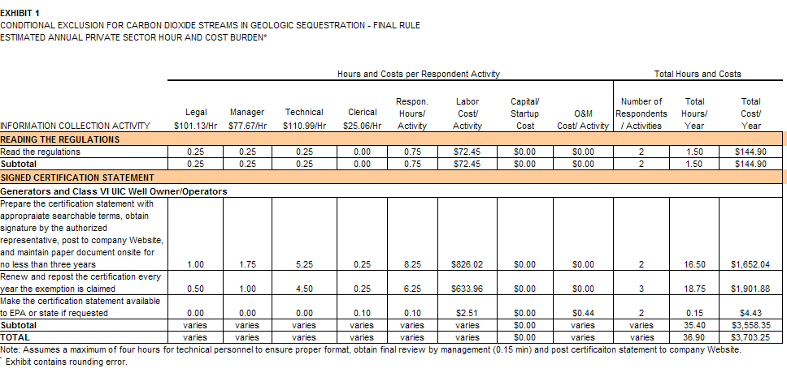

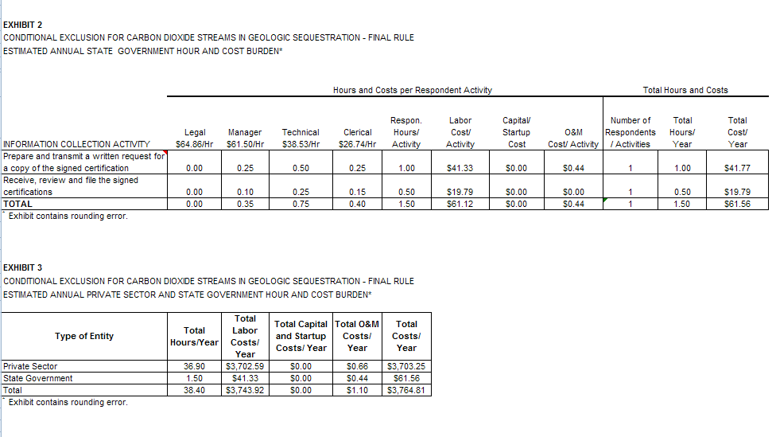

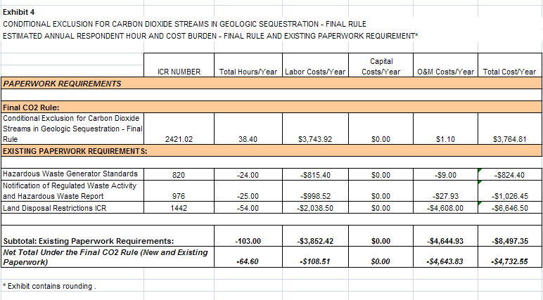

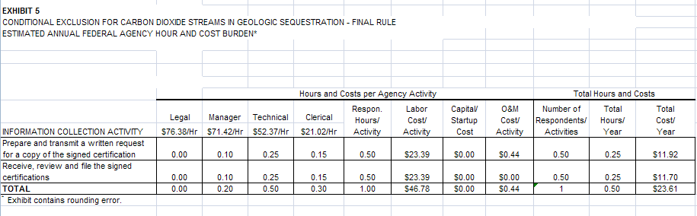

6(e) Bottom Line Burden Hours and Cost Tables

(1) Respondent Tally

As shown in Exhibit 3, EPA estimates the total annual burden to respondents (i.e., the private sector and state governments) under the new paperwork requirements to be 38 hours and $3,765. This includes $1.10 in operations & maintenance costs, of which 66 cents are for private respondents and 44 cents for state government respondents. There are no capital costs. In addition, Exhibit 4 indicates an annual burden savings under the existing paperwork requirements of 103 hours and $8,497. This results in a net annual savings of 65 hours and $4,733. The bottom-line burden savings over three years is estimated to be 195 hours and $14,199.

(2) Agency Tally

As shown in Exhibit 5, EPA estimates the total annual burden to the Federal government under the new paperwork requirements to be less than one hour and about $24. The bottom-line burden over three years is estimated to be 1.5 hours and $72.

6(f) Reasons for Change in Burden

EPA is taking this action to support its efforts to encourage the use of carbon capture and sequestration technologies to help reduce the levels of greenhouse gases emitted to the atmosphere. EPA estimates that the minor incremental burden imposed by the new paperwork requirements would be more than offset by savings that respondents would experience under the existing paperwork requirements. At the same time, the paperwork requirements are necessary to hold generators and Class VI UIC well owner/operators accountable for their actions under the exclusion and increase compliance rates.

6(g) Burden Statement

The annual public reporting and recordkeeping burden (private sector plus states) for this collection of information is estimated to average 4.8 hours per respondent. For private-sector respondents, the estimate is 5.3 hours per response. This includes time for reading the regulations, preparing the certification statement, posting the statement to the company website (if such exists), renewing it annually, and submitting it to EPA or authorized state, if requested. The annual public reporting and recordkeeping burden for this collection of information is estimated to average 1.5 hours per state government respondent. This includes the time for preparing and mailing a letter requesting the generator or UIC well owner/operator submit the signed certification statement, and then receiving, reviewing, and filing it after receipt.

Burden means the total time, effort, or financial resources expended by persons to generate, maintain, retain, or disclose or provide information to or for a Federal agency. This includes the time needed to review instructions; develop, acquire, install, and utilize technology and systems for the purposes of collecting, validating, and verifying information, processing and maintaining information, and disclosing and providing information; adjust the existing ways to comply with any previously applicable instructions and requirements; train personnel to be able to respond to a collection of information; search data sources; complete and review the collection of information; and transmit or otherwise disclose the information. An agency may not conduct or sponsor, and a person is not required to respond to, a collection of information unless it displays a currently valid OMB control number. The OMB control numbers for EPA's regulations are listed in 40 CFR part 9 and 48 CFR chapter 15.

To comment on the Agency's need for this information, the accuracy of the provided burden estimates, and any suggested methods for minimizing respondent burden, including the use of automated collection techniques, EPA has established a public docket for this ICR under Docket ID Number EPA-HQ-RCRA-2010-0695, which is available for online viewing at www.regulations.gov, or in person viewing at the RCRA Docket in the EPA Docket Center (EPA/DC), EPA West, Room 3334, 1301 Constitution Avenue, NW, Washington, D.C. The EPA Docket Center Public Reading Room is open from 8:30 a.m. to 4:30 p.m., Monday through Friday, excluding legal holidays. The telephone number for the Reading Room is (202) 566-1744, and the telephone number for the RCRA Docket is (202) 566-0270. An electronic version of the public docket is available at www.regulations.gov. This site can be used to submit or view public comments, access the index listing of the contents of the public docket, and to access those documents in the public docket that are available electronically. When in the system, select “search,” then key in the Docket ID Number identified above. Also, you can send comments to the Office of Information and Regulatory Affairs, Office of Management and Budget, 725 17th Street, NW, Washington, D.C. 20503, Attention: Desk Officer for EPA. Please include the EPA Docket ID Number EPA-HQ-RCRA-2010-0695 and OMB Control Number 2050-0207 in any correspondence.

Federal Requirements Under the Underground Injection Control (UIC) Program for Carbon Dioxide (CO₂)Geologic Sequestration (GS) Wells; Final Rule (75 FR 77230, December 10, 2010)
CO₂ is captured by fossil fuel power plants and other industrial processes.
Geological sequestration means the long-term containment of a gaseous, liquid or supercritical carbon dioxide stream in subsurface geologic formations. This term does not apply to its capture or transport.
Federal Register, Vol. 76, No. 152, 48073, August 8, 2011
See the web site: http://www.opm.gov/oca/10tables/pdf/gs_h.pdf.
See Table 4 – footnote a
Note that the Generator Standards ICR does not estimate the burden associated with generator hazardous waste determinations. Such burden is estimated in the Land Disposal Restrictions ICR, 1442.
ICR 1442 estimates that 50% of generators pay this fee and the other 50% use generator knowledge. This differs from the Economic Assessment (EA) prepared for the RCRA CO₂ rule. The EA’s estimates are based on a more detailed analysis of inputs specific to the rulemaking.

