October 2014

Dear Producer,

The U.S. Department of Agriculture’s National Agricultural Statistics Service (NASS) measures the size and condition of establishments generating grain by-products in the wet mill process of ethanol production each year through the monthly Wet Mill Producers of Ethanol survey.

Response to this survey is required by law (Title 7, U.S. Code). The survey results are used by producers, processors and commodity markets to make sound and informed business decisions and to help promote the production of ethanol. NASS will publish the survey results in the monthly *Current Agricultural Industrial Report*.

Please respond to the attached survey, which asks for information on the quantities of by-product production and corn grind used during ethanol production during September 2014. Your participation is important. Because we want to make it as easy as possible for you to participate, we offer you the following options to respond:

* **Online** at <http://www.agcounts.usda.gov>. This method is fast, easy and secure. You will need the 17-digit survey code found on the survey mailing label to begin; then follow the instructions on the back of this letter.
* **By mail.** Complete the survey questionnaire and return it in the envelope provided.

If we do not hear from you by the second week in October 2014, we will contact you to arrange a telephone interview. Please be assured that your responses are completely confidential, as required by Federal law. The National Agricultural Statistics Service safeguards the privacy of all respondents, ensuring that no individual operation or producer can be identified.

Thank you in advance for your cooperation and support of our programs.

Sincerely,

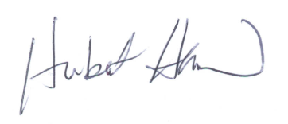

Hubert Hamer

Chair, Agricultural Statistics Board

Enclosure

