OMB Control No. 0690-0030
Expiration Date: 04/30/2014

MBDA.gov Website Survey

Based on today’s visit, how would you rate your overall satisfaction with the site? 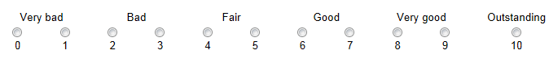
Which of the following best describes the primary purpose of your visit?
Use Business Tools (Phoenix/Opportunity Matching System, Business Plan Writer, Business/Resource Locator)
Learn more about MBDA or find a MBDA Business Center near me
Discover grant, contracting & trade opportunities
Visit our Business Blog
Find a recent press release or MBDA News
Access research publication or minority business data
Request a speaker
Other, please specify
Please rate the ability to accomplish what you wanted to on this site. 1=Unable to accomplish 10=Easy to accomplish

What do you value most about the http://www.mbda.gov website?
[Open Text Field]

Which of the following best describes how often you visit this website?
First Time
More than once a day
Daily
About once a week
About once a month
Rarely

Which of the following describes you:
Business owner with gross receipts under $500,000
Business owner with gross receipts over $500, 001
Potential small business owner
Press/Media
Congress/Government
MBDA Business Center staff
Student, academic, or researcher
Other

This information collection contains requirements subject to the Paperwork Reduction Act (PRA). Notwithstanding any other provisions of the law, no person is required to respond to, nor shall any person be subject to penalty for failure to comply with, a collection of information subject to the requirements of the PRA, unless that collection of information displays a currently valid OMB control number.

