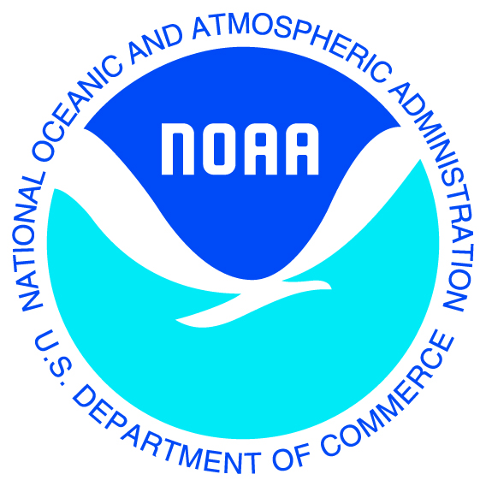
NOAA’s QR Code Enabled Charts
Testing a new concept

Quick Response codes (QR codes) are 2-dimensional bar codes. When you scan or read a QR code with an iPhone, Android or other camera-enabled Smartphone, you can automatically link to digital content on the Internet; activate a number of phone functions, or connect the mobile device to a Web browser.

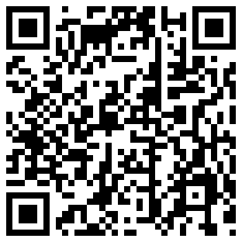
NOAA is evaluating QR codes as a way to enhance its static, printed paper charts by linking them to real-time information. Each Print-on-Demand NOAA nautical chart would have a QR code printed in the margin. When scanned with a SmartPhone, the code opens a chart-specific Web page on the phone. This Web page contains a menu of real-time and predictive data sites such as tides, currents, and marine weather. Simply tapping on a menu item then causes the selected data to be displayed.

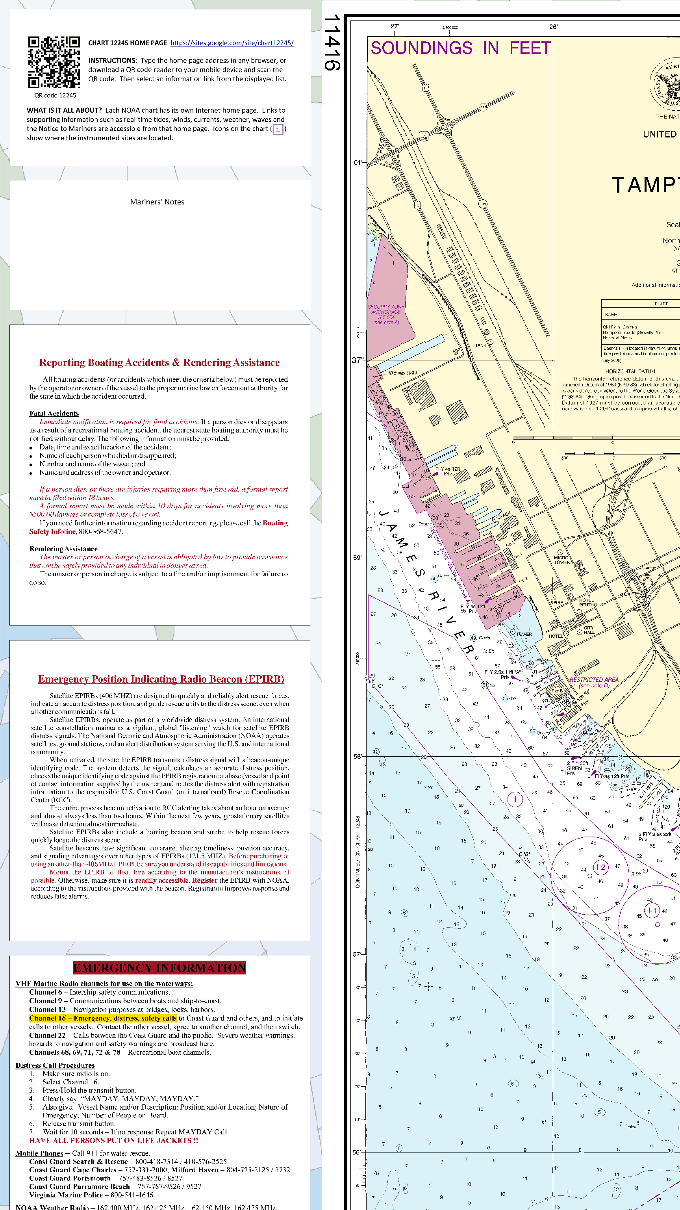
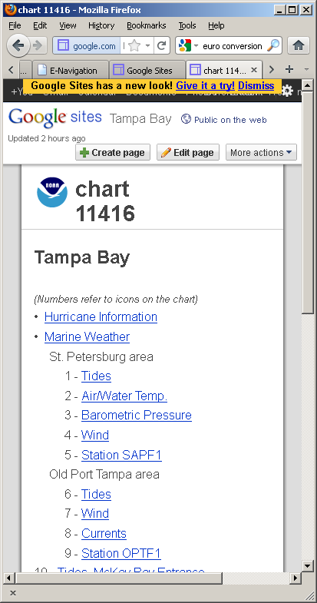
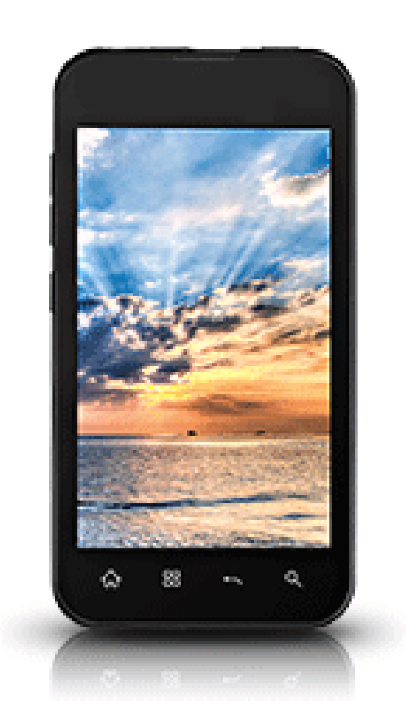
Scan QR code with SmartPhone camera
SmartPhone APP automatically goes to a URL encoded in QR code
Select a menu item from the touch screen.
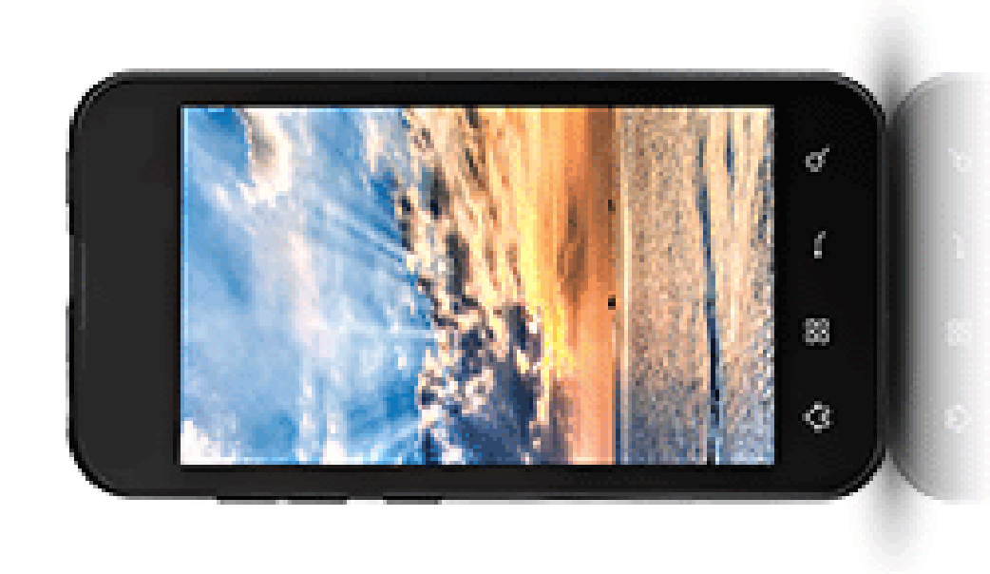
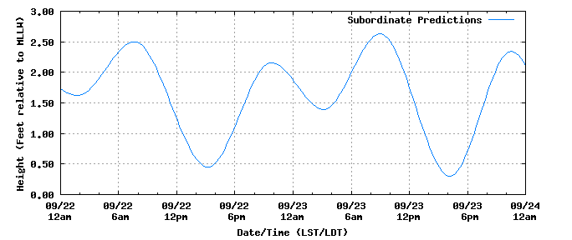


Numbered icons on the chart match numbered items on the SmartPhone menu
SmartPhone connects to real-time data over the Internet.
QR code enabled charts are being explored as a tool for recreational boaters who do not have an electronic charting system or a computer on board. It offers them:

- Access to real-time navigation information using their mobile device of choice – SmartPhones and tablet computers are becoming the preferred means of Internet access and national charting authorities like NOAA need to move with their users.

- Convenience by aggregating real-time information specific to a chart and mariner’s location rather than having mariners go to thematic sites (first tides, then weather, then currents, then waves…) and search each for relevant information.

Access to the QR sites would not be limited to SmartPhones and tablet computers. The URL for each chart can be printed on the chart along with the QR code. Mariners could then type the URL or make a desktop icon and access the real-time information like any other Internet site.

The QR code service would be free from NOAA. Print-on-Demand charts containing the codes would be available from NOAA’s partner OceanGrafix and their retailers (OceanGrafix.com). So, in addition to Print-on-Demand charts being updated for Notices to Mariners each week, QR codes could be included thus offering another advantage over traditional charts.

NOAA’s Experiment

NOAA’s test of QR codes uses 8 charts around Tampa Bay, Florida. With this suite NOAA is evaluating the desirability, utility, and usability of the QR Code real-time data service. In particular, NOAA is evaluating:

- Usability of the mobile interface, particularly at sea
- The mix of information that should be provided
- Benefits to mariners of the information
- Utility of the icons on the chart at the information stations
- Appropriate improvements
- Mobile connectivity in recreational boating areas
- The costs to build and maintain a mobile information service
- Whether NOAA should offer this as a service

This information will help NOAA evaluate how to best serve mariners in the emerging mobile environment.

Try the Service Yourself

Scan the QR codes at the right or buy one of the 8 QR-enabled PoD charts. You can also type a URL in your Internet browser or click on a link at the right. URL’s for the 8 test charts are of the form http://nauticalcharts.noaa.gov/qr/QR_11425m.php. Substitute the chart number you want in place of that in the example. Explore the two formats of Chart 11416 and Chart 11424.

Collaborate with NOAA in designing improved navigation services. Contribute your comments on the evaluation topics to NOAA at QRcodeCharts@noaa.gov or leave a voicemail at 888-990-NOAA (888-990-6622).

John Lowell, Captain (NOAA)
Director, Office of Coast Survey, NOAA
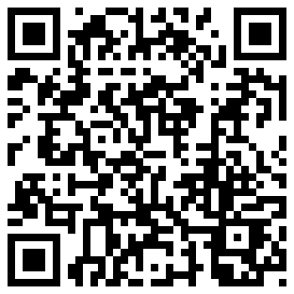
Chart 11013

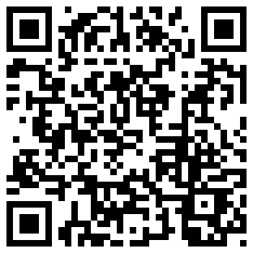
Chart 11400

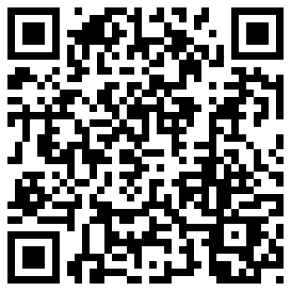
Chart 11411

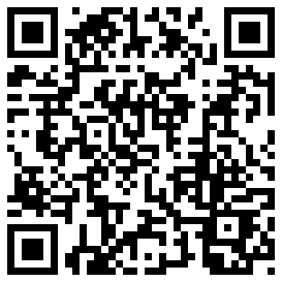
Chart 11412

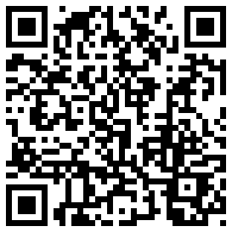
Chart 11415

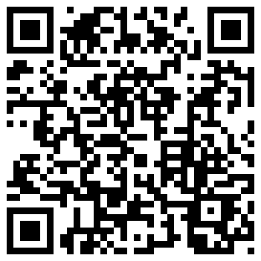
Chart 11416

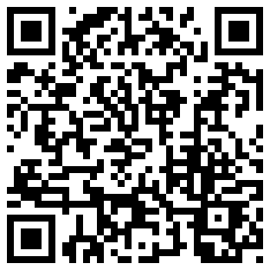
Chart 11424

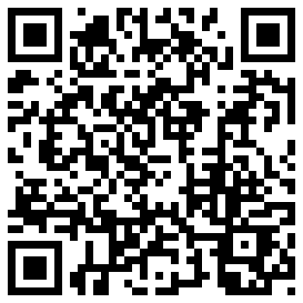
Chart 11425

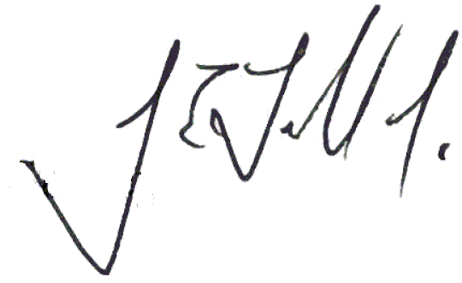
OMB Control No. 0690-0030
Expiration Date: 04/30/2014

You may need to download a free QR code reader application (APP) to your SmartPhone first.

