Survey Monkey Screen Images

Survey Questions for Attorney Forms

## Purpose

This document is prepared to support the survey approval process. Below are screen images of the Attorney Forms survey as it appears on SurveyMonkey.com. To preview the survey, use the link below. <https://www.surveymonkey.com/create/survey/preview?r=true&sm=oeCaqLcZaq6hkSFymgePqZL9MACkW8KuYF_2B6bPSPPTzNoyY5XrA4JBX2YNS7OzzZ>

## Images

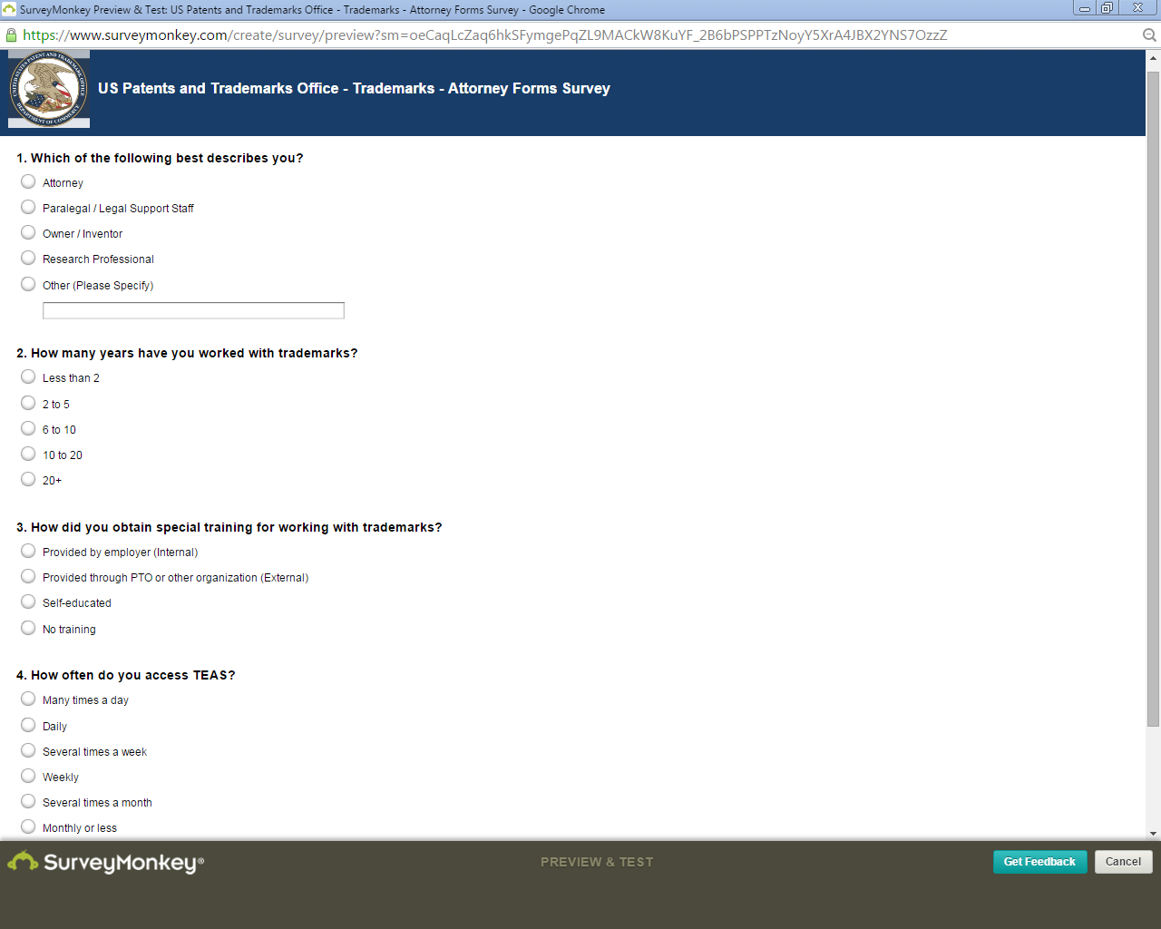

Figure - Questions 1 through 4

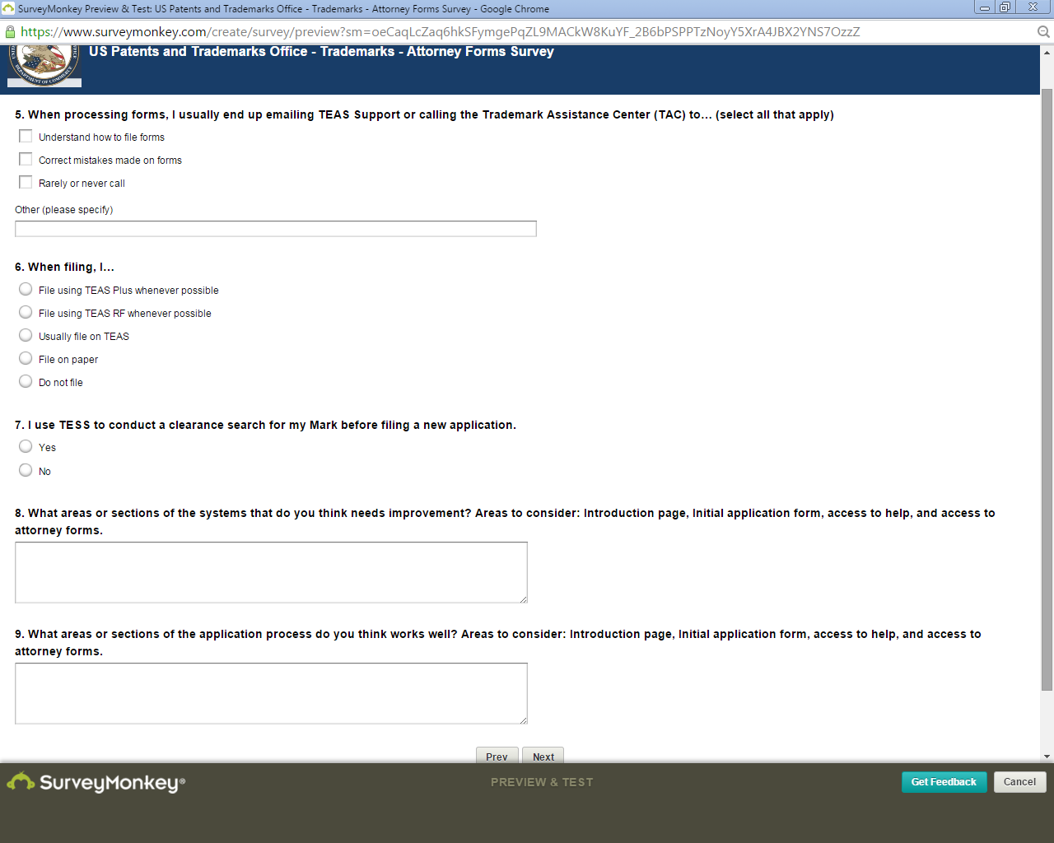

Figure - Questions 5 through 9

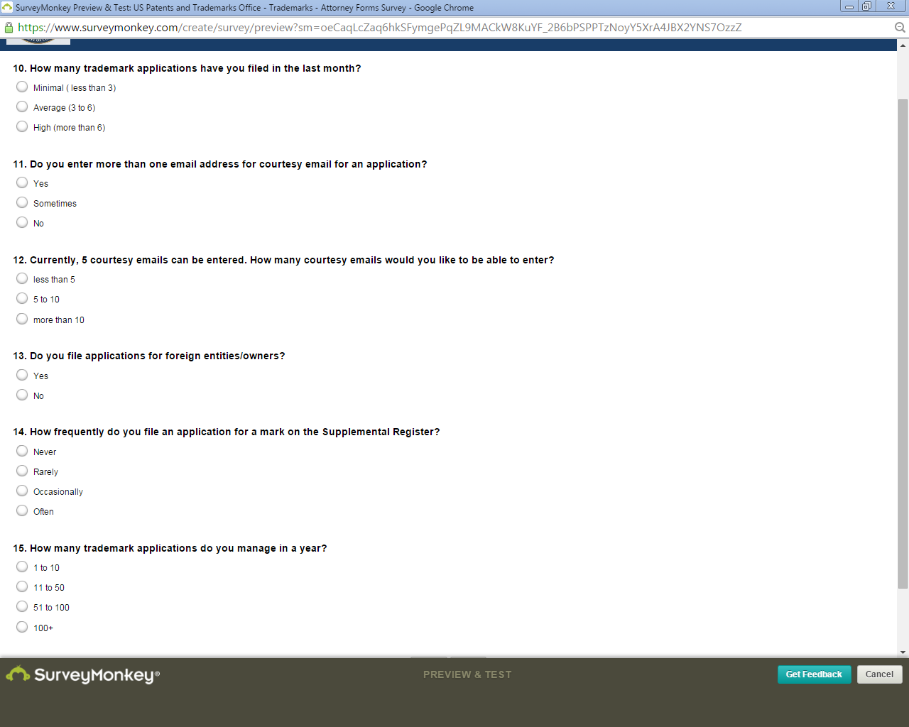

Figure - Questions 10 through 15

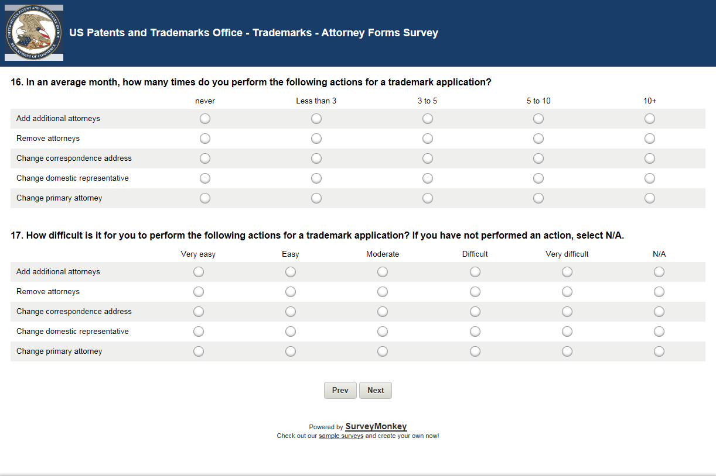

Figure - Questions 16 and 17

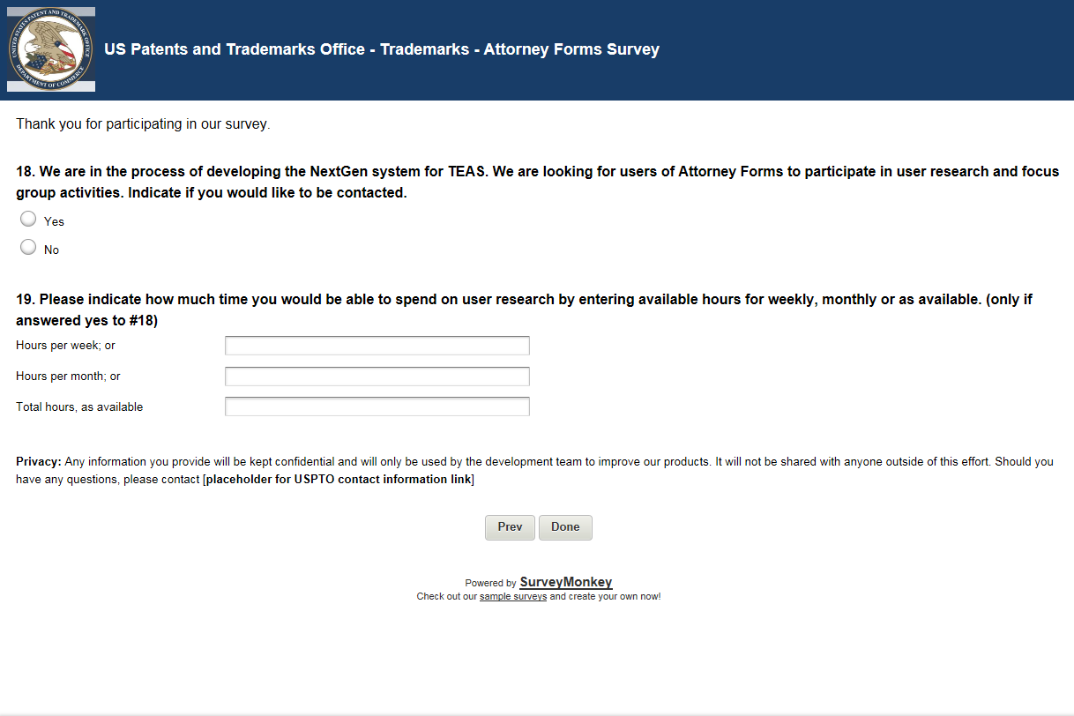

Figure - Questions 18 and 19 (End of Survey)