The Loop11 application will be used to display the test website and to collect usability data. Included in this document are the tasks/questions for the participants, screenshot example of the Loop11 application, and the test webpages (versions A and B).

**Participant Tasks:**

1. What type of device are you using to participate in this study?

* PC (desktop or laptop)
* Tablet
* Smartphone
* Other

1. What is your overall opinion of the U.S. Census Bureau?

* Very favorable


* Very unfavorable

1. How willing would you be to complete a survey from the U.S. Census Bureau if you received a letter in the mail with the URL for the online survey?

* Very willing
* Very unwilling

1. (Website is presented) Take a moment to explore this webpage and then click or touch an item on the webpage that most interests you. (Some items will take you off the webpage and some will not. After you have selected something, select Task Complete on the upper right.)
2. (Website is presented again) Take a moment to decide what you would be least likely to engage or interact with on this webpage. Please click or touch this item.
3. Now, that you have interacted with that webpage, what is your overall opinion of the U.S. Census Bureau?

* Very favorable


* Very unfavorable

1. What do you think is the purpose of that webpage?

[open-ended box with 500 characters max]

1. Think about the Census webpage that you were just interacting with. Please recall and type as much information as you can remember about what you saw on that page.

[open-ended box with 500 characters max]

1. (Website is presented again) Pretend that you wanted to respond to the American Community Survey. Starting from this page, find the American Community Survey. You may navigate off the page. Once you have found the American Community Survey, select Task Complete on the upper right.
2. Given that experience of finding the American Community Survey from that webpage, what is your overall opinion of the U.S. Census Bureau?

* Very favorable


* Very unfavorable

1. Given that experience, how willing would you be to complete a survey from the U.S. Census Bureau if you received a letter in the mail with the URL for the online survey?

* Very willing
* Very unwilling

1. If you have any other comments you would like to share about the webpage or your experience with the webpage, please do so in the space below.

**Loop11 Example: The tasks/questions will be displayed in the green box at the top of the screen and the webpage being tested will be displayed similar to this example.**



**Webpage Version A:**

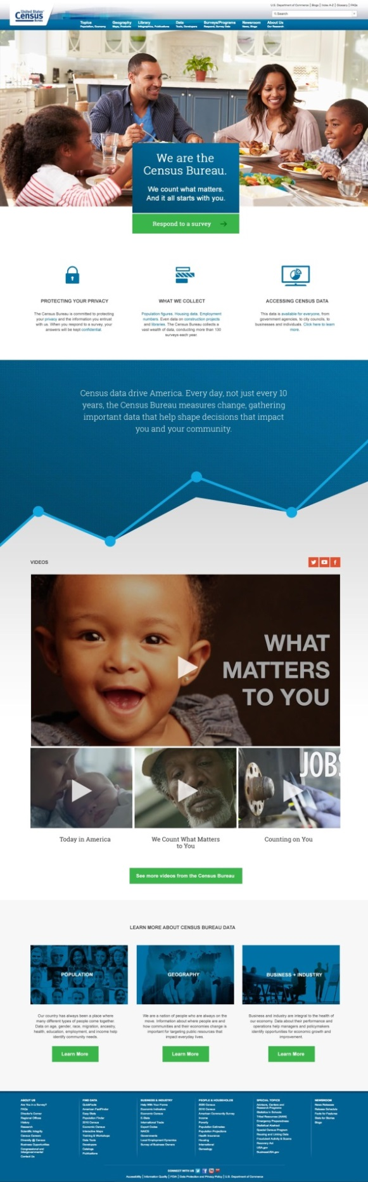

**Webpage Version B:**

