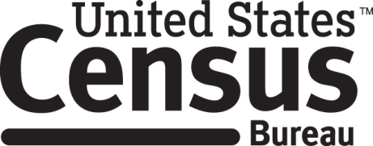

**Consent Form**

**American Community Survey Focus Groups**

The Census Bureau conducts an ongoing survey of the United States population called the American Community Survey (ACS). In order to improve the ACS, the Census Bureau conducts small tests in limited geographic areas. The ACS Focus Group is part of that effort.

______________________ [NAME] consents to take part in a focus group to improve the American Community Survey. In order to have a complete record of all comments, the interview session will be audio and video recorded. The Census Bureau plans to use the tapes to improve the ACS. Staff directly involved in the research project will have access to the recordings. Participation is voluntary and answers will remain strictly confidential.

This study is being conducted under the authority of Title 13 USC. The OMB control number for this study is 0690-0030. This valid approval number legally certifies this information collection.

I have agreed to participate in this Census Bureau focus group, and I give permission for my tapes to be used for the purposes stated above.

____________________________ ___________________________

Participant's Signature Researcher's Signature

____________________________ __________________________

Printed Name Printed Name

___________________________ _______________________

Date Date