OMB No. 0910-xxxx

Exp. Date xx/xx/xxxx

Attachment 10: Baseline parent lead letter

Lead Letter for the Evaluation of the Public Education Campaign on Teen Tobacco (ExPECTT)

[NAME County/Parish/District] Resident at:
1234 Main Street
Anywhere, XX 12345

Dear [NAME County/Parish/District] Resident:

The Food and Drug Administration’s Center for Tobacco Products (CTP) is conducting a study called the Evaluation of the Public Education Campaign on Teen Tobacco. This study will provide the FDA, policy makers, and researchers critical information about youth exposure to public education messages on the health risks of smoking or using other tobacco products. The information collected by this study will also improve our understanding of how public education campaigns affect youths’ attitudes, beliefs, and behaviors toward tobacco use.

Your address was randomly chosen along with more than 30,000 others across the U.S. RTI International, a nonprofit research organization, was selected by the FDA to conduct this study. Soon, an RTI interviewer will be in your neighborhood to give you more information. The interviewer will carry an identification card like the example shown below.

First, the interviewer will ask a few general questions about your household. With permission of a parent or legal guardian, the interviewer may then ask one or two eligible youth in your household to complete the full interview. If an eligible youth in your household is chosen and completes the full interview, he or she will be offered an incentive of $20.

Your participation is voluntary. All information provided by you or your child will be kept private to the fullest extent allowable by lawand used only for statistical purposes. You or your household will never be identified in any analysis, reports, or publications, and no one will try to sell you anything.

Please share this information with any others in your household. Feel free to ask the interviewer any questions you have about this study. For more information about the study, please contact Jennifer Keeney, at 800 334-8571 extension 23525. If you have a question about your rights as a study participant, you can call RTI’s Office of Research Protection toll-free at (866) 214-2043.

Your help is very important to this study’s success. Thank you for your cooperation.

Sincerely,

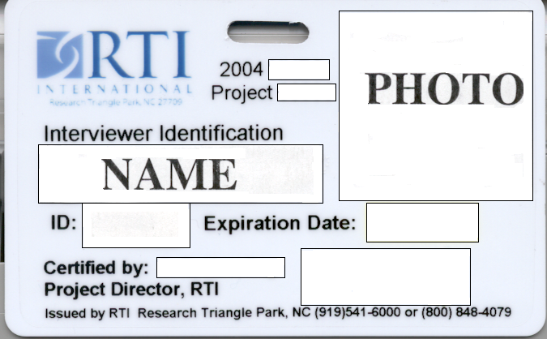

You will be contacted by: ___________________________________________ Interviewer Name

Thank you for taking time to complete this survey.

OMB No: 0910-xxxx Expiration Date: xx/xx/xxxx

Paperwork Reduction Act Statement: The public reporting burden for this collection of information has been estimated to average 10 minutes per response. Send comments regarding this burden estimate or any other aspects of this collection of information, including suggestions for reducing burden to PRAStaff@fda.hhs.gov

