**AIDS Drug Assistance Program (ADAP) Quarterly Report**

**Web System Screen Shots**

**Questions 1 – 13 Quarterly Submission**

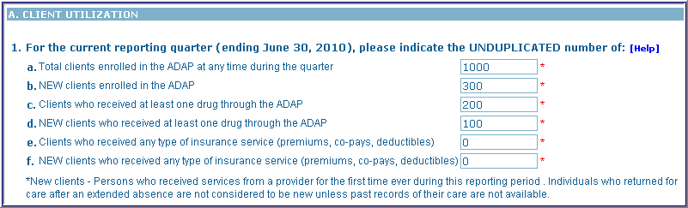

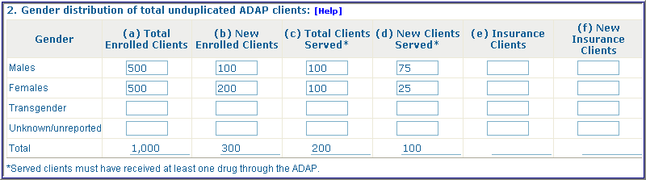

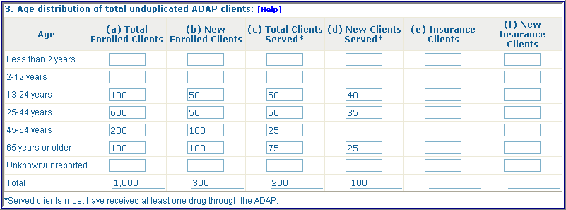

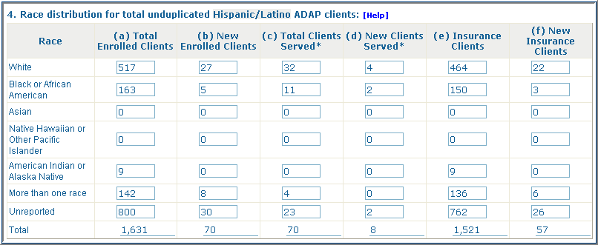

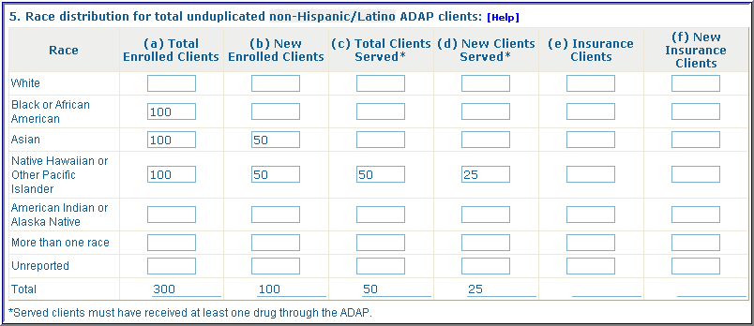

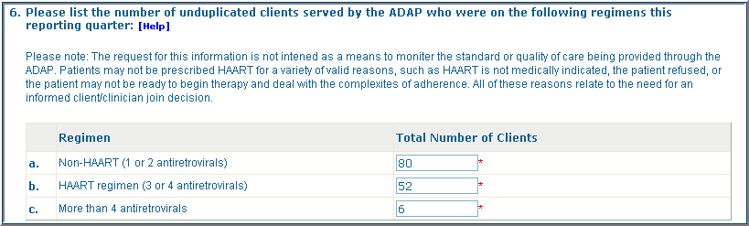



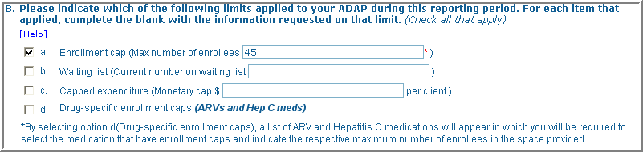

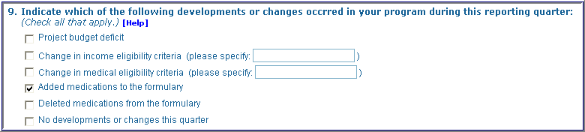

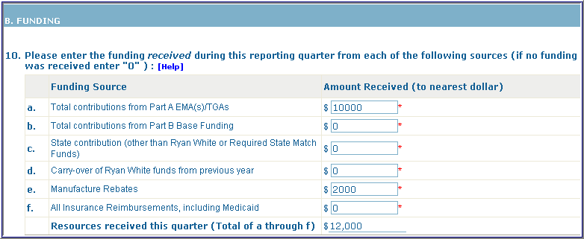

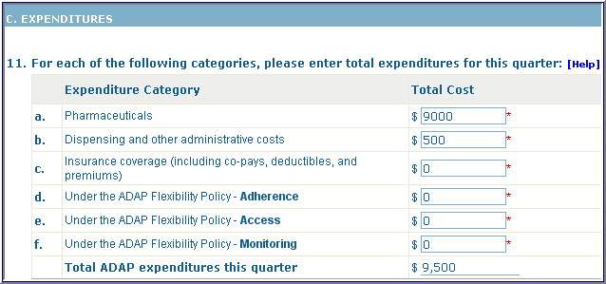

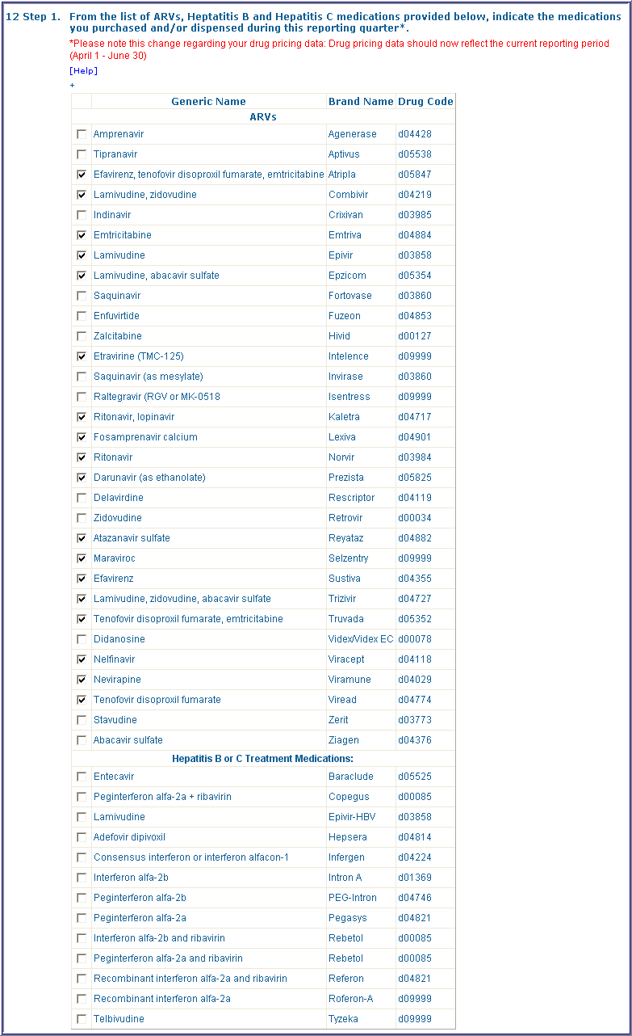

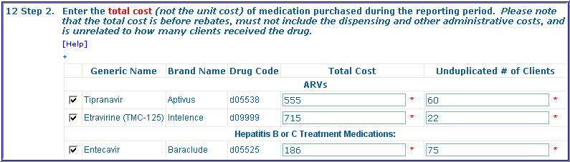

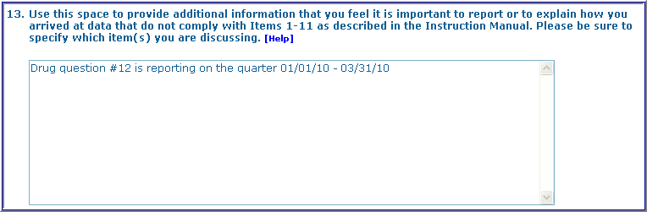

**Questions 14 – 22 Annual Submission**

